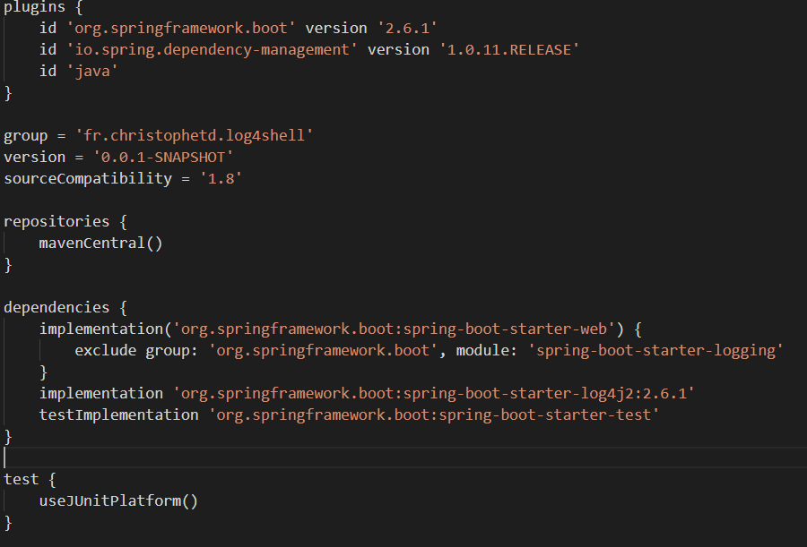

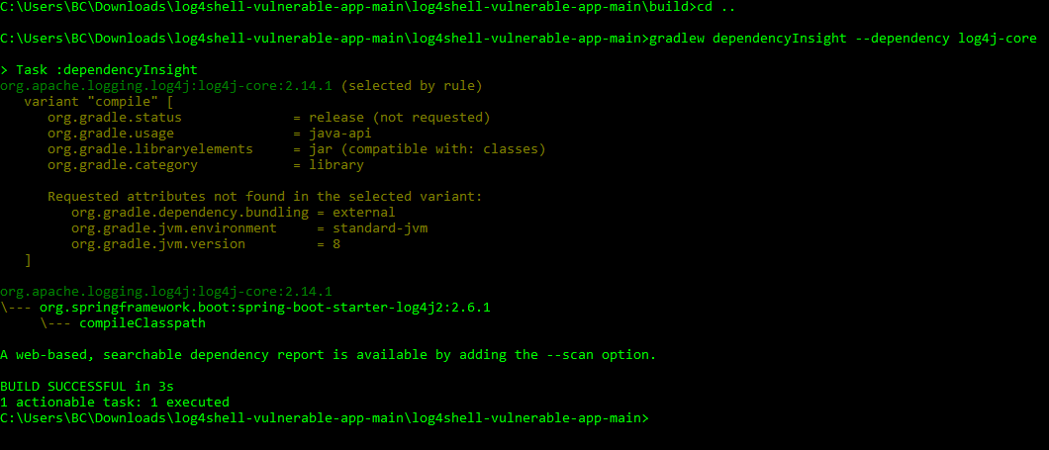

java -jar log4shell-vulnerable-app-0.0.1-SNAPSHOT.jar

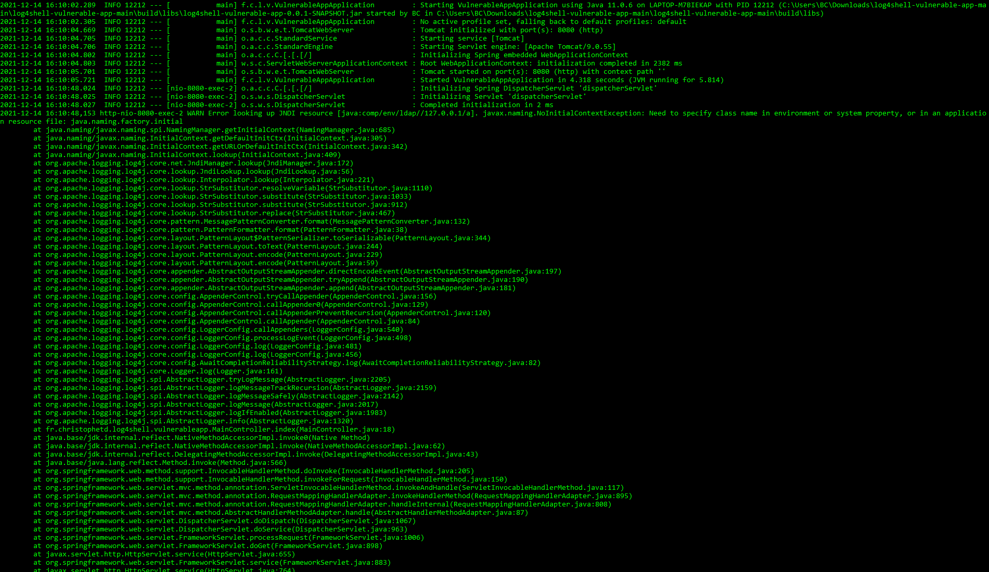

java -Dlog4j2.formatMsgNoLookups=true -jar log4shell-vulnerable-app-0.0.1-SNAPSHOT.jar

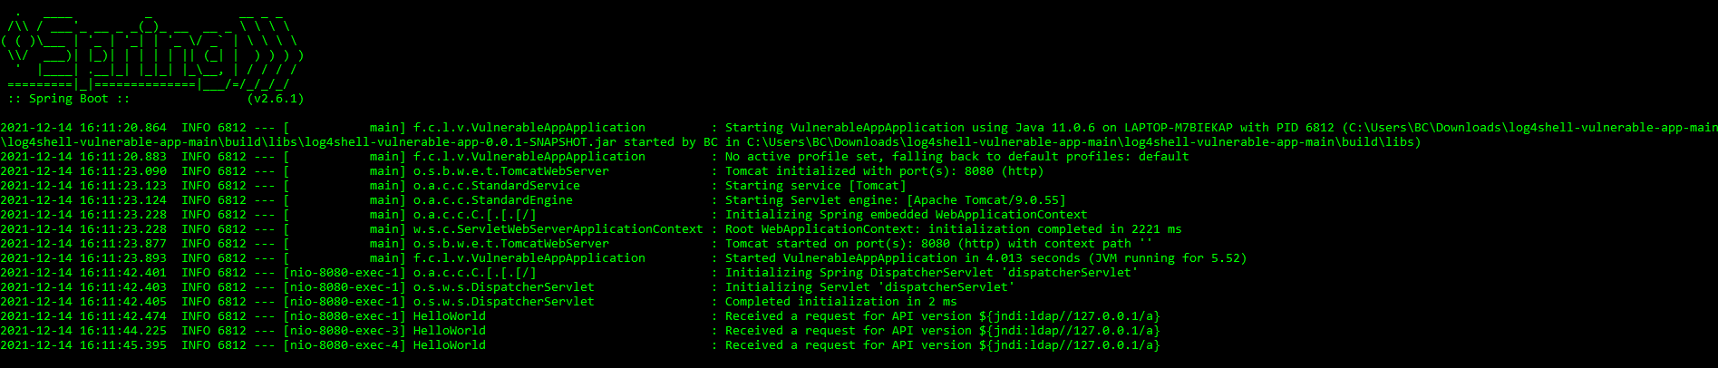

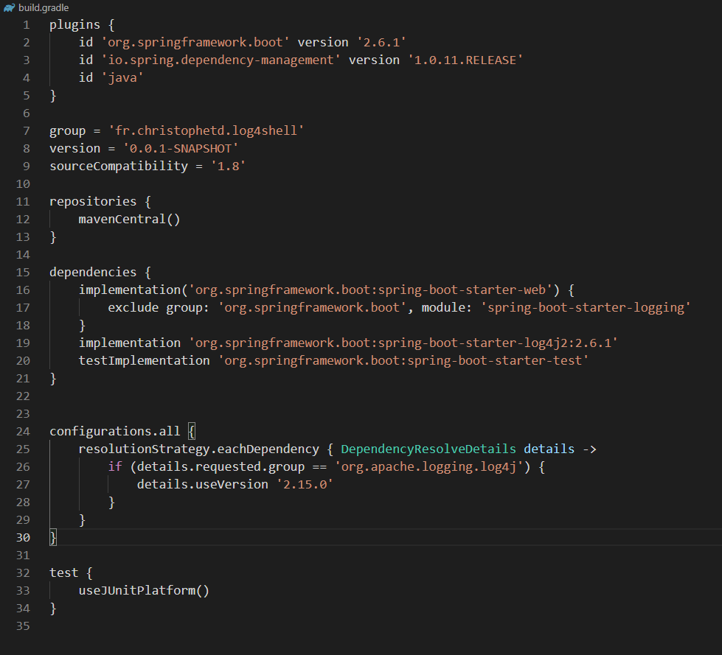

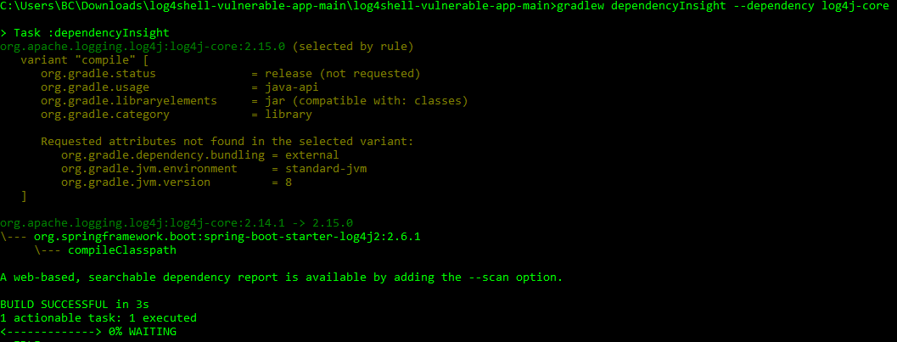

java -jar log4shell-vulnerable-app-0.0.1-SNAPSHOT.jar

