Act Report

By: Brandon Chung

April 29, 2018

**Introduction**

The analysis will revolve around dog type ratings, popularity of favorites and retweets and the top dog breeds.

**Dog Type Ratings**

In determining the 4 dog types we had to first merge the columns into one, then filter out the variable that contained ‘None’ or multiple types and exclude out the outliers. By looking at the 4 types of dogs we can see that although pupper has a higher count than the other three the average rating is the lowest at 1.07 as several low outliers lowers this average. Floofer and puppo consistently maintain a 1.2 rating closely followed by doggo.

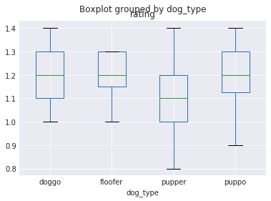

**Favorites vs Retweets**

When I compared the number of data points between favorites and retweets there are significantly more favorites than there are retweets. Also noted were several outliers for favorites with extremely popular retweets that might suggest there is something special about the image of the dog which is a rare case. The original distributions for both favorites and retweets show skewed positive long tails which correlates to a strong positive relationship and as a result the scatter graph may depict more of a logarithmic scale trend between the two variables.

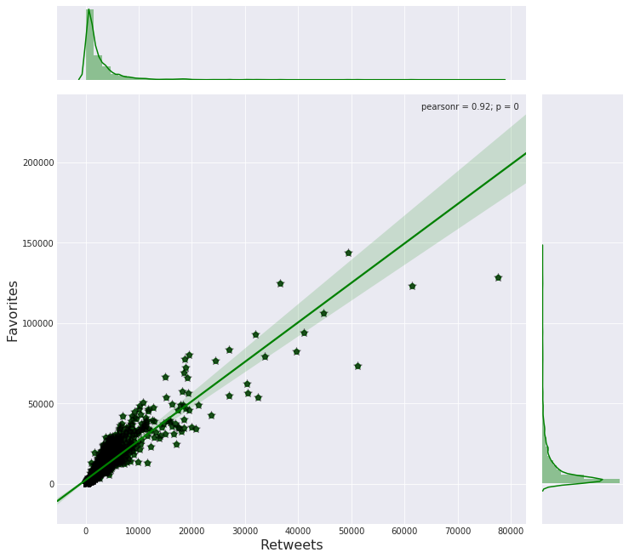

**Top Rated Dog Breeds**

Interesting to see that there are two types of retrievers in the top 2 which I assume most people own and are easily identifiable through neural networks. From the statistics table, the higher the count of dog breeds the higher the average ratings which is high than normal for the Golden Retriever. With a positive trend it is likely that applies for all the breeds with the exception of the Pomeranian breed. In this breed they had one of the highest average ratings but with a relatively low count which means that the outlier increases the average. We might come to think that these higher than normal ratings come from the bigger favorites and extreme retweets.

