Week 1 Assignment

First Last

Saddleback College

Class Name

Instructor: Bryan Cimo

January 1, 2025

Paper Title in Bold at the Top of Page 2

The first section of your paper is your introduction. Use these paragraphs to provide background and context. “Introduction” should not be used as a section heading as it’s assumed your paper will begin with an introduction. Remember to use first-person tense. Anytime you want to start a section on a new page, instead of adding page breaks, use the **Section Title** style. (To see the reader’s view of your document, click on the **View** tabthen select **Reading View.**)

Lorem ipsum dolor sit amet, consectetur adipiscing elit, sed do eiusmod tempor incididunt ut labore et dolore magna aliqua. The following is the output for question 1: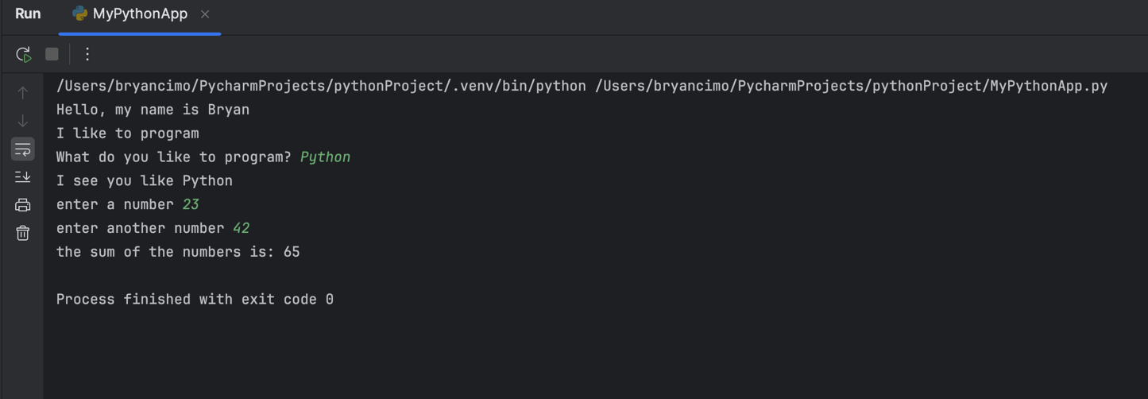

# Heading One

Heading levels 1-3 get their own paragraph, as shown. Headings 4 and 5 are run-in headings used at the beginning of the paragraph. Include a period at the end of a run-in heading. Double-space all text, including headings. Use descriptive headings to help readers identify sections of your paper.

## Heading Two

If needed, you can include consecutive paragraphs with their own headings, where appropriate. For APA Style formatting, type your own references. To correctly format a reference page according to APA Style guidelines, see page four.

### Heading Three

When citing any quote or text that consists of three or more lines, APA guidelines call for block-quote format:

Create a new paragraph to begin the block-quote. Double-space each line of text, as you have done with headings, section labels, and paragraphs of paraphrased text. To correctly format a block-quote, indent each line of the text to one-half inch. Remember to always cite your source.

Last Name (Year) citations can be used when writing a paper in narrative form. Parenthetical citations are also appropriate (Last Name, Year).

Heading Four: When using headings, don’t skip levels. If you need a heading 3, 4, or 5 with no text following it before the next heading, just add a period at the end of the heading and start a new paragraph for the subheading and its text.

Heading Five. Like all sections of your paper, references start on their own page, like the page that follows this one. All in-text citations should be included your references.

References

Last Name, A. B. (Year). Article Title. *Journal Title*, Pages #-#. URL.

Last Name, C. D. (Year). *Book Title (Edition).* Publisher Name. URL.

Last Name, D. E., Last Name, F. G., Last Name, H. I. (Year). *Report Title* (report number). Publisher. URL.

Last Name, J. K. (Year, Month Day). *Article Title/Headline*. Periodical. URL.

Organization Name. (Year, Month Day). *Webpage Title*. URL.

*For additional information on APA Style formatting, please consult the* [*APA Style Manual, 7th*](https://apastyle.apa.org/style-grammar-guidelines) *Edition.*