|  |
| --- |
| SLA Analyzer |

SLA Analyzer is a java application designed to match a ticket with its SLA and determine whether it is burned out or not when it reaches an Assignment Group (AG) of interest. This assignment groups were defined by the user during the design phase.ñ

SLA Analyzer

The main window of SLA Analyzer consists in a series of inputs for the necessary routes.

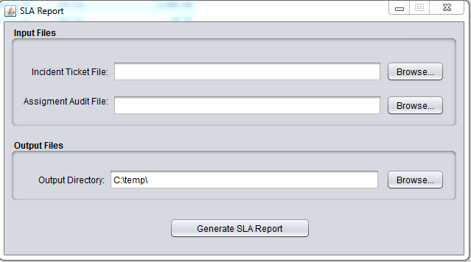

* **Incident Ticked File:** Is the file that contains the information of all the tickets, typically will have x columns. Each row represents one incident.
* **Assignment Audit File:** Is the file that contains the audits from the incidents. A row in this file is an audit associated with an incident. Each incident in the *Incident Ticket File* will have zero or more audits related in this file.
* **Output Directory:** This is the route where the report file will be generated.

When the necessary routes are set, the user can push the “Generate SLA Report” button.

When the button is pushed, if the inputs are correct, a new window will appear with the progress of the process. It starts matching both files and generating the condensed report computing the SLA for each.

The generated report will have two tabs:

The first tab contains the tickets which had an audit which belonged to an assignment group of interest, this tickets can be burned out or non-burned.

The second tab contain the tickets which did NOT contain an audit in the groups of interest, then the SLA is not computed and they are NOT marked as burned or non-burned.

