Text Features

Headings

This is a Heading 2

This is a Heading 3

This is a Heading 4

Paragraphs and Inline Formatting
A paragraph with bold, italic, E = mc², and H₂O, plus a hyperlink to BCIT.

Unordered List
- First bullet
- Second bullet with children
  - Nested bullet one
  - Nested bullet two
- Third bullet

Ordered List
- Step one
- Step two
- Step three

Blockquote
#quote
The only way to do great work is to love what you do.
Steve Jobs
/quote

Math
#math
a² + b² = c²
Pythagorean theorem
/math

Learning Blocks
#activity

Activity
Sample content for the activity learning block.
/activity
#assignment

Assignment
Sample content for the assignment learning block.
/assignment
#case

Case
Sample content for the case learning block.
/case
#definition

Definition
Sample content for the definition learning block.
/definition
#discussion

Discussion
Sample content for the discussion learning block.
/discussion
#doing

Doing
Sample content for the doing learning block.
/doing
#example

Example
Sample content for the example learning block.
/example
#group-activity

Group Activity
Sample content for the group-activity learning block.
/group-activity
#key-point

Key Point
Sample content for the key-point learning block.
/key-point
#knowing

Knowing
Sample content for the knowing learning block.
/knowing
#link

Link
Sample content for the link learning block.
/link
#note

Note
Sample content for the note learning block.
/note
#outcome

Outcome
Sample content for the outcome learning block.
/outcome
#quiz

Quiz
Sample content for the quiz learning block.
/quiz
#reading

Reading
Sample content for the reading learning block.
/reading
#reflection

Reflection
Sample content for the reflection learning block.
/reflection
#review

Review
Sample content for the review learning block.
/review
#warning

Warning
Sample content for the warning learning block.
/warning

Media

Image
#image
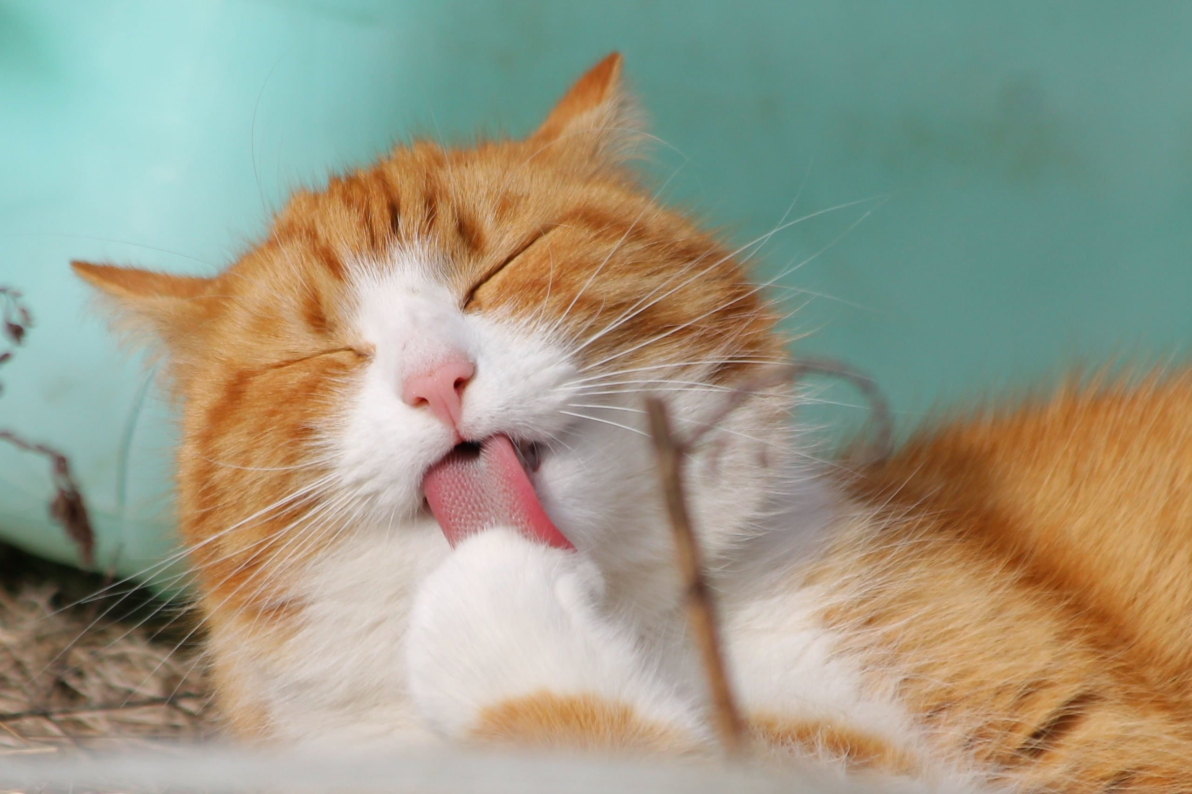
Alt: a small generated red square
A generated placeholder image.
License: CC0 Public Domain
/image

Audio
#audio
Source: https://freesound.org/data/previews/417/417476_47392-lq.mp3
Field recording of bird song.
License: CC BY 3.0
/audio

Video
#video
Source: https://www.youtube.com/embed/fTHSmKd8OvY
BCIT Burnaby Campus in 30 Seconds
License: BCIT 2019
/video

Slider
#slider

First Slide
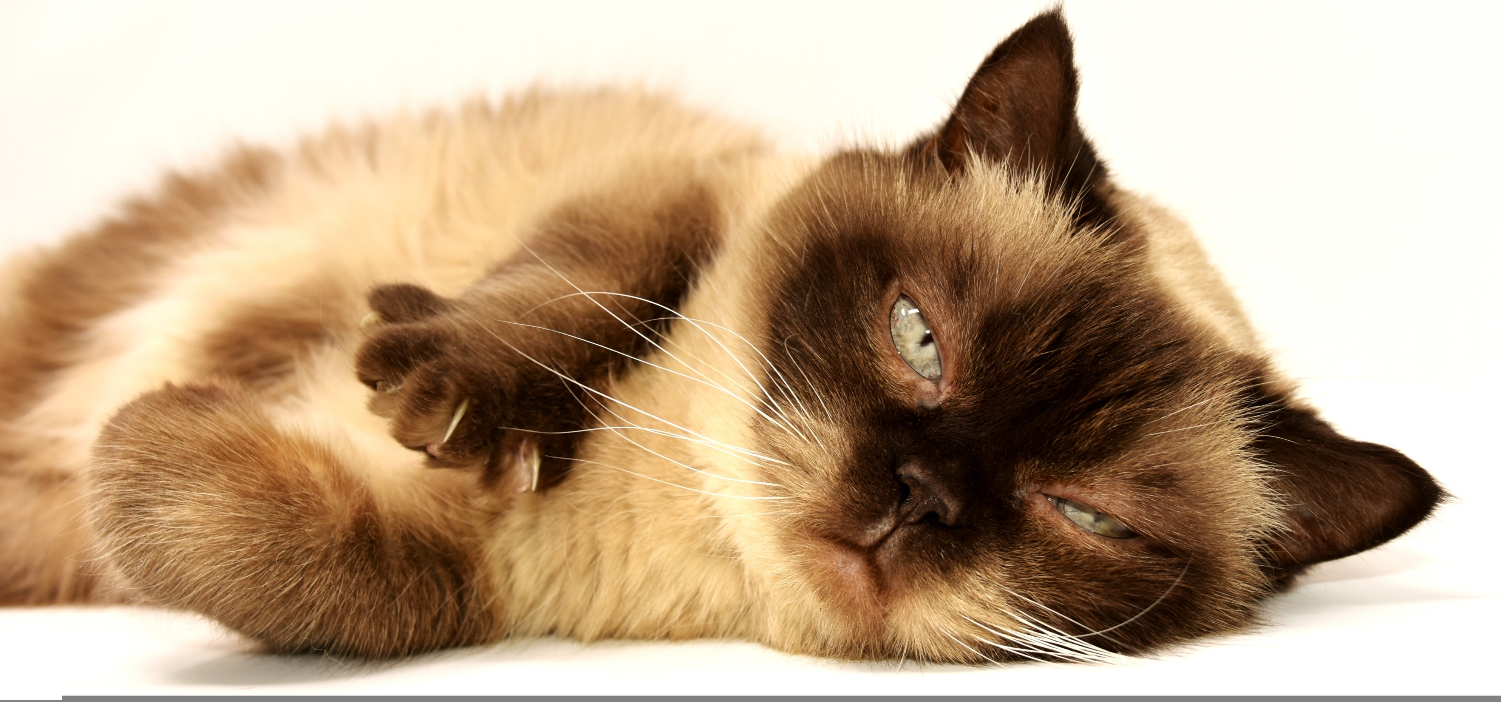
Caption for the first slide.

Second Slide
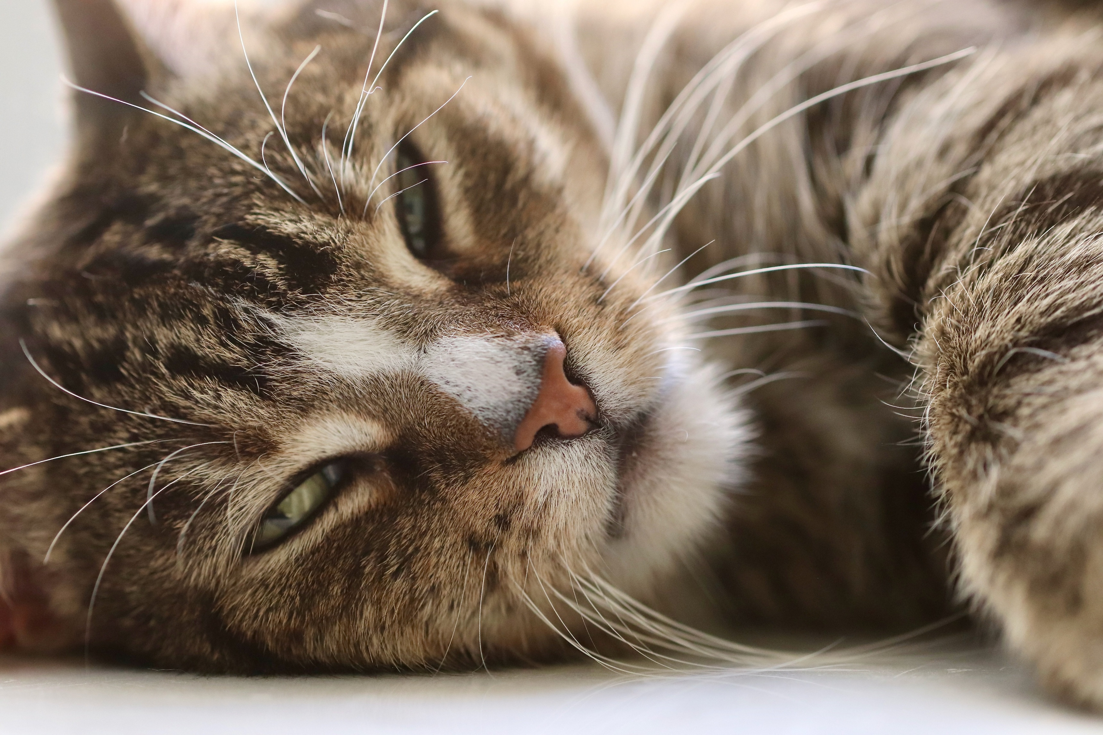
Caption for the second slide.
/slider

Interactions

Accordion
#accordion

First Panel
Content of the first accordion panel.

Second Panel
Content of the second accordion panel.
/accordion

Tabs
#tabs

Northwest Territories
tab-text: Northwest
- Capital: Yellowknife

Yukon
- Capital: Whitehorse
/tabs

Reveal
What is the capital of Canada?
#reveal
Button: Answer
Ottawa is the capital of Canada.
/reveal

Flashcards
#flashcards
Front | Back
What does HTML stand for? | HyperText Markup Language
What is the largest planet? | Jupiter
/flashcards

Swapper
#swapper
#note

A Note in a Swapper
Swapper items cycle one at a time.
/note
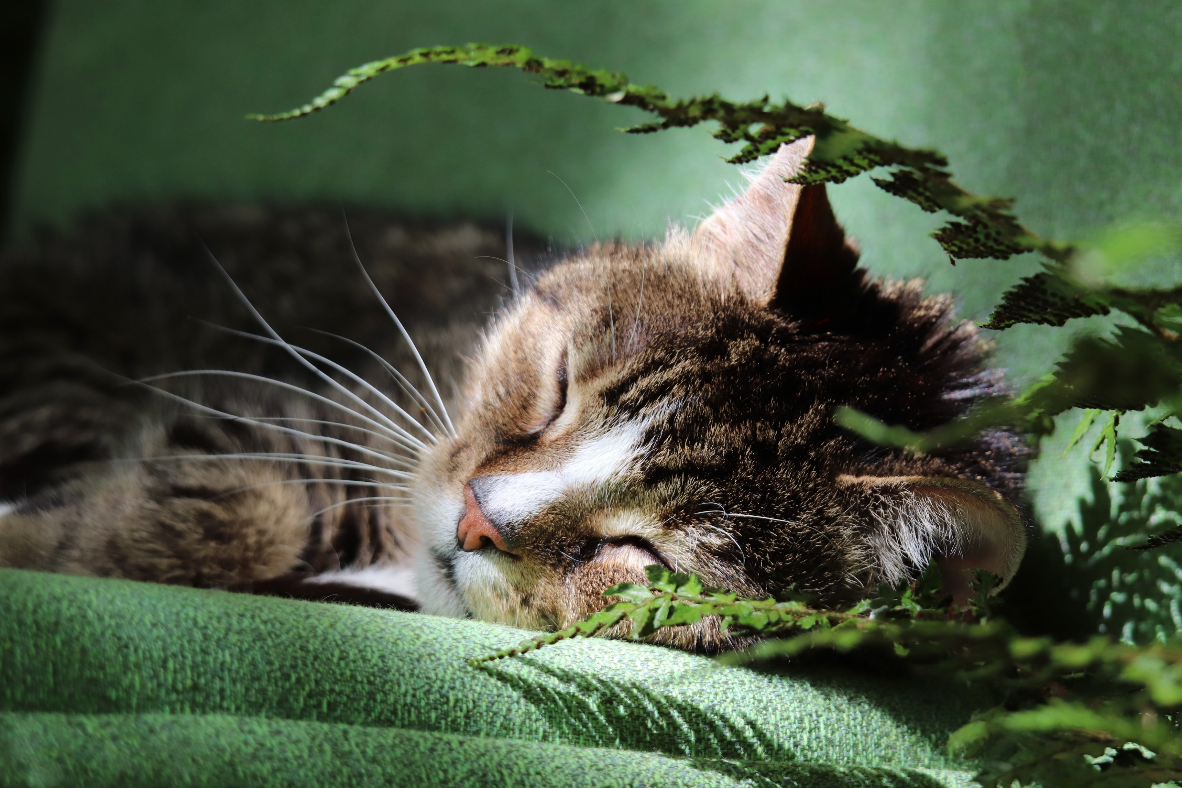
A swapper image caption.
/swapper

Line Matching
#line-matching
Match each term to its definition.
Term | Definition
HTML | Structure of a web page
CSS | Presentation of a web page
JavaScript | Behaviour of a web page
/line-matching

Checklist
#checklist
Before you submit:
- Proofread your work
- Check your citations
- Confirm the file format
/checklist

Knowledge Checks and Tables

Multiple Choice
#knowledge-check
- When was BCIT's 50th anniversary celebration?
  - 1967
  - 1987
  - *2014
/knowledge-check

Matching
#knowledge-check
- Match the following things to their colour:
  - Green = Leaf
  - Red = Tomato
  - Orange = Carrot
/knowledge-check

Fill in the Blank
#knowledge-check
- The capital of Canada is [open-ended,Ottawa].
- The sky is [*dropdown,blue,green,red].
/knowledge-check

Plain Table
Name | Role
Ada Lovelace | First programmer
Alan Turing | Father of computer science

