Predicted cardiovascular risk and blood pressure for Americans with diabetes, chronic kidney disease, and ≥65 years of age

Byron C. Jaeger1, Swati Sakhuja2, Shakia T. Hardy2, Paul Muntner2, and Paul K. Whelton3

1. Department of Biostatistics, University of Alabama at Birmingham
2. Department of Epidemiology, University of Alabama at Birmingham
3. Department of Epidemiology, Tulane University

In November 2017, the American College of Cardiology and the American Heart Association (ACC/AHA) published a guideline for the prevention, detection, evaluation, and management of high blood pressure (BP) in adults.(1) This guideline recommends using both predicted predicted risk for cardiovascular disease (CVD) and BP levels to guide the initiation of antihypertensive medication. All adults with systolic BP (SBP) ≥140 mm Hg or diastolic BP (DBP) ≥90 mm Hg, stage 2 hypertension in the guideline, are recommended to initiate antihypertensive medication. Additionally, adults with SBP between 130 and 139 mm Hg and/or DBP between 80 and 89 mm Hg, stage 1 hypertension in the guideline, who have prevalent diabetes mellitus, prevalent chronic kidney disease (CKD), ≥65 years of age, or high ASCVD() risk are recommended to initiate antihypertensive medication. High ASCVD() risk is defined as prevalent CVD or a 10-year predicted risk for atherosclerotic CVD (ASCVD) ≥10%

The 2017 ACC/AHA guideline recommends computing 10-year predicted risk for ASCVD in all adults with hypertension, including those with diabetes, CKD or ≥65 years of age. However, the guideline states that the vast majority of adults with diabetes, CKD, or ≥65 years of age can be assumed to have a 10-year predicted risk for ASCVD ≥10%. The purpose of the current analysis was to estimate the proportion of US adults with diabetes, CKD, or ≥65 years of age that have high ASCVD risk (i.e., a 10-year predicted risk for ASCVD ≥10% or prevalent CVD). A secondary objective was to estimate the proportion with high ASCVD risk among adults with stage 1 hypertension and diabetes, CKD, or ≥65 years as the 2017 ACC/AHA BP guideline recommends initiation of antihypertensive medication for all of these adults. To accomplish these goals, we analyzed data from 3 cycles of the US National Health and Nutrition Examination Survey (NHANES).

# METHODS

NHANES was designed to assess the health and nutritional status of the non-institutionalized US population and is conducted by the National Center for Health Statistics of the Centers for Disease Control and Prevention.(2) Since 1999-2000, NHANES has been conducted in two-year cycles using a multistage probability sampling design to select participants. Each cycle is independent with different participants recruited. For the current analysis, the 3 cycles conducted in 2013-2014, 2015-2016, and 2017-2018 were pooled for analysis.(3) The protocols for each NHANES cycle were approved by the National Center for Health Statistics of the Centers for Disease Control and Prevention Institutional Review Board. Written informed consent was obtained from each participant. The University of Alabama at Birmingham Institutional Review Board considered the analysis of NHANES data to be exempt research.

The current analysis was restricted to adults aged 40 to 79 years of age who completed the NHANES interview and examination (n = 9,937). Participants <40 or >79 years of age were not included because the Pooled Cohort risk equations are not recommended to be used in these age ranges.(4) Participants who did not have three SBP and DBP measurements (n = 565) and those who were missing information on age, race, sex, total and high-density lipoprotein cholesterol, smoking status, diabetes, or CKD status (n = 569) were excluded. After these exclusions, over the 3 NHANES cycles, a total of 8,803 survey participants were included in the analysis (Figure S1).

## Data collection

Data were collected during an in-home interview and a study visit completed at a mobile examination center. Standardized questionnaires were used to assess participants’ age, sex, race/ethnicity, smoking habits, medical history and use of antihypertensive medication, oral glucose lowering medication and insulin. Medical history included questions about whether the participant had been told by a doctor or other health professional that they have had a heart attack, coronary heart disease stroke, or heart failure. Blood and urine samples were collected during the medical examination. Of relevance to the current analysis, serum creatinine, serum glucose and glycated hemoglobin were measured. Diabetes was defined by fasting serum glucose ≥126 mg/dL, non-fasting glucose ≥200 mg/dL, glycated hemoglobin ≥6.5%, or self-reported use of insulin or oral glucose lowering medication. Estimated glomerular filtration rate was calculated using the Chronic Kidney Disease Epidemiology Collaboration equation.(5) Urinary albumin and creatinine levels were measured and used to calculate the albumin-to-creatinine ratio. CKD was defined by an estimated glomerular filtration rate <60 ml/min/1.73m2 or an albumin-to-creatinine ratio ≥30 mg/dL. Predicted 10-year risk for ASCVD was calculated using the Pooled Cohort risk equations for participants without prevalent CVD.(4) High ASCVD risk was defined as prevalent CVD or a 10-year predicted ASCVD risk ≥10%.

## Blood pressure measurements

The same protocol was followed to measure SBP and DBP in each NHANES cycle. After survey participants had rested 5 minutes, their BP was measured by a trained physician using a mercury sphygmomanometer and an appropriately sized cuff. Three BP measurements were obtained at 30 second intervals. The mean of all available measurements was used to define SBP and DBP. Quality control included re-certification of physicians every quarter with retraining if needed. All physicians participated in annual retraining.

## Blood pressure categories

Participants not taking antihypertensive medication were grouped into four non-overlapping categories based on the 2017 ACC/AHA BP guideline: Normal BP (SBP <120 mm Hg and DBP <80 mm Hg), elevated BP (SBP between 120 and 129 mm Hg and DBP <80 mm Hg), stage 1 hypertension (SBP between 130 and 139 mm Hg and/or DBP between 80 and 89 mm Hg with SBP <140 mm Hg and DBP <90 mm Hg), stage 2 hypertension (SBP ≥140 mm Hg or DBP ≥90 mm Hg). Participants taking antihypertensive medication were placed in a fifth category.

## Statistical analysis

Analyses were conducted for the overall population and among participants with diabetes, CKD, ≥65 years of age, and for those with any of these three conditions. Participant characteristics were summarized as mean with their standard error and percentage for continuous and categorical variables, respectively. The percentage of US adults in each of the five BP categories was computed. The 25th, 50th, and 75th percentile of 10-year predicted risk for ASCVD and the proportion of participants at high ASCVD risk were estimated for the overall US population and stratified by the 5 BP categories outlined in the preceding paragraph. To assess the extent to which participants with a 10-year predicted risk for ASCVD <10% were close to the 10% threshold, the proportion of participants in this subgroup with 10-year predicted risk for ASCVD from 0% to <2.5%, 2.5% to <5.0%, 5.0% to <7.5%, and 7.5% to <10% was estimated. The probability of having high ASCVD risk was estimated for each year of age from 40 to 79 years using logistic regression. Analyses of participant characteristics, the distribution of 10-year predicted risk for ASCVD, and the probability of having high ASCVD risk were repeated among participants with stage 1 hypertension.

NHANES sampling weights, which were calculated as the inverse probability of being selected for the survey, were used in all calculations to obtain US nationally representative estimates. The survey design of NHANES was also taken into account. P-values were two-sided. Data analysis was conducted using R version 4.0.2 (released June 22, 2020) along with a collection of open-source software packages (e.g., drake, dflow, officedown, and others).(6–9) The first author’s GitHub repository (< *Link not yet active so we won’t be scooped* >) provides code to reproduce the current manuscript.

# RESULTS

Among US adults aged 40 to 79 years in 2013-2018, the estimated prevalence (95% confidence interval [CI]) of diabetes and CKD was 17.2% (16.0%, 18.5%) and 17.2% (15.9%, 18.5%), respectively, 25.4% (23.7%, 27.2%) were estimated to be ≥65 years of age, and 42.1% (40.2%, 43.9%) had at least one of these conditions (Table 1). An estimated 14.6% (95% CI: 13.3%, 16.1%) of US adults who were 40 to 79 years of age had stage 1 hypertension (Table 2). Among those with diabetes, CKD, age ≥65 years, and any of these three conditions, the estimated prevalence (95% CI ) of stage 1 hypertension was 10.5% (8.5%, 12.8%), 8.9% (7.3%, 10.8%), 9.1% (7.5%, 10.9%), 10.2% (8.9%, 11.8%), respectively. Characteristics of US adults 40 to 79 years of age with stage 1 hypertension, overall and for subgroups defined by diabetes, CKD and age ≥65 years, are presented in Table S1

## Predicted 10-year risk for atherosclerotic cardiovascular disease

Among US adults aged 40 to 79 years without prevalent CVD, the estimated median (25th, 75th percentiles) 10-year predicted risk for ASCVD was 5.1% (1.9%, 11.4%) in the overall population and 14.4% (7.0%, 27.4%), 11.4% (4.8%, 22.3%), 17.9% (11.2%, 27.4%), 13.3% (6.9%, 22.0%) among those with diabetes, CKD, age ≥65 years, and any of these three conditions, respectively (Table 3; top panel). Among those with stage 1 hypertension and without prevalent CVD, the estimated median (25th, 75th percentiles) 10-year predicted risk for ASCVD was 4.2% (1.9%, 8.5%) overall and 8.9% (4.5%, 19.3%), 7.4% (2.8%, 12.2%), 13.8% (8.6%, 22.3%), 9.8% (5.3%, 16.5%) among those with diabetes, CKD, age ≥65 years, and any of these three conditions, respectively.

Among US adults aged 40 to 79 years, 72.5 (95% CI: 69.4, 75.6), 64.5 (95% CI: 61.4, 67.7), 83.9 (95% CI: 81.7, 86.1), and 69.1 (95% CI: 66.9, 71.3) of those with diabetes, CKD, age ≥65 years, or any of these conditions had high ASCVD risk, respectively (Table 3; bottom panel). Among those with stage 1 hypertension, 55.0 (95% CI: 43.7, 66.4), 36.7 (95% CI: 26.2, 47.2), 72.6 (95% CI: 63.2, 81.9), and 54.4 (95% CI: 46.7, 62.1) of those with diabetes, CKD, age ≥65 years, or any of these conditions had high ASCVD risk, respectively.

## Distribution of predicted risk in low risk groups

Among US adults who were not at high risk for ASCVD, an estimated 69.4% (95% CI: 67.5%, 71.3%) of US adults had 10-year predicted ASCVD risk <5% (Figure 1). Among those with diabetes, CKD and age ≥65 years, an estimated 47.7% (95% CI: 41.0%, 54.5%), 55.9% (95% CI: 50.3%, 61.3%), and 13.2% (95% CI: 8.4%, 20.1%) had a 10-year predicted ASCVD risk <5%, respectively. Among US adults with stage 1 hypertension who were not at high risk for ASCVD, an estimated 53.6% (95% CI: 35.6%, 70.6%), 52.2% (95% CI: 35.5%, 68.5%), and 7.4% (95% CI: 1.1%, 35.8%) of those with diabetes, CKD, and ≥65 years of age had a 10-year predicted ASCVD risk <5%, respectively (Figure S2).

## Age-specific analysis of 10-year predicted ASCVD risk ≥10% or prevalent CVD

The estimated probability of having high ASCVD risk increased with older age and exceeded 50% at 65 years for US adults without diabetes or CKD compared with 54 and 59 years for US adults with diabetes and CKD, respectively (Figure 2). Among US adults with stage 1 hypertension, the age at which the estimated probability of having high ASCVD risk exceeded 50% was 65, 55, and 65 years for US adults without diabetes or CKD, with diabetes, and with CKD, respectively (Figure S3). The minimum age where the probability of high ASCVD risk exceeded 50% was not determined for adults ≥65 years of age as the probability exceeded 50% at all ages above 65 years.

# DISCUSSION

In the current study, a majority of US adults with diabetes, CKD or age ≥65 years had a high risk for ASCVD, defined by a 10-year predicted ASCVD risk ≥10% or prevalent CVD. However, a substantial proportion of US adults with stage 1 hypertension and diabetes, CKD, or age ≥65 years did not have high ASCVD risk. Among all US adults who were not at high risk for ASCVD, approximately half of those with diabetes or CKD had a 10-year predicted ASCVD risk <5%. In contrast, over 80% of adults aged ≥65 years had 10-year predicted risk for ASCVD between 5% and 10%. The probability of having high risk was age-dependent with over 50% of those with diabetes who were 55 years of age and older and with CKD who were age 59 years of age and older having high ASCVD risk.

Among US adults aged 40 to 79 years, the current study estimates that roughly 33% use antihypertensive medication. Among US adults aged 40 to 79 years with diabetes, CKD, or ≥65 years of age, the current study estimates that roughly 50% use antihypertensive medication and relatively few (roughly 10%) have stage 1 hypertension. Therefore, the use of 10-year predicted ASCVD risk to guide treatment only applies to a small percentage of adults with at least one of these conditions. Additionally, it is possible that existing 10-year ASCVD risk prediction models, including the Pooled Cohort risk prediction equations, are not calibrated for prediction of ASCVD risk among this relatively small group of adults, particularly for those of younger age.

Previous studies have shown that the use of predicted ASCVD risk in addition to BP can direct antihypertensive medication to adults likely to receive the largest risk reduction benefit with treatment.(10, 11) In an analysis of the Reasons for Geographic and Racial Differences in Stroke study, those with stage 1 hypertension recommended versus not recommended to initiate antihypertensive medication by the 2017 ACC/AHA BP guideline were roughly 6 times more likely to experience a CVD event over 8 years of follow-up. Although a substantial proportion of US adults with stage 1 hypertension and diabetes, CKD, or age ≥65 years of age did not have a high ASCVD risk, they were more likely to have high ASCVD risk when compared to the overall US population with stage 1 hypertension. This suggests adults with stage 1 hypertension and diabetes, CKD or age ≥65 years of age may obtain greater risk reduction versus the overall population by initiating antihypertensive medication.

It has been suggested that the vast majority of adults with diabetes, CKD, or ≥65 years of age have a 10-year predicted risk for ASCVD ≥10%. Diabetes and CKD are each associated with an increased risk for ASCVD events.(12–14) Moreover, in the current study, the mean age was 4 to 6 years older for US adults with diabetes and CKD versus the overall US population. Age is a strong risk factor for incident ASCVD and a strong contributor to 10-year predicted ASCVD risk in the Pooled Cohort risk equations.(15, 16) However, the current study estimates suggest that a high proportion of US adults with diabetes or CKD do not have a high 10-year predicted risk for ASCVD, especially those with stage 1 hypertension. Future studies should assess the absolute CVD risk reduction for this population with antihypertensive medication treatment.

Although a majority of older adults with diabetes and CKD had high ASCVD risk, the majority of younger adults did not have high ASCVD risk. However, most young adults with diabetes and CKD have a high lifetime CVD risk.(17, 18) Prior studies have found that cumulative exposure to high BP is associated with increased CVD risk.(19) Therefore, for younger adults with diabetes or CKD, antihypertensive medication may provide substantial reduction in ASCVD across their life course. Patient-provider discussions, including discussions of 10-year and lifetime risk for CVD, and patient preference should be used to guide the decision to initiate antihypertensive medication.

The current study has a number of strengths. The design of NHANES allows its results to be weighted to provide results that are representative of the US population. Additionally, NHANES data are collected following a rigorous protocol by trained study staff. BP was measured three times following a standardized protocol. However, the results of this study should be considered in the context of known and potential limitations. NHANES participants completed only one visit and guidelines recommend using the mean BP averaged over 2 or more visits. The use of predicted ASCVD risk rather than observed ASCVD events may have over- or under-estimated ASCVD risk in subgroups where the Pooled Cohort risk equations are not well-calibrated.

In conclusion, a majority of US adults aged 40 to 79 years with diabetes, CKD or ≥65 years of age had 10-year predicted risk for ASCVD ≥10%. However, a lower percentage of with stage 1 hypertension and diabetes, CKD or age ≥65 years of age had 10-year predicted risk for ASCVD ≥10%. While most older US adults with diabetes or CKD have high risk, a substantial proportion of younger adults with diabetes or CKD have a 10-year predicted risk for ASCVD <10%. While prevention of hypertension should be a primary goal, the early initiation of antihypertensive medication may be an important step towards lowering lifetime CVD risk.

Table 1: Characteristics of US adults overall and in subgroups defined by diabetes, chronic kidney disease, and ≥65 years of age

|  | | **Sub-groups** | | | |
| --- | --- | --- | --- | --- | --- |
| **Characteristic\*** | **Overall  N = 8,803** | **Diabetes  N = 2,000†** | **CKD  N = 1,790‡** | **Age 65+ years  N = 2,506** | **Diabetes, CKD, or age 65+ years  N = 4,252** |
| Age, years | 56.7 (0.2) | 60.3 (0.4) | 62.4 (0.4) | 70.6 (0.1) | 64.0 (0.2) |
| Male | 48.2 | 55.7 | 45.8 | 46.7 | 48.1 |
| Race / ethnicity | | | | | |
| Non-Hispanic White | 68.6 | 60.1 | 68.0 | 76.8 | 69.4 |
| Non-Hispanic Black | 10.1 | 13.6 | 12.2 | 7.8 | 10.6 |
| Hispanic | 12.6 | 15.9 | 11.8 | 8.3 | 11.6 |
| Non-Hispanic Asian | 5.2 | 7.0 | 4.6 | 4.5 | 5.1 |
| Other Race/ethnicity - Including Multi-Racial | 3.5 | 3.5 | 3.4 | 2.7 | 3.3 |
| Total cholesterol, mg/dl | 197.0 (0.9) | 183.1 (1.8) | 193.4 (1.7) | 188.8 (1.3) | 191.4 (1.2) |
| HDL-cholesterol, mg/dl | 54.9 (0.4) | 46.6 (0.5) | 53.2 (0.7) | 56.6 (0.7) | 53.8 (0.5) |
| Systolic blood pressure, mm Hg | 126.0 (0.3) | 130.6 (0.6) | 132.7 (0.7) | 131.8 (0.6) | 130.7 (0.5) |
| Diastolic blood pressure, mm Hg | 72.8 (0.3) | 71.6 (0.4) | 71.8 (0.4) | 68.2 (0.4) | 71.0 (0.3) |
| Antihypertensive medication use | 33.5 | 60.1 | 55.6 | 53.3 | 51.8 |
| Diabetes | 17.2 | 100.0 | 35.8 | 24.7 | 40.9 |
| Chronic kidney disease | 17.2 | 35.7 | 100.0 | 32.3 | 40.8 |
| Aged 65+ years | 25.4 | 36.5 | 47.9 | 100.0 | 60.4 |
| Current smoker | 17.3 | 14.5 | 16.7 | 10.0 | 14.3 |
| Prevalent CVD§ | 10.5 | 22.5 | 22.3 | 21.4 | 18.9 |
| *Table values are mean (standard error) or proportion. | | | | | |
| †Diabetes was defined by fasting serum glucose ≥126 mg/dL, non-fasting glucose ≥200 mg/dL, HbA1c ≥6.5%, or self-reported use of insulin or oral glucose lowering medication. | | | | | |
| ‡Chronic kidney disease is defined by an albumin-to-creatinine ratio ≥30 mg/dl or an estimated glomerular filtration rate <60 ml/min/1.73m² | | | | | |
| §Prevalent cardiovascular disease was defined by self-report of previous heart failure, coronary heart disease, stroke, or myocardial infarction | | | | | |
| CKD = chronic kidney disease; CVD = cardiovascular disease; HDL = high density lipoprotein | | | | | |

Table 2: Estimated distribution of blood pressure categories among US adults, overall and for subgroups defined by diabetes, chronic kidney disease, and ≥65 years of age.

|  | | **Sub-groups** | | | |
| --- | --- | --- | --- | --- | --- |
| **Blood pressure category\*** | **Overall  N = 8,803** | **Diabetes  N = 2,000†** | **CKD  N = 1,790‡** | **Age 65+ years  N = 2,506** | **Diabetes, CKD, or age 65+ years  N = 4,252** |
| Normal blood pressure | 28.7% | 12.1% | 14.2% | 14.9% | 15.8% |
| Elevated blood pressure | 12.0% | 7.9% | 7.2% | 11.1% | 10.3% |
| Stage 1 hypertension | 14.6% | 10.5% | 8.9% | 9.1% | 10.2% |
| Stage 2 hypertension | 11.1% | 9.5% | 14.1% | 11.6% | 11.7% |
| Taking antihypertensive medication | 33.5% | 60.1% | 55.6% | 53.3% | 51.8% |
| *Normal blood pressure: systolic blood pressure <120 mm Hg and diastolic blood pressure <80 mm Hg; Elevated blood pressure: systolic blood pressure from 120 to 129 mm Hg and diastolic blood pressure <80 mm Hg; Stage 1 hypertension: systolic blood pressure between 130 and 139 mm Hg and/or diastolic blood pressure between 80 and 89 mm Hg with systolic blood pressure <140 mm Hg and diastolic blood pressure <90 mm Hg; Stage 2 hypertension: systolic blood pressure ≥140 mm Hg or diastolic blood pressure ≥90 mm Hg. | | | | | |
| †Diabetes was defined by fasting serum glucose ≥126 mg/dL, non-fasting glucose ≥200 mg/dL, HbA1c ≥6.5%, or self-reported use of insulin or oral glucose lowering medication. | | | | | |
| ‡Chronic kidney disease is defined by an albumin-to-creatinine ratio ≥30 mg/dl or an estimated glomerular filtration rate <60 ml/min/1.73m² | | | | | |
| CKD = chronic kidney disease | | | | | |

Table 3: Median 10-year predicted risk for atherosclerotic cardiovascular disease and proportion of US adults with high atherosclerotic cardiovascular disease risk overall and for subgroups defined by diabetes, chronic kidney disease, and ≥65 years of age, stratified by blood pressure categories based on the 2017 American College of Cardiology / American Heart Association blood pressure guidelines.

|  | | **Sub-groups** | | | |
| --- | --- | --- | --- | --- | --- |
| **Blood pressure category\*** | **Overall  N = 8,803** | **Diabetes  N = 2,000†** | **CKD  N = 1,790‡** | **Age 65+ years  N = 2,506** | **Diabetes, CKD, or age 65+ years  N = 4,252** |
| *Median (25th - 75th percentile) 10-year predicted risk for ASCVD among those without prevalent CVD‖§* | | | | | |
| Overall | 5.1 (1.9, 11.4) | 14.4 (7.0, 27.4) | 11.4 (4.8, 22.3) | 17.9 (11.2, 27.4) | 13.3 (6.9, 22.0) |
| Normal blood pressure | 2.0 (0.8, 4.8) | 6.8 (2.9, 15.8) | 3.3 (1.1, 8.9) | 10.6 (6.7, 16.0) | 6.8 (3.2, 12.4) |
| Elevated blood pressure | 4.3 (1.9, 9.3) | 11.4 (4.2, 17.3) | 6.2 (1.6, 16.7) | 14.6 (7.5, 19.9) | 11.3 (5.6, 17.4) |
| Stage 1 hypertension | 4.2 (1.9, 8.5) | 8.9 (4.5, 19.3) | 7.4 (2.8, 12.2) | 13.8 (8.6, 22.3) | 9.8 (5.3, 16.5) |
| Stage 2 hypertension | 8.1 (4.2, 16.0) | 18.8 (10.1, 30.2) | 13.2 (6.6, 21.8) | 20.4 (16.0, 29.6) | 16.8 (8.6, 24.6) |
| Taking antihypertensive medication | 10.5 (5.2, 19.8) | 17.4 (9.8, 31.6) | 16.8 (8.4, 28.7) | 21.4 (14.0, 31.6) | 16.9 (9.8, 27.1) |
| *Proportion (95% confidence interval) with high ASCVD risk¶* | | | | | |
| Overall | 36.7 (34.8, 38.6) | 72.5 (69.4, 75.6) | 64.5 (61.4, 67.7) | 83.9 (81.7, 86.1) | 69.1 (66.9, 71.3) |
| Normal blood pressure | 13.7 (11.4, 16.0) | 46.8 (39.0, 54.6) | 34.7 (26.2, 43.1) | 64.4 (57.7, 71.2) | 44.9 (39.1, 50.7) |
| Elevated blood pressure | 27.4 (23.3, 31.5) | 57.7 (49.6, 65.8) | 48.9 (39.0, 58.7) | 69.8 (59.6, 79.9) | 57.0 (49.8, 64.3) |
| Stage 1 hypertension | 24.3 (20.7, 27.9) | 55.0 (43.7, 66.4) | 36.7 (26.2, 47.2) | 72.6 (63.2, 81.9) | 54.4 (46.7, 62.1) |
| Stage 2 hypertension | 45.8 (40.5, 51.1) | 79.0 (69.3, 88.7) | 63.2 (53.5, 72.9) | 90.2 (83.9, 96.6) | 74.3 (67.4, 81.2) |
| Taking antihypertensive medication | 62.0 (59.5, 64.5) | 81.6 (78.0, 85.2) | 79.0 (75.3, 82.7) | 92.8 (91.0, 94.5) | 80.7 (78.2, 83.1) |
| *Normal blood pressure: systolic blood pressure <120 mm Hg and diastolic blood pressure <80 mm Hg; Elevated blood pressure: systolic blood pressure from 120 to 129 mm Hg and diastolic blood pressure <80 mm Hg; Stage 1 hypertension: systolic blood pressure between 130 and 139 mm Hg and/or diastolic blood pressure between 80 and 89 mm Hg with systolic blood pressure <140 mm Hg and diastolic blood pressure <90 mm Hg; Stage 2 hypertension: systolic blood pressure ≥140 mm Hg or diastolic blood pressure ≥90 mm Hg. | | | | | |
| †Diabetes was defined by fasting serum glucose ≥126 mg/dL, non-fasting glucose ≥200 mg/dL, HbA1c ≥6.5%, or self-reported use of insulin or oral glucose lowering medication. | | | | | |
| ‡Chronic kidney disease is defined by an albumin-to-creatinine ratio ≥30 mg/dl or an estimated glomerular filtration rate <60 ml/min/1.73m² | | | | | |
| ‖Predicted risk for atherosclerotic cardiovascular disease was computed using the Pooled Cohort risk equations, based on the guideline by American College of Cardiology / American Heart Association, 2013 | | | | | |
| §Prevalent cardiovascular disease was defined by self-report of previous heart failure, coronary heart disease, stroke, or myocardial infarction | | | | | |
| ¶High atherosclerotic cardiovascular disease risk was defined by a 10-year predicted risk for atherosclerotic cardiovascular disease ≥10% or prevalent cardiovascular disease | | | | | |
| ASCVD = atherosclerotic cardiovascular disease; CKD = chronic kidney disease; CVD = cardiovascular disease | | | | | |

Figure 1: Estimated distribution of 10-year predicted risk for atherosclerotic cardiovascular disease among US adults with predicted risk <10%, overall and for subgroups defined by diabetes, chronic kidney disease, and ≥65 years of age.

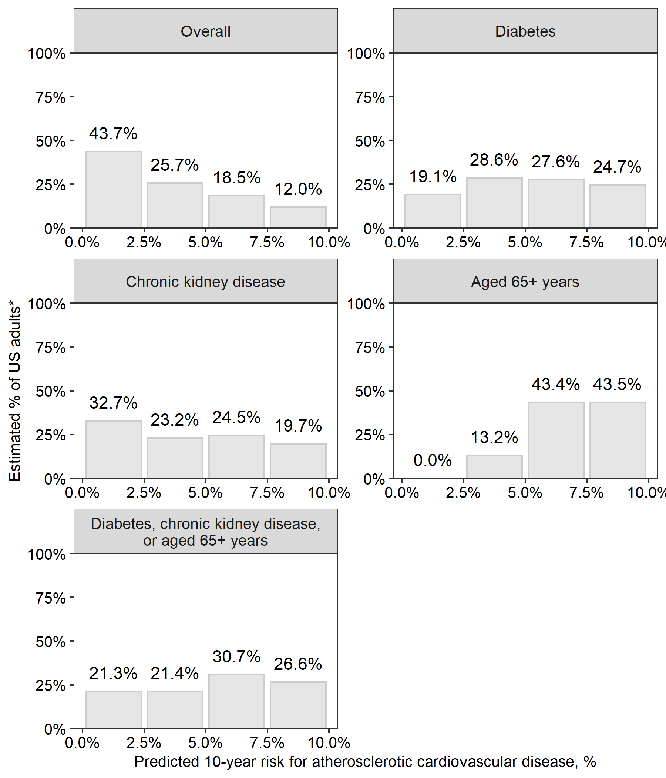

* Results do not include data from survey participants with prevalent cardiovascular disease or 10-year predicted risk for atherosclerotic cardiovascular disease ≥10%.

Figure 2: Estimated Probability of ten-year predicted risk for atherosclerotic cardiovascular disease ≥10% by age for US adults with diabetes, with chronic kidney disease, and without diabetes or chronic kidney disease.

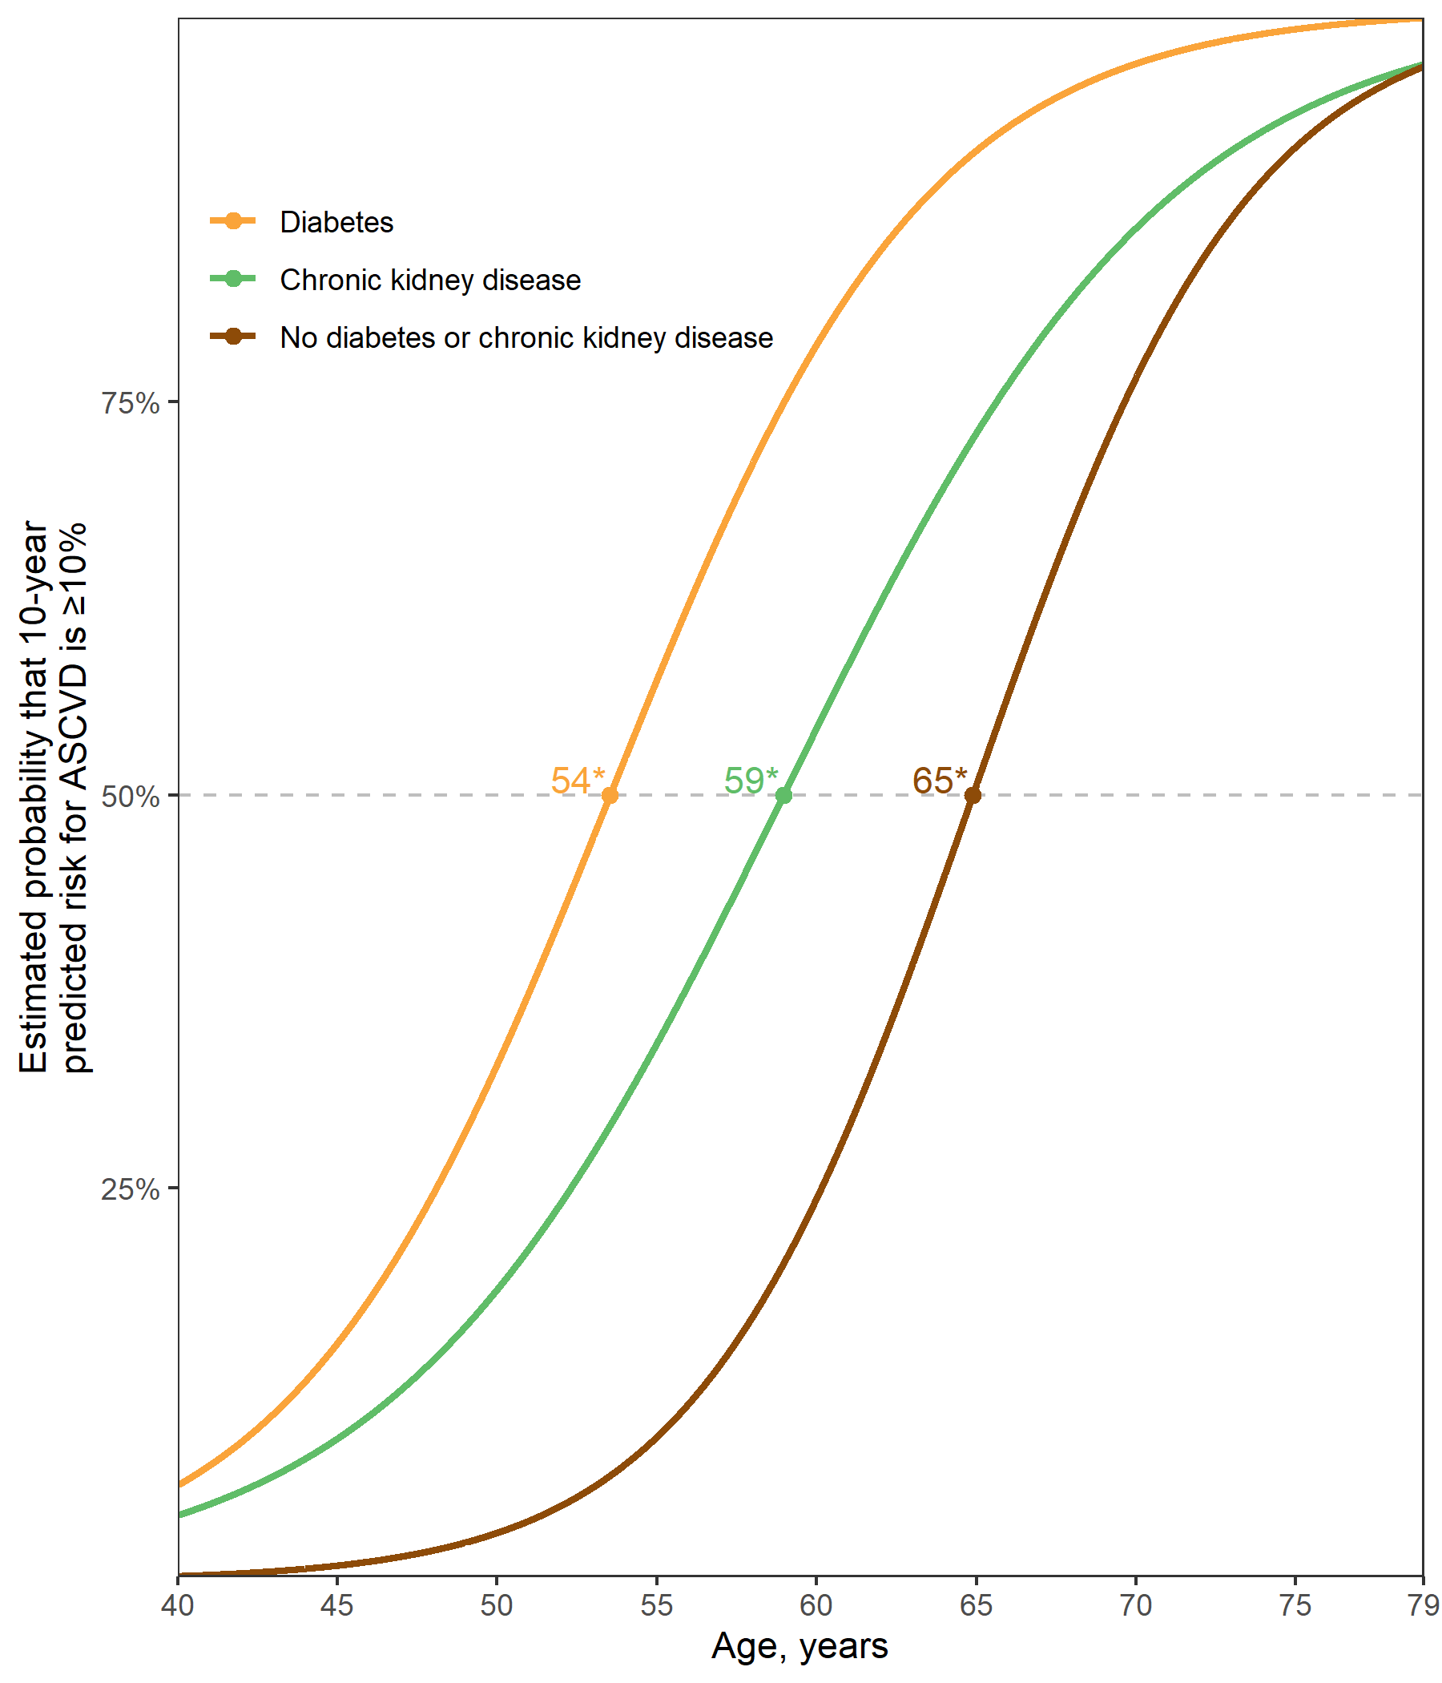

* Age at which 50% of the population is expected to have a predicted 10-year risk for atherosclerotic cardiovascular disease ≥10%.

**SUPPLEMENT**

Table S1: Characteristics of US adults with stage 1 hypertension, overall and for subgroups defined by diabetes, chronic kidney disease, and ≥65 years of age

|  | | **Sub-groups** | | | |
| --- | --- | --- | --- | --- | --- |
| **Characteristic\*** | **Overall  N = 1,271** | **Diabetes  N = 204†** | **CKD  N = 174‡** | **Age 65+ years  N = 236** | **Diabetes, CKD, or age 65+ years  N = 460** |
| Age, years | 54.0 (0.4) | 56.8 (1.2) | 57.7 (1.1) | 69.7 (0.4) | 61.5 (0.8) |
| Male | 52.3 | 58.5 | 49.3 | 51.5 | 51.9 |
| Race / ethnicity | | | | | |
| Non-Hispanic White | 66.3 | 60.0 | 61.6 | 73.8 | 65.3 |
| Non-Hispanic Black | 9.8 | 11.4 | 11.0 | 7.4 | 10.1 |
| Hispanic | 14.2 | 19.9 | 18.1 | 10.3 | 15.2 |
| Non-Hispanic Asian | 6.0 | 7.6 | 6.2 | 4.2 | 5.9 |
| Other Race/ethnicity - Including Multi-Racial | 3.7 | 1.2 | 3.0 | 4.4 | 3.4 |
| Total cholesterol, mg/dl | 205.0 (2.4) | 188.8 (4.6) | 196.5 (4.3) | 195.4 (3.5) | 195.7 (2.8) |
| HDL-cholesterol, mg/dl | 54.0 (0.7) | 47.1 (1.5) | 53.6 (2.0) | 57.9 (1.4) | 53.8 (1.0) |
| Systolic blood pressure, mm Hg | 129.6 (0.3) | 131.1 (0.7) | 131.4 (0.6) | 132.5 (0.6) | 131.4 (0.4) |
| Diastolic blood pressure, mm Hg | 78.6 (0.4) | 76.7 (1.0) | 75.8 (0.8) | 72.2 (1.0) | 75.2 (0.7) |
| Antihypertensive medication use | 0.0 | 0.0 | 0.0 | 0.0 | 0.0 |
| Diabetes | 12.3 | 100.0 | 30.1 | 21.0 | 41.7 |
| Chronic kidney disease | 10.5 | 25.6 | 100.0 | 19.8 | 35.5 |
| Aged 65+ years | 15.7 | 26.9 | 29.9 | 100.0 | 53.4 |
| Current smoker | 19.3 | 18.8 | 20.5 | 10.7 | 16.2 |
| Prevalent CVD§ | 5.8 | 15.2 | 11.1 | 13.2 | 11.2 |
| *Table values are mean (standard error) or proportion. | | | | | |
| †Diabetes was defined by fasting serum glucose ≥126 mg/dL, non-fasting glucose ≥200 mg/dL, HbA1c ≥6.5%, or self-reported use of insulin or oral glucose lowering medication. | | | | | |
| ‡Chronic kidney disease is defined by an albumin-to-creatinine ratio ≥30 mg/dl or an estimated glomerular filtration rate <60 ml/min/1.73m² | | | | | |
| §Prevalent cardiovascular disease was defined by self-report of previous heart failure, coronary heart disease, stroke, or myocardial infarction | | | | | |
| CKD = chronic kidney disease; CVD = cardiovascular disease; HDL = high density lipoprotein | | | | | |

Figure S1: Flowchart showing the number of NHANES participants included in the current analyses.

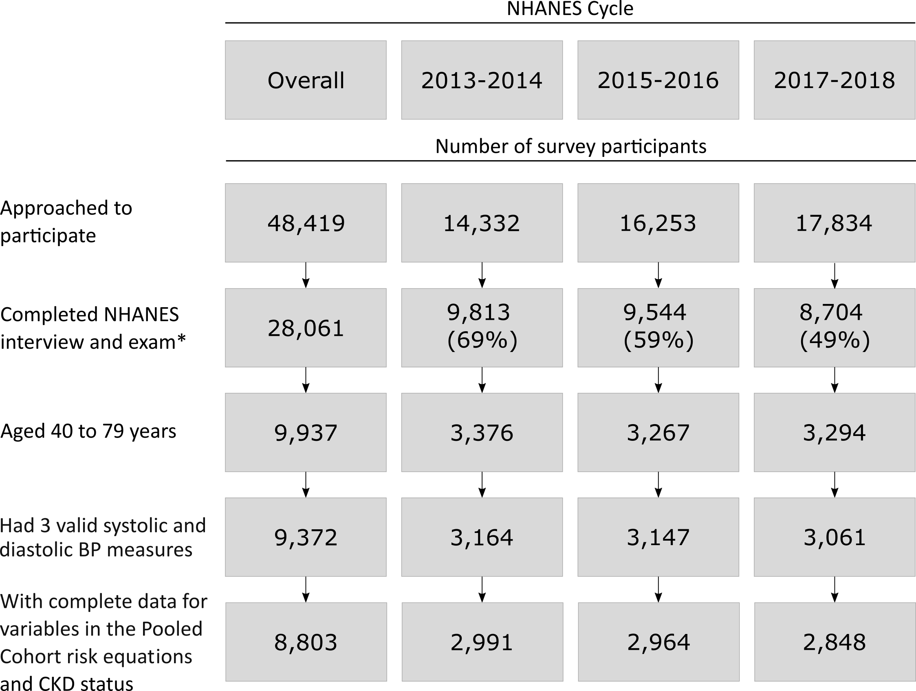

* The Completed NHANES interview and exam cells include number with the response rate in parentheses. BP = blood pressure; NHANES = National Health and Nutrition Examination Survey.

Figure S2: Estimated distribution of 10-year predicted risk for atherosclerotic cardiovascular disease among US adults with stage 1 hypertension and predicted risk <10%, overall and for subgroups defined by diabetes, chronic kidney disease, and ≥65 years of age.

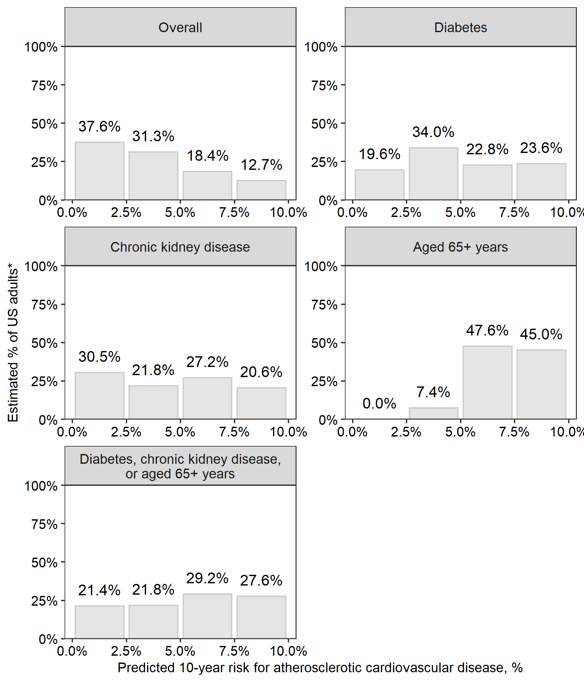

* Results do not include data from survey participants with prevalent cardiovascular disease or 10-year predicted risk for atherosclerotic cardiovascular disease ≥ 10%.

Figure S3: Estimated Probability of ten-year predicted risk for atherosclerotic cardiovascular disease ≥10% by age among US adults with stage 1 hypertension and diabetes, chronic kidney disease, and without diabetes or chronic kidney disease.

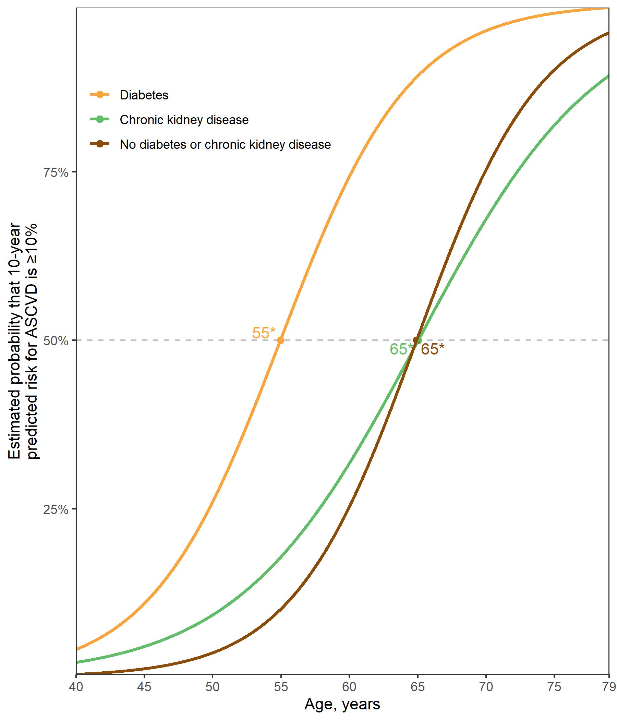

* Age at which 50% of the population is expected to have a predicted 10-year risk for atherosclerotic cardiovascular disease ≥ 10%.

# REFERENCES

1. Whelton PK, Carey RM, Aronow WS, et al. 2017 acc/aha/aapa/abc/acpm/ags/apha/ash/aspc/nma/pcna guideline for the prevention, detection, evaluation, and management of high blood pressure in adults: A report of the american college of cardiology/american heart association task force on clinical practice guidelines. Journal of the American College of Cardiology 2018;71:e127–e248.

2. Anon. NHANES - national health and nutrition examination survey homepage, available at <https://www.cdc.gov/nchs/nhanes/index.htm>.

3. Anon. NHANES tutorials - module 3 - weighting, available at <https://wwwn.cdc.gov/nchs/nhanes/tutorials/module3.aspx>.

4. Goff DC, Lloyd-Jones DM, Bennett G, et al. 2013 acc/aha guideline on the assessment of cardiovascular risk: A report of the american college of cardiology/american heart association task force on practice guidelines. Journal of the American College of Cardiology 2014;63:2935–2959.

5. Levey AS, Stevens LA, Schmid CH, et al. A new equation to estimate glomerular filtration rate. Annals of internal medicine 2009;150:604–612.

6. R Core Team. R: A language and environment for statistical computing. Vienna, Austria: R Foundation for Statistical Computing; 2020. Available at: <https://www.R-project.org/>.

7. Landau WM. The drake r package: A pipeline toolkit for reproducibility and high-performance computing. Journal of Open Source Software 2018;3. Available at: <https://doi.org/10.21105/joss.00550>.

8. Wickham H, Averick M, Bryan J, et al. Welcome to the tidyverse. Journal of Open Source Software 2019;4:1686.

9. Jaeger B. Table.glue: Make and apply customized rounding specifications for tables.; 2020. Available at: <https://github.com/bcjaeger/table.glue>.

10. Colantonio LD, Booth JN, Bress AP, et al. 2017 american college of cardiology/american heart association blood pressure treatment guideline recommendations and cardiovascular risk. Journal of the American College of Cardiology 2018;72:1187–1197.

11. Jaeger BC, Anstey DE, Bress AP, et al. Cardiovascular disease and mortality in adults aged ≥60 years according to recommendations by the american college of cardiology/american heart association and american college of physicians/american academy of family physicians. Hypertension 2019;73:327–334.

12. Coresh J, Astor B, Sarnak MJ. Evidence for increased cardiovascular disease risk in patients with chronic kidney disease. Current opinion in nephrology and hypertension 2004;13:73–81.

13. Consortium CKDP, others. Association of estimated glomerular filtration rate and albuminuria with all-cause and cardiovascular mortality in general population cohorts: A collaborative meta-analysis. The Lancet 2010;375:2073–2081.

14. Grundy SM, Benjamin IJ, Burke GL, et al. Diabetes and cardiovascular disease: A statement for healthcare professionals from the american heart association. Circulation 1999;100:1134–1146.

15. Lakatta EG. Age-associated cardiovascular changes in health: Impact on cardiovascular disease in older persons. Heart failure reviews 2002;7:29–49.

16. Pencina MJ, Navar AM, Wojdyla D, et al. Quantifying importance of major risk factors for coronary heart disease. Circulation 2019;139:1603–1611.

17. Lloyd-Jones DM, Leip EP, Larson MG, et al. Prediction of lifetime risk for cardiovascular disease by risk factor burden at 50 years of age. Circulation 2006;113:791–798.

18. Hippisley-Cox J, Coupland C, Robson J, Brindle P. Derivation, validation, and evaluation of a new qrisk model to estimate lifetime risk of cardiovascular disease: Cohort study using qresearch database. Bmj 2010;341.

19. Allen NB, Siddique J, Wilkins JT, et al. Blood pressure trajectories in early adulthood and subclinical atherosclerosis in middle age. Jama 2014;311:490–497.