**Predicted cardiovascular risk and blood pressure for Americans with diabetes, chronic kidney disease, and ≥65 years of age**

**Byron C. Jaeger, Shakia T. Hardy, Paul Muntner, Paul Whelton**

**Main idea:**

The 2017 ACC/AHA BP guideline states that the absolute CVD risk reduction with antihypertensive medication is greater for adults with higher CVD risk (see Section 8.1.1, first paragraph). The guideline also states that the vast majority of adults with diabetes, chronic kidney disease, or ≥65 years of age have a 10-year CVD risk ≥10%, placing them in the high risk category and are recommended the initiation of antihypertensive drug therapy with SBP ≥ 130 mm Hg or DBP* ≥ 80 mm Hg (see Section 9.3, 9.6, and 10.3.1 of ACC/AHA guidelines: treatment recommendations paragraph). However, data from NHANES show that a substantial proportion of US adults with stage 1 hypertension and diabetes or chronic kidney disease do not have a high 10-year predicted risk for CVD. While adults with diabetes and chronic kidney disease have higher risk on average compared to those without diabetes or chronic kidney disease, nationally representative survey data do not indicate that the vast majority of adults with these conditions have a 10-year CVD risk ≥10%. Therefore, when considering whether to initiate or intensify treatment to lower BP for an adult patient with stage 1 hypertension, physicians who aim to direct these treatments to those at higher risk for CVD should calculate CVD risk for patients with diabetes or chronic kidney disease rather than assuming it is high, particularly for adults aged 40 to 55 years.

* For adults aged ≥65 years DBP is not used.

Table 1: Characteristics of US adults overall and with diabetes, chronic kidney disease, and ≥ 65 years of age.

|  | | **Sub-groups** | | | |
| --- | --- | --- | --- | --- | --- |
| **Characteristic\*** | **Overall  N = 8,797** | **Diabetes  N = 1,998†** | **Chronic kidney disease  N = 1,566‡** | **Age 65+ years  N = 2,501** | **Any preceding condition  N = 4,183** |
| Age, years | 56.7 (0.2) | 60.3 (0.4) | 61.8 (0.4) | 70.6 (0.1) | 64.2 (0.3) |
| Male | 48.2 | 55.8 | 44.8 | 46.7 | 48.0 |
| Race / ethnicity | | | | | |
| Non-Hispanic White | 68.6 | 60.0 | 63.4 | 76.7 | 68.8 |
| Non-Hispanic Black | 10.1 | 13.6 | 15.0 | 7.8 | 10.9 |
| Hispanic | 12.6 | 15.9 | 13.1 | 8.3 | 11.7 |
| Non-Hispanic Asian | 5.2 | 7.0 | 4.9 | 4.5 | 5.2 |
| Other Race/ethnicity - Including Multi-Racial | 3.5 | 3.5 | 3.7 | 2.7 | 3.3 |
| Total cholesterol, mg/dl | 197.0 (0.9) | 183.2 (1.8) | 194.6 (1.8) | 188.9 (1.3) | 191.1 (1.2) |
| HDL-cholesterol, mg/dl | 54.9 (0.4) | 46.6 (0.5) | 53.0 (0.9) | 56.6 (0.7) | 53.7 (0.5) |
| Systolic blood pressure, mm Hg | 126.0 (0.3) | 130.5 (0.6) | 134.2 (0.7) | 131.8 (0.6) | 131.0 (0.5) |
| Diastolic blood pressure, mm Hg | 72.8 (0.3) | 71.6 (0.4) | 72.4 (0.4) | 68.3 (0.4) | 70.9 (0.3) |
| Antihypertensive medication use | 33.5 | 60.0 | 55.9 | 53.2 | 52.1 |
| Diabetes | 17.2 | 100.0 | 38.3 | 24.7 | 41.9 |
| Chronic kidney disease | 14.1 | 31.3 | 100.0 | 25.3 | 34.3 |
| Aged 65+ years | 25.4 | 36.4 | 45.6 | 100.0 | 61.9 |
| Current smoker | 17.3 | 14.6 | 19.1 | 10.0 | 14.4 |
| Prevalent CVD§ | 10.5 | 22.6 | 23.3 | 21.4 | 19.3 |
| *Table values are mean (standard error) or proportion. | | | | | |
| †Diabetes was defined by fasting serum glucose ≥ 126 mg/dL, non-fasting glucose ≥ 200 mg/dL, HbA1c ≥ 6.5%, or self-reported use of insulin or oral glucose lowering medication. | | | | | |
| ‡Chronic kidney disease is defined by an albumin-to-creatinine ratio ≥ 30 mg/dl or an estimated glomerular filtration rate <60 ml/min/1.73m² | | | | | |
| §Prevalent cardiovascular disease was defined by self-report of previous heart failure, coronary heart disease, stroke, or myocardial infarction | | | | | |
| CVD = cardiovascular disease; HDL = High density lipoprotein | | | | | |

Table 2: Estimated distribution of blood pressure categories among US adults, overall and for subgroups with diabetes, chronic kidney disease, and ≥ 65 years of age.

|  | | **Sub-groups** | | | |
| --- | --- | --- | --- | --- | --- |
| **Blood pressure category\*** | **Overall  N = 8,797** | **Diabetes  N = 1,998†** | **Chronic kidney disease  N = 1,566‡** | **Age 65+ years  N = 2,501** | **Any preceding condition  N = 4,183** |
| Normal blood pressure | 28.8 | 12.1 | 13.5 | 15.0 | 15.5 |
| Elevated blood pressure | 12.0 | 7.9 | 6.7 | 11.2 | 10.4 |
| Stage 1 hypertension | 14.6 | 10.5 | 9.5 | 9.1 | 10.4 |
| Stage 2 hypertension | 11.1 | 9.5 | 14.5 | 11.6 | 11.7 |
| Taking antihypertensive medication | 33.5 | 60.0 | 55.9 | 53.2 | 52.1 |
| *Normal blood pressure: systolic/diastolic blood pressure < 120/80 mm Hg; Elevated blood pressure: systolic/diastolic blood pressure 120-129/<80 mm Hg; Stage 1 hypertension: systolic/diastolic blood pressure 130-139/80-89 mm Hg; Stage 2 hypertension: systolic/diastolic blood pressure ≥ 140/90 mm Hg. | | | | | |
| †Diabetes was defined by fasting serum glucose ≥ 126 mg/dL, non-fasting glucose ≥ 200 mg/dL, HbA1c ≥ 6.5%, or self-reported use of insulin or oral glucose lowering medication. | | | | | |
| ‡Chronic kidney disease is defined by an albumin-to-creatinine ratio ≥ 30 mg/dl or an estimated glomerular filtration rate <60 ml/min/1.73m² | | | | | |

Table 3: Median predicted risk for cardiovascular disease and proportion of US adults with predicted risk ≥ 10% overall and among those with diabetes, chronic kidney disease, and ≥ 65 years of age, stratified by categorization of blood pressure according to the 2017 American College of Cardiology / American Heart Association blood pressure guidelines.

|  | | **Sub-groups** | | | |
| --- | --- | --- | --- | --- | --- |
| **Blood pressure category\*** | **Overall  N = 8,797** | **Diabetes  N = 1,998†** | **Chronic kidney disease  N = 1,566‡** | **Age 65+ years  N = 2,501** | **Any preceding condition  N = 4,183** |
| *Median (25th - 75th percentile) predicted risk§‖* | | | | | |
| Overall | 5.1 (1.9, 11.4) | 14.4 (7.0, 27.3) | 12.1 (4.8, 22.8) | 17.9 (11.2, 27.3) | 13.6 (7.0, 22.3) |
| Normal blood pressure | 2.0 (0.8, 4.8) | 6.8 (2.9, 15.8) | 3.0 (1.0, 8.1) | 10.6 (6.7, 16.0) | 7.0 (3.3, 12.9) |
| Elevated blood pressure | 4.3 (1.9, 9.3) | 11.4 (4.2, 17.3) | 6.2 (1.5, 13.8) | 14.6 (7.5, 19.9) | 11.8 (5.8, 17.4) |
| Stage 1 hypertension | 4.2 (1.9, 8.5) | 8.9 (4.5, 19.3) | 6.8 (2.6, 12.3) | 13.8 (8.6, 22.3) | 9.8 (5.3, 16.6) |
| Stage 2 hypertension | 8.1 (4.2, 16.0) | 18.8 (10.1, 30.2) | 13.9 (5.7, 21.3) | 20.4 (16.0, 29.6) | 17.3 (9.2, 25.4) |
| Taking antihypertensive medication | 10.5 (5.2, 19.8) | 17.2 (9.8, 31.6) | 17.0 (9.0, 29.0) | 21.2 (14.0, 31.6) | 17.2 (10.1, 27.3) |
| *Proportion (95% confidence interval) with predicted risk ≥ 10% or prevalent cardiovascular disease¶* | | | | | |
| Overall | 36.6 (34.7, 38.6) | 72.5 (69.3, 75.6) | 65.4 (61.7, 69.0) | 83.8 (81.6, 86.0) | 70.3 (68.0, 72.7) |
| Normal blood pressure | 13.7 (11.4, 16.0) | 46.8 (39.0, 54.6) | 32.3 (21.6, 43.0) | 64.4 (57.7, 71.2) | 46.3 (40.5, 52.1) |
| Elevated blood pressure | 27.4 (23.3, 31.5) | 57.7 (49.6, 65.8) | 47.9 (36.9, 59.0) | 69.8 (59.6, 79.9) | 57.9 (50.5, 65.3) |
| Stage 1 hypertension | 24.3 (20.7, 27.9) | 55.0 (43.7, 66.4) | 38.5 (27.4, 49.6) | 72.6 (63.2, 81.9) | 55.2 (47.0, 63.3) |
| Stage 2 hypertension | 45.7 (40.4, 51.0) | 79.0 (69.3, 88.7) | 65.6 (54.7, 76.4) | 90.2 (83.8, 96.6) | 75.6 (69.5, 81.7) |
| Taking antihypertensive medication | 61.9 (59.4, 64.5) | 81.6 (78.0, 85.2) | 79.9 (75.9, 84.0) | 92.8 (91.0, 94.5) | 81.8 (79.4, 84.2) |
| *Normal blood pressure: systolic/diastolic blood pressure < 120/80 mm Hg; Elevated blood pressure: systolic/diastolic blood pressure 120-129/<80 mm Hg; Stage 1 hypertension: systolic/diastolic blood pressure 130-139/80-89 mm Hg; Stage 2 hypertension: systolic/diastolic blood pressure ≥ 140/90 mm Hg. | | | | | |
| †Diabetes was defined by fasting serum glucose ≥ 126 mg/dL, non-fasting glucose ≥ 200 mg/dL, HbA1c ≥ 6.5%, or self-reported use of insulin or oral glucose lowering medication. | | | | | |
| ‡Chronic kidney disease is defined by an albumin-to-creatinine ratio ≥ 30 mg/dl or an estimated glomerular filtration rate <60 ml/min/1.73m² | | | | | |
| §Prevalent cardiovascular disease was defined by self-report of previous heart failure, coronary heart disease, stroke, or myocardial infarction | | | | | |
| ‖Predicted risk for cardiovascular disease was computed using the Pooled Cohort Risk equations, based on the guideline by American College of Cardiology / American Heart Association, 2013 | | | | | |
| ¶Data from survey participants with prevalent cardiovascular disease were not included for these statistics | | | | | |

Figure 1: Estimated distribution of 10-year predicted cardiovascular risk among US adults with predicted risk < 10% overall and for those with diabetes, chronic kidney disease, ≥ 65 years of age, or any of the preceding conditions.



Results do not include data from survey participants with prevalent cardiovascular disease or 10-year predicted risk for atherosclerotic cardiovascular disease ≥ 10%.

Figure 2: Estimated Probability of ten-year predicted risk for cardiovascular disease ≥ 10% as a function of age for US adults with diabetes, with chronic kidney disease, and without diabetes or chronic kidney disease.



* these values indicate the expected age where probability of having ≥10% predicted risk for atherosclerotic cardiovascular disease is ≥ 50%

**SUPPLEMENT**

Table S1: Characteristics of US adults with stage 1 hypertension, overall and with diabetes, chronic kidney disease, ≥ 65 years of age, or any of the three preceding conditions

|  | | **Sub-groups** | | | |
| --- | --- | --- | --- | --- | --- |
| **Characteristic\*** | **Overall  N = 1,271** | **Diabetes  N = 204†** | **Chronic kidney disease  N = 155‡** | **Age 65+ years  N = 236** | **Any preceding condition  N = 453** |
| Age, years | 54.0 (0.4) | 56.8 (1.2) | 57.0 (1.2) | 69.7 (0.4) | 61.5 (0.8) |
| Male | 52.3 | 58.5 | 48.8 | 51.5 | 51.9 |
| Race / ethnicity | | | | | |
| Non-Hispanic White | 66.3 | 60.0 | 59.1 | 73.8 | 65.5 |
| Non-Hispanic Black | 9.8 | 11.4 | 12.7 | 7.4 | 10.3 |
| Hispanic | 14.2 | 19.9 | 19.2 | 10.3 | 15.1 |
| Non-Hispanic Asian | 6.0 | 7.6 | 7.0 | 4.2 | 6.0 |
| Other Race/ethnicity - Including Multi-Racial | 3.7 | 1.2 | 1.9 | 4.4 | 3.1 |
| Total cholesterol, mg/dl | 205.0 (2.4) | 188.8 (4.6) | 198.4 (5.0) | 195.4 (3.5) | 195.8 (2.9) |
| HDL-cholesterol, mg/dl | 54.0 (0.7) | 47.1 (1.5) | 53.2 (2.3) | 57.9 (1.4) | 53.8 (1.0) |
| Systolic blood pressure, mm Hg | 129.6 (0.3) | 131.1 (0.7) | 131.2 (0.7) | 132.5 (0.6) | 131.3 (0.4) |
| Diastolic blood pressure, mm Hg | 78.6 (0.4) | 76.7 (1.0) | 76.5 (0.8) | 72.2 (1.0) | 75.3 (0.6) |
| Antihypertensive medication use | 0.0 | 0.0 | 0.0 | 0.0 | 0.0 |
| Diabetes | 12.3 | 100.0 | 30.7 | 21.0 | 42.4 |
| Chronic kidney disease | 9.1 | 22.6 | 100.0 | 16.1 | 31.3 |
| Aged 65+ years | 15.7 | 26.9 | 27.8 | 100.0 | 54.2 |
| Current smoker | 19.3 | 18.8 | 23.3 | 10.7 | 16.4 |
| Prevalent CVD§ | 5.8 | 15.2 | 12.8 | 13.2 | 11.4 |
| *Table values are mean (standard error) or proportion. | | | | | |
| †Diabetes was defined by fasting serum glucose ≥ 126 mg/dL, non-fasting glucose ≥ 200 mg/dL, HbA1c ≥ 6.5%, or self-reported use of insulin or oral glucose lowering medication. | | | | | |
| ‡Chronic kidney disease is defined by an albumin-to-creatinine ratio ≥ 30 mg/dl or an estimated glomerular filtration rate <60 ml/min/1.73m² | | | | | |
| §Prevalent cardiovascular disease was defined by self-report of previous heart failure, coronary heart disease, stroke, or myocardial infarction | | | | | |
| CVD = cardiovascular disease; HDL = High density lipoprotein | | | | | |

Figure S1: Flowchart showing the number of NHANES participants included in the current analyses.

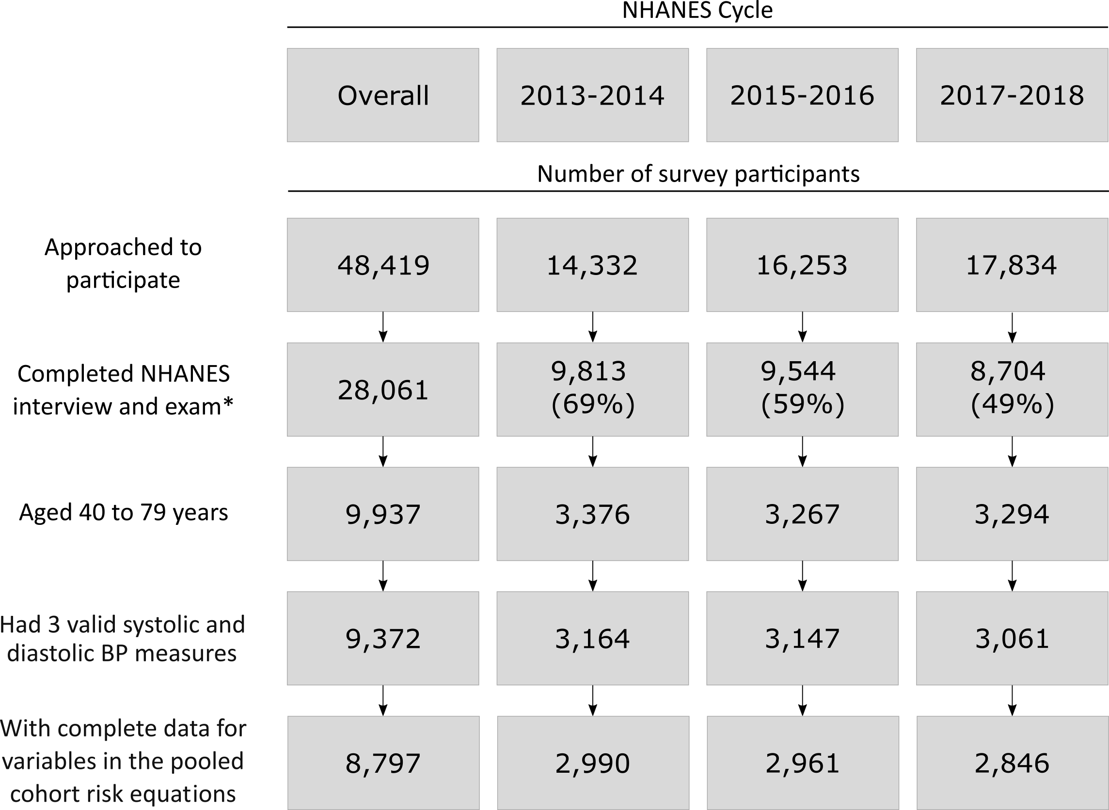

BP: blood pressure; NHANES: National Health and Nutrition Examination Survey.

* The Completed NHANES interview and exam cells include number with the response rate in parentheses.

Figure S2: Estimated distribution of 10-year predicted cardiovascular risk among US adults with stage 1 hypertension and predicted risk < 10% overall and for those with diabetes, chronic kidney disease, ≥ 65 years of age, or any of the preceding conditions.



Results do not include data from survey participants with prevalent cardiovascular disease or 10-year predicted risk for atherosclerotic cardiovascular disease ≥ 10%.

Figure S3: Estimated Probability of ten-year predicted risk for cardiovascular disease ≥ 10% as a function of age among US adults with stage 1 hypertension and diabetes, chronic kidney disease, and with without diabetes or chronic kidney disease.



* these values indicate the expected age where probability of having ≥10% predicted risk for atherosclerotic cardiovascular disease is ≥ 50%