**Predicted cardiovascular risk and blood pressure for Americans with diabetes, chronic kidney disease, and ≥65 years of age**

**Byron C. Jaeger, Shakia T. Hardy, Paul Muntner, Paul Whelton**

**Main idea:**

Secondary analyses of randomized controlled trials have found that the absolute CVD risk reduction with antihypertensive medication is greater for adults with higher CVD risk (see Section 8.1.1, first paragraph). Based on these data, the 2017 ACC/AHA BP guideline recommends using CVD risk and BP levels to guide the decision to initiate antihypertensive medication. The guideline states that the vast majority of adults with diabetes, chronic kidney disease, or ≥65 years of age have a 10-year CVD risk ≥10%, placing them in the high risk category and are recommended the initiation of antihypertensive drug therapy with SBP ≥ 130 mm Hg or DBP ≥ 80 mm Hg* (see Section 9.3, 9.6, and 10.3.1 of ACC/AHA guidelines: treatment recommendations paragraph). However, data from NHANES show that a substantial proportion of US adults with stage 1 hypertension and diabetes or chronic kidney disease do not have a 10-year predicted CVD risk ≥10%. Therefore, when considering whether to initiate or intensify treatment to lower BP for an adult patient with stage 1 hypertension, physicians who aim to direct these treatments to those at higher risk for CVD should calculate CVD risk for patients with diabetes or chronic kidney disease rather than assuming it is high, particularly for adults aged 40 to 55 years. For adults with diabetes or chronic kidney disease whose 10-year predicted CVD risk is < 10%, treatment to lower BP may still provide substantial reduction in lifetime risk for CVD and prevention of complications associated with diabetes or chronic kidney disease.

* For adults aged ≥65 years DBP is not used.

**METHODS**

NHANES was designed to assess the health and nutritional status of the US population and is conducted by the National Center for Health Statistics of the Centers for Disease Control and Prevention (1). Since 1999-2000, NHANES has been conducted in two-year cycles using a multistage probability sampling design to provide nationally representative estimates. Each cycle is independent with different survey participants recruited. For the current analysis, three cycles conducted from 2013-2014 through 2017-2018 were pooled and sample weights were divided by three (2). The protocols for each NHANES cycle were approved by the National Center for Health Statistics of the Centers for Disease Control and Prevention Institutional Review Board. Written informed consent was obtained from each participant. The University of Alabama at Birmingham Institutional Review Board considered the analysis of NHANES data to be exempt research.

The current analysis was restricted to adults aged 40 to 79 years of age who complete the NHANES interview and examination (n = 9,937). Participants who did not have three SBP and DBP measurements (n = 565) and those who were missing information on age, race, sex, cholesterol (total and high-density lipoprotein), smoking status, or diabetes (n = 575) were excluded. After these exclusions, over the three NHANES cycles, a total of 8,797 survey participants were included in the analysis (Online Figure 1).

***Data collection***

Data were provided by survey participants during an in-home interview and a study visit completed at a mobile examination center. Survey participants’ age, sex, race/ethnicity, medication use, smoking habits, and medical history were assessed by standardized questionnaires. Medication use included questions about whether the participant was currently using medications for BP, insulin, or glucose. Medical history included questions about whether the participant had been told by a doctor that they had congestive heart failure, stroke, heart attack, or coronary heart disease. Urinary albumin and creatinine were drawn during the mobile exam in addition to serum glucose and glycated hemoglobin (HbA1c). Estimated glomerular filtration rate was calculated using the Chronic Kidney Disease Epidemiology Collaboration equation.(3)

***Blood pressure measurement***

Each NHANES cycle applied the same protocol to measure SBP and DBP. After survey participants completed 5 minutes of seated rest, their BP was measured by a trained clinician using a mercury sphygmomanometer and an appropriately sized cuff. Three BP measurements were obtained at 30 second intervals. The mean of all available measurements was used to define SBP and DBP. Quality control included re-certification of clinicians every quarter with retraining if needed. All clinicians participated in annual retraining.

***Definitions of hypertension, diabetes and chronic kidney disease***

Participants were grouped into five non-overlapping categories based on the 2017 ACC/AHA BP guideline: Normal BP (SBP/DBP < 120/80 mm Hg), elevated BP (SBP/DBP 120-129/<80 mm Hg), stage 1 hypertension (SBP/DBP 130-139/80-89 mm Hg), stage 2 hypertension (SBP/DBP ≥ 140/90 mm Hg), and using antihypertensive medications. Diabetes was defined by fasting serum glucose ≥ 126 mg/dL, non-fasting glucose ≥ 200 mg/dL, HbA1c ≥ 6.5%, or self-reported use of insulin or oral glucose lowering medication. CKD was defined by an albumin-to-creatinine ratio ≥ 30 mg/dL or an estimated glomerular filtration rate < 60 ml/min/1.73m².

***Statistical analysis***

Analyses were replicated overall and among participants with diabetes, CKD, ≥65 years of age, and any of the preceding conditions, separately. Analyses were also replicated among participants with stage 1 hypertension. Participant characteristics were summarized using mean (standard error) and percentage for continuous and categorical variables, respectively. The percentage of adults in each of the five BP categories was computed. Next, for each of the five BP categories, the median 10-year predicted risk for CVD and proportion of adults with predicted risk ≥ 10% was computed. Among participants with no history of CVD and predicted risk < 10%, the percentage with predicted risk of 0% to < 2.5%, 2.5% to < 5.0%, 5.0% to < 7.5%, and 7.5% to <10% was computed. Last, the age-adjusted probability of having a 10-year predicted risk for CVD ≥ 10% was estimated using logistic regression.

NHANES sampling weights, which are calculated as the inverse probability of being selected for the survey, were used in all calculations to obtain US nationally representative estimates. Data analysis was conducted using R version 4.0.1 or higher (Vienna, Austria). P-values were two-sided.

**RESULTS**

**DISCUSSION**

**REFERENCES**

1. Anon. NHANES - National Health and Nutrition Examination Survey Homepage. 2020. Available at: https://www.cdc.gov/nchs/nhanes/index.htm. Accessed August 19, 2020.

2. Anon. NHANES Tutorials - Module 3 - Weighting. Available at: https://wwwn.cdc.gov/nchs/nhanes/tutorials/module3.aspx. Accessed August 19, 2020.

3. Levey AS, Stevens LA, Schmid CH, et al. A new equation to estimate glomerular filtration rate. Annals of internal medicine 2009;150:604–612.

Table 1: Characteristics of US adults overall and with diabetes, chronic kidney disease, and ≥ 65 years of age.

|  | | **Sub-groups** | | | |
| --- | --- | --- | --- | --- | --- |
| **Characteristic\*** | **Overall  N = 8,797** | **Diabetes  N = 1,998†** | **CKD  N = 1,566‡** | **Age 65+ years  N = 2,501** | **Diabetes, CKD, or age 65+ years  N = 4,183** |
| Age, years | 56.7 (0.2) | 60.3 (0.4) | 61.8 (0.4) | 70.6 (0.1) | 64.2 (0.3) |
| Male | 48.2 | 55.8 | 44.8 | 46.7 | 48.0 |
| Race / ethnicity | | | | | |
| Non-Hispanic White | 68.6 | 60.0 | 63.4 | 76.7 | 68.8 |
| Non-Hispanic Black | 10.1 | 13.6 | 15.0 | 7.8 | 10.9 |
| Hispanic | 12.6 | 15.9 | 13.1 | 8.3 | 11.7 |
| Non-Hispanic Asian | 5.2 | 7.0 | 4.9 | 4.5 | 5.2 |
| Other Race/ethnicity - Including Multi-Racial | 3.5 | 3.5 | 3.7 | 2.7 | 3.3 |
| Total cholesterol, mg/dl | 197.0 (0.9) | 183.2 (1.8) | 194.6 (1.8) | 188.9 (1.3) | 191.1 (1.2) |
| HDL-cholesterol, mg/dl | 54.9 (0.4) | 46.6 (0.5) | 53.0 (0.9) | 56.6 (0.7) | 53.7 (0.5) |
| Systolic blood pressure, mm Hg | 126.0 (0.3) | 130.5 (0.6) | 134.2 (0.7) | 131.8 (0.6) | 131.0 (0.5) |
| Diastolic blood pressure, mm Hg | 72.8 (0.3) | 71.6 (0.4) | 72.4 (0.4) | 68.3 (0.4) | 70.9 (0.3) |
| Antihypertensive medication use | 33.5 | 60.0 | 55.9 | 53.2 | 52.1 |
| Diabetes | 17.2 | 100.0 | 38.3 | 24.7 | 41.9 |
| Chronic kidney disease | 14.1 | 31.3 | 100.0 | 25.3 | 34.3 |
| Aged 65+ years | 25.4 | 36.4 | 45.6 | 100.0 | 61.9 |
| Current smoker | 17.3 | 14.6 | 19.1 | 10.0 | 14.4 |
| Prevalent CVD§ | 10.5 | 22.6 | 23.3 | 21.4 | 19.3 |
| *Table values are mean (standard error) or proportion. | | | | | |
| †Diabetes was defined by fasting serum glucose ≥ 126 mg/dL, non-fasting glucose ≥ 200 mg/dL, HbA1c ≥ 6.5%, or self-reported use of insulin or oral glucose lowering medication. | | | | | |
| ‡Chronic kidney disease is defined by an albumin-to-creatinine ratio ≥ 30 mg/dl or an estimated glomerular filtration rate <60 ml/min/1.73m² | | | | | |
| §Prevalent cardiovascular disease was defined by self-report of previous heart failure, coronary heart disease, stroke, or myocardial infarction | | | | | |
| CKD = chronic kidney disease; CVD = cardiovascular disease; HDL = High density lipoprotein | | | | | |

Table 2: Estimated distribution of blood pressure categories among US adults, overall and for subgroups with diabetes, chronic kidney disease, and ≥ 65 years of age.

|  | | **Sub-groups** | | | |
| --- | --- | --- | --- | --- | --- |
| **Blood pressure category\*** | **Overall  N = 8,797** | **Diabetes  N = 1,998†** | **CKD  N = 1,566‡** | **Age 65+ years  N = 2,501** | **Diabetes, CKD, or age 65+ years  N = 4,183** |
| Normal blood pressure | 28.8 | 12.1 | 13.5 | 15.0 | 15.5 |
| Elevated blood pressure | 12.0 | 7.9 | 6.7 | 11.2 | 10.4 |
| Stage 1 hypertension | 14.6 | 10.5 | 9.5 | 9.1 | 10.4 |
| Stage 2 hypertension | 11.1 | 9.5 | 14.5 | 11.6 | 11.7 |
| Taking antihypertensive medication | 33.5 | 60.0 | 55.9 | 53.2 | 52.1 |
| *Normal blood pressure: systolic/diastolic blood pressure < 120/80 mm Hg; Elevated blood pressure: systolic/diastolic blood pressure 120-129/<80 mm Hg; Stage 1 hypertension: systolic/diastolic blood pressure 130-139/80-89 mm Hg; Stage 2 hypertension: systolic/diastolic blood pressure ≥ 140/90 mm Hg. | | | | | |
| †Diabetes was defined by fasting serum glucose ≥ 126 mg/dL, non-fasting glucose ≥ 200 mg/dL, HbA1c ≥ 6.5%, or self-reported use of insulin or oral glucose lowering medication. | | | | | |
| ‡Chronic kidney disease is defined by an albumin-to-creatinine ratio ≥ 30 mg/dl or an estimated glomerular filtration rate <60 ml/min/1.73m² | | | | | |
| CKD = chronic kidney disease | | | | | |

Table 3: Median predicted risk for cardiovascular disease and proportion of US adults with predicted risk ≥ 10% overall and among those with diabetes, chronic kidney disease, and ≥ 65 years of age, stratified by categorization of blood pressure according to the 2017 American College of Cardiology / American Heart Association blood pressure guidelines.

|  | | **Sub-groups** | | | |
| --- | --- | --- | --- | --- | --- |
| **Blood pressure category\*** | **Overall  N = 8,797** | **Diabetes  N = 1,998†** | **CKD  N = 1,566‡** | **Age 65+ years  N = 2,501** | **Diabetes, CKD, or age 65+ years  N = 4,183** |
| *Median (25th - 75th percentile) predicted risk¶* | | | | | |
| Overall | 5.1 (1.9, 11.4) | 14.4 (7.0, 27.3) | 12.1 (4.8, 22.8) | 17.9 (11.2, 27.3) | 13.6 (7.0, 22.3) |
| Normal blood pressure | 2.0 (0.8, 4.8) | 6.8 (2.9, 15.8) | 3.0 (1.0, 8.1) | 10.6 (6.7, 16.0) | 7.0 (3.3, 12.9) |
| Elevated blood pressure | 4.3 (1.9, 9.3) | 11.4 (4.2, 17.3) | 6.2 (1.5, 13.8) | 14.6 (7.5, 19.9) | 11.8 (5.8, 17.4) |
| Stage 1 hypertension | 4.2 (1.9, 8.5) | 8.9 (4.5, 19.3) | 6.8 (2.6, 12.3) | 13.8 (8.6, 22.3) | 9.8 (5.3, 16.6) |
| Stage 2 hypertension | 8.1 (4.2, 16.0) | 18.8 (10.1, 30.2) | 13.9 (5.7, 21.3) | 20.4 (16.0, 29.6) | 17.3 (9.2, 25.4) |
| Taking antihypertensive medication | 10.5 (5.2, 19.8) | 17.2 (9.8, 31.6) | 17.0 (9.0, 29.0) | 21.2 (14.0, 31.6) | 17.2 (10.1, 27.3) |
| *Proportion (95% confidence interval) with predicted risk ≥ 10% or prevalent cardiovascular disease§‖* | | | | | |
| Overall | 36.6 (34.7, 38.6) | 72.5 (69.3, 75.6) | 65.4 (61.7, 69.0) | 83.8 (81.6, 86.0) | 70.3 (68.0, 72.7) |
| Normal blood pressure | 13.7 (11.4, 16.0) | 46.8 (39.0, 54.6) | 32.3 (21.6, 43.0) | 64.4 (57.7, 71.2) | 46.3 (40.5, 52.1) |
| Elevated blood pressure | 27.4 (23.3, 31.5) | 57.7 (49.6, 65.8) | 47.9 (36.9, 59.0) | 69.8 (59.6, 79.9) | 57.9 (50.5, 65.3) |
| Stage 1 hypertension | 24.3 (20.7, 27.9) | 55.0 (43.7, 66.4) | 38.5 (27.4, 49.6) | 72.6 (63.2, 81.9) | 55.2 (47.0, 63.3) |
| Stage 2 hypertension | 45.7 (40.4, 51.0) | 79.0 (69.3, 88.7) | 65.6 (54.7, 76.4) | 90.2 (83.8, 96.6) | 75.6 (69.5, 81.7) |
| Taking antihypertensive medication | 61.9 (59.4, 64.5) | 81.6 (78.0, 85.2) | 79.9 (75.9, 84.0) | 92.8 (91.0, 94.5) | 81.8 (79.4, 84.2) |
| *Normal blood pressure: systolic/diastolic blood pressure < 120/80 mm Hg; Elevated blood pressure: systolic/diastolic blood pressure 120-129/<80 mm Hg; Stage 1 hypertension: systolic/diastolic blood pressure 130-139/80-89 mm Hg; Stage 2 hypertension: systolic/diastolic blood pressure ≥ 140/90 mm Hg. | | | | | |
| †Diabetes was defined by fasting serum glucose ≥ 126 mg/dL, non-fasting glucose ≥ 200 mg/dL, HbA1c ≥ 6.5%, or self-reported use of insulin or oral glucose lowering medication. | | | | | |
| ‡Chronic kidney disease is defined by an albumin-to-creatinine ratio ≥ 30 mg/dl or an estimated glomerular filtration rate <60 ml/min/1.73m² | | | | | |
| §Prevalent cardiovascular disease was defined by self-report of previous heart failure, coronary heart disease, stroke, or myocardial infarction | | | | | |
| ‖Predicted risk for cardiovascular disease was computed using the Pooled Cohort Risk equations, based on the guideline by American College of Cardiology / American Heart Association, 2013 | | | | | |
| ¶Data from survey participants with prevalent cardiovascular disease were not included for these statistics | | | | | |
| CKD = chronic kidney disease | | | | | |

Figure 1: Estimated distribution of 10-year predicted cardiovascular risk among US adults with predicted risk < 10% overall and for those with diabetes, chronic kidney disease, ≥ 65 years of age, or any of the preceding conditions.



Results do not include data from survey participants with prevalent cardiovascular disease or 10-year predicted risk for cardiovascular disease ≥ 10%.

Figure 2: Estimated Probability of ten-year predicted risk for cardiovascular disease ≥ 10% by age for US adults with diabetes, with chronic kidney disease, and without diabetes or chronic kidney disease.



* Age at which 50% of the population is expected to have a predicted 10-year risk for cardiovascular disease ≥ 10%.

**SUPPLEMENT**

Table S1: Characteristics of US adults with stage 1 hypertension, overall and with diabetes, chronic kidney disease, ≥ 65 years of age, or any of the three preceding conditions

|  | | **Sub-groups** | | | |
| --- | --- | --- | --- | --- | --- |
| **Characteristic\*** | **Overall  N = 1,271** | **Diabetes  N = 204†** | **CKD‡** | **Age 65+ years  N = 236** | **Diabetes, CKD, or age 65+ years** |
| Age, years | 54.0 (0.4) | 56.8 (1.2) | 57.0 (1.2) | 69.7 (0.4) | 61.5 (0.8) |
| Male | 52.3 | 58.5 | 48.8 | 51.5 | 51.9 |
| Race / ethnicity | | | | | |
| Non-Hispanic White | 66.3 | 60.0 | 59.1 | 73.8 | 65.5 |
| Non-Hispanic Black | 9.8 | 11.4 | 12.7 | 7.4 | 10.3 |
| Hispanic | 14.2 | 19.9 | 19.2 | 10.3 | 15.1 |
| Non-Hispanic Asian | 6.0 | 7.6 | 7.0 | 4.2 | 6.0 |
| Other Race/ethnicity - Including Multi-Racial | 3.7 | 1.2 | 1.9 | 4.4 | 3.1 |
| Total cholesterol, mg/dl | 205.0 (2.4) | 188.8 (4.6) | 198.4 (5.0) | 195.4 (3.5) | 195.8 (2.9) |
| HDL-cholesterol, mg/dl | 54.0 (0.7) | 47.1 (1.5) | 53.2 (2.3) | 57.9 (1.4) | 53.8 (1.0) |
| Systolic blood pressure, mm Hg | 129.6 (0.3) | 131.1 (0.7) | 131.2 (0.7) | 132.5 (0.6) | 131.3 (0.4) |
| Diastolic blood pressure, mm Hg | 78.6 (0.4) | 76.7 (1.0) | 76.5 (0.8) | 72.2 (1.0) | 75.3 (0.6) |
| Antihypertensive medication use | 0.0 | 0.0 | 0.0 | 0.0 | 0.0 |
| Diabetes | 12.3 | 100.0 | 30.7 | 21.0 | 42.4 |
| Chronic kidney disease | 9.1 | 22.6 | 100.0 | 16.1 | 31.3 |
| Aged 65+ years | 15.7 | 26.9 | 27.8 | 100.0 | 54.2 |
| Current smoker | 19.3 | 18.8 | 23.3 | 10.7 | 16.4 |
| Prevalent CVD§ | 5.8 | 15.2 | 12.8 | 13.2 | 11.4 |
| *Table values are mean (standard error) or proportion. | | | | | |
| †Diabetes was defined by fasting serum glucose ≥ 126 mg/dL, non-fasting glucose ≥ 200 mg/dL, HbA1c ≥ 6.5%, or self-reported use of insulin or oral glucose lowering medication. | | | | | |
| ‡Chronic kidney disease is defined by an albumin-to-creatinine ratio ≥ 30 mg/dl or an estimated glomerular filtration rate <60 ml/min/1.73m² | | | | | |
| §Prevalent cardiovascular disease was defined by self-report of previous heart failure, coronary heart disease, stroke, or myocardial infarction | | | | | |
| CKD = chronic kidney disease; CVD = cardiovascular disease; HDL = High density lipoprotein | | | | | |

Figure S1: Flowchart showing the number of NHANES participants included in the current analyses.

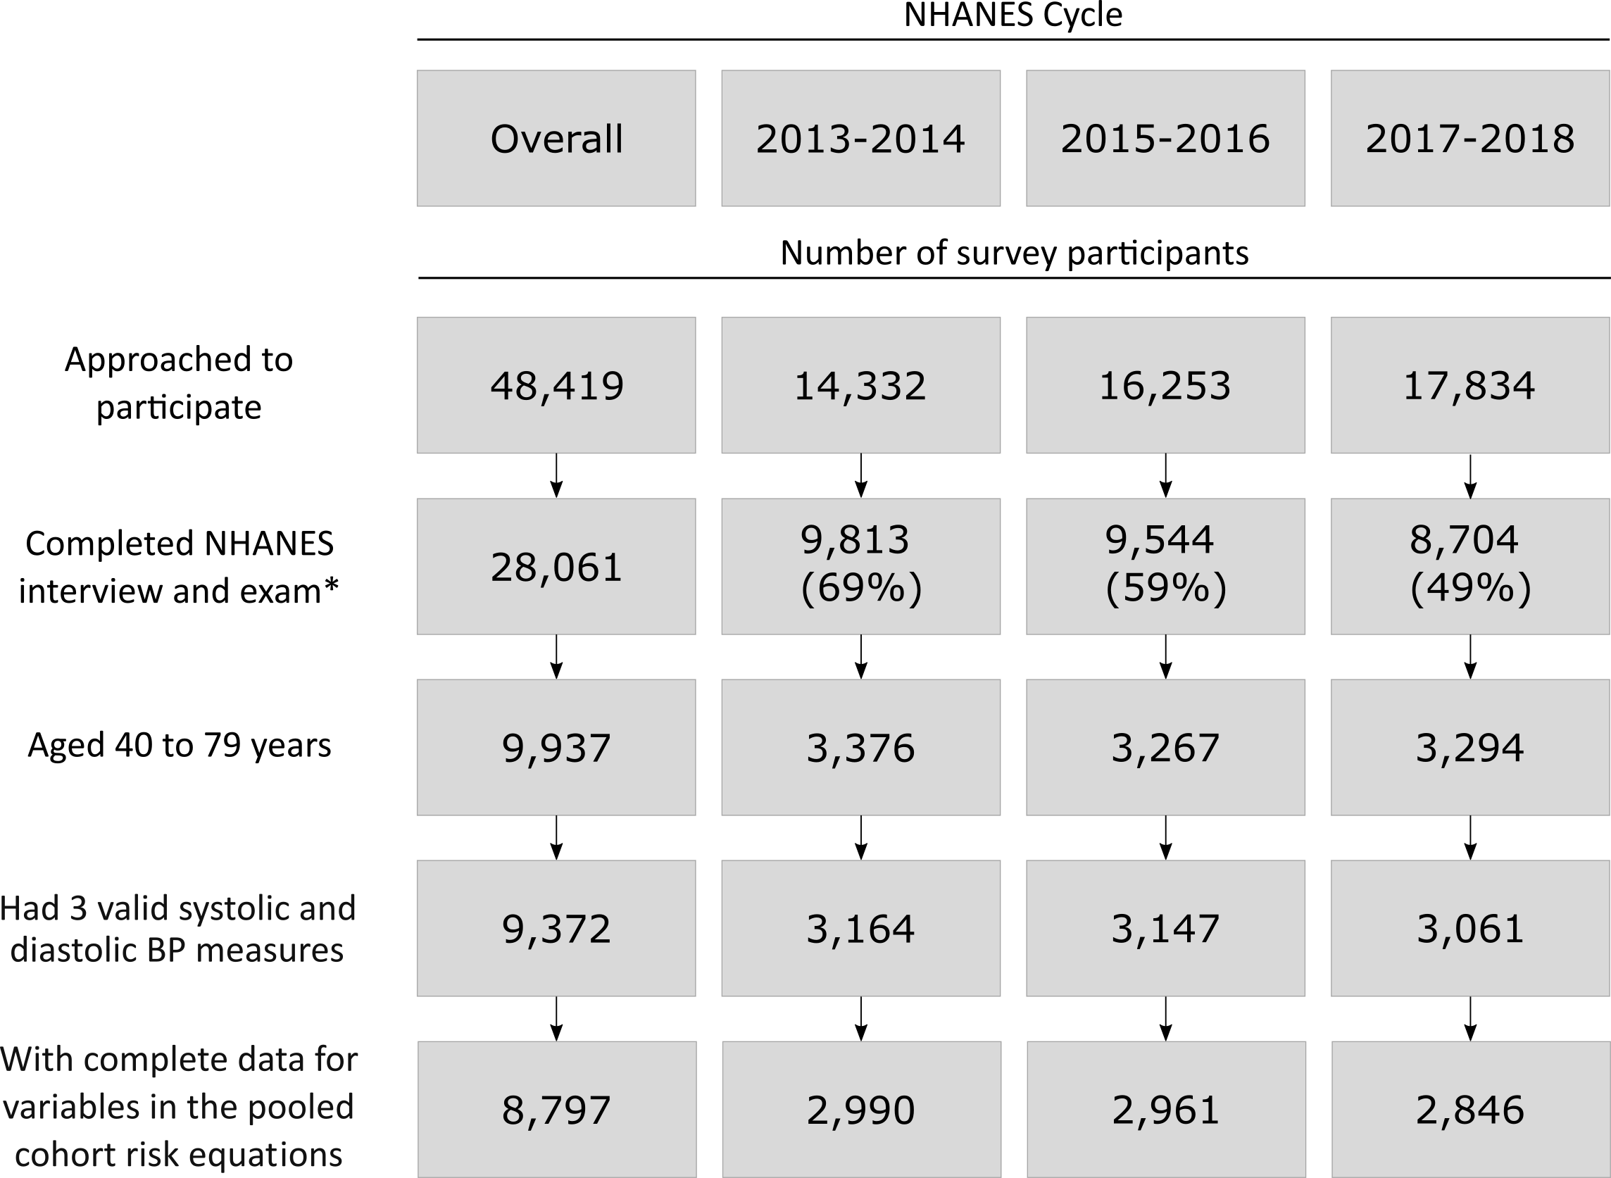

BP: blood pressure; NHANES: National Health and Nutrition Examination Survey. * The Completed NHANES interview and exam cells include number with the response rate in parentheses.

Figure S2: Estimated distribution of 10-year predicted cardiovascular risk among US adults with stage 1 hypertension and predicted risk < 10% overall and for those with diabetes, chronic kidney disease, ≥ 65 years of age, or any of the preceding conditions.



Results do not include data from survey participants with prevalent cardiovascular disease or 10-year predicted risk for cardiovascular disease ≥ 10%.

Figure S3: Estimated Probability of ten-year predicted risk for cardiovascular disease ≥ 10% by age among US adults with stage 1 hypertension and diabetes, chronic kidney disease, and with without diabetes or chronic kidney disease.



* Age at which 50% of the population is expected to have a predicted 10-year risk for cardiovascular disease ≥ 10%.