Predicted cardiovascular risk and blood pressure for Americans with diabetes, chronic kidney disease, and ≥65 years of age

Byron C. Jaeger1, Shakia T. Hardy2, Paul Muntner2, and Paul Whelton3

1. Department of Biostatistics, University of Alabama at Birmingham
2. Department of Epidemiology, University of Alabama at Birmingham
3. Department of Epidemiology, Tulane University

# INTRODUCTION

*To be written in next draft*

# METHODS

NHANES was designed to assess the health and nutritional status of the non-institutionalized US population and is conducted by the National Center for Health Statistics of the Centers for Disease Control and Prevention.(1) Since 1999-2000, NHANES has been conducted in two-year cycles using a multistage probability sampling design to select participants. Each cycle is independent with different participants recruited. For the current analysis, the 3 cycles conducted in 2013-2014, 2015-2016, and 2017-2018 were pooled for analysis.(2) The protocols for each NHANES cycle were approved by the National Center for Health Statistics of the Centers for Disease Control and Prevention Institutional Review Board. Written informed consent was obtained from each participant. The University of Alabama at Birmingham Institutional Review Board considered the analysis of NHANES data to be exempt research.

The current analysis was restricted to adults aged 40 to 79 years of age who complete the NHANES interview and examination (n = 9,937). Participants < 40 or > 79 years of age were not included because the Pooled Cohort risk equations are not recommended in these age ranges. Participants who did not have three SBP and DBP measurements (n = 565) and those who were missing information on age, race, sex, total and high-density lipoprotein cholesterol, smoking status, or diabetes (n = 575) were excluded. After these exclusions, over the three NHANES cycles, a total of 8,797 survey participants were included in the analysis (Figure S1).

## Data collection

Data were collected during an in-home interview and a study visit completed at a mobile examination center. Standardized questionnaires were used to assess participants’ age, sex, race/ethnicity, smoking habits, medical history and use of antihypertensive medication, oral glucose lowering medication and insulin. Medical history included questions about whether the participant had been told by a doctor or other health professional that they have had a heart attack, coronary heart disease stroke, or heart failure. Blood and urine samples were collected during the medical examination. Of relevance to the current analysis, serum creatinine, serum glucose and glycated hemoglobin (HbA1c) were measured. Diabetes was defined by fasting serum glucose ≥126 mg/dL, non-fasting glucose ≥200 mg/dL, HbA1c ≥6.5%, or self-reported use of insulin or oral glucose lowering medication. Estimated glomerular filtration rate was calculated using the Chronic Kidney Disease Epidemiology Collaboration equation.(3) Urinary albumin and creatinine levels were measured and used to calculate the albumin-to-creatinine ratio (ACR). CKD was defined by an estimated glomerular filtration rate <60 ml/min/1.73m2 or an ACR ≥30 mg/dL. Ten-year predicted risk for ASCVD was calculated using the pooled cohort risk equations for participants without a history of CVD.(4) Participants with a history of CVD were presumed to have 10-year risk for ASCVD ≥10%.

## Blood pressure measurements

The same protocol was followed to measure SBP and DBP in each NHANES cycle. After survey participants had rested 5 minutes, their BP was measured by a trained physician using a mercury sphygmomanometer and an appropriately sized cuff. Three BP measurements were obtained at 30 second intervals. The mean of all available measurements was used to define SBP and DBP. Quality control included re-certification of physicians every quarter with retraining if needed. All physicians participated in annual retraining.

## BP Categories

Participants not taking antihypertensive medication were grouped into four non-overlapping categories based on the 2017 ACC/AHA BP guideline: Normal BP (SBP <120 mm Hg and DBP <80 mm Hg), elevated BP (SBP between 120 and 129 mm Hg and DBP <80 mm Hg), stage 1 hypertension (SBP between 130 and 139 mm Hg and/or DBP between 80 and 89 mm Hg with SBP <140 mm Hg and DBP <90 mm Hg), stage 2 hypertension (SBP ≥140 mm Hg or DBP ≥90 mm Hg). Participants taking antihypertensive medication were placed in a fifth group.

## Statistical analysis

Analyses were conducted for the overall population and among participants with diabetes, CKD, ≥65 years of age, and for those with any of these three conditions, separately. Participant characteristics were summarized as mean with their standard error and percentage for continuous and categorical variables, respectively. The percentage of US adults in each of the five BP categories was computed. The median 10-year predicted risk for ASCVD and the proportion with a predicted risk ≥10% was computed for participants in each of the BP categories. To assess the extent to which participants with a 10-year predicted ASCVD risk <10% were close to this threshold, the proportion of participants in this subgroup with predicted risk of <2.5%, 2.5% to <5.0%, 5.0% to <7.5%, and 7.5% to <10% was estimated. The age-adjusted probability of having a 10-year predicted ASCVD risk ≥10% was estimated using logistic regression. The above analyses were repeated among participants with stage 1 hypertension.

NHANES sampling weights, which were calculated as the inverse probability of being selected for the survey, were used in all calculations to obtain US nationally representative estimates. The survey design of NHANES was also taken into account. Data analysis was conducted using R version 4.0.2 (2020-06-22). P-values were two-sided.

# RESULTS

Among US adults who were 40 to 79 years of age in 2013-2018, the estimated prevalence (95% confidence interval [CI]) of diabetes and CKD was 17.2% (16.0, 18.5) and 14.1% (13.0, 15.2), respectively, and 25.4% (23.7, 27.1) were estimated to be ≥65 years of age (Table 1). Overall, an estimated 14.6% (95% CI: 13.3, 16.1) of US adults who were 40 to 79 years of age had stage 1 hypertension (Table 2). Among those with diabetes, CKD, and age ≥65 years, the estimated prevalence (95% CI) of stage 1 hypertension was 10.5% (8.5, 12.9), 10.5% (8.5, 12.9) 9.5% (7.6, 11.7), and 9.1% (7.6, 10.9), respectively. Characteristics of US adults 40 to 79 years of age with stage 1 hypertension, overall, and with diabetes, CKD and age ≥65 years are presented in Table S1.

## Predicted 10-year risk for atherosclerotic cardiovascular disease

Among US adults without a history of CVD, the estimated median (25th, 75th percentiles) 10-year predicted risk for ASCVD was 5.1% (1.9, 11.4) in the overall population and 14.4% (7.0, 27.3), 12.1% (4.8, 22.8), and 17.9% (11.2, 27.3) among those with diabetes, CKD, and age ≥65 years, respectively (Table 3; top panel). Among US adults with stage 1 hypertension and no history of CVD, the estimated median (25th, 75th percentiles) 10-year predicted risk for ASCVD was 4.2% (1.9, 8.5). Within this subgroup of adults with stage 1 hypertension, those with diabetes and CKD had median (25th, 75th percentiles) predicted risks of of 8.9% (4.5, 19.3) and 6.8% (2.6, 12.3), respectively, while adults aged ≥65 years had a median (25th, 75th percentiles) predicted risk of 13.8% (8.6, 22.3). Among all US adults with stage 1 hypertension, an estimated 55.0% (95% CI: 43.2, 66.3) of those with diabetes, 38.5% (95% CI: 27.8, 50.4) of those with CKD and 72.6% (95% CI: 62.0, 81.1) who were ≥65 years of age had a 10-year predicted risk for ASCVD ≥10% or a history of CVD (Table 3; bottom panel).

## Distribution of predicted risk in low risk groups

Among US adults with 10-year predicted risk for ASCVD <10% and no history of CVD, an estimated 69.4% (95% CI: 67.5, 71.3) had a 10-year predicted ASCVD risk <5% (Figure 1). Also, among those with 10-year predicted risk for ASCVD <10% and no history of CVD, 47.7% (95% CI: 41.0, 54.5), 55.9% (95% CI: 49.6, 62.0), and 13.2% (95% CI: 8.4, 20.1) of those with diabetes, CKD and age ≥65 years had a 10-year predicted ASCVD risk <5%. Among US adults with predicted risk <10% and stage 1 hypertension, 53.6% (95% CI: 35.6, 70.6) of those with diabetes, 55.8% (95% CI: 40.5, 70.0) of those with CKD, and 7.4% (95% CI: 1.1, 35.8) of those with ≥65 years of age had a 10-year predicted ASCVD risk <5% (Figure S2).

## Age-specific analysis of 10-year predicted ASCVD risk ≥10%

The estimated probability of having a 10-year predicted ASCVD risk ≥10% or a history of CVD increased with older age and was 50% (95% CI: 46.8, 53.2) at 64.9 years for US adults without diabetes or CKD (Figure 2). For US adults with diabetes and with CKD, the age when estimated probability was ≥50% for having a 10-year predicted ASCVD risk ≥10% or a history of CVD was 53.5 and 58.0 years, respectively. Among US adults with stage 1 hypertension, the age where estimated probability of having a 10-year predicted ASCVD risk ≥10% or a history of CVD exceeded 50% was 65.2, 54.9, and 63.7 years for US adults without diabetes or CKD, with diabetes, and with CKD, respectively (Figure S3).

# DISCUSSION

The 2017 ACC/AHA BP guideline states that the vast majority of adults with diabetes, CKD, or ≥65 years of age have a 10-year predicted risk for ASCVD ≥10% and are recommended the initiation of antihypertensive drug therapy for stage 1 hypertension. However, the current analysis estimates that among US adults 40 to 79 years of age, 72.5% (95% CI: 69.1, 75.6) of those with diabetes and 65.4% (95% CI: 61.6, 69.0) with CKD had a 10-year predicted risk for ASCVD ≥10% or CVD. Among those with stage 1 hypertension, 55.0% (95% CI: 43.2, 66.3) of US adults with diabetes and 38.5% (95% CI: 27.8, 50.4) with CKD had 10-year predicted risk for ASCVD ≥10% or prevalent CVD. In contrast, among US adults with ≥65 years of age, 83.8% (95% CI: 81.4, 85.9) have 10-year predicted risk for ASCVD ≥10% or prevalent CVD and 72.6% (95% CI: 62.0, 81.1) of US adults with stage 1 hypertension and ≥65 years of age do. Among adults whose 10-year predicted risk for ASCVD was <10%, roughly 50% of those with diabetes or CKD had 10-year predicted risk for ASCVD <5%, whereas over 90% of adults aged ≥65 years had 10-year predicted risk for ASCVD between 5% and 10%.

I wonder if it would make sense to have a paragraph about how people with diabetes have a high risk for CVD and same for those with CKD and even age. Maybe start with “The 2017 ACC/AHA BP guideline suggested that the vast majority of adults with diabetes, CKD, or ≥65 years of age have a 10-year predicted risk for ASCVD ≥10%.” Then discuss why this may be – prior studies suggest these groups have high risk (HR of 1.5 to 2) and people with CKD and diabetes tend to be older and age is a strong risk factor. However, a high proportion with diabetes/CKD do not have a high predicted risk, especially for those with stage 1 hypertension….

Maybe add a paragraph about the value of using predicted risk to guide antihypertensive medication initiation (PMID: **25131978 and https://www.thelancet.com/journals/lancet/article/PIIS0140-6736(19)31359-5/fulltext** ).

The 2017 ACC/AHA BP guideline recommends using BP level, 10-year predicted risk for ASCVD, and CVD risk factors including diabetes, CKD, and age ≥65 years to guide the decision to initiate antihypertensive medication. A previous analysis of pooled data from the REasons for Geographic and Racial Differences in Stroke study and the Jackson Heart Study showed that adults with stage 1 hypertension recommended versus not recommended to initiate antihypertensive medication by the 2017 ACC/AHA BP guideline were roughly 5 times more likely to experience a stroke or coronary heart disease event over 12.2 years of follow-up. Moreover, 87.7% of adults with stage 1 hypertension recommended to initiate treatment by the 2017 ACC/AHA BP guideline had a 10-year predicted risk for ASCVD ≥10%. However, the mean age of adults in this group was 70.2 years, whereas the estimated mean (95% CI) age of US adults, 40 to 79 years of age, with stage 1 hypertension in the current analysis was 54.0 years As age is one of the most influential predictors in the pooled cohort risk equation, the younger age of adults in the US with stage 1 hypertension recommended to initiate antihypertensive medication by the ACC/AHA BP guidelines likely explains the difference in the distribution of 10-year predicted risk for ASCVD in the current study.

Add a paragraph about how age is an important piece when considering 10-year risk and maybe talking about how even though many of those <50 years of age with diabetes and/or CKD do not have high risk, they have a high lifetime risk for CVD. Therefore, tx may be beneficial. We probably need to talk somewhere about patient-provider discussion and patient preference.

A prior analysis of NHANES data found that the proportion of adults in the US with SBP >130 mm Hg or DBP >80 mm Hg who wee aware they had hypertension declined from 2013-2014 to 2017-2018. Together with data showing that these adults may be at high risk for incident ASCVD, it is clear that the pooled cohort risk equations or other CVD risk prediction tools should be used in clinical practice to advance critical healthcare goals such as increasing awareness of hypertension and controlling BP levels. Computing 10-year predicted risk for ASCVD in the clinical setting may require additional time if a patient’s medical record does not contain recent cholesterol measurements, but the current study suggests it is probably safe to assume US adults with stage 1 hypertension and ≥65 years of age have 10-year predicted risk for ASCVD ≥10%. This assumption is not supported for patients with stage 1 hypertension and diabetes or CKD, particularly for those aged <55 years of age. However, for younger adults with diabetes or CKD whose predicted 10-year risk for ASCVD is <10%, antihypertensive treatment may still provide substantial reduction in lifetime risk for ASCVD and prevention of complications associated with diabetes or CKD.

This study has several limitations. First, NHANES participants completed only one visit and guidelines recommend using the mean BP aggregated over 2 or more visits. Second, the response rate for NHANES has declined form 1999-2000 to 2017-2018. The effect of this decline on the current study is unclear. Third, the use of predicted ASCVD risk rather than observed ASCVD events may have over- or under-estimated ASCVD risk in subgroups where the pooled cohort risk equations are not well-calibrated. The current study also has a number of strengths. First, NHANES data are publicly available and representative of the US population when coupled with the NHANES survey design. Second, a collection of open-source software geared to enhance the transparency and reproducibility of scientific findings were leveraged to make the current analysis entirely reproducible and publicly available (see first author’s GitHub repository: < *Link not yet active so we won’t be scooped* >). A point of novelty is that anyone with internet access may download this repository of code and reproduce the current manuscript as-is or with different initial parameters, e.g. using data from four NHANES cycles rather than three or modifying exclusion criteria. When different parameters are used, results in the manuscript will dynamically update. A detailed set of instructions for engaging with the project is provided in the repository.

In conclusion, the claim that a vast majority of adults with diabetes, CKD, or ≥65 years of age have a 10-year predicted risk for ASCVD ≥10% is not supported by data representative of the US population. Future studies should assess the cost-to-benefit ratio of early treatment for this population.

Table 1: Characteristics of US adults overall and with diabetes, chronic kidney disease, and ≥65 years of age.

|  | | **Sub-groups** | | | |
| --- | --- | --- | --- | --- | --- |
| **Characteristic\*** | **Overall  N = 8,797** | **Diabetes  N = 1,998†** | **CKD  N = 1,566‡** | **Age 65+ years  N = 2,501** | **Diabetes, CKD, or age 65+ years  N = 4,183** |
| Age, years | 56.7 (0.2) | 60.3 (0.4) | 61.8 (0.4) | 70.6 (0.1) | 64.2 (0.3) |
| Male | 48.2 | 55.8 | 44.8 | 46.7 | 48.0 |
| Race / ethnicity | | | | | |
| Non-Hispanic White | 68.6 | 60.0 | 63.4 | 76.7 | 68.8 |
| Non-Hispanic Black | 10.1 | 13.6 | 15.0 | 7.8 | 10.9 |
| Hispanic | 12.6 | 15.9 | 13.1 | 8.3 | 11.7 |
| Non-Hispanic Asian | 5.2 | 7.0 | 4.9 | 4.5 | 5.2 |
| Other Race/ethnicity - Including Multi-Racial | 3.5 | 3.5 | 3.7 | 2.7 | 3.3 |
| Total cholesterol, mg/dl | 197.0 (0.9) | 183.2 (1.8) | 194.6 (1.8) | 188.9 (1.3) | 191.1 (1.2) |
| HDL-cholesterol, mg/dl | 54.9 (0.4) | 46.6 (0.5) | 53.0 (0.9) | 56.6 (0.7) | 53.7 (0.5) |
| Systolic blood pressure, mm Hg | 126.0 (0.3) | 130.5 (0.6) | 134.2 (0.7) | 131.8 (0.6) | 131.0 (0.5) |
| Diastolic blood pressure, mm Hg | 72.8 (0.3) | 71.6 (0.4) | 72.4 (0.4) | 68.3 (0.4) | 70.9 (0.3) |
| Antihypertensive medication use | 33.5 | 60.0 | 55.9 | 53.2 | 52.1 |
| Diabetes | 17.2 | 100.0 | 38.3 | 24.7 | 41.9 |
| Chronic kidney disease | 14.1 | 31.3 | 100.0 | 25.3 | 34.3 |
| Aged 65+ years | 25.4 | 36.4 | 45.6 | 100.0 | 61.9 |
| Current smoker | 17.3 | 14.6 | 19.1 | 10.0 | 14.4 |
| Prevalent CVD§ | 10.5 | 22.6 | 23.3 | 21.4 | 19.3 |
| *Table values are mean (standard error) or proportion. | | | | | |
| †Diabetes was defined by fasting serum glucose ≥ 126 mg/dL, non-fasting glucose ≥ 200 mg/dL, HbA1c ≥ 6.5%, or self-reported use of insulin or oral glucose lowering medication. | | | | | |
| ‡Chronic kidney disease is defined by an albumin-to-creatinine ratio ≥ 30 mg/dl or an estimated glomerular filtration rate <60 ml/min/1.73m² | | | | | |
| §Prevalent cardiovascular disease was defined by self-report of previous heart failure, coronary heart disease, stroke, or myocardial infarction | | | | | |
| CKD = chronic kidney disease; CVD = cardiovascular disease; HDL = high density lipoprotein | | | | | |

Table 2: Estimated distribution of blood pressure categories among US adults, overall and for subgroups with diabetes, chronic kidney disease, and ≥65 years of age.

|  | | **Sub-groups** | | | |
| --- | --- | --- | --- | --- | --- |
| **Blood pressure category\*** | **Overall  N = 8,797** | **Diabetes  N = 1,998†** | **CKD  N = 1,566‡** | **Age 65+ years  N = 2,501** | **Diabetes, CKD, or age 65+ years  N = 4,183** |
| Normal blood pressure | 28.8 | 12.1 | 13.5 | 15.0 | 15.5 |
| Elevated blood pressure | 12.0 | 7.9 | 6.7 | 11.2 | 10.4 |
| Stage 1 hypertension | 14.6 | 10.5 | 9.5 | 9.1 | 10.4 |
| Stage 2 hypertension | 11.1 | 9.5 | 14.5 | 11.6 | 11.7 |
| Taking antihypertensive medication | 33.5 | 60.0 | 55.9 | 53.2 | 52.1 |
| *Normal blood pressure: systolic/diastolic blood pressure < 120/80 mm Hg; Elevated blood pressure: systolic/diastolic blood pressure 120-129/<80 mm Hg; Stage 1 hypertension: systolic/diastolic blood pressure 130-139/80-89 mm Hg; Stage 2 hypertension: systolic/diastolic blood pressure ≥ 140/90 mm Hg. | | | | | |
| †Diabetes was defined by fasting serum glucose ≥ 126 mg/dL, non-fasting glucose ≥ 200 mg/dL, HbA1c ≥ 6.5%, or self-reported use of insulin or oral glucose lowering medication. | | | | | |
| ‡Chronic kidney disease is defined by an albumin-to-creatinine ratio ≥ 30 mg/dl or an estimated glomerular filtration rate <60 ml/min/1.73m² | | | | | |
| CKD = chronic kidney disease | | | | | |

Table 3: Median 10-year predicted risk for atherosclerotic cardiovascular disease and proportion of US adults with predicted risk ≥10% overall and among those with diabetes, chronic kidney disease, and ≥65 years of age, stratified by categorization of blood pressure according to the 2017 American College of Cardiology / American Heart Association blood pressure guidelines.

|  | | **Sub-groups** | | | |
| --- | --- | --- | --- | --- | --- |
| **Blood pressure category\*** | **Overall  N = 8,797** | **Diabetes  N = 1,998†** | **CKD  N = 1,566‡** | **Age 65+ years  N = 2,501** | **Diabetes, CKD, or age 65+ years  N = 4,183** |
| *Median (25th - 75th percentile) predicted risk¶* | | | | | |
| Overall | 5.1 (1.9, 11.4) | 14.4 (7.0, 27.3) | 12.1 (4.8, 22.8) | 17.9 (11.2, 27.3) | 13.6 (7.0, 22.3) |
| Normal blood pressure | 2.0 (0.8, 4.8) | 6.8 (2.9, 15.8) | 3.0 (1.0, 8.1) | 10.6 (6.7, 16.0) | 7.0 (3.3, 12.9) |
| Elevated blood pressure | 4.3 (1.9, 9.3) | 11.4 (4.2, 17.3) | 6.2 (1.5, 13.8) | 14.6 (7.5, 19.9) | 11.8 (5.8, 17.4) |
| Stage 1 hypertension | 4.2 (1.9, 8.5) | 8.9 (4.5, 19.3) | 6.8 (2.6, 12.3) | 13.8 (8.6, 22.3) | 9.8 (5.3, 16.6) |
| Stage 2 hypertension | 8.1 (4.2, 16.0) | 18.8 (10.1, 30.2) | 13.9 (5.7, 21.3) | 20.4 (16.0, 29.6) | 17.3 (9.2, 25.4) |
| Taking antihypertensive medication | 10.5 (5.2, 19.8) | 17.2 (9.8, 31.6) | 17.0 (9.0, 29.0) | 21.2 (14.0, 31.6) | 17.2 (10.1, 27.3) |
| *Proportion (95% confidence interval) with 10-year predicted risk for ASCVD ≥10% or prevalent cardiovascular disease§‖* | | | | | |
| Overall | 36.6 (34.7, 38.6) | 72.5 (69.3, 75.6) | 65.4 (61.7, 69.0) | 83.8 (81.6, 86.0) | 70.3 (68.0, 72.7) |
| Normal blood pressure | 13.7 (11.4, 16.0) | 46.8 (39.0, 54.6) | 32.3 (21.6, 43.0) | 64.4 (57.7, 71.2) | 46.3 (40.5, 52.1) |
| Elevated blood pressure | 27.4 (23.3, 31.5) | 57.7 (49.6, 65.8) | 47.9 (36.9, 59.0) | 69.8 (59.6, 79.9) | 57.9 (50.5, 65.3) |
| Stage 1 hypertension | 24.3 (20.7, 27.9) | 55.0 (43.7, 66.4) | 38.5 (27.4, 49.6) | 72.6 (63.2, 81.9) | 55.2 (47.0, 63.3) |
| Stage 2 hypertension | 45.7 (40.4, 51.0) | 79.0 (69.3, 88.7) | 65.6 (54.7, 76.4) | 90.2 (83.8, 96.6) | 75.6 (69.5, 81.7) |
| Taking antihypertensive medication | 61.9 (59.4, 64.5) | 81.6 (78.0, 85.2) | 79.9 (75.9, 84.0) | 92.8 (91.0, 94.5) | 81.8 (79.4, 84.2) |
| *Normal blood pressure: systolic/diastolic blood pressure < 120/80 mm Hg; Elevated blood pressure: systolic/diastolic blood pressure 120-129/<80 mm Hg; Stage 1 hypertension: systolic/diastolic blood pressure 130-139/80-89 mm Hg; Stage 2 hypertension: systolic/diastolic blood pressure ≥ 140/90 mm Hg. | | | | | |
| †Diabetes was defined by fasting serum glucose ≥ 126 mg/dL, non-fasting glucose ≥ 200 mg/dL, HbA1c ≥ 6.5%, or self-reported use of insulin or oral glucose lowering medication. | | | | | |
| ‡Chronic kidney disease is defined by an albumin-to-creatinine ratio ≥ 30 mg/dl or an estimated glomerular filtration rate <60 ml/min/1.73m² | | | | | |
| §Prevalent cardiovascular disease was defined by self-report of previous heart failure, coronary heart disease, stroke, or myocardial infarction | | | | | |
| ‖Predicted risk for cardiovascular disease was computed using the Pooled Cohort Risk equations, based on the guideline by American College of Cardiology / American Heart Association, 2013 | | | | | |
| ¶Data from survey participants with prevalent cardiovascular disease were not included for these statistics | | | | | |
| ASCVD = atherosclerotic cardiovascular disease; CKD = chronic kidney disease | | | | | |

Figure 1: Estimated distribution of 10-year predicted atherosclerotic cardiovascular disease risk among US adults with predicted risk <10% overall and for those with diabetes, chronic kidney disease, ≥65 years of age, or any of the preceding conditions.

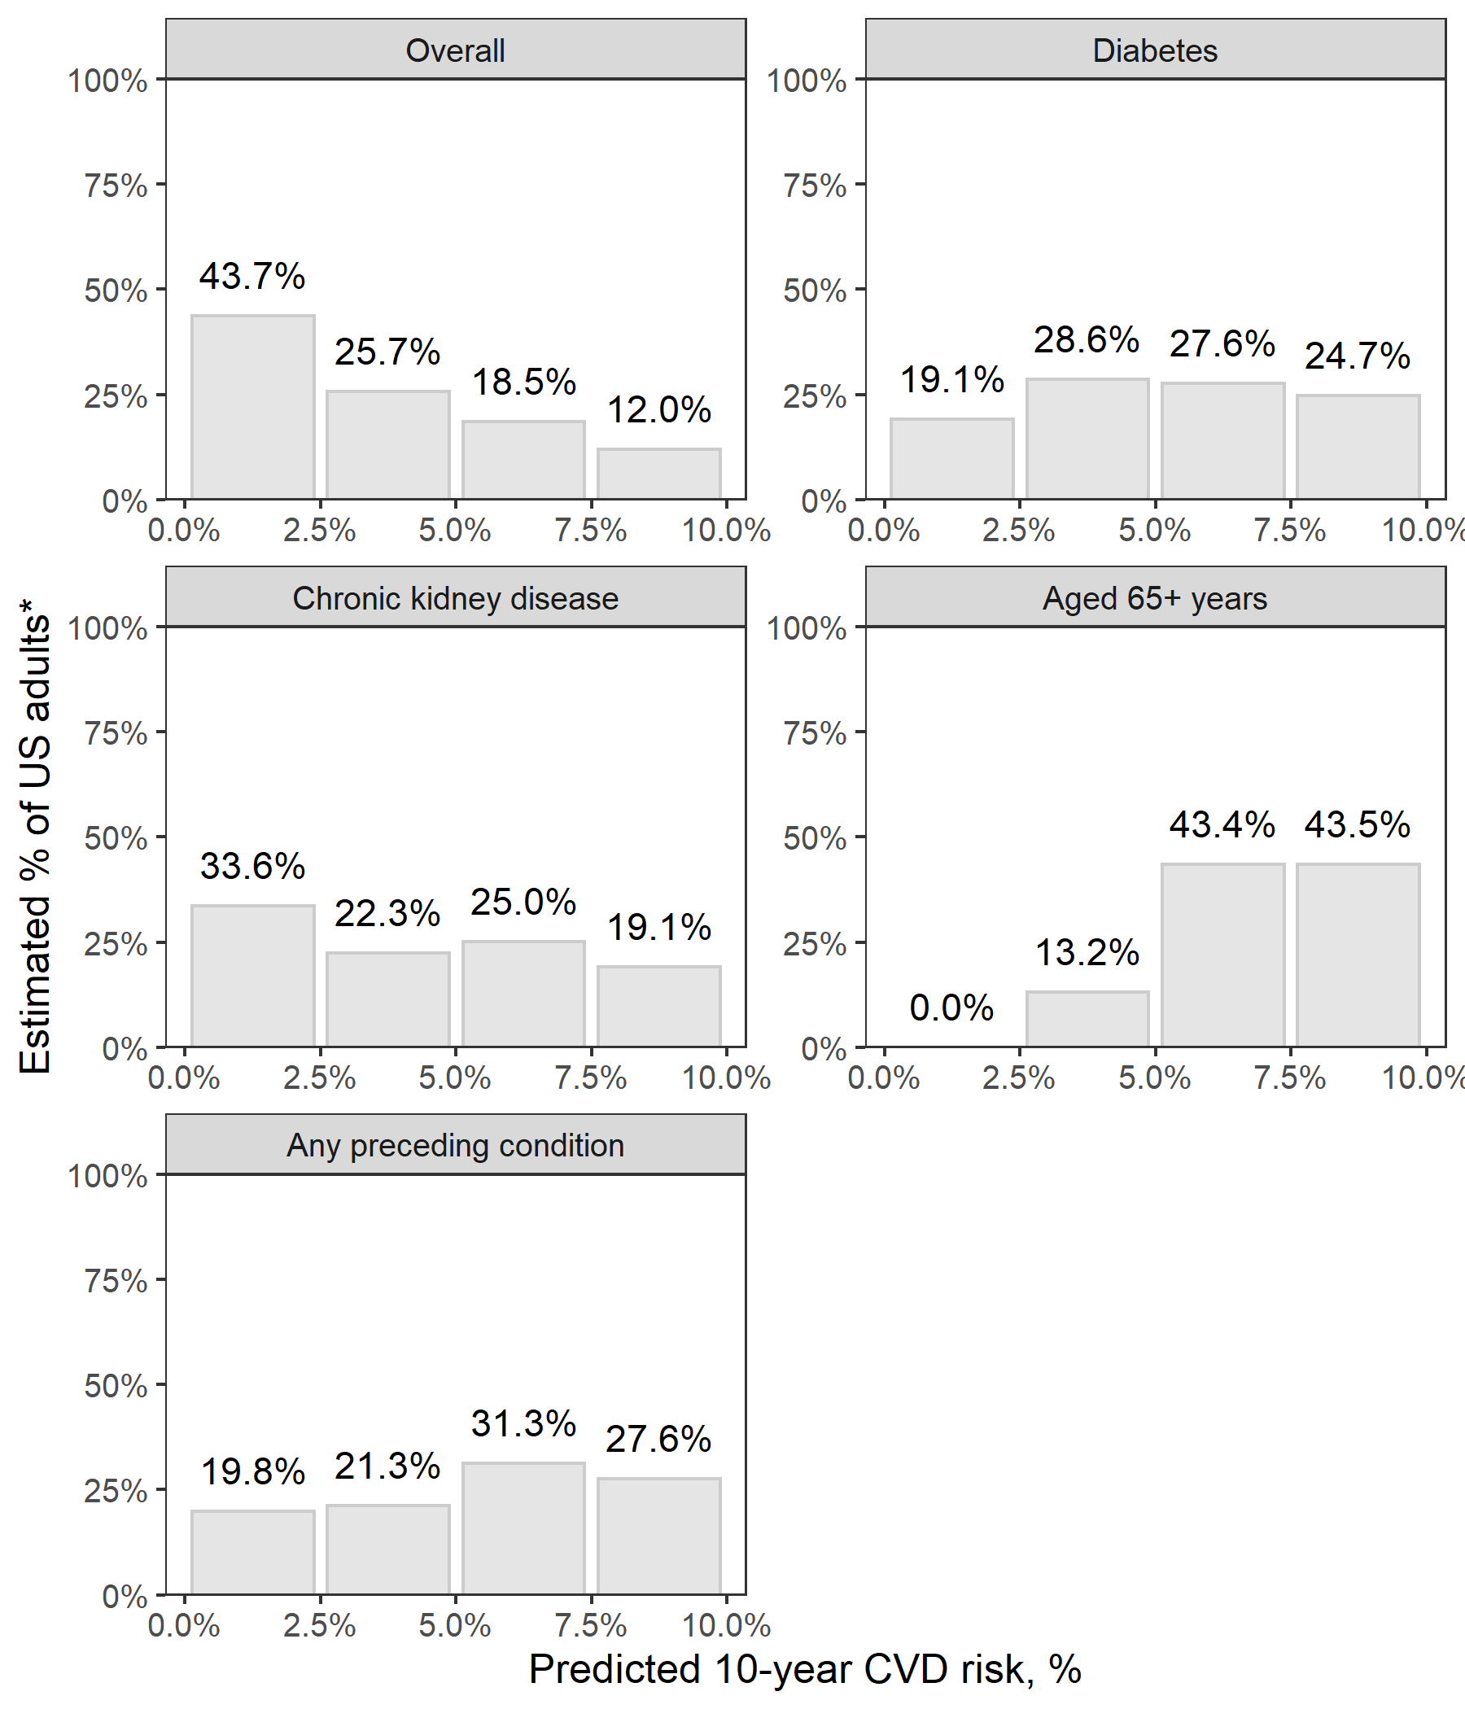

Results do not include data from survey participants with prevalent cardiovascular disease or 10-year predicted risk for atherosclerotic cardiovascular disease ≥ 10%.

Figure 2: Estimated Probability of ten-year predicted risk for atherosclerotic cardiovascular disease ≥10% by age for US adults with diabetes, with chronic kidney disease, and without diabetes or chronic kidney disease.

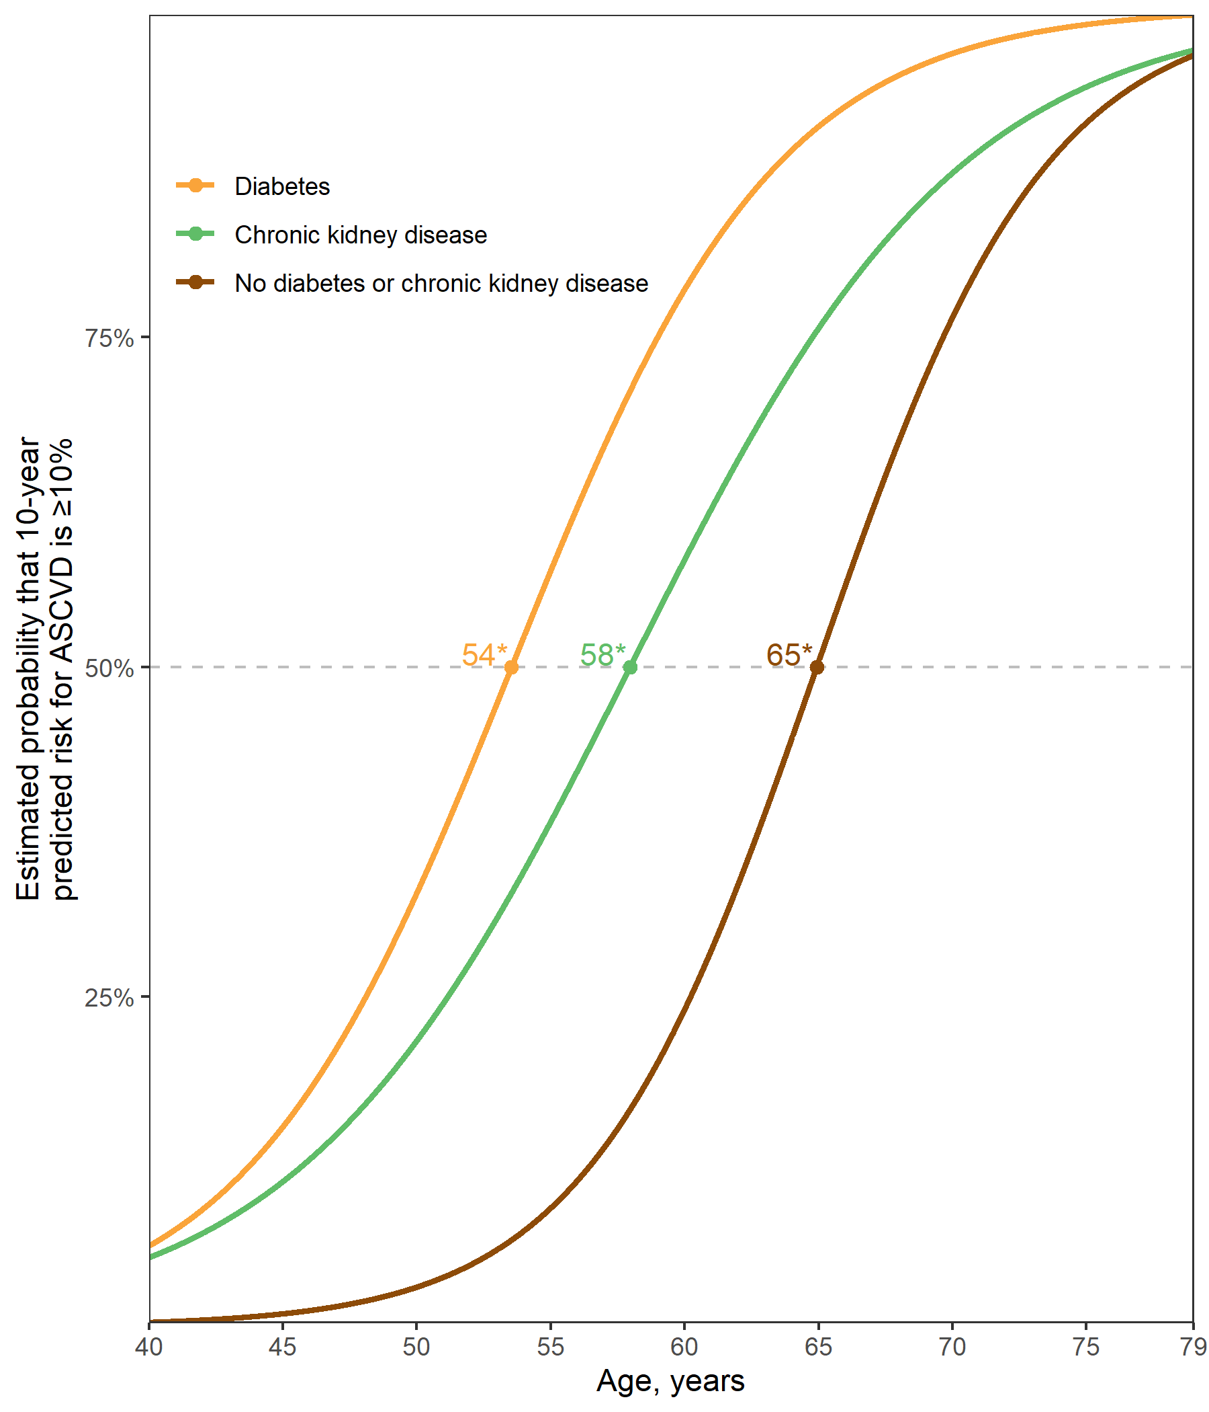

*Age at which 50% of the population is expected to have a predicted 10-year risk for atherosclerotic cardiovascular disease ≥10%.

**SUPPLEMENT**

Table S1: Characteristics of US adults with stage 1 hypertension, overall and with diabetes, chronic kidney disease, ≥65 years of age, or any of the three preceding conditions

|  | | **Sub-groups** | | | |
| --- | --- | --- | --- | --- | --- |
| **Characteristic\*** | **Overall  N = 1,271** | **Diabetes  N = 204†** | **CKD  N = 155‡** | **Age 65+ years  N = 236** | **Diabetes, CKD, or age 65+ years  N = 453** |
| Age, years | 54.0 (0.4) | 56.8 (1.2) | 57.0 (1.2) | 69.7 (0.4) | 61.5 (0.8) |
| Male | 52.3 | 58.5 | 48.8 | 51.5 | 51.9 |
| Race / ethnicity | | | | | |
| Non-Hispanic White | 66.3 | 60.0 | 59.1 | 73.8 | 65.5 |
| Non-Hispanic Black | 9.8 | 11.4 | 12.7 | 7.4 | 10.3 |
| Hispanic | 14.2 | 19.9 | 19.2 | 10.3 | 15.1 |
| Non-Hispanic Asian | 6.0 | 7.6 | 7.0 | 4.2 | 6.0 |
| Other Race/ethnicity - Including Multi-Racial | 3.7 | 1.2 | 1.9 | 4.4 | 3.1 |
| Total cholesterol, mg/dl | 205.0 (2.4) | 188.8 (4.6) | 198.4 (5.0) | 195.4 (3.5) | 195.8 (2.9) |
| HDL-cholesterol, mg/dl | 54.0 (0.7) | 47.1 (1.5) | 53.2 (2.3) | 57.9 (1.4) | 53.8 (1.0) |
| Systolic blood pressure, mm Hg | 129.6 (0.3) | 131.1 (0.7) | 131.2 (0.7) | 132.5 (0.6) | 131.3 (0.4) |
| Diastolic blood pressure, mm Hg | 78.6 (0.4) | 76.7 (1.0) | 76.5 (0.8) | 72.2 (1.0) | 75.3 (0.6) |
| Antihypertensive medication use | 0.0 | 0.0 | 0.0 | 0.0 | 0.0 |
| Diabetes | 12.3 | 100.0 | 30.7 | 21.0 | 42.4 |
| Chronic kidney disease | 9.1 | 22.6 | 100.0 | 16.1 | 31.3 |
| Aged 65+ years | 15.7 | 26.9 | 27.8 | 100.0 | 54.2 |
| Current smoker | 19.3 | 18.8 | 23.3 | 10.7 | 16.4 |
| Prevalent CVD§ | 5.8 | 15.2 | 12.8 | 13.2 | 11.4 |
| *Table values are mean (standard error) or proportion. | | | | | |
| †Diabetes was defined by fasting serum glucose ≥ 126 mg/dL, non-fasting glucose ≥ 200 mg/dL, HbA1c ≥ 6.5%, or self-reported use of insulin or oral glucose lowering medication. | | | | | |
| ‡Chronic kidney disease is defined by an albumin-to-creatinine ratio ≥ 30 mg/dl or an estimated glomerular filtration rate <60 ml/min/1.73m² | | | | | |
| §Prevalent cardiovascular disease was defined by self-report of previous heart failure, coronary heart disease, stroke, or myocardial infarction | | | | | |
| CKD = chronic kidney disease; CVD = cardiovascular disease; HDL = high density lipoprotein | | | | | |

Figure S1: Flowchart showing the number of NHANES participants included in the current analyses.

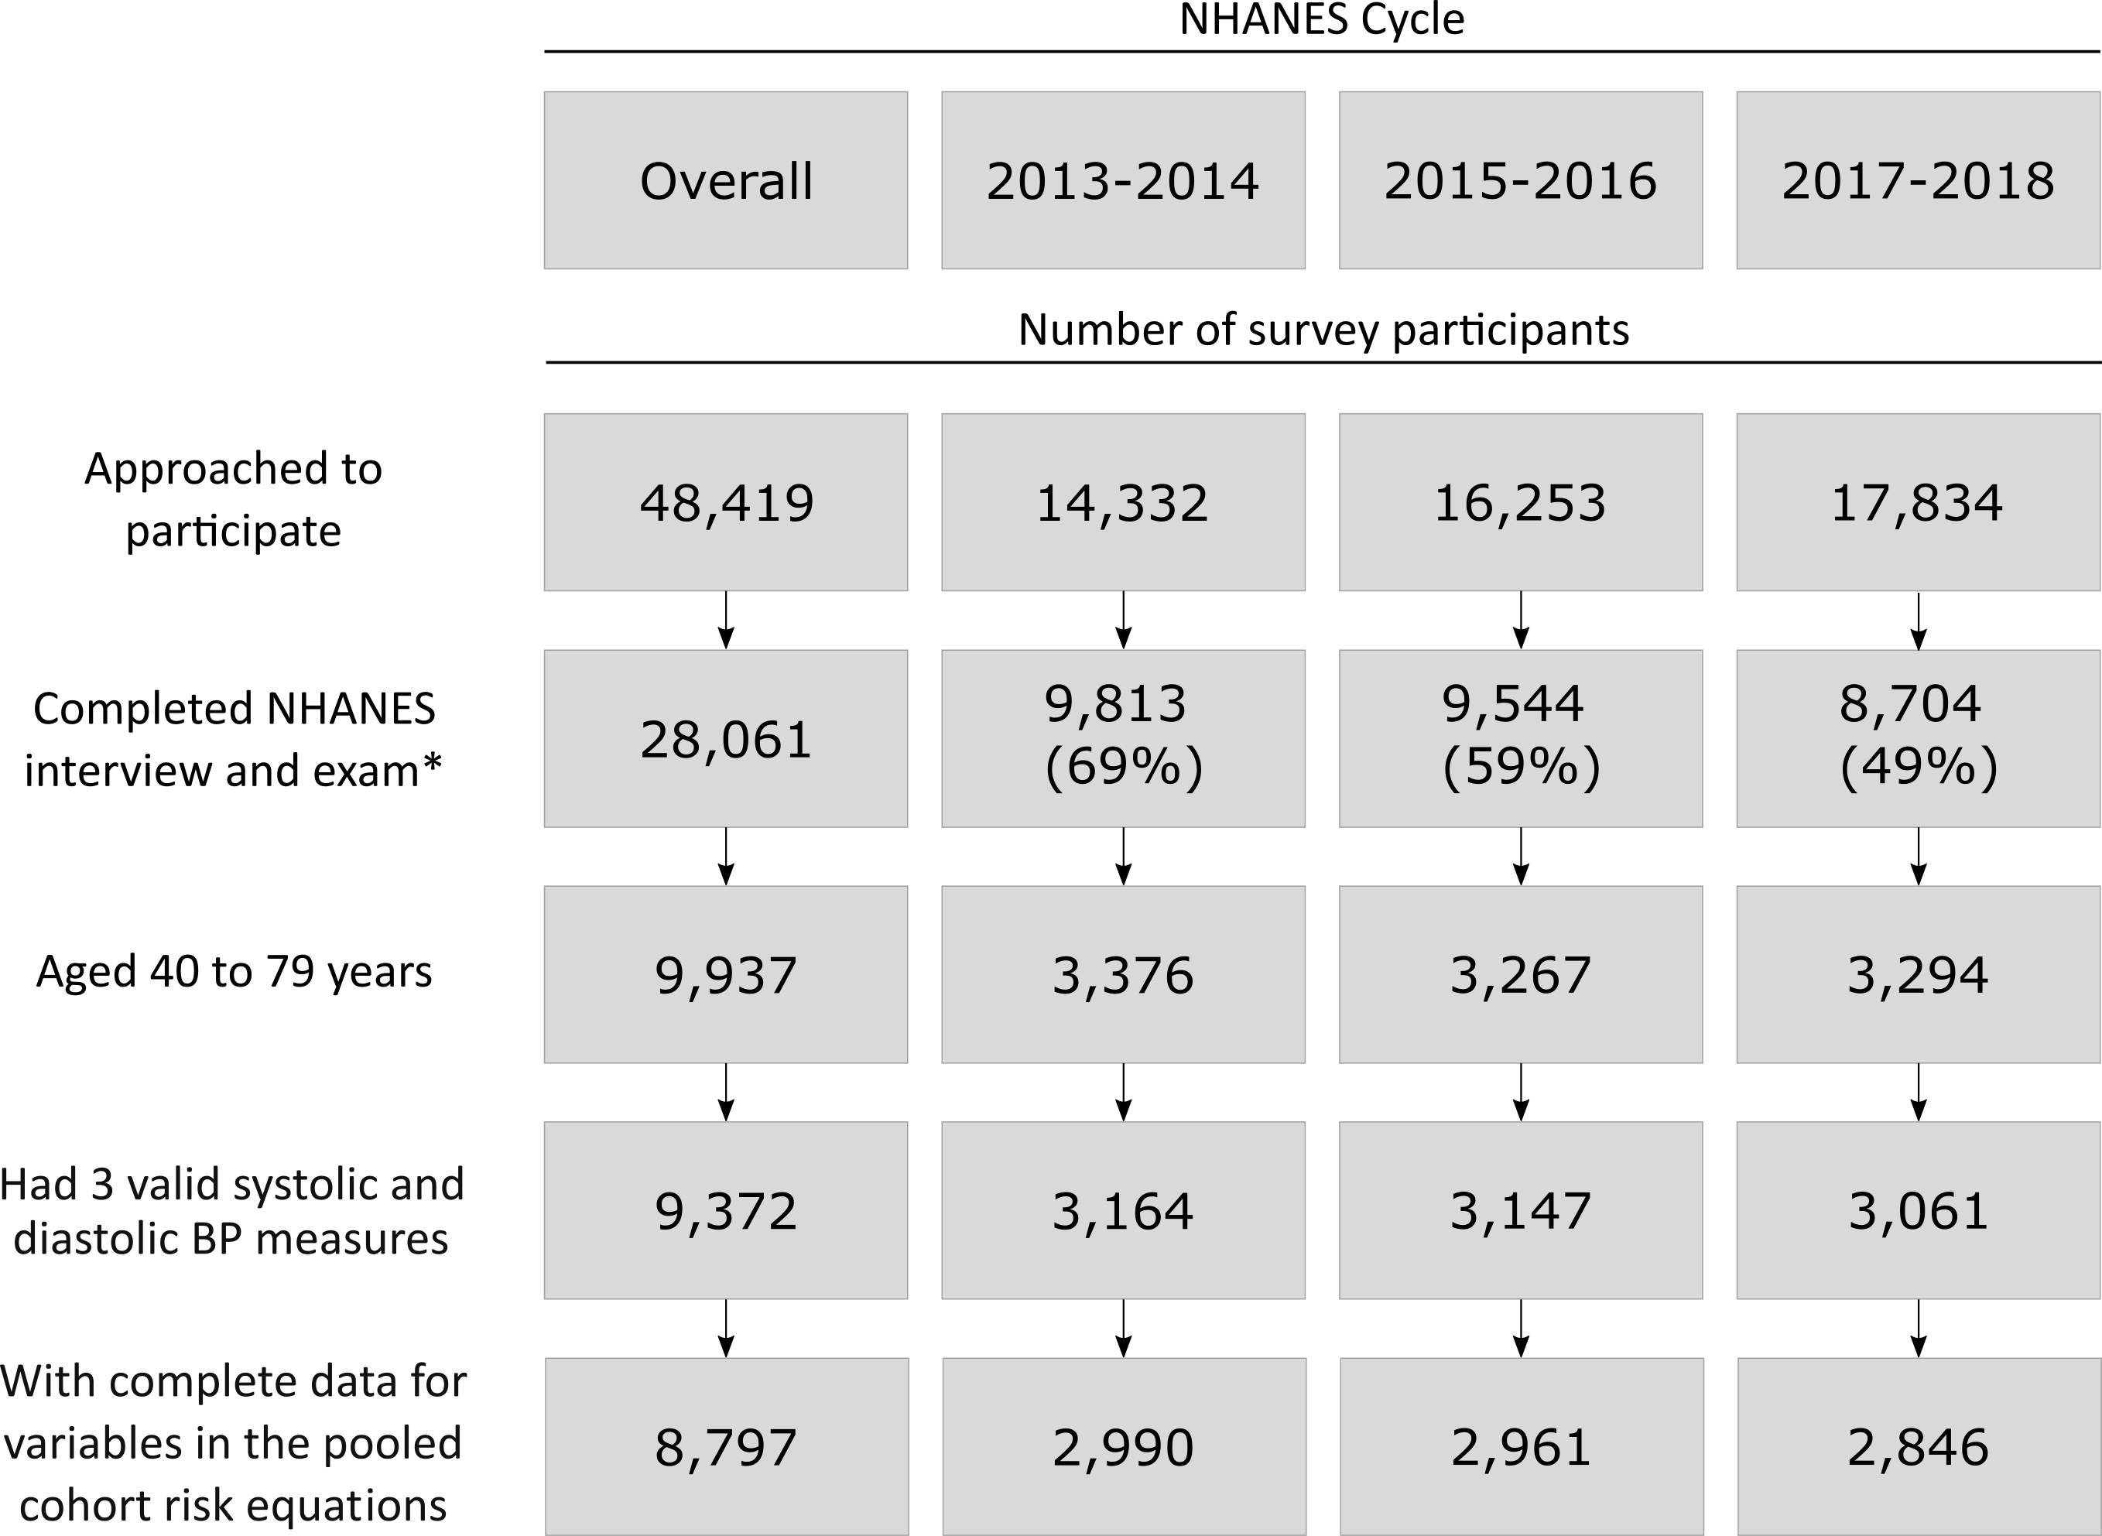

BP: blood pressure; NHANES: National Health and Nutrition Examination Survey.

*The Completed NHANES interview and exam cells include number with the response rate in parentheses.

Figure S2: Estimated distribution of 10-year predicted atherosclerotic cardiovascular disease risk among US adults with stage 1 hypertension and predicted risk < 10% overall and for those with diabetes, chronic kidney disease, ≥65 years of age, or any of the preceding conditions.

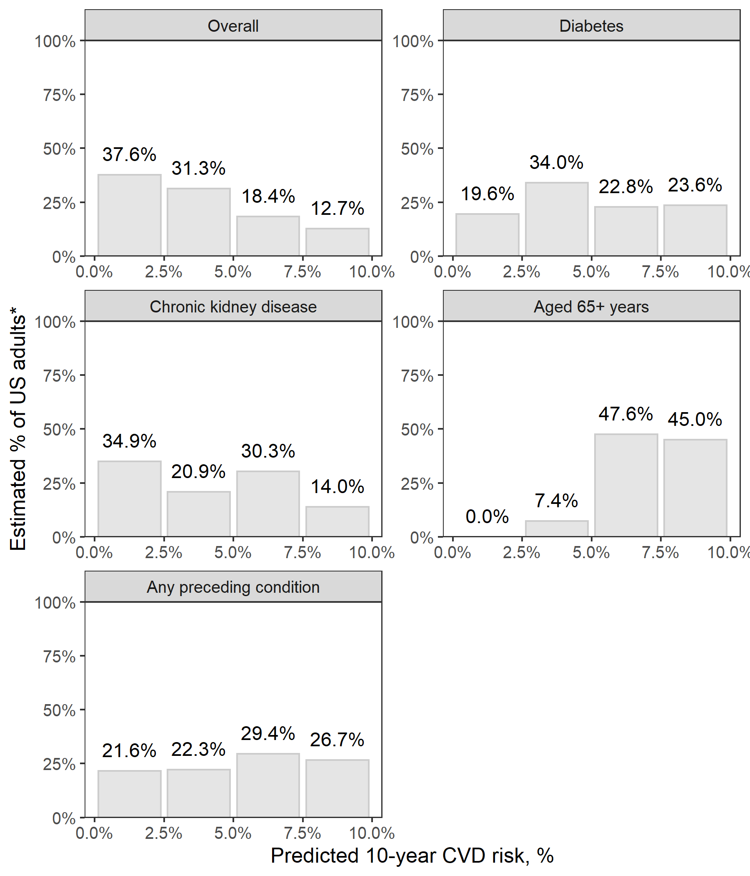

Results do not include data from survey participants with prevalent cardiovascular disease or 10-year predicted risk for atherosclerotic cardiovascular disease ≥ 10%.

Figure S3: Estimated Probability of ten-year predicted risk for atherosclerotic cardiovascular disease ≥10% by age among US adults with stage 1 hypertension and diabetes, chronic kidney disease, and without diabetes or chronic kidney disease.

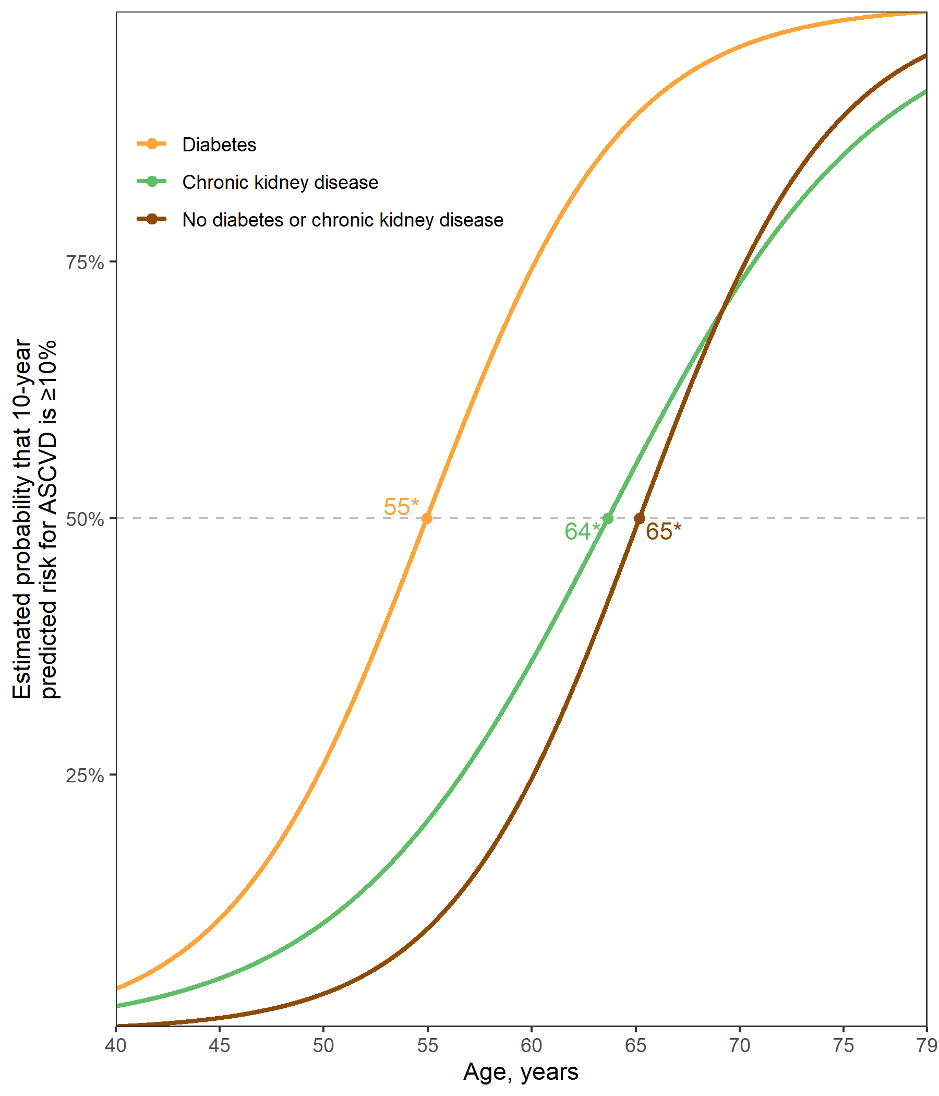

*Age at which 50% of the population is expected to have a predicted 10-year risk for atherosclerotic cardiovascular disease ≥ 10%.

# REFERENCES

1. Anon. NHANES - national health and nutrition examination survey homepage, available at <https://www.cdc.gov/nchs/nhanes/index.htm>.

2. Anon. NHANES tutorials - module 3 - weighting, available at <https://wwwn.cdc.gov/nchs/nhanes/tutorials/module3.aspx>.

3. Levey AS, Stevens LA, Schmid CH, et al. A new equation to estimate glomerular filtration rate. Annals of internal medicine 2009;150:604–612.

4. Goff DC, Lloyd-Jones DM, Bennett G, et al. 2013 acc/aha guideline on the assessment of cardiovascular risk: A report of the american college of cardiology/american heart association task force on practice guidelines. Journal of the American College of Cardiology 2014;63:2935–2959.