Long term mortality risk and maximal fitness

**Multi-variable adjustment**: All estimates are adjusted for CARDIA center, race, sex, education, age, the estimated number of years after Year 0 where paying for basics was somewhat hard, highest degree obtained was high school graduate or general education degree, self reported health was fair or poor, the participant reported smoking or drinking alcohol, body mass index was in the obese or overweight range, and self-reported physical activity did not meet guidelines.

**Figure 1**: Multivariable-adjusted hazard ratios for all-cause mortality and cardiovascular events using natural cubic splines.

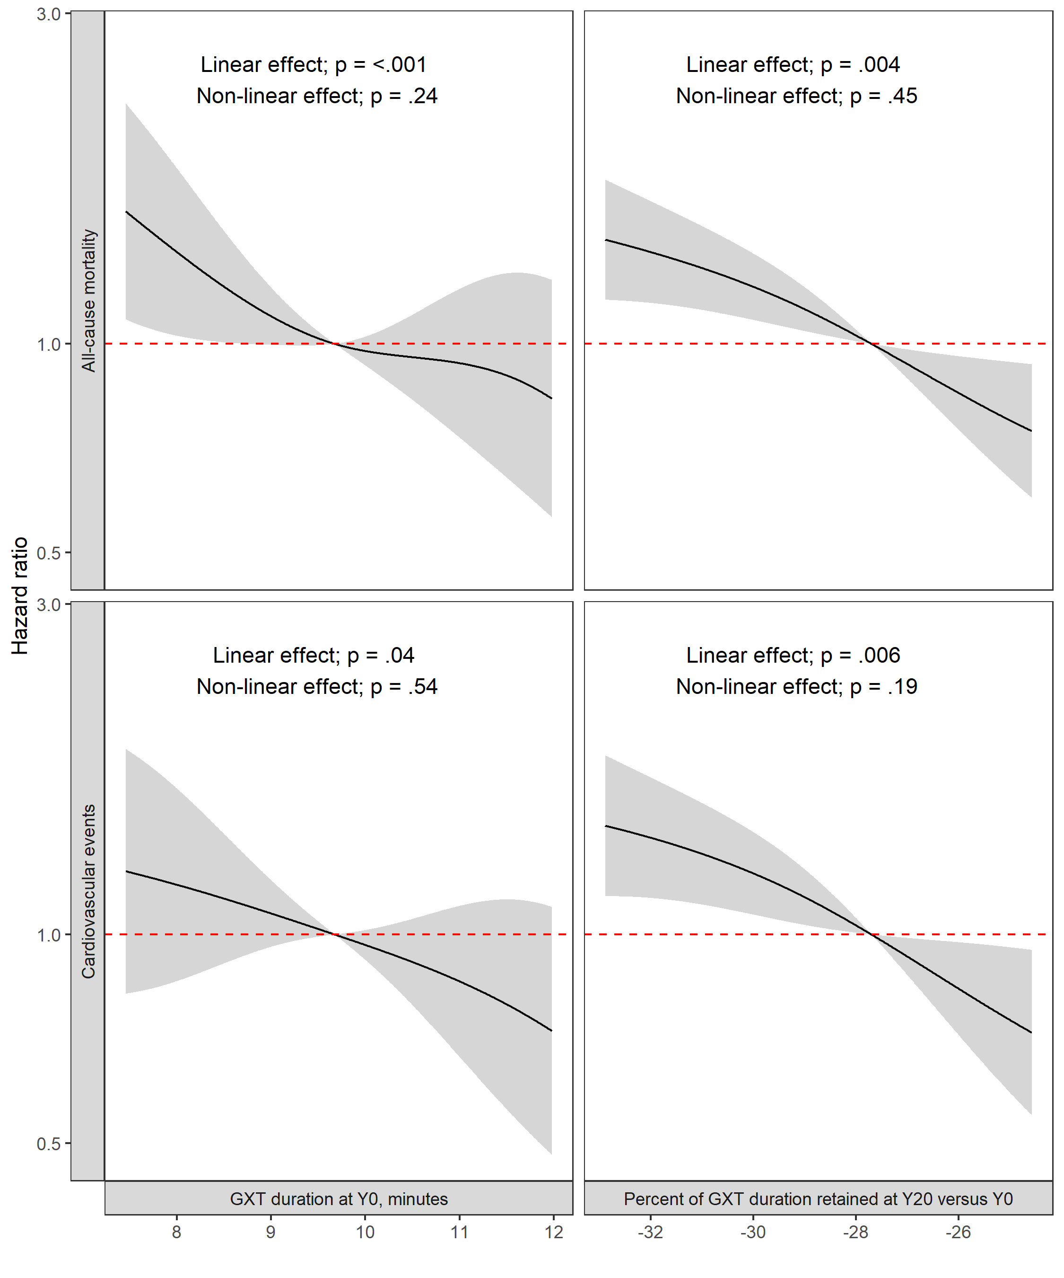

Grey shaded areas represent 95% confidence intervals for the point-estimate.

**Figure 2**: Multivariable-adjusted hazard ratios for all-cause mortality.

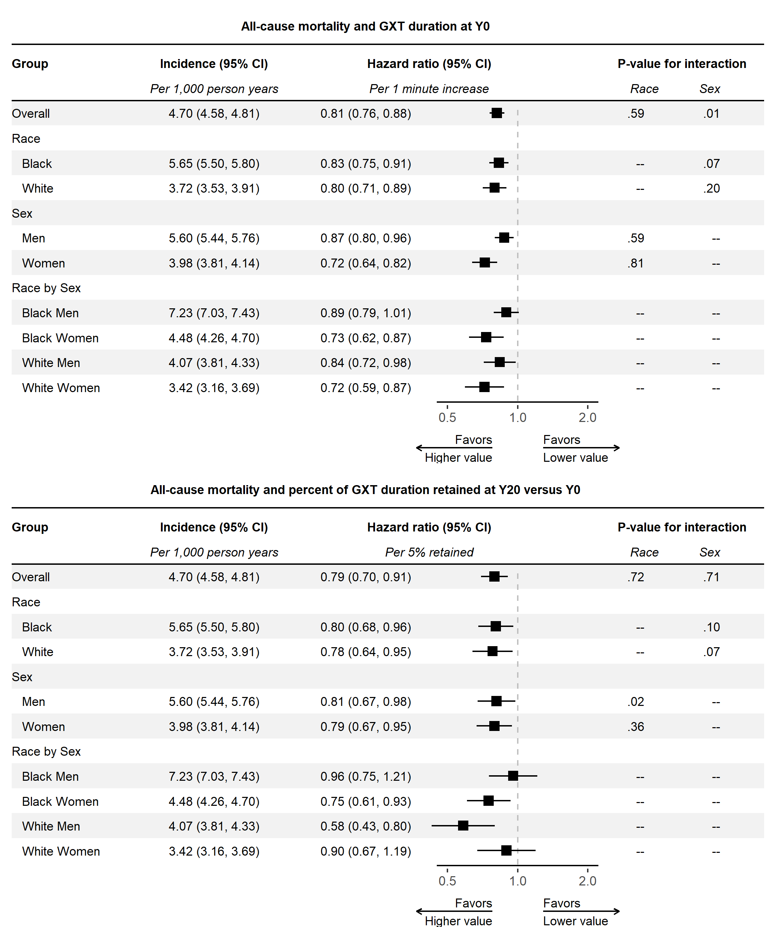

**Figure 3**: Multivariable-adjusted hazard ratios for cardiovascular events.

