Long term mortality risk and maximal fitness

**Multi-variable adjustment**: All estimates are adjusted for CARDIA center, race, sex, education, age, the estimated number of years after Year 0 where paying for basics was somewhat hard, highest degree obtained was high school graduate or general education degree, self reported health was fair or poor, the participant reported smoking or drinking alcohol, body mass index was in the obese or overweight range, and self-reported physical activity did not meet guidelines.

**Table** Inclusion criteria for the current study

| **Exclusion criteria** | **Number of participants** |
| --- | --- |
| CARDIA participants enrolled at Year 0 exam | 5,114 |
| Completed at least one graded exercise test | 5,079 |
| Not using beta blockers during graded exercise test | 5,062 |
| Alive and CVD free at Year 20 exam | 4,805 |
| Alive and CVD free for at least 2 years after Y20 | 4,744 |

**Table** Participant characteristics at the Year 0 Exam.

| **Characteristic** | **Overall** | **Black Females** | **Black Males** | **White Females** | **White Males** | **p-value1** |
| --- | --- | --- | --- | --- | --- | --- |
| No. of participants | 4,720 | 1,369 | 1,017 | 1,256 | 1,078 |  |
| Testing center |  |  |  |  |  | <0.001 |
| Birmingham | 22 | 24 | 25 | 19 | 22 |  |
| Chicago | 22 | 22 | 21 | 22 | 24 |  |
| Minnesota | 28 | 21 | 26 | 31 | 32 |  |
| Oakland | 28 | 33 | 29 | 28 | 22 |  |
| Age | 24.8 (3.6) | 24.3 (3.8) | 24.0 (3.7) | 25.4 (3.4) | 25.3 (3.4) | <0.001 |
| GXT duration, seconds | 581 (183) | 429 (124) | 666 (154) | 551 (143) | 730 (147) | <0.001 |
| Education at year 20 |  |  |  |  |  | <0.001 |
| Associate's or more | 33 | 20 | 18 | 48 | 46 |  |
| Highschool/GED or less | 67 | 80 | 82 | 52 | 54 |  |
| Difficulty paying for basics |  |  |  |  |  | <0.001 |
| Not very hard | 66 | 62 | 61 | 68 | 73 |  |
| Somewhat hard | 34 | 38 | 39 | 32 | 27 |  |
| Marital status |  |  |  |  |  | <0.001 |
| Married or co-habitating | 22 | 19 | 18 | 28 | 22 |  |
| Other | 78 | 81 | 82 | 72 | 78 |  |
| Body mass index, kg/m2 | 24.4 (4.9) | 25.7 (6.4) | 24.5 (4.2) | 23.1 (4.3) | 24.3 (3.5) | <0.001 |
| Self-reported physical activity |  |  |  |  |  | <0.001 |
| Meeting guidelines | 59 | 37 | 73 | 58 | 74 |  |
| Not meeting guidelines | 41 | 63 | 27 | 42 | 26 |  |
| Self-reported health |  |  |  |  |  | <0.001 |
| Excellent or good | 90 | 85 | 88 | 94 | 94 |  |
| Fair or poor | 9.9 | 15 | 12 | 5.9 | 6.0 |  |
| Alcohol use |  |  |  |  |  | <0.001 |
| Does not drink alcohol | 14 | 21 | 14 | 9.4 | 8.0 |  |
| Drinks alcohol | 86 | 79 | 86 | 91 | 92 |  |
| Smoking status |  |  |  |  |  | <0.001 |
| Current | 29 | 31 | 35 | 27 | 25 |  |
| Former | 13 | 8.4 | 9.1 | 20 | 16 |  |
| Never smoked | 57 | 61 | 55 | 53 | 59 |  |
| *1Kruskal-Wallis rank sum test; Pearson's Chi-squared test* | | | | | | |

**Table** Participant characteristics at the Year 20 Exam.

| **Characteristic** | **Overall** | **Black Females** | **Black Males** | **White Females** | **White Males** | **p-value1** |
| --- | --- | --- | --- | --- | --- | --- |
| No. of participants | 4,576 | 1,306 | 985 | 1,227 | 1,058 |  |
| Testing center |  |  |  |  |  | <0.001 |
| Birmingham | 22 | 23 | 25 | 19 | 22 |  |
| Chicago | 22 | 22 | 21 | 22 | 24 |  |
| Minnesota | 28 | 22 | 26 | 32 | 32 |  |
| Oakland | 28 | 33 | 29 | 27 | 22 |  |
| Age | 44.8 (3.7) | 44.3 (3.8) | 44.0 (3.7) | 45.5 (3.4) | 45.4 (3.4) | <0.001 |
| GXT duration, seconds | 433 (160) | 299 (111) | 461 (130) | 429 (141) | 555 (135) | <0.001 |
| Education at year 20 |  |  |  |  |  | <0.001 |
| Associate's or more | 64 | 53 | 44 | 77 | 73 |  |
| Highschool/GED or less | 36 | 47 | 56 | 23 | 27 |  |
| Difficulty paying for basics |  |  |  |  |  | <0.001 |
| Not very hard | 76 | 65 | 73 | 81 | 85 |  |
| Somewhat hard | 24 | 35 | 27 | 19 | 15 |  |
| Marital status |  |  |  |  |  | <0.001 |
| Married or co-habitating | 57 | 40 | 50 | 67 | 67 |  |
| Other | 43 | 60 | 50 | 33 | 33 |  |
| Body mass index, kg/m2 | 29 (7) | 32 (8) | 29 (6) | 27 (7) | 28 (5) | <0.001 |
| Self-reported physical activity |  |  |  |  |  | <0.001 |
| Meeting guidelines | 48 | 29 | 56 | 49 | 61 |  |
| Not meeting guidelines | 52 | 71 | 44 | 51 | 39 |  |
| Self-reported health |  |  |  |  |  | <0.001 |
| Excellent or good | 90 | 83 | 87 | 94 | 94 |  |
| Fair or poor | 10 | 17 | 13 | 5.6 | 6.2 |  |
| Alcohol use |  |  |  |  |  | <0.001 |
| Does not drink alcohol | 21 | 30 | 27 | 14 | 14 |  |
| Drinks alcohol | 79 | 70 | 73 | 86 | 86 |  |
| Smoking status |  |  |  |  |  | <0.001 |
| Current | 19 | 23 | 29 | 13 | 15 |  |
| Former | 19 | 12 | 12 | 29 | 21 |  |
| Never smoked | 62 | 65 | 60 | 59 | 64 |  |
| *1Kruskal-Wallis rank sum test; Pearson's Chi-squared test* | | | | | | |

**Table** Number (%) of deaths among CARDIA participants.

| **Cause of death** | **Overall** | **Race** | | **Sex** | | **Race by Sex** | | | |
| --- | --- | --- | --- | --- | --- | --- | --- | --- | --- |
| **Overall (N = 244)** | **Black (N = 148)** | **White (N = 96)** | **Female (N = 114)** | **Male (N = 130)** | **Black Female (N = 69)** | **Black Male (N = 79)** | **White Female (N = 45)** | **White Male (N = 51)** |
| AIDS | 8 (3.3%) | 6 (4.1%) | 2 (2.1%) | 0 (0%) | 8 (6.2%) | 0 (0%) | 6 (7.6%) | 0 (0%) | 2 (3.9%) |
| Asthma | 2 (0.82%) | 2 (1.4%) | 0 (0%) | 1 (0.88%) | 1 (0.77%) | 1 (1.4%) | 1 (1.3%) | 0 (0%) | 0 (0%) |
| Cancer | 65 (27%) | 37 (25%) | 28 (29%) | 41 (36%) | 24 (18%) | 23 (33%) | 14 (18%) | 18 (40%) | 10 (20%) |
| ASCVD, CHD | 19 (7.8%) | 5 (3.4%) | 14 (15%) | 6 (5.3%) | 13 (10%) | 2 (2.9%) | 3 (3.8%) | 4 (8.9%) | 10 (20%) |
| ASCVD, other | 2 (0.82%) | 2 (1.4%) | 0 (0%) | 0 (0%) | 2 (1.5%) | 0 (0%) | 2 (2.5%) | 0 (0%) | 0 (0%) |
| ASCVD, stroke | 8 (3.3%) | 6 (4.1%) | 2 (2.1%) | 5 (4.4%) | 3 (2.3%) | 3 (4.3%) | 3 (3.8%) | 2 (4.4%) | 0 (0%) |
| CVD, non-atherosclerotic | 9 (3.7%) | 7 (4.7%) | 2 (2.1%) | 2 (1.8%) | 7 (5.4%) | 2 (2.9%) | 5 (6.3%) | 0 (0%) | 2 (3.9%) |
| Pulmonary embolism | 2 (0.82%) | 1 (0.68%) | 1 (1.0%) | 2 (1.8%) | 0 (0%) | 1 (1.4%) | 0 (0%) | 1 (2.2%) | 0 (0%) |
| Diabetes | 1 (0.41%) | 1 (0.68%) | 0 (0%) | 1 (0.88%) | 0 (0%) | 1 (1.4%) | 0 (0%) | 0 (0%) | 0 (0%) |
| Kidney disease | 5 (2.0%) | 4 (2.7%) | 1 (1.0%) | 5 (4.4%) | 0 (0%) | 4 (5.8%) | 0 (0%) | 1 (2.2%) | 0 (0%) |
| Liver disease | 10 (4.1%) | 5 (3.4%) | 5 (5.2%) | 5 (4.4%) | 5 (3.8%) | 3 (4.3%) | 2 (2.5%) | 2 (4.4%) | 3 (5.9%) |
| Other | 31 (13%) | 20 (14%) | 11 (11%) | 15 (13%) | 16 (12%) | 9 (13%) | 11 (14%) | 6 (13%) | 5 (9.8%) |
| Sepsis | 3 (1.2%) | 3 (2.0%) | 0 (0%) | 1 (0.88%) | 2 (1.5%) | 1 (1.4%) | 2 (2.5%) | 0 (0%) | 0 (0%) |
| Homicide | 5 (2.0%) | 5 (3.4%) | 0 (0%) | 0 (0%) | 5 (3.8%) | 0 (0%) | 5 (6.3%) | 0 (0%) | 0 (0%) |
| Suicide | 5 (2.0%) | 1 (0.68%) | 4 (4.2%) | 3 (2.6%) | 2 (1.5%) | 0 (0%) | 1 (1.3%) | 3 (6.7%) | 1 (2.0%) |
| Unintentional injury | 13 (5.3%) | 8 (5.4%) | 5 (5.2%) | 3 (2.6%) | 10 (7.7%) | 3 (4.3%) | 5 (6.3%) | 0 (0%) | 5 (9.8%) |
| Unknown | 56 (23%) | 35 (24%) | 21 (22%) | 24 (21%) | 32 (25%) | 16 (23%) | 19 (24%) | 8 (18%) | 13 (25%) |

**Figure 1**: Multivariable-adjusted hazard ratios for all-cause mortality and cardiovascular events using natural cubic splines.

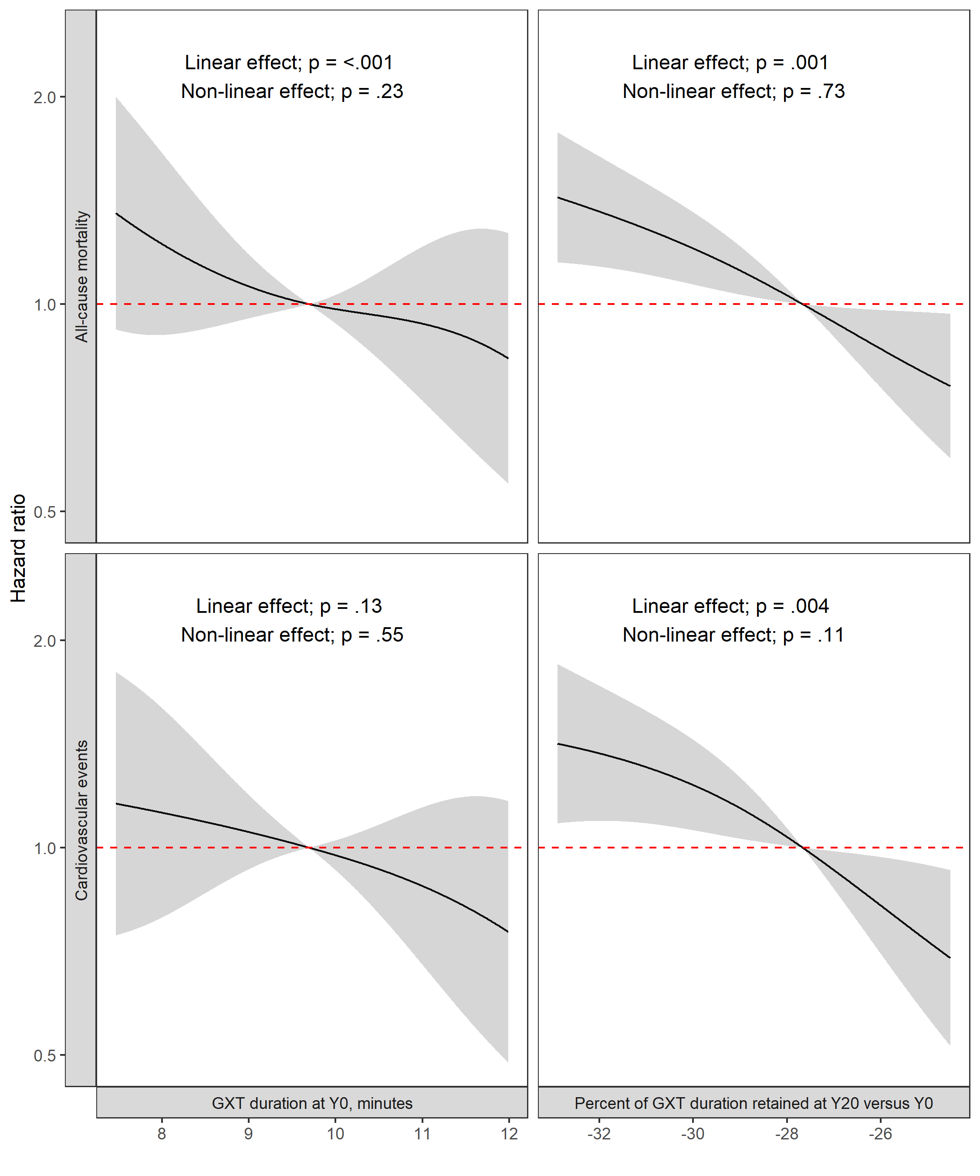

Grey shaded areas represent 95% confidence intervals for the point-estimate.

**Figure 2**: Multivariable-adjusted hazard ratios for all-cause mortality.

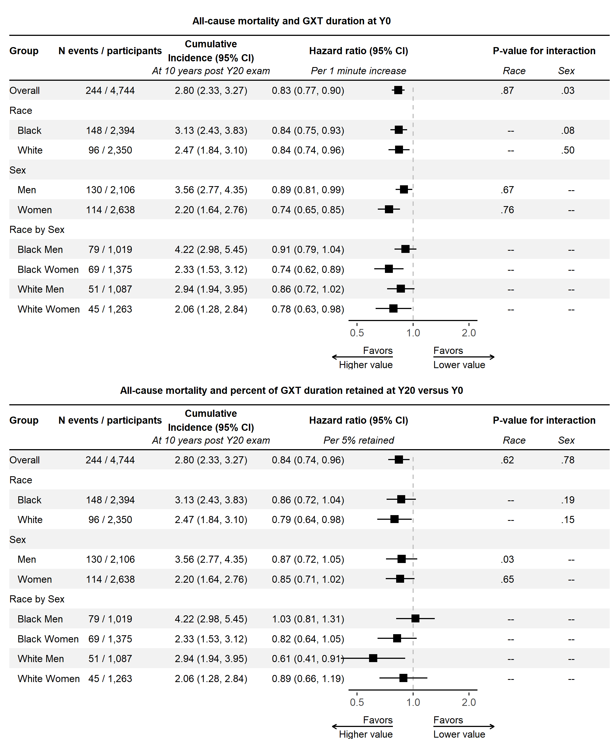

**Figure 3**: Multivariable-adjusted hazard ratios for cardiovascular events.

