Number and Timing of Ambulatory Blood Pressure Monitoring Measurements

Byron C. Jaeger, PhDa, Oluwasegun P. Akinyelure, MDb, Swati Sakhuja, MPHb, Joshua D. Bundy, PhD, MPHc, Cora E. Lewis, MD MSPHb, Yuichiro Yano, MD, PhDd, George Howard, DrPHa, Daichi Shimbo, MDe, Paul Muntner, PhDb, Joseph E. Schwartz, PhDe,f

1. Department of Biostatistics, University of Alabama at Birmingham, Birmingham, AL
2. Department of Epidemiology, University of Alabama at Birmingham, Birmingham, AL
3. Department of Epidemiology, Tulane University School of Public Health and Tropical Medicine, New Orleans, LA
4. Department of Medicine, Duke University, Durham, NC
5. Department of Medicine, Columbia University Irving Medical Center, New York City, NY
6. Department of Psychiatry, Stony Brook School of Medicine, Stony Brook, NY

**Word count exclusive of references, tables, and figure legends**

* Abstract: 196
* Text: 3434

# ABSTRACT

Ambulatory blood pressure (BP) monitoring (ABPM) may cause sleep disturbances. Some home BP monitoring (HBPM) devices obtain a limited number of BP readings during sleep and may be preferred to ABPM. It is unclear how closely a few BP readings approximate a full night of ABPM. We used data from the Jackson Heart (N=621) and Coronary Artery Risk Development in Young Adults (N=458) studies to evaluate 74 alternatives for sampling BP during sleep. We sampled 2 to 4 BP measurements at specific times from a full night of ABPM and computed chance-corrected agreement (i.e., Kappa) of nocturnal hypertension (i.e., mean asleep systolic BP≥120 mmHg or diastolic BP≥70 mmHg) defined using the full night of ABPM and subsets of BP readings. Measuring BP at 2, 3, and 4 hours after falling asleep, an approach applied by some HBPM devices, obtained a Kappa of 0.81 (95% confidence interval [CI]: 0.78, 0.85). The highest Kappa was obtained by measuring BP at 1, 2, 4, and 5 hours after falling asleep: 0.84 (95% CI: 0.81, 0.87). In conclusion, measuring BP 3 or 4 times during sleep may have high agreement with hypertension status based on a full night of ABPM.

*Key words:* ambulatory monitoring; blood pressure measurement; nocturnal hypertension

# INTRODUCTION

Higher blood pressure (BP) levels during sleep have been associated with an increased risk for cardiovascular disease (CVD) and target organ damage, independent of BP measured in a clinical setting.1–6 Ambulatory BP monitoring (ABPM) typically measures BP every 15 to 30 minutes throughout the day and night,7 and is recognized as the gold standard for measuring nocturnal BP.8 Although most people find ABPM acceptable, it may cause sleep disturbances for some individuals.9–12 Home BP monitoring (HBPM) is another approach for measuring BP outside of the office setting and some HBPM devices can be programmed to measure BP at specific times, including when someone is asleep. HBPM devices are available that measure BP at 2, 3, and 4 AM and 2, 3, and 4 hours after falling asleep.13–17

Obtaining fewer BP readings during sleep with an HBPM device instead of BP from a full night’s sleep on an ABPM device may reduce discomfort and disrupted sleep. However, the fewer BP measurements obtained using HBPM instead of ABPM may result in a loss of information and a weaker association with outcomes.18 Few studies have estimated the number and timing of BP measurements required to obtain an estimate of mean BP during sleep similar to that obtained by a full night of ABPM (i.e., using ABPM throughout an entire night). Others have previously studied the validity of using a fixed number of BP measurements, sampled randomly during wakefulness or sleep, to determine how many measurements were needed for reliable estimation of mean BP in the research setting.19,20 In the current study, we investigate the specific timing, as well as the number, of measurements needed for reliable estimation of mean BP during sleep. Using data from participants in the Jackson Heart Study (JHS) and the Coronary Artery Risk Development in Young Adults (CARDIA) study, we evaluated 74 variations on the number and timing of BP measurements during sleep to assess whether a limited number of BP measurements, taken at specific times, could provide an accurate estimate of mean BP from a full night of ABPM. From the complete set of ABPM measurements taken during sleep, subsets of 2 to 4 BP measurements at specific times were selected to represent HBPM during sleep. BP sampling variations were defined by the number and timing of the selected measurements.

# METHODS

## *Study population*

The JHS, a community-based prospective cohort study, was designed to evaluate the etiology of CVD among African Americans.21 The JHS enrolled 5,306 non-institutionalized African Americans aged ≥ 21 years from the Jackson, MS metropolitan area between 2000 and 2004. At the baseline JHS visit, 1,146 participants elected to undergo ABPM. The CARDIA study was designed to examine the development and determinants of clinical and subclinical CVD and their risk factors.22 The CARDIA study enrolled 5,115 participants, 18 to 30 years of age, at four field centers in the United States (Birmingham, AL; Chicago, IL; Minneapolis, MN; and Oakland, CA) in 1985-1986. During the Year 30 Exam (2015-2016), 831 CARDIA participants volunteered for an ABPM ancillary study conducted in the Birmingham, AL and Chicago, IL field centers.

We included participants who slept ≥ 5 hours and recorded ≥ 1 valid asleep BP measurement every 30 minutes from midnight to 5:00 AM during their ABPM assessment (N = 621 JHS and 458 CARDIA participants; Table S1). Conduct of each study was approved by institutional review boards at the participating institutions and the current analysis was approved by the University of Alabama at Birmingham Institutional Review Board. Written informed consent was obtained from all participants.

## *Ambulatory blood pressure monitoring*

In the JHS, ABPM was conducted using the previously validated SpaceLabs model 90207 device (SpaceLabs Healthcare, Snoqualmie, WA), and BP was measured every 20 minutes over a 24-hour period.23 JHS participants self-reported the times they went to sleep and woke up while wearing the ABPM device. In CARDIA, ABPM was conducted using the also validated SpaceLabs OnTrak model 90227 device (SpaceLabs Healthcare, Snoqualmie, WA), and BP was measured every 30 minutes over a 24-hour period.24 CARDIA participants also wore an Actiwatch activity monitor (Philips Respironics, Murrysville, PA) on the wrist of their non-dominant arm. In CARDIA, awake and asleep time periods were determined using the activity monitor data in conjunction with participants’ self-reported awake and asleep times. Nocturnal hypertension was defined by a mean SBP ≥ 120 mm Hg or mean DBP ≥ 70 mm Hg based on all BP measurements during sleep.

## *Blood pressure sampling strategies and variations*

We considered both ‘distributed’ and ‘consecutive’ strategies for sampling BP during sleep (Figure 1). The distributed strategies sampled BP at fixed intervals of 1 hour or more. The consecutive strategies sampled consecutive BP measurements. We considered 25 distributed and 12 consecutive BP sampling variations, and implemented each variation using either hours since midnight or hours since falling asleep. Overall, we assessed a total of 74 variations.

*Left ventricular hypertrophy and albuminuria*

Echocardiograms and urine specimens were obtained during the Year 30 Exam for CARDIA participants and during the baseline study visit for JHS participants. Left ventricular mass was determined and indexed to body surface area to obtain left ventricular mass index (LVMI) according to recommendations from the American Society of Echocardiography and European Association of Cardiovascular Imaging.25 Left ventricular hypertrophy (LVH) was defined as LVMI > 95 g/m2 in women and > 115 g/m2 in men. Urinary albumin and creatinine excretion, measured from urine specimens, were used to calculate urinary albumin-to-creatinine ratio (ACR). ACR was quantified using a 24-hour urine sample in the JHS, if available. Otherwise, a spot urine sample was used. In CARDIA, a spot urine sample was collected from all willing participants. Albuminuria was defined as an ACR ≥ 30 mg/g.

## *Statistical analyses*

Participant characteristics were summarized for the overall population and stratified by cohort. Differences between cohorts were assessed using t- and chi-square tests for continuous and categorical variables, respectively. The mean and standard deviation of SBP and DBP according to each BP sampling variation was tabulated along with the mean SBP and DBP according to a full night of ABPM. Linear regression with a natural cubic spline was applied to visualize the mean SBP and DBP over time from midnight to 5am and from onset of sleep to 5 hours thereafter among CARDIA and JHS participants, separately.

*Evaluation of 74 blood pressure sampling variations*: We computed the chance-corrected agreement (i.e., Kappa statistic) for the presence of nocturnal hypertension between each BP sampling variation and the full night of ABPM. The mean absolute difference in mean SBP and DBP during sleep between each BP sampling variation and full night of ABPM was also computed. The 74 BP sampling variations were grouped into 12 categories based on the number of measurements, sampling strategy (i.e., consecutive or distributed) and time structure (i.e., time since midnight or time since falling asleep; Table S2). Within each category, we defined the best variation as the one that obtained the highest Kappa statistic. We applied bootstrap resampling to estimate differences in Kappa statistics between the best sampling variation from each category and the Kappa statistics obtained by sampling BP at 2, 3, and 4 hours after falling asleep or midnight. Kappa statistics using BP sampled at 2, 3, and 4 hours after falling asleep or midnight was selected for comparison as these two variations has been used in previous studies and are applied by some HBPM devices.13–17 We also conducted pairwise comparisons of Kappa statistics among the 12 best BP sampling variations of their category. Bootstrap resampling was applied using bias correction and acceleration.26

*Prevalence ratios and concordance*: Poisson regression with robust standard error estimation was applied to obtain prevalence ratios and concordance (C-statistic) for the outcomes of LVH and albuminuria.27 Models were fit using SBP and DBP from the full night of ABPM and using SBP and DBP from the best BP sampling variations within the categories described above. DeLong’s test was applied to assess whether individual BP sampling variations obtained different C-statistics for LVH or albuminuria compared to a full night of ABPM.28 All models included adjustment for age, sex, race, smoking status, diabetes, antihypertensive medication use, and sleep duration. Models fitted to the pooled JHS and CARDIA data additionally adjusted for cohort.

*Consistency of results between the JHS and CARDIA*: We calculated the Spearman rank order correlation coefficient for rankings of BP sampling variations by Kappa statistic within the JHS and CARDIA studies. A high correlation between the rankings would indicate that BP sampling variations were ranked similarly in the two studies; i.e., that the results were consistent across the two studies.

Analyses were conducted using R version 4.0.4 (Vienna, Austria) and several additional R packages.29–33 Code for the current analysis is available at <https://github.com/bcjaeger/number-and-timing-of-ABPM>. Data to replicate the current analysis can be requested from the JHS and CARDIA study Executive Committees.

# RESULTS

Among 1,079 participants included in the current analysis, the mean (standard deviation; SD) age was 57.1 (8.57) years, 32.0% were male and 81.0% were black. Among JHS and CARDIA participants, the mean (SD) asleep SBP was 120 (14.7) mm Hg and 111 (15.1) mm Hg, respectively (Table 1; p < 0.001), and the mean (SD) asleep DBP was 67.8 (9.16) mm Hg and 66.3 (8.59) mm Hg, respectively (p = 0.006). There was no evidence of a difference in the prevalence of LVH (p = 0.336) or albuminuria (p = 0.290) between JHS and CARDIA participants. Most BP sampling variations underestimated the mean SBP and DBP according to a full night of ABPM by 1 to 2 mm Hg (Table S3). Descriptive visualizations of SBP and DBP during sleep suggest that this underestimation is attributable to fewer BP values sampled during the later stages of sleep (Figures S1 and S2). Put another way, after 5am or after 5 hours of sleep, BP tends to be higher than from 1am to 5am or during the first 1 to 5 hours of sleep, respectively.

## *Evaluation of 74 blood pressure sampling variations*

Table S4 presents Kappa statistics and mean absolute differences for all 74 BP sampling variations compared with mean BP from a full night of ABPM. In the pooled cohort, 14 BP sampling variations obtained an estimated Kappa for nocturnal hypertension statistic ≥ 0.80. There was substantial variation in the Kappa statistic depending on the timing of BP measurements; e.g., among BP sampling variations with 3 measurements using hours after falling asleep or after midnight, Kappa statistics ranged from 0.69 to 0.83 and from 0.69 to 0.81, respectively. In particular, Kappa statistics (95% confidence interval [CI]) from sampling variations used in prior studies – sampling BP at 2, 3, and 4 hours after falling asleep or after midnight – were 0.81 (0.78, 0.85) and 0.77 (0.73, 0.81), respectively. Neither of these BP variations were among those that obtained the highest Kappa statistic within their respective categories, which are presented in Table 2. Sampling BP at 1, 2, 4, and 5 hours after falling asleep or after midnight obtained Kappa statistics (95% CI) of 0.84 (0.81, 0.87) and 0.82 (0.78, 0.85), respectively. For the sampling variation with the highest Kappa statistic in the pooled cohort – BP sampled at 1, 2, 4 and 5 hours after falling asleep – participants asleep SBP and DBP differed by an average of 3.11 (95% CI 2.97, 3.26) and 2.66 (95% CI 2.53, 2.78) mm Hg, respectively, from the corresponding asleep BPs calculated from a full night of ABPM. For SBP, this was the lowest mean absolute difference obtained by any of the BP sampling variations.

The sampling variation with the highest Kappa statistic among those that used 3 BP measurements – BP sampled at 1, 2, and 4 hours after falling asleep – obtained a 0.02 (95% CI -0.03, 0.08) higher Kappa statistic among CARDIA participants but a -0.01 (95% CI -0.05, 0.05) lower Kappa among JHS participants compared to sampling BP at 2, 3, and 4 hours after falling asleep (Table 3). Sampling BP at 1, 2, 4, and 5 hours after falling asleep resulted in 0.03 (95% CI -0.02, 0.08) and 0.03 (95% CI -0.03, 0.09) higher Kappa statistic in the JHS and CARDIA, respectively, compared to sampling BP at 2, 3, and 4 hours after falling asleep. Pairwise comparisons of Kappa statistics between each category indicated that, in both cohorts, distributed sampling variations exhibited higher agreement with a full night of ABPM than consecutive variations (Figures S3 and S4). Also, in CARDIA, using 4 instead of 3 BP measurements resulted in a statistically significant increase in the Kappa statistic when time was measured in hours since midnight.

## *Prevalence ratios and concordance*

The prevalence ratios (95% CI) for LVH associated with a 10 mm Hg higher mean asleep SBP according to a full night of ABPM or BP sampled 1, 2, 4, and 5 hours after falling sleep were 1.22 (1.02, 1.46) and 1.24 (1.04, 1.48), respectively (Table 4). The C-statistics for mean asleep SBP according to a full night of ABPM or BP sampled 1, 2, 4, and 5 hours after falling asleep were 0.712 (0.659, 0.765) and 0.705 (0.651, 0.760), respectively (p-value for difference: 0.31; Table 5).

The prevalence ratios (95% CI) for albuminuria associated with a 10 mm Hg higher mean asleep SBP according to a full night of ABPM or BP assessed 1, 2, 4, and 5 hours after falling asleep were 1.27 (1.07, 1.52) and 1.35 (1.15, 1.60), respectively (Table S5). The C-statistics for mean asleep SBP from a full night of ABPM and for BP assessed 1, 2, 4, and 5 hours after falling asleep were 0.774 (0.719, 0.829) and 0.776 (0.720, 0.832), respectively (p-value for difference: 0.72; Table S6).

## *Consistency of results between the JHS and CARDIA*

The correlations between the JHS and CARDIA cohort rankings of BP sampling variations according to the mean absolute difference in SBP, mean absolute difference in DBP, and Kappa statistics were 0.92, 0.93, and 0.78, respectively.

# DISCUSSION

In the current study, the highest Kappa statistic assessing agreement with nocturnal hypertension based on a full ABPM assessment, and lowest mean absolute difference for estimating mean SBP during sleep, resulted from sampling BP at 1, 2, 4, and 5 hours after falling asleep. The prevalence ratios for LVH and albuminuria based on sampling BP at these times were slightly higher than prevalence ratios based on the full night of ABPM. There was no evidence that the ability of sleep BP based on this sampling variation to discriminate (i.e., C-statistic) those with versus without LVH or albuminuria was different than sleep BP based on a full night of ABPM. The low mean absolute differences of roughly 3.1 mm Hg and 2.7 mm Hg for SBP and DBP, respectively, when sampling BP at 1, 2, 4, and 5 hours after falling asleep suggests that this approach may be a suitable method to approximate mean BP according to a full night of ABPM. The high correlation of Kappa statistics and mean absolute difference rankings for the 74 BP sampling variations in CARDIA and the JHS indicated that results were consistent across the two cohorts, suggesting that findings from the current study were not overly influenced by a single cohort.

Yang et. al., and Rinfret et. al., independently investigated how many BP readings should be collected in order to obtain a reasonably accurate estimate of mean daytime and nighttime BP or mean BP using HBPM twice in the morning and twice in the evening for one week.19,20 Each analysis examined scenarios where BP measurements were randomly sampled from a larger set of BP measurements. Yang et. al., concluded that randomly measuring BP four times during sleep versus measuring BP throughout sleep does not lead to a meaningful loss of information in hypertension categorization or risk stratification.19 The current results are consistent with findings from Yang et. al., indicating that four BP measurements are sufficient for estimating BP during sleep, but further demonstrate that the timing of BP measurements substantially impacts the accuracy of mean BP during sleep. Given that 24 BP measurements are expected during 8 hours of sleep with one measurement every 20 minutes, collecting only four BP measurements at select times may substantially lower sleep disturbance without meaningful loss of information.

Sleep disturbance is a known side effect of ABPM for some individuals.34 A previous study evaluating the acceptability of an ABPM device among 110 pregnant women found that 28.8% reported difficulty initiating sleep with ABPM, 56.3% reported difficulty maintaining sleep with ABPM, and sleep disturbance was associated with increased odds of discontinuing ABPM (odds ratio for discontinuation: 1.68, 95% CI: 1.23, 2.27). Waking due to the inflation of ABPM cuffs can also increase BP and falsely suggest BP does not decline during sleep, an ABPM phenotype known as non-dipping.35 The current study introduces strategies that may reduce sleep disturbance by reducing the number of BP measurements taken during sleep. In total, 14 BP sampling variations obtained an estimated Kappa for nocturnal hypertension statistic ≥ 0.80, suggesting strong agreement with a full night of ABPM. These results suggest that devices can be designed with a large set of valid sampling options to estimate mean BP during sleep.

In the Japan Morning Surge Home Blood Pressure (J-HOP) study, mean BP from a self-measured HBPM device programmed to measure BP at 2am, 3am, and 4am was associated with LVMI and ACR, independent of clinic BP and home BP during the morning and evening.15 The current study replicates these results by showing that BP measured 2 to 4 times during sleep is associated with LVH and albuminuria in other cohorts. Another analysis of the J-HOP data found that the average of BP readings assessed at 2am, 3am, and 4am over an average of 8.89 nights, using the same HBPM device, was associated with incident CVD events, but found no evidence of association between mean BP from a single night of ABPM and CVD.36 The current study found a mean absolute difference of roughly 4 mm Hg in SBP between a full night of ABPM and measuring BP at 2am, 3am, and 4am. Future studies should identify whether the additional prognostic value of HBPM versus ABPM for incident CVD risk persists when both techniques are repeated over multiple nights.

The current study assessed BP sampling variations that measured BP at specific times relative to midnight and at specific times relative to the onset of sleep. Although both approaches are valid, the latter may be more likely to adequately measure BP during sleep in samples where participants go to sleep at a broad range of times. Study participants may also prefer the latter definition as it does not require them to be asleep at specific times. Future studies should investigate the reliability of and preference for HBPM devices that are programmed to measure BP at times relative to midnight versus relative to the onset of sleep.

The current study has several strengths. We analyzed data from two cohorts that collected ABPM data. We investigated a comprehensive set of variations for sampling BP during sleep, allowing us to identify several variants that exhibited high agreement with full ABPM. We conducted analyses separately by cohort, and the parallel assessment of each BP sampling variant reduced the likelihood of finding spurious results that would not generalize to broader settings. In addition, the current study has some limitations. While sleep was monitored using actigraphy in the CARDIA cohort, the JHS relied on self-reported sleep diaries to identify awake and asleep times. Due to strict inclusion criteria, especially the requirement that there be a valid BP reading every 30 minutes between midnight and 5 AM, the current study excluded a substantial proportion of participants from each cohort. Results from the current study may not generalize to settings where participants sleep for <5 hours or miss planned BP measurements, e.g. older adults who typically wake up early and often do not sleep for 5 consecutive hours.

In conclusion, measuring BP 3 or 4 times during sleep with at least 1 hour between measurements may provide mean asleep BP estimates that have high agreement with a full night of ABPM and are similarly predictive of target organ damage. Investigators of BP during sleep may find the current study’s results relevant for designing and implementing future studies that measure BP during sleep, as the use of 3 to 4 BP measurements instead of 16 or more BP measurements could improve study recruitment and increase the likelihood of participants agreeing to have their sleep BP assessed multiple times. Results from the current study also suggest desirability for HBPM devices that measure BP at specific times during sleep, allowing users to program the number of readings and specific assessment times.

# Acknowledgements

The Jackson Heart Study (JHS) is supported and conducted in collaboration with Jackson State University (HHSN268201800013I), Tougaloo College (HHSN268201800014I), the Mississippi State Department of Health (HHSN268201800015I/HHSN26800001) and the University of Mississippi Medical Center (HHSN268201800010I, HHSN268201800011I and HHSN268201800012I) contracts from the National Heart, Lung, and Blood Institute (NHLBI) and the National Institute for Minority Health and Health Disparities (NIMHD). The authors also wish to thank the staffs and participants of the JHS.

The CARDIA (Coronary Artery Risk Development in Young Adults) study is conducted and supported by the NHLBI in collaboration with the University of Alabama at Birmingham (HHSN268201800005I and HHSN268201800007I), Northwestern University (HHSN268 201800003I), University of Minnesota (HHSN2682018000 06I), and Kaiser Foundation Research Institute (HHSN268201 800004I). The funding to conduct ambulatory blood pressure monitoring in the CARDIA study was provided by grant 15SFRN2390002 from the American Heart Association.

# Conflict of Interest

PM received grant funding and consulting fees from Amgen Inc., unrelated to the current manuscript. All other authors have nothing to disclose.

# Disclaimer

The views expressed in this manuscript are those of the authors and do not necessarily represent the views of the National Heart, Lung, and Blood Institute; the National Institutes of Health; or the U.S. Department of Health and Human Services.

Table 1: Participant characteristics in the overall population and stratified by study.

|  | | **Study** | |  |
| --- | --- | --- | --- | --- |
| **Characteristic\*** | **Overall (N = 1079)** | **CARDIA (N = 458)** | **JHS (N = 621)** | **P-value‖** |
| Age, years | 57.1 (8.57) | 54.7 (3.70) | 58.8 (10.5) | < 0.001 |
| Male, % | 32.0 | 37.8 | 27.7 | < 0.001 |
| Black, % | 81.0 | 55.2 | 100 | < 0.001 |
| Education, % |  |  |  | < 0.001 |
| College graduate | 62.3 | 61.1 | 63.2 |  |
| High School graduate/GED | 10.5 | 0.00 | 18.2 |  |
| Less than High School | 27.2 | 38.9 | 18.5 |  |
| Current smoker, %† | 10.8 | 12.9 | 9.25 | 0.071 |
| Diabetes, %‡ | 22.3 | 17.7 | 25.6 | 0.003 |
| Albuminuria, % | 8.06 | 6.99 | 9.09 | 0.290 |
| Left ventricular mass indexed to BSA, g/m2 | 77.5 (21.1) | 78.8 (20.2) | 76.7 (21.7) | 0.109 |
| Left ventricular hypertrophy, % | 9.78 | 8.59 | 10.6 | 0.336 |
| Sleep duration, hours | 8.00 (1.47) | 7.62 (1.43) | 8.29 (1.44) | < 0.001 |
| Nocturnal hypertension, %§ | 46.9 | 36.7 | 54.4 | < 0.001 |
| Antihypertensive medication use, % | 53.3 | 43.5 | 60.6 | < 0.001 |
| Blood pressure, mm Hg | | | | |
| Asleep systolic | 116 (15.6) | 111 (15.1) | 120 (14.7) | < 0.001 |
| Asleep diastolic | 67.2 (8.95) | 66.3 (8.59) | 67.8 (9.16) | 0.006 |
| Clinic systolic | 124 (16.2) | 119 (15.1) | 128 (16.0) | < 0.001 |
| Clinic diastolic | 73.8 (9.25) | 72.9 (9.86) | 74.5 (8.71) | 0.004 |
| *Table values are mean (standard deviation) and percent for continuous and categorical variables, respectively. | | | | |
| †Smoking status was defined as self-reporting cigarette use within the past year. | | | | |
| ‡Diabetes was defined as fasting (8+ hours) glucose of at least 126 mg/dL or current use of anti-diabetes medication. | | | | |
| §Nocturnal hypertension was defined as asleep systolic/diastolic blood pressure ≥120/70 mm Hg. | | | | |
|  | | | | |
| ‖p-values correspond to t-tests and chi-square tests for continuous and categorical variables, respectively, for differences between cohorts. | | | | |
| Missing counts (%): albuminuria: 148 (14%); left ventricular mass and hypertrophy: 57 (5.3%); antihypertensive medication use: 8 (0.74%); Smoking status: 6 (0.56%); diabetes: 2 (0.19%); education: 1 (0.09%) | | | | |
| BSA = body surface area; CARDIA = Coronary Artery Risk Development in Young Adults; GED = General Educational Development; JHS = Jackson Heart Study | | | | |

Table 2: Kappa statistics and mean absolute error for the blood pressure sampling variation that obtained the highest overall chance-corrected agreement (i.e., Kappa statistic) with ambulatory blood pressure monitoring throughout sleep within each of the 12 categories defined by number of measurements, sampling strategy and time structure.

| **BP sampling variation\*** | **Kappa statistic (95% CI) for nocturnal hypertension†‡** | | | **Mean absolute error (95% CI) for mean systolic BP during sleep** | | | **Mean absolute error (95% CI) for mean diastolic BP during sleep** | | |
| --- | --- | --- | --- | --- | --- | --- | --- | --- | --- |
| **Overall** | **CARDIA** | **JHS** | **Overall** | **CARDIA** | **JHS** | **Overall** | **CARDIA** | **JHS** |
| *2 Consecutive BP measurements* | | | | | | | | | |
| starting at 4 hours after midnight | 0.72 (0.68, 0.76) | 0.72 (0.65, 0.79) | 0.71 (0.65, 0.76) | 5.31 (5.06, 5.55) | 5.46 (5.08, 5.86) | 5.20 (4.88, 5.53) | 4.55 (4.33, 4.77) | 4.65 (4.33, 5.00) | 4.48 (4.19, 4.76) |
| starting at 2 hours after falling asleep | 0.73 (0.69, 0.77) | 0.72 (0.65, 0.79) | 0.72 (0.66, 0.77) | 5.52 (5.24, 5.81) | 5.42 (5.01, 5.89) | 5.57 (5.23, 5.94) | 4.53 (4.30, 4.76) | 4.44 (4.07, 4.81) | 4.59 (4.28, 4.88) |
| *2 Distributed BP measurements* | | | | | | | | | |
| at 1 and 3 hours after midnight | 0.74 (0.70, 0.78) | 0.78 (0.72, 0.84) | 0.70 (0.65, 0.76) | 4.86 (4.64, 5.09) | 4.72 (4.37, 5.10) | 4.97 (4.68, 5.25) | 3.95 (3.75, 4.16) | 3.74 (3.44, 4.08) | 4.10 (3.83, 4.37) |
| at 1 and 5 hours after falling asleep | 0.77 (0.73, 0.81) | 0.79 (0.73, 0.85) | 0.75 (0.69, 0.80) | 4.67 (4.46, 4.88) | 4.54 (4.21, 4.90) | 4.77 (4.50, 5.05) | 3.81 (3.61, 4.00) | 3.55 (3.26, 3.85) | 3.98 (3.74, 4.25) |
| *3 Consecutive BP measurements* | | | | | | | | | |
| starting at 1 hours after midnight | 0.74 (0.70, 0.78) | 0.75 (0.68, 0.81) | 0.72 (0.66, 0.77) | 4.88 (4.64, 5.12) | 4.77 (4.41, 5.16) | 4.95 (4.63, 5.28) | 4.08 (3.87, 4.28) | 3.96 (3.66, 4.29) | 4.16 (3.87, 4.46) |
| starting at 1 hours after falling asleep | 0.76 (0.72, 0.80) | 0.77 (0.71, 0.83) | 0.73 (0.68, 0.78) | 5.27 (5.02, 5.53) | 4.79 (4.43, 5.15) | 5.64 (5.27, 6.00) | 4.27 (4.06, 4.47) | 3.87 (3.59, 4.17) | 4.56 (4.28, 4.84) |
| *3 Distributed BP measurements* | | | | | | | | | |
| at 1, 2 and 4 hours after midnight | 0.79 (0.75, 0.83) | 0.80 (0.74, 0.86) | 0.77 (0.72, 0.82) | 3.82 (3.63, 4.02) | 3.93 (3.65, 4.20) | 3.74 (3.49, 3.99) | 3.25 (3.09, 3.42) | 3.25 (2.99, 3.50) | 3.27 (3.06, 3.48) |
| at 1, 2 and 4 hours after falling asleep | 0.82 (0.78, 0.85) | 0.83 (0.78, 0.89) | 0.80 (0.75, 0.84) | 4.01 (3.83, 4.20) | 4.01 (3.73, 4.28) | 4.01 (3.77, 4.26) | 3.31 (3.15, 3.46) | 3.07 (2.85, 3.30) | 3.49 (3.28, 3.69) |
| *4 Consecutive BP measurements* | | | | | | | | | |
| starting at 1 hours after midnight | 0.77 (0.73, 0.81) | 0.80 (0.74, 0.86) | 0.74 (0.69, 0.79) | 4.30 (4.10, 4.51) | 4.09 (3.80, 4.42) | 4.46 (4.18, 4.74) | 3.66 (3.47, 3.84) | 3.40 (3.13, 3.68) | 3.84 (3.61, 4.09) |
| starting at 1 hours after falling asleep | 0.78 (0.74, 0.81) | 0.78 (0.72, 0.84) | 0.76 (0.71, 0.81) | 4.58 (4.36, 4.81) | 4.16 (3.86, 4.48) | 4.89 (4.58, 5.21) | 3.71 (3.53, 3.90) | 3.31 (3.07, 3.57) | 4.01 (3.77, 4.26) |
| *4 Distributed BP measurements* | | | | | | | | | |
| at 1, 2, 4 and 5 hours after midnight | 0.82 (0.78, 0.85) | 0.85 (0.81, 0.90) | 0.78 (0.73, 0.83) | 3.16 (3.01, 3.32) | 3.15 (2.92, 3.37) | 3.18 (2.97, 3.38) | 2.61 (2.48, 2.76) | 2.60 (2.38, 2.85) | 2.62 (2.46, 2.79) |
| at 1, 2, 4 and 5 hours after falling asleep | 0.84 (0.81, 0.87) | 0.84 (0.79, 0.89) | 0.83 (0.79, 0.88) | 3.11 (2.97, 3.26) | 3.10 (2.88, 3.33) | 3.13 (2.94, 3.32) | 2.66 (2.53, 2.78) | 2.48 (2.30, 2.66) | 2.79 (2.62, 2.95) |
| BP = blood pressure; CARDIA = Coronary Artery Risk Development in Young Adults; CI = confidence interval; JHS = Jackson Heart Study | | | | | | | | | |
| *Blood pressure sampling variations were compared to other variations that measure blood pressure the same number of times (i.e., 2, 3, or 4) using the same strategy (i.e., consecutive or distributed) and the same time reference (i.e., midnight or onset of sleep). Each of these 12 comparison groups had one variation with the highest overall Kappa statistic, and those variations are presented here. | | | | | | | | | |
| †Kappa statistics measure the chance-corrected agreement in classification of nocturnal hypertension between ambulatory blood pressure monitoring throughout sleep and a blood pressure sampling variation. | | | | | | | | | |
| ‡Nocturnal hypertension was defined as asleep systolic blood pressure ≥120 mm Hg or asleep diastolic blood pressure ≥70 mm Hg. | | | | | | | | | |

Table 3: Difference (95% confidence interval) in chance-corrected agreement (Kappa statistic) with a full night of ambulatory blood pressure monitoring in classification of nocturnal hypertension for the best blood pressure sampling variation within each of the 12 categories defined by number of measurements, sampling strategy and time structure versus sampling blood pressure at 2, 3, and 4 hours after falling asleep or midnight.

| **BP sampling variation** | **Overall** | **CARDIA** | **JHS** |
| --- | --- | --- | --- |
| *Time is measured in hours after falling asleep* | | | |
| 3 distributed BP measurements at 2, 3 and 4* | 0.81 (reference)† | 0.81 (reference) | 0.80 (reference) |
| 2 consecutive BP measurements starting at 2 | -0.08 (-0.13, -0.04)† | -0.09 (-0.16, -0.03) | -0.08 (-0.14, -0.03) |
| 3 consecutive BP measurements starting at 1 | -0.06 (-0.10, -0.01) | -0.04 (-0.11, 0.03) | -0.07 (-0.14, -0.01) |
| 4 consecutive BP measurements starting at 1 | -0.04 (-0.08, 0.01) | -0.03 (-0.11, 0.04) | -0.04 (-0.10, 0.02) |
| 2 distributed BP measurements at 1 and 5 | -0.04 (-0.09, 0.01) | -0.02 (-0.10, 0.05) | -0.06 (-0.12, 0.01) |
| 3 distributed BP measurements at 1, 2 and 4 | 0.01 (-0.03, 0.04) | 0.02 (-0.03, 0.08) | -0.01 (-0.05, 0.05) |
| 4 distributed BP measurements at 1, 2, 4 and 5 | 0.03 (-0.01, 0.06) | 0.03 (-0.03, 0.09) | 0.03 (-0.02, 0.08) |
| *Time is measured in hours after midnight* | | | |
| 3 distributed BP measurements at 2, 3 and 4* | 0.77 (reference) | 0.80 (reference) | 0.75 (reference) |
| 2 consecutive BP measurements starting at 4 | -0.05 (-0.10, -0.01) | -0.08 (-0.15, -0.01) | -0.04 (-0.10, 0.03) |
| 3 consecutive BP measurements starting at 1 | -0.04 (-0.09, 0.01) | -0.05 (-0.13, 0.02) | -0.03 (-0.09, 0.04) |
| 4 consecutive BP measurements starting at 1 | 0.00 (-0.05, 0.04) | 0.00 (-0.07, 0.06) | 0.00 (-0.07, 0.06) |
| 2 distributed BP measurements at 1 and 3 | -0.03 (-0.08, 0.01) | -0.02 (-0.09, 0.04) | -0.04 (-0.11, 0.02) |
| 3 distributed BP measurements at 1, 2 and 4 | 0.02 (-0.03, 0.06) | 0.00 (-0.06, 0.06) | 0.03 (-0.03, 0.08) |
| 4 distributed BP measurements at 1, 2, 4 and 5 | 0.04 (0.00, 0.08) | 0.05 (0.00, 0.11) | 0.04 (-0.02, 0.09) |
| BP = blood pressure; CARDIA = Coronary Artery Risk Development in Young Adults; JHS = Jackson Heart Study | | | |
| *Because of its use in previous studies, the Kappa statistic obtained by this blood pressure sampling variation is a reference value for other blood pressure sampling variations that use the same time definition (i.e., hours since falling asleep or hours since midnight). | | | |
| †Table values are Kappa statistic for the referent blood pressure sampling variations and the change in Kappa statistic (95% confidence interval) relative to the reference for non-referent blood pressure sampling variations. | | | |
| Kappa statistics measure the chance-corrected agreement in classification of nocturnal hypertension between ambulatory blood pressure monitoring throughout sleep and a blood pressure sampling variation. | | | |
| Nocturnal hypertension was defined as asleep systolic blood pressure ≥120 mm Hg or asleep diastolic blood pressure ≥70 mm Hg. | | | |

Table 4: Prevalence ratios (95% confidence intervals) for left ventricular hypertrophy associated with mean systolic blood pressure.

| **Blood pressure sampling variation\*** | **Overall** | | **CARDIA** | | **JHS** | |
| --- | --- | --- | --- | --- | --- | --- |
| **Prevalence ratio†‡** | **P-value** | **Prevalence ratio†‡** | **P-value** | **Prevalence ratio†‡** | **P-value** |
| Full night of ABPM | 1.22 (1.02, 1.46) | .03 | 1.44 (1.13, 1.83) | .004 | 1.14 (0.88, 1.48) | .33 |
| *2 Distributed BP measurements* | | | | | | |
| at 1 and 3 hours after midnight | 1.25 (1.06, 1.47) | .009 | 1.57 (1.24, 1.99) | <.001 | 1.14 (0.90, 1.43) | .28 |
| at 1 and 5 hours after falling asleep | 1.25 (1.06, 1.46) | .006 | 1.42 (1.13, 1.78) | .003 | 1.19 (0.96, 1.49) | .11 |
| *2 Consecutive BP measurements* | | | | | | |
| starting at 2 hours after falling asleep | 1.18 (1.01, 1.39) | .04 | 1.31 (1.07, 1.60) | .009 | 1.10 (0.86, 1.42) | .45 |
| starting at 4 hours after midnight | 1.27 (1.07, 1.50) | .005 | 1.41 (1.13, 1.75) | .002 | 1.20 (0.96, 1.49) | .10 |
| *3 Distributed BP measurements* | | | | | | |
| at 1, 2 and 4 hours after falling asleep | 1.23 (1.03, 1.46) | .02 | 1.35 (1.04, 1.74) | .02 | 1.18 (0.92, 1.51) | .20 |
| at 1, 2 and 4 hours after midnight | 1.23 (1.04, 1.45) | .01 | 1.33 (1.05, 1.68) | .02 | 1.22 (0.97, 1.52) | .09 |
| *3 Consecutive BP measurements* | | | | | | |
| starting at 1 hours after falling asleep | 1.20 (1.02, 1.41) | .02 | 1.33 (1.06, 1.67) | .01 | 1.15 (0.91, 1.45) | .25 |
| starting at 1 hours after midnight | 1.18 (1.01, 1.39) | .04 | 1.39 (1.12, 1.72) | .003 | 1.10 (0.87, 1.38) | .45 |
| *4 Distributed BP measurements* | | | | | | |
| at 1, 2, 4 and 5 hours after falling asleep | 1.24 (1.04, 1.48) | .01 | 1.42 (1.10, 1.83) | .007 | 1.18 (0.93, 1.51) | .18 |
| at 1, 2, 4 and 5 hours after midnight | 1.20 (1.02, 1.43) | .03 | 1.30 (1.01, 1.67) | .04 | 1.19 (0.95, 1.50) | .13 |
| *4 Consecutive BP measurements* | | | | | | |
| starting at 1 hours after falling asleep | 1.21 (1.02, 1.42) | .03 | 1.35 (1.07, 1.70) | .01 | 1.13 (0.89, 1.44) | .31 |
| starting at 1 hours after midnight | 1.23 (1.05, 1.45) | .01 | 1.45 (1.15, 1.82) | .002 | 1.15 (0.91, 1.46) | .24 |
| CARDIA = Coronary Artery Risk Development in Young Adults; JHS = Jackson Heart Study | | | | | | |
| Left ventricular hypertrophy was defined as a left ventricular mass index >95 g/m2 in women and >115 g/m2 in men. | | | | | | |
| *Blood pressure sampling variations were compared to other variations that measure blood pressure the same number of times (i.e., 2, 3, or 4) using the same strategy (i.e., consecutive or distributed) and the same time reference (i.e., midnight or onset of sleep). Each of these 12 comparison groups had one variation with the highest overall Kappa statistic, and those variations are presented here. | | | | | | |
| †Prevalence ratios are adjusted for participant age, sex, diabetes status, smoking status, antihypertensive medication use and sleep duration | | | | | | |
| ‡Prevalence ratios correspond to 10 mm Hg higher systolic blood pressure | | | | | | |

Table 5: Concordance statistics for left-ventricular hypertrophy in a multivariable-adjusted model.

| **Blood pressure sampling variation\*** | **Overall** | | **CARDIA** | | **JHS** | |
| --- | --- | --- | --- | --- | --- | --- |
| **C-statistic (95% CI)‡** | **P-value for difference§** | **C-statistic (95% CI)** | **P-value for difference** | **C-statistic (95% CI)** | **P-value for difference** |
| Full night of ABPM | 0.712 (0.659, 0.765) | reference | 0.708 (0.622, 0.793) | reference | 0.717 (0.650, 0.783) | reference |
| Foregoing BP measurement† | 0.678 (0.623, 0.734) | .05 | 0.664 (0.578, 0.750) | .18 | 0.695 (0.625, 0.765) | .28 |
| *2 Distributed BP measurements* | | | | | | |
| at 1 and 3 hours after midnight | 0.713 (0.659, 0.768) | .85 | 0.722 (0.635, 0.809) | .32 | 0.712 (0.642, 0.782) | .53 |
| at 1 and 5 hours after falling asleep | 0.705 (0.651, 0.759) | .42 | 0.711 (0.632, 0.791) | .80 | 0.709 (0.639, 0.778) | .47 |
| *2 Consecutive BP measurements* | | | | | | |
| starting at 2 hours after falling asleep | 0.705 (0.650, 0.760) | .37 | 0.703 (0.615, 0.790) | .76 | 0.708 (0.639, 0.777) | .37 |
| starting at 4 hours after midnight | 0.710 (0.657, 0.763) | .85 | 0.700 (0.615, 0.786) | .71 | 0.716 (0.650, 0.782) | .93 |
| *3 Distributed BP measurements* | | | | | | |
| at 1, 2 and 4 hours after falling asleep | 0.698 (0.643, 0.753) | .14 | 0.694 (0.610, 0.779) | .30 | 0.704 (0.634, 0.774) | .34 |
| at 1, 2 and 4 hours after midnight | 0.706 (0.653, 0.760) | .44 | 0.698 (0.616, 0.780) | .58 | 0.716 (0.648, 0.785) | .95 |
| *3 Consecutive BP measurements* | | | | | | |
| starting at 1 hours after falling asleep | 0.699 (0.643, 0.754) | .12 | 0.697 (0.610, 0.784) | .40 | 0.704 (0.634, 0.773) | .28 |
| starting at 1 hours after midnight | 0.711 (0.658, 0.765) | .94 | 0.716 (0.632, 0.801) | .51 | 0.712 (0.643, 0.781) | .53 |
| *4 Distributed BP measurements* | | | | | | |
| at 1, 2, 4 and 5 hours after falling asleep | 0.705 (0.651, 0.760) | .31 | 0.704 (0.621, 0.788) | .74 | 0.709 (0.640, 0.778) | .41 |
| at 1, 2, 4 and 5 hours after midnight | 0.705 (0.652, 0.758) | .36 | 0.692 (0.610, 0.774) | .40 | 0.715 (0.648, 0.782) | .79 |
| *4 Consecutive BP measurements* | | | | | | |
| starting at 1 hours after falling asleep | 0.700 (0.644, 0.756) | .15 | 0.696 (0.608, 0.784) | .28 | 0.703 (0.634, 0.773) | .27 |
| starting at 1 hours after midnight | 0.714 (0.660, 0.768) | .72 | 0.724 (0.636, 0.811) | .20 | 0.712 (0.643, 0.781) | .55 |
| BP = blood pressure; C = concordance; CARDIA = Coronary Artery Risk Development in Young Adults; CI = confidence interval; JHS = Jackson Heart Study | | | | | | |
| Left ventricular hypertrophy was defined as a left ventricular mass index >95 g/m2 in women and >115 g/m2 in men. | | | | | | |
| *Blood pressure sampling variations were compared to other variations that measure blood pressure the same number of times (i.e., 2, 3, or 4) using the same strategy (i.e., consecutive or distributed) and the same time reference (i.e., midnight or onset of sleep). Each of these 12 comparison groups had one variation with the highest overall Kappa statistic, and those variations are presented here. | | | | | | |
| †Foregoing blood pressure measurement indicates omission of any term in the model predictors that corresponds to mean blood pressure during sleep | | | | | | |
| ‡All concordance statistics obtained from blood pressure sampling variations were compared to the concordance statistic obtained when blood pressure was measured throughout sleep. | | | | | | |
| §P-values were obtained using DeLong's test for correlated concordance statistics. | | | | | | |

Figure 1: Illustration of blood pressure sampling variations following a consecutive and distributed sampling strategy when blood pressure is measured every 30 minutes.

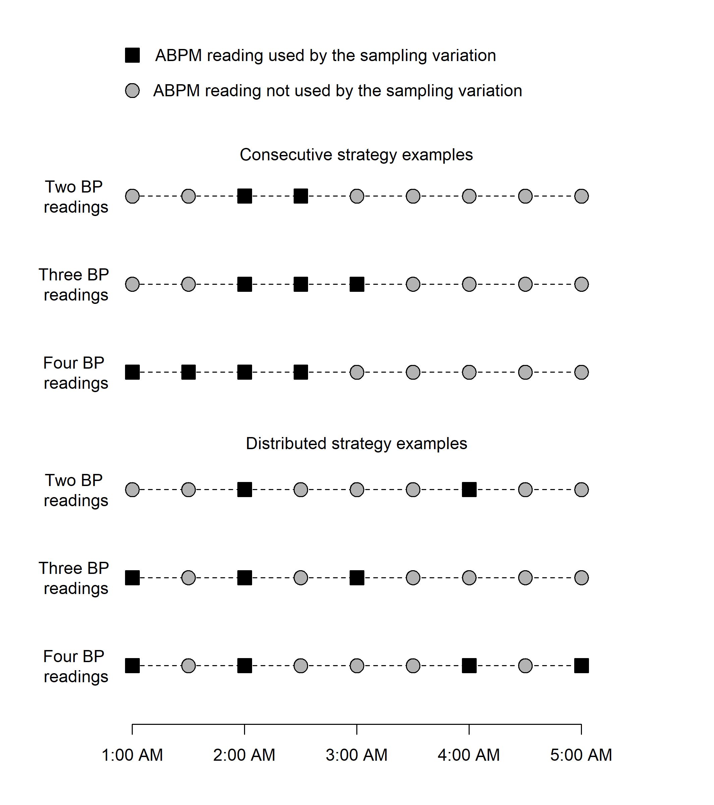

# SUPPLEMENT

Table S1: Participant inclusion cascade.

| **Inclusion criteria** | **Overall** | **CARDIA participants** | **JHS participants** |
| --- | --- | --- | --- |
| All study participants | 10,421 | 5,115 | 5,306 |
| Participants who underwent 24-hour ABPM. | 1,977 | 831 | 1,146 |
| Participants with ≥5 asleep systolic and diastolic blood pressure measurements. | 1,729 | 788 | 941 |
| Participants who were asleep for all measurements between 1am and 5am. | 1,499 | 645 | 854 |
| Participants with at least 1 systolic and diastolic blood pressure measurement within 30 minutes of all sampling times | 1,079 | 458 | 621 |
| ABPM = ambulatory blood pressure monitoring; CARDIA = Coronary Artery Risk Development in Young Adults; JHS = Jackson Heart Study | | | |

Table S2: Summary of 12 groups of blood pressure sampling variations.

| **Group description** | **BP sampling variations** |
| --- | --- |
| 2 Consecutive BP measurements, hours since falling asleep | starting at 1; starting at 2; starting at 3; and starting at 4 |
| 2 Consecutive BP measurements, hours since midnight | starting at 1am; starting at 2am; starting at 3am; and starting at 4am |
| 2 Distributed BP measurements, hours since falling asleep | at 1 and 2; at 1 and 3; at 1 and 4; at 1 and 5; at 2 and 3; at 2 and 4; at 2 and 5; at 3 and 4; at 3 and 5; and at 4 and 5 |
| 2 Distributed BP measurements, hours since midnight | at 1am and 2am; at 1am and 3am; at 1am and 4am; at 1am and 5am; at 2am and 3am; at 2am and 4am; at 2am and 5am; at 3am and 4am; at 3am and 5am; and at 4am and 5am |
| 3 Consecutive BP measurements, hours since falling asleep | starting at 1; starting at 2; starting at 3; and starting at 4 |
| 3 Consecutive BP measurements, hours since midnight | starting at 1am; starting at 2am; starting at 3am; and starting at 4am |
| 3 Distributed BP measurements, hours since falling asleep | at 1, 2 and 3; at 1, 2 and 4; at 1, 2 and 5; at 1, 3 and 4; at 1, 3 and 5; at 1, 4 and 5; at 2, 3 and 4; at 2, 3 and 5; at 2, 4 and 5; and at 3, 4 and 5 |
| 3 Distributed BP measurements, hours since midnight | at 1am, 2am and 3am; at 1am, 2am and 4am; at 1am, 2am and 5am; at 1am, 3am and 4am; at 1am, 3am and 5am; at 1am, 4am and 5am; at 2am, 3am and 4am; at 2am, 3am and 5am; at 2am, 4am and 5am; and at 3am, 4am and 5am |
| 4 Consecutive BP measurements, hours since falling asleep | starting at 1; starting at 2; starting at 3; and starting at 4 |
| 4 Consecutive BP measurements, hours since midnight | starting at 1am; starting at 2am; starting at 3am; and starting at 4am |
| 4 Distributed BP measurements, hours since falling asleep | at 1, 2, 3 and 4; at 1, 2, 3 and 5; at 1, 2, 4 and 5; at 1, 3, 4 and 5; and at 2, 3, 4 and 5 |
| 4 Distributed BP measurements, hours since midnight | at 1am, 2am, 3am and 4am; at 1am, 2am, 3am and 5am; at 1am, 2am, 4am and 5am; at 1am, 3am, 4am and 5am; and at 2am, 3am, 4am and 5am |

Table S3: Mean (standard deviation) of systolic and diastolic blood pressure to a full night of ambulatory blood pressure monitoring 74 blood pressure sampling variations.

| **BP sampling variation** | **Mean (standard deviation) systolic BP during sleep** | | | **Mean (standard deviation) diastolic BP during sleep** | | |
| --- | --- | --- | --- | --- | --- | --- |
| **Overall** | **CARDIA** | **JHS** | **Overall** | **CARDIA** | **JHS** |
| Full night of ABPM | 116.1 (15.6) | 110.8 (15.1) | 120.1 (14.7) | 67.2 (8.9) | 66.3 (8.6) | 67.8 (9.2) |
| *4 Consecutive BP measurements* | | | | | | |
| starting at 1 hours after midnight | 115.1 (16.5) | 110.0 (15.9) | 118.8 (15.9) | 66.2 (10.0) | 65.5 (9.4) | 66.7 (10.4) |
| starting at 2 hours after midnight | 114.8 (16.1) | 110.0 (15.4) | 118.4 (15.7) | 66.4 (9.7) | 66.0 (9.1) | 66.6 (10.1) |
| starting at 3 hours after midnight | 115.2 (16.4) | 110.5 (15.7) | 118.7 (16.0) | 66.8 (10.0) | 66.6 (9.6) | 66.9 (10.3) |
| starting at 4 hours after midnight | 116.1 (16.6) | 111.6 (16.4) | 119.4 (16.0) | 67.5 (10.0) | 67.4 (9.9) | 67.6 (10.1) |
| *3 Consecutive BP measurements* | | | | | | |
| starting at 1 hours after midnight | 115.2 (16.9) | 110.0 (16.3) | 119.1 (16.3) | 66.2 (10.3) | 65.4 (9.8) | 66.7 (10.7) |
| starting at 2 hours after midnight | 114.6 (16.4) | 109.8 (15.8) | 118.2 (15.9) | 66.2 (10.0) | 65.8 (9.6) | 66.4 (10.3) |
| starting at 3 hours after midnight | 115.0 (16.5) | 110.2 (15.8) | 118.5 (16.2) | 66.6 (10.3) | 66.3 (9.8) | 66.8 (10.6) |
| starting at 4 hours after midnight | 115.9 (16.7) | 111.2 (16.5) | 119.4 (16.1) | 67.4 (10.2) | 67.1 (10.1) | 67.6 (10.3) |
| *2 Consecutive BP measurements* | | | | | | |
| starting at 1 hours after midnight | 115.4 (17.5) | 110.3 (17.1) | 119.3 (16.8) | 66.1 (11.0) | 65.3 (10.6) | 66.7 (11.2) |
| starting at 2 hours after midnight | 114.6 (16.6) | 109.7 (16.2) | 118.2 (16.0) | 66.2 (10.3) | 65.8 (9.9) | 66.5 (10.7) |
| starting at 3 hours after midnight | 115.1 (16.8) | 110.2 (16.0) | 118.7 (16.5) | 66.6 (10.7) | 66.3 (10.3) | 66.8 (11.0) |
| starting at 4 hours after midnight | 115.6 (17.0) | 110.8 (16.7) | 119.2 (16.3) | 67.2 (10.6) | 66.9 (10.6) | 67.4 (10.5) |
| *4 Consecutive BP measurements* | | | | | | |
| starting at 1 hours after falling asleep | 115.8 (16.7) | 110.0 (15.8) | 120.1 (16.1) | 66.2 (10.1) | 65.1 (9.2) | 67.1 (10.5) |
| starting at 2 hours after falling asleep | 115.1 (16.5) | 109.7 (16.1) | 119.0 (15.6) | 66.0 (9.9) | 65.3 (9.3) | 66.6 (10.3) |
| starting at 3 hours after falling asleep | 114.8 (16.3) | 109.9 (16.0) | 118.3 (15.6) | 66.2 (9.9) | 65.9 (9.6) | 66.5 (10.2) |
| starting at 4 hours after falling asleep | 115.1 (16.4) | 110.7 (16.1) | 118.3 (15.9) | 66.7 (10.0) | 66.8 (9.6) | 66.6 (10.3) |
| *3 Consecutive BP measurements* | | | | | | |
| starting at 1 hours after falling asleep | 115.9 (17.1) | 110.0 (16.1) | 120.3 (16.5) | 66.3 (10.5) | 65.0 (9.7) | 67.3 (10.9) |
| starting at 2 hours after falling asleep | 115.1 (16.7) | 109.7 (16.3) | 119.1 (15.9) | 66.0 (10.1) | 65.2 (9.6) | 66.6 (10.5) |
| starting at 3 hours after falling asleep | 114.7 (16.5) | 109.6 (16.2) | 118.5 (15.7) | 66.1 (10.2) | 65.7 (9.8) | 66.5 (10.5) |
| starting at 4 hours after falling asleep | 114.9 (16.6) | 110.6 (16.2) | 118.1 (16.2) | 66.6 (10.4) | 66.7 (10.0) | 66.5 (10.6) |
| *2 Consecutive BP measurements* | | | | | | |
| starting at 1 hours after falling asleep | 116.2 (17.3) | 110.3 (16.3) | 120.6 (16.7) | 66.4 (11.0) | 65.0 (10.2) | 67.4 (11.5) |
| starting at 2 hours after falling asleep | 115.3 (17.2) | 109.8 (16.7) | 119.3 (16.4) | 66.0 (10.5) | 65.2 (10.0) | 66.6 (10.9) |
| starting at 3 hours after falling asleep | 114.8 (16.9) | 109.5 (16.7) | 118.6 (16.1) | 66.1 (10.6) | 65.4 (10.2) | 66.6 (10.9) |
| starting at 4 hours after falling asleep | 114.6 (17.0) | 110.2 (16.5) | 117.9 (16.6) | 66.4 (10.7) | 66.2 (10.4) | 66.5 (10.8) |
| *2 Distributed BP measurements* | | | | | | |
| at 1 and 2 hours after midnight | 115.0 (16.8) | 110.1 (16.3) | 118.7 (16.2) | 66.2 (10.5) | 65.5 (10.1) | 66.7 (10.8) |
| at 1 and 3 hours after midnight | 115.3 (16.8) | 110.2 (16.3) | 119.1 (16.2) | 66.5 (10.5) | 65.7 (10.1) | 67.0 (10.7) |
| at 1 and 4 hours after midnight | 115.5 (16.8) | 110.4 (16.4) | 119.2 (16.1) | 66.6 (10.3) | 66.0 (10.1) | 67.0 (10.5) |
| at 1 and 5 hours after midnight | 115.8 (16.8) | 111.3 (16.7) | 119.2 (16.1) | 66.9 (10.3) | 66.5 (10.1) | 67.2 (10.5) |
| at 2 and 3 hours after midnight | 114.7 (16.5) | 109.7 (15.9) | 118.4 (16.0) | 66.3 (10.2) | 65.7 (10.0) | 66.8 (10.4) |
| at 2 and 4 hours after midnight | 114.8 (16.6) | 109.9 (16.1) | 118.5 (15.9) | 66.5 (10.1) | 66.0 (9.9) | 66.8 (10.2) |
| at 2 and 5 hours after midnight | 115.2 (16.5) | 110.7 (16.3) | 118.5 (16.0) | 66.8 (10.1) | 66.5 (10.0) | 67.0 (10.2) |
| at 3 and 4 hours after midnight | 115.2 (16.7) | 110.0 (16.2) | 118.9 (16.1) | 66.7 (10.2) | 66.2 (10.1) | 67.1 (10.3) |
| at 3 and 5 hours after midnight | 115.5 (16.7) | 110.9 (16.5) | 118.9 (16.1) | 67.1 (10.3) | 66.7 (10.2) | 67.3 (10.3) |
| at 4 and 5 hours after midnight | 115.6 (17.0) | 111.1 (16.9) | 119.0 (16.3) | 67.2 (10.4) | 67.0 (10.4) | 67.3 (10.4) |
| *3 Distributed BP measurements* | | | | | | |
| at 1, 2 and 3 hours after midnight | 115.0 (16.3) | 110.0 (15.8) | 118.7 (15.8) | 66.3 (9.9) | 65.7 (9.5) | 66.8 (10.2) |
| at 1, 2 and 4 hours after midnight | 115.1 (16.3) | 110.1 (15.8) | 118.8 (15.7) | 66.4 (9.8) | 65.9 (9.5) | 66.8 (10.1) |
| at 1, 2 and 5 hours after midnight | 115.3 (16.3) | 110.7 (16.0) | 118.8 (15.7) | 66.6 (9.8) | 66.2 (9.6) | 67.0 (10.0) |
| at 1, 3 and 4 hours after midnight | 115.3 (16.4) | 110.2 (15.8) | 119.1 (15.7) | 66.6 (9.8) | 66.0 (9.5) | 67.0 (10.1) |
| at 1, 3 and 5 hours after midnight | 115.6 (16.4) | 110.8 (16.0) | 119.1 (15.7) | 66.8 (9.8) | 66.3 (9.6) | 67.2 (10.0) |
| at 1, 4 and 5 hours after midnight | 115.7 (16.4) | 110.9 (16.2) | 119.2 (15.7) | 66.9 (9.8) | 66.5 (9.7) | 67.2 (10.0) |
| at 2, 3 and 4 hours after midnight | 114.9 (16.2) | 109.8 (15.7) | 118.6 (15.6) | 66.5 (9.7) | 66.0 (9.5) | 66.9 (9.9) |
| at 2, 3 and 5 hours after midnight | 115.1 (16.2) | 110.4 (15.8) | 118.6 (15.6) | 66.7 (9.7) | 66.3 (9.6) | 67.0 (9.9) |
| at 2, 4 and 5 hours after midnight | 115.2 (16.3) | 110.5 (16.0) | 118.7 (15.7) | 66.8 (9.7) | 66.5 (9.6) | 67.0 (9.8) |
| at 3, 4 and 5 hours after midnight | 115.4 (16.4) | 110.7 (16.1) | 118.9 (15.8) | 67.0 (9.8) | 66.7 (9.7) | 67.2 (9.9) |
| *4 Distributed BP measurements* | | | | | | |
| at 1, 2, 3 and 4 hours after midnight | 115.1 (16.1) | 110.0 (15.5) | 118.8 (15.5) | 66.5 (9.6) | 65.9 (9.2) | 66.9 (9.8) |
| at 1, 2, 3 and 5 hours after midnight | 115.3 (16.1) | 110.5 (15.7) | 118.8 (15.5) | 66.6 (9.6) | 66.1 (9.3) | 67.0 (9.8) |
| at 1, 2, 4 and 5 hours after midnight | 115.3 (16.1) | 110.6 (15.7) | 118.9 (15.5) | 66.7 (9.5) | 66.3 (9.3) | 67.0 (9.7) |
| at 1, 3, 4 and 5 hours after midnight | 115.5 (16.2) | 110.7 (15.8) | 119.1 (15.5) | 66.8 (9.6) | 66.4 (9.3) | 67.2 (9.7) |
| at 2, 3, 4 and 5 hours after midnight | 115.2 (16.1) | 110.4 (15.7) | 118.7 (15.5) | 66.8 (9.5) | 66.4 (9.3) | 67.0 (9.6) |
| *2 Distributed BP measurements* | | | | | | |
| at 1 and 2 hours after falling asleep | 115.9 (17.1) | 110.2 (16.6) | 120.1 (16.3) | 66.2 (10.5) | 64.9 (9.9) | 67.1 (10.9) |
| at 1 and 3 hours after falling asleep | 115.7 (16.8) | 110.1 (16.3) | 119.8 (16.1) | 66.3 (10.5) | 65.1 (9.8) | 67.2 (10.9) |
| at 1 and 4 hours after falling asleep | 115.4 (16.7) | 110.2 (16.0) | 119.3 (16.2) | 66.4 (10.4) | 65.6 (10.0) | 67.1 (10.7) |
| at 1 and 5 hours after falling asleep | 116.0 (16.5) | 111.1 (16.0) | 119.7 (15.9) | 66.9 (10.2) | 66.3 (9.8) | 67.3 (10.5) |
| at 2 and 3 hours after falling asleep | 115.0 (17.0) | 109.5 (16.7) | 119.1 (16.1) | 65.9 (10.4) | 65.0 (9.9) | 66.6 (10.8) |
| at 2 and 4 hours after falling asleep | 114.8 (16.7) | 109.6 (16.2) | 118.5 (16.1) | 66.0 (10.2) | 65.5 (9.8) | 66.4 (10.5) |
| at 2 and 5 hours after falling asleep | 115.4 (16.5) | 110.5 (16.2) | 118.9 (15.8) | 66.5 (10.1) | 66.2 (9.8) | 66.7 (10.3) |
| at 3 and 4 hours after falling asleep | 114.6 (16.8) | 109.6 (16.3) | 118.3 (16.1) | 66.1 (10.4) | 65.6 (10.0) | 66.5 (10.6) |
| at 3 and 5 hours after falling asleep | 115.2 (16.5) | 110.5 (16.3) | 118.7 (15.8) | 66.6 (10.1) | 66.3 (9.8) | 66.8 (10.4) |
| at 4 and 5 hours after falling asleep | 114.9 (16.6) | 110.6 (16.3) | 118.1 (16.1) | 66.7 (10.4) | 66.8 (10.2) | 66.7 (10.5) |
| *3 Distributed BP measurements* | | | | | | |
| at 1, 2 and 3 hours after falling asleep | 115.5 (16.6) | 109.9 (16.1) | 119.7 (15.8) | 66.1 (10.0) | 65.0 (9.3) | 67.0 (10.4) |
| at 1, 2 and 4 hours after falling asleep | 115.4 (16.4) | 110.0 (15.8) | 119.3 (15.8) | 66.2 (9.9) | 65.3 (9.3) | 66.9 (10.2) |
| at 1, 2 and 5 hours after falling asleep | 115.8 (16.3) | 110.6 (15.8) | 119.6 (15.6) | 66.5 (9.7) | 65.8 (9.3) | 67.1 (10.1) |
| at 1, 3 and 4 hours after falling asleep | 115.3 (16.4) | 110.0 (15.7) | 119.1 (15.7) | 66.3 (9.9) | 65.4 (9.4) | 66.9 (10.2) |
| at 1, 3 and 5 hours after falling asleep | 115.7 (16.2) | 110.6 (15.7) | 119.4 (15.5) | 66.6 (9.7) | 65.9 (9.2) | 67.1 (10.1) |
| at 1, 4 and 5 hours after falling asleep | 115.5 (16.2) | 110.7 (15.6) | 119.0 (15.6) | 66.7 (9.8) | 66.2 (9.5) | 67.0 (10.1) |
| at 2, 3 and 4 hours after falling asleep | 114.8 (16.5) | 109.6 (16.0) | 118.7 (15.8) | 66.0 (9.9) | 65.4 (9.4) | 66.5 (10.2) |
| at 2, 3 and 5 hours after falling asleep | 115.2 (16.3) | 110.2 (15.9) | 118.9 (15.5) | 66.3 (9.7) | 65.8 (9.3) | 66.7 (10.0) |
| at 2, 4 and 5 hours after falling asleep | 115.0 (16.2) | 110.3 (15.7) | 118.5 (15.6) | 66.4 (9.7) | 66.1 (9.4) | 66.6 (10.0) |
| at 3, 4 and 5 hours after falling asleep | 114.9 (16.3) | 110.2 (15.9) | 118.4 (15.6) | 66.5 (9.8) | 66.2 (9.5) | 66.7 (10.1) |
| *4 Distributed BP measurements* | | | | | | |
| at 1, 2, 3 and 4 hours after falling asleep | 115.2 (16.3) | 109.9 (15.7) | 119.2 (15.6) | 66.2 (9.7) | 65.3 (9.1) | 66.8 (10.0) |
| at 1, 2, 3 and 5 hours after falling asleep | 115.5 (16.1) | 110.3 (15.7) | 119.4 (15.4) | 66.4 (9.5) | 65.6 (9.0) | 67.0 (9.9) |
| at 1, 2, 4 and 5 hours after falling asleep | 115.4 (16.0) | 110.4 (15.5) | 119.1 (15.4) | 66.5 (9.5) | 65.9 (9.1) | 66.9 (9.8) |
| at 1, 3, 4 and 5 hours after falling asleep | 115.3 (16.0) | 110.4 (15.5) | 119.0 (15.4) | 66.5 (9.6) | 65.9 (9.2) | 66.9 (9.9) |
| at 2, 3, 4 and 5 hours after falling asleep | 115.0 (16.1) | 110.1 (15.7) | 118.6 (15.4) | 66.3 (9.6) | 65.9 (9.1) | 66.6 (9.8) |
| ABPM = ambulatory blood pressure monitoring; BP = blood pressure; CARDIA = Coronary Artery Risk Development in Young Adults; JHS = Jackson Heart Study | | | | | | |

Table S4: Kappa statistics and mean absolute error for all 74 evaluated blood pressure sampling variations.

| **BP sampling variation** | **Kappa statistic (95% CI) for nocturnal hypertension*†** | | | **Mean absolute error (95% CI) for mean systolic BP during sleep** | | | **Mean absolute error (95% CI) for mean diastolic BP during sleep** | | |
| --- | --- | --- | --- | --- | --- | --- | --- | --- | --- |
| **Overall** | **CARDIA** | **JHS** | **Overall** | **CARDIA** | **JHS** | **Overall** | **CARDIA** | **JHS** |
| *2 Consecutive BP measurements* | | | | | | | | | |
| starting at 1 hours after midnight | 0.70 (0.66, 0.75) | 0.72 (0.65, 0.78) | 0.68 (0.62, 0.74) | 5.83 (5.55, 6.11) | 5.95 (5.51, 6.41) | 5.75 (5.36, 6.11) | 4.70 (4.45, 4.94) | 4.78 (4.39, 5.22) | 4.62 (4.32, 4.96) |
| starting at 2 hours after midnight | 0.69 (0.65, 0.74) | 0.72 (0.65, 0.78) | 0.66 (0.61, 0.72) | 5.36 (5.10, 5.62) | 5.04 (4.65, 5.44) | 5.61 (5.26, 5.94) | 4.49 (4.26, 4.71) | 4.24 (3.93, 4.58) | 4.66 (4.38, 4.96) |
| starting at 3 hours after midnight | 0.70 (0.66, 0.74) | 0.71 (0.65, 0.78) | 0.68 (0.63, 0.74) | 5.35 (5.11, 5.62) | 5.01 (4.63, 5.41) | 5.61 (5.27, 5.97) | 4.62 (4.40, 4.84) | 4.50 (4.16, 4.86) | 4.71 (4.42, 4.99) |
| starting at 4 hours after midnight | 0.72 (0.68, 0.76) | 0.72 (0.65, 0.79) | 0.71 (0.65, 0.76) | 5.31 (5.06, 5.55) | 5.46 (5.08, 5.86) | 5.20 (4.88, 5.53) | 4.55 (4.33, 4.77) | 4.65 (4.33, 5.00) | 4.48 (4.19, 4.76) |
| starting at 1 hours after falling asleep | 0.70 (0.66, 0.74) | 0.73 (0.67, 0.80) | 0.66 (0.60, 0.72) | 6.04 (5.78, 6.32) | 5.47 (5.07, 5.87) | 6.45 (6.07, 6.84) | 5.00 (4.77, 5.25) | 4.61 (4.28, 4.95) | 5.30 (4.97, 5.62) |
| starting at 2 hours after falling asleep | 0.73 (0.69, 0.77) | 0.72 (0.65, 0.79) | 0.72 (0.66, 0.77) | 5.52 (5.24, 5.81) | 5.42 (5.01, 5.89) | 5.57 (5.23, 5.94) | 4.53 (4.30, 4.76) | 4.44 (4.07, 4.81) | 4.59 (4.28, 4.88) |
| starting at 3 hours after falling asleep | 0.71 (0.67, 0.75) | 0.74 (0.67, 0.80) | 0.67 (0.62, 0.73) | 5.29 (5.04, 5.55) | 5.21 (4.81, 5.61) | 5.35 (5.01, 5.72) | 4.54 (4.33, 4.77) | 4.28 (3.95, 4.61) | 4.74 (4.44, 5.05) |
| starting at 4 hours after falling asleep | 0.72 (0.67, 0.76) | 0.73 (0.67, 0.80) | 0.69 (0.64, 0.75) | 5.27 (5.02, 5.53) | 4.98 (4.62, 5.38) | 5.47 (5.16, 5.80) | 4.50 (4.29, 4.71) | 4.41 (4.09, 4.72) | 4.56 (4.29, 4.85) |
| *2 Distributed BP measurements* | | | | | | | | | |
| at 1 and 2 hours after midnight | 0.74 (0.70, 0.78) | 0.74 (0.67, 0.80) | 0.73 (0.67, 0.78) | 5.03 (4.79, 5.27) | 5.05 (4.67, 5.42) | 5.01 (4.70, 5.33) | 4.30 (4.09, 4.52) | 4.20 (3.87, 4.54) | 4.38 (4.11, 4.65) |
| at 1 and 3 hours after midnight | 0.74 (0.70, 0.78) | 0.78 (0.72, 0.84) | 0.70 (0.65, 0.76) | 4.86 (4.64, 5.09) | 4.72 (4.37, 5.10) | 4.97 (4.68, 5.25) | 3.95 (3.75, 4.16) | 3.74 (3.44, 4.08) | 4.10 (3.83, 4.37) |
| at 1 and 4 hours after midnight | 0.72 (0.68, 0.76) | 0.72 (0.65, 0.78) | 0.71 (0.65, 0.76) | 4.47 (4.24, 4.69) | 4.74 (4.41, 5.10) | 4.26 (4.00, 4.54) | 3.85 (3.65, 4.05) | 3.98 (3.67, 4.33) | 3.75 (3.50, 4.01) |
| at 1 and 5 hours after midnight | 0.73 (0.69, 0.77) | 0.72 (0.66, 0.79) | 0.72 (0.67, 0.78) | 4.56 (4.34, 4.77) | 4.73 (4.40, 5.08) | 4.42 (4.17, 4.69) | 3.71 (3.52, 3.90) | 3.76 (3.46, 4.07) | 3.67 (3.44, 3.90) |
| at 2 and 3 hours after midnight | 0.69 (0.65, 0.73) | 0.69 (0.62, 0.76) | 0.68 (0.62, 0.74) | 4.98 (4.74, 5.22) | 4.74 (4.39, 5.11) | 5.16 (4.85, 5.46) | 4.09 (3.89, 4.31) | 3.97 (3.66, 4.30) | 4.19 (3.92, 4.44) |
| at 2 and 4 hours after midnight | 0.73 (0.69, 0.77) | 0.72 (0.65, 0.79) | 0.72 (0.67, 0.78) | 4.79 (4.56, 5.02) | 4.88 (4.54, 5.23) | 4.71 (4.42, 5.02) | 3.96 (3.76, 4.16) | 3.96 (3.65, 4.31) | 3.96 (3.71, 4.21) |
| at 2 and 5 hours after midnight | 0.72 (0.68, 0.77) | 0.76 (0.70, 0.82) | 0.69 (0.63, 0.75) | 4.69 (4.47, 4.91) | 4.45 (4.14, 4.80) | 4.86 (4.56, 5.17) | 3.74 (3.54, 3.94) | 3.56 (3.26, 3.95) | 3.86 (3.64, 4.10) |
| at 3 and 4 hours after midnight | 0.72 (0.68, 0.76) | 0.74 (0.67, 0.80) | 0.70 (0.64, 0.76) | 4.79 (4.59, 5.02) | 4.78 (4.45, 5.14) | 4.81 (4.53, 5.10) | 3.97 (3.78, 4.16) | 3.96 (3.64, 4.30) | 3.97 (3.73, 4.21) |
| at 3 and 5 hours after midnight | 0.70 (0.66, 0.75) | 0.70 (0.63, 0.77) | 0.70 (0.64, 0.75) | 4.75 (4.51, 4.99) | 4.57 (4.21, 4.94) | 4.89 (4.61, 5.19) | 3.84 (3.65, 4.05) | 3.84 (3.54, 4.13) | 3.86 (3.61, 4.11) |
| at 4 and 5 hours after midnight | 0.71 (0.67, 0.75) | 0.72 (0.66, 0.79) | 0.69 (0.63, 0.75) | 5.01 (4.78, 5.27) | 5.06 (4.68, 5.48) | 4.99 (4.70, 5.29) | 4.05 (3.86, 4.26) | 4.12 (3.79, 4.50) | 4.00 (3.76, 4.25) |
| at 1 and 2 hours after falling asleep | 0.74 (0.70, 0.78) | 0.76 (0.70, 0.82) | 0.71 (0.65, 0.77) | 5.33 (5.07, 5.59) | 5.40 (5.01, 5.82) | 5.29 (4.94, 5.64) | 4.40 (4.19, 4.62) | 4.23 (3.92, 4.57) | 4.51 (4.23, 4.78) |
| at 1 and 3 hours after falling asleep | 0.73 (0.69, 0.77) | 0.76 (0.69, 0.82) | 0.69 (0.64, 0.75) | 5.06 (4.82, 5.30) | 4.88 (4.55, 5.21) | 5.19 (4.87, 5.52) | 4.21 (4.01, 4.41) | 3.92 (3.65, 4.20) | 4.42 (4.15, 4.69) |
| at 1 and 4 hours after falling asleep | 0.76 (0.72, 0.80) | 0.77 (0.71, 0.83) | 0.74 (0.69, 0.79) | 4.72 (4.49, 4.95) | 4.80 (4.46, 5.13) | 4.66 (4.38, 4.96) | 3.96 (3.77, 4.17) | 3.85 (3.58, 4.14) | 4.03 (3.77, 4.30) |
| at 1 and 5 hours after falling asleep | 0.77 (0.73, 0.81) | 0.79 (0.73, 0.85) | 0.75 (0.69, 0.80) | 4.67 (4.46, 4.88) | 4.54 (4.21, 4.90) | 4.77 (4.50, 5.05) | 3.81 (3.61, 4.00) | 3.55 (3.26, 3.85) | 3.98 (3.74, 4.25) |
| at 2 and 3 hours after falling asleep | 0.70 (0.66, 0.75) | 0.68 (0.61, 0.75) | 0.71 (0.65, 0.76) | 5.10 (4.85, 5.36) | 5.12 (4.75, 5.55) | 5.09 (4.79, 5.41) | 4.25 (4.05, 4.47) | 4.11 (3.79, 4.46) | 4.34 (4.08, 4.62) |
| at 2 and 4 hours after falling asleep | 0.77 (0.73, 0.81) | 0.78 (0.72, 0.84) | 0.75 (0.70, 0.80) | 4.69 (4.47, 4.92) | 4.66 (4.31, 5.01) | 4.72 (4.44, 5.00) | 3.90 (3.72, 4.09) | 3.65 (3.36, 3.94) | 4.09 (3.85, 4.34) |
| at 2 and 5 hours after falling asleep | 0.76 (0.72, 0.80) | 0.75 (0.68, 0.81) | 0.76 (0.71, 0.81) | 4.50 (4.28, 4.70) | 4.52 (4.19, 4.86) | 4.48 (4.22, 4.73) | 3.79 (3.61, 3.98) | 3.80 (3.50, 4.13) | 3.79 (3.57, 4.03) |
| at 3 and 4 hours after falling asleep | 0.74 (0.70, 0.78) | 0.75 (0.69, 0.81) | 0.73 (0.68, 0.79) | 4.91 (4.67, 5.15) | 4.99 (4.65, 5.36) | 4.85 (4.54, 5.16) | 4.01 (3.82, 4.21) | 3.99 (3.70, 4.30) | 4.03 (3.79, 4.30) |
| at 3 and 5 hours after falling asleep | 0.73 (0.69, 0.77) | 0.71 (0.64, 0.77) | 0.74 (0.68, 0.79) | 4.76 (4.53, 4.98) | 4.75 (4.42, 5.09) | 4.75 (4.47, 5.04) | 3.79 (3.61, 3.98) | 3.79 (3.53, 4.07) | 3.78 (3.55, 4.01) |
| at 4 and 5 hours after falling asleep | 0.74 (0.70, 0.78) | 0.72 (0.65, 0.78) | 0.74 (0.69, 0.79) | 4.89 (4.67, 5.13) | 5.03 (4.67, 5.43) | 4.80 (4.52, 5.10) | 4.17 (3.98, 4.37) | 4.10 (3.80, 4.42) | 4.22 (3.96, 4.47) |
| *3 Consecutive BP measurements* | | | | | | | | | |
| starting at 1 hours after midnight | 0.74 (0.70, 0.78) | 0.75 (0.68, 0.81) | 0.72 (0.66, 0.77) | 4.88 (4.64, 5.12) | 4.77 (4.41, 5.16) | 4.95 (4.63, 5.28) | 4.08 (3.87, 4.28) | 3.96 (3.66, 4.29) | 4.16 (3.87, 4.46) |
| starting at 2 hours after midnight | 0.71 (0.67, 0.75) | 0.72 (0.65, 0.79) | 0.69 (0.64, 0.75) | 4.71 (4.49, 4.94) | 4.27 (3.93, 4.60) | 5.03 (4.72, 5.34) | 3.92 (3.73, 4.12) | 3.56 (3.30, 3.85) | 4.19 (3.93, 4.46) |
| starting at 3 hours after midnight | 0.71 (0.66, 0.75) | 0.72 (0.65, 0.78) | 0.69 (0.63, 0.74) | 4.65 (4.43, 4.88) | 4.33 (4.01, 4.65) | 4.90 (4.58, 5.21) | 4.01 (3.82, 4.20) | 3.77 (3.48, 4.08) | 4.18 (3.93, 4.43) |
| starting at 4 hours after midnight | 0.72 (0.68, 0.76) | 0.76 (0.70, 0.82) | 0.69 (0.63, 0.74) | 4.68 (4.45, 4.91) | 4.61 (4.27, 4.95) | 4.73 (4.44, 5.04) | 3.89 (3.70, 4.08) | 3.86 (3.58, 4.17) | 3.92 (3.69, 4.16) |
| starting at 1 hours after falling asleep | 0.76 (0.72, 0.80) | 0.77 (0.71, 0.83) | 0.73 (0.68, 0.78) | 5.27 (5.02, 5.53) | 4.79 (4.43, 5.15) | 5.64 (5.27, 6.00) | 4.27 (4.06, 4.47) | 3.87 (3.59, 4.17) | 4.56 (4.28, 4.84) |
| starting at 2 hours after falling asleep | 0.75 (0.71, 0.79) | 0.73 (0.67, 0.80) | 0.75 (0.70, 0.80) | 4.77 (4.53, 5.01) | 4.65 (4.28, 5.04) | 4.86 (4.56, 5.18) | 3.95 (3.76, 4.15) | 3.72 (3.41, 4.02) | 4.12 (3.85, 4.39) |
| starting at 3 hours after falling asleep | 0.74 (0.69, 0.78) | 0.78 (0.72, 0.84) | 0.69 (0.64, 0.75) | 4.65 (4.43, 4.87) | 4.58 (4.25, 4.92) | 4.68 (4.41, 4.99) | 3.96 (3.77, 4.16) | 3.73 (3.46, 4.00) | 4.13 (3.86, 4.39) |
| starting at 4 hours after falling asleep | 0.75 (0.71, 0.79) | 0.76 (0.70, 0.82) | 0.73 (0.67, 0.78) | 4.55 (4.33, 4.78) | 4.35 (4.02, 4.65) | 4.71 (4.41, 5.00) | 3.98 (3.79, 4.17) | 3.71 (3.43, 4.00) | 4.18 (3.92, 4.45) |
| *3 Distributed BP measurements* | | | | | | | | | |
| at 1, 2 and 3 hours after midnight | 0.77 (0.74, 0.81) | 0.81 (0.75, 0.86) | 0.74 (0.69, 0.79) | 4.08 (3.88, 4.27) | 3.87 (3.56, 4.19) | 4.24 (3.99, 4.50) | 3.34 (3.17, 3.52) | 3.09 (2.85, 3.37) | 3.52 (3.30, 3.76) |
| at 1, 2 and 4 hours after midnight | 0.79 (0.75, 0.83) | 0.80 (0.74, 0.86) | 0.77 (0.72, 0.82) | 3.82 (3.63, 4.02) | 3.93 (3.65, 4.20) | 3.74 (3.49, 3.99) | 3.25 (3.09, 3.42) | 3.25 (2.99, 3.50) | 3.27 (3.06, 3.48) |
| at 1, 2 and 5 hours after midnight | 0.78 (0.74, 0.81) | 0.79 (0.74, 0.85) | 0.75 (0.70, 0.81) | 3.74 (3.56, 3.90) | 3.63 (3.38, 3.90) | 3.81 (3.58, 4.05) | 3.08 (2.92, 3.24) | 3.00 (2.76, 3.28) | 3.13 (2.93, 3.33) |
| at 1, 3 and 4 hours after midnight | 0.78 (0.74, 0.82) | 0.80 (0.75, 0.86) | 0.75 (0.70, 0.81) | 3.65 (3.47, 3.82) | 3.63 (3.37, 3.90) | 3.66 (3.43, 3.90) | 3.08 (2.92, 3.23) | 3.01 (2.77, 3.25) | 3.13 (2.92, 3.33) |
| at 1, 3 and 5 hours after midnight | 0.79 (0.75, 0.82) | 0.81 (0.76, 0.87) | 0.76 (0.71, 0.81) | 3.65 (3.48, 3.82) | 3.55 (3.27, 3.83) | 3.72 (3.51, 3.95) | 2.91 (2.77, 3.06) | 2.80 (2.59, 3.04) | 2.99 (2.82, 3.18) |
| at 1, 4 and 5 hours after midnight | 0.79 (0.75, 0.82) | 0.78 (0.72, 0.84) | 0.78 (0.73, 0.83) | 3.64 (3.47, 3.81) | 3.73 (3.47, 4.02) | 3.56 (3.36, 3.78) | 2.95 (2.80, 3.10) | 3.05 (2.80, 3.31) | 2.87 (2.70, 3.06) |
| at 2, 3 and 4 hours after midnight | 0.77 (0.73, 0.81) | 0.80 (0.74, 0.86) | 0.75 (0.69, 0.80) | 4.01 (3.83, 4.21) | 3.92 (3.64, 4.21) | 4.08 (3.83, 4.33) | 3.25 (3.09, 3.42) | 3.20 (2.96, 3.44) | 3.30 (3.08, 3.52) |
| at 2, 3 and 5 hours after midnight | 0.76 (0.72, 0.80) | 0.78 (0.72, 0.84) | 0.74 (0.69, 0.79) | 3.90 (3.72, 4.09) | 3.60 (3.33, 3.89) | 4.13 (3.88, 4.38) | 3.07 (2.91, 3.23) | 2.93 (2.68, 3.20) | 3.17 (2.98, 3.37) |
| at 2, 4 and 5 hours after midnight | 0.76 (0.72, 0.80) | 0.76 (0.70, 0.82) | 0.74 (0.69, 0.79) | 3.95 (3.77, 4.14) | 3.87 (3.59, 4.16) | 4.00 (3.76, 4.25) | 3.15 (2.98, 3.32) | 3.13 (2.87, 3.44) | 3.15 (2.96, 3.35) |
| at 3, 4 and 5 hours after midnight | 0.76 (0.73, 0.80) | 0.76 (0.70, 0.83) | 0.75 (0.70, 0.81) | 3.99 (3.81, 4.17) | 3.90 (3.62, 4.21) | 4.05 (3.81, 4.28) | 3.18 (3.03, 3.35) | 3.18 (2.94, 3.45) | 3.18 (2.99, 3.38) |
| at 1, 2 and 3 hours after falling asleep | 0.77 (0.73, 0.81) | 0.78 (0.73, 0.84) | 0.75 (0.70, 0.80) | 4.42 (4.21, 4.63) | 4.33 (4.02, 4.67) | 4.48 (4.21, 4.75) | 3.59 (3.44, 3.76) | 3.35 (3.12, 3.61) | 3.76 (3.54, 3.99) |
| at 1, 2 and 4 hours after falling asleep | 0.82 (0.78, 0.85) | 0.83 (0.78, 0.89) | 0.80 (0.75, 0.84) | 4.01 (3.83, 4.20) | 4.01 (3.73, 4.28) | 4.01 (3.77, 4.26) | 3.31 (3.15, 3.46) | 3.07 (2.85, 3.30) | 3.49 (3.28, 3.69) |
| at 1, 2 and 5 hours after falling asleep | 0.80 (0.77, 0.84) | 0.82 (0.76, 0.87) | 0.78 (0.73, 0.83) | 3.78 (3.61, 3.96) | 3.80 (3.52, 4.07) | 3.77 (3.54, 4.01) | 3.10 (2.95, 3.25) | 2.95 (2.72, 3.19) | 3.21 (3.01, 3.41) |
| at 1, 3 and 4 hours after falling asleep | 0.79 (0.75, 0.83) | 0.81 (0.75, 0.86) | 0.77 (0.72, 0.82) | 3.92 (3.75, 4.12) | 3.86 (3.59, 4.14) | 3.97 (3.72, 4.22) | 3.25 (3.11, 3.42) | 3.12 (2.88, 3.35) | 3.35 (3.15, 3.57) |
| at 1, 3 and 5 hours after falling asleep | 0.79 (0.75, 0.82) | 0.78 (0.72, 0.84) | 0.78 (0.73, 0.83) | 3.75 (3.59, 3.92) | 3.56 (3.31, 3.83) | 3.89 (3.67, 4.13) | 3.04 (2.91, 3.18) | 2.79 (2.59, 3.01) | 3.22 (3.04, 3.41) |
| at 1, 4 and 5 hours after falling asleep | 0.81 (0.77, 0.84) | 0.80 (0.75, 0.86) | 0.80 (0.76, 0.85) | 3.64 (3.47, 3.81) | 3.67 (3.41, 3.95) | 3.62 (3.40, 3.85) | 3.13 (2.98, 3.28) | 2.98 (2.76, 3.23) | 3.24 (3.05, 3.45) |
| at 2, 3 and 4 hours after falling asleep | 0.81 (0.78, 0.85) | 0.81 (0.76, 0.87) | 0.80 (0.76, 0.85) | 4.11 (3.92, 4.30) | 4.07 (3.78, 4.38) | 4.13 (3.89, 4.40) | 3.34 (3.18, 3.51) | 3.14 (2.90, 3.39) | 3.48 (3.27, 3.70) |
| at 2, 3 and 5 hours after falling asleep | 0.79 (0.75, 0.82) | 0.76 (0.70, 0.83) | 0.79 (0.75, 0.84) | 3.81 (3.63, 3.99) | 3.75 (3.47, 4.04) | 3.85 (3.62, 4.09) | 3.13 (2.99, 3.28) | 3.02 (2.79, 3.27) | 3.21 (3.02, 3.41) |
| at 2, 4 and 5 hours after falling asleep | 0.80 (0.76, 0.84) | 0.78 (0.72, 0.84) | 0.81 (0.76, 0.85) | 3.66 (3.51, 3.83) | 3.62 (3.35, 3.89) | 3.68 (3.47, 3.91) | 3.15 (3.01, 3.30) | 3.03 (2.81, 3.26) | 3.25 (3.05, 3.45) |
| at 3, 4 and 5 hours after falling asleep | 0.78 (0.74, 0.82) | 0.78 (0.72, 0.84) | 0.77 (0.72, 0.82) | 3.95 (3.77, 4.15) | 3.96 (3.66, 4.26) | 3.94 (3.71, 4.19) | 3.21 (3.06, 3.37) | 3.12 (2.89, 3.37) | 3.27 (3.08, 3.47) |
| *4 Consecutive BP measurements* | | | | | | | | | |
| starting at 1 hours after midnight | 0.77 (0.73, 0.81) | 0.80 (0.74, 0.86) | 0.74 (0.69, 0.79) | 4.30 (4.10, 4.51) | 4.09 (3.80, 4.42) | 4.46 (4.18, 4.74) | 3.66 (3.47, 3.84) | 3.40 (3.13, 3.68) | 3.84 (3.61, 4.09) |
| starting at 2 hours after midnight | 0.75 (0.71, 0.79) | 0.77 (0.70, 0.83) | 0.73 (0.67, 0.78) | 4.19 (3.99, 4.38) | 3.73 (3.46, 4.01) | 4.51 (4.24, 4.78) | 3.40 (3.23, 3.58) | 3.04 (2.82, 3.26) | 3.67 (3.44, 3.91) |
| starting at 3 hours after midnight | 0.74 (0.70, 0.78) | 0.74 (0.68, 0.81) | 0.73 (0.68, 0.78) | 4.14 (3.94, 4.35) | 3.83 (3.53, 4.15) | 4.36 (4.09, 4.64) | 3.53 (3.37, 3.70) | 3.33 (3.08, 3.57) | 3.69 (3.47, 3.93) |
| starting at 4 hours after midnight | 0.72 (0.67, 0.76) | 0.76 (0.70, 0.83) | 0.67 (0.62, 0.73) | 4.43 (4.21, 4.65) | 4.28 (3.94, 4.64) | 4.54 (4.27, 4.83) | 3.53 (3.35, 3.70) | 3.48 (3.22, 3.75) | 3.55 (3.34, 3.79) |
| starting at 1 hours after falling asleep | 0.78 (0.74, 0.81) | 0.78 (0.72, 0.84) | 0.76 (0.71, 0.81) | 4.58 (4.36, 4.81) | 4.16 (3.86, 4.48) | 4.89 (4.58, 5.21) | 3.71 (3.53, 3.90) | 3.31 (3.07, 3.57) | 4.01 (3.77, 4.26) |
| starting at 2 hours after falling asleep | 0.78 (0.74, 0.81) | 0.79 (0.73, 0.85) | 0.75 (0.70, 0.81) | 4.23 (4.01, 4.45) | 4.00 (3.68, 4.33) | 4.40 (4.11, 4.69) | 3.49 (3.32, 3.70) | 3.17 (2.92, 3.44) | 3.73 (3.48, 3.98) |
| starting at 3 hours after falling asleep | 0.77 (0.73, 0.81) | 0.77 (0.71, 0.83) | 0.76 (0.71, 0.81) | 4.06 (3.87, 4.26) | 3.80 (3.52, 4.10) | 4.27 (4.01, 4.52) | 3.43 (3.26, 3.61) | 3.22 (2.99, 3.46) | 3.60 (3.35, 3.84) |
| starting at 4 hours after falling asleep | 0.75 (0.71, 0.79) | 0.78 (0.72, 0.84) | 0.72 (0.67, 0.78) | 4.13 (3.92, 4.32) | 3.88 (3.58, 4.17) | 4.31 (4.04, 4.57) | 3.53 (3.38, 3.71) | 3.27 (3.05, 3.51) | 3.73 (3.50, 3.96) |
| *4 Distributed BP measurements* | | | | | | | | | |
| at 1, 2, 3 and 4 hours after midnight | 0.81 (0.77, 0.84) | 0.84 (0.78, 0.89) | 0.78 (0.73, 0.83) | 3.39 (3.23, 3.55) | 3.30 (3.06, 3.54) | 3.45 (3.25, 3.67) | 2.79 (2.66, 2.94) | 2.64 (2.44, 2.85) | 2.89 (2.71, 3.08) |
| at 1, 2, 3 and 5 hours after midnight | 0.81 (0.77, 0.84) | 0.84 (0.78, 0.89) | 0.78 (0.73, 0.83) | 3.20 (3.05, 3.36) | 2.95 (2.72, 3.20) | 3.38 (3.17, 3.60) | 2.59 (2.45, 2.72) | 2.44 (2.24, 2.65) | 2.70 (2.53, 2.88) |
| at 1, 2, 4 and 5 hours after midnight | 0.82 (0.78, 0.85) | 0.85 (0.81, 0.90) | 0.78 (0.73, 0.83) | 3.16 (3.01, 3.32) | 3.15 (2.92, 3.37) | 3.18 (2.97, 3.38) | 2.61 (2.48, 2.76) | 2.60 (2.38, 2.85) | 2.62 (2.46, 2.79) |
| at 1, 3, 4 and 5 hours after midnight | 0.81 (0.78, 0.85) | 0.85 (0.80, 0.90) | 0.78 (0.73, 0.83) | 3.13 (2.99, 3.27) | 3.05 (2.82, 3.27) | 3.17 (2.99, 3.36) | 2.49 (2.36, 2.61) | 2.42 (2.22, 2.63) | 2.53 (2.38, 2.70) |
| at 2, 3, 4 and 5 hours after midnight | 0.79 (0.75, 0.83) | 0.79 (0.73, 0.85) | 0.78 (0.73, 0.83) | 3.40 (3.24, 3.57) | 3.27 (3.03, 3.52) | 3.49 (3.27, 3.72) | 2.71 (2.58, 2.85) | 2.65 (2.45, 2.87) | 2.75 (2.57, 2.93) |
| at 1, 2, 3 and 4 hours after falling asleep | 0.82 (0.78, 0.85) | 0.84 (0.79, 0.90) | 0.79 (0.74, 0.84) | 3.57 (3.41, 3.74) | 3.52 (3.28, 3.77) | 3.61 (3.37, 3.84) | 2.90 (2.77, 3.03) | 2.69 (2.49, 2.88) | 3.06 (2.87, 3.25) |
| at 1, 2, 3 and 5 hours after falling asleep | 0.82 (0.79, 0.86) | 0.83 (0.77, 0.88) | 0.81 (0.76, 0.86) | 3.33 (3.17, 3.49) | 3.21 (2.98, 3.46) | 3.42 (3.20, 3.64) | 2.68 (2.55, 2.81) | 2.49 (2.31, 2.69) | 2.83 (2.66, 3.00) |
| at 1, 2, 4 and 5 hours after falling asleep | 0.84 (0.81, 0.87) | 0.84 (0.79, 0.89) | 0.83 (0.79, 0.88) | 3.11 (2.97, 3.26) | 3.10 (2.88, 3.33) | 3.13 (2.94, 3.32) | 2.66 (2.53, 2.78) | 2.48 (2.30, 2.66) | 2.79 (2.62, 2.95) |
| at 1, 3, 4 and 5 hours after falling asleep | 0.83 (0.79, 0.86) | 0.83 (0.78, 0.88) | 0.82 (0.77, 0.86) | 3.20 (3.06, 3.36) | 3.12 (2.89, 3.35) | 3.26 (3.07, 3.48) | 2.62 (2.50, 2.76) | 2.47 (2.28, 2.67) | 2.74 (2.57, 2.91) |
| at 2, 3, 4 and 5 hours after falling asleep | 0.82 (0.78, 0.85) | 0.79 (0.73, 0.85) | 0.83 (0.78, 0.87) | 3.30 (3.14, 3.45) | 3.23 (2.99, 3.47) | 3.34 (3.14, 3.55) | 2.74 (2.61, 2.87) | 2.56 (2.37, 2.77) | 2.87 (2.70, 3.04) |
| BP = blood pressure; CARDIA = Coronary Artery Risk Development in Young Adults; CI = confidence interval; JHS = Jackson Heart Study | | | | | | | | | |
| *Kappa statistics measure the chance-corrected agreement in classification of nocturnal hypertension between ambulatory blood pressure monitoring throughout sleep and a blood pressure sampling variation. | | | | | | | | | |
| †Nocturnal hypertension was defined as asleep systolic blood pressure ≥120 mm Hg or asleep diastolic blood pressure ≥70 mm Hg. | | | | | | | | | |

Table S5: Prevalence ratios (95% confidence intervals) for albuminuria associated with mean systolic blood pressure.

| **Blood pressure sampling variation\*** | **Overall** | | **CARDIA** | | **JHS** | |
| --- | --- | --- | --- | --- | --- | --- |
| **Prevalence ratio†‡** | **P-value** | **Prevalence ratio†‡** | **P-value** | **Prevalence ratio†‡** | **P-value** |
| Full night of ABPM | 1.27 (1.07, 1.52) | .008 | 1.08 (0.76, 1.53) | .68 | 1.38 (1.10, 1.73) | .006 |
| *2 Distributed BP measurements* | | | | | | |
| at 1 and 3 hours after midnight | 1.35 (1.17, 1.56) | <.001 | 1.17 (0.91, 1.50) | .22 | 1.40 (1.15, 1.70) | <.001 |
| at 1 and 5 hours after falling asleep | 1.30 (1.11, 1.52) | .001 | 1.17 (0.86, 1.59) | .33 | 1.38 (1.12, 1.70) | .002 |
| *2 Consecutive BP measurements* | | | | | | |
| starting at 2 hours after falling asleep | 1.41 (1.23, 1.62) | <.001 | 1.24 (1.01, 1.52) | .04 | 1.57 (1.30, 1.90) | <.001 |
| starting at 4 hours after midnight | 1.27 (1.07, 1.50) | .007 | 1.10 (0.81, 1.50) | .53 | 1.34 (1.08, 1.67) | .008 |
| *3 Distributed BP measurements* | | | | | | |
| at 1, 2 and 4 hours after falling asleep | 1.34 (1.14, 1.58) | <.001 | 1.14 (0.86, 1.53) | .36 | 1.48 (1.19, 1.83) | <.001 |
| at 1, 2 and 4 hours after midnight | 1.23 (1.05, 1.45) | .01 | 0.93 (0.70, 1.23) | .60 | 1.37 (1.12, 1.67) | .003 |
| *3 Consecutive BP measurements* | | | | | | |
| starting at 1 hours after falling asleep | 1.24 (1.07, 1.44) | .004 | 1.08 (0.83, 1.41) | .57 | 1.35 (1.08, 1.68) | .008 |
| starting at 1 hours after midnight | 1.24 (1.08, 1.43) | .003 | 1.04 (0.82, 1.32) | .75 | 1.33 (1.10, 1.59) | .002 |
| *4 Distributed BP measurements* | | | | | | |
| at 1, 2, 4 and 5 hours after falling asleep | 1.35 (1.15, 1.60) | <.001 | 1.15 (0.84, 1.57) | .39 | 1.51 (1.22, 1.86) | <.001 |
| at 1, 2, 4 and 5 hours after midnight | 1.19 (1.01, 1.41) | .04 | 0.93 (0.69, 1.25) | .62 | 1.33 (1.08, 1.63) | .008 |
| *4 Consecutive BP measurements* | | | | | | |
| starting at 1 hours after falling asleep | 1.30 (1.11, 1.52) | .001 | 1.12 (0.85, 1.47) | .42 | 1.42 (1.15, 1.77) | .001 |
| starting at 1 hours after midnight | 1.26 (1.09, 1.47) | .003 | 1.04 (0.80, 1.36) | .76 | 1.36 (1.12, 1.65) | .002 |
| CARDIA = Coronary Artery Risk Development in Young Adults; JHS = Jackson Heart Study | | | | | | |
| Albuminuria was defined as an albumin-to-creatinine ratio ≥30 mg/g | | | | | | |
| *Blood pressure sampling variations were compared to other variations that measure blood pressure the same number of times (i.e., 2, 3, or 4) using the same strategy (i.e., consecutive or distributed) and the same time reference (i.e., midnight or onset of sleep). Each of these 12 comparison groups had one variation with the highest overall Kappa statistic, and those variations are presented here. | | | | | | |
| †Prevalence ratios are adjusted for participant age, sex, diabetes status, smoking status, antihypertensive medication use and sleep duration | | | | | | |
| ‡Prevalence ratios correspond to 10 mm Hg higher systolic blood pressure | | | | | | |

Table S6: Concordance statistics for albuminuria in a multivariable-adjusted model

| **Blood pressure sampling variation\*** | **Overall** | | **CARDIA** | | **JHS** | |
| --- | --- | --- | --- | --- | --- | --- |
| **C-statistic (95% CI)‡** | **P-value for difference§** | **C-statistic (95% CI)** | **P-value for difference** | **C-statistic (95% CI)** | **P-value for difference** |
| Full night of ABPM | 0.774 (0.719, 0.829) | reference | 0.833 (0.768, 0.897) | reference | 0.728 (0.643, 0.813) | reference |
| Foregoing BP measurement† | 0.727 (0.666, 0.788) | .02 | 0.813 (0.741, 0.885) | .14 | 0.662 (0.571, 0.753) | .11 |
| *2 Distributed BP measurements* | | | | | | |
| at 1 and 3 hours after midnight | 0.776 (0.720, 0.832) | .76 | 0.836 (0.770, 0.901) | .71 | 0.733 (0.649, 0.817) | .72 |
| at 1 and 5 hours after falling asleep | 0.759 (0.700, 0.817) | .03 | 0.821 (0.751, 0.891) | .10 | 0.718 (0.633, 0.804) | .38 |
| *2 Consecutive BP measurements* | | | | | | |
| starting at 2 hours after falling asleep | 0.781 (0.724, 0.839) | .49 | 0.826 (0.751, 0.902) | .53 | 0.753 (0.676, 0.831) | .21 |
| starting at 4 hours after midnight | 0.766 (0.710, 0.822) | .49 | 0.834 (0.772, 0.896) | .94 | 0.716 (0.629, 0.804) | .54 |
| *3 Distributed BP measurements* | | | | | | |
| at 1, 2 and 4 hours after falling asleep | 0.780 (0.724, 0.836) | .36 | 0.834 (0.766, 0.901) | .89 | 0.742 (0.659, 0.825) | .18 |
| at 1, 2 and 4 hours after midnight | 0.775 (0.719, 0.831) | .92 | 0.840 (0.776, 0.905) | .58 | 0.721 (0.637, 0.804) | .51 |
| *3 Consecutive BP measurements* | | | | | | |
| starting at 1 hours after falling asleep | 0.771 (0.714, 0.828) | .75 | 0.832 (0.762, 0.903) | .95 | 0.726 (0.642, 0.811) | .90 |
| starting at 1 hours after midnight | 0.767 (0.710, 0.824) | .38 | 0.829 (0.759, 0.898) | .67 | 0.725 (0.644, 0.807) | .81 |
| *4 Distributed BP measurements* | | | | | | |
| at 1, 2, 4 and 5 hours after falling asleep | 0.776 (0.720, 0.832) | .72 | 0.829 (0.761, 0.897) | .45 | 0.741 (0.658, 0.824) | .14 |
| at 1, 2, 4 and 5 hours after midnight | 0.773 (0.718, 0.828) | .90 | 0.838 (0.775, 0.901) | .62 | 0.716 (0.630, 0.802) | .16 |
| *4 Consecutive BP measurements* | | | | | | |
| starting at 1 hours after falling asleep | 0.775 (0.718, 0.832) | .91 | 0.831 (0.761, 0.902) | .82 | 0.734 (0.651, 0.817) | .72 |
| starting at 1 hours after midnight | 0.772 (0.716, 0.828) | .78 | 0.835 (0.768, 0.902) | .79 | 0.730 (0.648, 0.811) | .91 |
| BP = blood pressure; C = concordance; CARDIA = Coronary Artery Risk Development in Young Adults; CI = confidence interval; JHS = Jackson Heart Study | | | | | | |
| Albuminuria was defined as an albumin-to-creatinine ratio ≥30 mg/g | | | | | | |
| *Blood pressure sampling variations were compared to other variations that measure blood pressure the same number of times (i.e., 2, 3, or 4) using the same strategy (i.e., consecutive or distributed) and the same time reference (i.e., midnight or onset of sleep). Each of these 12 comparison groups had one variation with the highest overall Kappa statistic, and those variations are presented here. | | | | | | |
| †Foregoing blood pressure measurement indicates omission of any term in the model predictors that corresponds to mean blood pressure during sleep | | | | | | |
| ‡All concordance statistics obtained from blood pressure sampling variations were compared to the concordance statistic obtained when blood pressure was measured throughout sleep. | | | | | | |
| §P-values were obtained using DeLong's test for correlated concordance statistics. | | | | | | |

Figure S1: Estimated mean systolic blood pressure over time since falling asleep (left column) and time since midnight (right column) for participants in the CARDIA (top row) and JHS cohorts (bottom row).

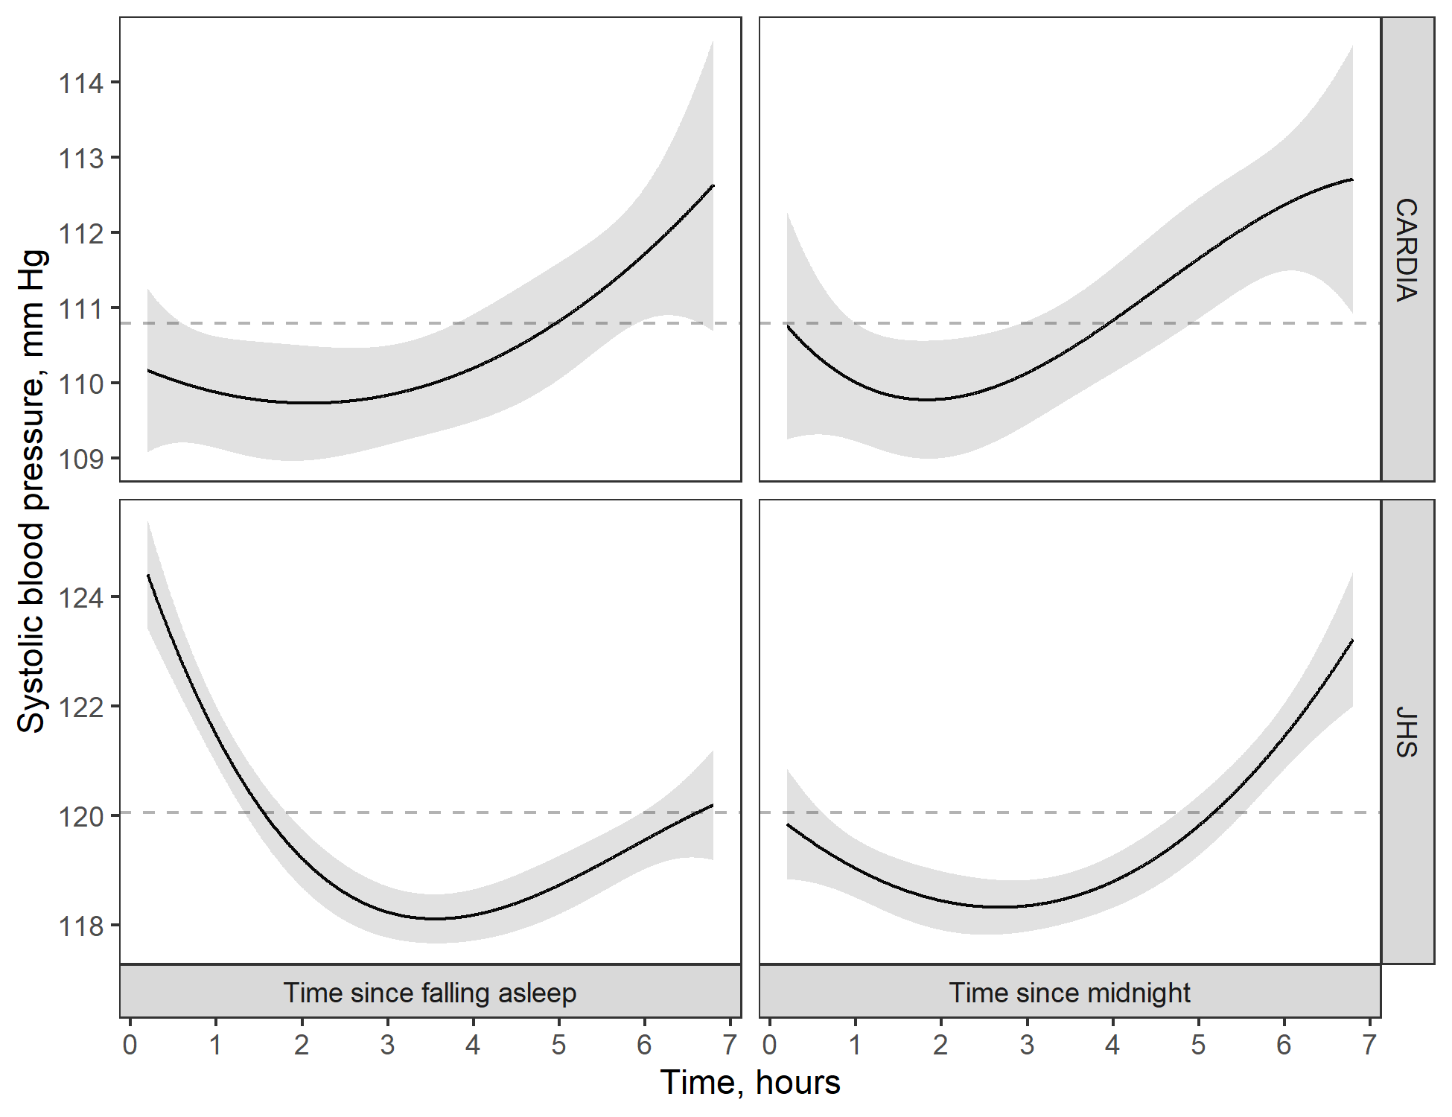

Blood pressure was estimated using linear regression with a natural cubic spline to capture nonlinear patterns in blood pressure over time. Shaded ribbons around the black lines show 95% confidence limits for the blood pressure estimates. The grey dashed line shows the mean systolic blood pressure during sleep for participants in the Coronary Artery Risk Development in Young Adults study (top row) and the Jackson Heart Study (bottom row)

Figure S2: Estimated mean diastolic blood pressure over time since falling asleep (left column) and time since midnight (right column) for participants in the CARDIA (top row) and JHS cohorts (bottom row).

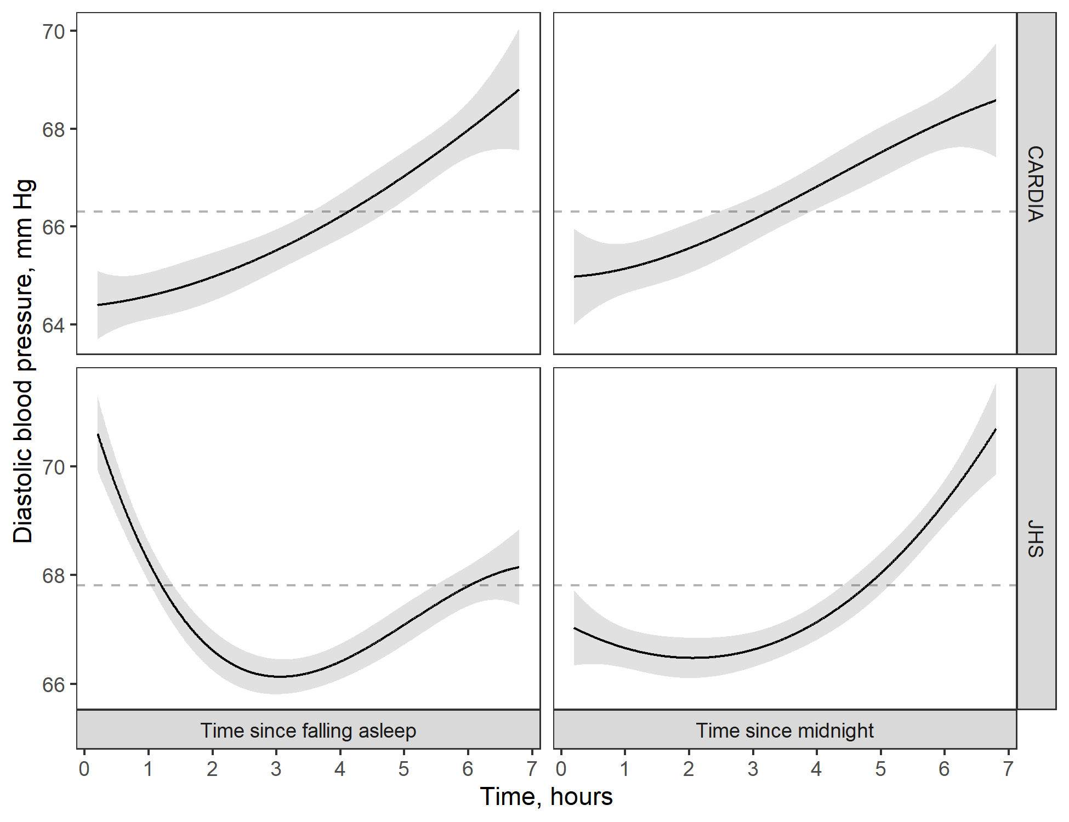

Blood pressure was estimated using linear regression with a natural cubic spline to capture nonlinear patterns in blood pressure over time. Shaded ribbons around the black lines show 95% confidence limits for the blood pressure estimates. The grey dashed line shows the mean diastolic blood pressure during sleep for participants in the Coronary Artery Risk Development in Young Adults study (top row) and the Jackson Heart Study (bottom row)

Figure S3: Summary of Kappa statistics (multiplied by 100) for the 6 blood pressure sampling variations, based on time in hours since falling asleep, with the highest Kappa statistics in their category. Panels on the diagonal (white background) show the Kappa statistic values for participants in the JHS (lower left) and CARDIA study (upper right). Panels on the off-diagonal show bootstrapped differences between the Kappa statistics presented on the corresponding diagonal tiles. Differences between the JHS Kappa statistics are shown below the diagonal while differences between the CARDIA Kappa statistics are" shown above the diagonal.

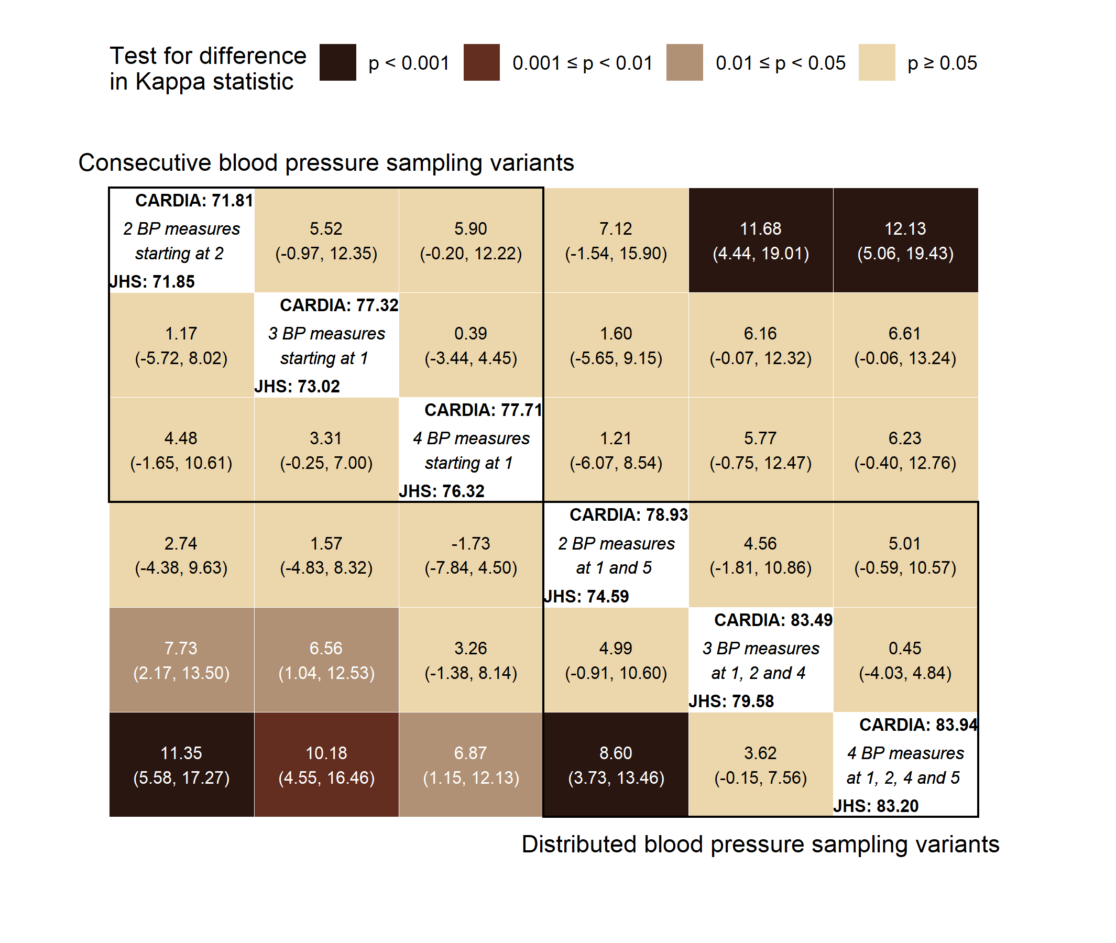

Confidence intervals were estimated using bootstrap resampling with bias correction and acceleration. Each interval was based on the aggregate of 10,000 bootstrap replicates.

Figure S4: Summary of Kappa statistics (multiplied by 100) for the 6 blood pressure sampling variations with highest overall Kappa statistics among those that measured time in hours since midnight. Panels on the diagonal (white background) show the Kappa statistic values for participants in the JHS (lower left) and CARDIA cohort (upper right). Panels on the off-diagonal show bootstrapped differences between the Kappa statistics presented on the corresponding diagonal tiles. Differences between the JHS Kappa statistics are shown below the diagonal while differences between the CARDIA Kappa statistics are" shown above the diagonal.

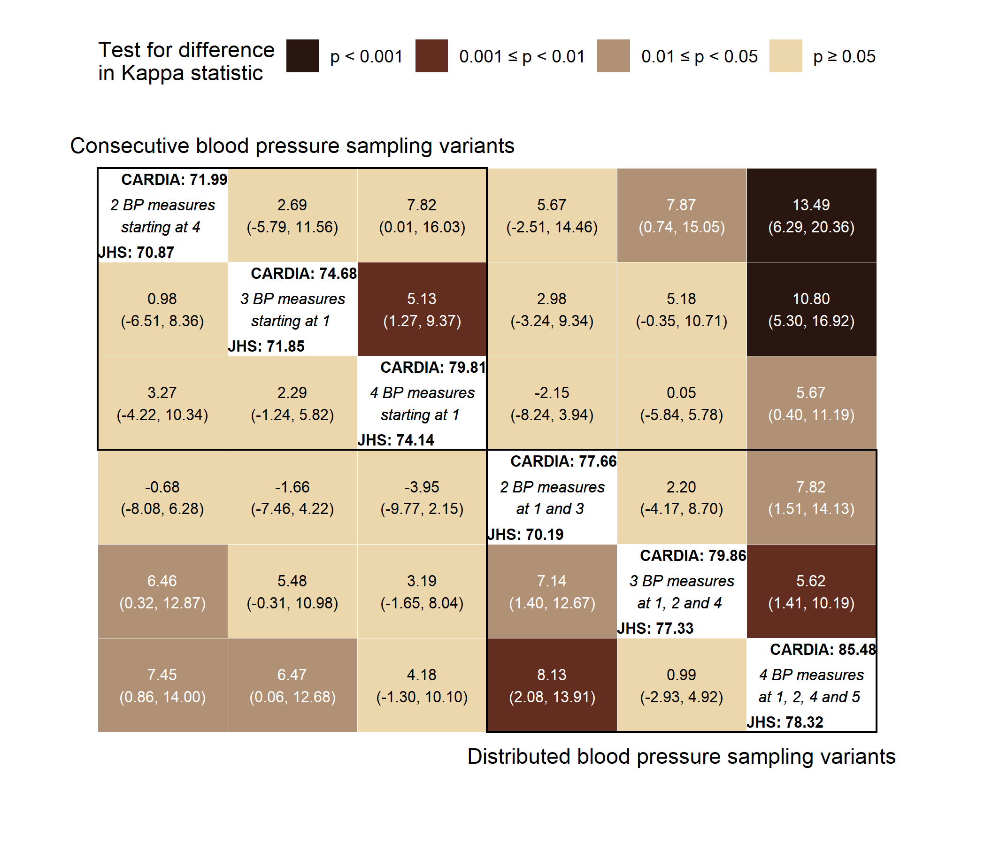

Confidence intervals were estimated using bootstrap resampling with bias correction and acceleration. Each interval was based on the aggregate of 10,000 bootstrap replicates.

# REFERENCES

1 O’Brien E, Parati G, Stergiou G, Asmar R, Beilin L, Bilo G, Clement D, De La Sierra A, De Leeuw P, Dolan E. European society of hypertension position paper on ambulatory blood pressure monitoring. *Journal of hypertension* 2013; **31**: 1731–1768.

2 Parati G, Stergiou G, O’Brien E, Asmar R, Beilin L, Bilo G, Clement D, De La Sierra A, De Leeuw P, Dolan E. European society of hypertension practice guidelines for ambulatory blood pressure monitoring. *Journal of hypertension* 2014; **32**: 1359–1366.

3 Umemura S, Arima H, Arima S, Asayama K, Dohi Y, Hirooka Y, Horio T, Hoshide S, Ikeda S, Ishimitsu T, others. The Japanese society of hypertension guidelines for the management of hypertension (JSH 2019). *Hypertension Research* 2019; **42**: 1235–1481.

4 Friedman O, Logan AG. Can nocturnal hypertension predict cardiovascular risk? *Integrated blood pressure control* 2009; **2**: 25.<https://www.ncbi.nlm.nih.gov/pmc/articles/PMC3172086/>. Accessed 14 October 2017

5 Yano Y, Tanner RM, Sakhuja S, Jaeger BC, Booth JN, Abdalla M, Pugliese D, Seals SR, Ogedegbe G, Jones DW, Muntner P, Shimbo D. Association of daytime and nighttime blood pressure with cardiovascular disease events among african american individuals. *JAMA Cardiol* (e-pub ahead of print 14 August 2019; doi:[10.1001/jamacardio.2019.2845](https://doi.org/10.1001/jamacardio.2019.2845)).

6 Kario K. Nocturnal hypertension: New technology and evidence. *Hypertension* 2018; **71**: 997–1009.

7 Pickering TG, Shimbo D, Haas D. Ambulatory blood-pressure monitoring. *New England Journal of Medicine* 2006; **354**: 2368–2374.

8 Kario K, Hoshide S, Chia Y-C, Buranakitjaroen P, Siddique S, Shin J, Turana Y, Park S, Tsoi K, Chen C-H, others. Guidance on ambulatory blood pressure monitoring: A statement from the hope asia network. *The Journal of Clinical Hypertension* 2021; **23**: 411–421.

9 Ernst ME, Bergus GR. Favorable patient acceptance of ambulatory blood pressure monitoring in a primary care setting in the United States: A cross-sectional survey. *BMC family practice* 2003; **4**: 15.

10 Degaute JP, Kerkhofs M, Dramaix M, Linkowski P. Does non-invasive ambulatory blood pressure monitoring disturb sleep? *Journal of hypertension* 1992; **10**: 879–885.

11 Agarwal R, Light RP. The effect of measuring ambulatory blood pressure on nighttime sleep and daytime activity—implications for dipping. *Clinical Journal of the American Society of Nephrology* 2010; **5**: 281–285.

12 Gaffey AE, Schwartz JE, Harris KM, Hall MH, Burg MM. Effects of ambulatory blood pressure monitoring on sleep in healthy, normotensive men and women. *Blood Pressure Monitoring* 2020.

13 Stergiou GS, Nasothimiou EG, Destounis A, Poulidakis E, Evagelou I, Tzamouranis D. Assessment of the diurnal blood pressure profile and detection of non-dippers based on home or ambulatory monitoring. *American journal of hypertension* 2012; **25**: 974–978.

14 Ishikawa J, Hoshide S, Eguchi K, Ishikawa S, Shimada K, Kario K, Group JMS-HBPSI. Nighttime home blood pressure and the risk of hypertensive target organ damage. *Hypertension* 2012; **60**: 921–928.

15 Kario K, Hoshide S, Haimoto H, Yamagiwa K, Uchiba K, Nagasaka S, Yano Y, Eguchi K, Matsui Y, Shimizu M, others. Sleep blood pressure self-measured at home as a novel determinant of organ damage: Japan morning surge home blood pressure (j-hop) study. *The Journal of Clinical Hypertension* 2015; **17**: 340–348.

16 Ishikawa J, Shimizu M, Edison ES, Yano Y, Hoshide S, Eguchi K, Kario K, others. Assessment of the reductions in night-time blood pressure and dipping induced by antihypertensive medication using a home blood pressure monitor. *Journal of hypertension* 2014; **32**: 82–89.

17 Fujiwara T, Tomitani N, Kanegae H, Kario K. Comparative effects of valsartan plus either cilnidipine or hydrochlorothiazide on home morning blood pressure surge evaluated by information and communication technology–based nocturnal home blood pressure monitoring. *The Journal of Clinical Hypertension* 2018; **20**: 159–167.

18 Kario K, Saito I, Kushiro T, Teramukai S, Ishikawa Y, Mori Y, Kobayashi F, Shimada K. Home blood pressure and cardiovascular outcomes in patients during antihypertensive therapy: Primary results of HONEST, a large-scale prospective, real-world observational study. *Hypertension* 2014; **64**: 989–996.

19 Yang W-Y, Thijs L, Zhang Z-Y, Asayama K, Boggia J, Hansen TW, Ohkubo T, Jeppesen J, Stolarz-Skrzypek K, Malyutina S. Evidence-based proposal for the number of ambulatory readings required for assessing blood pressure level in research settings: An analysis of the IDACO database. *Blood pressure* 2018; **27**: 341–350.

20 Rinfret F, Ouattara F, Cloutier L, Larochelle P, Ilinca M, Lamarre-Cliche M. The impact of unrecorded readings on the precision and diagnostic performance of home blood pressure monitoring: A statistical study. *Journal of human hypertension* 2018; **32**: 197–202.

21 Taylor Jr HA, Wilson JG, Jones DW, Sarpong DF, Srinivasan A, Garrison RJ, Nelson C, Wyatt SB. Toward resolution of cardiovascular health disparities in african americans: Design and methods of the jackson heart study. *Ethn Dis* 2005; **15**: S6–4.

22 Friedman GD, Cutter GR, Donahue RP, Hughes GH, Hulley SB, Jacobs DR, Liu K, Savage PJ. CARDIA: Study design, recruitment, and some characteristics of the examined subjects. *Journal of clinical epidemiology* 1988; **41**: 1105–1116.

23 O’Brien E, Mee F, Atkins N, O’Malley K. Accuracy of the SpaceLabs 90207 determined by the British Hypertension Society protocol. *J Hypertens* 1991; **9**: S25–S31.

24 Greef A de, Shannan AH. Validation of spacelabs 90227 OnTrak upper arm blood pressure monitor, for clinical use, according to the European Society of Hypertension International Protocol 2010 and the British Hypertension Society Protocol. <http://www.dableducational.org/Publications/2014/ESH-IP%202010%20and%20BHS%20Validation%20of%20Spascelabs%2090227%20OnTrak.pdf>

25 Lang RM, Badano LP, Mor-Avi V, Afilalo J, Armstrong A, Ernande L, Flachskampf FA, Foster E, Goldstein SA, Kuznetsova T. Recommendations for cardiac chamber quantification by echocardiography in adults: An update from the American Society of Echocardiography and the European Association of Cardiovascular Imaging. *European Heart Journal-Cardiovascular Imaging* 2015; **16**: 233–271.

26 Efron B. Better bootstrap confidence intervals. *Journal of the American statistical Association* 1987; **82**: 171–185.

27 Zou G. A modified poisson regression approach to prospective studies with binary data. *American journal of epidemiology* 2004; **159**: 702–706.

28 DeLong ER, DeLong DM, Clarke-Pearson DL. Comparing the areas under two or more correlated receiver operating characteristic curves: A nonparametric approach. *Biometrics* 1988;: 837–845.

29 R Core Team. *R: A language and environment for statistical computing*. Vienna, Austria: R Foundation for Statistical Computing<https://www.R-project.org/>

30 Wickham H, Averick M, Bryan J, Chang W, McGowan L, François R, Grolemund G, Hayes A, Henry L, Hester J. Welcome to the tidyverse. *Journal of Open Source Software* 2019; **4**: 1686.

31 Landau WM. The drake r package: A pipeline toolkit for reproducibility and high-performance computing. *Journal of Open Source Software* 2018; **3**.<https://doi.org/10.21105/joss.00550>

32 Buuren S van, Groothuis-Oudshoorn K. Mice: Multivariate imputation by chained equations in r. *Journal of statistical software* 2010;: 1–68.

33 Jaeger B. *table.glue: Make and apply customized rounding specifications for tables*. doi:[10.5281/zenodo.4107159](https://doi.org/10.5281/zenodo.4107159)

34 Steen MS van der, Lenders JW, Thien T. Side effects of ambulatory blood pressure monitoring. *Blood pressure monitoring* 2005; **10**: 151–155.

35 Agarwal R, Light RP. The effect of measuring ambulatory blood pressure on nighttime sleep and daytime activity—implications for dipping. *Clinical Journal of the American Society of Nephrology* 2010; **5**: 281–285.

36 Mokwatsi GG, Hoshide S, Kanegae H, Fujiwara T, Negishi K, Schutte AE, Kario K. Direct comparison of home versus ambulatory defined nocturnal hypertension for predicting cardiovascular events: The japan morning surge-home blood pressure (j-hop) study. *Hypertension* 2020; **76**: 554–561.