Cardiometabolic statistics for US adults: an open source web application for exploratory analysis

Byron C. Jaeger, PhD,1 Ligong Chen, PhD,2 Adam P. Bress, PharmD, MS,3,4 YOUR NAME, DEGREE,x Bharat Poudel, MSPH,2 Ashley Christenson, BS,2 Lisandro D. Colantonio, PhD,2 Paul Muntner, PhD,2

1Department of Biostatistics and Data Science, Wake Forest School of Medicine, Winston-Salem, NC. 2Department of Epidemiology, University of Alabama at Birmingham. 3Informatics, Decision-Enhancement, and Analytic Sciences (IDEAS) Center, Veterans Affairs, Salt Lake City Health Care System, Salt Lake City, UT. 4Department of Population Health Sciences, University of Utah School of Medicine, Salt Lake City, UT. x YOUR AFFILIATION IF IT ISN’T ALREADY DEFINED ABOVE

**ABSTRACT**

**Background**: Data from the National Health and Nutrition Examination Survey (NHANES) program are freely available. However, analysis of these data may be time-intensive and challenging.

**Objectives**: Develop, validate, and share an open-source web application that allows for interactive, exploratory analysis of NHANES data that can be used and extended upon by others.

**Methods**: We developed the open-source web application using the R programming language and several R packages. We validated the web application by using it to reproduce results from two prior studies and a report from the Centers for Disease Control. To demonstrate the application’s capabilities, we estimated characteristics of adults in the US, the prevalence of hypertension, distribution of the number of antihypertensive medication classes being used, prevalence of controlled blood pressure (BP) among those with hypertension, and the prevalence of resistant hypertension.

**Results**: The estimated mean systolic BP for all US adults was 123 mm Hg in 1999-2000, 120 mm Hg in 2009-2010, and 123 mm Hg in 2017-2020. The estimated prevalence of hypertension among US adults was lowest in 2009-2010 (43.3%) and highest in 2017-2020 (46.6%), with the estimated number of US adults with hypertension increasing from 89.8 million in 1999-2000 to 115.3 million in 2017-2020 . The age adjusted mean systolic BP was 140 in 1999-2000, 134 in 2009-2010, and 136 in 2017-2020 among US adults with hypertension. Among US adults who self-reported taking antihypertensive medication, the percentage taking four or more classes of antihypertensive medication increased from 3.5% in 1999-2000 to 7.6% in 2017-2020. The age-adjusted estimated prevalence of BP control among US adults with hypertension was 10.2%, 25.8%, and 23.8% in 1999-2000, 2009-2010, and 2017-2020, respectively. Among US adults with hypertension who self-reported taking antihypertensive medication, the prevalence of resistant hypertension was 13.7% in 1999-2000, 17.7% in 2009-2010, and 16.2% in 2017-2020.

**Conclusions.**: The web application developed in the current analysis may increase the usage of NHANES data for research and policy decision making, ensuring results are valid, transparent, and reproducible.

The National Health and Nutrition Examination Survey (NHANES) is a program conducted by the US National Center for Health Statistics (NCHS) of the Centers for Disease Control and Prevention (CDC) and is designed to assess the health and nutritional status of the US population. NHANES data have been used to provide nationally representative estimates for adults living in the United States (US) in multiple studies of cardiometabolic outcomes. For example, NHANES data have been used to estimate the impact of the lower blood pressure (BP) levels used to define hypertension and controlled BP in the 2017 American College of Cardiology/American Heart Association (ACC/AHA) BP guideline versus the Seventh Joint National Committee (JNC7) BP guideline on the proportion and number of US adults with hypertension, recommended antihypertensive medication and with uncontrolled BP. Additionally, NHANES data have been used to track the proportion of US adults with controlled BP, which were included in a Call-to-Action to Control BP from the US Surgeon General.

NHANES data are publicly available and accessible through the CDC website. However, analyzing NHANES data may be challenging for a number of reasons. In particular, specific statistical techniques are required to account for the multi-stage sampling design of NHANES data and produce nationally representative estimates. Also, each NHANES cycle includes over 50 data files, each of which has detailed informational material. NHANES data collection protocols have changed over time for certain variables, and these differences should be accounted for when harmonizing or pooling data from multiple cycles. Another potential challenge is implementation of recommended standards from the CDC, such as their guidelines for suppression of unreliable results.

To address the challenges of analyzing NHANES data, we developed an open-source web-based application that allows users to obtain nationally representative summaries of cardiometabolic outcomes for US adults using NHANES data. The goal of the application is to increase the usage of NHANES data for research and policy decision making with a focus on ensuring results are valid, transparent, and reproducible. The application is designed to be extended with the addition of “modules”, which we define as a set of variables measured among a sub-population of NHANES participants. In this manuscript, we review the design and development of the application, present nationally representative summaries of outcomes from the “BP and Hypertension module”, and describe online tutorials and resources that may help users engage with the application.

**METHODS**

The NHANES program was initiated in the early 1960s and beginning in 1999 has been conducted continuously, in two-year cycles. In each cycle, potential participants were identified using a multi-stage sampling process. The protocols for each cycle were approved by the NCHS Institutional Review Board. Written informed consent was obtained from each participant.

NHANES data include in-home interviews and study examinations conducted at mobile examination centers. The interview includes questions about demographics, health behaviors, prior diagnoses, medication use, and medical history. During the interview, the labels of medications that participants reported taking in the preceding 30 days were recorded. During the study examination, height and weight were measured, blood samples were used to measure cholesterol, glycated hemoglobin and serum creatinine, and spot urine was used to measure albumin and creatinine and to conduct a pregnancy test. Systolic and diastolic BP (SBP and DBP, respectively) were measured three times. BP was measured using a mercury sphygmomanometer from 1999-2000 through 2015-2016 and using an oscillometric device in 2017-2020.

*Features of the Open-Source Web-Based Application*

Full summaries of this application’s features and associated tutorials are available. Briefly, users can select NHANES cycles to be analyzed. Contiguous cycles can be combined to increase precision. Estimates are weighted to represent the non-institutionalized US population and may incorporate age-adjustment using direct standardization. Count estimates are calibrated to match the estimated total number of US adults. Users may visualize summaries of outcomes in groups (i.e., prevalence of hypertension by sex) with all groups in the same figure or with one figure per group, and may additionally specify subsets to exclude from their analyses. All outputs created with the web application can be downloaded and saved. Following CDC recommendations, unreliable statistical estimates are automatically suppressed.

*Design of the Open-Source Web-Based Application*

The web application was created using Shiny, an open-source software package that translates code from the R programming language into HTML, CSS, or JavaScript commands that create a website interface. The “cardioStatsUSA” R package provides additional details on the web application’s design and comprehensive documentation of its components.

*The Blood Pressure and Hypertension Module*

We define a module as a subpopulation of NHANES participants paired with a collection of variables. Each variable in the collection has designated roles. For example, hypertension can be an outcome and can also be used to define groups when analyzing another outcome. This module definition is general enough to allow for diverse extensions of the web application, but may not be specific enough to illustrate how the web application works. Therefore, in the current analysis, we define and present results from the “BP and hypertension” module, defined as follows.

**Subpopulation:** Beginning with 107,622 US individuals who participated in NHANES 1999-2000 to 2017- March 2020, we restricted the subpopulation to adults ≥ 18 years of age. This exclusion was applied because statistics for hypertension and BP levels in children and adolescents are markedly different than for adults. We further restricted the subpopulation to participants who completed the in-home interview and study examination, with one or more SBP and DBP measurement, and who had data on self-reported antihypertensive medication use. After these exclusions were applied, the sub-population included data from 56,035 participants (Figure S1).

**Variables** The primary variables from the BP and hypertension module are listed in Table 1, with full definitions provided in Supplemental Table 1. Briefly, mean SBP and DBP levels were computed over all available measurements for each participant. Oscillometric BP values were calibrated to the mercury device as described previously. Antihypertensive medication classes were defined using recommendations from the 2017 ACC/AHA BP guideline.

*Validation of the web application*

We validated the web application by using it in combination with our BP and hypertension module to reproduce results from two prior studies and one CDC report. A full description of the validation procedure is available.

*Statistical analysis*

We conducted a series of statistical analyses using the BP and hypertension module defined above. We estimated characteristics of the population, crude and age-adjusted mean SBP, and prevalence of hypertension for US adults by NHANES cycle. To demonstrate computation of results by group, we computed the age-adjusted prevalence of hypertension by NHANES cycle for individuals with versus without chronic kidney disease. For age adjustment in these analyses, we used the estimated age distribution of US adults from 1999 to 2020 as the standard (49.3%, 33.6%, 10.1% and 7.0% being 18 to 44, 45 to 64, 65 to 74 and ≥75 years of age, respectively). We also estimated the number of US adults with hypertension by NHANES cycle from 1999-2000 through 2017-2020.

The age-adjusted distribution of the number of antihypertensive medication classes being taken was estimated for US adults with hypertension in each NHANES cycle, overall and among those who self-reported taking antihypertensive medication and had at least one antihypertensive drug class identified in their medication inventory. The age-adjusted proportion of US adults with controlled BP (i.e., SBP < 130 mm Hg and DBP < 80 mm Hg) was estimated by NHANES cycle among US adults with hypertension and who self-reported taking antihypertensive medication. The age-adjusted prevalence of resistant hypertension was estimated by NHANES cycle for US adults with hypertension taking antihypertensive medication and among those with hypertension taking ≥ 3 classes of antihypertensive medication. For age adjustment in these analyses, we set the age distribution for the standard population to represent US adults with hypertension from 1999 to 2020: 26.4%, 43.4%, 17.0% and 13.2% being 18 to 44 years, 45 to 64, 65 to 74, and ≥75 years of age, respectively. We estimated the prevalence of hypertension in NHANES 2017-2020 by age group, sex, and race-ethnicity. Using the data pooling option in the application, we grouped the NHANES 2011-2020 cycles to estimate the proportion of pregnant women who had uncontrolled BP (i.e., SBP ≥ 130 mm Hg or DBP ≥ 80 mm Hg).

**RESULTS**

The estimated crude mean SBP for all US adults was 123 mm Hg in 1999-2000, 120 mm Hg in 2009-2010, and 123 mm Hg in 2017-2020 (Figure 1; panel A). The estimated age-adjusted mean SBP was 124, 120, and 122 mm Hg in 1999-2000, 2009-2010 and 2017-2020, respectively (Figure 1; panel B). The estimated crude prevalence of hypertension among US adults was lowest in 2009-2010 (43.3%) and highest in 2017-2020 (46.6%) (Figure 2; panel A). After age-adjustment, the prevalence of hypertension was highest in 1999-2000 (47.9%), lowest in 2009-2010 and 2013-2014 (43.0%) and was 44.7% in 2017-2020. (Figure 2; panel B). The number of US adults with hypertension increased from 89.8 million in 1999-2000 to 115.3 million US adults in 2017-2020 (Figure 3). The age adjusted mean SBP was 140 in 1999-2000, 134 in 2009-2010, and 136 in 2017-2020 among US adults with hypertension and 117 in 1999-2000, 115 in 2009-2010, and 117 in 2017-2020 among US adults without hypertension (Figure S2). In each NHANES cycle, the age-adjusted estimated mean SBP was 18 to 23 mm Hg higher among US adults with versus without hypertension. In 2017-2020, a higher percentage of US adults with versus without hypertension were non-Hispanic Black (13.5% versus 9.3%) while a lower percentage of US adults with versus without hypertension were Hispanic (12.3% versus 18.1%) (Table 1). In each NHANES cycle, the estimated age-adjusted prevalence of hypertension among US adults with CKD was higher versus their counterparts without CKD (Figure S3).

Among US adults with hypertension, 61.5% were not taking antihypertensive medication in 1999-2020 compared with 44.6% in 2017-2020. (Figure 4; panel A). Among US adults who self-reported taking antihypertensive medication, the percentage taking four or more classes of antihypertensive medication increased from 3.5% in 1999-2000 to 7.6% in 2017-2020 (Figure 4; panel B). The age-adjusted estimated prevalence of BP control among US adults with hypertension was 10.2%, 25.8%, and 23.8% in 1999-2000, 2009-2010, and 2017-2020, respectively (Figure 5; panel A). For adults who self-report taking antihypertensive medication, 26.2%, 44.1%, and 43.3% had controlled BP in 1999-2000, 2009-2010, and 2017-2020, respectively (Figure 5; panel B).

Among US adults with hypertension who self-reported taking antihypertensive medication, the prevalence of resistant hypertension was 13.7% in 1999-2000, 17.7% in 2009-2010, and 16.2% in 2017-2020 (Figure S4; panel A). Among those who were taking three or more classes of antihypertensive medication, the prevalence of resistant hypertension was 73.5%, 64.1%, and 67.9% in 1999-2000, 2009-2010, and 2017-2020, respectively (Figure S4; panel B).

In 2017-2020, the prevalence of hypertension was higher at progressively older age (Figure S5), among men versus women (Figure S6), and among non-Hispanic Black adults versus non-Hispanic White adults, non-Hispanic Asian adults, Hispanic adults and adults from other race/ethnic groups (Figure S7).

**DISCUSSION**

In the current manuscript, we describe the development of an open-access web-based application that allows the calculation of nationally representative estimates for a number of BP-related outcomes using publicly available data from NHANES. Using this app, we generated statistics for some of these BP-related outcomes over time, both crude and adjusted by age. We also generated statistics stratified by characteristics of US adults (e.g., CKD), and by pooling multiple NHANES cycles to obtain more precise estimates when working with small group sizes. Researchers, stakeholders, and the public in general interested in BP-related outcomes can now use the current app to accomplish a variety of purposes.

NHANES is a program specifically designed to obtain nationally representative estimates of the health and nutrition status of non-institutionalized US adults. Therefore, NHANES represents the ideal data source to obtain valid and reliable statistic on BP-related outcomes among US adults. Although NHANES data are publicly available, working with these data is not exempt of challenges. Examples of challenges that may face working with NHANES data include the need to download multiple files, even for a single NHANES cycle; combining multiple NHANES variables to create the measurement of interest, which may require dealing with missing data and questionnaire skip patterns; harmonizing definitions across multiple NHANES cycles; and the analyses of complex survey design data. NHANES has been conducted over many cycles and some of the methods have been updated over time. For example, NHANES switched from using sphygmomanometer devices to oscillometric devices to measure BP in 2017-2018. NHANES data users need to be careful when analyzing data across multiple cycles. Reducing barriers to using NHANES data will facilitate the use of these data to inform BP-related public health decisions and future research.

Several design decisions have been incorporated into the app. We required participants to have only a single SBP and DBP to be included. This approach is consistent with several analyses conducted by CDC investigators (cite pmid 26633197, 29155682). However, mean BP and the prevalence of high BP would be lower if we required multiple BP measurements (cite pmid 23126346). Any bias resulting from this decision is likely to be small as over 95% of adult NHANES participants within one SBP and DBP measurement had three SBP and DBP measurements. We re-calibrated the NHANES weights for the calculation of population counts (cite pmid 12500213). When estimating population counts, participants missing data on SBP, DBP or antihypertensive medication use cannot have BP or hypertension-related outcomes. Weights were not recalibrated when estimating portions as participants missing data are removed from the numerator and denominator. Medication classes were coded using generic names and the drug classes in the 2017 ACC/AHA BP guideline. We recognize the NCHS recommends using Lexicon Plus®, a proprietary database, to categorize medication classes. While the categorization of most medications is identical using generic drug names and Lexicon Plus®, some differences exist. Many additional decisions were made regarding the definitions of variables, inclusion of study participants, and analytic approach. We sought to make decisions that would be acceptable to people who use the app and transparent to ensure the results could be described accurately.

We were able to replicate several prior manuscripts using the app. However, some results could not be replicated. For example, a prior manuscript reported the prevalence of resistant hypertension defined by the 2017 ACC/AHA BP guideline to be 19.7% in 2009-2014. When estimated by the app, the prevalence of resistant hypertension was 17.7%, 16.5% and 17.2% in 2009-2010, 2011-2012, and 2013-2014, respectively (cite pmid 30580690). The difference in the prevalence estimates can be attributed to the approach used to categorize medication into classes. For example, the prior publication used Lexicon Plus®, which counted spironolactone as two drug classes, a potassium-sparing diuretic and an aldosterone antagonist. Additionally, Lexicon Plus®includes Sotalol as a beta blocker and nitroglycerine as a direct vasodilator and we did not include these drugs as antihypertensive medications as they are not listed in the 2017 ACC/AHA BP guideline. The differences in results between the app and this previously published manuscript emphasize two important points. First, while we encourage users to check results when using the app with prior publications, it may not be possible to always generate results that are identical to prior publications. Second, users should be aware of the choices made in defining variables.

The web application has a number of complementary features that allow users to complete various analysis tasks. In particular, users can generate descriptive summaries of the US population spanning over 20 years, including summaries of characteristics and cardiometabolic outcomes. The flexibility of inclusion criteria paired with the large set of outcomes and stratifying variables available allow an enormous number of hypotheses to be explored. Outputs from the app can be included in scientific proposals, presentations, or articles, citing the application’s publicly available documentation to contextualize results. With the ability to download summary data from the application, users can visualize or tabulate results with aesthetics and software of their choosing. The web application can also be used for educational purposes, as teachers can use it to analyze health outcomes for US adults interactively with students.

With an open-source software license and publicly available documentation and data, the web application we developed is designed to be extended. The Shiny interface and R codes supporting this application can support general sub-populations of NHANES participants, such as a sub-population of participants with cholesterol data or a sub-population of pediatric survey participants. As the current analysis demonstrates creation and analysis of a sub-population of participants with BP measurements, others can use it as a template for developing extensions of the web application that engage with new sub-populations. In addition to including new sub-populations of NHANES participants, the application may be extended to include inferential statistics and hypothesis testing, and may also incorporate new cycles of NHANES data as they become available.

**Table 1**: Variables included in the blood pressure and hypertension module.

| **Variables included in module** |
| --- |
| *Blood pressure* |
| Systolic blood pressure, mm Hg |
| Diastolic blood pressure, mm Hg |
| Blood pressure category (not including antihypertensive medication use) |
| Blood pressure category (including antihypertensive medication use) |
| Blood pressure control (SBP < 140 mm Hg and DBP < 90 mm Hg) |
| Blood pressure control (SBP < 130 mm Hg and DBP < 80 mm Hg) |
| Uncontrolled BP (SBP ≥ 140 mm Hg or DBP ≥ 90 mm Hg) |
| Uncontrolled BP (SBP ≥ 130 mm Hg or DBP ≥ 80 mm Hg) |
| *Hypertension* |
| Hypertension (JNC7 guideline definition) |
| Hypertension (2017 ACC/AHA BP guideline definition) |
| Awareness of hypertension |
| Resistant hypertension (JNC7 guideline definition) |
| Resistant hypertension (2017 ACC/AHA BP guideline definition) |
| Resistant hypertension (JNC7 guideline definition requires thiazide diuretic) |
| Resistant hypertension (2017 ACC/AHA BP guideline definition requires thiazide diuretic) |
| *Antihypertensive medication* |
| Self-reported antihypertensive medication use |
| Antihypertensive medications recommended by JNC7 |
| Antihypertensive medications recommended by ACC/AHA 2017 |
| Number of antihypertensive medication classes |
| *Antihypertensive medication classes* |
| ACE inhibitors |
| Aldosterone antagonists |
| Alpha-1 blockers |
| Angiotensin receptor blockers |
| Beta blockers |
| Central alpha1 agonist and other centrally acting agents |
| Calcium channel blockers |
| Potassium sparing diuretics |
| Loop diuretics |
| Thiazide or thiazide-type diuretics |
| Direct renin inhibitors |
| Direct vasodilators |
| Abbreviations: ACC = American College of Cardiology; AHA = American Heart Association; BP = blood pressure; DBP = diastolic blood pressure; JNC7 = Seventh Joint National Committee; and SBP = systolic blood pressure |

**Table 2**: Race/ethnicity distribution of the population with and without hypertension in 2017-2020

| **svy_year** | **htn_accaha** | **demo_race** | **estimate** | **std_error** | **ci_lower** | **ci_upper** |
| --- | --- | --- | --- | --- | --- | --- |
| 2017-2020 | No | Hispanic | 18.1 | 1.84 | 14.5 | 21.7 |
| 2017-2020 | No | Non-Hispanic Asian | 5.90 | 0.88 | 4.18 | 7.62 |
| 2017-2020 | No | Non-Hispanic Black | 9.26 | 1.15 | 7.00 | 11.5 |
| 2017-2020 | No | Non-Hispanic White | 62.8 | 2.35 | 58.2 | 67.4 |
| 2017-2020 | No | Other | 3.96 | 0.38 | 3.21 | 4.71 |
| 2017-2020 | Yes | Hispanic | 12.3 | 1.21 | 9.95 | 14.7 |
| 2017-2020 | Yes | Non-Hispanic Asian | 5.06 | 0.79 | 3.50 | 6.61 |
| 2017-2020 | Yes | Non-Hispanic Black | 13.5 | 1.84 | 9.88 | 17.1 |
| 2017-2020 | Yes | Non-Hispanic White | 64.8 | 2.80 | 59.4 | 70.3 |
| 2017-2020 | Yes | Other | 4.30 | 0.58 | 3.17 | 5.43 |

**Figure 1** Mean systolic blood pressure for US adults by calendar year

A. Without age adjustment

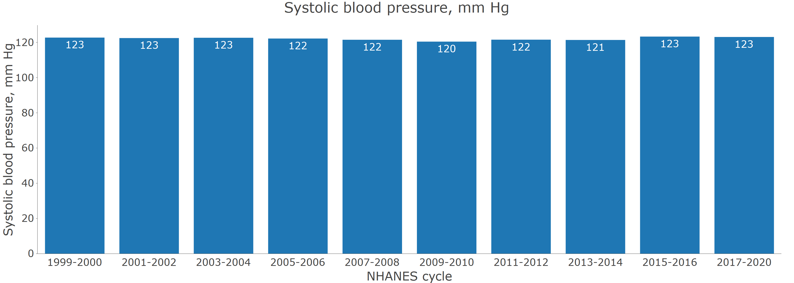

B. With age adjustment through direct standardization.

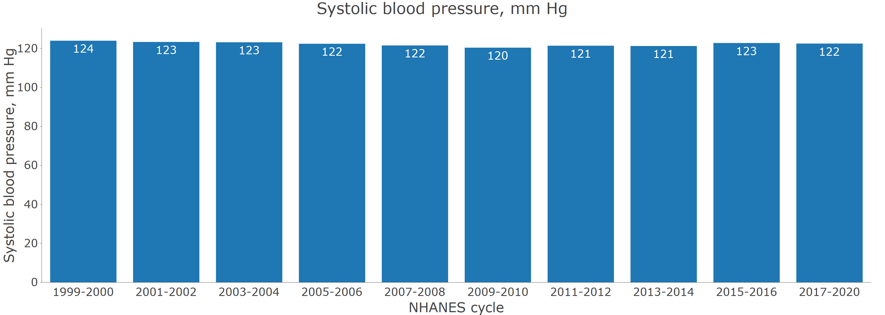

**Figure 2** Prevalence of hypertension for US adults by calendar year

A. Without age adjustment

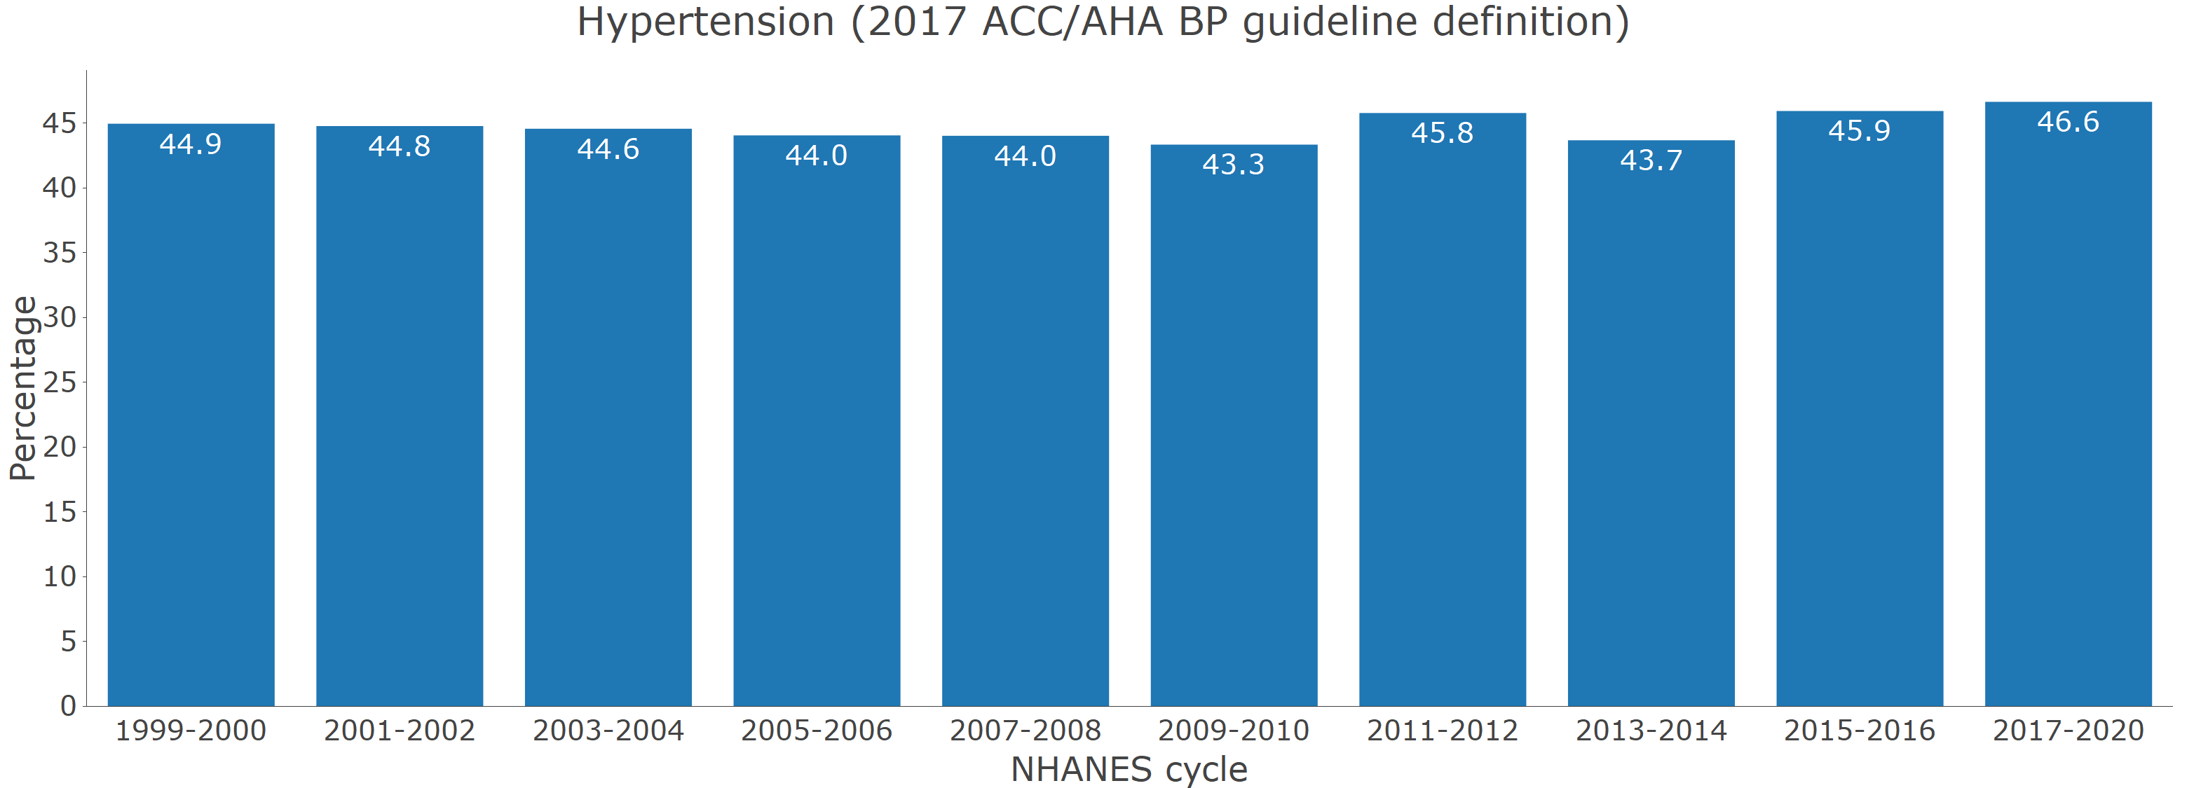

B. With age adjustment through direct standardization.

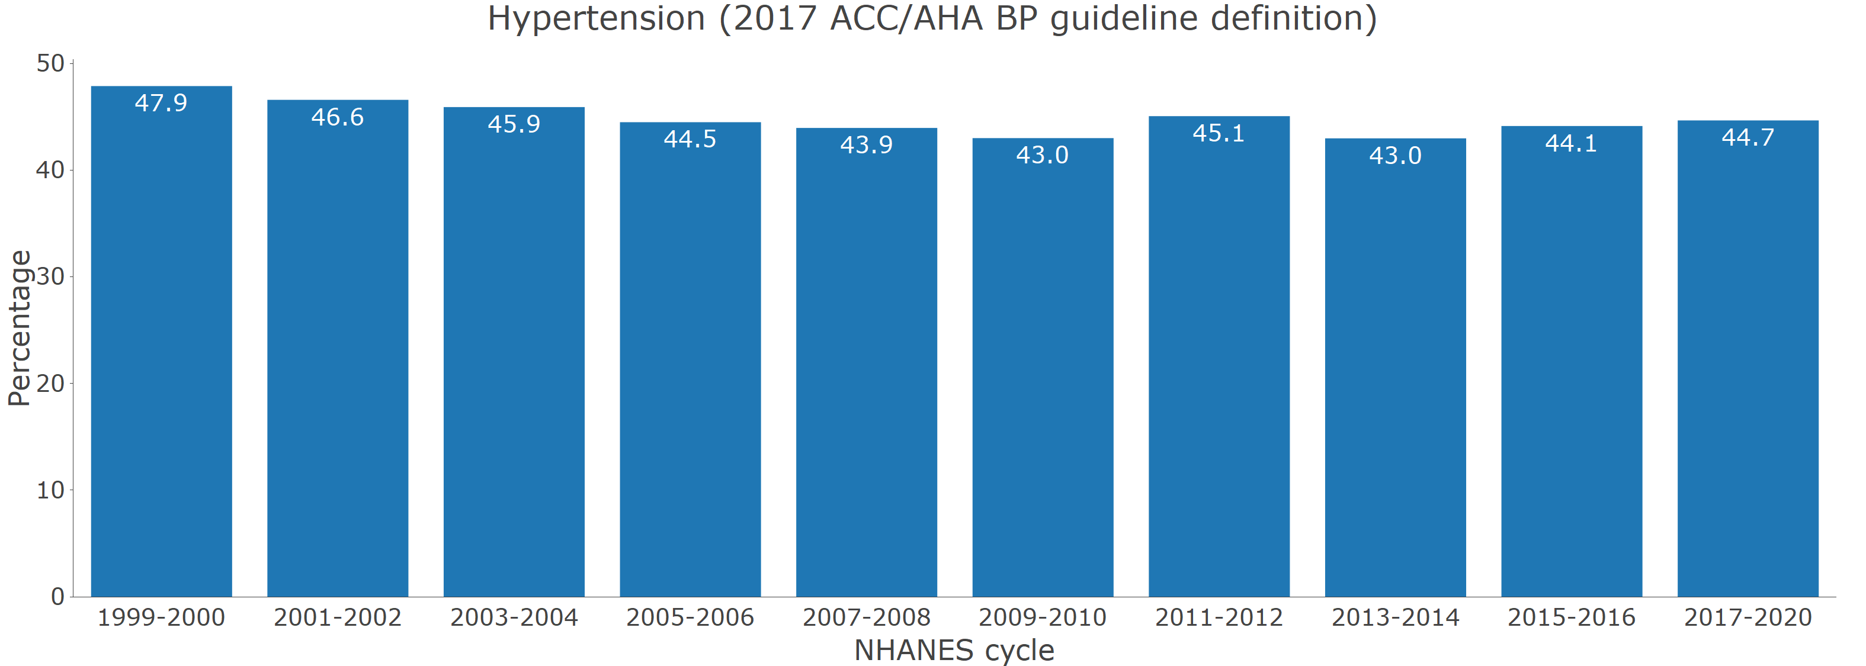

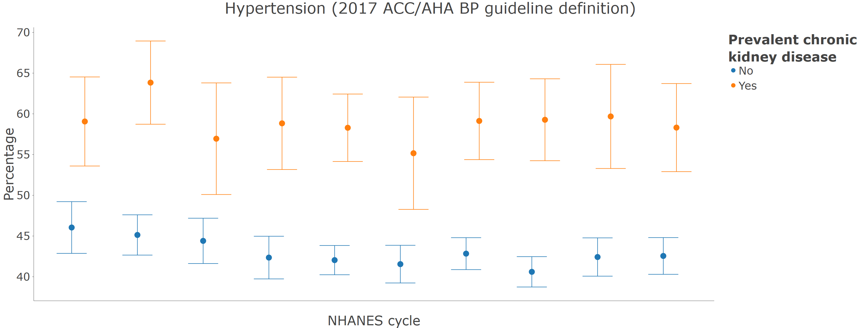

**Figure 3** Number of US adults with hypertension

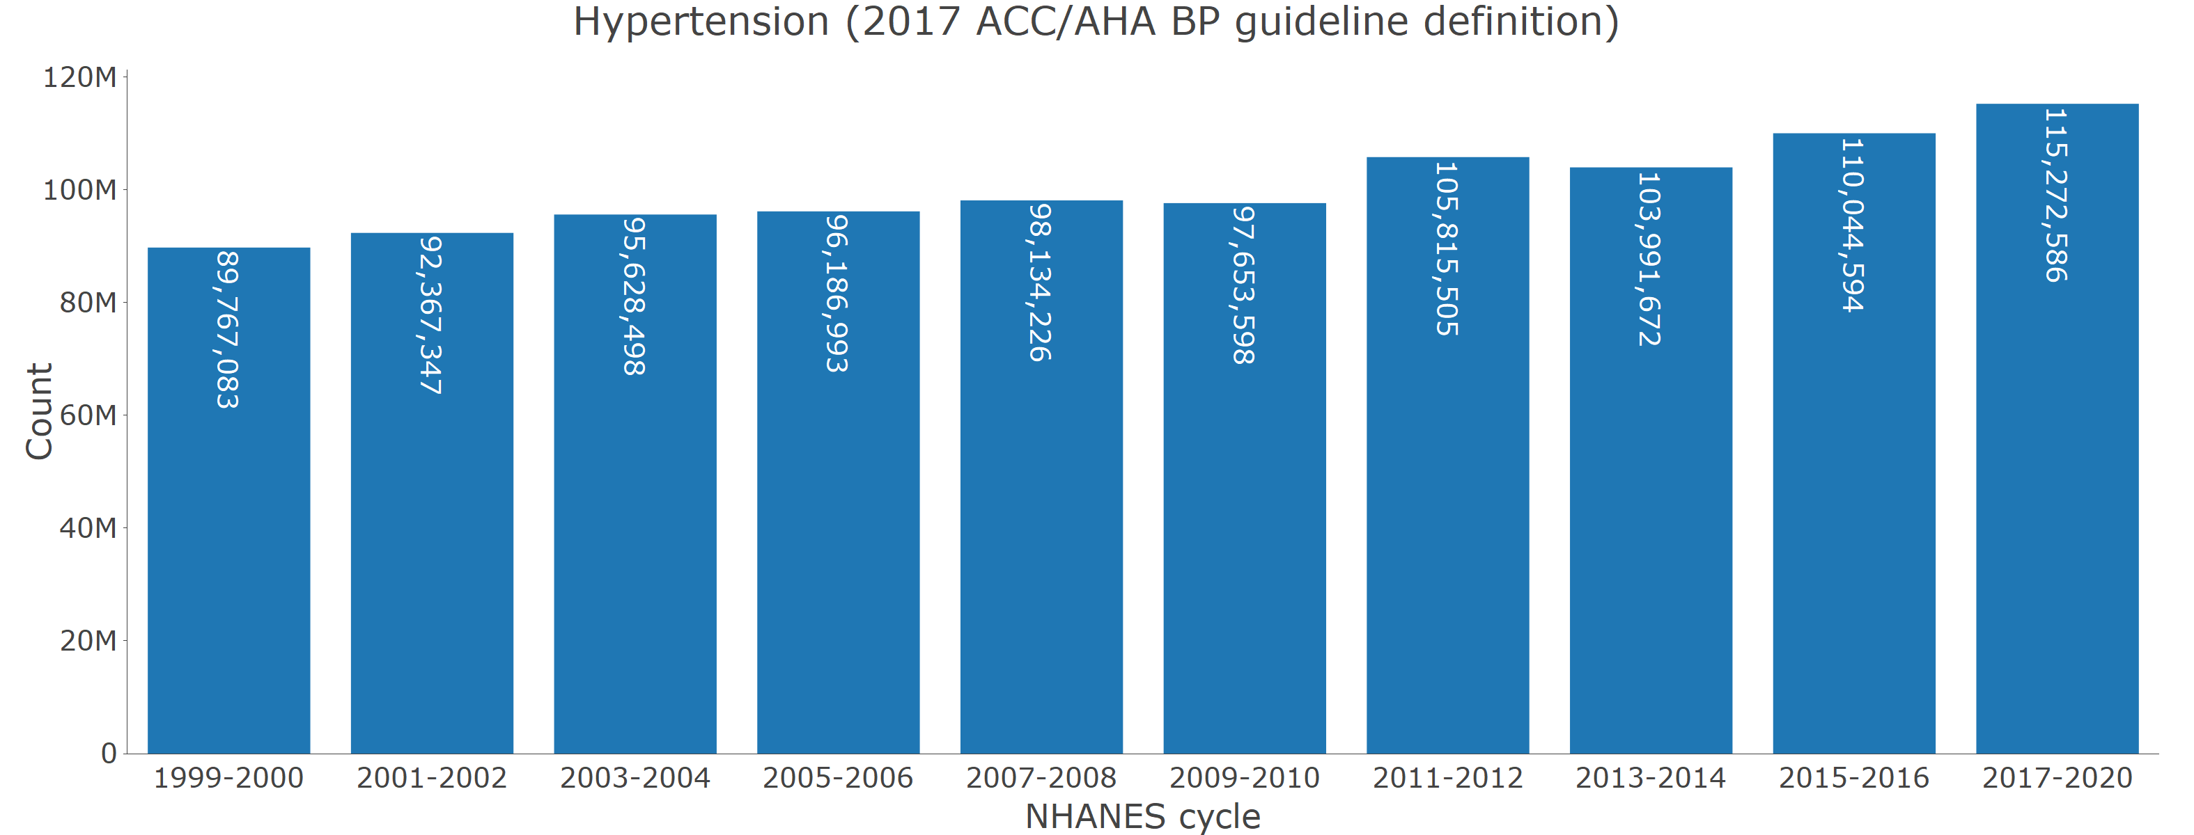

**Figure 4** Distribution of the number of antihypertensive medication classes being taken among those with hypertension by calendar period

A. Among those with hypertension

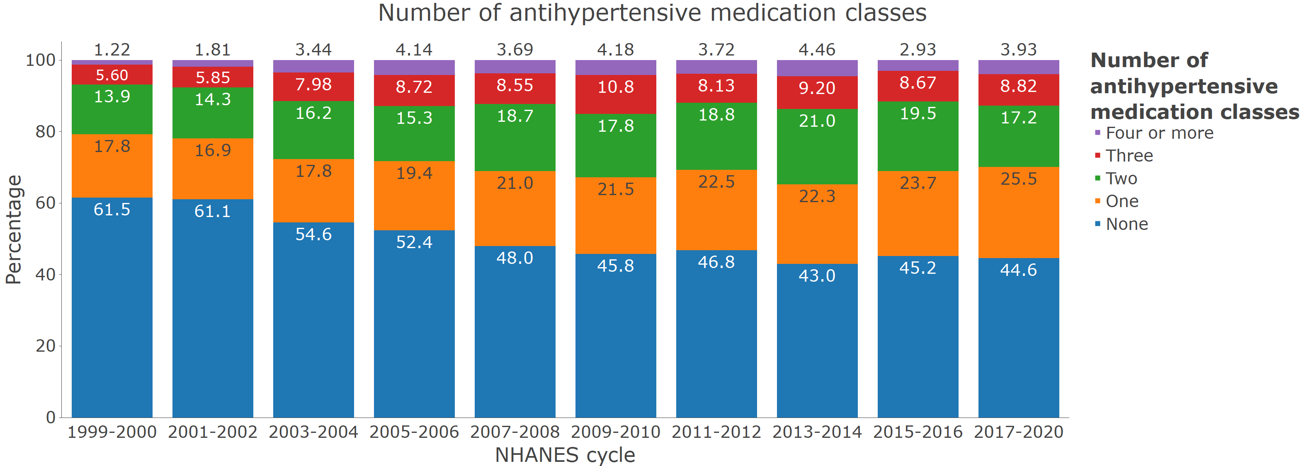

B. Among those with hypertension who self-report taking antihypertensive medication

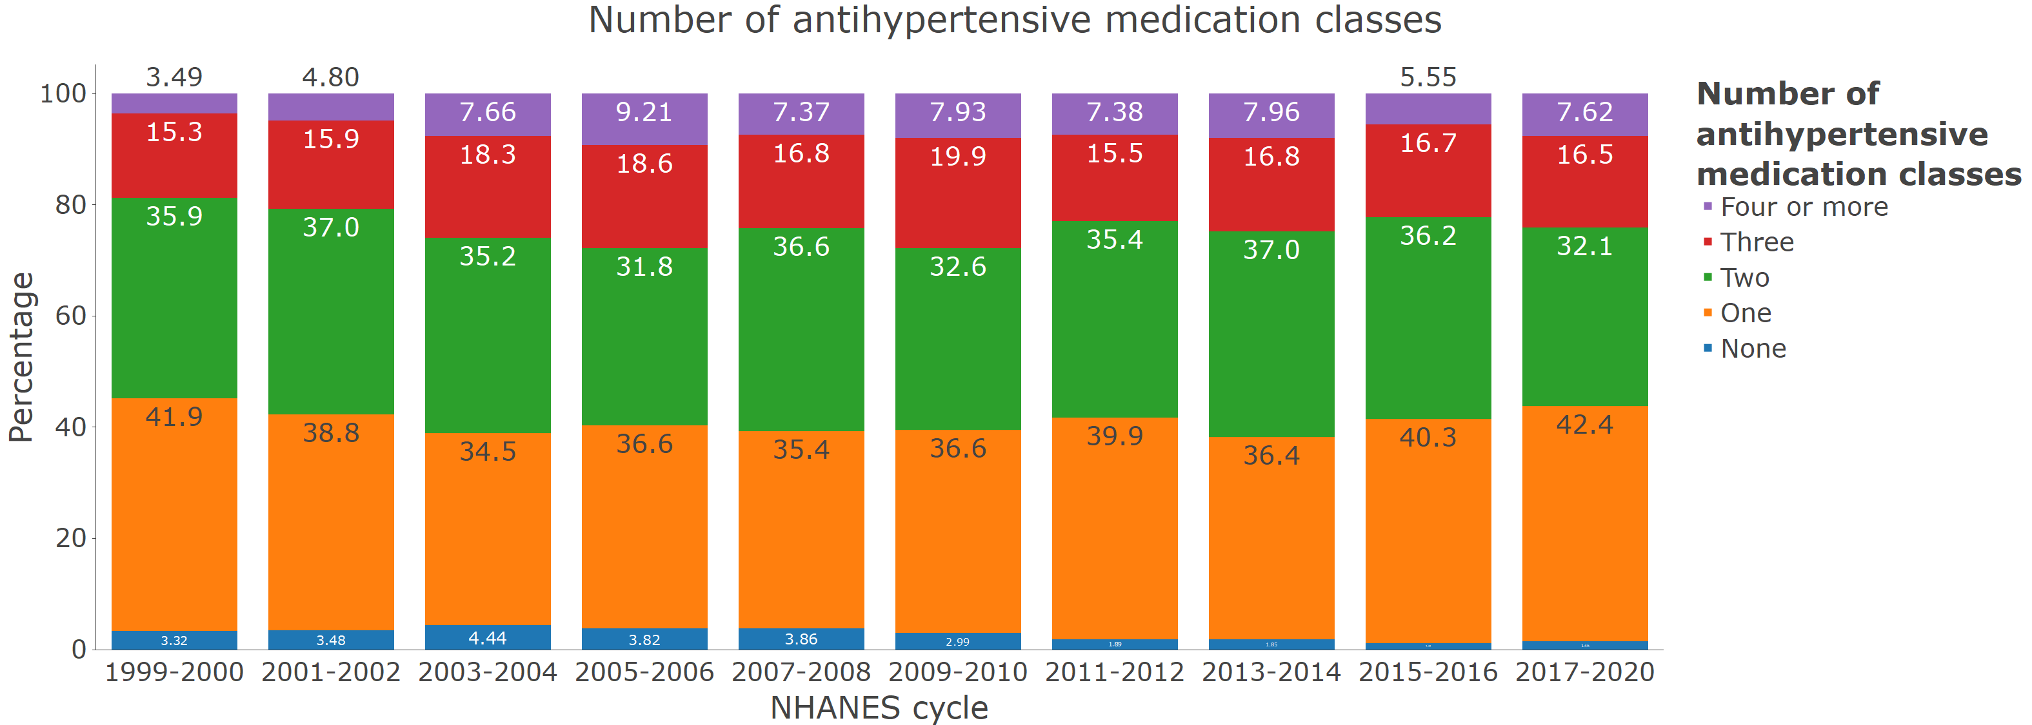

**Figure 5** Blood pressure control by calendar year

A. Age-adjusted among those with hypertension

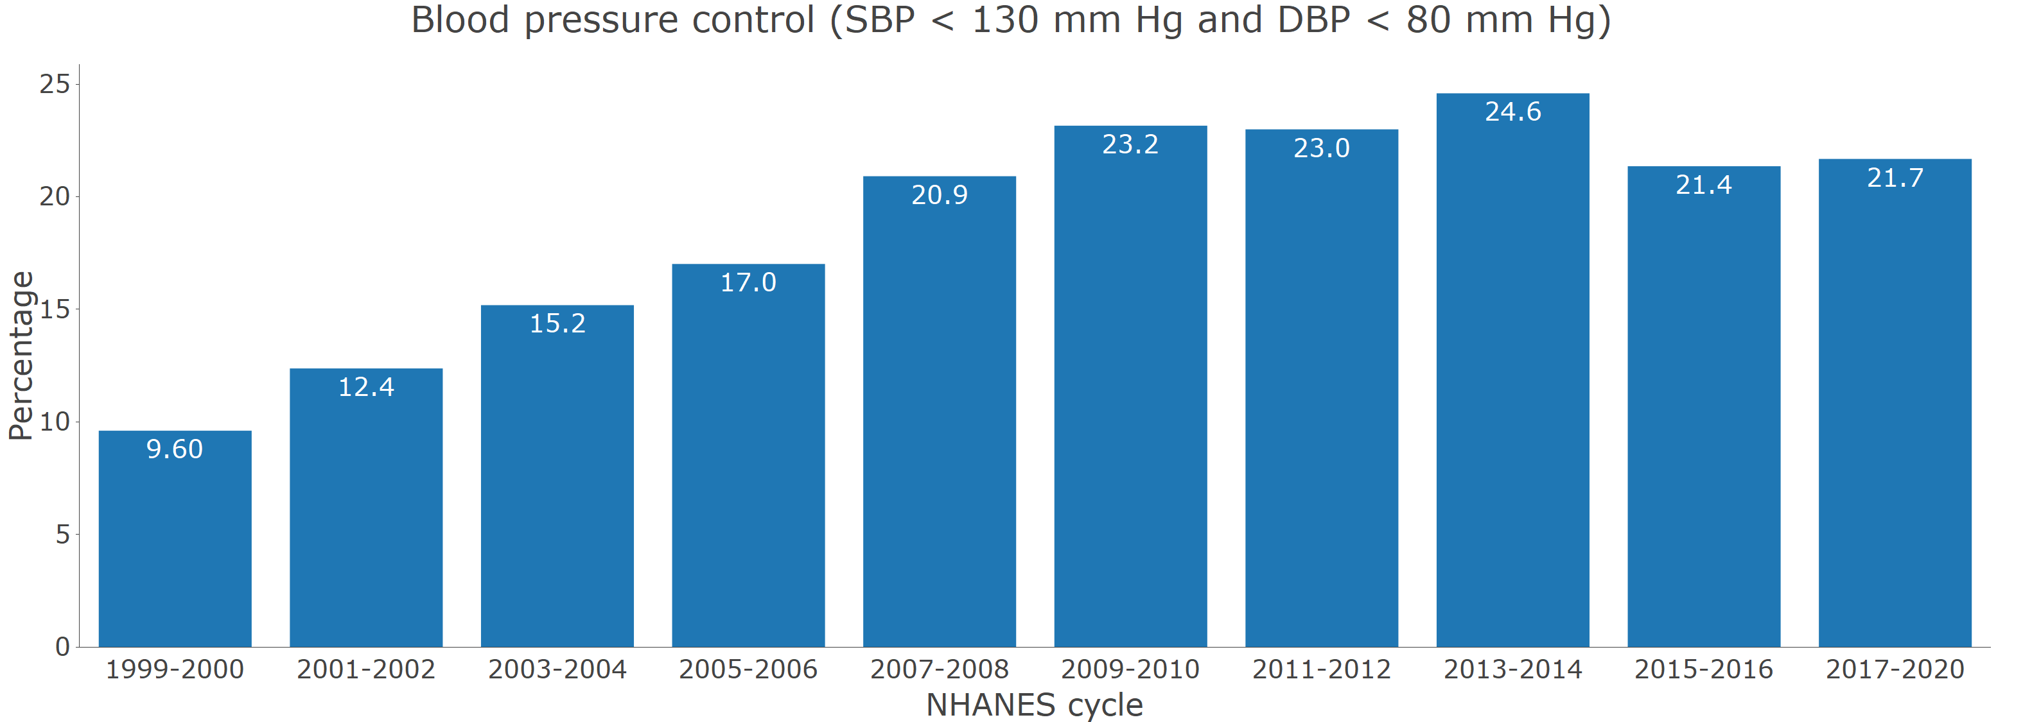

B. Age-adjusted among those who self-report taking antihypertensive medication

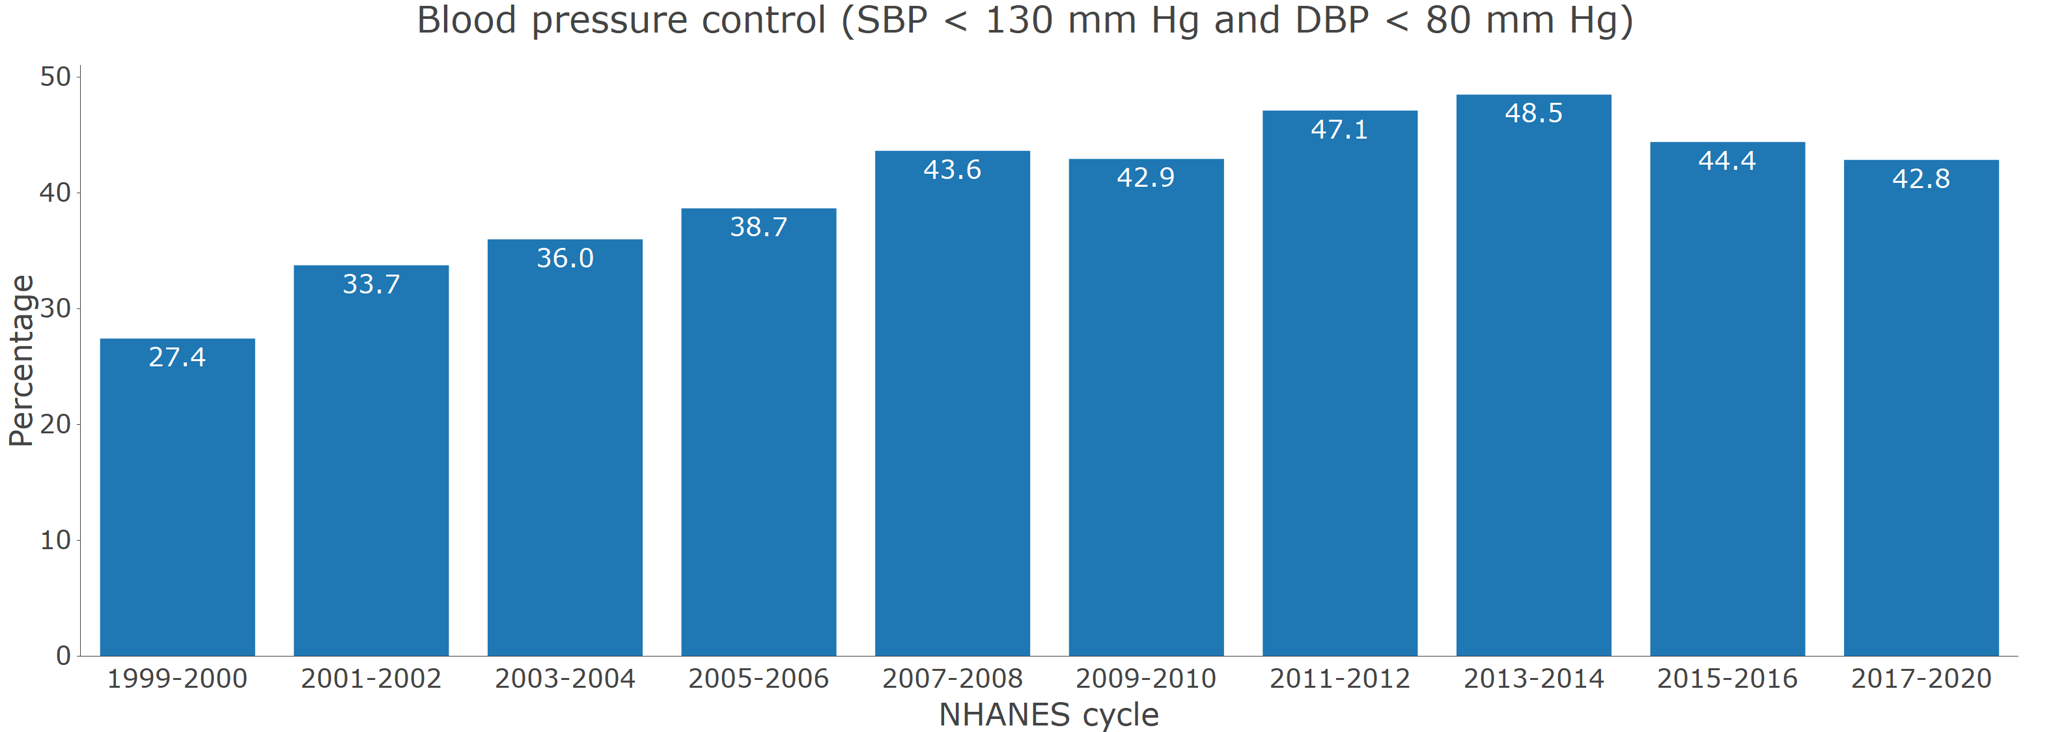

**Table S1**

| **All variables included in module** | **Variable definition** |
| --- | --- |
| *Survey* | |
| participant identifier | NHANES participant’s unique identifier. |
| primary sampling unit | Population sampling unit. This variable is used to account for the non-random selection of study participants for NHANES |
| strata | Population stratification. This variable is used to account for the non-random selection of study participants for NHANES |
| Mobile examination center weights | Weight applied to produce statistical estimates for the non-institutionalized US population. This weight is used for calculating means and proportions. |
| Calibrated mobile examination center weights | Weight applied to produce statistical estimates for the non-institutionalized US population. This weight is used for estimating population counts and is recalibrated to account for participants excluded from this analysis due to missing data on systolic blood pressure, diastolic blood pressure or self-reported antihypertensive medication use. |
| Subpopulation for hypertension | This indicates that the person has data needed to be included in the analysis of blood pressure or hypertension data (i.e., they had at least one systolic and diastolic blood pressure measurement and they had information on self-reported antihypertensive medication use). |
| NHANES cycle | NHANES survey cycle: 1999-2000, 2001-2002, 2003-2004, 2005-2006, 2007-2008, 2009-2010, 2011-2012, 2013-2014, 2015-2016, 2017-2020 |
| *Demographics* | |
| Age category, years | Age grouping: 18-44, 45-64, 65-74, ≥ 75 years |
| Race | Self-reported race/ethnicity. From 1999-2000 through 2009-2010 this was available as non-Hispanic White, non-Hispanic Black, Hispanic and other. From 2011-2012 through 2017-2020 this was available as non-Hispanic White, non-Hispanic Black, non-Hispanic Asian, Hispanic and other. |
| Age, years | Participants’ age in years. Participants > 80 years of age are given an age of 80 years. |
| Pregnant | Pregnancy status. This is defined by either self-report of being pregnant or a positive pregnancy test conducted during the study visit. |
| Gender | Self-reported gender |
| *Blood pressure* | |
| Systolic blood pressure, mm Hg | Mean systolic blood pressure in mm Hg. This is based on the average of up to 3 readings. Overall, >95% of participants with at least one systolic blood pressure reading had three readings. From 1999-2000 through 2015-2016, systolic blood pressure was measured using a mercury sphygmomanometer. In 2017-2020, systolic blood pressure was measured using an oscillometric device. The systolic blood pressure in 2017-2020 was calibrated to the mercury device by adding 1.5 mm Hg to the mean measured value. |
| Diastolic blood pressure, mm Hg | Mean diastolic blood pressure in mm Hg. This is based on the average of up to 3 readings. Overall, >95% of participants with at least one diastolic blood pressure reading had three readings. From 1999-2000 through 2015-2016, diastolic blood pressure was measured using a mercury sphygmomanometer. In 2017-2020, diastolic blood pressure was measured using an oscillometric device. The diastolic blood pressure in 2017-2020 was calibrated to the mercury device by subtracting 1.0 mm Hg to the mean measured value. |
| Blood pressure category (not including antihypertensive medication use) | Systolic/diastolic blood pressure <120/80, 120-129/<80, 130-139/80-89, 140-159/90-99, ≥160/100. Participants were placed in the category associated with higher blood pressure (e.g., someone with systolic blood pressure of 150 mm Hg and diastolic blood pressure of 76 mm Hg was placed in the ≥ 140/90 mm Hg category) |
| Blood pressure category (including antihypertensive medication use) | Systolic/diastolic blood pressure <120/80, 120-129/<80, 130-139/80-89, 140-159/90-99, ≥160/100. Participants taking antihypertensive medication were placed in a separate category. Participants were placed in the category associated with higher blood pressure (e.g., someone with systolic blood pressure of 150 mm Hg and diastolic blood pressure of 76 mm Hg was placed in the ≥ 140/90 mm Hg category) |
| Blood pressure control (SBP < 140 mm Hg and DBP < 90 mm Hg) | Systolic and diastolic blood pressure controlled to the levels recommended in the JNC7 guideline, systolic blood pressure < 140 mm Hg and diastolic blood pressure < 90 mm Hg. |
| Blood pressure control (SBP < 130 mm Hg and DBP < 80 mm Hg) | Systolic and diastolic blood pressure controlled to the levels recommended in the 2017 ACC/AHA BP guideline, systolic blood pressure < 130 mm Hg and diastolic blood pressure < 80 mm Hg except for those ≥ 65 years of age without diabetes, chronic kidney disease, history of cardiovascular disease or 10-year predicted ASCVD risk ≥10%. For this group, blood pressure control was defined as systolic blood pressure < 130 mm Hg |
| Uncontrolled BP (SBP ≥ 140 mm Hg or DBP ≥ 90 mm Hg) | Systolic blood pressure ≥ 140 mm Hg or diastolic blood pressure ≥ 90 mm Hg |
| Uncontrolled BP (SBP ≥ 130 mm Hg or DBP ≥ 80 mm Hg) | Systolic blood pressure ≥ 130 mm Hg or diastolic blood pressure ≥ 80 mm Hg except for individuals without diabetes, chronic kidney disease, history of cardiovascular disease or 10-year predicted ASCVD risk ≥10%. For this group, uncontrolled blood pressure was defined as systolic blood pressure ≥ 130 mm Hg |
| *Hypertension* | |
| Hypertension (JNC7 guideline definition) | Hypertension defined by the JNC7 guideline, systolic blood pressure ≥ 140 mm Hg, diastolic blood pressure ≥ 90 mm Hg or self-reported antihypertensive medication use. |
| Hypertension (2017 ACC/AHA BP guideline definition) | Hypertension defined by the 2017 ACC/AHA blood pressure guideline, systolic blood pressure ≥ 130 mm Hg, diastolic blood pressure ≥ 80 mm Hg or self-reported antihypertensive medication use. |
| Awareness of hypertension | Self-report of a prior diagnosis of antihypertensive medication. |
| Resistant hypertension (JNC7 guideline definition) | Taking 4 or more classes of antihypertensive medication, systolic blood pressure ≥ 140 mm Hg or diastolic blood pressure ≥ 90 mm Hg with the use of 3 classes of antihypertensive medication, or systolic blood pressure ≥ 130 mm Hg or diastolic blood pressure ≥ 80 mm Hg with the use of 3 classes of antihypertensive medication for those with diabetes or chronic kidney disease. |
| Resistant hypertension (2017 ACC/AHA BP guideline definition) | Taking 4 or more classes of antihypertensive medication, systolic blood pressure ≥ 140 mm Hg or diastolic blood pressure ≥ 90 mm Hg with the use of 3 classes of antihypertensive medication, or systolic blood pressure ≥ 130 mm Hg or diastolic blood pressure ≥ 80 mm Hg with the use of 3 classes of antihypertensive medication for those <65 years of age and those ≥ 65 years of age with diabetes, chronic kidney disease or high cardiovascular risk defined by a history of cardiovascular disease or 10-year predicted risk ≥ 10% using the pooled cohort risk equations. |
| Resistant hypertension (JNC7 guideline definition requires thiazide diuretic) | Taking 4 or more classes of antihypertensive medication, systolic blood pressure ≥ 140 mm Hg or diastolic blood pressure ≥ 90 mm Hg with the use of 3 classes of antihypertensive medication, or systolic blood pressure ≥ 130 mm Hg or diastolic blood pressure ≥ 80 mm Hg with the use of 3 classes of antihypertensive medication for those < 65 years of age and those ≥ 65 years of age with diabetes, chronic kidney disease or high cardiovascular risk defined by a history of cardiovascular disease or 10-year predicted risk ≥ 10% using the pooled cohort risk equations. To meet this definition of resistant hypertension, the participant had to be taking a thiazide diuretic. |
| Resistant hypertension (2017 ACC/AHA BP guideline definition requires thiazide diuretic) | Taking 4 or more classes of antihypertensive medication, systolic blood pressure ≥ 140 mm Hg or diastolic blood pressure ≥ 90 mm Hg with the use of 3 classes of antihypertensive medication, or systolic blood pressure ≥ 130 mm Hg or diastolic blood pressure ≥ 80 mm Hg with the use of 3 classes of antihypertensive medication for those with diabetes or chronic kidney disease. To meet this definition of resistant hypertension, the participant had to be taking a thiazide diuretic. |
| *Antihypertensive medication* | |
| Self-reported antihypertensive medication use | Self-reported use of antihypertensive medication |
| Antihypertensive medications recommended by JNC7 | Systolic blood pressure ≥ 140 mm Hg or diastolic blood pressure ≥ 90 mm Hg; Systolic blood pressure ≥ 130 mm Hg or diastolic blood pressure ≥ 80 mm Hg for those with chronic kidney disease or diabetes. Those taking antihypertensive medications were considered to be recommended treatment by this definition. |
| Antihypertensive medications recommended by ACC/AHA 2017 | Systolic blood pressure ≥ 140 mm Hg or diastolic blood pressure ≥ 90 mm Hg; Systolic blood pressure ≥ 130 mm Hg or diastolic blood pressure ≥ 80 mm Hg for those with chronic kidney disease, diabetes, 10-year predicted atherosclerotic cardiovascular disease risk by the pooled cohort risk equations or age ≥ 65 years. Those taking antihypertensive medications were considered to be recommended treatment by this definition. |
| Number of antihypertensive medication classes | Number of antihypertensive medication classes being taken based on the pill bottle review |
| *Antihypertensive medication classes* | |
| ACE inhibitors | Taking an angiotensin converting enzyme inhibitor, defined using the pill bottle review. Drugs in this class included bnazepril, captopril, enalapril, fosinopril, lisonopril, moexipril, perindopril, quinapril, ramipril, trandolapril |
| Aldosterone antagonists | Taking an aldosterone antagonist, defined using the pill bottle review. Drugs in this class included eplerenone, spironolactone. |
| Alpha-1 blockers | Taking an alpha blocker, defined using the pill bottle review. Drugs in this class included doxazosin, prazosin, terazosin. |
| Angiotensin receptor blockers | Taking an angiotensin receptor blocker, defined using the pill bottle review. Drugs in this class included candesartan, eprosartan, irbesartan, losartan, olmesartan, telmisartan, valsartan, azilsartan. |
| Beta blockers | Taking a beta blocker. Drugs in this class included acebutolol, atenolol, betaxolol, bisoprolol, carvedilol, labetalol, metoprolol, nadolol, nebivolol, pindolol, propranolol. |
| Central alpha1 agonist and other centrally acting agents | Taking a centrally acting agents, defined using the pill bottle review. Drugs in this class included clonidine, guanabenz, guanfaacine, methyldopa, reserpine. |
| Calcium channel blockers | Taking a calcium channel blocker, defined using the pill bottle review. Drugs in this class included amlodipine, diltiazem, felodipine, isradipine, nicardipine, nifedipine, nisoldipine, verapamil. |
| Potassium sparing diuretics | Taking a potassium-sparing diuretic, defined using the pill bottle review. Drugs in this class included amiloride, triamterene. |
| Loop diuretics | Taking a loop diuretic, defined using the pill bottle review. Drugs in this class included bumetanide, furosemide, torsemide, ethacrynic acid. |
| Thiazide or thiazide-type diuretics | Taking a thiazide diuretic, defined using the pill bottle review. Drugs in this class included bendroflumethiazide, chlorthalidone, chlorothiazide, hydrochlorothiazide, indapamide, metolazone, polythiazide. |
| Direct renin inhibitors | Taking a renin inhibitor, defined using the pill bottle review. Drugs in this class included aliskiren. |
| Direct vasodilators | Taking a vasodilator, defined using the pill bottle review. Drugs in this class included hydralazine, minoxidil. |
| *Comorbidities* | |
| Number of high risk conditions | Self-reported history of coronary heart disease, myocardial infarction, stroke or heart failure or 10-year predicted risk ≥ 10% estimated by the pooled cohort risk equations |
| Smoking status | Self-reported current cigarette smoking |
| Body mass index, kg/m2 | Body mass index in kg/m2, estimated using the height and weight measured during the study examination. |
| Prevalent diabetes | HbA1c ≵6.5% or self-report of a prior diagnosis of diabetes with use of insulin or oral glucose-lowering medications. |
| Prevalent chronic kidney disease | Estimated glomerular filtration rate < 60 ml/min/1.73 m2 or albumin-to-creatinine > 30 mg/g. Estimated glomerular filtration rate was calculated using the 2021 serum creatinine-based equation. |
| History of myocardial infarction | Self-reported history of myocardial infarction |
| History of coronary heart disease | Self-reported history of myocardial infarction or coronary heart disease |
| History of stroke | Self-reported history of stroke |
| History of ASCVD | Self-reported history of coronary heart disease, myocardial infarction or stroke |
| History of heart failure | Self-reported history of heart failure |
| History of CVD | Self-reported history of coronary heart disease, myocardial infarction, stroke or heart failure |
| Abbreviations: ACC = American College of Cardiology; AHA = American Heart Association; BP = blood pressure; DBP = diastolic blood pressure; JNC7 = Seventh Joint National Committee; and SBP = systolic blood pressure | |

**Figure S1** Application of inclusion and exclusion criteria for the application of NHANES hypertension data.

|  | **Overall** | **1999-2000** | **2001-2002** | **2003-2004** | **2005-2006** | **2007-2008** | **2009-2010** | **2011-2012** | **2013-2014** | **2015-2016** | **2017-2020** |
| --- | --- | --- | --- | --- | --- | --- | --- | --- | --- | --- | --- |
| Participants | 107,622 | 9,965 | 11,039 | 10,122 | 10,348 | 10,149 | 10,537 | 9,756 | 10,175 | 9,971 | 15,560 |
| ≥ 18 years old | 63,041 | 5,448 | 5,993 | 5,620 | 5,563 | 6,228 | 6,527 | 5,864 | 6,113 | 5,992 | 9,693 |
| Completed interview and examination | 59,799 | 4,976 | 5,592 | 5,303 | 5,334 | 5,995 | 6,360 | 5,615 | 5,924 | 5,735 | 8,965 |
| Had SBP and DBP measurements | 56,286 | 4,755 | 5,251 | 4,902 | 5,028 | 5,670 | 6,053 | 5,436 | 5,700 | 5,557 | 8,024 |
| Had self-reported information on antihypertensive medication | 56,035 | 4,694 | 5,184 | 4,838 | 5,015 | 5,665 | 6,043 | 5,337 | 5,694 | 5,552 | 8,013 |
| Final Sample size | 56,035 | 4,694 | 5,184 | 4,838 | 5,015 | 5,665 | 6,043 | 5,337 | 5,694 | 5,552 | 8,013 |

**Figure S2**: Age-adjusted mean systolic blood pressure among people with and without hypertension

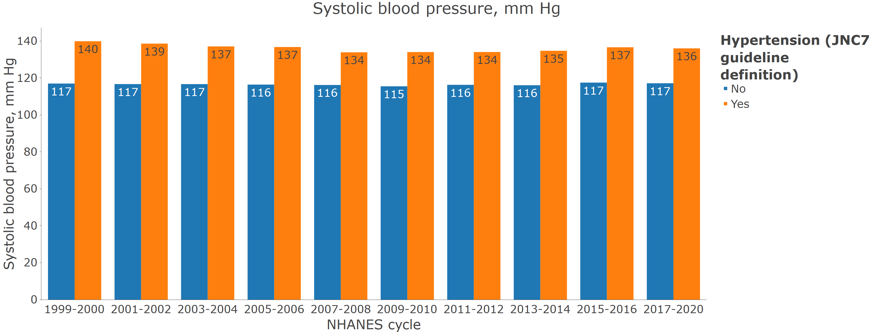

**Figure S3**: Age-adjusted prevalence of hypertension among US adults with and without chronic kidney disease

**Figure S4**: Prevalence of resistant hypertension by calendar year

A. Among those with hypertension who self report taking antihypertensive medication

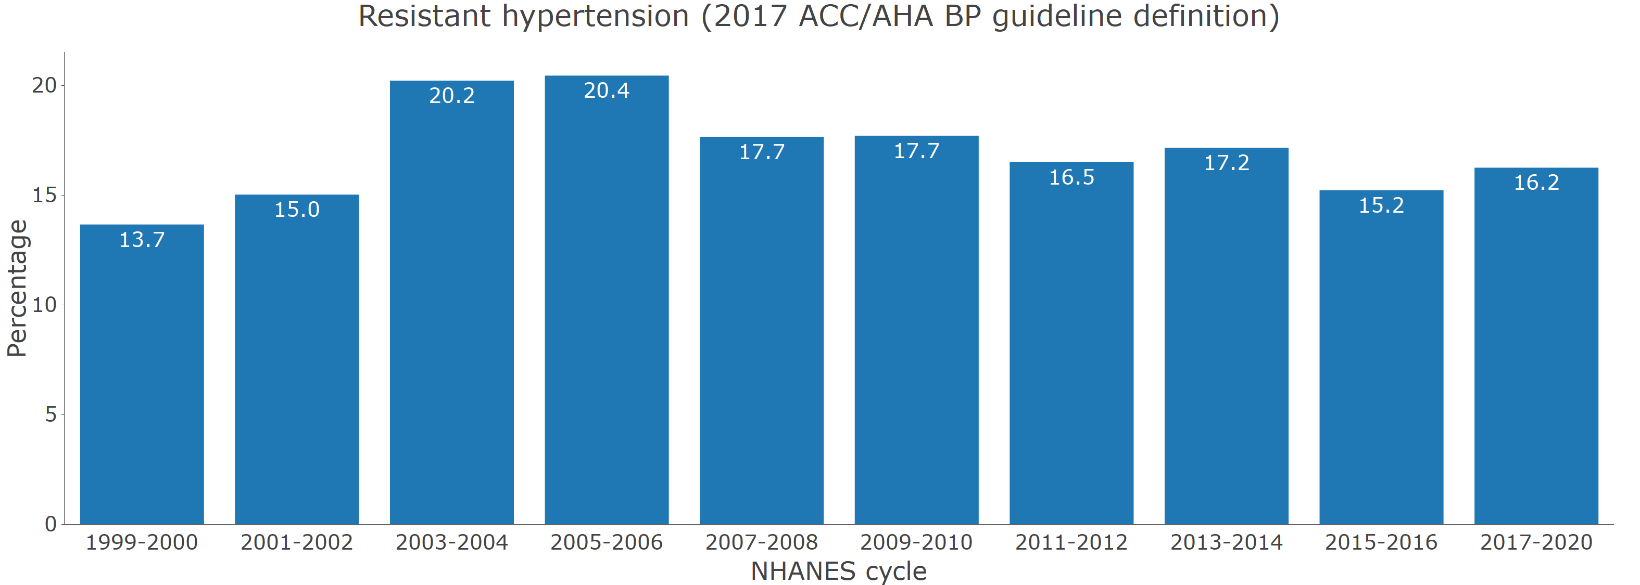

B. Among those with hypertension who self report and are taking 3+ classes of antihypertensive medication

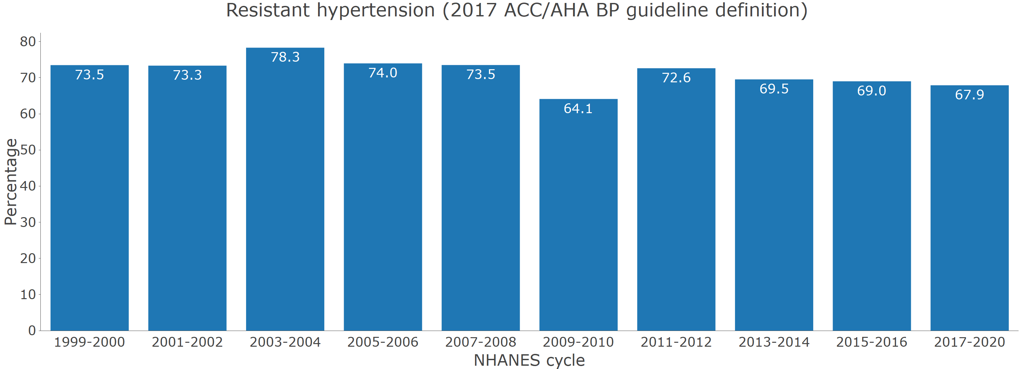

**Figure S5** Prevalence of hypertension by age categories in 2017-2020

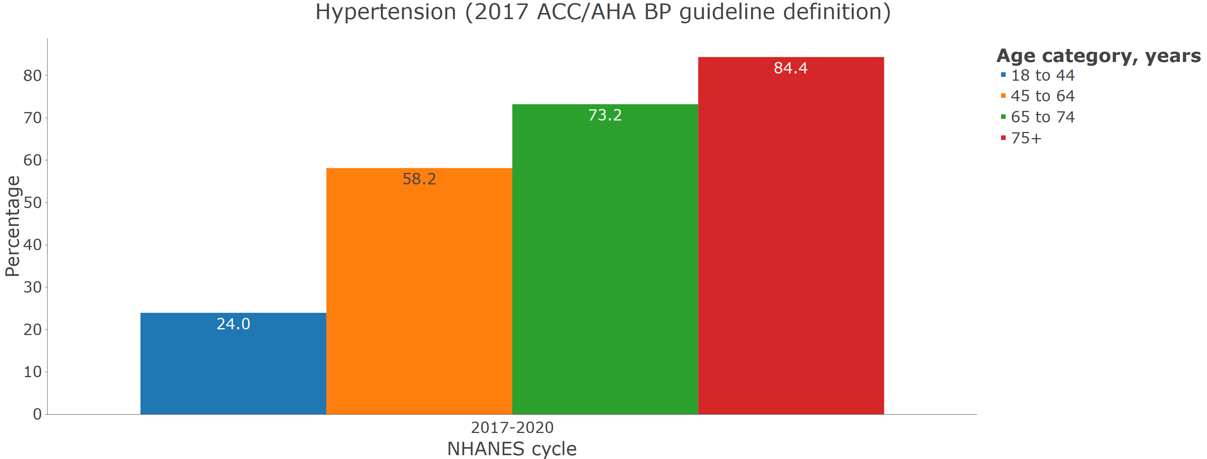

**Figure S6** Prevalence of hypertension by sex in 2017-2020

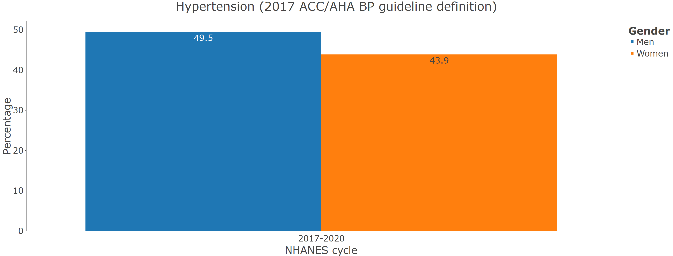

**Figure S7** Prevalence of hypertension by race/ethnicity in 2017-2020

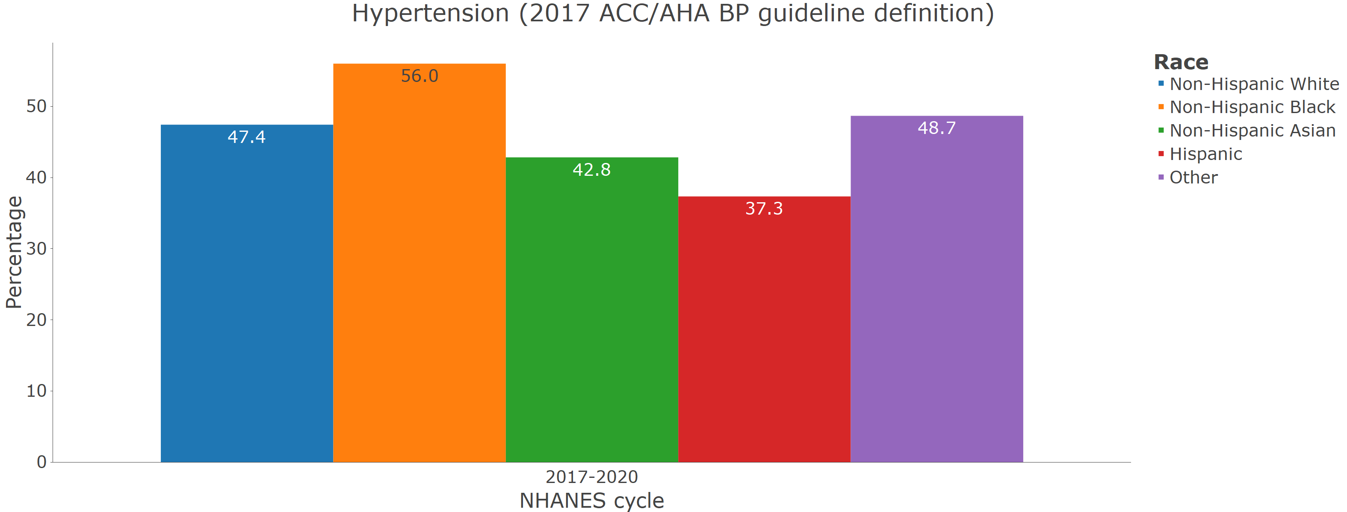

**Figure S8** Prevalence of uncontrolled blood pressure among pregnant women from 2011-2012 through 2017-2020.

