Hypertension statistics for US adults: an open-source web application for analysis and visualization of US NHANES data

Byron C. Jaeger, PhD,1 Ligong Chen, PhD,2 Kathryn Foti, PhD, MPH2 Shakia T. Hardy,2 Adam P. Bress, PharmD, MS,3,4 Sean P. Kane, PharmD, BCPS,5 Jennifer S. Herrick, MS,3,6 Catherine G. Derington, PharmD, MS,7 Bharat Poudel, MSPH,2 Ashley Christenson, BS,2 Lisandro D. Colantonio, MD, PhD,2 Paul Muntner, PhD,2

**AUTHOR ORDER NOT FINALIZED**

1Department of Biostatistics and Data Science, Wake Forest University School of Medicine, Winston-Salem, NC. 2Department of Epidemiology, University of Alabama at Birmingham, Birmingham, AL. 3Informatics, Decision-Enhancement, and Analytic Sciences (IDEAS) Center, Veterans Affairs, Salt Lake City Health Care System, Salt Lake City, UT. 4 Intermountain Healthcare Department of Population Health Sciences, Spencer Fox Eccles School of Medicine, University of Utah, Salt Lake City, UT. 5Department of Pharmacy Practice, Rosalind Franklin University of Medicine and Science, North Chicago, IL, USA 6Department of Internal Medicine, Spencer Fox Eccles School of Medicine, University of Utah, Salt Lake City, UT

# ABSTRACT

**Background**: Data from the US National Health and Nutrition Examination Survey (NHANES) are freely available and can be analyzed to produce hypertension statistics for the non-institutionalized US population. The analysis of these data requires statistical programming knowledge.

**Methods**: We developed and validated a web-based application that provides hypertension statistics for US adults using 10 cycles of NHANES data, 1999-2000 through 2017-2020, without requiring users to conduct statistical programming. The application’s interface allows users to estimate crude and age-adjusted means, quantiles and proportions. Population counts can also be estimated. The application was validated by replicating statistics from three publications. To demonstrate the application’s capabilities, we estimated hypertension statistics for US adults.

**Results**: The estimated mean systolic blood pressure (BP) declined from 123 mmHg in 1999-2000 to 120 mmHg in 2009-2010 and increased to 123 mmHg in 2017-2020. The age-adjusted prevalence of hypertension (i.e., systolic BP ≥130 mmHg, diastolic BP ≥80 mmHg or self-reported antihypertensive medication use) was 47.9% in 1999-2000, 43.0% in 2009-2010, and 44.7% in 2017-2020. In 2017-2020, 115.3 million US adults had hypertension. The age-adjusted prevalence of controlled BP, defined by the 2017 American College of Cardiology/American Heart Association BP guideline, among non-pregnant US adults with hypertension was 9.7% in 1999-2000, 25.0% in 2013-2014, and 21.9% in 2017-2020. After age-adjustment and among non-pregnant US adults who self-reported taking antihypertensive medication, 27.6%, 48.5%, and 43.0% had controlled BP in 1999-2000, 2013-2014, and 2017-2020, respectively.

**Conclusions**: The application developed in the current study is publicly available and produced valid, transparent, and reproducible results.

The National Health and Nutrition Examination Survey (NHANES) is a program conducted by the US National Center for Health Statistics (NCHS) of the Centers for Disease Control and Prevention (CDC) and is designed to assess the health and nutritional status of the non-institutionalized US population.1 NHANES data have been analyzed to provide hypertension statistics for non-institutionalized US adults with important policy and public health implications. For example, NHANES data have been used to estimate the impact of the lower blood pressure (BP) levels that define hypertension and controlled BP in the 2017 American College of Cardiology/American Heart Association (ACC/AHA) BP guideline compared with the Seventh Report of the Joint National Committee on Prevention, Detection, Evaluation, and Treatment of High BP (JNC7) guideline.2 Additionally, NHANES data have been used to track the proportion of US adults with hypertension that have controlled BP, which were included in a Call-to-Action to Control BP from the US Surgeon General.3

NHANES data are publicly available and accessible through the CDC website.4,5 However, analyzing NHANES data requires specific statistical techniques to account for the multi-stage sampling design used to select participants and analyses need to be weighted to produce nationally representative estimates. Also, NHANES data are collected in two-year periods referred to as cycles and protocols have changed over time for some variables. These changes need to be accounted for when estimating statistics from multiple NHANES cycles.

Prior studies have found errors in peer-reviewed publications reporting results from secondary analyses of public-use data sets.6,7. We developed a web-based application that provides nationally representative BP and hypertension statistics for non-institutionalized US adults using NHANES data without requiring users to conduct statistical programming. The goal of the application is to increase the use of NHANES data for research and policy decision making with a focus on ensuring results are valid and reproducible. The application is open-source and it’s code is publicly available.11 In this manuscript, we review the design, development and validation of the application and present BP and hypertension statistics for US adults that were generated using the application.

# METHODS

The NHANES program was initiated in the early 1960s and beginning in 1999 has been conducted continuously, in two-year cycles. In each cycle, potential participants were identified using a multi-stage sampling process. The protocols for each cycle were approved by the NCHS Institutional Review Board. Written informed consent was obtained from each participant.

NHANES data were collected through an in-home interview and a study examination conducted at a mobile examination center. The interview included questions about demographics, health behaviors, medical history, and medication use. During the interview, the labels of medications that participants reported taking in the preceding 30 days were recorded. We defined antihypertensive medication classes using those listed in the 2017 ACC/AHA BP guideline.12 During the study examination, height, weight and BP were measured and blood and spot urine samples were collected. Of relevance to the current application, blood samples were used to measure total and high-density lipoprotein cholesterol, glycated hemoglobin and serum creatinine, and the urine sample was used to measure albumin and creatinine and to conduct a pregnancy test. The protocol for measuring BP is available online.13 In brief, systolic and diastolic BP (SBP and DBP, respectively) were measured three times by trained and certified physicians. BP was measured using a mercury sphygmomanometer from 1999-2000 through 2015-2016 and using an oscillometric device in 2017-2020. The mean SBP and DBP levels were computed over all available measurements for each participant. The oscillometric SBP and DBP values were calibrated to the mercury device.14,15 For the current analysis, we defined hypertension, BP control, and resistant hypertension according to the 2017 ACC/AHA BP guideline.12 The application also has these variables defined according to the JNC7 definitions.16 A list of BP, hypertension, and antihypertensive medication variables available in the application is provided in **Table 1** with full definitions for all variables included in the application provided in **Table S1**.

There were 107,622 NHANES participants in the 10 cycles from 1999-2000 to 2017-2020. We restricted the dataset to adults ≥ 18 years of age. This exclusion was applied because statistics for BP levels and the prevalence of hypertension in children and adolescents are markedly different than for adults.17 We further restricted the population to participants who completed the in-home interview and study examination, with one or more SBP and DBP measurement, and who had data on self-reported antihypertensive medication use. After these exclusions were applied, the population in the current application included 56,017 participants (**Figure S1**).

## Features of the web application

A full summary of the application’s features and associated tutorials are available online.11 Briefly, users can select NHANES cycles from 1999-2000 to 2017-2020 to be analyzed. Estimates are weighted to represent the non-institutionalized US population and users can incorporate age-adjustment through direct standardization. Users can restrict analyses to subsets of participants (e.g., participants who self-reported taking antihypertensive medication). When population count estimates are requested, survey weights are calibrated within race, sex, and age groups to account for missing information on SBP, DBP or self-reported antihypertensive medication use. The results can be presented in tables or figures and for the overall population or in subgroups. All tables and figures created with the web application can be downloaded and saved in standard formats. Following CDC recommendations, unreliable statistical estimates are automatically suppressed.10 To increase precision and reliability of estimates, contiguous NHANES cycles can be combined.18

## Development and validation of the web application

The web application was created using Shiny,19–21 an open-source software package that translates code from the R programming language into HTML, CSS, or JavaScript commands and creates a website interface.22 We validated the web application by using it to reproduce statistics reported in two prior studies and one CDC report.14,23,24 We created the “cardioStatsUSA” R package to provide additional details on the web application’s design, documentation of its components, and further details on its validation.11

## Statistical analysis

We performed statistical analyses to demonstrate core features of the application. We estimated the mean SBP for US adults by NHANES cycle, 1999-2000 through 2017-2020, with points and error bars representing the estimated means and 95% confidence intervals (CI), respectively. We made bar charts presenting the age-adjusted prevalence of hypertension and the estimated number of US adults with hypertension. For age adjustment, we used the estimated age distribution of US adults from 1999 to 2020 as the standard (49.3%, 33.6%, 10.1% and 7.0% being 18 to 44, 45 to 64, 65 to 74 and ≥ 75 years of age, respectively). We created a table of the estimated race/ethnicity distribution of US adults with and without hypertension, separately. We demonstrated stratification by estimating the prevalence of hypertension by NHANES cycle for US adults with and without chronic kidney disease. We showed the application’s ability to suppress output when statistical estimates are unstable by attempting to estimate the distribution of BP categories (SBP/DBP < 120/80 mm Hg, 120-129/<80 mm Hg, 130-139/80-89 mm Hg, 140-159/90-99 mm Hg and ≥ 160/100 mm Hg) among pregnant women in 2017-2020. We then showed the ability of the application to pool NHANES cycles to achieve reliable estimates. Specifically, we estimated the distribution of BP categories among pregnant women after pooling the NHANES cycles from 2009-2010 through 2017-2020.

Next, we illustrated how core features of the application can be combined to perform customized analyses. We estimated the age-adjusted proportion of US adults with controlled BP by NHANES cycle among non-pregnant US adults with hypertension, overall and among those who self-reported taking antihypertensive medication. We estimated the age-adjusted prevalence of resistant hypertension by NHANES cycle for non-pregnant US adults with hypertension who self-reported taking antihypertensive medication and had ≥ 1 classes of antihypertensive medication identified during the medication inventory. This analysis was repeated among those taking ≥ 3 classes of antihypertensive medication. For age adjustment in the analysis of BP control and resistant hypertension, we set the age distribution for the standard population to represent US adults with hypertension from 1999 to 2020: 26.4%, 43.4%, 17.0% and 13.2% being 18 to 44 years, 45 to 64, 65 to 74, and ≥ 75 years of age, respectively.

# RESULTS

Among non-institutionalized US adults ≥ 18 years of age, the estimated mean SBP was 123 (95% CI 121, 124) mm Hg in 1999-2000, 120 (95% CI 120, 121) mm Hg in 2009-2010 and 123 (95% CI 122, 124) mm Hg in 2017-2020 (**Figure 1**). The age-adjusted prevalence of hypertension defined according to the 2017 ACC/AHA BP guideline was highest in 1999-2000 (47.9%), lowest in 2009-2010 (43.0%), and 44.7% in 2017-2020 (**Figure 2**). In 1999-2000, there were an estimated 89.8 (95% CI 77.9, 101.7) million US adults with hypertension (**Figure 3**). The number of US adults with hypertension increased to 115.3 (95% CI 107.4, 123.2) million in 2017-2020. In each NHANES cycle, the estimated prevalence of hypertension was higher among US adults with versus without chronic kidney disease (**Figure S2**). In 2017-2020, a higher percentage of US adults with versus without hypertension were non-Hispanic Black (13.5% versus 9.3%) while a lower percentage of US adults with versus without hypertension were Hispanic (12.3% versus 18.1%) (**Table 2**). Among pregnant women, the distribution of BP categories could not be estimated reliably in 2017-2020 (**Figure S3; Panel A**), but it could be estimated reliably after pooling NHANES cycles from 2009-2010 through 2017-2020 (**Figure S3; Panel B**)

The age-adjusted prevalence of BP control, defined by the 2017 ACC/AHA BP guideline, among non-pregnant US adults with hypertension was lowest in 1999-2000 (9.7%), highest in 2013-2014 (25.0%), and 21.9% in 2017-2020 (**Figure 4; Panel A**). Among US adults with hypertension who self-reported taking antihypertensive medication, 27.6%, 48.5%, and 43.0% had controlled BP in 1999-2000, 2013-2014, and 2017-2020, respectively (**Figure 4; Panel B**). The age-adjusted prevalence of resistant hypertension defined according to the 2017 ACC/AHA BP guideline among non-pregnant US adults with hypertension who self-reported taking antihypertensive medication and had ≥1 antihypertensive medication class identified during the medication inventory was lowest in 1999-2000 (14.3%), highest in 2005-2006 (21.4%), and 16.6% in 2017-2020 (**Figure S4; Panel A**). Further restricting this analysis to those who were taking ≥3 classes of antihypertensive medication, the prevalence of resistant hypertension was lowest in 2009-2010 (64.1%), highest in 2003-2004 (78.3%), and 67.9% in 2017-2020 (**Figure S4; Panel B**).

# DISCUSSION

In the current manuscript, we present a web application with a point and click interface that allows the calculation of US nationally representative estimates for BP, hypertension and antihypertensive medication-related statistics using NHANES data. Using this application, we generated crude and age-adjusted BP and hypertension statistics. Also, we generated statistics stratified by characteristics of US adults and demonstrated how multiple NHANES cycles can be pooled to obtain more precise estimates when working with small sub-groups (e.g., pregnant women). Version 0.0.1 of the application has been released and deployed on a publicly available server on **DATE TBD (it’s almost ready)**.25

NHANES is an ideal data source to obtain statistics related to hypertension for US adults. It was designed to obtain nationally representative estimates of the health and nutrition status of non-institutionalized US population. SBP and DBP were measured following a standardized protocol by trained and certified physicians. NHANES data are publicly available, but working with these data requires understanding variable definitions and advanced programming and statistical knowledge. Challenges of analyzing NHANES data include downloading and merging multiple data files, even for a single NHANES cycle; combining multiple variables to create outcome definitions, which may require dealing with missing data and questionnaire skip patterns; harmonizing variables across multiple NHANES cycles; and the analysis of complex survey design data. Although there have been multiple reports based on NHANES data , people may be interested in statistics that are not published. The web application that we present in the current manuscript addresses these challenges, increasing the accessibility of NHANES data to clinicians, researchers, and decision-makers.

Several design decisions have been incorporated into the application. We required participants to have at least one SBP and DBP to be included in the application while some prior analyses required three SBP and DBP measurements.2 We chose this approach as it is consistent with several analyses conducted by CDC investigators.24,26 The mean SBP and DBP values and the prevalence of high BP is likely to be lower if we had required multiple BP measurements.27 Any bias resulting from this decision is likely to be small as over 95% of adult NHANES participants with at least one SBP and DBP measurement had three SBP and DBP measurements. The application re-calibrates the NHANES weights for the estimation of population counts.28 This was done because participants missing data on SBP, DBP or antihypertensive medication use cannot have BP or hypertension-related outcomes. Weights were not re-calibrated when estimating means or proportions as participants missing data are removed from the numerator and denominator. Medication classes were coded using generic names and the drug classes in the 2017 ACC/AHA BP guideline. We recognize the NCHS recommends using Lexicon Plus®, a proprietary database, to categorize medication classes.29 While the categorization of most medications is identical using generic drug names and Lexicon Plus®, some differences exist. Many additional decisions were made regarding the definitions of variables, inclusion of study participants, and analytic approach. We sought to make decisions that would be widely acceptable and transparent to ensure the results could be described accurately.

Using the application, we replicated results from several prior manuscripts.14,23,24 However, we were not able to replicate some results.30 For example, a prior manuscript reported the prevalence of resistant hypertension defined by the 2017 ACC/AHA BP guideline to be 19.7% in 2009-2014.30 When estimated by the application, the prevalence of resistant hypertension over this time period was 17.1%. The difference in the prevalence estimates can be attributed to the approach used to categorize antiyhpertensive medications into their medication classes. The prior publication used Lexicon Plus®, which counted spironolactone as two drug classes, a potassium-sparing diuretic and an aldosterone antagonist. We included spironolactone as a single drug class, an aldosterone antagonist. Additionally, Lexicon Plus® includes sotalol as a beta blocker and nitroglycerine as a direct vasodilator, and although these are mechanisms of actions for these drugs, we did not include these drugs as antihypertensive medications as they are not listed in the 2017 ACC/AHA BP guideline and are not approved by the Food and Drug Administration for an indication for treating essential hypertension.12 The differences in results between the application and this previously published manuscript emphasize that it may not be possible to always generate results that are identical to prior publications. Users should be aware of the choices made in defining variables as this may affect the statistical estimates generated using the application.

The application has a number of features that can be used in combination to create customized statistics. Combining the variables, tens of thousands of unique statistics can be estimated using the application. In addition, users can generate statistics for US adults from 1999-2000 to 2017-2020, pooling results or stratifying by calendar period. All results from the application can be saved as an image and included in scientific proposals or presentations. In addition, the ability to download results as a data set from the application allows users to further customize their results in tabular or graphical formats.

## Strengths/limitations

This study has a number of strengths. We used NHANES data, which are publicly available, rigorously collected, and allow for estimation of nationally representative statistics. Also, we leveraged open-source software to ensure that our application is transparent and freely available. This study also has several limitations. NHANES participants had their mean BP measured during a single visit, and BP guidelines recommend obtaining mean BP using at least two BP values measured on separate days.12 Many estimates, including medication use, are derived from participant report, and we cannot exclude the possibility of reporting or recall bias. The response rate for NHANES has declined from 1999-2000 through 2017-2020. Effects of this decline are unclear.

## Perspectives

We developed a web-based application for analysis of hypertension statistics among non-institutionalized adults living in the US from 1999-2000 through 2017-2020. The application is publicly available and produces valid, transparent, and reproducible results.

# REFERENCES

1. Centers for Disease Control and Prevention (CDC). National Center for Health Statistics (NCHS). About the national health and nutrition examination survey. Hyattsville, MD: U.S. Department of Health and Human Services, Centers for Disease Control and Prevention. Accessed October 26, 2022. <https://www.cdc.gov/nchs/nhanes/about_nhanes.htm>

2. Muntner P, Carey RM, Gidding S, et al. Potential US population impact of the 2017 ACC/AHA high blood pressure guideline. *Journal of the American College of Cardiology*. 2018;71(2):109-118. doi:[10.1016/j.jacc.2017.10.073](https://doi.org/10.1016/j.jacc.2017.10.073)

3. U.S. Department of Health and Human Services. The Surgeon General’s call to action to control hypertension. Washington, DC: U.S. Department of Health and Human Services, Office of the Surgeon General; 2020. <https://www.cdc.gov/bloodpressure/docs/SG-CTA-HTN-Control-Report-508.pdf>

4. NHANES. National health and nutrition examination survey homepage, available at <https://www.cdc.gov/nchs/nhanes/index.htm>. Accessed on 10/23/2022.

5. Centers for Disease Control and Prevention (CDC). National Center for Health Statistics (NCHS). National health and nutrition examination survey data. Hyattsville, MD: U.S. Department of Health and Human Services, Centers for Disease Control and Prevention. Accessed October 26, 2022. <https://wwwn.cdc.gov/nchs/nhanes/default.aspx>

6. West BT, Sakshaug JW, Kim Y. Analytic error as an important component of total survey error: Results from a meta-analysis. *Total survey error in practice*. Published online 2017:487-510.

7. West BT, Sakshaug JW, Aurelien GAS. How big of a problem is analytic error in secondary analyses of survey data? *PloS one*. 2016;11(6):e0158120.

8. Disease Control C for, Prevention. National Health and Nutrition Examination Survey (NHANES). Physician Examination Procedures Manual. *Hyattsville, MD*. Published online 2015.

9. Ostchega Y, Nwankwo T, Sorlie PD, Wolz M, Zipf G. Assessing the validity of the omron HEM-907XL oscillometric blood pressure measurement device in a national survey environment. *The Journal of Clinical Hypertension*. 2010;12(1):22-28.

10. Parker JD, Talih M, Malec DJ, et al. [National Center for Health Statistics data presentation standards for proportions](https://www.ncbi.nlm.nih.gov/pubmed/30248016). *Vital and Health Statistics Series 2, Data Evaluation and Methods Research*. 2017;(175):1-22.

11. Jaeger B, Chen L, Muntner P. *cardioStatsUSA: Analysis and Visualization of Cardiometabolic Outcomes Using NHANES*.; 2022. <https://jhs-hwg.github.io/cardioStatsUSA/>

12. Whelton PK, Carey RM, Aronow WS, et al. 2017 ACC/AHA/AAPA/ABC/ACPM/AGS/APhA/ASH/ASPC/NMA/PCNA guideline for the prevention, detection, evaluation, and management of high blood pressure in adults: A report of the American College of Cardiology/American Heart Association task force on clinical practice guidelines. *Journal of the American College of Cardiology*. 2018;71(19):e127-e248. doi:[10.1016/j.jacc.2017.11.006](https://doi.org/10.1016/j.jacc.2017.11.006)

13. Ostchega Y, Prineas RJ, Paulose-Ram R, Grim CM, Willard G, Collins D. National health and nutrition examination survey 1999-2000: Effect of observer training and protocol standardization on reducing blood pressure measurement error. *Journal of Clinical Epidemiology*. 2003;56(8):768-774. doi:[10.1016/S0895-4356(03)00085-4](https://doi.org/10.1016/S0895-4356(03)00085-4)

14. Muntner P, Miles MA, Jaeger BC, et al. Blood pressure control among US adults, 2009 to 2012 through 2017 to 2020. *Hypertension*. 2022;79(9):1971-1980. doi:[10.1161/HYPERTENSIONAHA.122.19222](https://doi.org/10.1161/HYPERTENSIONAHA.122.19222)

15. Ostchega Y, Nwankwo T, Chiappa M, Wolz M, Graber J, Nguyen DT. Comparing blood pressure values obtained by two different protocols: National health and nutrition examination survey, 2017–2018. National Center for Health Statistics. Vital Health Stat 2(187). Published online 2021. doi:[10.15620/cdc:104185](https://doi.org/10.15620/cdc:104185)

16. Chobanian AV, Bakris GL, Black HR, et al. The seventh report of the Joint National Committee on prevention, detection, evaluation, and treatment of high blood pressure: The JNC 7 report. *JAMA*. 2003;289(19):2560-2572. doi:[10.1001/jama.289.19.2560](https://doi.org/10.1001/jama.289.19.2560)

17. Muntner P, He J, Cutler JA, Wildman RP, Whelton PK. Trends in blood pressure among children and adolescents. *JAMA*. 2004;291(17):2107-2113. doi:[10.1001/jama.291.17.2107](https://doi.org/10.1001/jama.291.17.2107)

18. NHANES. Tutorials - module 3 - weighting, available at <https://wwwn.cdc.gov/nchs/nhanes/tutorials/module3.aspx>. Accessed on 10/23/2022.

19. Chang W, Cheng J, Allaire J, et al. *Shiny: Web Application Framework for R*.; 2021. <https://CRAN.R-project.org/package=shiny>

20. Perrier V, Meyer F, Granjon D. *shinyWidgets: Custom Inputs Widgets for Shiny*.; 2022. <https://CRAN.R-project.org/package=shinyWidgets>

21. Attali D, Edwards T. *Shinyalert: Easily Create Pretty Popup Messages (Modals) in Shiny*.; 2021. <https://CRAN.R-project.org/package=shinyalert>

22. R Core Team. *R: A Language and Environment for Statistical Computing*. R Foundation for Statistical Computing; 2022. <https://www.R-project.org/>

23. Muntner P, Hardy ST, Fine LJ, et al. Trends in blood pressure control among US adults with hypertension, 1999-2000 to 2017-2018. *JAMA*. 2020;324(12):1190-1200. doi:[10.1001/jama.2020.14545](https://doi.org/10.1001/jama.2020.14545)

24. Fryar CD, Ostchega Y, Hales CM, Zhang G, Kruszon-Moran D. [Hypertension prevalence and control among adults: United States, 2015-2016](https://www.ncbi.nlm.nih.gov/pubmed/29155682). *NCHS data brief*. 2017;(289):1-8.

25. Jaeger B, Chen L, Muntner P. Cardiometabolic statistics for US adults. Accessed October 24, 2022. <https://bcjaeger.shinyapps.io/nhanesShinyBP/>

26. Yoon SSS, Carroll MD, Fryar CD. [Hypertension prevalence and control among adults: United States, 2011-2014](https://www.ncbi.nlm.nih.gov/pubmed/26633197). *NCHS data brief*. 2015;(220):1-8.

27. Handler J, Zhao Y, Egan BM. Impact of the number of blood pressure measurements on blood pressure classification in US adults: NHANES 1999-2008. *Journal of Clinical Hypertension (Greenwich, Conn)*. 2012;14(11):751-759. doi:[10.1111/jch.12009](https://doi.org/10.1111/jch.12009)

28. Coresh J, Astor BC, Greene T, Eknoyan G, Levey AS. Prevalence of chronic kidney disease and decreased kidney function in the adult US population: Third national health and nutrition examination survey. *American Journal of Kidney Diseases: The Official Journal of the National Kidney Foundation*. 2003;41(1):1-12. doi:[10.1053/ajkd.2003.50007](https://doi.org/10.1053/ajkd.2003.50007)

29. National Center for Health Statistics. NHANES 1988–2016 data documentation, codebook, and frequencies: Prescription medications - drug information (RXQ_DRUG). Accessed October 27, 2022. <https://wwwn.cdc.gov/Nchs/Nhanes/1999-2000/RXQ_DRUG.htm>

30. Carey RM, Sakhuja S, Calhoun DA, Whelton PK, Muntner P. Prevalence of apparent treatment-resistant hypertension in the United States. *Hypertension*. 2019;73(2):424-431. doi:[10.1161/HYPERTENSIONAHA.118.12191](https://doi.org/10.1161/HYPERTENSIONAHA.118.12191)

# FUNDING/SUPPORT

**this section is under construction and should be checked for correctness**

Drs Muntner and Jaeger receive support through grant R01HL144773 from the National Heart, Lung, and Blood Institute. Drs Muntner and Hardy receive support through grant R01HL117323 from the National Heart, Lung, and Blood Institute. Dr Muntner receives support through grant R01HL139716 from the National Heart, Lung, and Blood Institute.

# FINANCIAL DISCLOSURE

**this section is under construction and should be checked for correctness**

Dr Muntner reported receiving grant funding and consulting fees from Amgen Inc. Dr Colantonio reported receiving grant funding from Amgen Inc. No other disclosures were reported.

### Table 1: Blood pressure, hypertension and antihypertensive medication variables that are available in the web application.

| **Variable** |
| --- |
| *Blood pressure domain* |
| Systolic blood pressure (SBP), mm Hg |
| Diastolic blood pressure (DBP), mm Hg |
| Blood pressure category |
| Blood pressure category including antihypertensive medication use as a group |
| Blood pressure control defined by the JNC7 guideline |
| Blood pressure control defined by the 2017 ACC/AHA BP guideline |
| Blood pressure control (SBP < 140 mm Hg and DBP < 90 mm Hg) |
| Blood pressure control (SBP < 130 mm Hg and DBP < 80 mm Hg) |
| Uncontrolled blood pressure defined by the JNC7 guideline |
| Uncontrolled blood pressure defined by the 2017 ACC/AHA BP guideline |
| Uncontrolled blood pressure (SBP ≥ 140 mm Hg or DBP ≥ 90 mm Hg) |
| Uncontrolled blood pressure (SBP ≥ 130 mm Hg or DBP ≥ 80 mm Hg) |
| *Hypertension domain* |
| Hypertension defined by the JNC7 guideline |
| Hypertension defined by the 2017 ACC/AHA BP guideline |
| Awareness of hypertension |
| Resistant hypertension defined by the JNC7 guideline |
| Resistant hypertension defined by the 2017 ACC/AHA BP guideline |
| Resistant hypertension defined by the JNC7 guideline, requires thiazide diuretic |
| Resistant hypertension defined by the 2017 ACC/AHA BP guideline, requires thiazide diuretic |
| *Antihypertensive medication domain* |
| Self-reported antihypertensive medication use |
| Antihypertensive medications recommended defined by the JNC7 guideline |
| Antihypertensive medications recommended by the 2017 ACC/AHA BP guideline |
| Number of antihypertensive medication classes |
| *Antihypertensive medication classes* |
| ACE inhibitors |
| Aldosterone antagonists |
| Alpha-1 blockers |
| Angiotensin receptor blockers |
| Beta blockers |
| Central alpha1 agonist and other centrally acting agents |
| Calcium channel blockers |
| Potassium sparing diuretics |
| Loop diuretics |
| Thiazide or thiazide-type diuretics |
| Direct renin inhibitors |
| Direct vasodilators |
| Abbreviations: ACC = American College of Cardiology; ACE = angiotensin-converting enzyme; AHA = American Heart Association; BP = blood pressure; DBP = diastolic blood pressure; JNC7 = Seventh Joint National Committee; and SBP = systolic blood pressure |

### Table 2: Race/ethnicity distribution of US adults with and without hypertension in 2017-2020

| **svy_year** | **htn_accaha** | **demo_race** | **statistic** | **estimate** | **std_error** | **ci_lower** | **ci_upper** | **n_obs** | **unreliable_status** | **unreliable_reason** | **review_needed** | **review_reason** |
| --- | --- | --- | --- | --- | --- | --- | --- | --- | --- | --- | --- | --- |
| 2017-2020 | No | Hispanic | percentage | 18.1 | 1.8 | 14.5 | 21.7 | 953 | FALSE |  | FALSE |  |
| 2017-2020 | No | Non-Hispanic Asian | percentage | 5.9 | 0.9 | 4.2 | 7.6 | 502 | FALSE |  | FALSE |  |
| 2017-2020 | No | Non-Hispanic Black | percentage | 9.3 | 1.2 | 7.0 | 11.5 | 802 | FALSE |  | FALSE |  |
| 2017-2020 | No | Non-Hispanic White | percentage | 62.8 | 2.3 | 58.2 | 67.4 | 1,325 | FALSE |  | FALSE |  |
| 2017-2020 | No | Other | percentage | 4.0 | 0.4 | 3.2 | 4.7 | 200 | FALSE |  | FALSE |  |
| 2017-2020 | Yes | Hispanic | percentage | 12.3 | 1.2 | 10.0 | 14.7 | 752 | FALSE |  | FALSE |  |
| 2017-2020 | Yes | Non-Hispanic Asian | percentage | 5.0 | 0.8 | 3.5 | 6.6 | 425 | FALSE |  | FALSE |  |
| 2017-2020 | Yes | Non-Hispanic Black | percentage | 13.5 | 1.8 | 9.9 | 17.1 | 1,343 | FALSE |  | FALSE |  |
| 2017-2020 | Yes | Non-Hispanic White | percentage | 64.9 | 2.8 | 59.4 | 70.3 | 1,510 | FALSE |  | FALSE |  |
| 2017-2020 | Yes | Other | percentage | 4.3 | 0.6 | 3.2 | 5.4 | 198 | FALSE |  | FALSE |  |
| Table format is identical to the web application's output. | | | | | | | | | | | | |
| svy_year indicates the NHANES cycle | | | | | | | | | | | | |
| htn_accaha indicates hypertension status. | | | | | | | | | | | | |
| demo_race indicates the race subgroup. | | | | | | | | | | | | |
| statistic indicates the type of statistic computed. | | | | | | | | | | | | |
| estimate is the point estimate of the given statistic | | | | | | | | | | | | |
| std_error is the standard error for estimate | | | | | | | | | | | | |
| ci_lower is the lower bound of a 95% confidence interval for estimate | | | | | | | | | | | | |
| ci_upper is the upper bound of a 95% confidence interval for estimate | | | | | | | | | | | | |
| n_obs is the number of observations (unweighted) used for computations | | | | | | | | | | | | |
| unreliable_status is TRUE if the result is unreliable, FALSE otherwise | | | | | | | | | | | | |
| unreliable_reason is blank if the result is reliable, and lists reason(s) for unreliability otherwise | | | | | | | | | | | | |
| review_needed is TRUE if the result should be reviewed, FALSE otherwise | | | | | | | | | | | | |
| review_reason is blank if the result does not require review, and lists reason(s) for requiring review otherwise | | | | | | | | | | | | |

### Figure 1: Mean systolic blood pressure for US adults by calendar year

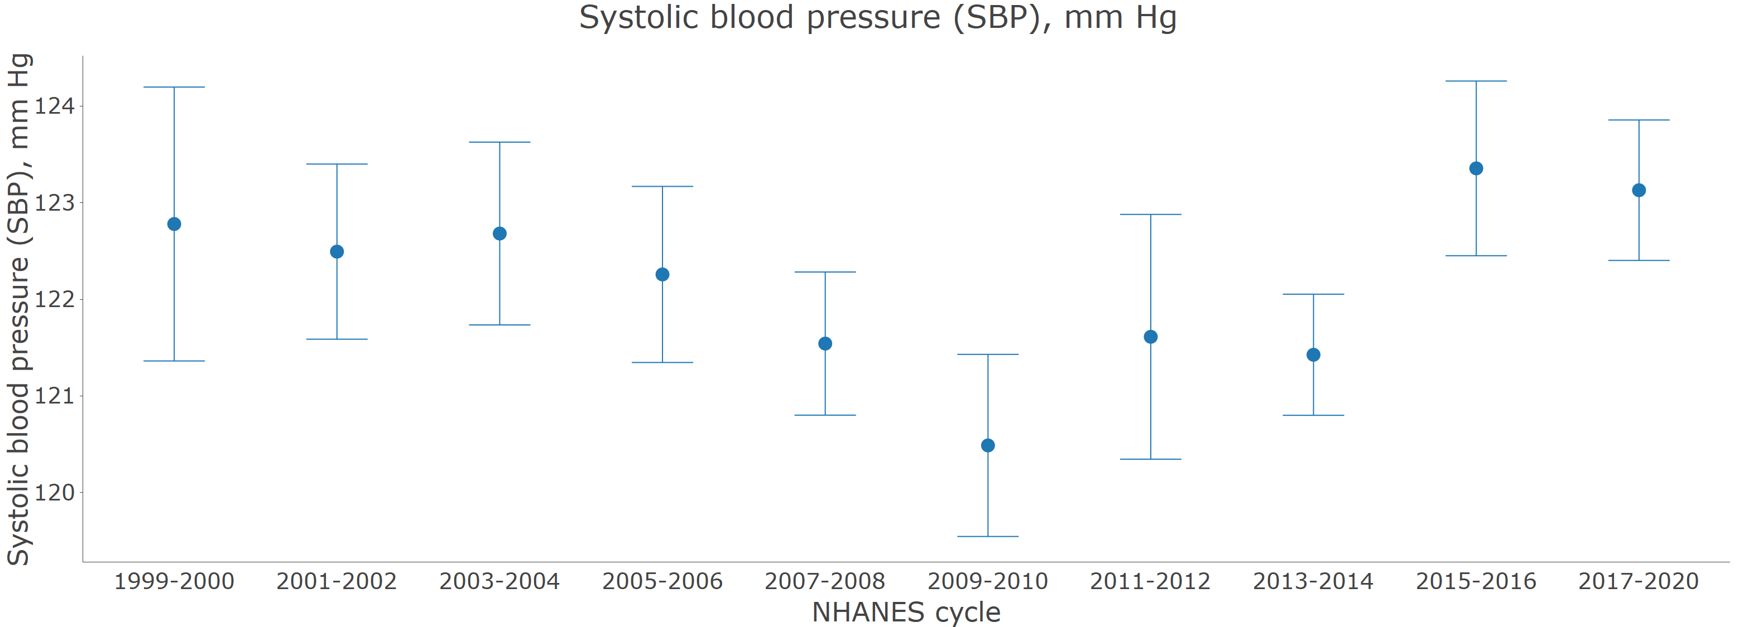

Dots represent mean systolic blood pressure. Vertical lines represent the 95% confidence interval.

The graph is identical to the web application’s output. All values (estimated mean and the upper and lower limits of the 95% confidence interval) can be obtained in the app by hovering over the mean systolic blood pressure.

This commands used to generate this graph are [available online](https://bcjaeger.shinyapps.io/nhanesShinyBP/?_inputs_&standard_weights_2=33.6&help=0&stratify_class=null&group=null&wont_do_computation=0&standard_weights_1=49.3&year_stratify=%5B%221999-2000%22%2C%222001-2002%22%2C%222003-2004%22%2C%222005-2006%22%2C%222007-2008%22%2C%222009-2010%22%2C%222011-2012%22%2C%222013-2014%22%2C%222015-2016%22%2C%222017-2020%22%5D&shinyjs-delay-09f5dfa7e9684def7b5c54ddf5175adf=200&geom=%22scatter%22&outcome=%22bp_sys_mean%22&statistic_primary=%22mean%22&standard_weights_4=7&shinyjs-delay-9c5ec1c3f7219bb7bf0d2e2dae255e33=200&shinyjs-delay-c2a3e79393f36660786d425d151ef85e=500&n_exposure_group=null&pool=%22no%22&stratify=null&exposure_cut_type=%22interval%22&group_class=null&statistic=%22mean%22&subset_n=%220%22&outcome_class=%22Blood%20pressure%22&standard_weights_3=10.1&.clientValue-default-plotlyCrosstalkOpts=%7B%22on%22%3A%22plotly_click%22%2C%22persistent%22%3Afalse%2C%22dynamic%22%3Afalse%2C%22selectize%22%3Afalse%2C%22opacityDim%22%3A0.2%2C%22selected%22%3A%7B%22opacity%22%3A1%7D%2C%22debounce%22%3A0%2C%22color%22%3A%5B%5D%7D&do=%22figure%22&year_pool=%5B%221999-2000%22%2C%222017-2020%22%5D&plotly_afterplot-A=%22%5C%22htmlwidget-b15366fdef4727083aad%5C%22%22&age_standardize=false&plotly_hover-A=null)

### Figure 2: Age-adjusted prevalence of hypertension for US adults by calendar year

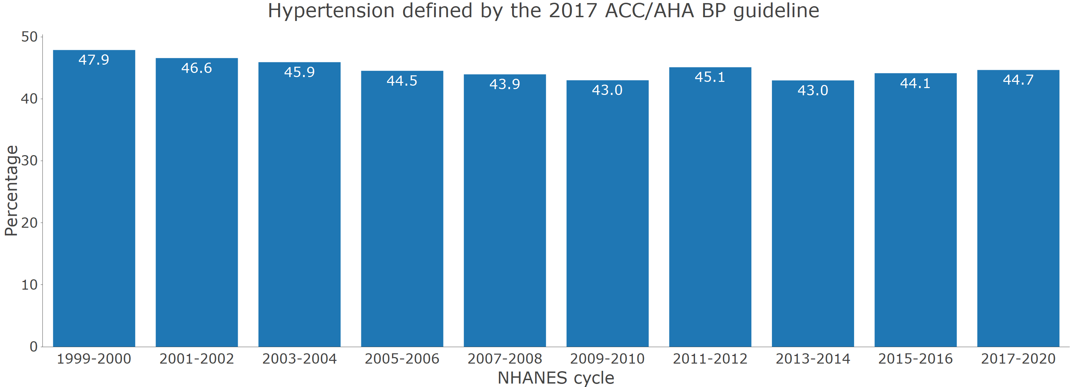

Age adjustment was performed through direct standardization, using the estimated age distribution of US adults from 1999 to 2020 as the standard (49.3%, 33.6%, 10.1% and 7.0% being 18 to 44, 45 to 64, 65 to 74 and ≥ 75 years of age, respectively).

The graph is identical to the web application’s output. All values (estimated prevalence and the upper and lower limits of the 95% confidence interval) can be obtained in the app by hovering over the bars.

This commands used to generate this graph are [available online](https://bcjaeger.shinyapps.io/nhanesShinyBP/?_inputs_&standard_weights_2=33.6&help=0&stratify_class=null&group=null&wont_do_computation=0&standard_weights_1=49.3&year_stratify=%5B%221999-2000%22%2C%222001-2002%22%2C%222003-2004%22%2C%222005-2006%22%2C%222007-2008%22%2C%222009-2010%22%2C%222011-2012%22%2C%222013-2014%22%2C%222015-2016%22%2C%222017-2020%22%5D&geom=%22bar%22&outcome=%22htn_accaha%22&statistic_primary=%22percentage%22&standard_weights_4=7&outcome_open=false&plotly_hover-A=null&n_exposure_group=null&pool=%22no%22&stratify=null&exposure_cut_type=%22interval%22&group_class=null&statistic=%22percentage%22&subset_n=%220%22&outcome_class=%22Hypertension%22&standard_weights_3=10.1&.clientValue-default-plotlyCrosstalkOpts=%7B%22on%22%3A%22plotly_click%22%2C%22persistent%22%3Afalse%2C%22dynamic%22%3Afalse%2C%22selectize%22%3Afalse%2C%22opacityDim%22%3A0.2%2C%22selected%22%3A%7B%22opacity%22%3A1%7D%2C%22debounce%22%3A0%2C%22color%22%3A%5B%5D%7D&do=%22figure%22&year_pool=%5B%221999-2000%22%2C%222017-2020%22%5D&plotly_afterplot-A=%22%5C%22htmlwidget-9eb170c07bf326bb924d%5C%22%22&age_standardize=true&outcome_class_open=false)

### Figure 3: Number of US adults with hypertension by calendar year

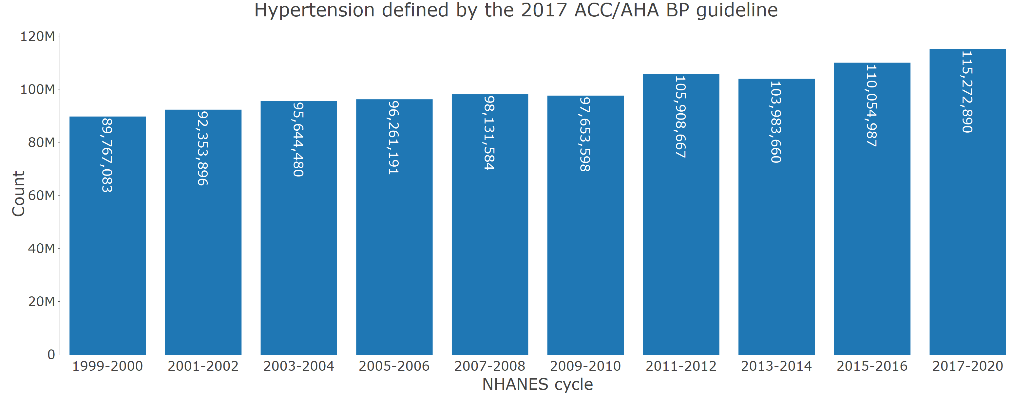

The graph is identical to the web application’s output. All values (estimated count and the upper and lower limits of the 95% confidence interval) can be obtained in the app by hovering over the bars.

This commands used to generate this graph are [available online](https://bcjaeger.shinyapps.io/nhanesShinyBP/?_inputs_&standard_weights_2=33.6&help=0&stratify_class=null&group=null&wont_do_computation=0&standard_weights_1=49.3&year_stratify=%5B%221999-2000%22%2C%222001-2002%22%2C%222003-2004%22%2C%222005-2006%22%2C%222007-2008%22%2C%222009-2010%22%2C%222011-2012%22%2C%222013-2014%22%2C%222015-2016%22%2C%222017-2020%22%5D&geom=%22bar%22&outcome=%22htn_accaha%22&statistic_primary=%22count%22&standard_weights_4=7&outcome_open=false&plotly_hover-A=null&n_exposure_group=null&pool=%22no%22&stratify=null&exposure_cut_type=%22interval%22&group_class=null&statistic=%22count%22&subset_n=%220%22&outcome_class=%22Hypertension%22&standard_weights_3=10.1&.clientValue-default-plotlyCrosstalkOpts=%7B%22on%22%3A%22plotly_click%22%2C%22persistent%22%3Afalse%2C%22dynamic%22%3Afalse%2C%22selectize%22%3Afalse%2C%22opacityDim%22%3A0.2%2C%22selected%22%3A%7B%22opacity%22%3A1%7D%2C%22debounce%22%3A0%2C%22color%22%3A%5B%5D%7D&do=%22figure%22&year_pool=%5B%221999-2000%22%2C%222017-2020%22%5D&plotly_afterplot-A=%22%5C%22htmlwidget-72fc5230e0cbdfdb5676%5C%22%22&age_standardize=false&outcome_class_open=false)

### Figure 4: Age-adjusted prevalence of blood pressure control by calendar year.

A. Among non-pregnant US adults with hypertension

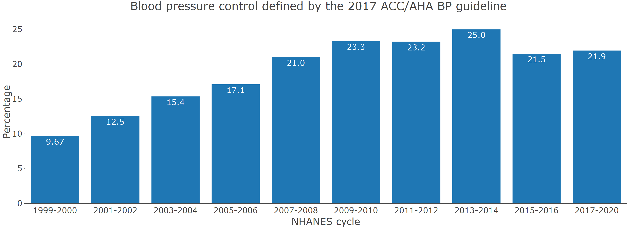

Age adjustment was performed through direct standardization, using the estimated age distribution of US adults with hypertension from 1999 to 2020 as the standard (26.4%, 43.4%, 17.0% and 13.2% being 18 to 44 years, 45 to 64, 65 to 74, and ≥ 75 years of age, respectively)

The graph is identical to the web application’s output. All values (estimated prevalence and the upper and lower limits of the 95% confidence interval) can be obtained in the app by hovering over the bars.

Survey participants with missing values for pregnancy status were assumed to be non-pregnant

This commands used to generate this graph are [available online](https://bcjaeger.shinyapps.io/nhanesShinyBP/?_inputs_&standard_weights_2=43.5&subset_variable_2=%22demo_pregnant%22&help=0&stratify_class=null&subset_value_1_ctns=%5B0%2C0%5D&subset_value_2_catg=%5B%22No%22%2C%22Missing%22%5D&subset_variable_1=%22htn_accaha%22&group=null&wont_do_computation=0&standard_weights_1=26.4&subset_variable_2_open=false&year_stratify=%5B%221999-2000%22%2C%222001-2002%22%2C%222003-2004%22%2C%222005-2006%22%2C%222007-2008%22%2C%222009-2010%22%2C%222011-2012%22%2C%222013-2014%22%2C%222015-2016%22%2C%222017-2020%22%5D&subset_value_1_catg=%22Yes%22&geom=%22bar%22&outcome=%22bp_control_accaha%22&statistic_primary=%22percentage%22&subset_n_open=false&standard_weights_4=13.2&outcome_open=false&plotly_hover-A=null&n_exposure_group=null&pool=%22no%22&stratify=null&exposure_cut_type=%22interval%22&group_class=null&statistic=%22percentage%22&subset_n=%222%22&outcome_class=%22Blood%20pressure%22&standard_weights_3=17&.clientValue-default-plotlyCrosstalkOpts=%7B%22on%22%3A%22plotly_click%22%2C%22persistent%22%3Afalse%2C%22dynamic%22%3Afalse%2C%22selectize%22%3Afalse%2C%22opacityDim%22%3A0.2%2C%22selected%22%3A%7B%22opacity%22%3A1%7D%2C%22debounce%22%3A0%2C%22color%22%3A%5B%5D%7D&do=%22figure%22&year_pool=%5B%221999-2000%22%2C%222017-2020%22%5D&plotly_afterplot-A=%22%5C%22htmlwidget-1d7ba8c29733e6d67fa7%5C%22%22&age_standardize=true&statistic_primary_open=false&subset_value_2_ctns=%5B0%2C0%5D&subset_variable_1_open=false&outcome_class_open=false)

B. Among non-pregnant US adults who self-report taking antihypertensive medication

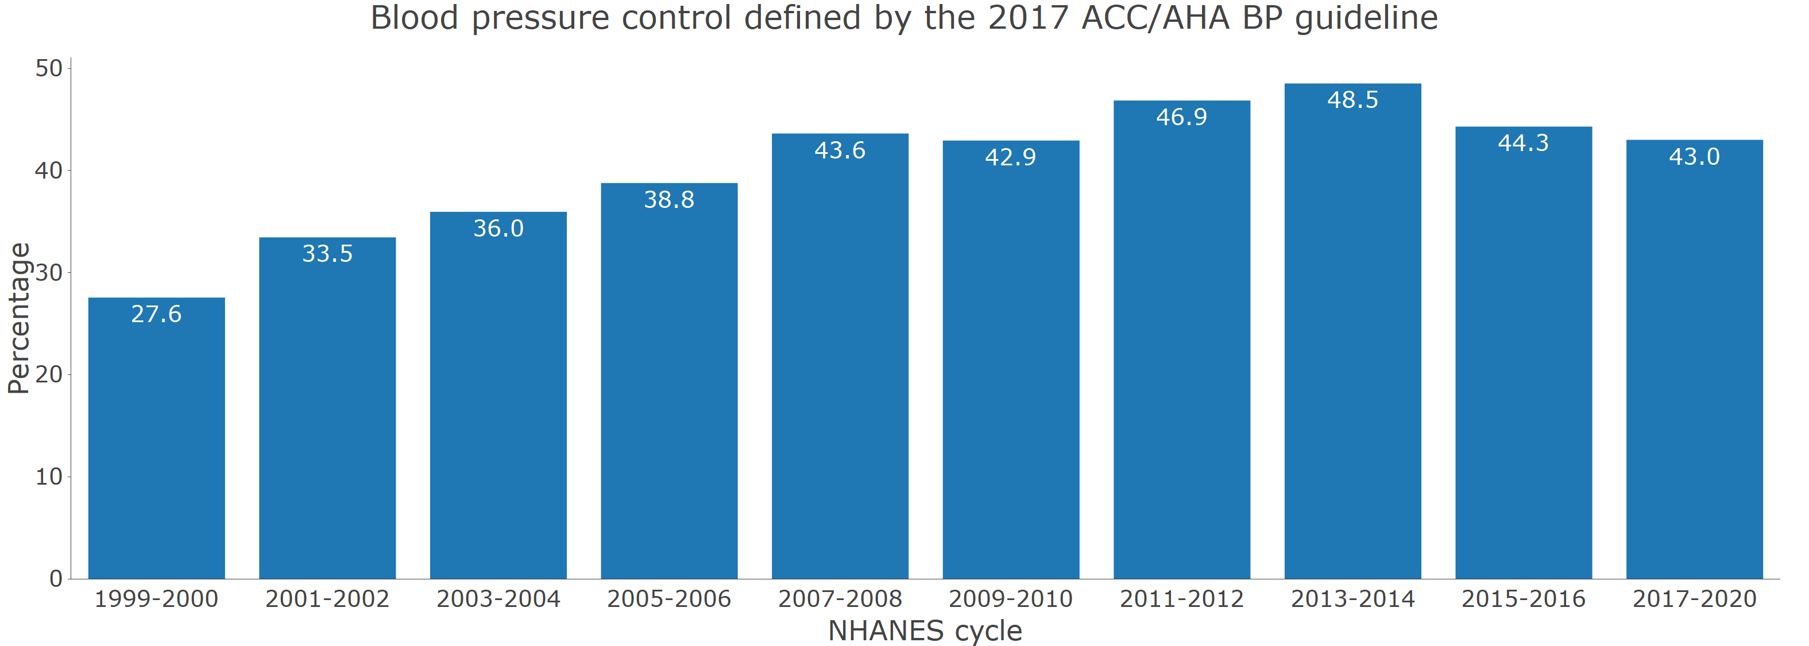

Age adjustment was performed through direct standardization, using the estimated age distribution of US adults with hypertension from 1999 to 2020 as the standard (26.4%, 43.4%, 17.0% and 13.2% being 18 to 44 years, 45 to 64, 65 to 74, and ≥ 75 years of age, respectively)

The graph is identical to the web application’s output. All values (estimated prevalence and the upper and lower limits of the 95% confidence interval) can be obtained in the app by hovering over the bars.

Survey participants with missing values for pregnancy status were assumed to be non-pregnant

This commands used to generate this graph are [available online](https://bcjaeger.shinyapps.io/nhanesShinyBP/?_inputs_&standard_weights_2=43.5&subset_variable_2=%22demo_pregnant%22&subset_variable_3=%22bp_med_use%22&help=0&stratify_class=null&subset_value_1_ctns=%5B0%2C0%5D&subset_value_2_catg=%5B%22No%22%2C%22Missing%22%5D&subset_variable_1=%22htn_accaha%22&group=null&wont_do_computation=0&standard_weights_1=26.4&subset_variable_2_open=false&subset_value_3_ctns=%5B0%2C0%5D&year_stratify=%5B%221999-2000%22%2C%222001-2002%22%2C%222003-2004%22%2C%222005-2006%22%2C%222007-2008%22%2C%222009-2010%22%2C%222011-2012%22%2C%222013-2014%22%2C%222015-2016%22%2C%222017-2020%22%5D&subset_value_1_catg=%22Yes%22&geom=%22bar%22&outcome=%22bp_control_accaha%22&statistic_primary=%22percentage%22&subset_n_open=false&standard_weights_4=13.2&outcome_open=false&plotly_hover-A=null&n_exposure_group=null&pool=%22no%22&stratify=null&exposure_cut_type=%22interval%22&group_class=null&statistic=%22percentage%22&subset_n=%223%22&outcome_class=%22Blood%20pressure%22&standard_weights_3=17&.clientValue-default-plotlyCrosstalkOpts=%7B%22on%22%3A%22plotly_click%22%2C%22persistent%22%3Afalse%2C%22dynamic%22%3Afalse%2C%22selectize%22%3Afalse%2C%22opacityDim%22%3A0.2%2C%22selected%22%3A%7B%22opacity%22%3A1%7D%2C%22debounce%22%3A0%2C%22color%22%3A%5B%5D%7D&do=%22figure%22&year_pool=%5B%221999-2000%22%2C%222017-2020%22%5D&plotly_afterplot-A=%22%5C%22htmlwidget-49855de1c73b4f93593a%5C%22%22&age_standardize=true&statistic_primary_open=false&subset_value_2_ctns=%5B0%2C0%5D&subset_variable_3_open=false&subset_value_3_catg=%22Yes%22&subset_variable_1_open=false&outcome_class_open=false)

### Table S1: Definitions of variables included in the web-based application.

| **All variables included in module** | **Variable definition** |
| --- | --- |
| *Survey* | |
| participant identifier | NHANES participant unique identifier. |
| primary sampling unit | Population sampling unit. This variable is used to account for the non-random selection of study participants for NHANES |
| strata | Population stratification. This variable is used to account for the non-random selection of study participants for NHANES |
| Mobile examination center weights | Weight applied to produce statistical estimates for the non-institutionalized US population. This weight is used for calculating means and proportions. |
| Calibrated mobile examination center weights | Weight applied to produce statistical estimates for the non-institutionalized US population. This weight is used for estimating population counts and is recalibrated to account for participants excluded from this analysis due to missing data on systolic blood pressure, diastolic blood pressure or self-reported antihypertensive medication use. |
| Subpopulation for hypertension | This indicates that the person has data needed to be included in the analysis of blood pressure or hypertension data (i.e., they had at least one systolic and diastolic blood pressure measurement and they had information on self-reported antihypertensive medication use). |
| NHANES cycle | NHANES survey cycle: 1999-2000, 2001-2002, 2003-2004, 2005-2006, 2007-2008, 2009-2010, 2011-2012, 2013-2014, 2015-2016, 2017-2020. Each cycle is 2 years in length, apart from 2017-2020, which covers 2017 through March of 2020 (approximately 3.2 years) |
| *Demographics* | |
| Age category, years | Age grouping: 18-44, 45-64, 65-74, ≥ 75 years |
| Race | Self-reported race/ethnicity. From 1999-2000 through 2009-2010 this was available as non-Hispanic White, non-Hispanic Black, Hispanic and other. From 2011-2012 through 2017-2020 this was available as non-Hispanic White, non-Hispanic Black, non-Hispanic Asian, Hispanic and other. |
| Age, years | Participant age in years. Participants > 80 years of age are given an age of 80 years. This top-coding was changed from 85 years to 80 with the 2007-2008 cycle (prior to then, was top-coded at 85). |
| Pregnant | Pregnancy status. This is defined by either self-report of being pregnant or a positive pregnancy test conducted during the study visit. |
| Gender | Self-reported gender |
| *Blood pressure* | |
| Systolic blood pressure (SBP), mm Hg | Mean systolic blood pressure in mm Hg. This is based on the average of up to 3 readings. Participants were required to have at least one reading. Overall, >95% of participants with at least one systolic blood pressure reading had three readings. From 1999-2000 through 2015-2016, systolic blood pressure was measured using a mercury sphygmomanometer. In 2017-2020, systolic blood pressure was measured using an oscillometric device. The systolic blood pressure in 2017-2020 was calibrated to the mercury device by adding 1.5 mm Hg to the mean measured oscillometric value. |
| Diastolic blood pressure (DBP), mm Hg | Mean diastolic blood pressure in mm Hg. This is based on the average of up to 3 readings. Participants were required to have at least one reading. Overall, >95% of participants with at least one diastolic blood pressure reading had three readings. From 1999-2000 through 2015-2016, diastolic blood pressure was measured using a mercury sphygmomanometer. In 2017-2020, diastolic blood pressure was measured using an oscillometric device. The diastolic blood pressure in 2017-2020 was calibrated to the mercury device by subtracting 1.3 mm Hg to the mean measured oscillometric value. |
| Blood pressure category | Systolic/diastolic blood pressure <120/80, 120-129/<80, 130-139/80-89, 140-159/90-99, ≥ 160/100. All participants were placed in the category associated with a higher blood pressure (e.g., someone with systolic blood pressure of 150 mm Hg and diastolic blood pressure of 76 mm Hg was placed in the 140-159/90-99 mm Hg category) |
| Blood pressure category including antihypertensive medication use as a group | Systolic/diastolic blood pressure <120/80, 120-129/<80, 130-139/80-89, 140-159/90-99, ≥ 160/100. Participants taking antihypertensive medication were placed in a separate category. Participants were placed in the category associated with higher blood pressure (e.g., someone with systolic blood pressure of 150 mm Hg and diastolic blood pressure of 76 mm Hg was placed in the 140-159/90-99 mm Hg category) |
| Blood pressure control defined by the JNC7 guideline | Systolic and diastolic blood pressure controlled to the levels recommended in the JNC7 guideline, systolic blood pressure < 140 mm Hg and diastolic blood pressure < 90 mm Hg except for those with diabetes or chronic kidney disease, where blood pressure control was defined by systolic blood pressure < 130 mm Hg and diastolic blood pressure < 80 mm Hg. |
| Blood pressure control defined by the 2017 ACC/AHA BP guideline | Systolic and diastolic blood pressure controlled to the levels recommended in the 2017 ACC/AHA BP guideline, systolic blood pressure < 130 mm Hg and diastolic blood pressure < 80 mm Hg except for those ≥ 65 years of age without diabetes, chronic kidney disease, history of cardiovascular disease or 10-year predicted ASCVD risk ≥ 10% estimated using the Pooled Cohort risk equations. For this group, blood pressure control was defined as systolic blood pressure < 130 mm Hg |
| Blood pressure control (SBP < 140 mm Hg and DBP < 90 mm Hg) | Systolic blood pressure < 140 mm Hg and diastolic blood pressure < 90 mm Hg |
| Blood pressure control (SBP < 130 mm Hg and DBP < 80 mm Hg) | Systolic blood pressure < 130 mm Hg and diastolic blood pressure < 80 mm Hg |
| Uncontrolled blood pressure defined by the JNC7 guideline | Systolic blood pressure = 140 mm Hg or diastolic blood pressure = 90 mm Hg for those without diabetes and without chronic kidney disease; Systolic blood pressure = 130 mm Hg or diastolic blood pressure = 80 mm Hg for those with diabetes or chronic kidney disease |
| Uncontrolled blood pressure defined by the 2017 ACC/AHA BP guideline | Systolic blood pressure = 130 mm Hg or diastolic blood pressure = 80 mm Hg except for adults = 65 years of age without diabetes, chronic kidney disease, history of cardiovascular disease or 10-year predicted ASCVD risk = 10%. For this group, uncontrolled blood pressure was defined as systolic blood pressure = 130 mm Hg. |
| Uncontrolled blood pressure (SBP ≥ 140 mm Hg or DBP ≥ 90 mm Hg) | Systolic blood pressure ≥ 140 mm Hg or diastolic blood pressure ≥ 90 mm Hg |
| Uncontrolled blood pressure (SBP ≥ 130 mm Hg or DBP ≥ 80 mm Hg) | Systolic blood pressure ≥ 130 mm Hg or diastolic blood pressure ≥ 80 mm Hg |
| *Hypertension* | |
| Hypertension defined by the JNC7 guideline | Hypertension defined by the JNC7 guideline, systolic blood pressure ≥ 140 mm Hg, diastolic blood pressure ≥ 90 mm Hg or self-reported antihypertensive medication use. |
| Hypertension defined by the 2017 ACC/AHA BP guideline | Hypertension defined by the 2017 ACC/AHA blood pressure guideline, systolic blood pressure ≥ 130 mm Hg, diastolic blood pressure ≥ 80 mm Hg or self-reported antihypertensive medication use. |
| Awareness of hypertension | Self-report of a prior diagnosis of antihypertensive medication. |
| Resistant hypertension defined by the JNC7 guideline | Taking 4 or more classes of antihypertensive medication, systolic blood pressure ≥ 140 mm Hg or diastolic blood pressure ≥ 90 mm Hg with the use of 3 classes of antihypertensive medication, or systolic blood pressure ≥ 130 mm Hg or diastolic blood pressure ≥ 80 mm Hg with the use of 3 classes of antihypertensive medication for those with diabetes or chronic kidney disease. |
| Resistant hypertension defined by the 2017 ACC/AHA BP guideline | Taking 4 or more classes of antihypertensive medication; systolic blood pressure = 130 mm Hg or diastolic blood pressure = 80 mm Hg with the use of 3 classes of antihypertensive medication for those < 65 years of age and those = 65 years of age with diabetes, chronic kidney disease, history of cardiovascular disease or 10-year predicted ASCVD risk = 10%; Systolic blood pressure = 130 mm Hg with the use of 3 classes of antihypertensive medication for those = 65 years of age without diabetes, chronic kidney disease, history of cardiovascular disease or 10-year predicted ASCVD risk = 10%. |
| Resistant hypertension defined by the JNC7 guideline, requires thiazide diuretic | Taking 4 or more classes of antihypertensive medication; systolic blood pressure = 130 mm Hg or diastolic blood pressure = 80 mm Hg with the use of 3 classes of antihypertensive medication for those < 65 years of age and those = 65 years of age with diabetes, chronic kidney disease, history of cardiovascular disease or 10-year predicted ASCVD risk = 10%; Systolic blood pressure = 130 mm Hg with the use of 3 classes of antihypertensive medication for those = 65 years of age without diabetes, chronic kidney disease, history of cardiovascular disease or 10-year predicted ASCVD risk = 10%. To meet this definition of resistant hypertension, the participant had to be taking a thiazide diuretic. |
| Resistant hypertension defined by the 2017 ACC/AHA BP guideline, requires thiazide diuretic | Taking 4 or more classes of antihypertensive medication, systolic blood pressure ≥ 140 mm Hg or diastolic blood pressure ≥ 90 mm Hg with the use of 3 classes of antihypertensive medication, or systolic blood pressure ≥ 130 mm Hg or diastolic blood pressure ≥ 80 mm Hg with the use of 3 classes of antihypertensive medication for those with diabetes or chronic kidney disease. To meet this definition of resistant hypertension, the participant had to be taking a thiazide diuretic. |
| *Antihypertensive medication* | |
| Self-reported antihypertensive medication use | Self-reported use of antihypertensive medication |
| Antihypertensive medications recommended defined by the JNC7 guideline | Systolic blood pressure ≥ 140 mm Hg or diastolic blood pressure ≥ 90 mm Hg; Systolic blood pressure ≥ 130 mm Hg or diastolic blood pressure ≥ 80 mm Hg for those with chronic kidney disease or diabetes. Those taking antihypertensive medications were considered to be recommended treatment. |
| Antihypertensive medications recommended by the 2017 ACC/AHA BP guideline | Systolic blood pressure = 130 mm Hg or diastolic blood pressure = 80 mm Hg; Systolic blood pressure = 130 mm Hg for those age = 65 years without diabetes, chronic kidney disease, history of cardiovascular disease, or 10-year predicted atherosclerotic cardiovascular disease risk = 10% by the pooled cohort risk equations. Those taking antihypertensive medications were considered to be recommended treatment. |
| Number of antihypertensive medication classes | Number of antihypertensive medication classes being taken based on the pill bottle review |
| *Antihypertensive medication classes* | |
| ACE inhibitors | Taking an angiotensin converting enzyme inhibitor, defined using the pill bottle review. Drugs in this class included benazepril, captopril, enalapril, fosinopril, lisinopril, moexipril, perindopril, quinapril, ramipril, trandolapril |
| Aldosterone antagonists | Taking an aldosterone antagonist, defined using the pill bottle review. Drugs in this class included eplerenone, spironolactone. |
| Alpha-1 blockers | Taking an alpha blocker, defined using the pill bottle review. Drugs in this class included doxazosin, prazosin, terazosin. |
| Angiotensin receptor blockers | Taking an angiotensin receptor blocker, defined using the pill bottle review. Drugs in this class included candesartan, eprosartan, irbesartan, losartan, olmesartan, telmisartan, valsartan, azilsartan. |
| Beta blockers | Taking a beta blocker. Drugs in this class included acebutolol, atenolol, betaxolol, bisoprolol, carvedilol, labetalol, metoprolol, nadolol, nebivolol, pindolol, propranolol. |
| Central alpha1 agonist and other centrally acting agents | Taking a centrally acting agents, defined using the pill bottle review. Drugs in this class included clonidine, guanabenz, guanfacine, methyldopa, reserpine. |
| Calcium channel blockers | Taking a calcium channel blocker, defined using the pill bottle review. Drugs in this class included amlodipine, diltiazem, felodipine, isradipine, nicardipine, nifedipine, nisoldipine, verapamil. |
| Potassium sparing diuretics | Taking a potassium-sparing diuretic, defined using the pill bottle review. Drugs in this class included amiloride, triamterene. |
| Loop diuretics | Taking a loop diuretic, defined using the pill bottle review. Drugs in this class included bumetanide, furosemide, torsemide, ethacrynic acid. |
| Thiazide or thiazide-type diuretics | Taking a thiazide diuretic, defined using the pill bottle review. Drugs in this class included bendroflumethiazide, chlorthalidone, chlorothiazide, hydrochlorothiazide, indapamide, metolazone, polythiazide. |
| Direct renin inhibitors | Taking a renin inhibitor, defined using the pill bottle review. Drugs in this class included aliskiren. |
| Direct vasodilators | Taking a vasodilator, defined using the pill bottle review. Drugs in this class included hydralazine, minoxidil. |
| *Comorbidities* | |
| Number of high risk conditions | Self-reported history of coronary heart disease, myocardial infarction, stroke or heart failure or 10-year predicted risk ≥ 10% estimated by the pooled cohort risk equations |
| Smoking status | Self-reported current cigarette smoking |
| Body mass index, kg/m2 | Body mass index in kg/m2, estimated using the height and weight measured during the study examination. |
| Prevalent diabetes | HbA1c ≥ 6.5% or self-report of a prior diagnosis of diabetes with self-reported use of insulin or oral glucose-lowering medications. |
| Prevalent chronic kidney disease | Estimated glomerular filtration rate < 60 ml/min/1.73 m2 or albumin-to-creatinine > 30 mg/g. Estimated glomerular filtration rate was calculated using the 2021 serum creatinine-based equation. |
| History of myocardial infarction | Self-reported history of myocardial infarction |
| History of coronary heart disease | Self-reported history of myocardial infarction or coronary heart disease |
| History of stroke | Self-reported history of stroke |
| History of ASCVD | Self-reported history of coronary heart disease, myocardial infarction or stroke |
| History of heart failure | Self-reported history of heart failure |
| History of CVD | Self-reported history of coronary heart disease, myocardial infarction, stroke or heart failure |
| Abbreviations: ACC = American College of Cardiology; ACE = angiotensin-converting enzyme; AHA = American Heart Association; ASCVD = atherosclerotic cardiovascular disease; BP = blood pressure; CVD = cardiovascular disease; DBP = diastolic blood pressure; HbA1c = hemoglobin A1C; JNC7 = Seventh Joint National Committee; NHANES = National Health and Nutrition Examination Survey; and SBP = systolic blood pressure | |

### Figure S1: Sample size after inclusion and exclusion criteria were applied for the NHANES hypertension application

|  | | **NHANES cycle** | | | | | | | | | |
| --- | --- | --- | --- | --- | --- | --- | --- | --- | --- | --- | --- |
|  | **Overall** | **1999-2000** | **2001-2002** | **2003-2004** | **2005-2006** | **2007-2008** | **2009-2010** | **2011-2012** | **2013-2014** | **2015-2016** | **2017-2020** |
| Participants | 107,622 | 9,965 | 11,039 | 10,122 | 10,348 | 10,149 | 10,537 | 9,756 | 10,175 | 9,971 | 15,560 |
| ≥ 18 years old | 63,041 | 5,448 | 5,993 | 5,620 | 5,563 | 6,228 | 6,527 | 5,864 | 6,113 | 5,992 | 9,693 |
| Completed interview and examination | 59,799 | 4,976 | 5,592 | 5,303 | 5,334 | 5,995 | 6,360 | 5,615 | 5,924 | 5,735 | 8,965 |
| Had SBP and DBP measurements | 56,286 | 4,755 | 5,251 | 4,902 | 5,028 | 5,670 | 6,053 | 5,436 | 5,700 | 5,557 | 8,024 |
| Had self-reported information on antihypertensive medication | 56,017 | 4,694 | 5,181 | 4,836 | 5,012 | 5,664 | 6,043 | 5,334 | 5,692 | 5,551 | 8,010 |
| Final Sample size | 56,017 | 4,694 | 5,181 | 4,836 | 5,012 | 5,664 | 6,043 | 5,334 | 5,692 | 5,551 | 8,010 |
| Abbreviations: DBP = diastolic blood pressure; NHANES = National Health and Nutrition Examination Survey; and SBP = systolic blood pressure | | | | | | | | | | | |

### Figure S2: Prevalence of hypertension among US adults with and without chronic kidney disease by calendar year.

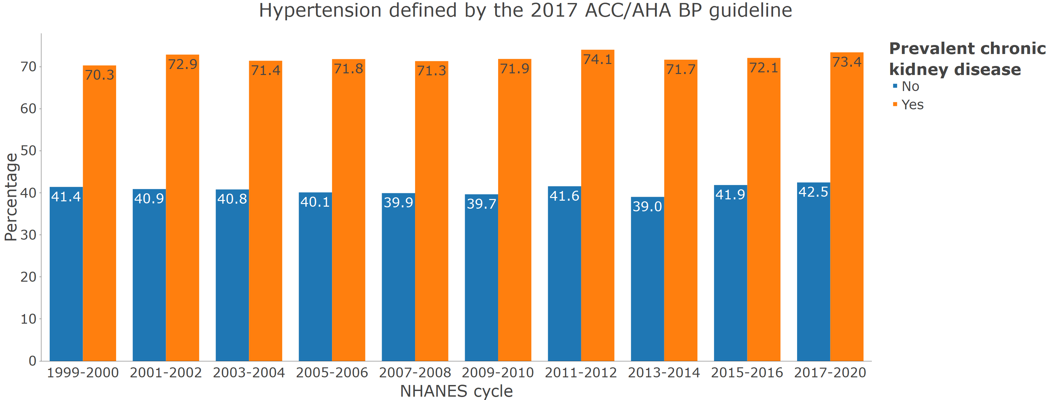

The graph is identical to the web application’s output. All values (estimated prevalence and the upper and lower limits of the 95% confidence interval) can be obtained in the app by hovering over the bars.

### Figure S3: Distribution of blood pressure categories among pregnant women.

A. In 2017-2020

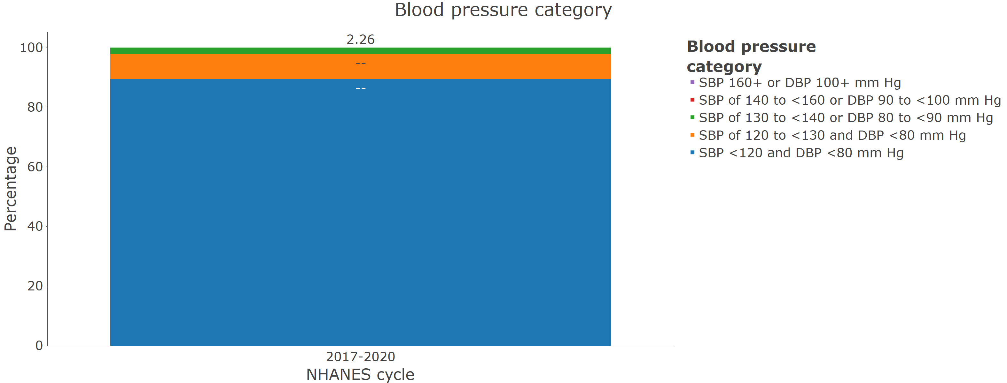

The – symbol indicates that an estimate is not reliable.

2.26 represents the estimated proportion of pregnant women with systolic blood pressure of 130 to < 140 mm Hg or diastolic blood pressure of 80 to < 90 mm Hg.

The graph is identical to the web application’s output. All values (estimated prevalence, upper and lower limits of the 95% confidence interval, or reasons for the suppression of data if applicable) can be obtained in the app by hovering over the bars.

There were no pregnant women in the two highest blood pressure categories, so the figure does not include segments for these categories.

B. In 2009-2010 through 2017-2020

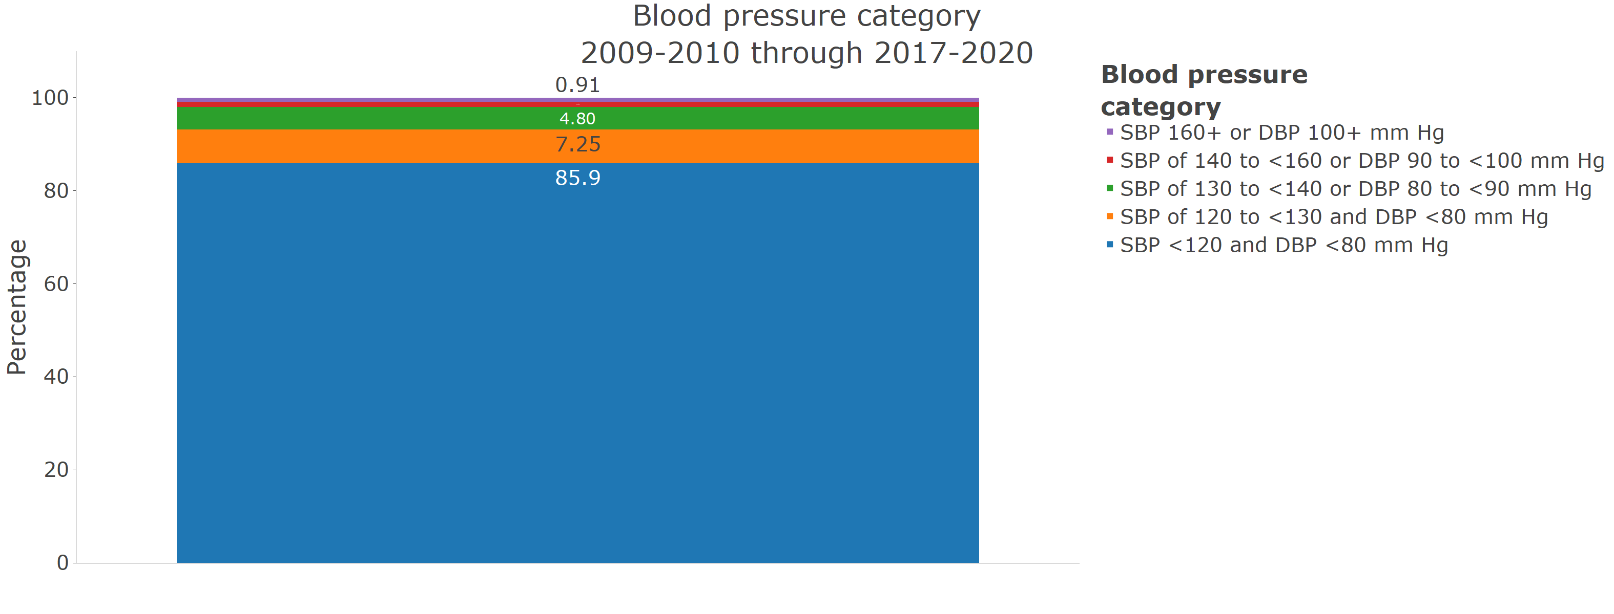

The graph is identical to the web application’s output. All values (estimated prevalence and the upper and lower limits of the 95% confidence interval) can be obtained in the app by hovering over the bars.

The estimate for systolic blood pressure of 140 to < 160 or diastolic blood pressure of 90 to < 100 mm Hg is 1.1%. This can be seen on the application by hovering over the red bar with your mouse.

### Figure S4: Age-adjusted prevalence of resistant hypertension by calendar year.

A. Among non-pregnant US adults who self report taking antihypertensive medication and are taking 1 or more antihypertensive medication classes

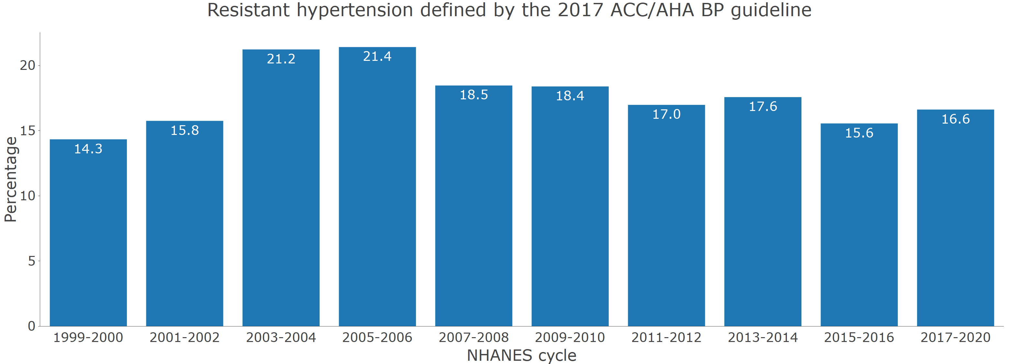

Age adjustment was performed through direct standardization, using the estimated age distribution of US adults with hypertension from 1999 to 2020 as the standard (26.4%, 43.4%, 17.0% and 13.2% being 18 to 44 years, 45 to 64, 65 to 74, and ≥ 75 years of age, respectively)

The graph is identical to the web application’s output. All values (estimated prevalence and the upper and lower limits of the 95% confidence interval) can be obtained in the app by hovering over the bars.

Survey participants with missing values for pregnancy status were assumed to be non-pregnant

B. Among non-pregnant US adults who self report taking antihypertensive medication and are taking 3 or more antihypertensive medication classes

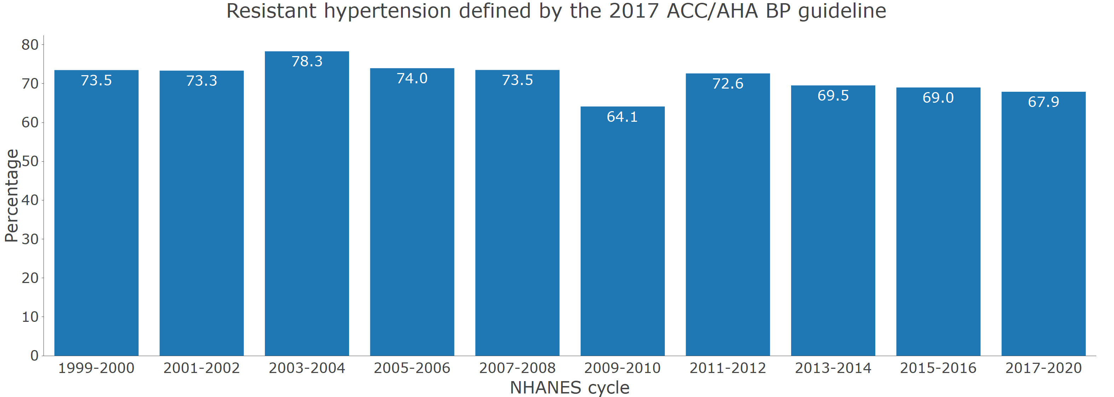

Age adjustment was performed through direct standardization, using the estimated age distribution of US adults with hypertension from 1999 to 2020 as the standard (26.4%, 43.4%, 17.0% and 13.2% being 18 to 44 years, 45 to 64, 65 to 74, and ≥ 75 years of age, respectively)

The graph is identical to the web application’s output. All values (estimated prevalence and the upper and lower limits of the 95% confidence interval) can be obtained in the app by hovering over the bars.

Survey participants with missing values for pregnancy status were assumed to be non-pregnant