DRAFT OF RESULTS

**RESULTS**

A total of 56,035 survey participants (mean age 46 years, 52% women, 68% non-Hispanic white) were included in the BP and hypertension cohort (**Table 1**). The estimated prevalence of hypertension was 45.9% (95% CI 43.1, 48.8) in 1999-2000, 43.8% (95% CI 41.1, 46.5) in 2009-2010, and 47.0% (95% CI 44.5, 49.5) in 2017-2020 (**Figure 1**). For US adults in 2017-2020, hypertension was estimated to be more prevalent among older versus younger adults (**Figure S2**), more prevalent among men versus women (**Figure S3**), and more prevalent among adults are non-Hispanic Black versus other race/ethnicity subgroups (**Figure S4**).

**Self-reported antihypertensive medication use**

Among US adults with hypertension, the estimated percentage who self-reported using antihypertensive medication was 35.0% (95% CI 30.7, 39.7) in 1999-2000, 52.8% (95% CI 48.3, 57.2) in 2009-2010, and 51.3% (95% CI 48.7, 54.0) in 2017-2020 (**Figure 2**). For US adults with hypertension in 2017-2020, adults aged 65 to 74 years had a higher estimated percentage who self-report using antihypertensive medication versus other age groups (**Figure S5**), women had a higher estimated percentage who self-report using antihypertensive medication compared to men (**Figure S6**), and Hispanic adults had a lower estimated percentage who self-report using antihypertensive medication versus other race/ethnicity subgroups (**Figure S7**).

**Classes of antihypertensive medication**

Among US adults with hypertension, the estimated percentage using one or more classes of antihypertensive medication was 38.5% (95% CI 34.5, 42.4) in 1999-2000, 54.3% (95% CI 50.1, 58.5) in 2009-2010, and 55.4% (95% CI 54.0, 57.8) in 2017-2020 (**Figure 3**). For US adults with hypertension in 2017-2020, adults aged 75+ had a higher estimated percentage using one or more antihypertensive medication class versus other age groups (**Figure S8**), women a higher estimated percentage using one or more antihypertensive medication class versus men (**Figure S9**), and non-Hispanic white adults a higher estimated percentage using one or more classes of antihypertensive medication versus other race/ethnicity groups (**Figure S10**).

**Resistant hypertension**

Among US adults with hypertension using three or more classes of antihypertensive medication, the estimated prevalence of resistant hypertension was 70.6 (95% CI 62.8, 78.3) in 1999-2000, 62.7 (95% CI 58.6, 66.7) in 2009-2010, and 66.0 (95% CI 61.9, 70.1) in 2017-2020 (**Figure 4**). For US adults with hypertension using three or more classes of antihypertensive medication in 2017-2020, adults aged 18 to 44 years had a higher estimated prevalence of resistant hypertension versus other age groups (**Figure S11**), men a higher estimated prevalence versus women (**Figure S12**), and non-Hispanic Black adults a higher estimated prevalence versus other race/ethnicity groups (**Figure S13**).

**Table 1** Characteristics of participants included in the blood pressure and hypertension cohort of the online platform.

| **Characteristic** | **Overall** | **1999-2000** | **2001-2002** | **2003-2004** | **2005-2006** | **2007-2008** | **2009-2010** | **2011-2012** | **2013-2014** | **2015-2016** | **2017-2020** |
| --- | --- | --- | --- | --- | --- | --- | --- | --- | --- | --- | --- |
| No. of Adults | 56,035 | 4,694 | 5,184 | 4,838 | 5,015 | 5,665 | 6,043 | 5,337 | 5,694 | 5,552 | 8,013 |
| Age category, years |  |  |  |  |  |  |  |  |  |  |  |
| 18 to 44 | 49 | 56 | 53 | 52 | 50 | 49 | 48 | 47 | 48 | 45 | 45 |
| 45 to 64 | 34 | 29 | 32 | 32 | 34 | 35 | 35 | 36 | 34 | 35 | 35 |
| 65 to 74 | 10 | 9.0 | 8.2 | 9.2 | 9.3 | 8.7 | 9.9 | 9.9 | 11 | 12 | 13 |
| 75+ | 7.1 | 6.0 | 6.5 | 6.7 | 7.0 | 7.4 | 7.2 | 7.2 | 7.0 | 7.8 | 7.5 |
| Race |  |  |  |  |  |  |  |  |  |  |  |
| Non-Hispanic White | 68 | 70 | 72 | 73 | 72 | 69 | 68 | 66 | 66 | 64 | 64 |
| Non-Hispanic Black | 11 | 10 | 11 | 11 | 11 | 11 | 11 | 12 | 11 | 11 | 11 |
| Non-Hispanic Asian | 2.3 | 0 | 0 | 0 | 0 | 0 | 0 | 5.0 | 5.3 | 5.6 | 5.5 |
| Hispanic | 14 | 15 | 13 | 11 | 12 | 14 | 14 | 14 | 15 | 16 | 15 |
| Other | 4.5 | 4.7 | 4.4 | 5.1 | 5.2 | 5.7 | 6.7 | 2.7 | 2.7 | 3.7 | 4.1 |
| Age, years | 46 (17) | 44 (17) | 45 (17) | 45 (17) | 46 (17) | 46 (17) | 46 (17) | 46 (17) | 46 (18) | 47 (18) | 48 (18) |
| Pregnant | 1.4 | 2.5 | 2.2 | 1.7 | 2.1 | 0.9 | 1.1 | 1.0 | 1.1 | 1.2 | 0.9 |
| Gender |  |  |  |  |  |  |  |  |  |  |  |
| Men | 48 | 48 | 48 | 49 | 48 | 48 | 49 | 49 | 48 | 48 | 49 |
| Women | 52 | 52 | 52 | 51 | 52 | 52 | 51 | 51 | 52 | 52 | 51 |
| Systolic blood pressure, mm Hg | 122 (18) | 123 (19) | 123 (19) | 123 (18) | 122 (18) | 122 (17) | 120 (17) | 122 (17) | 121 (17) | 123 (17) | 123 (17) |
| Diastolic blood pressure, mm Hg | 71 (11) | 73 (12) | 72 (12) | 71 (12) | 70 (12) | 71 (11) | 70 (12) | 71 (11) | 70 (11) | 70 (11) | 72 (11) |
| Blood pressure category (including antihypertensive medication use) |  |  |  |  |  |  |  |  |  |  |  |
| SBP <120 and DBP <80 mm Hg | 42 | 43 | 44 | 42 | 43 | 43 | 45 | 42 | 45 | 40 | 40 |
| SBP of 120 to <130 and DBP < 80 mm Hg | 13 | 13 | 12 | 13 | 13 | 13 | 12 | 13 | 11 | 14 | 13 |
| SBP of 130 to <140 or DBP 80 to <90 mm Hg | 15 | 18 | 18 | 15 | 15 | 14 | 13 | 15 | 12 | 14 | 13 |
| SBP of 140 to <160 or DBP 90 to <100 mm Hg | 6.9 | 8.5 | 7.7 | 7.8 | 7.4 | 7.0 | 5.6 | 5.9 | 6.1 | 6.7 | 7.2 |
| SBP 160+ or DBP 100+ mm Hg | 2.0 | 2.6 | 2.9 | 2.6 | 2.0 | 1.6 | 1.5 | 1.8 | 1.6 | 1.7 | 2.1 |
| taking antihypertensive medications | 21 | 16 | 16 | 19 | 20 | 22 | 23 | 23 | 24 | 23 | 24 |
| Self-reported antihypertensive medication use | 21 | 16 | 16 | 19 | 20 | 22 | 23 | 23 | 24 | 23 | 24 |
| Antihypertensive medications recommended by JNC7 | 32 | 29 | 29 | 31 | 31 | 32 | 31 | 33 | 34 | 34 | 35 |
| Antihypertensive medications recommended by ACC/AHA 2017 | 34 | 32 | 32 | 34 | 33 | 34 | 33 | 35 | 35 | 35 | 37 |
| Number of antihypertensive medication classes |  |  |  |  |  |  |  |  |  |  |  |
| None | 75 | 81 | 80 | 77 | 76 | 74 | 74 | 73 | 73 | 71 | 71 |
| One | 11 | 9.4 | 9.2 | 9.6 | 11 | 11 | 11 | 12 | 12 | 13 | 14 |
| Two | 8.4 | 6.7 | 7.0 | 7.9 | 7.5 | 8.8 | 8.4 | 9.1 | 9.7 | 9.7 | 8.8 |
| Three | 3.9 | 2.6 | 2.7 | 3.8 | 4.0 | 3.9 | 5.0 | 3.9 | 4.1 | 4.1 | 4.3 |
| Four or more | 1.5 | 0.6 | 0.8 | 1.6 | 1.9 | 1.6 | 1.9 | 1.7 | 2.0 | 1.4 | 1.8 |
| ACE inhibitors | 10 | 6.4 | 7.6 | 9.2 | 9.5 | 9.9 | 11 | 11 | 12 | 13 | 12 |
| Aldosterone antagonists | 0.7 | 0.4 | 0.3 | 0.6 | 0.5 | 0.6 | 0.8 | 0.5 | 0.7 | 1.0 | 1.1 |
| Alpha-1 blockers | 1.0 | 1.4 | 1.0 | 1.1 | 0.8 | 1.2 | 1.0 | 0.9 | 1.0 | 0.8 | 1.0 |
| Angiotensin receptor blockers | 5.5 | 2.2 | 3.0 | 4.4 | 4.4 | 6.5 | 6.4 | 5.7 | 6.1 | 7.4 | 7.7 |
| Beta blockers | 9.6 | 5.9 | 6.7 | 9.0 | 10 | 9.6 | 11 | 10 | 10 | 9.9 | 12 |
| Central alpha1 agonist and other centrally acting agents | 0.7 | 0.8 | 0.5 | 0.7 | 0.5 | 0.6 | 0.5 | 0.9 | 0.9 | 0.5 | 0.8 |
| Calcium channel blockers | 6.6 | 6.3 | 5.1 | 6.2 | 6.8 | 6.0 | 6.6 | 6.3 | 7.8 | 6.7 | 7.4 |
| Potassium sparing diuretics | 1.3 | 2.0 | 1.8 | 1.9 | 1.6 | 1.7 | 1.2 | 1.1 | 0.9 | 0.7 | 0.4 |
| Loop diuretics | 2.6 | 2.3 | 2.2 | 2.7 | 2.5 | 2.8 | 2.8 | 2.6 | 2.6 | 2.5 | 2.5 |
| Thiazide or thiazide-type diuretics | 8.0 | 5.5 | 6.4 | 7.6 | 8.2 | 8.6 | 8.6 | 9.2 | 8.4 | 8.7 | 7.8 |
| Direct renin inhibitors | <0.1 | 0 | 0 | 0 | 0 | <0.1 | <0.1 | <0.1 | <0.1 | 0 | 0 |
| Direct vasodilators | 0.3 | 0.2 | 0.1 | 0.1 | 0.2 | 0.2 | 0.3 | 0.4 | 0.4 | 0.3 | 0.5 |
| Blood pressure control (SBP < 140 mm Hg and DBP < 90 mm Hg) | 84 | 82 | 82 | 82 | 84 | 84 | 86 | 85 | 86 | 84 | 83 |
| Blood pressure control (SBP < 130 mm Hg and DBP < 80 mm Hg) | 64 | 59 | 61 | 62 | 63 | 65 | 67 | 65 | 67 | 64 | 64 |
| Uncontrolled BP (SBP >= 140 mm Hg or DBP >= 90 mm Hg) | 16 | 18 | 18 | 18 | 16 | 16 | 14 | 15 | 14 | 16 | 17 |
| Uncontrolled BP (SBP >= 130 mm Hg or DBP >= 80 mm Hg) | 36 | 41 | 39 | 38 | 37 | 35 | 33 | 35 | 33 | 36 | 36 |
| Hypertension (JNC7 guideline definition) | 30 | 27 | 27 | 29 | 29 | 30 | 30 | 31 | 31 | 32 | 33 |
| Hypertension (2017 ACC/AHA BP guideline definition) | 45 | 45 | 45 | 45 | 44 | 44 | 43 | 46 | 44 | 46 | 47 |
| Awareness of hypertension | 29 | 23 | 25 | 29 | 29 | 30 | 29 | 31 | 34 | 32 | 32 |
| Resistant hypertension (JNC7 guideline definition) | 3.2 | 2.0 | 2.1 | 3.4 | 3.5 | 3.5 | 3.6 | 3.5 | 3.6 | 3.3 | 3.5 |
| Resistant hypertension (2017 ACC/AHA BP guideline definition) | 3.6 | 2.1 | 2.4 | 3.9 | 4.1 | 3.8 | 4.0 | 3.8 | 4.1 | 3.5 | 3.9 |
| Resistant hypertension (2017 ACC/AHA BP guideline definition requires thiazide diuretic) | 2.0 | 1.3 | 1.4 | 2.1 | 2.3 | 2.1 | 2.2 | 2.3 | 2.0 | 2.1 | 1.8 |
| Resistant hypertension (JNC7 guideline definition requires thiazide diuretic) | 2.2 | 1.5 | 1.6 | 2.4 | 2.6 | 2.4 | 2.5 | 2.5 | 2.2 | 2.2 | 2.1 |
| Smoking status |  |  |  |  |  |  |  |  |  |  |  |
| Never | 54 | 51 | 51 | 49 | 51 | 53 | 55 | 56 | 57 | 57 | 58 |
| Former | 25 | 25 | 25 | 25 | 25 | 24 | 25 | 25 | 23 | 25 | 25 |
| Current | 21 | 24 | 25 | 26 | 24 | 23 | 20 | 20 | 20 | 18 | 17 |
| Body mass index, kg/m2 |  |  |  |  |  |  |  |  |  |  |  |
| <25 | 32 | 37 | 36 | 35 | 34 | 33 | 32 | 32 | 31 | 29 | 27 |
| 25 to <30 | 33 | 33 | 35 | 34 | 33 | 34 | 33 | 33 | 32 | 31 | 31 |
| 30 to <35 | 20 | 17 | 18 | 20 | 19 | 19 | 20 | 20 | 20 | 21 | 21 |
| 35+ | 15 | 13 | 12 | 12 | 14 | 14 | 15 | 15 | 17 | 18 | 20 |
| Prevalent diabetes | 9.4 | 6.8 | 7.0 | 7.9 | 7.9 | 9.8 | 9.9 | 10 | 10 | 11 | 12 |
| Prevalent chronic kidney disease | 14 | 13 | 13 | 13 | 13 | 14 | 12 | 14 | 15 | 14 | 14 |
| Number of high risk conditions |  |  |  |  |  |  |  |  |  |  |  |
| 3 or fewer | 97 | 98 | 98 | 98 | 97 | 97 | 96 | 96 | 96 | 97 | 96 |
| 4 | 2.6 | 1.7 | 2.0 | 2.0 | 2.1 | 2.5 | 3.0 | 3.0 | 3.4 | 2.7 | 3.2 |
| 5 | 0.5 | 0.2 | 0.3 | 0.3 | 0.7 | 0.8 | 0.5 | 0.8 | 0.6 | 0.5 | 0.5 |
| 6 | <0.1 | 0 | 0 | <0.1 | 0.2 | <0.1 | 0.1 | 0.3 | <0.1 | <0.1 | 0 |
| 7 or more | <0.1 | 0 | 0 | 0 | 0 | 0 | 0 | <0.1 | 0 | 0 | 0 |
| History of myocardial infarction | 3.4 | 3.5 | 2.9 | 3.8 | 3.5 | 3.3 | 3.2 | 3.2 | 3.2 | 3.4 | 3.6 |
| History of coronary heart disease | 5.1 | 4.9 | 4.6 | 5.5 | 5.1 | 4.8 | 4.9 | 4.5 | 5.2 | 5.3 | 5.7 |
| History of stroke | 2.8 | 2.2 | 2.2 | 2.6 | 2.8 | 3.2 | 2.6 | 2.9 | 2.9 | 2.8 | 3.6 |
| History of ASCVD | 6.8 | 6.1 | 6.0 | 7.1 | 6.9 | 6.9 | 6.5 | 6.5 | 7.0 | 7.1 | 8.2 |
| History of heart failure | 2.4 | 2.0 | 2.1 | 2.4 | 2.4 | 2.2 | 2.0 | 2.8 | 2.5 | 2.4 | 2.6 |
| History of CVD | 7.7 | 6.8 | 6.7 | 7.9 | 7.7 | 7.6 | 7.2 | 7.6 | 7.8 | 7.8 | 9.1 |

**Figure 1** Prevalence of hypertension by calendar year.

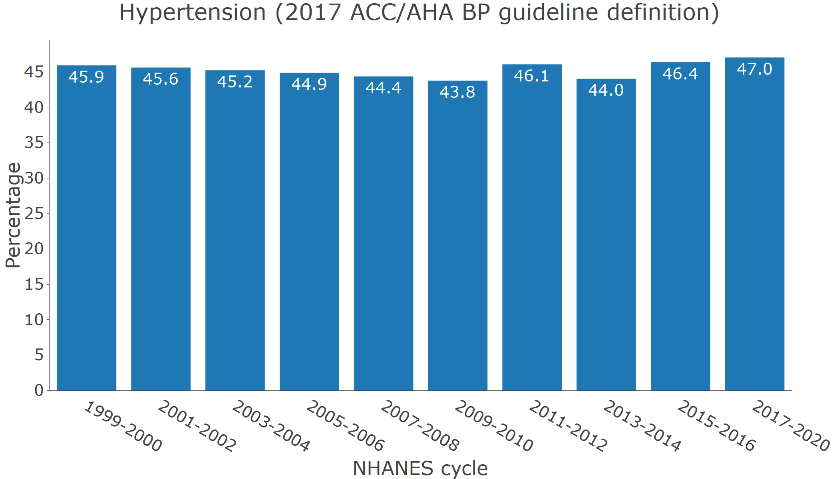

**Figure 2** Antihypertensive medication use by calendar year among adults with hypertension.

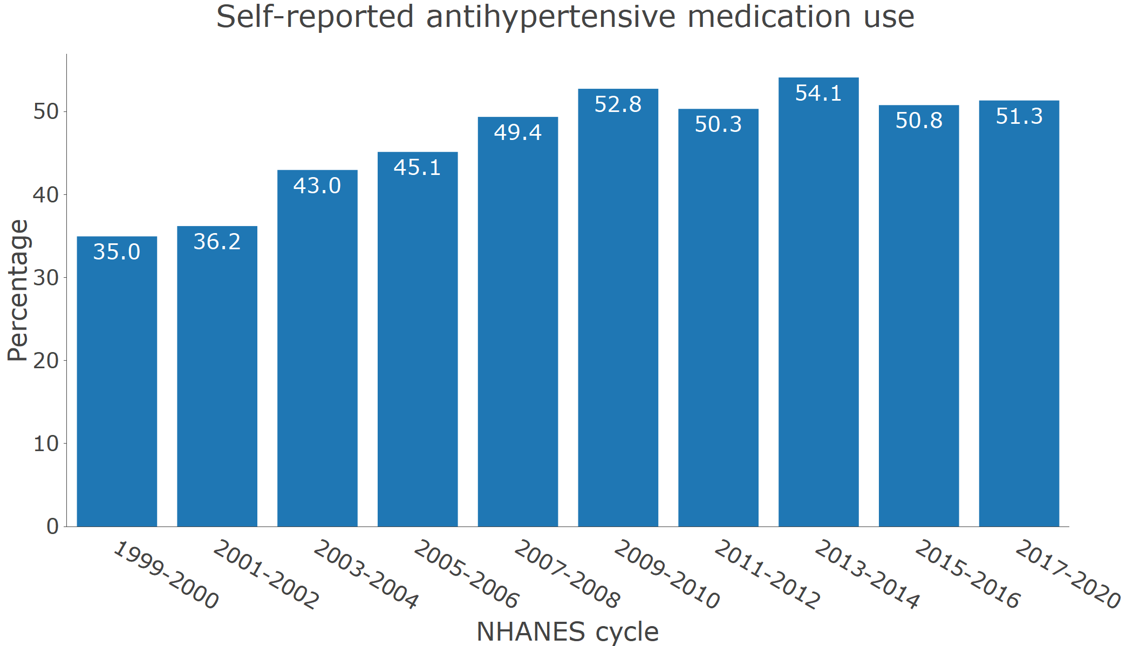

**Figure 3** Number of antihypertensive medication classes by calendar period among adults with hypertension.

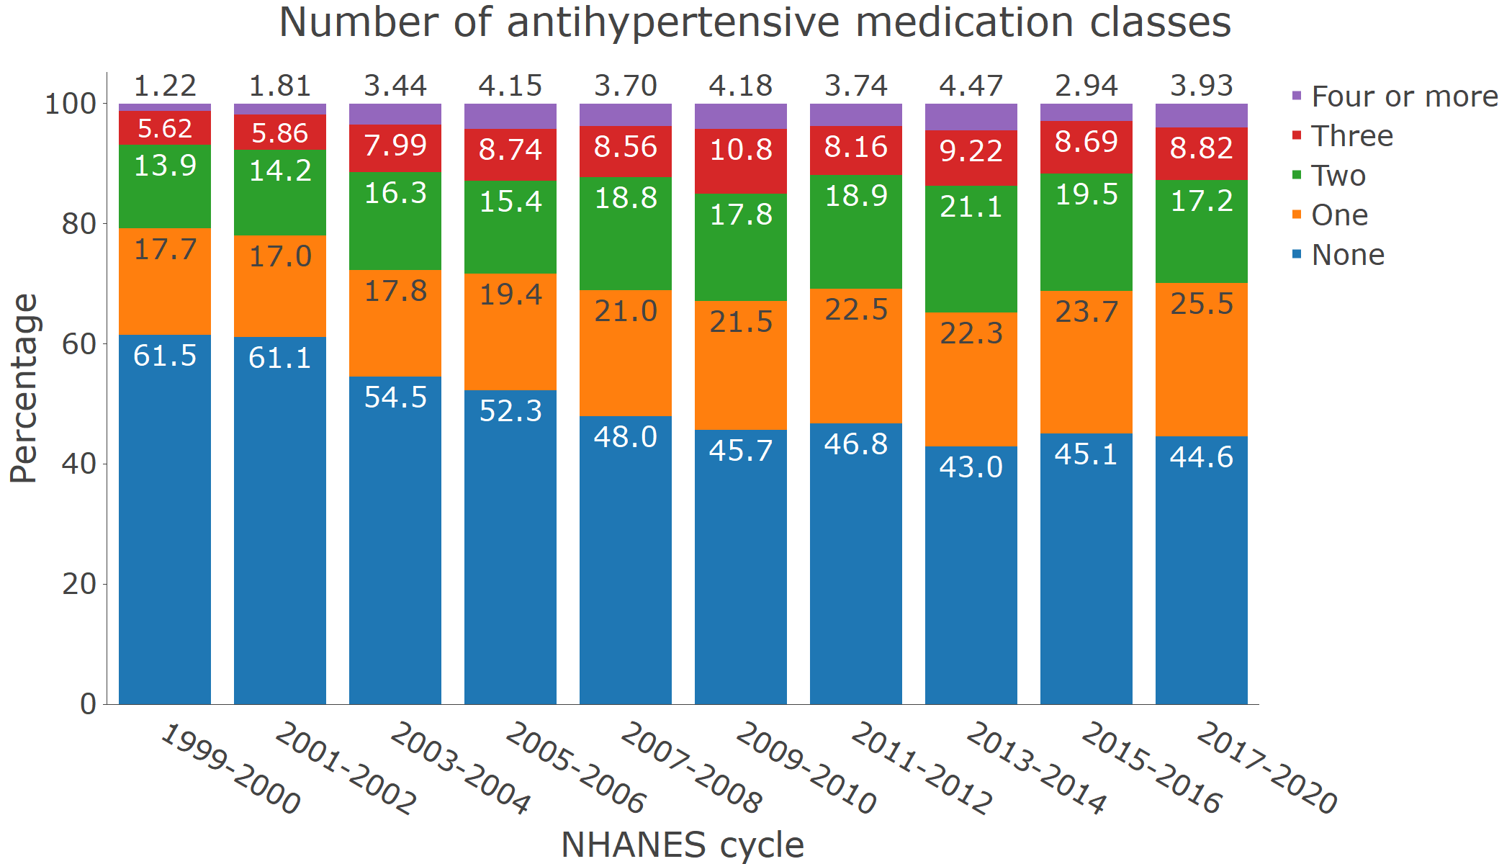

**Figure 4** Prevalence of resistant hypertension among adults with hypertension taking three or more classes of antihypertensive medication.

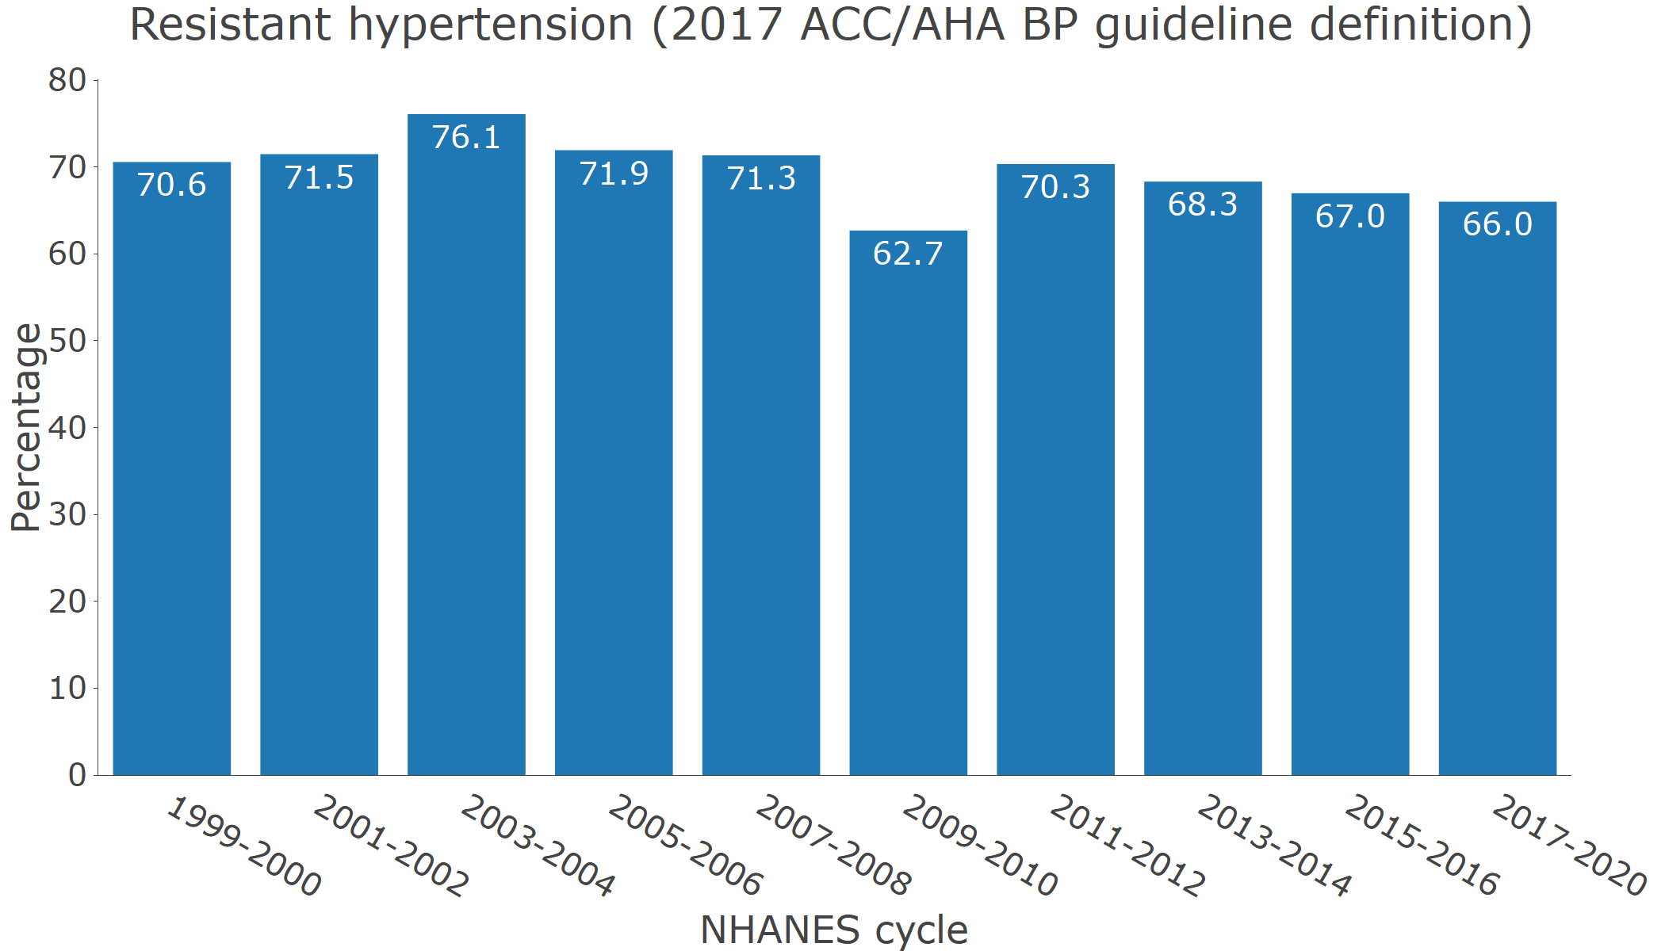

**Figure S1**: Participants included in the current analysis.

**Figure S2** Prevalence of hypertension by age group in 2017-2020.

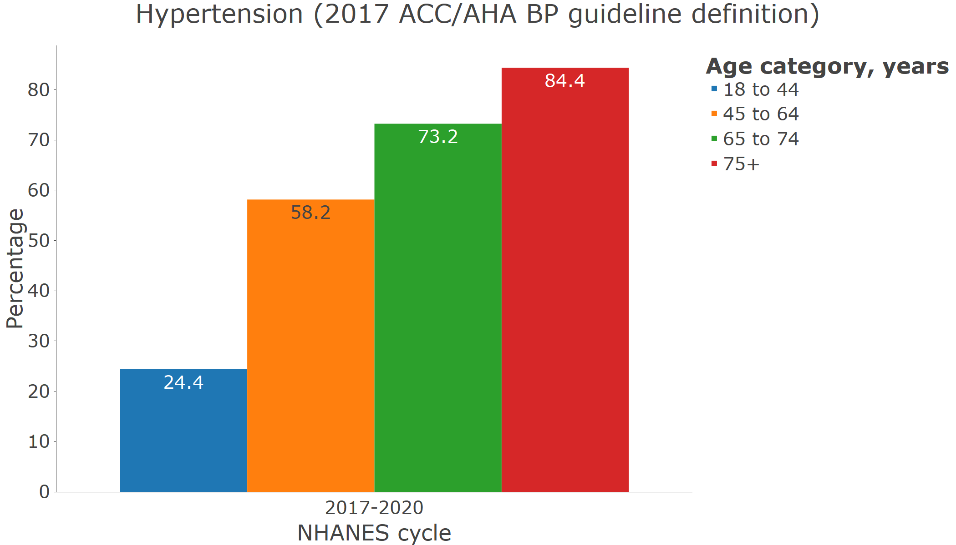

**Figure S3** Prevalence of hypertension by sex in 2017-2020.

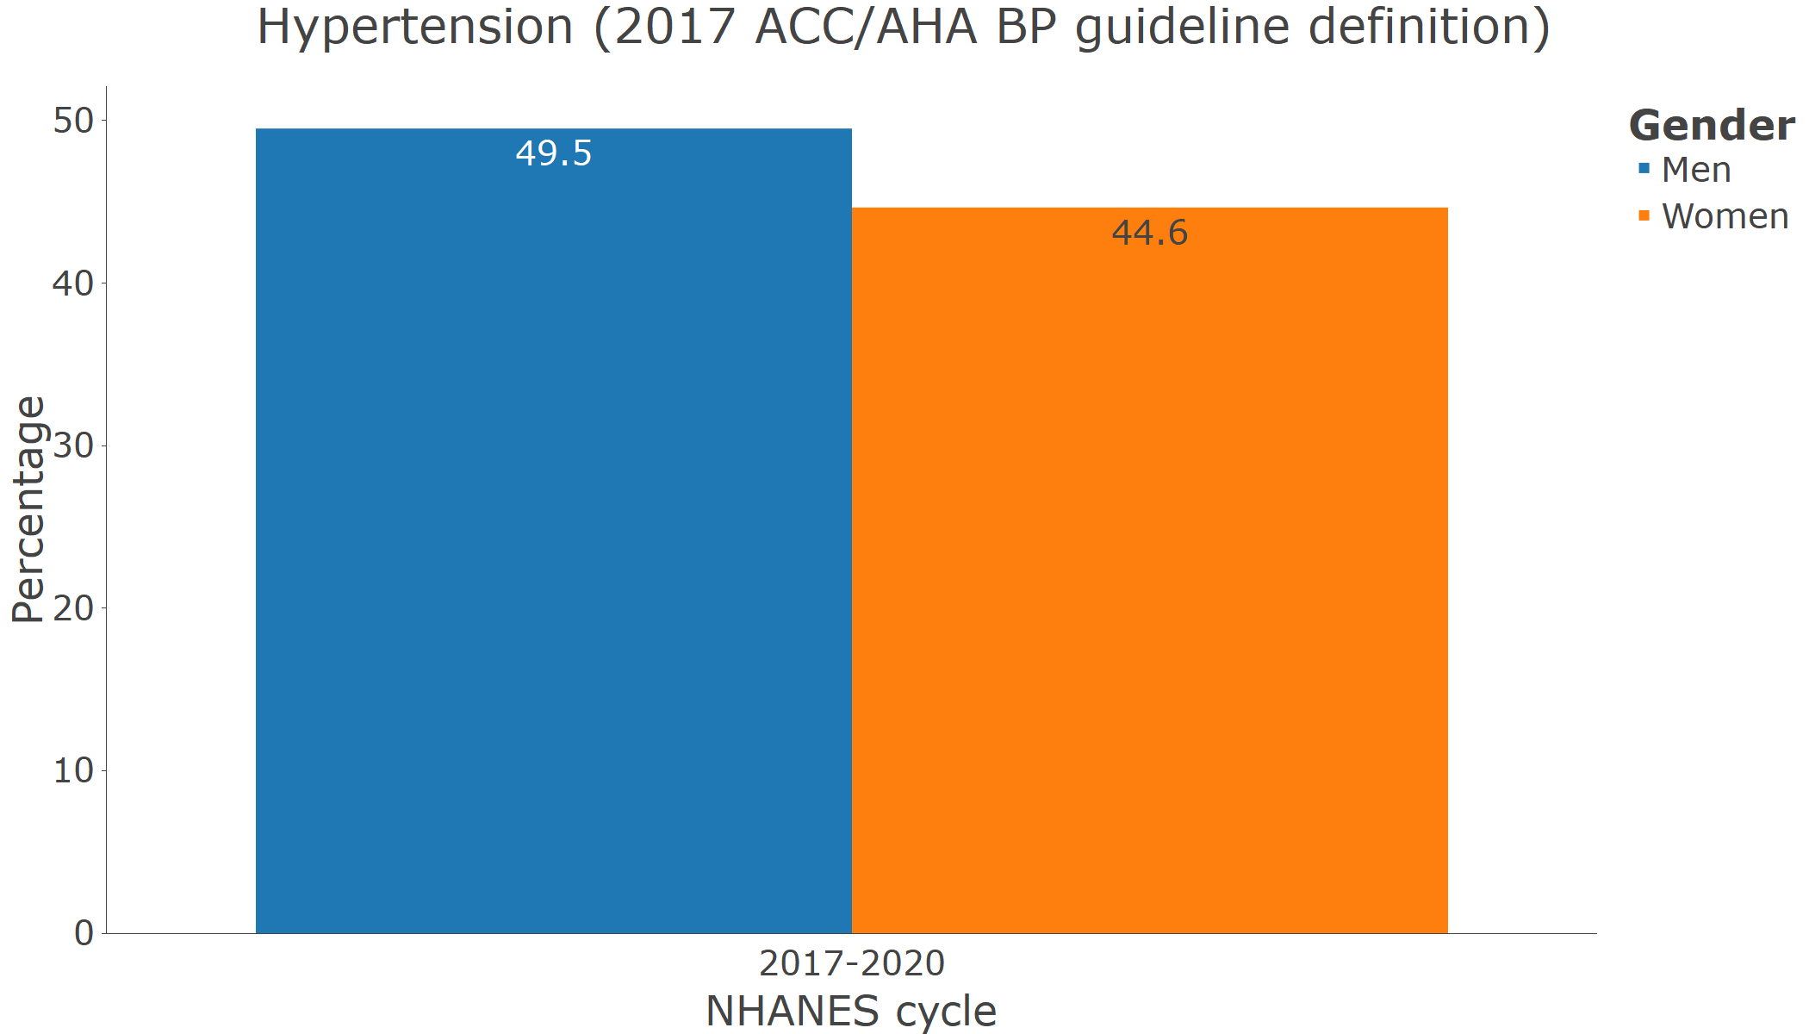

**Figure S4** Prevalence of hypertension by race/ethnicity in 2017-2020.

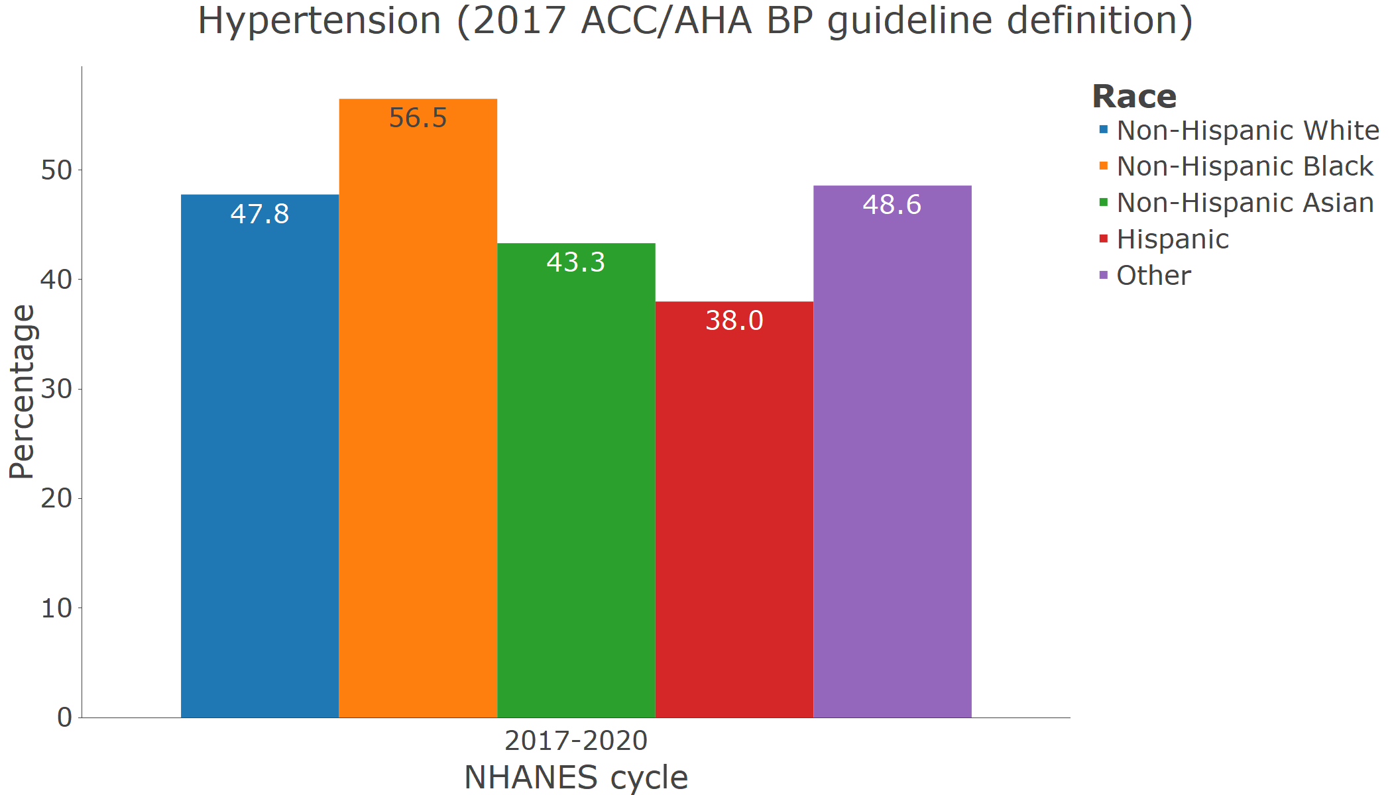

**Figure S5** Antihypertensive medication use by age category in 2017-2020 among adults with hypertension.

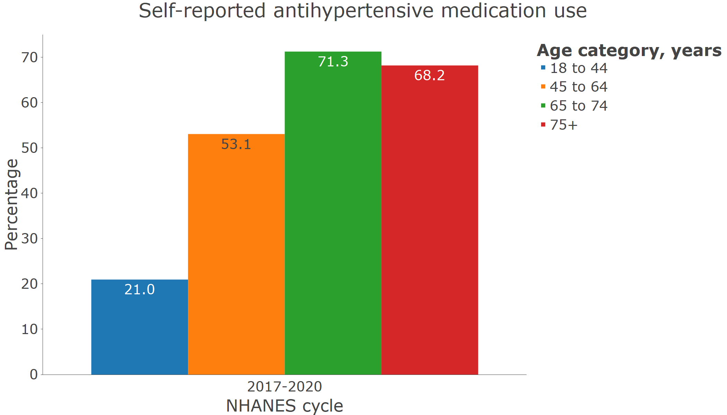

**Figure S6** Antihypertensive medication use by sex in 2017-2020 among adults with hypertension.

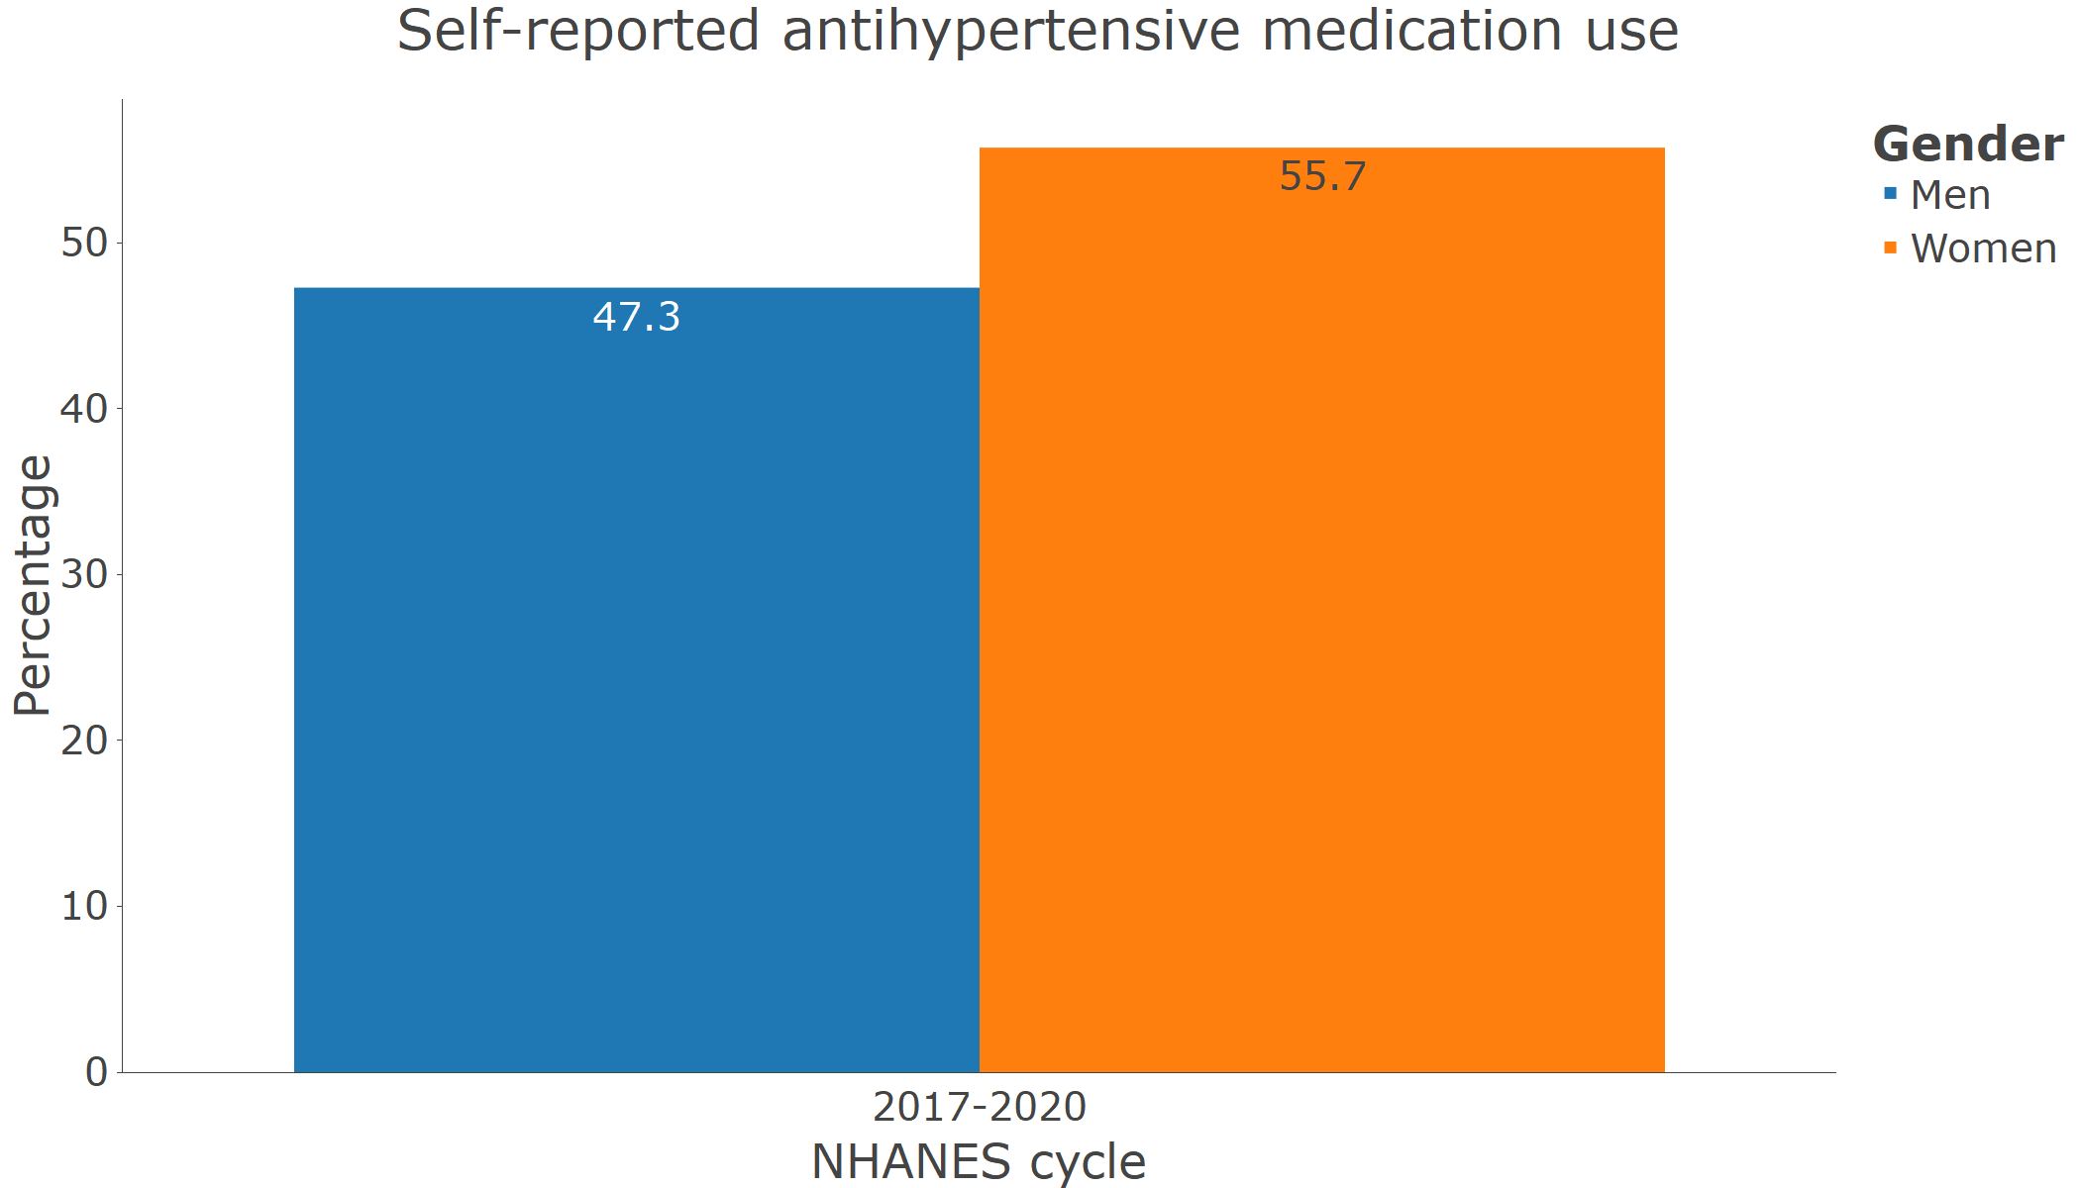

**Figure S7** Antihypertensive medication use by race/ethnicity in 2017-2020 among adults with hypertension.

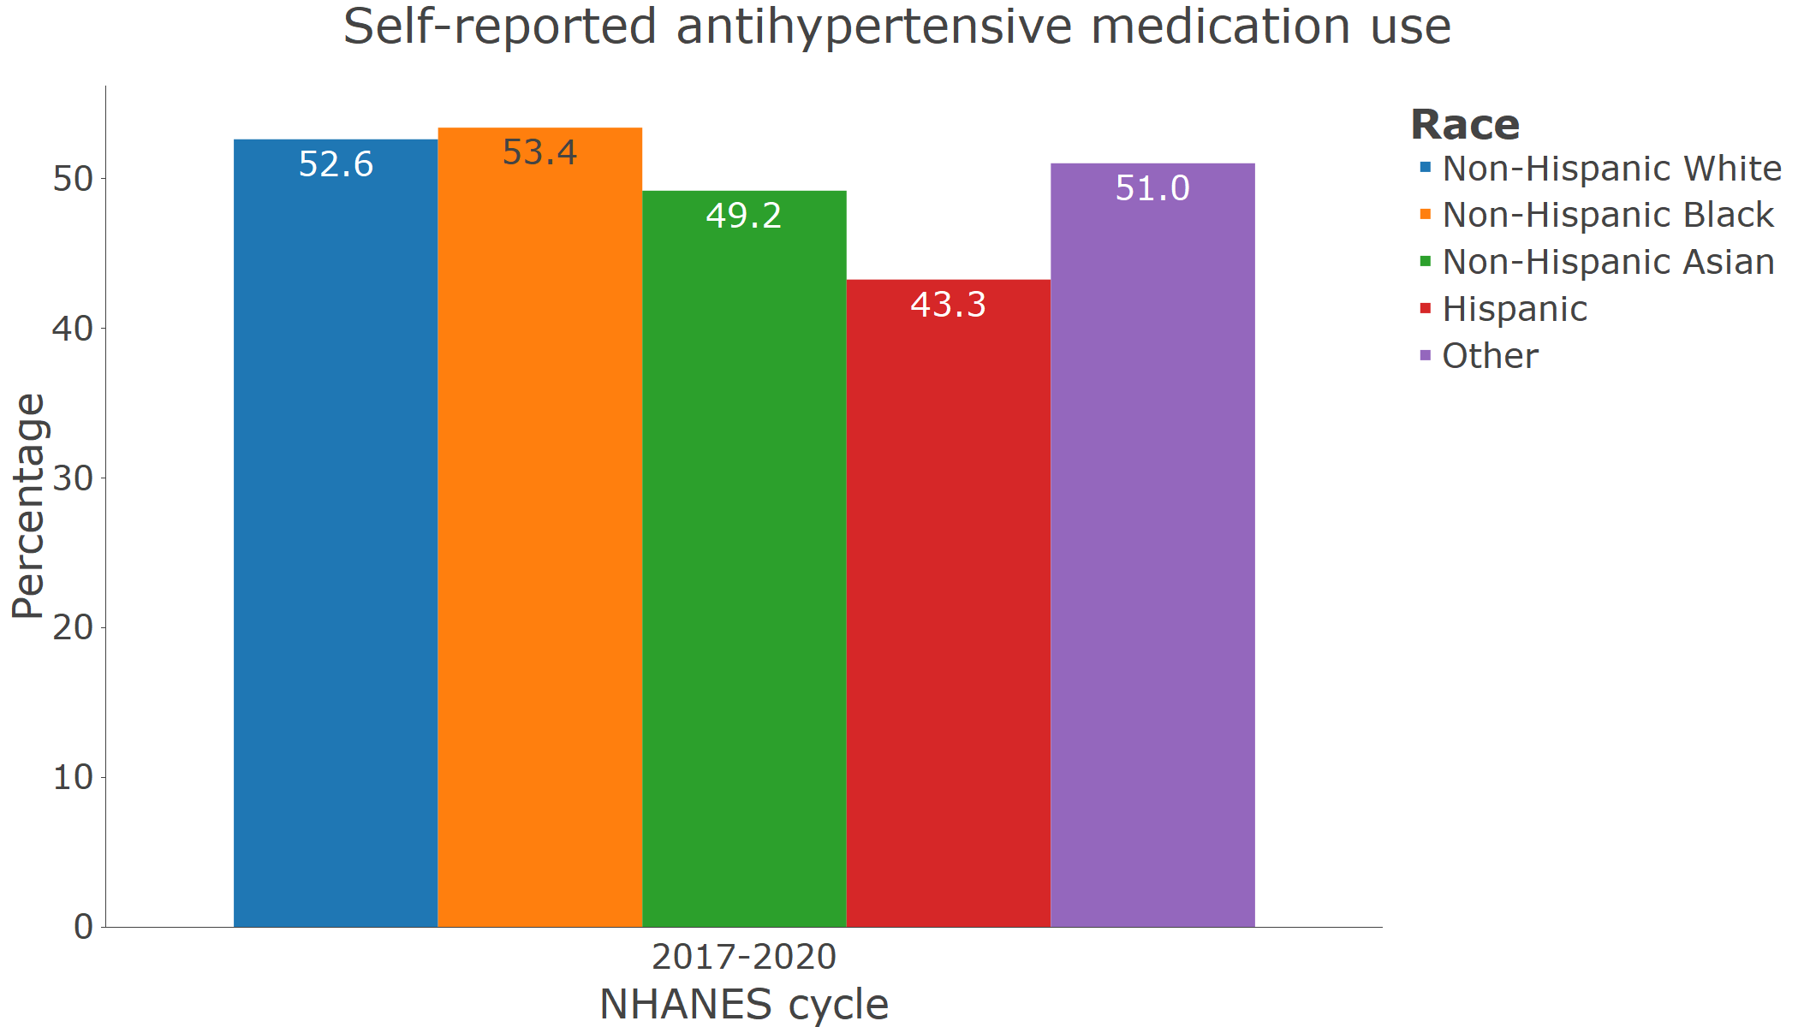

**Figure S8** Number of antihypertensive medication classes by age category in 2017-2020 among adults with hypertension.

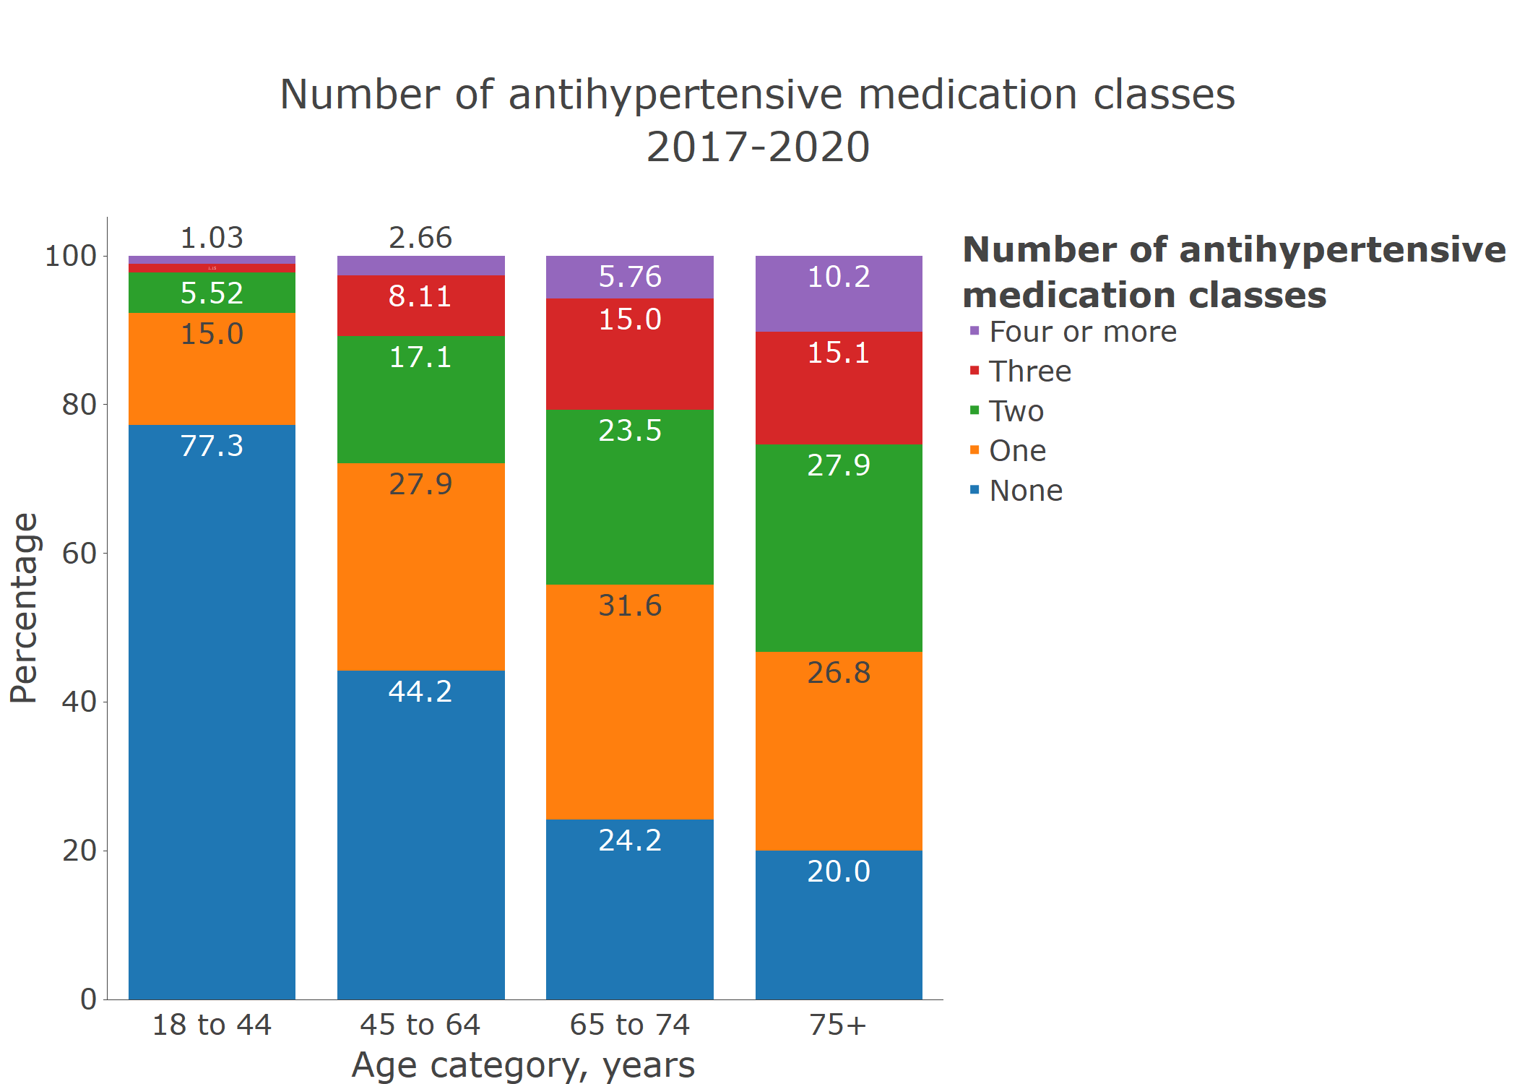

**Figure S9** Number of antihypertensive medication classes by sex in 2017-2020 among adults with hypertension.

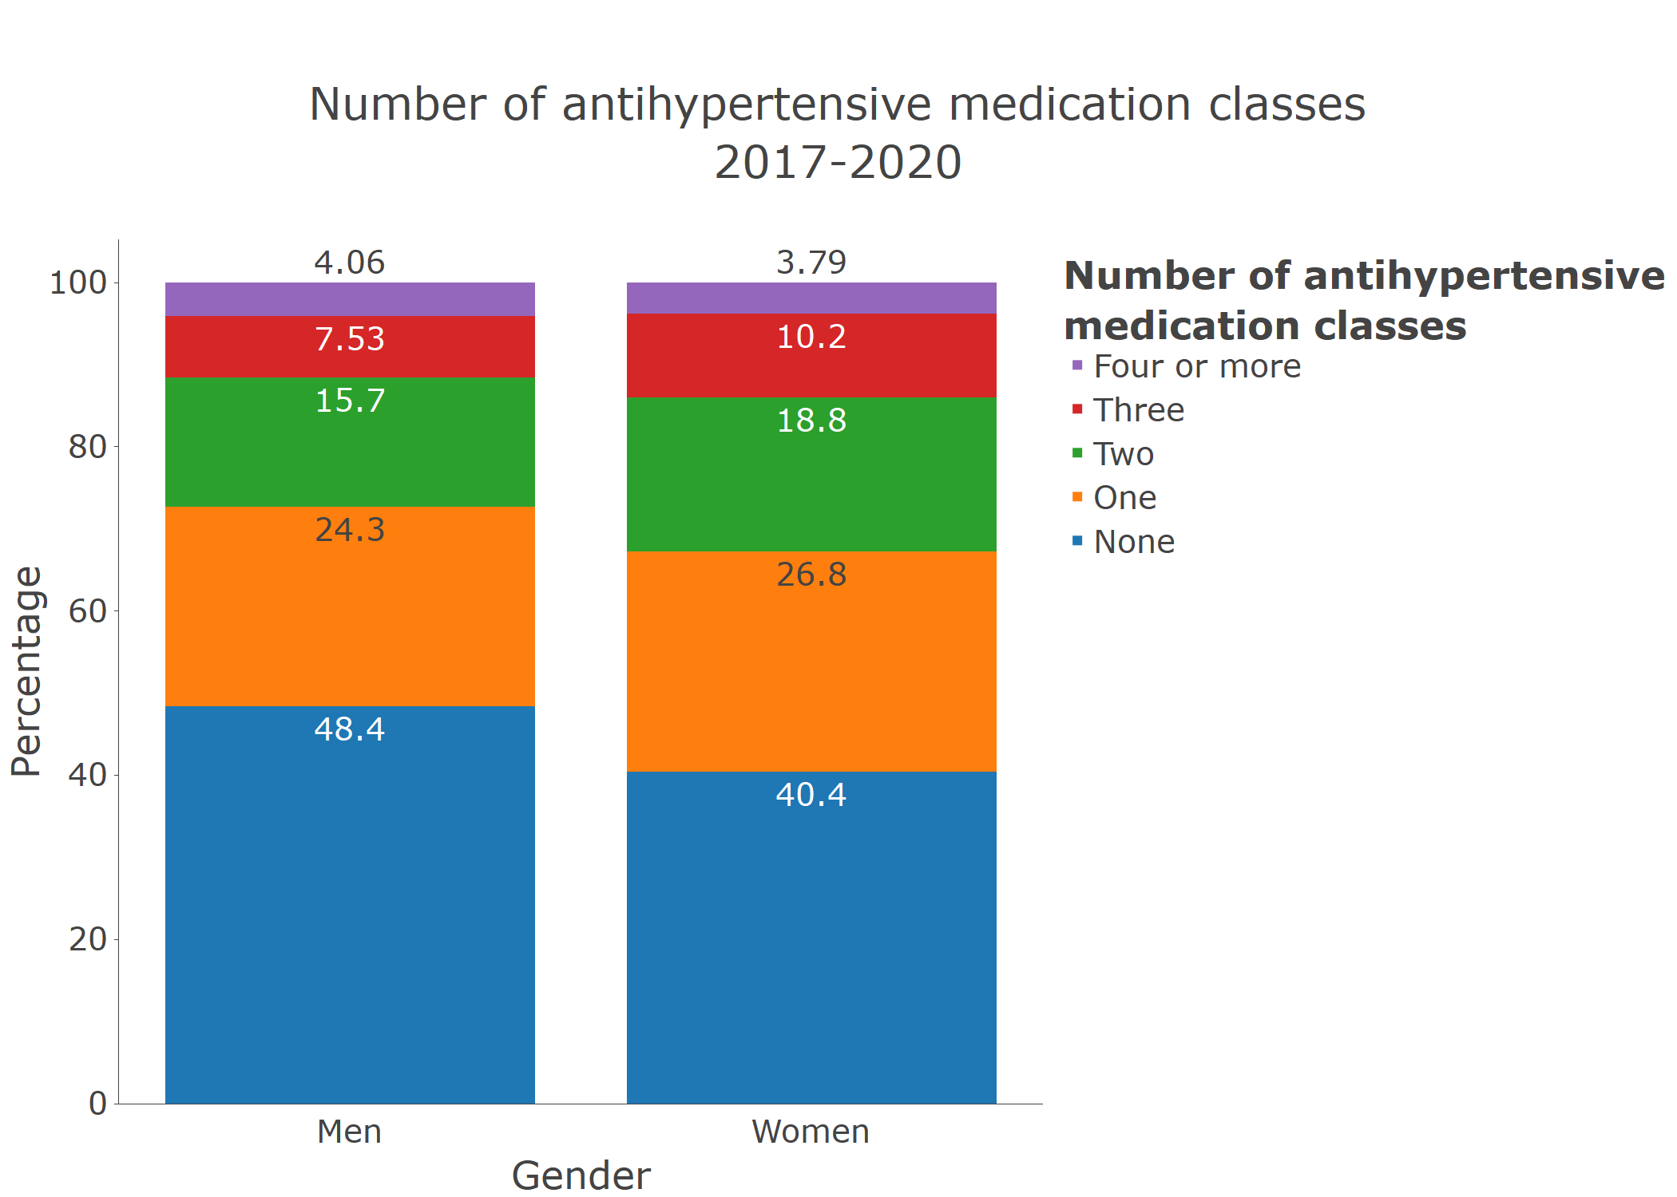

**Figure S10** Number of antihypertensive medication classes by race/ethnicity in 2017-2020 among adults with hypertension.

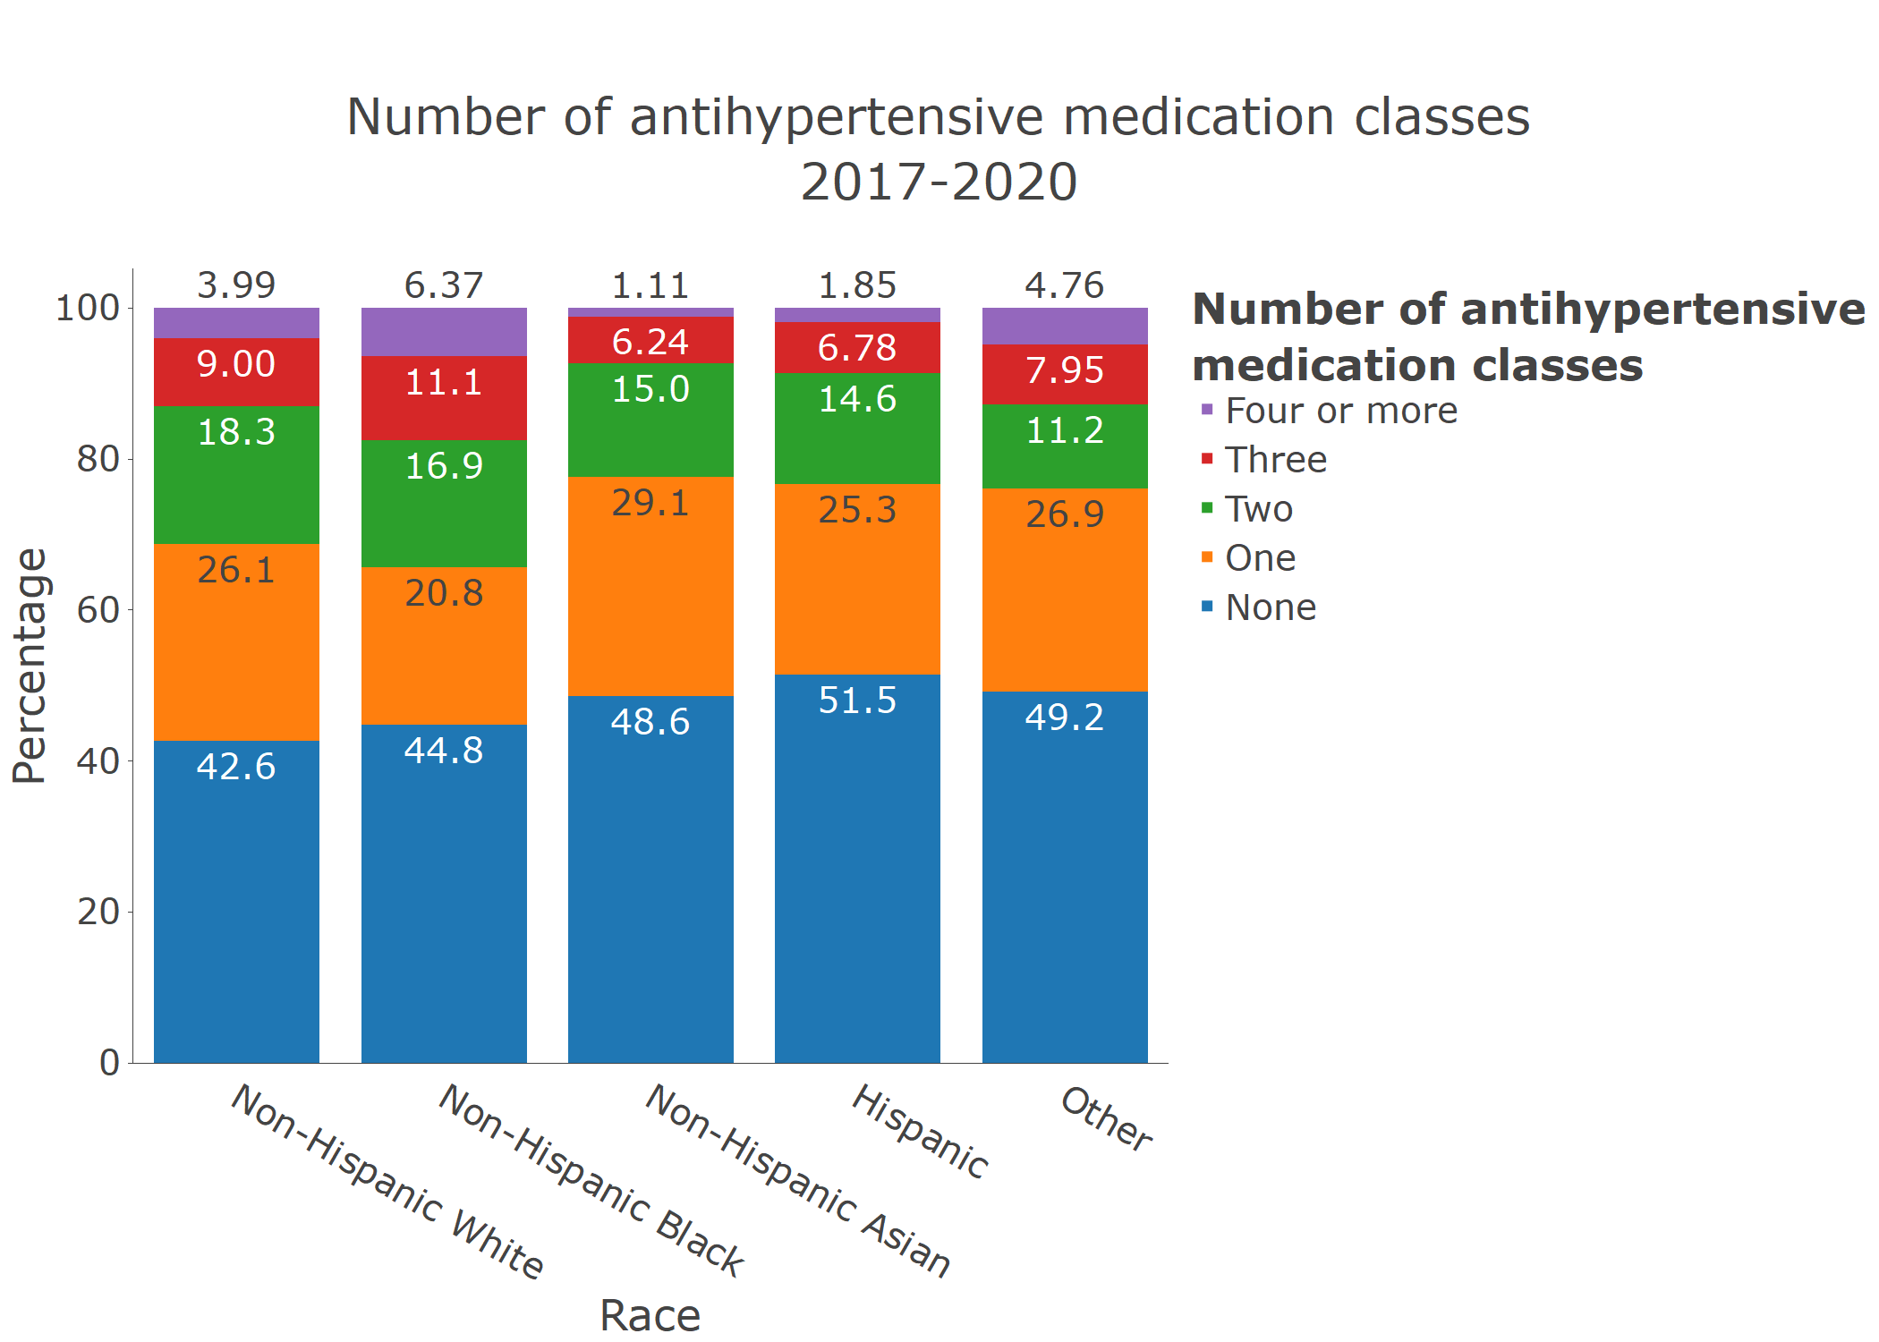

**Figure S11** Prevalence of resistant hypertension by age category in 2017-2020 among adults with hypertension taking three or more classes of antihypertensive medication.

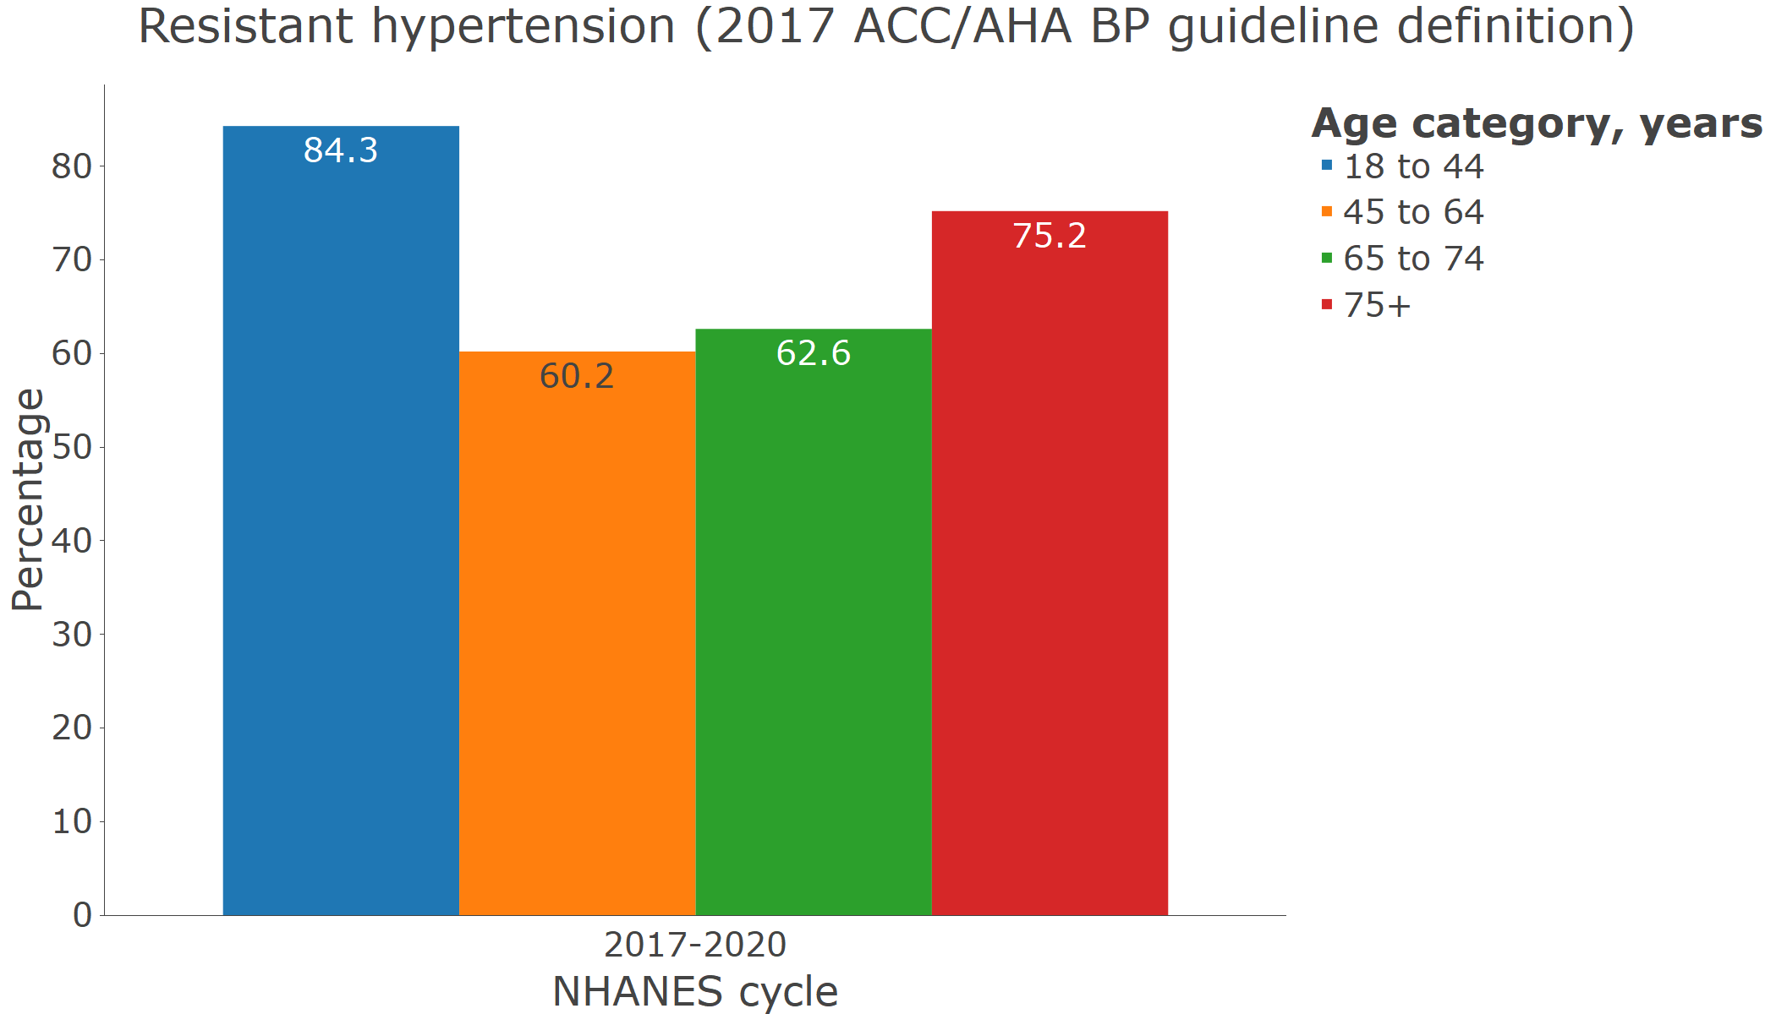

**Figure S12** Prevalence of resistant hypertension by sex in 2017-2020 among adults with hypertension taking three or more classes of antihypertensive medication.

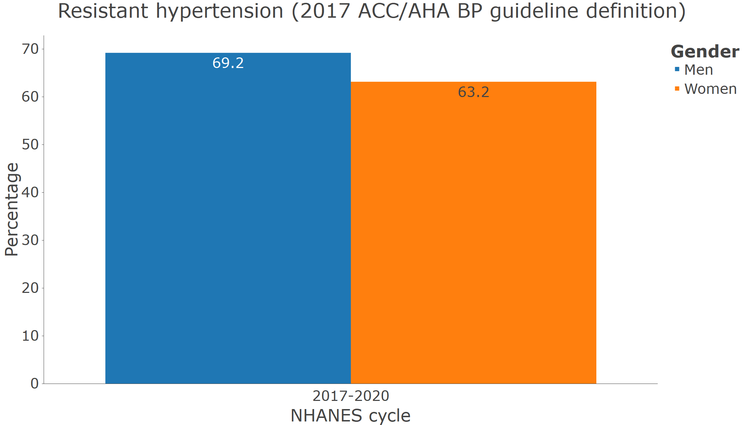

**Figure S13** Prevalence of resistant hypertension by race/ethnicity in 2017-2020 among adults with hypertension taking three or more classes of antihypertensive medication.

