**RESULTS**

The estimated mean SBP for US adults was 123 mm Hg in 1999-2000, 120 mm Hg in 2009-2010, and 123 mm Hg in 2017-2020 (**Figure 1; panel A**). The estimated mean age adjusted SBP in these cycles was 124, 120, and 122 mm Hg, respectively (**Figure 1; panel B**). The estimated prevalence of hypertension among US adults in these cycles was 44.9, 43.3, and 46.6, respectively (**Figure 2; panel A**) and was 47.9, 43.0, and 44.7 with adjustment for age (**Figure 2; panel B**). Since 2011-2012, the estimated number of US adults with hypertension exceeded 100 million (**Figure 3**).

Among adults with hypertension, the age adjusted mean SBP was 140 in 1999-2000, 134 in 1999-2000, and 136 in 2017-2020, while the age adjusted mean SBP among adults without hypertension was stable (**Figure S2**). The estimated percentage of US adults without hypertension who were Hispanic in 2017-2020 was 18.1% versus 12.3% with hypertension, while the estimated percentage without versus with hypertension who were non-Hispanic Black was 9.26% and 13.5%, respectively (**Table 1**). The estimated prevalence of hypertension among US adults with CKD was consistently higher versus adults without CKD (**Figure S3**).

Among US adults with hypertension, the estimated percentage using one or more classes of antihypertensive medication was 38.5% in 1999-2000, 54.2% in 2009-2010, and 55.4% in 2017-2020 (**Figure 4; panel A**), while over 95% of US adults who self-reported use of antihypertensive medication were estimated to be using one or more classes (**Figure 4; panel B**). The age-adjusted estimated prevalence of BP control among US adults with hypertension was 10.2%, 25.8%, and 23.8% in 1999-2000, 2009-2010, and 2017-2020, respectively (**Figure 5; panel A**). For adults who self-reported use of antihypertensive medication, the prevalence of BP control in these cycles was 26.2%, 44.1%, and 43.3% (**Figure 5; panel B**).

Among adults with hypertension who self-reported use of antihypertensive medication, the prevalence of resistant hypertension was 13.7% in 1999-2000, 17.7% in 2009-2010, and 16.2% in 2017-2020 (**Figure S4; panel A**). Among those who were taking three or more classes of antihypertensive medication, the prevalence of resistant hypertension in these cycles was 73.5%, 64.1%, and 67.9% (**Figure S4; panel B**).

For US adults in 2017-2020, hypertension was estimated to be more prevalent among older versus younger adults (**Figure S5**), more prevalent among men versus women (**Figure S6**), and more prevalent among adults are non-Hispanic Black versus other race/ethnicity subgroups (**Figure S7**).

**Table 1**: Race/ethnicity distribution of the population with and without hypertension in 2017-2020

| **Race** | **Without hypertension** | **With hypertenion** |
| --- | --- | --- |
| Hispanic | 18.1 (14.5, 21.7) | 12.3 (9.95, 14.7) |
| Non-Hispanic Asian | 5.90 (4.18, 7.62) | 5.06 (3.50, 6.61) |
| Non-Hispanic Black | 9.26 (7.00, 11.5) | 13.5 (9.88, 17.1) |
| Non-Hispanic White | 62.8 (58.2, 67.4) | 64.8 (59.4, 70.3) |
| Other | 3.96 (3.21, 4.71) | 4.30 (3.17, 5.43) |

**Figure 1** Mean systolic blood pressure for US adults by calendar year

A. TEXT HERE

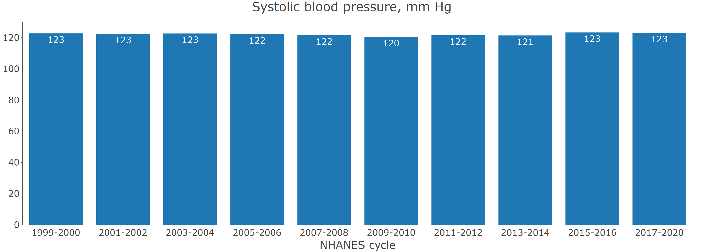

B. TEXT HERE

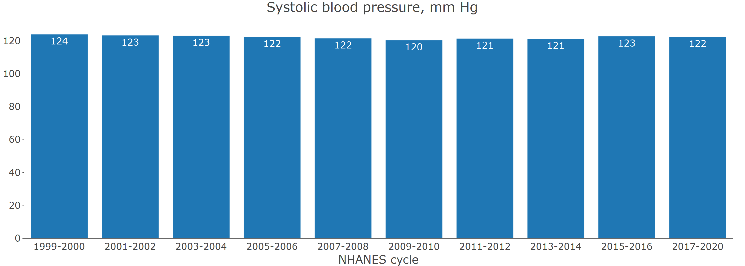

**Figure S2**: Age-adjusted mean systolic blood pressure among people with and without hypertension

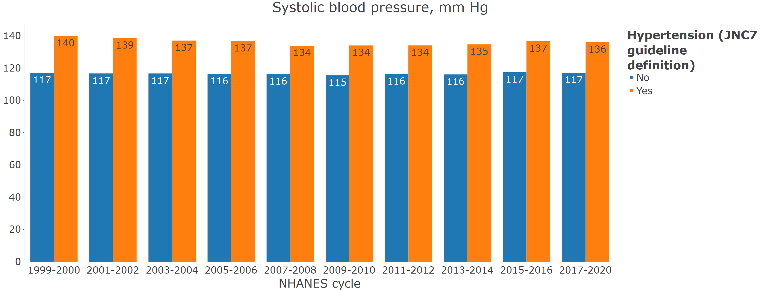

**Figure 2** Prevalence of hypertension for US adults by calendar year

A. TEXT HERE

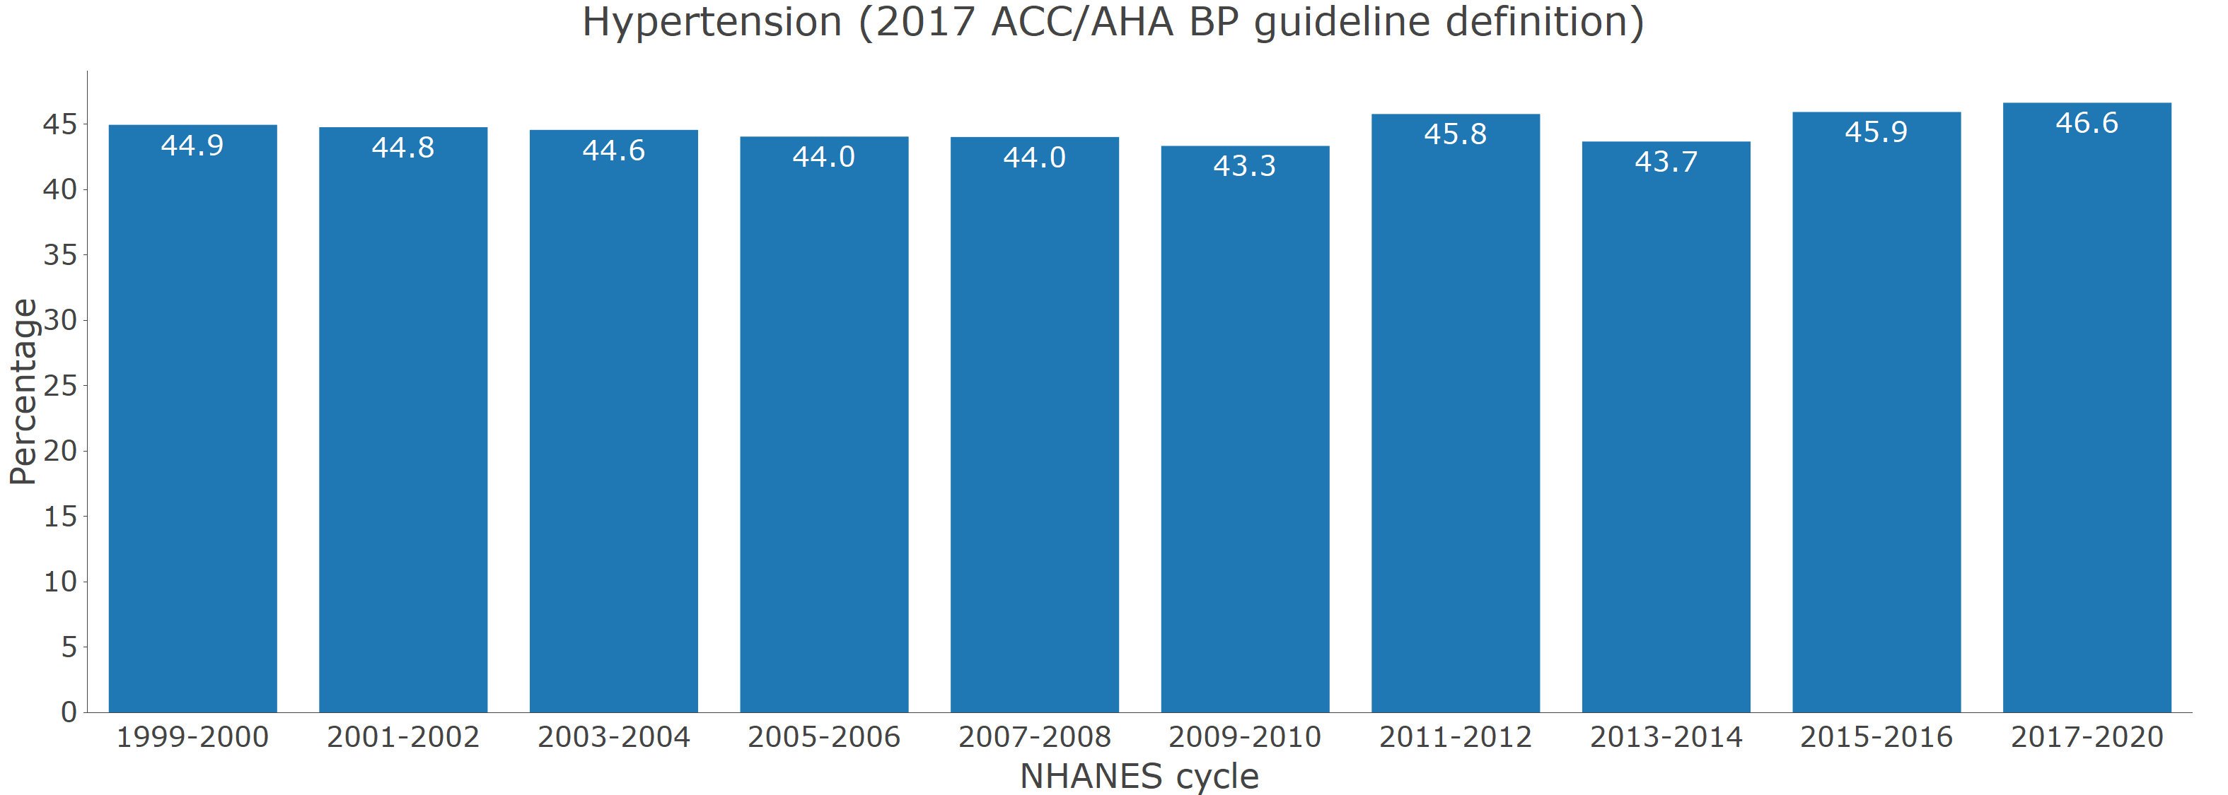

B. TEXT HERE

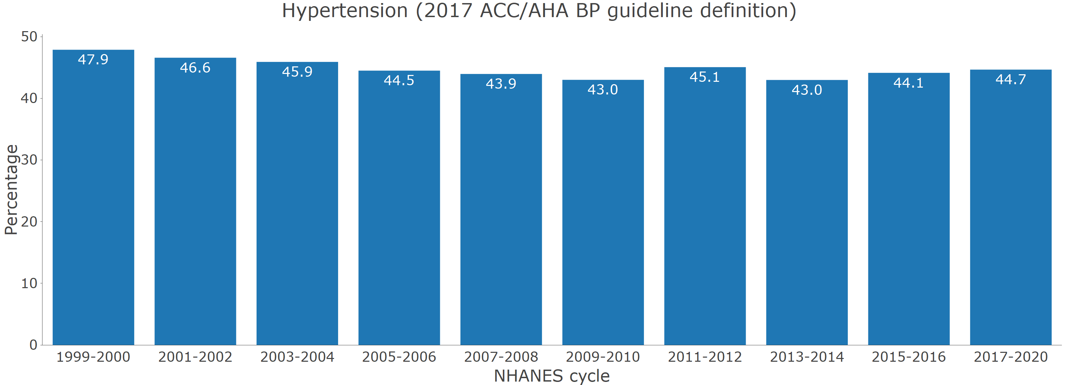

**Figure S3**: Age-adjusted prevalence of hypertension among US adults with and without chronic kidney disease

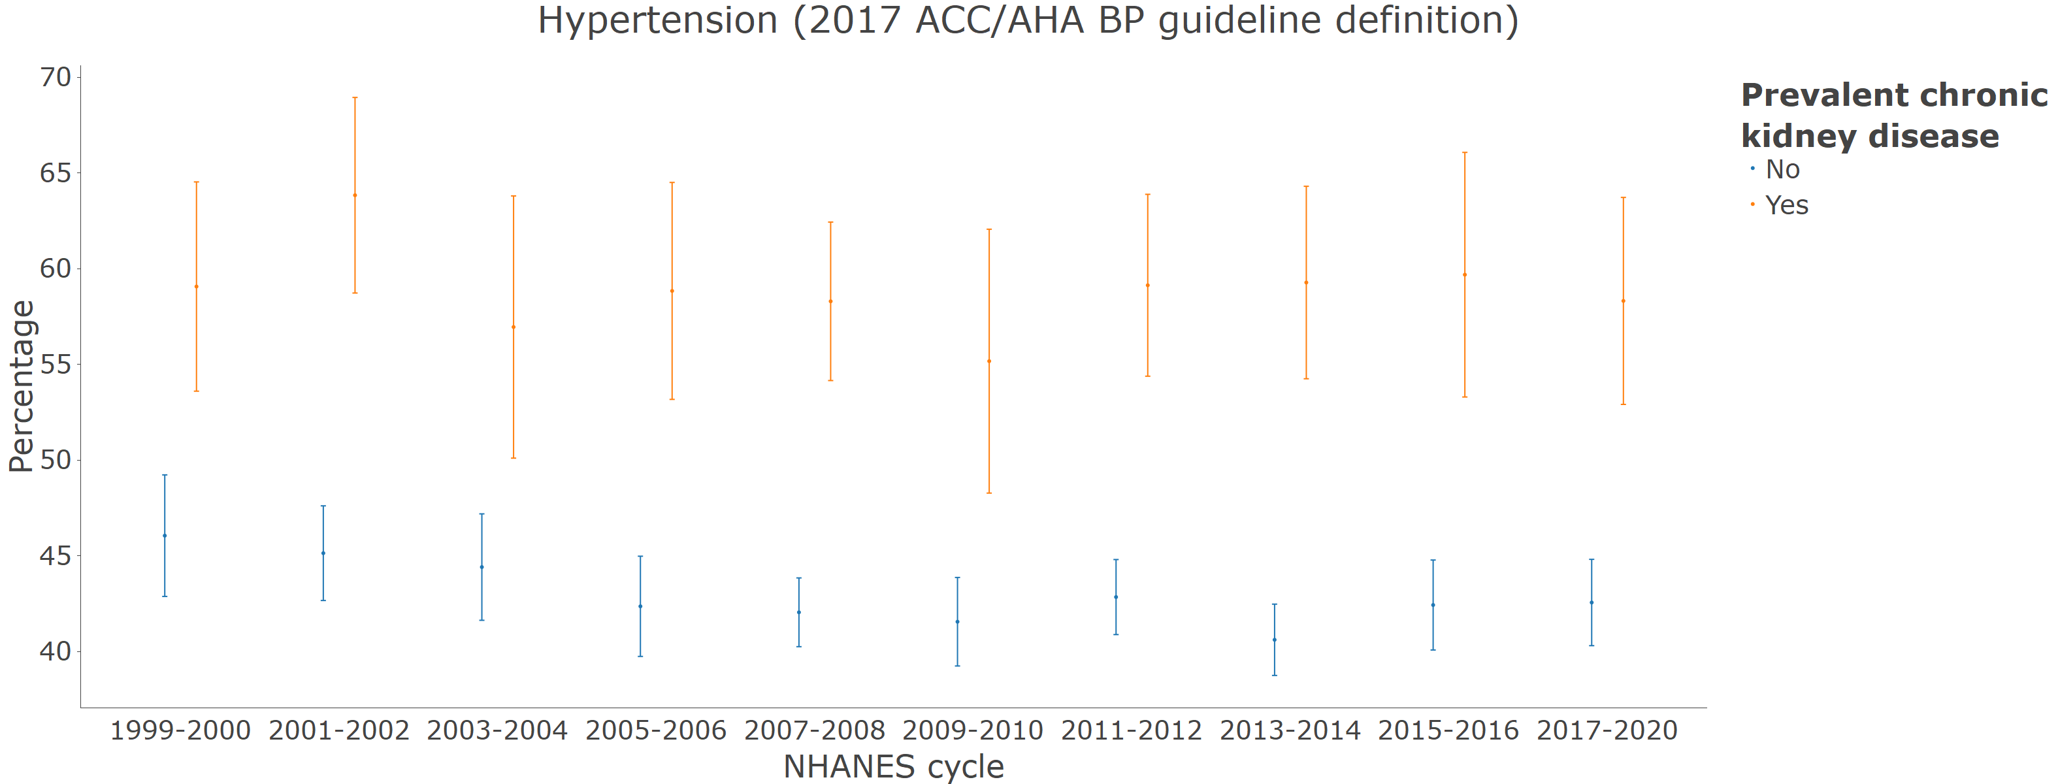

**Figure 3** Number of US adults with hypertension

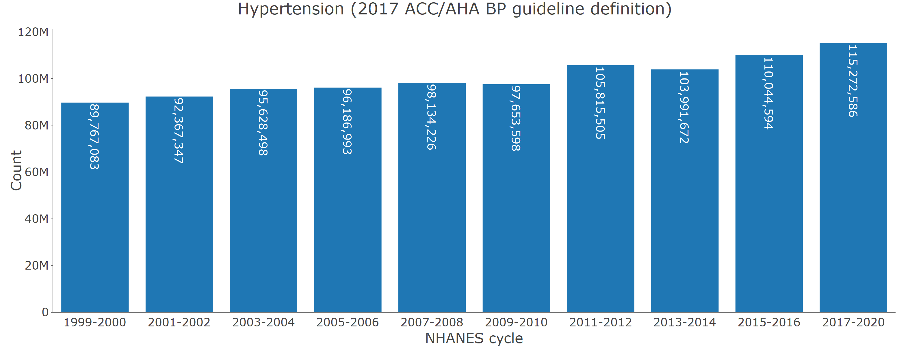

**Figure 4** Distribution of the number of antihypertensive medication classes being taken among those with hypertension by calendar period

A. Among those with hypertension

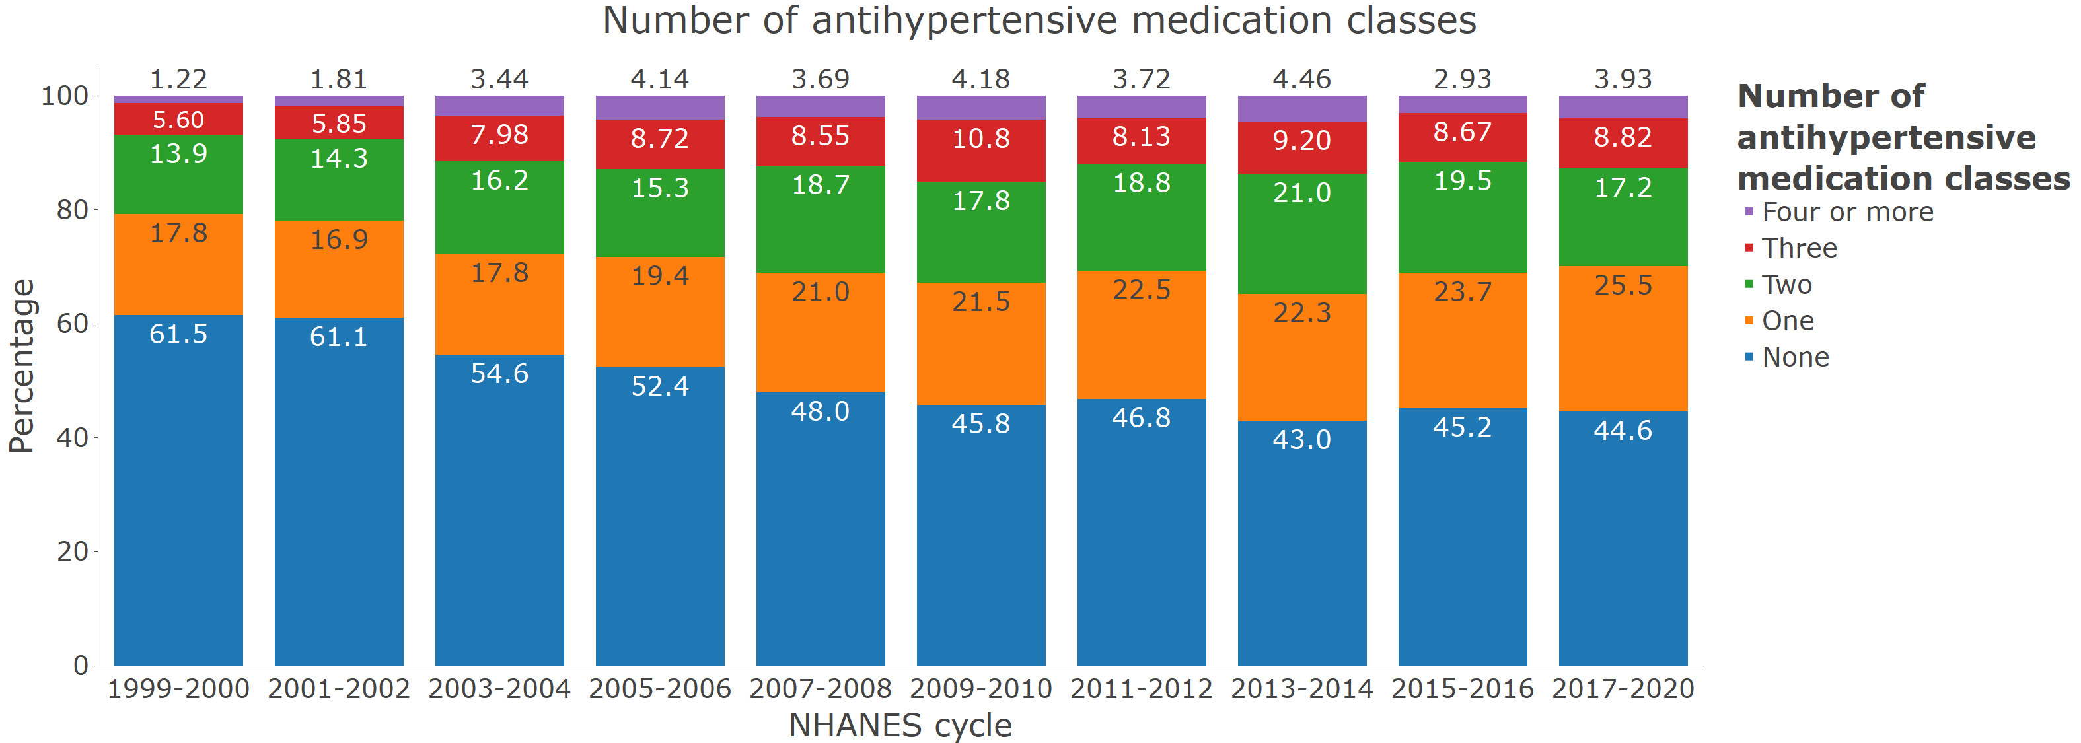

B. Among those with hypertension who self-report taking antihypertensive medication

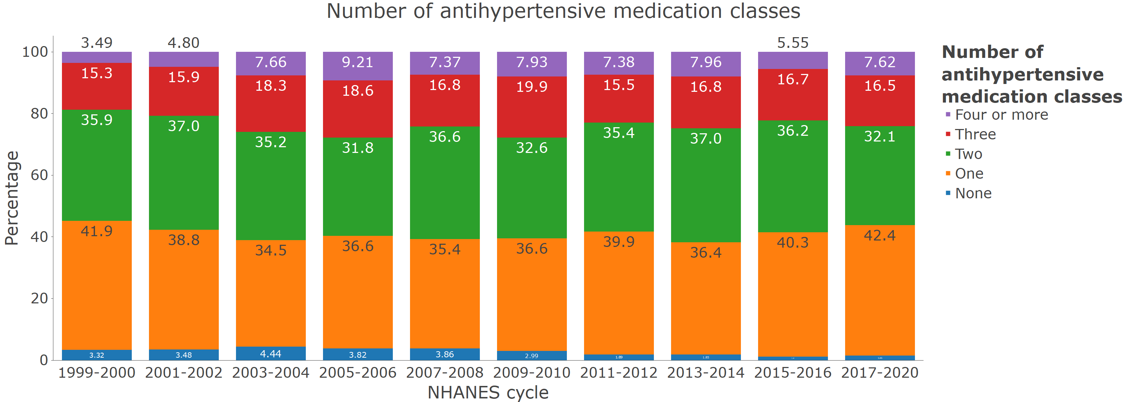

**Figure S4**: Prevalence of resistant hypertension by calendar year

A. Among those with hypertension who self report taking antihypertensive medication

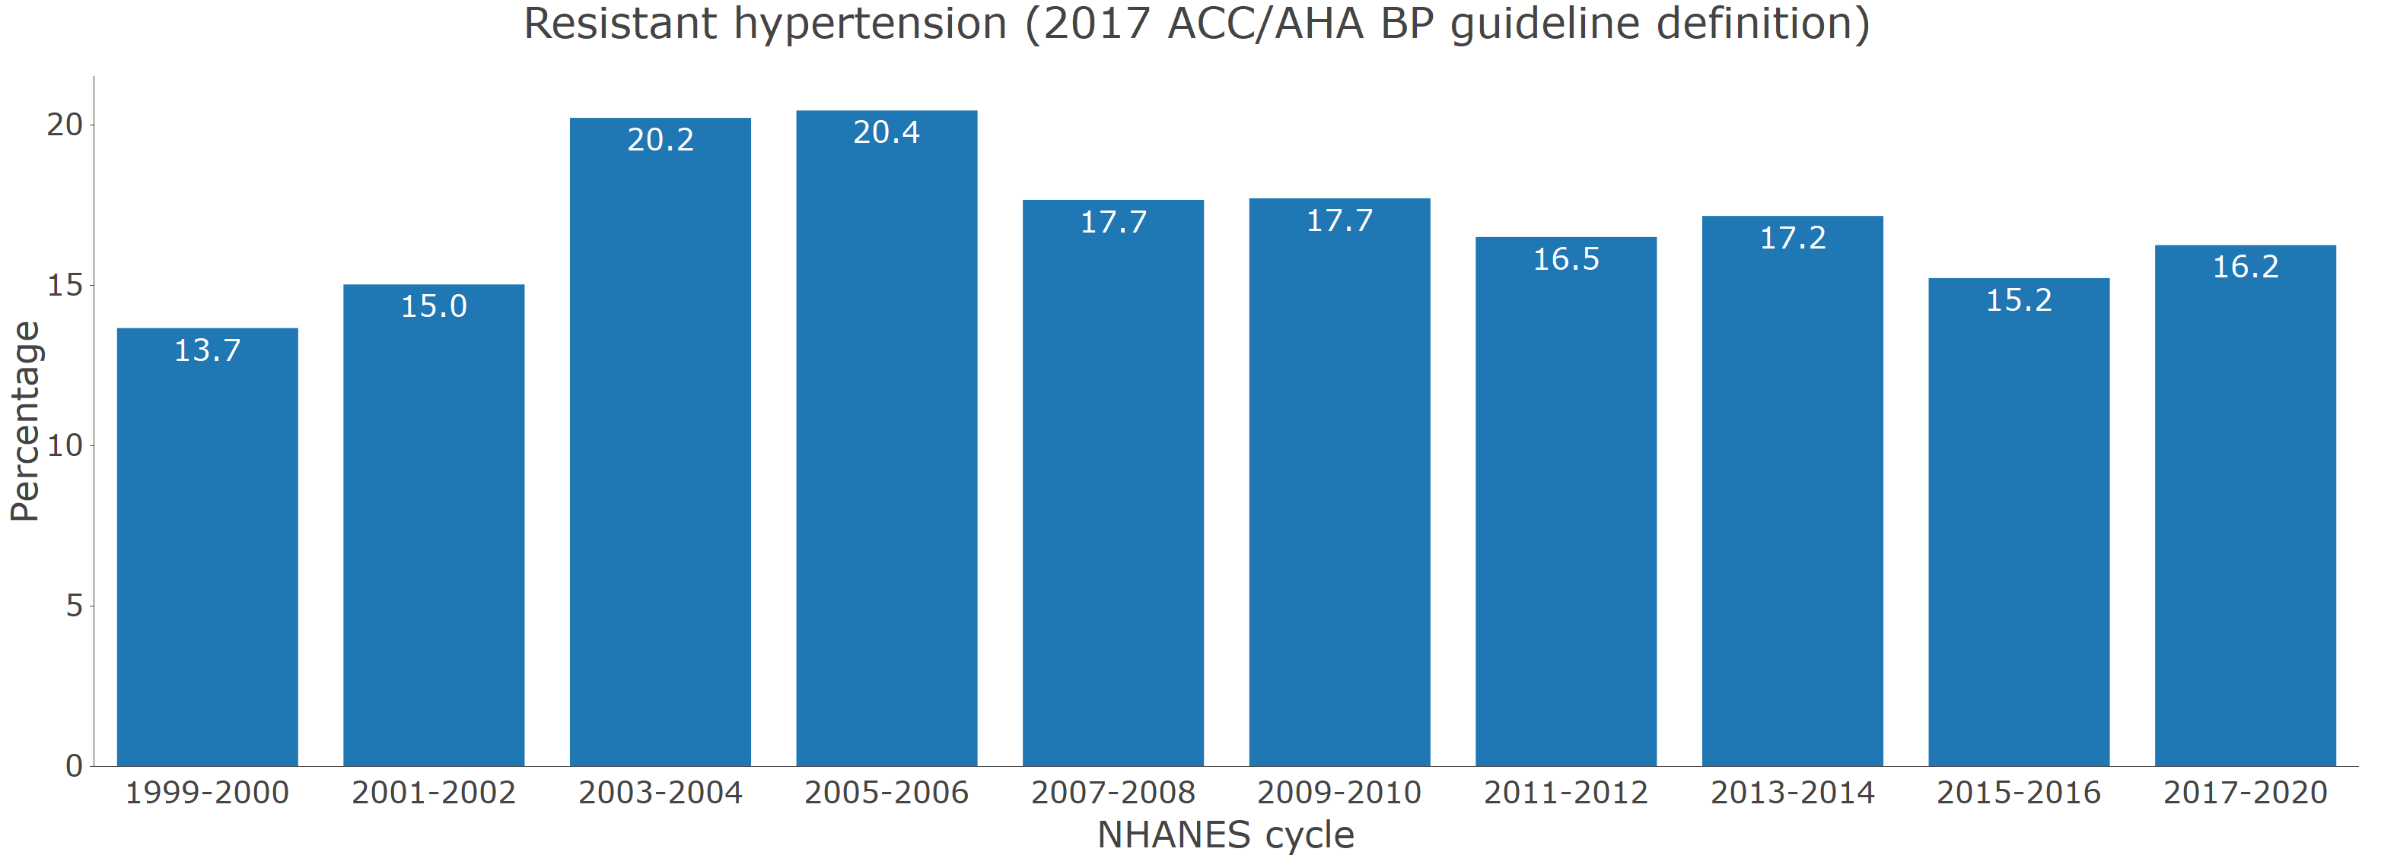

B. Among those with hypertension who self report and are taking 3+ classes of antihypertensive medication

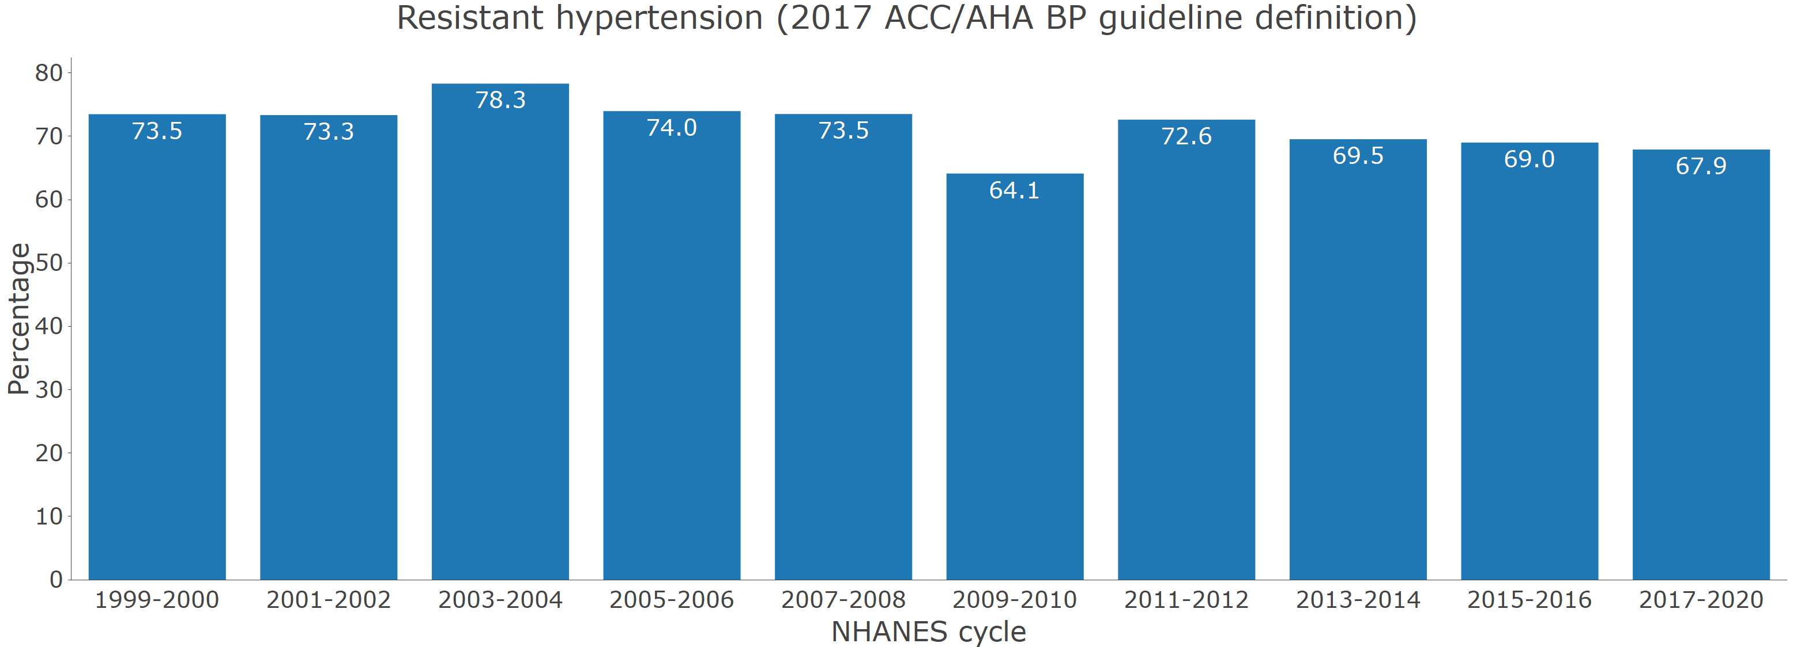

**Figure 5** Blood pressure control by calendar year

A. Age-adjusted among those with hypertension

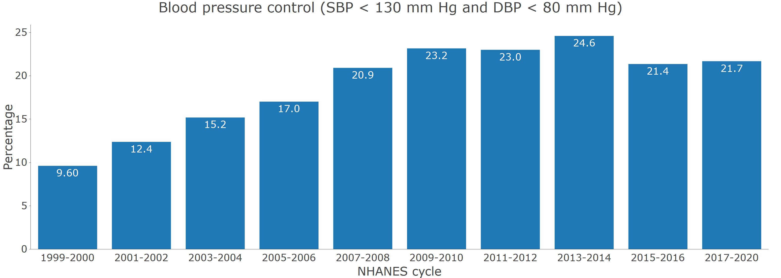

B. Age-adjusted among those who self-report taking antihypertensive medication

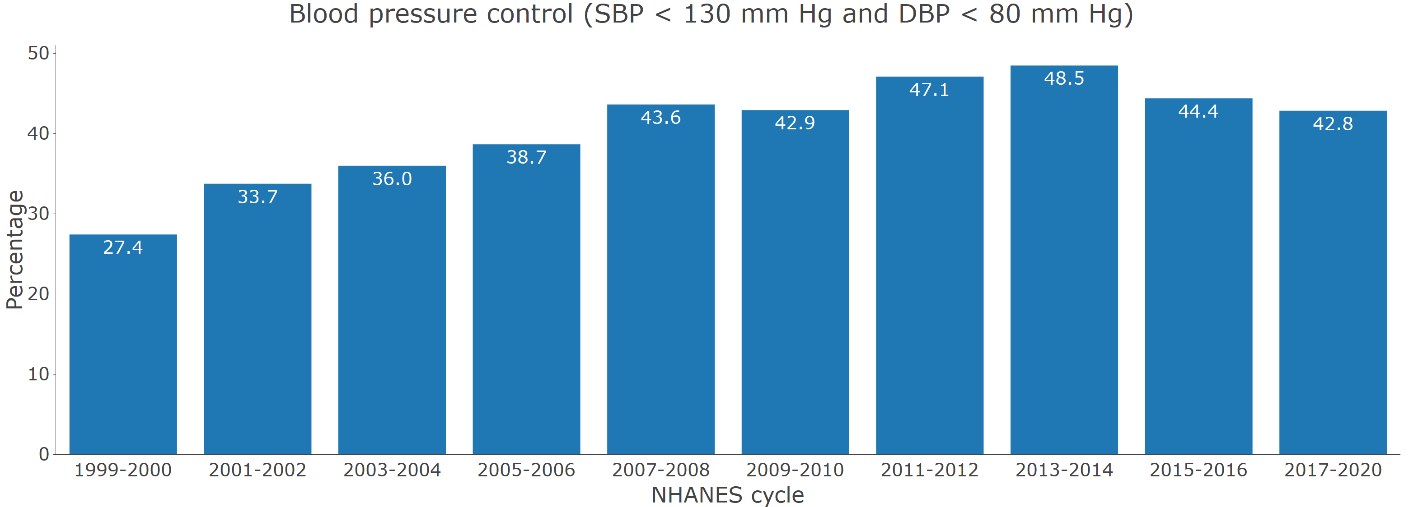

**Figure S5** Prevalence of hypertension by age categories in 2017-2020

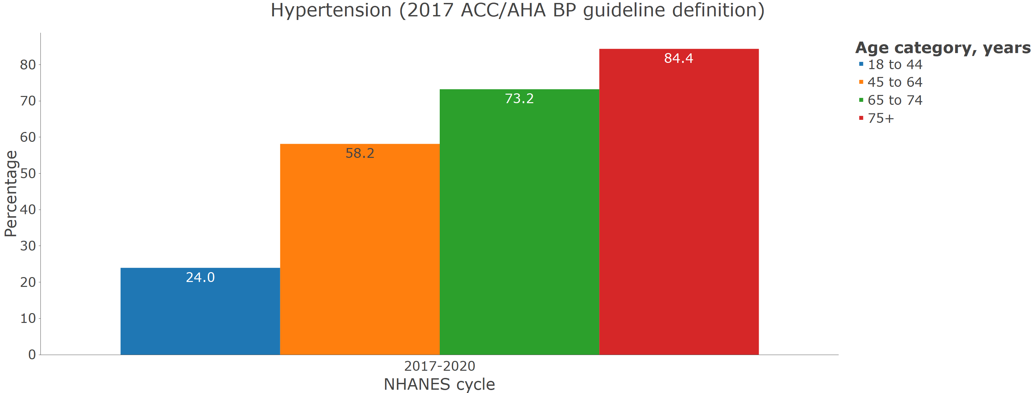

**Figure S6** Prevalence of hypertension by sex in 2017-2020

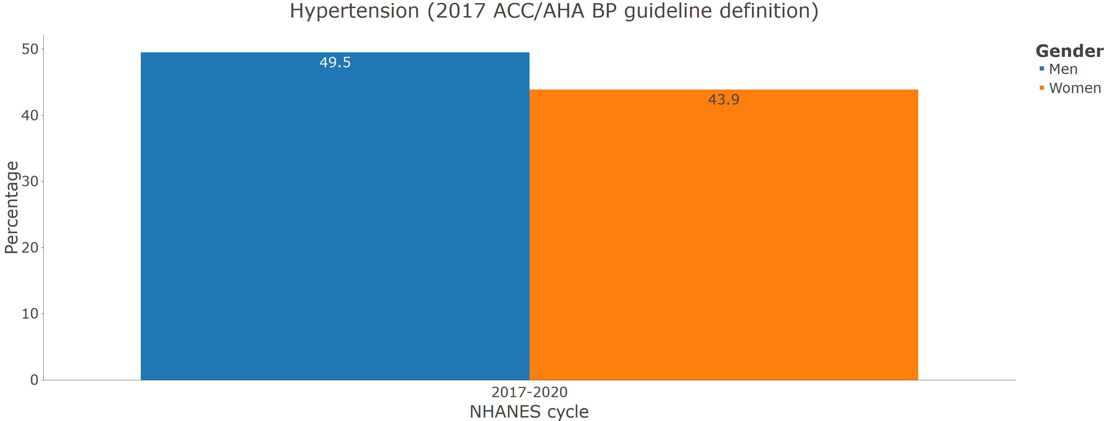

**Figure S7** Prevalence of hypertension by race/ethnicity in 2017-2020

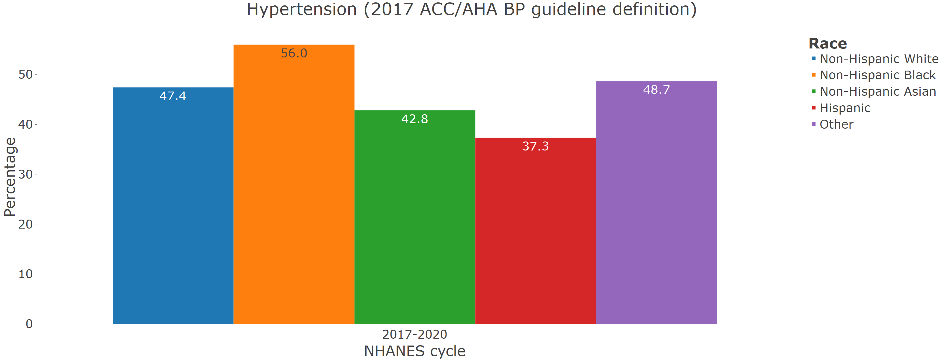

**Figure S8** Prevalence of uncontrolled blood pressure among pregnant women from 2011-2012 through 2017-2020.

