Hypertension statistics for US adults: an open-source web application for analysis and visualization of US NHANES data

Byron C. Jaeger, PhD,1 Ligong Chen, PhD,2 Adam P. Bress, PharmD, MS,3,4 YOUR NAME, DEGREE,x Bharat Poudel, MSPH,2 Ashley Christenson, BS,2 Lisandro D. Colantonio, PhD,2 Paul Muntner, PhD,2

1Department of Biostatistics and Data Science, Wake Forest School of Medicine, Winston-Salem, NC. 2Department of Epidemiology, University of Alabama at Birmingham. 3Informatics, Decision-Enhancement, and Analytic Sciences (IDEAS) Center, Veterans Affairs, Salt Lake City Health Care System, Salt Lake City, UT. 4Department of Population Health Sciences, University of Utah School of Medicine, Salt Lake City, UT. x YOUR AFFILIATION IF IT ISN’T ALREADY DEFINED ABOVE

# ABSTRACT

**Background**: Data from the US National Health and Nutrition Examination Survey (NHANES) are freely available and can be analyzed to produce hypertension statistics for the non-institutionalized US population. However, the analysis of these data requires statistical programming knowledge.

**Methods**: We developed and validated a web-based application that provides hypertension statistics for US adults using 10 cycles of NHANES data, 1999-2000 through 2017-2020, without requiring users to conduct statistical programming. The application’s interface allows users to estimate crude and age-adjusted means, quantiles, and proportions. Population counts can also be estimated. To demonstrate the application’s capabilities, we estimated hypertension statistics for US adults.

**Results**: The estimated mean systolic blood pressure (BP) declined from 123 mmHg in 1999-2000 to 120 mmHg in 2009-2010 and increased to 123 mmHg in 2017-2020. The age-adjusted prevalence of hypertension (i.e., systolic BP ≥130 mmHg, diastolic BP ≥80 mmHg or self-reported antihypertensive medication use) was 47.9% in 1999-2000, 43.0% in 2009-2010, and 44.7% in 2017-2020. In 2017-2020, 115.3 million US adults had hypertension. The age-adjusted prevalence of controlled BP, defined according to the 2017 American College of Cardiology/American Heart Association BP guideline, among US adults with hypertension was 9.6% in 1999-2000, 24.6% in 2013-2014, and 21.7% in 2017-2020. After age-adjustment and among US adults who self-report taking antihypertensive medication, 27.4%, 48.5%, and 42.8% had controlled BP in 1999-2000, 2013-2014, and 2017-2020, respectively. The application was validated by replicating statistics from three publications.

**Conclusions**: The application developed and validated is publicly available and produced valid, transparent, and reproducible results.

The National Health and Nutrition Examination Survey (NHANES) is a program conducted by the US National Center for Health Statistics (NCHS) of the Centers for Disease Control and Prevention (CDC) and is designed to assess the health and nutritional status of the non-institutionalized US population. NHANES data have been analyzed to provide hypertension statistics for non-institutionalized US adults with important policy and public health implications. For example, NHANES data have been used to estimate the impact of the lower blood pressure (BP) levels that define hypertension and controlled BP in the 2017 American College of Cardiology/American Heart Association (ACC/AHA) BP guideline versus the Seventh Joint National Committee (JNC7) BP guideline. Additionally, NHANES data have been used to track the proportion of US adults with hypertension that have controlled BP, which were included in a Call-to-Action to Control BP from the US Surgeon General.

NHANES data are publicly available and accessible through the CDC website. However, analyzing NHANES data may be challenging for a number of reasons. Specific statistical techniques are required to account for the multi-stage sampling design used to select NHANES participants and analyses need to be weighted to produce nationally representative estimates. Each NHANES cycle includes over 50 data files, each of which has detailed informational material. NHANES data collection protocols have changed over time for some variables, and these differences should be taken into account when comparing or aggregating data from multiple cycles. Also, tests need to be performed to ensure the statistical estimates are reliable, and unstable estimates should be suppressed.

To address these challenges, we developed an open-source web-based application that provides nationally representative BP and hypertension statistics for non-institutionalized US adults using NHANES data without requiring users to conduct statistical programming. The goal of the application is to increase the use of NHANES data for research and policy decision making with a focus on ensuring results are valid, transparent, and reproducible. In this manuscript, we review the design, development and validation of the application, present BP and hypertension statistics for US adults, and describe online tutorials and resources that may help users engage with the application.

# METHODS

The NHANES program was initiated in the early 1960s and beginning in 1999 has been conducted continuously, in two-year cycles. In each cycle, potential participants were identified using a multi-stage sampling process. The protocols for each cycle were approved by the NCHS Institutional Review Board. Written informed consent was obtained from each participant.

NHANES data are collected through in-home interviews and study examinations conducted at mobile examination centers. The interview included questions about demographics, health behaviors, medical history, and medication use. During the interview, the labels of medications that participants reported taking in the preceding 30 days were recorded. During the study examination, height, weight and BP were measured and blood and spot urine samples were collected. Of relevance to the application, blood samples were used to measure total and HDL cholesterol, glycated hemoglobin and serum creatinine, and the urine sample was used to measure albumin and creatinine and to conduct a pregnancy test. The protocol for the BP measurement is available online. In brief, systolic and diastolic BP (SBP and DBP, respectively) were measured three times by trained and certified physicians. BP was measured using a mercury sphygmomanometer from 1999-2000 through 2015-2016 and using an oscillometric device in 2017-2020. The mean SBP and DBP levels were computed over all available measurements for each participant. The oscillometric SBP and DBP values were calibrated to the mercury device. Antihypertensive medication classes were defined using recommendations from the 2017 ACC/AHA BP guideline. For the current analysis, we defined hypertension, BP control, and resistant hypertension according to the 2017 ACC/AHA BP guideline. The application also has these variables defined according to the Seventh Report of the Joint National Committee on Prevention, Detection, Evaluation, and Treatment of High Blood Pressure definitions. A complete list of the variables available in the data set is provided in **Table 1** with full definitions provided in **Table S1**.

There were 107,622 NHANES participants in the 10 cycles from 1999-2000 to 2017-2020. We restricted the dataset to adults ≥ 18 years of age. This exclusion was applied because statistics for BP levels and hypertension in children and adolescents are markedly different than for adults. We further restricted the population to participants who completed the in-home interview and study examination, with one or more SBP and DBP measurement, and who had data on self-reported antihypertensive medication use. After these exclusions were applied, the population in this application included 56,035 participants (**Figure S1**).

## Features of the web application

A full summary of this application’s features and associated tutorials are available online. Briefly, users can select NHANES cycles from 1999-2000 to 2017-2020 to be analyzed. Estimates are weighted to represent the non-institutionalized US population and users may incorporate age-adjustment through direct standardization. Users can restrict analyses to subsets of participants (e.g., participants who self-reported taking antihypertensive medication). When population count estimates are requested, survey weights are calibrated to account for participants missing information on SBP, DBP or self-reported antihypertensive medication use. Users may tabulate or visualize summaries, and can present results for the overall population or in subgroups defined by a stratifying variable. All figures and datasets created with the web application can be downloaded and saved. Following CDC recommendations, unreliable statistical estimates are automatically suppressed. To increase precision and reliability of estimates, contiguous NHANES cycles can be combined.

## Development and validation of the web application

The web application was created using Shiny, an open-source software package that translates code from the R programming language into HTML, CSS, or JavaScript commands that create a website interface. We created the “cardioStatsUSA” R package to provide additional details on the web application’s design and comprehensive documentation of its components. We validated the web application by using it to reproduce statistics reported in two prior studies and one CDC report.

## Statistical analysis

We performed statistical analyses to demonstrate core features of the application. We estimated the mean SBP for US adults by NHANES cycle, 1999-2000 through 2017-2020, with points showing the estimated means and error bars showing the 95% confidence intervals. We made bar charts presenting the age-adjusted prevalence of hypertension and the estimated number of US adults with hypertension. For age adjustment, we used the estimated age distribution of US adults from 1999 to 2020 as the standard (49.3%, 33.6%, 10.1% and 7.0% being 18 to 44, 45 to 64, 65 to 74 and ≥75 years of age, respectively). To illustrate how results from the application appear when saved in various formats (e.g., comma separated, portable document format, Microsoft Excel), we tabulated the estimated race/ethnicity distribution of US adults with and without hypertension, separately. We demonstrated stratification by estimating the prevalence of hypertension by NHANES cycle for US adults with and without chronic kidney disease (CKD). We showed the application’s ability to suppress output when statistical estimates are unstable by attempting to estimate the distribution of BP categories (SBP/DBP < 120/80 mm Hg, 120-129/<80 mm Hg, 130-139/80-89 mm Hg, 140-159/90-99 mm Hg and ≥ 160/100 mm Hg) among pregnant women in 2017-2020. We then showed that reliable estimates can be obtained for the distribution of BP categories among pregnant women by pooling NHANES cycles from 2009-2010 through 2017-2020.

We also illustrated how core features of the application can be combined to perform customized analyses. Specifically, we estimated the age-adjusted proportion of US adults with controlled BP by NHANES cycle among non-pregnant US adults with hypertension, overall and among those who self-reported taking antihypertensive medication. We also estimated the age-adjusted prevalence of resistant hypertension by NHANES cycle for US adults with hypertension taking antihypertensive medication and among US adults with hypertension taking ≥ 3 classes of antihypertensive medication. For age adjustment in the analysis of resistant hypertension, we set the age distribution for the standard population to represent US adults with hypertension from 1999 to 2020: 26.4%, 43.4%, 17.0% and 13.2% being 18 to 44 years, 45 to 64, 65 to 74, and ≥75 years of age, respectively.

# RESULTS

The web application successfully replicated results from prior studies. Full details on how to use the application to replicate these studies are available online. Following its validation, version 0.0.1 of the application was released and deployed in a publicly available server on **DATE TBD**.(add a citation to version 0.0.1 of the cardioStatsUSA package and a citation to the url where the shiny app lives)

## Demonstration of core features

Among non-institutionalized US adults ≥ 18 years of age, the estimated mean SBP was 123 mm Hg (95% CI 121, 124) in 1999-2000, 120 mm Hg (95% CI 120, 121) in 2009-2010 and 123 mm Hg (95% CI 122, 124) in 2017-2020 (**Figure 1**). The age-adjusted prevalence of hypertension was highest in 1999-2000 (47.9%), lowest in 2009-2010 (43.0%), and 44.7% in 2017-2020 (**Figure 2**). In 1999-2000, there were an estimated 89.8 million US adults with hypertension (**Figure 3**). The number of US adults with hypertension increased to 115.3 million in 2017-2020. In each NHANES cycle, the estimated age-adjusted prevalence of hypertension was higher among US adults with versus without CKD (**Figure S2**). In 2017-2020, a higher percentage of US adults with versus without hypertension were non-Hispanic Black (13.5% versus 9.3%) while a lower percentage of US adults with versus without hypertension were Hispanic (12.3% versus 18.1%) (**Table 2**). Among pregnant women, the distribution of BP categories could not be estimated reliably in 2017-2020 (**Figure S3; Panel A**) except for the group with SBP of 130 to < 140 or DBP of 80 to < 90, but was stable for all groups after pooling NHANES cycles from 2009-2010 through 2017-2020 (**Figure S3; Panel B**)

## Demonstration of customized analyses

The age-adjusted prevalence of BP control among US adults with hypertension was lowest in 1999-2000 (9.6%), highest in 2013-2014 (24.6%), and 21.7% in 2017-2020 (**Figure 4; panel A**). Among US adults who self-reported taking antihypertensive medication, 27.4%, 48.5%, and 42.8% had controlled BP in 1999-2000, 2013-2014, and 2017-2020, respectively (**Figure 4; panel B**). The age-adjusted prevalence of resistant hypertension among US adults who self-reported taking antihypertensive medication was lowest in 1999-2000 (13.7%), highest in 2005-2006 (20.4), and 16.2% in 2017-2020 (**Figure S4; panel A**). Among US adults who were taking three or more classes of antihypertensive medication, the prevalence of resistant hypertension was lowest in 2009-2010 (64.1%), highest in 2003-2004 (78.3%), and 67.9% in 2017-2020 (**Figure S4; panel B**).

# DISCUSSION

In the current manuscript, we present a web application that allows the calculation of nationally representative estimates for BP, hypertension and antihypertensive medication-related outcomes using publicly available data from NHANES. Using this application, we generated crude and age-adjusted BP and hypertension statistics. Also, we generated statistics stratified by characteristics of US adults (e.g., CKD), and pooling multiple NHANES cycles to obtain more precise estimates when working with the small sub-group of pregnant women. Researchers, clinicians, and the general public can use the application to generate customized BP and hypertension statistics for US adults.

NHANES was designed to obtain nationally representative estimates of the health and nutrition status of non-institutionalized US adults and is an ideal data source to obtain statistics related to hypertension. SBP and DBP were measured following a standardized protocol by trained and certified staff. NHANES data are publicly available to download but working with these data requires understanding variable definitions and advanced programming and statistical knowledge. Challenges that users encounter when analyzing with NHANES include the need to download and merge multiple data files, even for a single NHANES cycle; combining multiple variables to create outcome definitions, which may require dealing with missing data and questionnaire skip patterns; harmonizing definitions across multiple NHANES cycles; and the analyses of complex survey design data. The web application that we present in the current manuscript was designed to reduce barriers to using NHANES so that these data can more fully inform public health decisions and future research related to hypertension.

Several design decisions have been incorporated into the application. We required participants to have a single SBP and DBP to be included while some prior analyses required three SBP and DBP measurements. We chose an approach that is consistent with several analyses conducted by CDC investigators (cite pmid 26633197, 29155682). However, mean BP and the prevalence of high BP would be lower if we required multiple BP measurements (cite pmid 23126346). Any bias resulting from this decision is likely to be small as over 95% of adult NHANES participants with at least one SBP and DBP measurement had three SBP and DBP measurements. The application re-calibrates the NHANES weights for the estimation of population counts (cite pmid 12500213). When estimating population counts, participants missing data on SBP, DBP or antihypertensive medication use cannot have BP or hypertension-related outcomes. Weights were not re-calibrated when estimating proportions as participants missing data are removed from the numerator and denominator. Medication classes were coded using generic names and the drug classes in the 2017 ACC/AHA BP guideline. We recognize the NCHS recommends using Lexicon Plus®, a proprietary database, to categorize medication classes. While the categorization of most medications is identical using generic drug names and Lexicon Plus®, some differences exist. Many additional decisions were made regarding the definitions of variables, inclusion of study participants, and analytic approach. We sought to make decisions that would be widely acceptable and transparent to ensure the results could be described accurately.

We were able to replicate several prior manuscripts using the application. However, we were not able to replicate some results. For example, a prior manuscript reported the prevalence of resistant hypertension defined by the 2017 ACC/AHA BP guideline to be 19.7% in 2009-2014(cite pmid 30580690). When estimated by the application, the prevalence of resistant hypertension over this time period was X%. The difference in the prevalence estimates can be attributed to the approach used to categorize medication into classes. The prior publication used Lexicon Plus®, which counted spironolactone as two drug classes, a potassium-sparing diuretic and an aldosterone antagonist. We included spironolactone as a single drug class, an aldosterone antagonist. Additionally, Lexicon Plus® includes Sotalol as a beta blocker and nitroglycerine as a direct vasodilator and we did not include these drugs as antihypertensive medications as they are not listed in the 2017 ACC/AHA BP guideline. The differences in results between the application and this previously published manuscript emphasize that it may not be possible to always generate results that are identical to prior publications. Users should be aware of the choices made in defining variables as this may affect the statistical estimates generated using the application.

The application has a number of features that can be used in combination to create highly customized statistics. Variables can be analyzed as outcomes or used to stratify results or restrict analyses to subsets of participants. Combining the variables, tens of thousands of unique statistics can be estimated. In addition, users can generate statistics for US adults over 22 years, pooling results or stratifying the data. All results from the application can be saved as an image and included in scientific proposals or presentations. In addition, the ability to download summary data from the application allows users to further customize their results in tabular or graphical formats. The web application can also be used for educational purposes, as teachers can use it to analyze health outcomes for US adults interactively with students.

With an open-source software license and publicly available documentation and data, the web application we developed can be extended. The current manuscript described a set of hypertension variables and a sub-population of NHANES participants with data on BP and antihypertensive medication use. The application’s interface and its supporting R package allows additional variables to be added. In addition, the application may be extended to include data from additional NHANES cycles as they become available.

## Strengths/limitations

This study has a number of strengths. We used NHANES data, which are publicly available, rigorously collected, and allow for estimation of nationally representative statistics. Also, we leveraged open-source software to ensure that our application is transparent, able to be extended, and freely available. This study also has several limitations. First, NHANES participants had their mean BP measured during a single visit, and BP guidelines recommend obtaining mean BP using at least two BP values measured on separate days. Second, the response rate for NHANES has declined from 1999-2000 through 2017-2020. Effects of this decline are unclear.

## Conclusions

We developed a web-based application for analysis of hypertension outcomes among non-institutionalized adults living in the US from 1999-2000 through 2017-2020. The application is publicly available and produces valid, transparent, and reproducible results.

### Table 1: Blood pressure, hypertension and antihypertensive medication variables that may be analyzed using the web application.

| **Variable** |
| --- |
| *Blood pressure* |
| Systolic blood pressure, mm Hg |
| Diastolic blood pressure, mm Hg |
| Blood pressure category |
| Blood pressure category (including antihypertensive medication use) |
| Blood pressure control (JNC7 guideline) |
| Blood pressure control (2017 ACC/AHA BP guideline) |
| Uncontrolled BP (JNC7 guideline) |
| Uncontrolled BP (2017 ACC/AHA BP guideline) |
| *Hypertension* |
| Hypertension (JNC7 guideline) |
| Hypertension (2017 ACC/AHA BP guideline) |
| Awareness of hypertension |
| Resistant hypertension (JNC7 guideline definition) |
| Resistant hypertension (2017 ACC/AHA BP guideline) |
| Resistant hypertension (JNC7 guideline, requires thiazide diuretic) |
| Resistant hypertension (2017 ACC/AHA BP guideline, requires thiazide diuretic) |
| *Antihypertensive medication* |
| Self-reported antihypertensive medication use |
| Antihypertensive medications recommended (JNC7 guideline) |
| Antihypertensive medications recommended (2017 ACC/AHA BP guideline) |
| Number of antihypertensive medication classes |
| *Antihypertensive medication classes* |
| ACE inhibitors |
| Aldosterone antagonists |
| Alpha-1 blockers |
| Angiotensin receptor blockers |
| Beta blockers |
| Central alpha1 agonist and other centrally acting agents |
| Calcium channel blockers |
| Potassium sparing diuretics |
| Loop diuretics |
| Thiazide or thiazide-type diuretics |
| Direct renin inhibitors |
| Direct vasodilators |
| Abbreviations: ACC = American College of Cardiology; AHA = American Heart Association; BP = blood pressure; DBP = diastolic blood pressure; JNC7 = Seventh Joint National Committee; and SBP = systolic blood pressure |

### Table 2: Race/ethnicity distribution of US adults with and without hypertension in 2017-2020

| **NHANES cycle** | **Hypertension** | **Race/Ethnicity** | **Estimate** | **Standard error** | **CI lower** | **CI upper** | **N observations** |
| --- | --- | --- | --- | --- | --- | --- | --- |
| 2017-2020 | No | Hispanic | 18.1 | 1.8 | 14.5 | 21.7 | 953 |
| 2017-2020 | No | Non-Hispanic Asian | 5.9 | 0.9 | 4.2 | 7.6 | 502 |
| 2017-2020 | No | Non-Hispanic Black | 9.3 | 1.2 | 7.0 | 11.5 | 803 |
| 2017-2020 | No | Non-Hispanic White | 62.8 | 2.3 | 58.2 | 67.4 | 1,325 |
| 2017-2020 | No | Other | 4.0 | 0.4 | 3.2 | 4.7 | 200 |
| 2017-2020 | Yes | Hispanic | 12.3 | 1.2 | 9.9 | 14.7 | 752 |
| 2017-2020 | Yes | Non-Hispanic Asian | 5.1 | 0.8 | 3.5 | 6.6 | 426 |
| 2017-2020 | Yes | Non-Hispanic Black | 13.5 | 1.8 | 9.9 | 17.1 | 1,344 |
| 2017-2020 | Yes | Non-Hispanic White | 64.8 | 2.8 | 59.4 | 70.3 | 1,510 |
| 2017-2020 | Yes | Other | 4.3 | 0.6 | 3.2 | 5.4 | 198 |

### Figure 1 Mean systolic blood pressure for US adults by calendar year

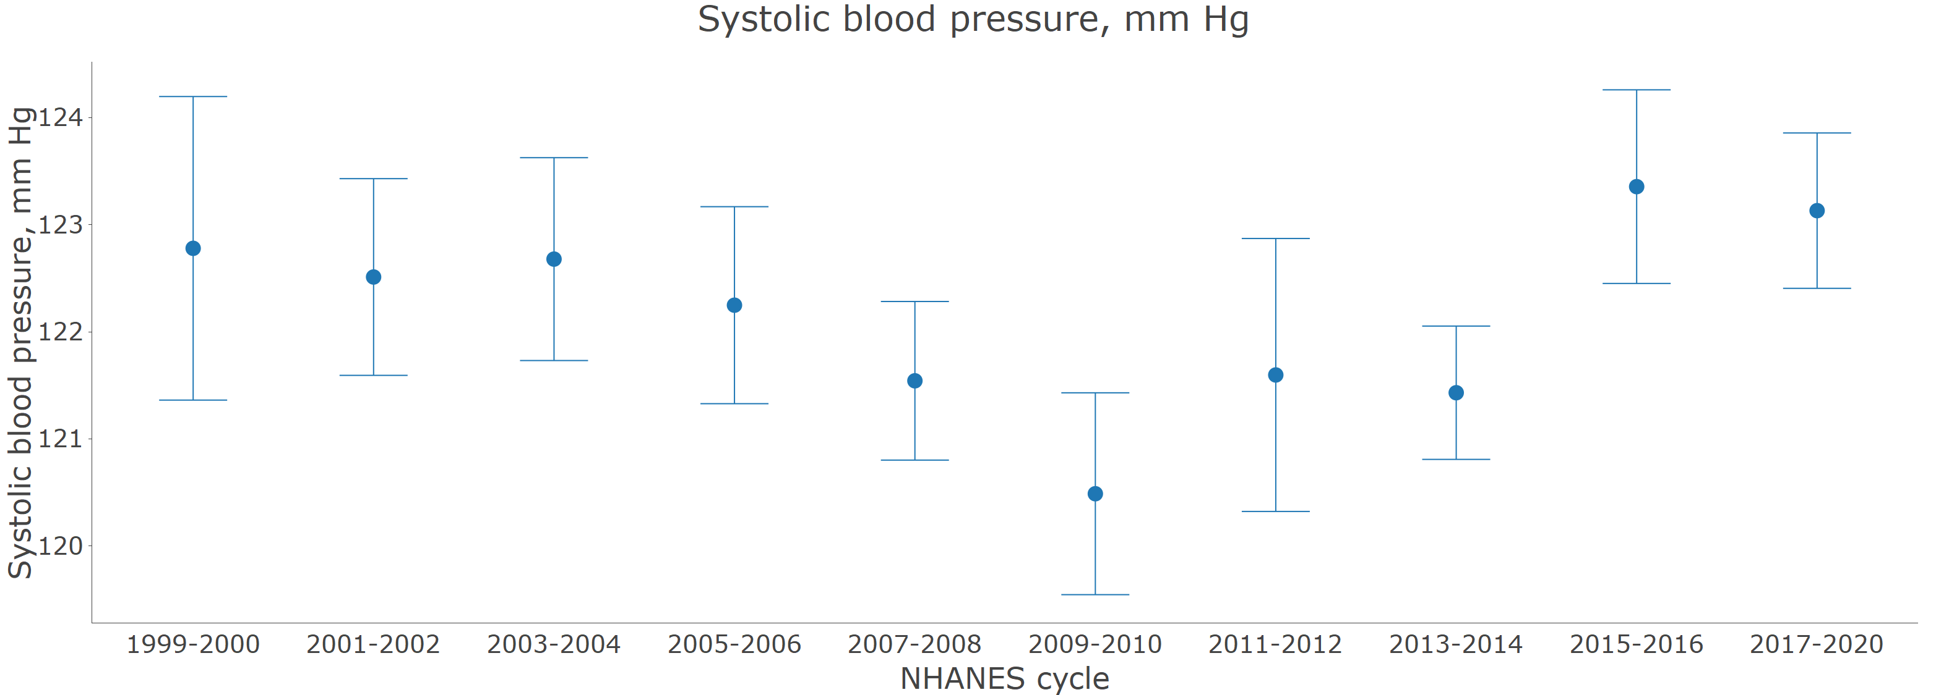

Dots represent mean systolic blood pressure. Vertical lines represent the 95% confidence interval.

### Figure 2 Age-adjusted prevalence of hypertension for US adults by calendar year

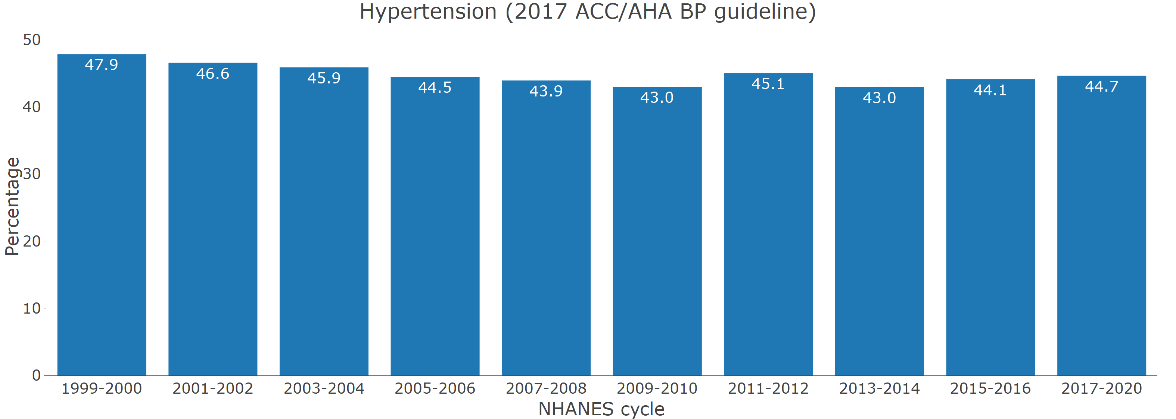

Age adjustment was performed through direct standardization

### Figure 3 Number of US adults with hypertension

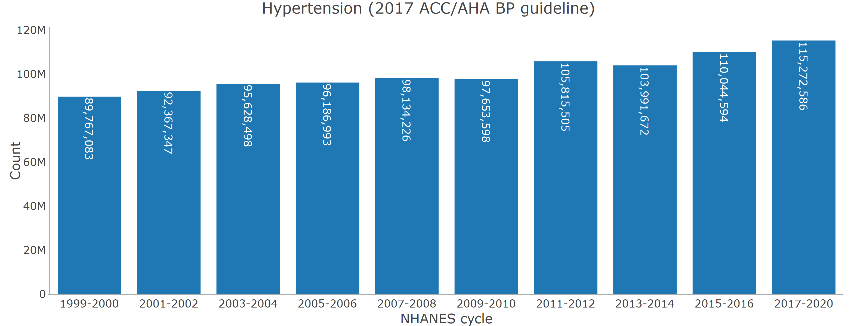

### Figure 4 Age-adjusted prevalence of blood pressure control by calendar year.

A. Among those with hypertension

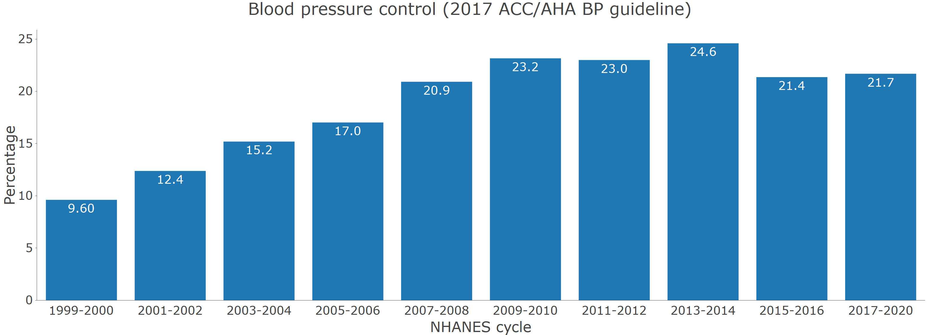

B. Among those who self-report taking antihypertensive medication

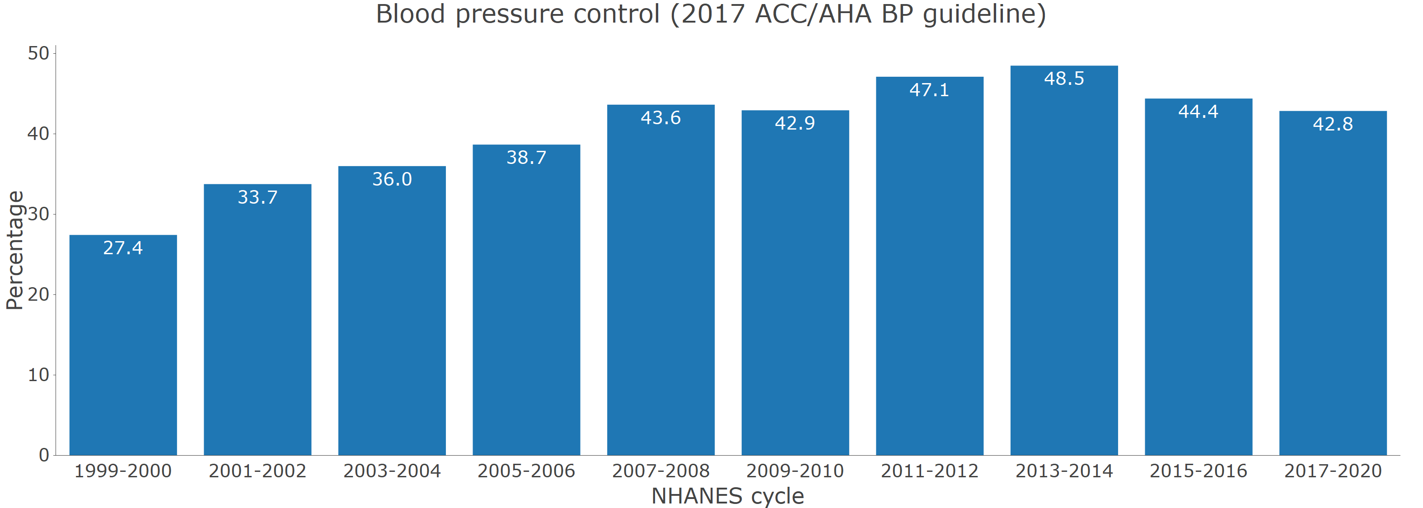

Age adjustment was performed through direct standardization

### Table S1: All variables included in the web-based application.

| **All variables included in module** | **Variable definition** |
| --- | --- |
| *Survey* | |
| participant identifier | NHANES participant unique identifier. |
| primary sampling unit | Population sampling unit. This variable is used to account for the non-random selection of study participants for NHANES |
| strata | Population stratification. This variable is used to account for the non-random selection of study participants for NHANES |
| Mobile examination center weights | Weight applied to produce statistical estimates for the non-institutionalized US population. This weight is used for calculating means and proportions. |
| Calibrated mobile examination center weights | Weight applied to produce statistical estimates for the non-institutionalized US population. This weight is used for estimating population counts and is recalibrated to account for participants excluded from this analysis due to missing data on systolic blood pressure, diastolic blood pressure or self-reported antihypertensive medication use. |
| Subpopulation for hypertension | This indicates that the person has data needed to be included in the analysis of blood pressure or hypertension data (i.e., they had at least one systolic and diastolic blood pressure measurement and they had information on self-reported antihypertensive medication use). |
| NHANES cycle | NHANES survey cycle: 1999-2000, 2001-2002, 2003-2004, 2005-2006, 2007-2008, 2009-2010, 2011-2012, 2013-2014, 2015-2016, 2017-2020 |
| *Demographics* | |
| Age category, years | Age grouping: 18-44, 45-64, 65-74, ≥ 75 years |
| Race | Self-reported race/ethnicity. From 1999-2000 through 2009-2010 this was available as non-Hispanic White, non-Hispanic Black, Hispanic and other. From 2011-2012 through 2017-2020 this was available as non-Hispanic White, non-Hispanic Black, non-Hispanic Asian, Hispanic and other. |
| Age, years | Participant age in years. Participants > 80 years of age are given an age of 80 years. |
| Pregnant | Pregnancy status. This is defined by either self-report of being pregnant or a positive pregnancy test conducted during the study visit. |
| Gender | Self-reported gender |
| *Blood pressure* | |
| Systolic blood pressure, mm Hg | Mean systolic blood pressure in mm Hg. This is based on the average of up to 3 readings. Overall, >95% of participants with at least one systolic blood pressure reading had three readings. From 1999-2000 through 2015-2016, systolic blood pressure was measured using a mercury sphygmomanometer. In 2017-2020, systolic blood pressure was measured using an oscillometric device. The systolic blood pressure in 2017-2020 was calibrated to the mercury device by adding 1.5 mm Hg to the mean measured value. |
| Diastolic blood pressure, mm Hg | Mean diastolic blood pressure in mm Hg. This is based on the average of up to 3 readings. Overall, >95% of participants with at least one diastolic blood pressure reading had three readings. From 1999-2000 through 2015-2016, diastolic blood pressure was measured using a mercury sphygmomanometer. In 2017-2020, diastolic blood pressure was measured using an oscillometric device. The diastolic blood pressure in 2017-2020 was calibrated to the mercury device by subtracting 1.0 mm Hg to the mean measured value. |
| Blood pressure category | Systolic/diastolic blood pressure <120/80, 120-129/<80, 130-139/80-89, 140-159/90-99, ≥ 160/100. Participants were placed in the category associated with higher blood pressure (e.g., someone with systolic blood pressure of 150 mm Hg and diastolic blood pressure of 76 mm Hg was placed in the ≥ 140/90 mm Hg category) |
| Blood pressure category (including antihypertensive medication use) | Systolic/diastolic blood pressure <120/80, 120-129/<80, 130-139/80-89, 140-159/90-99, ≥ 160/100. Participants taking antihypertensive medication were placed in a separate category. Participants were placed in the category associated with higher blood pressure (e.g., someone with systolic blood pressure of 150 mm Hg and diastolic blood pressure of 76 mm Hg was placed in the ≥ 140/90 mm Hg category) |
| Blood pressure control (JNC7 guideline) | Systolic and diastolic blood pressure controlled to the levels recommended in the JNC7 guideline, systolic blood pressure < 140 mm Hg and diastolic blood pressure < 90 mm Hg. |
| Blood pressure control (2017 ACC/AHA BP guideline) | Systolic and diastolic blood pressure controlled to the levels recommended in the 2017 ACC/AHA BP guideline, systolic blood pressure < 130 mm Hg and diastolic blood pressure < 80 mm Hg except for those ≥ 65 years of age without diabetes, chronic kidney disease, history of cardiovascular disease or 10-year predicted ASCVD risk ≥ 10%. For this group, blood pressure control was defined as systolic blood pressure < 130 mm Hg |
| Uncontrolled BP (JNC7 guideline) | Systolic blood pressure ≥ 140 mm Hg or diastolic blood pressure ≥ 90 mm Hg |
| Uncontrolled BP (2017 ACC/AHA BP guideline) | Systolic blood pressure ≥ 130 mm Hg or diastolic blood pressure ≥ 80 mm Hg except for individuals without diabetes, chronic kidney disease, history of cardiovascular disease or 10-year predicted ASCVD risk ≥ 10%. For this group, uncontrolled blood pressure was defined as systolic blood pressure ≥ 130 mm Hg |
| *Hypertension* | |
| Hypertension (JNC7 guideline) | Hypertension defined by the JNC7 guideline, systolic blood pressure ≥ 140 mm Hg, diastolic blood pressure ≥ 90 mm Hg or self-reported antihypertensive medication use. |
| Hypertension (2017 ACC/AHA BP guideline) | Hypertension defined by the 2017 ACC/AHA blood pressure guideline, systolic blood pressure ≥ 130 mm Hg, diastolic blood pressure ≥ 80 mm Hg or self-reported antihypertensive medication use. |
| Awareness of hypertension | Self-report of a prior diagnosis of antihypertensive medication. |
| Resistant hypertension (JNC7 guideline definition) | Taking 4 or more classes of antihypertensive medication, systolic blood pressure ≥ 140 mm Hg or diastolic blood pressure ≥ 90 mm Hg with the use of 3 classes of antihypertensive medication, or systolic blood pressure ≥ 130 mm Hg or diastolic blood pressure ≥ 80 mm Hg with the use of 3 classes of antihypertensive medication for those with diabetes or chronic kidney disease. |
| Resistant hypertension (2017 ACC/AHA BP guideline) | Taking 4 or more classes of antihypertensive medication, systolic blood pressure ≥ 140 mm Hg or diastolic blood pressure ≥ 90 mm Hg with the use of 3 classes of antihypertensive medication, or systolic blood pressure ≥ 130 mm Hg or diastolic blood pressure ≥ 80 mm Hg with the use of 3 classes of antihypertensive medication for those <65 years of age and those ≥ 65 years of age with diabetes, chronic kidney disease or high cardiovascular risk defined by a history of cardiovascular disease or 10-year predicted risk ≥ 10% using the pooled cohort risk equations. |
| Resistant hypertension (JNC7 guideline, requires thiazide diuretic) | Taking 4 or more classes of antihypertensive medication, systolic blood pressure ≥ 140 mm Hg or diastolic blood pressure ≥ 90 mm Hg with the use of 3 classes of antihypertensive medication, or systolic blood pressure ≥ 130 mm Hg or diastolic blood pressure ≥ 80 mm Hg with the use of 3 classes of antihypertensive medication for those < 65 years of age and those ≥ 65 years of age with diabetes, chronic kidney disease or high cardiovascular risk defined by a history of cardiovascular disease or 10-year predicted risk ≥ 10% using the pooled cohort risk equations. To meet this definition of resistant hypertension, the participant had to be taking a thiazide diuretic. |
| Resistant hypertension (2017 ACC/AHA BP guideline, requires thiazide diuretic) | Taking 4 or more classes of antihypertensive medication, systolic blood pressure ≥ 140 mm Hg or diastolic blood pressure ≥ 90 mm Hg with the use of 3 classes of antihypertensive medication, or systolic blood pressure ≥ 130 mm Hg or diastolic blood pressure ≥ 80 mm Hg with the use of 3 classes of antihypertensive medication for those with diabetes or chronic kidney disease. To meet this definition of resistant hypertension, the participant had to be taking a thiazide diuretic. |
| *Antihypertensive medication* | |
| Self-reported antihypertensive medication use | Self-reported use of antihypertensive medication |
| Antihypertensive medications recommended (JNC7 guideline) | Systolic blood pressure ≥ 140 mm Hg or diastolic blood pressure ≥ 90 mm Hg; Systolic blood pressure ≥ 130 mm Hg or diastolic blood pressure ≥ 80 mm Hg for those with chronic kidney disease or diabetes. Those taking antihypertensive medications were considered to be recommended treatment by this definition. |
| Antihypertensive medications recommended (2017 ACC/AHA BP guideline) | Systolic blood pressure ≥ 140 mm Hg or diastolic blood pressure ≥ 90 mm Hg; Systolic blood pressure ≥ 130 mm Hg or diastolic blood pressure ≥ 80 mm Hg for those with chronic kidney disease, diabetes, 10-year predicted atherosclerotic cardiovascular disease risk by the pooled cohort risk equations or age ≥ 65 years. Those taking antihypertensive medications were considered to be recommended treatment by this definition. |
| Number of antihypertensive medication classes | Number of antihypertensive medication classes being taken based on the pill bottle review |
| *Antihypertensive medication classes* | |
| ACE inhibitors | Taking an angiotensin converting enzyme inhibitor, defined using the pill bottle review. Drugs in this class included bnazepril, captopril, enalapril, fosinopril, lisonopril, moexipril, perindopril, quinapril, ramipril, trandolapril |
| Aldosterone antagonists | Taking an aldosterone antagonist, defined using the pill bottle review. Drugs in this class included eplerenone, spironolactone. |
| Alpha-1 blockers | Taking an alpha blocker, defined using the pill bottle review. Drugs in this class included doxazosin, prazosin, terazosin. |
| Angiotensin receptor blockers | Taking an angiotensin receptor blocker, defined using the pill bottle review. Drugs in this class included candesartan, eprosartan, irbesartan, losartan, olmesartan, telmisartan, valsartan, azilsartan. |
| Beta blockers | Taking a beta blocker. Drugs in this class included acebutolol, atenolol, betaxolol, bisoprolol, carvedilol, labetalol, metoprolol, nadolol, nebivolol, pindolol, propranolol. |
| Central alpha1 agonist and other centrally acting agents | Taking a centrally acting agents, defined using the pill bottle review. Drugs in this class included clonidine, guanabenz, guanfaacine, methyldopa, reserpine. |
| Calcium channel blockers | Taking a calcium channel blocker, defined using the pill bottle review. Drugs in this class included amlodipine, diltiazem, felodipine, isradipine, nicardipine, nifedipine, nisoldipine, verapamil. |
| Potassium sparing diuretics | Taking a potassium-sparing diuretic, defined using the pill bottle review. Drugs in this class included amiloride, triamterene. |
| Loop diuretics | Taking a loop diuretic, defined using the pill bottle review. Drugs in this class included bumetanide, furosemide, torsemide, ethacrynic acid. |
| Thiazide or thiazide-type diuretics | Taking a thiazide diuretic, defined using the pill bottle review. Drugs in this class included bendroflumethiazide, chlorthalidone, chlorothiazide, hydrochlorothiazide, indapamide, metolazone, polythiazide. |
| Direct renin inhibitors | Taking a renin inhibitor, defined using the pill bottle review. Drugs in this class included aliskiren. |
| Direct vasodilators | Taking a vasodilator, defined using the pill bottle review. Drugs in this class included hydralazine, minoxidil. |
| *Comorbidities* | |
| Number of high risk conditions | Self-reported history of coronary heart disease, myocardial infarction, stroke or heart failure or 10-year predicted risk ≥ 10% estimated by the pooled cohort risk equations |
| Smoking status | Self-reported current cigarette smoking |
| Body mass index, kg/m2 | Body mass index in kg/m2, estimated using the height and weight measured during the study examination. |
| Prevalent diabetes | HbA1c ≥ 6.5% or self-report of a prior diagnosis of diabetes with use of insulin or oral glucose-lowering medications. |
| Prevalent chronic kidney disease | Estimated glomerular filtration rate < 60 ml/min/1.73 m2 or albumin-to-creatinine > 30 mg/g. Estimated glomerular filtration rate was calculated using the 2021 serum creatinine-based equation. |
| History of myocardial infarction | Self-reported history of myocardial infarction |
| History of coronary heart disease | Self-reported history of myocardial infarction or coronary heart disease |
| History of stroke | Self-reported history of stroke |
| History of ASCVD | Self-reported history of coronary heart disease, myocardial infarction or stroke |
| History of heart failure | Self-reported history of heart failure |
| History of CVD | Self-reported history of coronary heart disease, myocardial infarction, stroke or heart failure |
| Abbreviations: ACC = American College of Cardiology; AHA = American Heart Association; BP = blood pressure; DBP = diastolic blood pressure; JNC7 = Seventh Joint National Committee; and SBP = systolic blood pressure | |

### Figure S1 Application of inclusion and exclusion criteria for the application of NHANES hypertension data.

|  | | **NHANES cycle** | | | | | | | | | |
| --- | --- | --- | --- | --- | --- | --- | --- | --- | --- | --- | --- |
|  | **Overall** | **1999-2000** | **2001-2002** | **2003-2004** | **2005-2006** | **2007-2008** | **2009-2010** | **2011-2012** | **2013-2014** | **2015-2016** | **2017-2020** |
| Participants | 107,622 | 9,965 | 11,039 | 10,122 | 10,348 | 10,149 | 10,537 | 9,756 | 10,175 | 9,971 | 15,560 |
| ≥ 18 years old | 63,041 | 5,448 | 5,993 | 5,620 | 5,563 | 6,228 | 6,527 | 5,864 | 6,113 | 5,992 | 9,693 |
| Completed interview and examination | 59,799 | 4,976 | 5,592 | 5,303 | 5,334 | 5,995 | 6,360 | 5,615 | 5,924 | 5,735 | 8,965 |
| Had SBP and DBP measurements | 56,286 | 4,755 | 5,251 | 4,902 | 5,028 | 5,670 | 6,053 | 5,436 | 5,700 | 5,557 | 8,024 |
| Had self-reported information on antihypertensive medication | 56,035 | 4,694 | 5,184 | 4,838 | 5,015 | 5,665 | 6,043 | 5,337 | 5,694 | 5,552 | 8,013 |
| Final Sample size | 56,035 | 4,694 | 5,184 | 4,838 | 5,015 | 5,665 | 6,043 | 5,337 | 5,694 | 5,552 | 8,013 |

### Figure S2: Prevalence of hypertension among US adults with and without chronic kidney disease

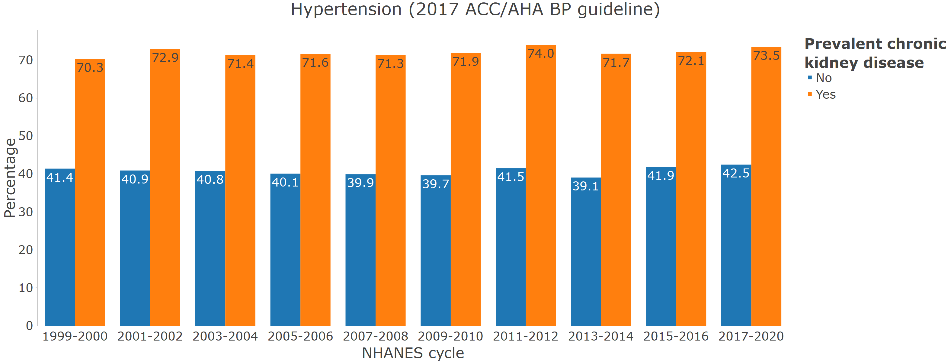

### Figure S3: Distribution of blood pressure categories among pregnant women.

A. In 2017-2020

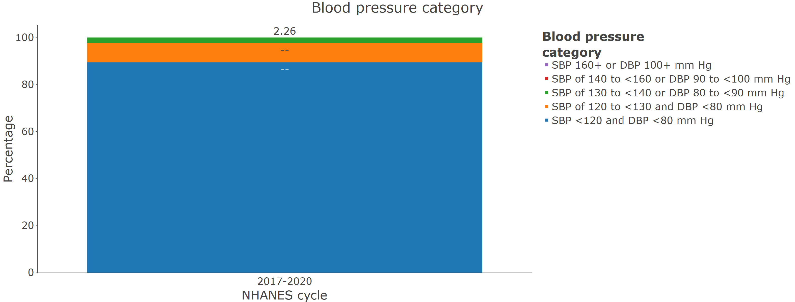

B. In 2009-2010 through 2017-2020

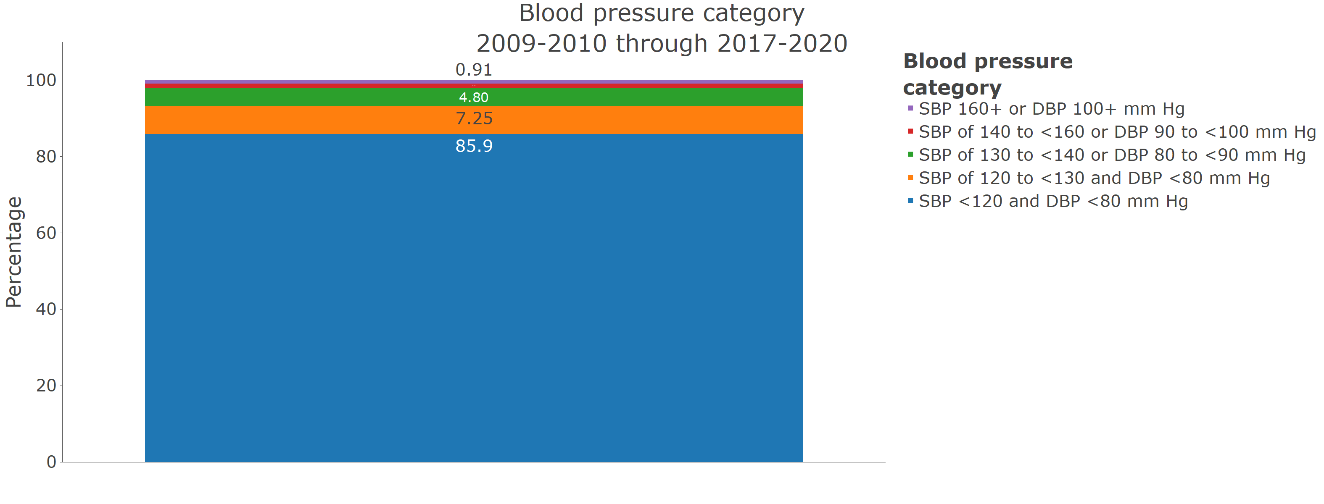

### Figure S4: Age-adjusted prevalence of resistant hypertension by calendar year.

A. Among those who self report taking antihypertensive medication

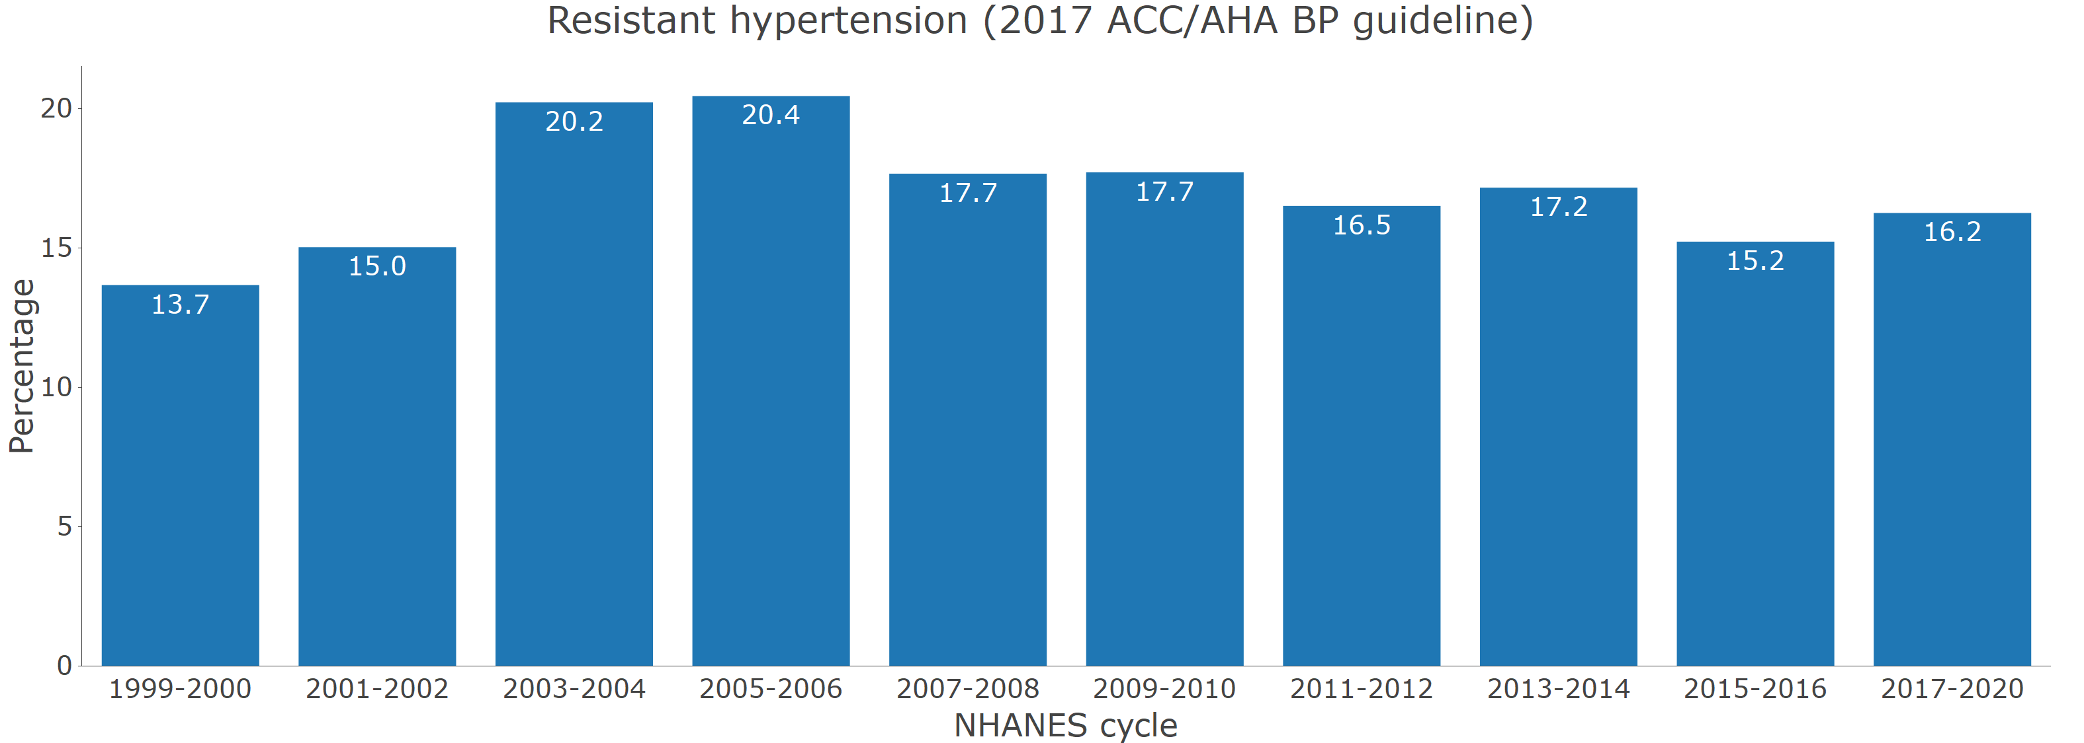

B. Among those who self report taking antihypertensive medication and are taking 3 or more classes.

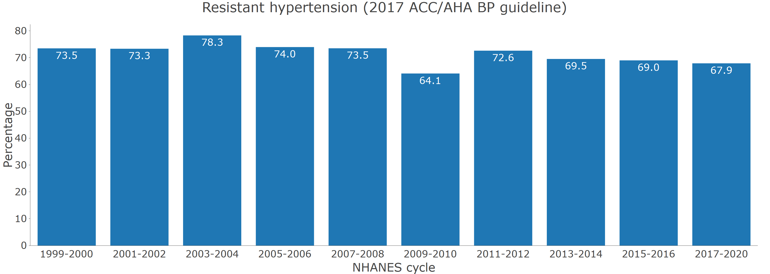

Age adjustment was performed through direct standardization