Longer term All-Cause and Cardiovascular Mortality with Intensive Blood Pressure Control: A Secondary Analysis of a Randomized Trial

Byron C. Jaeger, PhD,1 Adam P. Bress, PharmD, MS,2,3 Joshua D. Bundy, PhD,4 Alfred K. Cheung, MD,5,6 William C. Cushman, MD,7 Paul E. Drawz, MD,8 Karen C. Johnson, MD, MPH7 Cora E. Lewis, MD, MSPH9 Suzanne Oparil, MD,10 Michael V. Rocco, MD,11 Stephen R. Rapp, PhD, 12 Mark A. Supiano, MD,13 Paul K. Whelton, MD,4 Jeff D. Williamson, MD, MHS,14 Jackson T. Wright, Jr, MD, PhD,15 David M. Reboussin, PhD,1 and Nicholas M. Pajewski, PhD1

1Department of Biostatistics and Data Science, Wake Forest School of Medicine, Winston-Salem, NC. 2Informatics, Decision-Enhancement, and Analytic Sciences (IDEAS) Center, Veterans Affairs, Salt Lake City Health Care System, Salt Lake City, UT. 3Department of Population Health Sciences, University of Utah School of Medicine, Salt Lake City, UT. 4Department of Epidemiology, Tulane University School of Public Health and Tropical Medicine, New Orleans, LA. 5Renal Section, Veterans Affairs Salt Lake City Healthcare System, UT. 6Division of Nephrology and Hypertension, Department of Internal Medicine, University of Utah School of Medicine, Salt Lake City, UT. 7Department of Preventive Medicine, University of Tennessee Health Science Center, Memphis, TN. 8Division of Renal Diseases & Hypertension, University of Minnesota, MN. 9Department of Epidemiology, University of Alabama at Birmingham. 10Division of Cardiovascular Disease, Department of Medicine, University of Alabama at Birmingham. 11Section on Nephrology, Department of Internal Medicine, Wake Forest School of Medicine, Winston-Salem, NC. 11Departments of Psychiatry and Behavioral Medicine & Social Sciences and Health Policy, Wake Forest School of Medicine, Winston-Salem, NC. 13Division of Geriatrics, University of Utah School of Medicine, Salt Lake City. 14Section on Gerontology and Geriatric Medicine, Department of Internal Medicine, Wake Forest School of Medicine, Winston-Salem, NC. 15Division of Nephrology and Hypertension, University Hospitals Cleveland Medical Center, Case Western Reserve University, OH

**Correspondence to:**  
Nicholas M. Pajewski, PhD  
Department of Biostatistics and Data Science  
Division of Public Health Sciences  
Wake Forest School of Medicine  
Medical Center Boulevard  
Winston-Salem, NC 27154  
(336) 713-1396  
[npajewsk@wakehealth.edu](mailto:npajewsk@wakehealth.edu)

**Word Count:** Abstract: 350; Manuscript: 2641

# ABSTRACT

**IMPORTANCE**. The Systolic Blood Pressure Intervention Trial (SPRINT) showed that intensive blood pressure control reduced cardiovascular morbidity and mortality. However, the legacy effect of intensive treatment is unknown.

**OBJECTIVE**. To evaluate the long-term effects of randomization to intensive treatment with the incidence of cardiovascular and all-cause mortality approximately 4 years after the trial ended.

**DESIGN**. Secondary analysis of a multicenter randomized clinical trial. Randomization began on November 8, 2010, the trial intervention ended on August 20, 2015, and trial close-out visits occurred through July 2016. Analyses were conducted between October 2021 and February 2022.

**SETTING.** 102 clinic sites in the United States and Puerto Rico.

**PARTICIPANTS.** Patients (N=9361) aged ≥50 years with hypertension and increased cardiovascular risk, but without diabetes or history of stroke.

**INTERVENTIONS**. Randomization to SBP goal of <120 mm Hg (intensive, N=4678) versus <140 mm Hg (standard, N=4683).

**MAIN OUTCOMES AND MEASURES**. Extended observational follow-up for mortality via the US National Death Index from 2016 through 2020. In a subset of 2944 trial participants, outpatient SBP from electronic health records during and after the trial were examined.

**RESULTS**. Among 9361 randomized participants, the mean (standard deviation) age was 67.9 (9.4) years and 35.6% were women. Over a median intervention period of 3.3 years, intensive treatment was beneficial for both cardiovascular mortality (Hazard Ratio [HR] = 0.66, 95% confidence interval [CI], 0.49-0.89) and all-cause mortality (HR = 0.83, 95% CI, 0.68-1.01). However, at the median total follow-up of 8.8 years, there was no longer evidence of benefit for cardiovascular mortality (HR = 1.02, 95% CI, 0.84-1.24) or all-cause mortality (HR = 1.08, 95% CI, 0.94-1.23). In a subgroup of participants, the estimated mean outpatient SBP among participants randomized to intensive treatment increased from 132.8 mm Hg (95% CI, 132.0-133.7) at five years to 140.4 mm Hg (95% CI, 137.8-143.0) ten years following randomization.

**CONCLUSIONS AND RELEVANCE**. The beneficial effect of intensive treatment on cardiovascular and all-cause mortality did not persist after the trial. Given increasing outpatient SBP levels in participants randomized to intensive treatment following the trial, these results highlight the importance of consistent long-term management of hypertension.

**TRIAL REGISTRATION:** clinicaltrials.gov Identifier: NCT01206062

# INTRODUCTION

Hypertension is the leading modifiable risk factor for cardiovascular disease (CVD).1 Meta analyses of randomized trials have shown that pharmacological blood pressure (BP) lowering reduces the risk of major cardiovascular events across the spectrum of initial BP.2,3 The Systolic Blood Pressure Intervention Trial (SPRINT) showed that intensive treatment, defined by a SBP target < 120 mm Hg, reduced the risk for incident cardiovascular disease and all-cause mortality compared with treatment to an SBP target of < 140 mm Hg.4 Similar results, in favor of a lower SBP target of 110 mm Hg to <130 mm Hg, were also recently observed for a composite cardiovascular outcome in the Strategy of Blood Pressure Intervention in the Elderly Hypertensive Patients (STEP) trial.5 However, both trials were stopped after a median follow-up of approximately 3.3 years. The longer term effect of intensive treatment on cardiovascular and all-cause mortality after either trial (i.e., the legacy effect)6 has not been evaluated.

The objective of the current study was to evaluate the longer term legacy effect of intensive treatment in SPRINT on mortality, passive follow-up using administrative data sources. We linked participants to the National Death Index (NDI) from 2016 through 2020, adding 4 years of follow-up after the conclusion of trial visits. A secondary objective was to examine change in attained BP levels following the discontinuation of the trial intervention and study visits. To examine this issue, we extracted longitudinal outpatient measurements of SBP from 2010 to 2020 available in the electronic health record (EHR) for a subset of trial participants.

# METHODS

**Trial Design**: The design and methods of the trial have been published previously.4,7 Briefly, it was a multicenter randomized clinical trial that compared two strategies for managing SBP in older adults with hypertension who were at increased risk for CVD. Participants were aged 50 years or older and had an SBP between 130 and 180 mm Hg at the screening visit, depending on the use and number of anti-hypertensive agents prescribed. Participants were considered to have an increased cardiovascular risk if they had clinical or subclinical cardiovascular disease, chronic kidney disease (CKD), a Framingham Risk Score of 15% or greater, or if they were aged 75 years or older. Individuals residing in a nursing home, with a diagnosis of dementia (based on medical record review), and those treated with medications prescribed for dementia were excluded, as were persons with prevalent diabetes mellitus, history of stroke, proteinuria > 1 gram per day, or polycystic kidney disease. Individuals at 102 sites in the United States and Puerto Rico were randomized (1:1) by the Data Coordinating Center to a SBP goal of less than 120 mm Hg (intensive treatment group, n = 4678) or a goal of less than 140 mm Hg (standard treatment group, n = 4683), using random permuted blocks with the randomization stratified by clinic site. Randomization began on November 8, 2010 and ended in March 2013. On August 20, 2015, the Director of the National Heart, Lung, and Blood Institute accepted the data and safety monitoring board’s recommendation to inform the investigators and participants of the cardiovascular results, and decided to stop the trial, early, for benefit. In addition to the trial’s intervention phase, which spanned November 8, 2010 through August 20, 2015, when the administrative decision to stop the trial was made, the current study includes as part of the “trial phase” the additional period of study-provided antihypertensive medications prior to the final closeout visit on July 1, 2016 (**eFigure 1**). Observational follow-up continued through December 2020. The study was approved by the institutional review board at each participating site, and each participant provided written informed consent. The study is registered at ClinicalTrials.gov (NCT01206062).

**Baseline Study Measurements**: Sociodemographic data were collected at baseline, with race or ethnicity information collected via self-report. In the current study, the estimated glomerular filtration rate (eGFR) was calculated by the race-free 2021 CKD-EPI creatinine equation.8 Cognitive function was assessed using the Montreal Cognitive Assessment (MoCA).9 Lower cognitive function was defined as scoring at or below the estimated age and education-specific normative 10th percentile from the Irish Longitudinal Study of Aging,10 after adding three points to the scores of non-White participants.11 We defined frailty status at baseline using a 36-item Frailty Index (FI) based upon the model of deficit accumulation.12 The FI is calculated as the sum of the score for each deficit divided by the total number of nonmissing items. We categorized frailty status as fit (FI ≤ 0.10), less fit (0.10 < FI ≤ 0.21), or frail (FI > 0.21).

**National Death Index Linkage**: Outcomes of interest included all-cause and cardiovascular mortality. Methods of ascertainment and adjudication through the course of trial follow-up have been previously described.4 In the final report of trial results, mortality was ascertained through a US National Death Index (NDI) search completed in December 2016.4 For the current analysis, we completed an NDI search including deaths through December 2020. Possible matches were identified according to NDI guidelines.13 Deaths were treated as confirmed if they were a Class 1 match, or a Class 2, 3, or 4 match with a probabilistic score above cutoffs recommended by the NDI.13 Deaths ascertained in 2020 were based on the NDI preliminary data release. CVD mortality for NDI-based follow-up used the NDI Plus System, which automatically identifies underlying causes of death from death certificates, including conversion to ICD-10 codes. We defined CVD mortality as any death containing the ICD-10 codes of I00 to I99.14

**EHR Ancillary Study**: Methods for the linkage of participants to their medical record number and the extraction of vital sign data have been previously described.15 We identified 3074 participants with 3 or more electronic health record reports of outpatient BP measurements during the trial. After excluding 130 participants without EHR data following July 2016 (i.e., conclusion of the trial phase), a total of 2944 patients were included for the ancillary BP analysis. Because encounter type information was inconsistently available (i.e. outpatient, inpatient, observation, etc.), we defined a BP measurement as outpatient if there was not a BP measurement on the preceding or following day, and if there were 2 or less BP measurements on a particular day. We averaged outpatient EHR BP readings when there were 2 on the same day.

**Statistical Analysis**: Given the *a priori* expectation that treatment group differences may not be constant as a function of follow-up time (i.e. the proportional hazards assumption was likely to be invalid), we modeled treatment group differences as a function of time using two approaches. The first approach split each participant’s follow-up time into non-overlapping trial and observational phases, and estimated regression coefficients for intensive treatment separately during each phase.16 The second approach estimated a regression coefficient for intensive treatment as a continuous function of time since randomization.17,18 All analyses accounted for correlation within study sites,19 and analyses of cardiovascular mortality accounted for the competing risk of non-cardiovascular mortality.20

We examined the trajectory of SBP following the conclusion of the trial using outpatient SBPs extracted from the EHR. Mean between-group differences in outpatient SBP were estimated using linear mixed models. Models included random effects for participant and clinic site and an interaction between treatment group and time since randomization, which was modeled using B-splines. All analyses were performed using SAS version 9.4 (SAS Institute Inc, Cary, NC) and R version 4.1.2 (R Project for Statistical Computing [<http://www.r-project.org>]) with assistance from multiple R packages.21–26 All hypothesis tests were 2-sided, and P values less than 0.05 were considered statistically significant. No adjustments for multiple comparisons were made.

# RESULTS

***Study Participants***. A total of 9361 participants were randomized between November 2010 and March 2013 (**Figure 1**). The mean (standard deviation [SD]) age was 67.9 (9.4) years, with 28.2% of participants aged 75 years or older (**eTable 1**). Participants were 35.6% female and 31.5% black. The mean SBP at baseline was 139.7 mm Hg (SD, 15.6) and 27.0% of participants MoCA scores were below an age and education-specific normative 10th percentile. Compared to participants not included in the ancillary EHR study, participants included were more likely to be male, older, with lower SBP and higher scores on the MoCA, and a higher prevalence of CKD.

***All-cause Mortality***. In both treatment groups, the total median follow-up time was 8.8 years. A total of 818 and 826 deaths occurred among participants randomized to intensive and standard treatment, respectively (**eTable 2**). The hazard ratio (HR) for all-cause mortality comparing intensive to standard treatment was 0.83 (95% confidence interval [CI], 0.68-1.01) during the trial phase, and 1.08 (95% CI, 0.94-1.23) during the observational phase. The continuous time-dependent effect of intensive versus standard treatment indicated a benefit for all-cause mortality from 1.03 to 2.8 years following randomization, and was attenuated throughout the remainder of the observational phase (**eFigure 2**). In subgroups based on age, sex, race, CKD, cognitive function, and frailty status, there was no evidence that intensive treatment during the trial phase produced benefit for all-cause mortality during the observational phase of follow-up (**Figure 2**).

***Cardiovascular Mortality***. During the 8.8 years of follow-up, a total of 248 and 273 CVD deaths occurred among participants randomized to intensive and standard treatment, respectively (**eTable 3**). The HR for CVD mortality among participants randomized to intensive versus standard treatment was 0.66 (95% CI, 0.49-0.89) during the trial phase and 1.02 (95% CI, 0.84-1.24) during the observational phase. The time-dependent effect of intensive versus standard treatment indicated a benefit for CVD mortality from 2.3 to 5.6 years from randomization, and was attenuated throughout the remainder of the observational phase (**Figure 3**). Adults randomized to intensive treatment who were <75 years of age, men, non-black, without CKD, or with cognitive function >10th percentile had a lower CVD mortality risk during the trial phase compared to their counterparts randomized to standard treatment, but there was no evidence that intensive treatment during the trial phase produced benefit for CVD mortality during the observational phase (**Figure 4**).

***Blood Pressure***. Amongst a subset of 2944 trial participants, the median number of outpatient BP measurements extracted from the EHR during the observational phase of follow-up was 20 (interquartile range: 10 to 34). The estimated mean SBP among participants randomized to intensive treatment was 132.8 mm Hg (95% CI, 132.0-133.7) at 5 years following randomization and 140.4 mm Hg (95% CI, 137.8-143.0) at 10 years following randomization (**Figure 5**). For participants randomized to standard treatment, mean SBP was estimated to be 138.8 mm Hg (95% CI, 137.9-139.6) at 5 years following randomization and 140.2 mm Hg (95% CI, 137.7-142.6) at 10 years following randomization. The between-group difference in mean SBP levels (intensive minus standard) was 5.9 mm Hg (95% CI, 5.2-6.7) mm Hg at 5 years following randomization and was reduced to -0.21 mm Hg (95% CI, -3.6-3.2) at 10 years following randomization (**eFigure 3**).

# DISCUSSION

The current study analyzed all-cause and CVD mortality among trial participants up to 10 years following randomization, finding that the mortality benefits associated with intensive treatment quickly attenuated after the trial intervention was discontinued. Time-varying estimates of the benefit of intensive treatment for all-cause mortality were attenuated at 2.8 years while the benefit for CVD mortality was attenuated at 5.6 years following randomization. Findings from our ancillary study of outpatient SBP measured in routine clinical practice indicated that the difference in SBP between treatment groups diminished steadily over time, with no detectable difference in SBP approximately 9 years after randomization. These results, in combination with the primary findings of the trial, indicate that the beneficial effect of intensive treatment among adults with hypertension appears to diminish quickly if intensive BP control is not sustained.

The STEP trial enrolled 8511 Chinese patients 60 to 80 years of age with hypertension and randomized patients to a SBP target of 110 to less than 130 mm Hg (intensive treatment) or a target of 130 to less than 150 mm Hg (standard treatment).6 STEP found a HR of 0.72 (95% CI, 0.39-1.32) with intensive versus standard treatment for incident CVD after a median follow-up of 3.34 years, but did not find evidence of a benefit for all-cause mortality. In the current trial, the protective effect of intensive treatment for all-cause mortality was attenuated several years before attenuation of the protective effect for CVD mortality. These results in, combination with findings from STEP, suggest weaker evidence for reduced all-cause versus CVD mortality risk with intensive BP control, consistent with the suggestion that the non-CVD mortality benefit in SPRINT was driven by an increased visit frequency amongst participants randomized to intensive treatment.27

Previous studies have found rising BP levels among US adults during the time period of the current study. General population studies of adults living in the US with hypertension found that the prevalence of uncontrolled BP (SBP ≥ 140 mm Hg or DBP ≥ 90 mm Hg) increased from 2013 to 2017.28 In addition, an analysis of data from 464,585 adults enrolled in a Quest Diagnostics wellness program found that SBP was between 1 mm Hg and 3 mm Hg higher, depending on age group and sex, in April through December of 2020 versus their corresponding values throughout 2019.29 The current study shows that even for adults who have maintained more intensive BP control for 3 years or more, relaxation of BP control quickly erodes the beneficial effect on CVD mortality. Combined with previous findings on rising BP levels among US adults, data from the current study emphasize the need for implementation of sustainable population- and community-level strategies to improve BP control in the US.

In October 2020, the US Surgeon General published a call to action to control hypertension.30 Evidenced-based strategies to improve BP control addressed in the call to action include implementing treatment protocols, using integrated care teams, providing clinicians feedback on their performance, and promoting shared patient-provider management with self-measured BP monitoring. During the trial, participants received team-based care consistent with strategies outlined in the 2020 call to action and providers received real time feedback on individual and aggregate participant BP control. After the trial phase, when these protocols were no longer followed by the primary care providers, the incidence of all-cause mortality approximately doubled in both treatment groups. These data emphasize the benefit that can be realized by implementing the goals and strategies of the 2020 US Surgeon General’s call to action. Future research should continue to evaluate strategies for obtaining consistent BP control in clinical settings to reduce the burden of CVD, which remains the leading cause of death for US adults.

This study has several limitations. First, while we restricted analyses to high quality NDI matches, misclassification in linking participants to the NDI is possible. Second, while some studies have shown reasonable performance of using NDI diagnosis codes for defining CVD mortality,14,31 it is certainly subject to misclassification, and it is not as robust as the adjudication process used in the primary follow-up for the trial. Third, information about SBP control after the trial was limited to routine outpatient SBP values in a subgroup of the trial participants and was extracted from the EHR, which is known to have poor concordance with the standardized BP measurement process used during the trial.15 While this prohibits definite conclusions about the absolute level of BP in both treatment groups, as well as pin-pointing when the between-group difference may or may not have completely attenuated, the observation of steadily increasing SBP for participants in the intensive treatment and relatively stable, or slightly decreased, SBP in the standard treatment group following the trial is likely still valid.

In conclusion, while intensive treatment produced beneficial effects on mortality during the trial, there was no evidence that this produced sustained benefits on cardiovascular and all-cause mortality subsequent to discontinuing the intervention protocol. Given steadily increasing mean SBP levels in participants randomized to intensive treatment after the trial, these results suggest that maintaining more intensive BP targets throughout adulthood will likely be essential for long-term CVD risk management.

**REFERENCES**

1. Roth GA, Mensah GA, Johnson CO, et al. Global Burden of Cardiovascular Diseases and Risk Factors, 1990-2019: Update From the GBD 2019 Study. *J Am Coll Cardiol*. 2020;76(25):2982-3021.
2. Rahimi K, Bidel Z, Nazarzadeh M, et al. Age-stratified and blood-pressure-stratified effects of blood-pressure-lowering pharmacotherapy for the prevention of cardiovascular disease and death: An individual participant-level data meta-analysis. *The Lancet*. 2021;398(10305):1053-1064. doi:[10.1016/S0140-6736(21)01921-8](https://doi.org/10.1016/S0140-6736(21)01921-8)
3. Bundy JD, Li C, Stuchlik P, et al. Systolic blood pressure reduction and risk of cardiovascular disease and mortality: A systematic review and network meta-analysis. *JAMA Cardiology*. 2017;2(7):775-781.
4. SPRINT Research Group, Lewis CE, Fine LJ, et al. Final Report of a Trial of Intensive versus Standard Blood-Pressure Control. *N Engl J Med*. 2021;384(20):1921-1930.
5. Wander GS, Bansal M. Legacy effect in medicine—the expanding horizon! *Indian Heart Journal*. 2018;70(6):769-771. doi:[10.1016/j.ihj.2018.12.001](https://doi.org/10.1016/j.ihj.2018.12.001)
6. Zhang W, Zhang S, Deng Y, et al. Trial of Intensive Blood-Pressure Control in Older Patients with Hypertension. *N Engl J Med*. 2021;385(14):1268-1279.
7. Ambrosius WT, Sink KM, Foy CG, et al. The design and rationale of a multicenter clinical trial comparing two strategies for control of systolic blood pressure: The Systolic Blood Pressure Intervention Trial (SPRINT). *Clinical Trials*. 2014;11(5):532-546. doi:[10.1177/1740774514537404](https://doi.org/10.1177/1740774514537404)
8. Inker LA, Eneanya ND, Coresh J, et al. New Creatinine- and Cystatin C–Based Equations to Estimate GFR without Race. *N Engl J Med*. 2021;385(19):1737-1749. doi:[10.1056/NEJMoa2102953](https://doi.org/10.1056/NEJMoa2102953)
9. Nasreddine ZS, Phillips NA, Bédirian V, et al. The Montreal Cognitive Assessment, MoCA: A Brief Screening Tool For Mild Cognitive Impairment. *Journal of the American Geriatrics Society*. 2005;53(4):695-699. doi:[10.1111/j.1532-5415.2005.53221.x](https://doi.org/10.1111/j.1532-5415.2005.53221.x)
10. Kenny RA, Coen RF, Frewen J, Donoghue OA, Cronin H, Savva GM. Normative values of cognitive and physical function in older adults: Findings from the Irish Longitudinal Study on Ageing. *Journal of the American Geriatrics Society*. 2013;61 Suppl 2:S279-290. doi:[10.1111/jgs.12195](https://doi.org/10.1111/jgs.12195)
11. Sachs BC, Chelune GJ, Rapp SR, et al. Robust demographically-adjusted normative data for the Montreal Cognitive Assessment (MoCA): Results from the systolic blood pressure intervention trial. *Clin Neuropsychol*. Published online September 2021:1-16.
12. Pajewski NM, Williamson JD, Applegate WB, et al. Characterizing Frailty Status in the Systolic Blood Pressure Intervention Trial. *The Journals of Gerontology Series A, Biological Sciences and Medical Sciences*. 2016;71(5):649-655. doi:[10.1093/gerona/glv228](https://doi.org/10.1093/gerona/glv228)
13. National Center for Health Statistics. *National Death Index User’s Guide*.; 2013. <https://www.cdc.gov/nchs/data/ndi/ndi_users_guide.pdf>
14. Olubowale OT, Safford MM, Brown TM, et al. Comparison of Expert Adjudicated Coronary Heart Disease and Cardiovascular Disease Mortality With the National Death Index: Results From the REasons for Geographic And Racial Differences in Stroke (REGARDS) Study. *J Am Heart Assoc*. 2017;6(5).
15. Drawz PE, Agarwal A, Dwyer JP, et al. Concordance Between Blood Pressure in the Systolic Blood Pressure Intervention Trial and in Routine Clinical Practice. *JAMA Internal Medicine*. 2020;180(12):1655-1663. doi:[10.1001/jamainternmed.2020.5028](https://doi.org/10.1001/jamainternmed.2020.5028)
16. Zhang Z, Reinikainen J, Adeleke KA, Pieterse ME, Groothuis-Oudshoorn CGM. Time-varying covariates and coefficients in Cox regression models. *Annals of Translational Medicine*. 2018;6(7):121. doi:[10.21037/atm.2018.02.12](https://doi.org/10.21037/atm.2018.02.12)
17. Martinussen T, Scheike TH. *Dynamic Regression Models for Survival Data*. Springer Science & Business Media; 2007.
18. Therneau T, Crowson C, Atkinson E. Using time dependent covariates and time dependent coefficients in the Cox model. *Survival Vignettes*. 2017;2:3.
19. Lin DY, Wei LJ. The robust inference for the Cox proportional hazards model. *Journal of the American Statistical Association*. 1989;84(408):1074-1078.
20. Scheike TH, Zhang MJ. Flexible competing risks regression modeling and goodness-of-fit. *Lifetime Data Analysis*. 2008;14(4):464-483. doi:[10.1007/s10985-008-9094-0](https://doi.org/10.1007/s10985-008-9094-0)
21. R Core Team. *R: A Language and Environment for Statistical Computing*. R Foundation for Statistical Computing; 2020. <https://www.R-project.org/>
22. Jaeger B. *Table.glue: Make and Apply Customized Rounding Specifications for Tables*. <https://github.com/bcjaeger/table.glue>
23. Wickham H, Averick M, Bryan J, et al. Welcome to the tidyverse. *Journal of Open Source Software*. 2019;4(43):1686. doi:[10.21105/joss.01686](https://doi.org/10.21105/joss.01686)
24. Therneau TM. *A Package for Survival Analysis in R*.; 2021. <https://CRAN.R-project.org/package=survival>
25. Scheike TH, Zhang MJ. Analyzing competing risk data using the R timereg package. *Journal of Statistical Software*. 2011;38(2):1-15. <https://www.jstatsoft.org/v38/i02/>
26. Landau WM. The targets R package: A dynamic make-like function-oriented pipeline toolkit for reproducibility and high-performance computing. *Journal of Open Source Software*. 2021;6(57):2959. <https://doi.org/10.21105/joss.02959>
27. Kreutz R, Brunström M, Thomopoulos C, Carlberg B, Mancia G. Do recent meta-analyses truly prove that treatment with blood pressure-lowering drugs is beneficial at any blood pressure value, no matter how low? A critical review. J Hypertens. 2022 Feb 21. doi: 10.1097/HJH.0000000000003056. Epub ahead of print. PMID: 35191413.
28. Muntner P, Hardy ST, Fine LJ, et al. Trends in Blood Pressure Control Among US Adults With Hypertension, 1999-2000 to 2017-2018. *JAMA*. 2020;324(12):1190-1200.
29. Laffin LJ, Kaufman HW, Chen Z, et al. Rise in Blood Pressure Observed Among US Adults During the COVID-19 Pandemic. *Circulation*. 2022;145(3):235-237. doi:[10.1161/CIRCULATIONAHA.121.057075](https://doi.org/10.1161/CIRCULATIONAHA.121.057075)
30. Substance Abuse and Mental Health Services Administration (US), Office of the Surgeon General (US). *The Surgeon General’s Call to Action to Control Hypertension*. US Department of Health; Human Services; 2020. Accessed November 24, 2021. <http://www.ncbi.nlm.nih.gov/books/NBK567645/>
31. Quin JA, Hattler B, Shroyer ALW, et al. Concordance between administrative data and clinical review for mortality in the randomized on/off bypass follow-up study (ROOBY-FS). J Card Surg. 2017 Dec;32(12):751-756. doi: 10.1111/jocs.13379.

# ACKNOWLEDGMENTS

The views expressed in this paper are those of the authors and do not represent the official position of the National Institutes of Health (NIH), the National Heart, Lung, and Blood Institute, the Department of Veterans Affairs, or the U.S. Government, or the SPRINT Research Group. This paper was not reviewed by the SPRINT Publications and Presentations Committee. The authors also wish to acknowledge computing support provided the Veterans Affairs Informatics and Computing Infrastructure (VINCI).

# FINANCIAL DISCLOSURE

The work presented here was supported by R01HL136679, R01AG055606, and R01AG065805. The Systolic Blood Pressure Intervention Trial was funded by the National Institutes of Health (including the National Heart, Lung, and Blood Institute, the National Institute of Diabetes and Digestive and Kidney Diseases, the National Institute on Aging, and the National Institute of Neurological Disorders and Stroke) under contracts HHSN268200900040C, HHSN268200900046C, HHSN268200900047C, HHSN268200900048C, and HHSN268200900049C and interagency agreement A-HL-13-002-001. It was also supported in part with resources and use of facilities through the Department of Veterans Affairs. Azilsartan and chlorthalidone (combined with azilsartan) were provided by Takeda Pharmaceuticals International Inc.

Additional support was provided through the following National Center for Advancing Translational Sciences clinical and translational science awards: UL1TR000439 (awarded to Case Western Reserve University); UL1RR025755 (Ohio State University); UL1RR024134 and UL1TR000003 (University of Pennsylvania); UL1RR025771 (Boston University); UL1TR000093 (Stanford University); UL1RR025752, UL1TR000073, and UL1TR001064 (Tufts University); UL1TR000050 (University of Illinois); UL1TR000005 (University of Pittsburgh); U54TR000017-06 (University of Texas Southwestern Medical Center); UL1TR000105-05 (University of Utah); UL1 TR000445 (Vanderbilt University); UL1TR000075 (George Washington University); UL1 TR000002 (University of California, Davis); UL1 TR000064 (University of Florida); and UL1TR000433 (University of Michigan); and by National Institute of General Medical Sciences, Centers of Biomedical Research Excellence award NIGMS P30GM103337 (awarded to Tulane University).

**Figure 1.** Participant Flow in the Systolic Blood Pressure Intervention Trial (SPRINT)

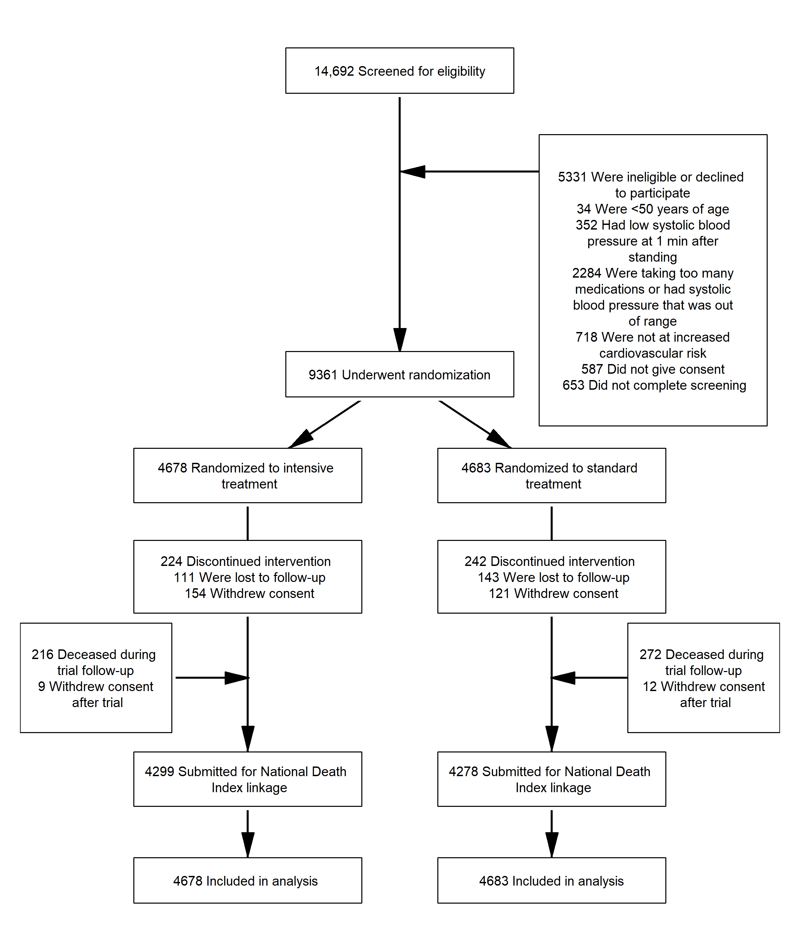

**Figure 2.** All-Cause Mortality by Treatment Group, Phase of Follow-up, and According to Subgroups

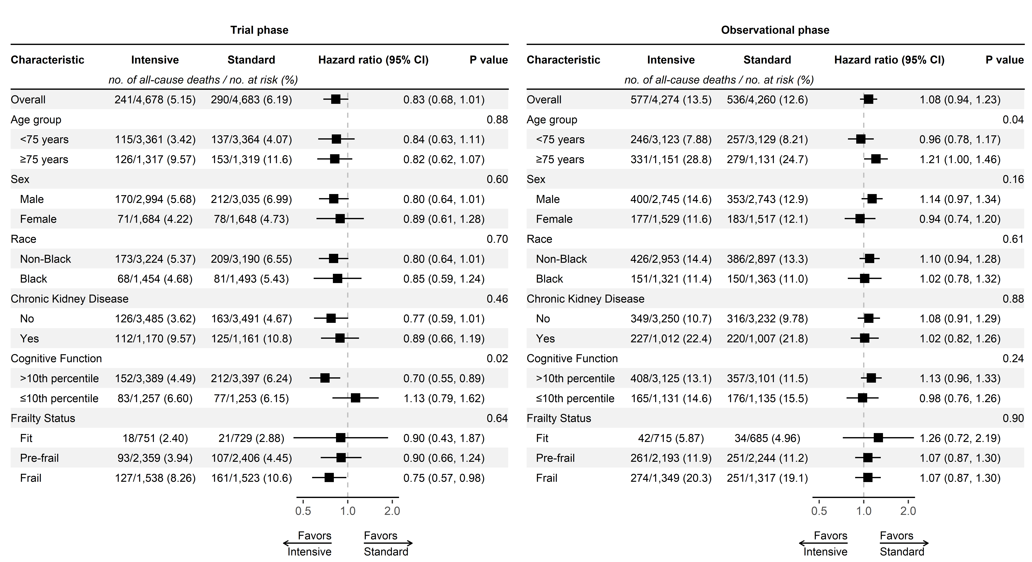

Abbreviations: CI, confidence interval.

Chronic Kidney Disease defined as an estimated glomerular filtration rate <60 ml/min/1.73 m2 based on the 2021 CKD-EPI creatinine equation. Cognitive function groups based on age and education-specific normative 10th percentile from the Irish Longitudinal Study of Aging, after adding +3 points to the scores of non-White participants.

Frailty status based on frailty index, for which scores range from 0 to 1, with higher values indicating greater frailty.

Trial phase encompasses follow-up through the end of study closeout visits (**eFigure 1**).

**Figure 3.** Cardiovascular versus Non-cardiovascular Mortality by Treatment Group

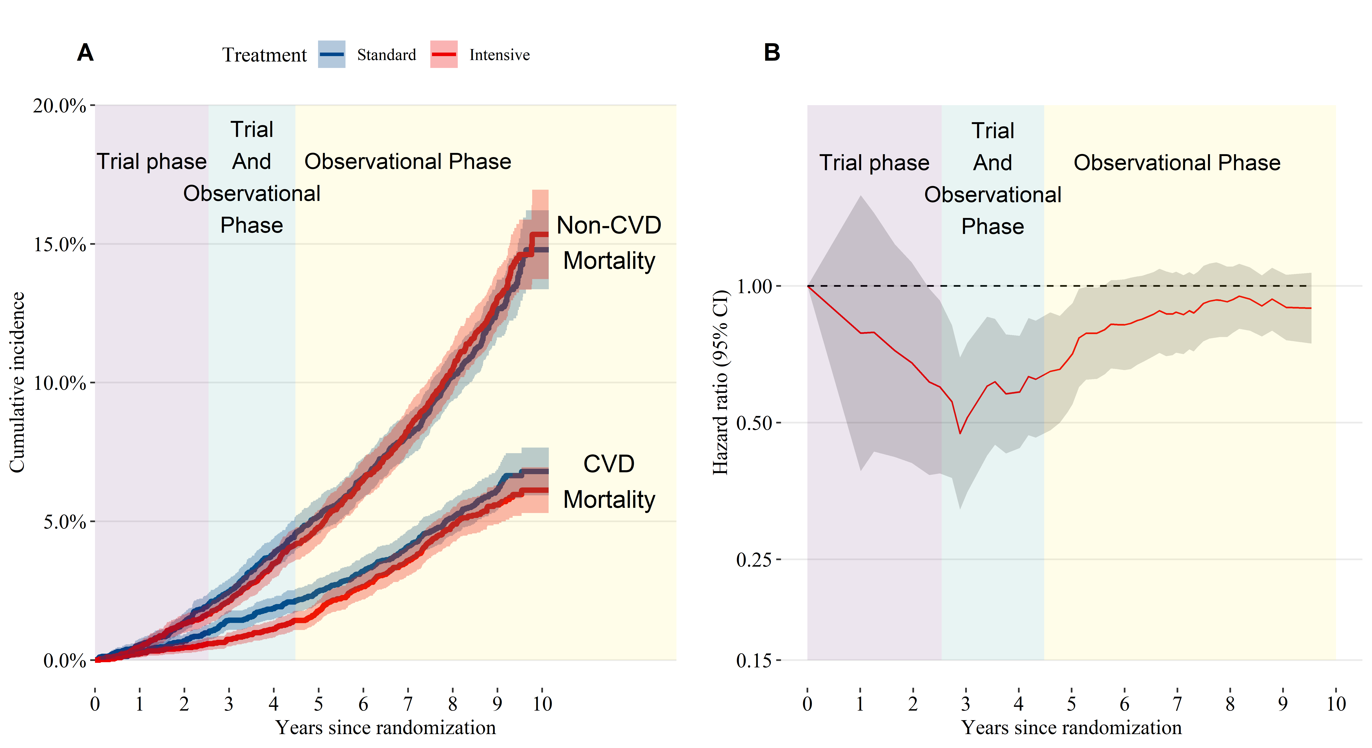

(A) Cumulative incidence of cardiovascular and non-cardiovascular mortality by treatment group. (B) Time-dependent hazard ratio for cardiovascular mortality estimated from a competing risks regression model comparing intensive to standard treatment. The trial phase and observational phase do not overlap for individual participants, but due to participants being randomized over time, there is an overlap in the trial and observational phase for the trial population when time is measured relative to the date of randomization. Trial phase encompasses follow-up through the end of study closeout visits (**eFigure 1**).

**Figure 4.** Cardiovascular mortality hazard ratio subgroup analysis for participants randomized to intensive versus standard treatment.

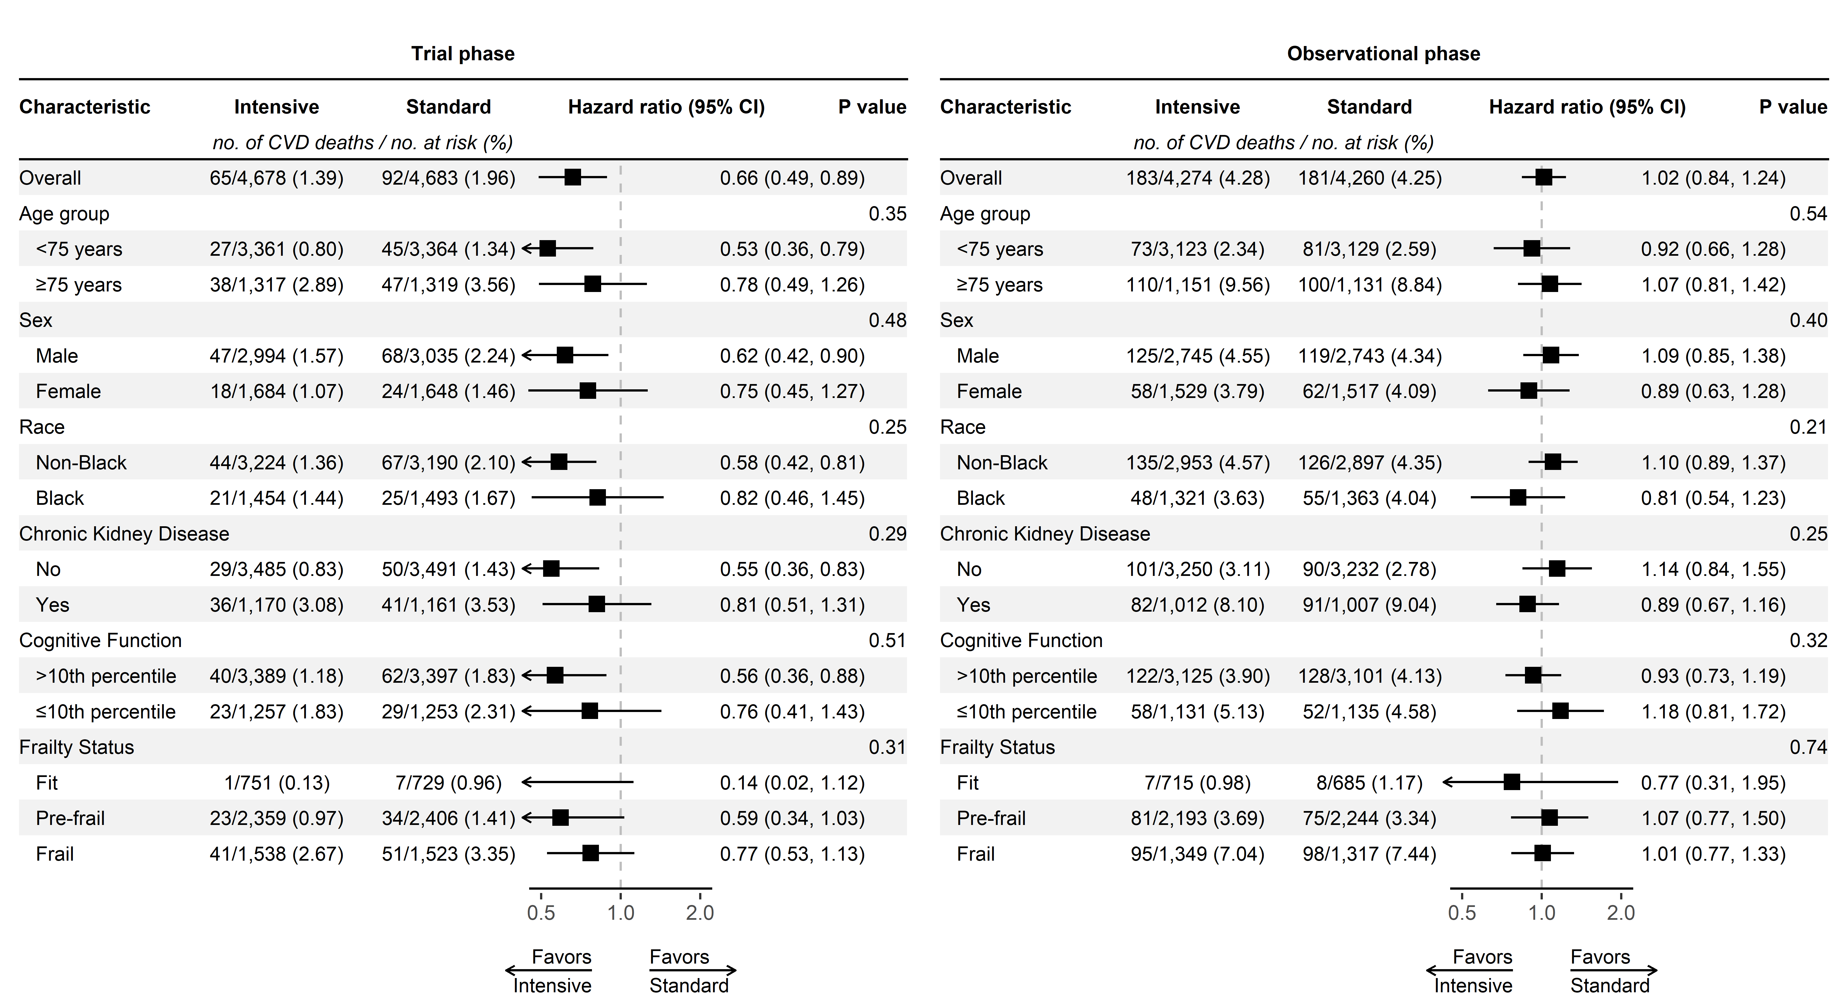

Abbreviations: CI, confidence interval.

Chronic Kidney Disease defined as an estimated glomerular filtration rate <60 ml/min/1.73 m2 based on the 2021 CKD-EPI creatinine equation. Cognitive function groups based on age and education-specific normative 10th percentile from the Irish Longitudinal Study of Aging, after adding +3 points to the scores of non-White participants.

Frailty status based on frailty index, for which scores range from 0 to 1, with higher values indicating greater frailty.

Trial phase encompasses follow-up through the end of study closeout visits (**eFigure 1**).

**Figure 5.** Mean Difference in Systolic Blood Pressure During Follow-up.

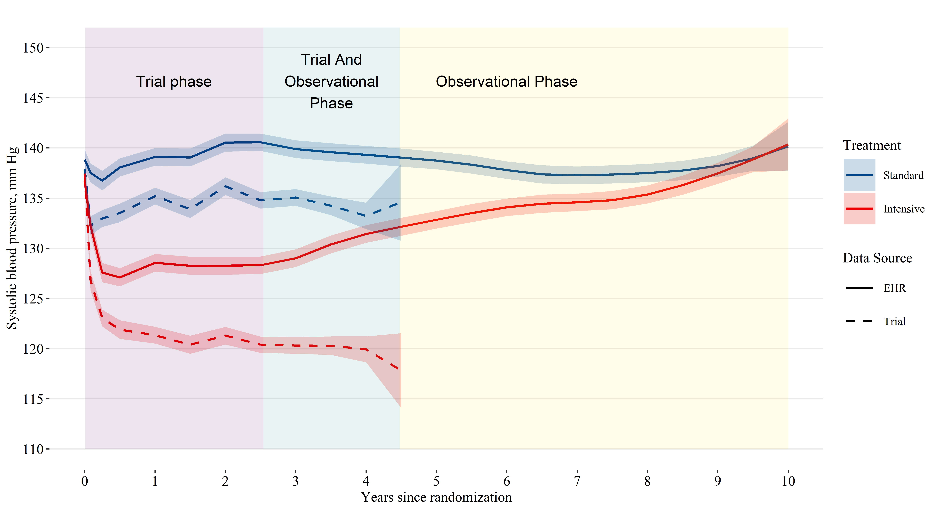

Abbreviations: EHR, electronic health record. Estimates based on a linear mixed model with random intercepts for participant and clinic site, with years since randomization modeled using B-splines. Shaded areas denote 95% pointwise confidence intervals. The trial phase and observational phase do not overlap for individual participants, but due to participants being randomized over time, there is an overlap in the trial and observational phase for the trial population when time is measured relative to the date of randomization. Trial phase encompasses follow-up through the end of study closeout visits (**eFigure 1**).