**Supplementary Online Content**

Jaeger BC, Bress AP, Bundy JD, Cheung AK, Cushman WC, Drawz PE, Johnson KC, Lewis CE, Oparil S, Rocco MV, Rapp SR, Supiano MA, Whelton PK, Williamson JD, Wright Jr JT, Reboussin DM, and Pajewski NM. Longer term All-Cause and Cardiovascular Mortality with Intensive Blood Pressure Control: A Secondary Analysis of SPRINT

**eTable 1.** Baseline Characteristics of Randomized Participants, Overall and by Inclusion in Electronic Health Record Ancillary Study

**eTable 2.** All-Cause Mortality by Treatment Group, Phase of Follow-up, and According to Subgroups

**eTable 3.** Competing Risks of Cardiovascular and Non-Cardiovascular Mortality by Treatment Group, Phase of Follow-up, and According to Subgroups

**eFigure 1.** Timeline for Follow-up of Mortality in SPRINT

**eFigure 2.** All-Cause Mortality by Treatment Group

**eFigure 3.** Mean Difference in Systolic Blood Pressure during Follow-up

**eTable 1.** Baseline Characteristics of Randomized Participants, Overall and by Inclusion in Electronic Health Record Ancillary Study

| **Characteristic** | **Treatment** | | **Included in EHR ancillary study** | | **P Valuea** |
| --- | --- | --- | --- | --- | --- |
| **Intensive N = 4678** | **Standard N = 4683** | **Yes N = 2944** | **No N = 6417** |
| Age, years, mean (SD) | 67.9 (9.4) | 67.9 (9.5) | 68.5 (9.1) | 67.7 (9.6) | <0.001 |
| Age ≥75 years, % | 28.2 | 28.2 | 29.9 | 27.4 | 0.01 |
| Female sex, % | 36.0 | 35.2 | 18.5 | 43.4 | <0.001 |
| Black race, No. % | 31.1 | 31.9 | 30.3 | 32.0 | 0.09 |
| Systolic blood pressure, mm Hg, mean (SD) | 139.7 (15.8) | 139.7 (15.4) | 137.8 (14.9) | 140.5 (15.8) | <0.001 |
| Randomized to intensive treatment, % | -- | -- | 50.3 | 49.8 | 0.60 |
| Included in EHR ancillary study, No. % | 31.7 | 31.2 |  |  |  |
| Chronic Kidney Disease, %b | 25.1 | 25.0 | 26.8 | 24.2 | 0.01 |
| MoCA≤10th percentile, %c | 27.1 | 26.9 | 26.5 | 27.2 | 0.50 |
| Frailty Status, %d |  |  |  |  | <0.001 |
| Fit (frailty index≤0.10) | 16.2 | 15.7 | 13.7 | 16.9 |  |
| Pre-frail (0.10<frailty index≤0.21) | 50.8 | 51.7 | 49.8 | 51.9 |  |
| Frail (frailty index>0.21) | 33.1 | 32.7 | 36.5 | 31.2 |  |

Abbreviation: EHR, electronic health record; FI, frailty index; MoCA, Montreal Cognitive Assessment.

aP Values corresponding to test of differences between participants included versus excluded in the EHR ancillary study.

bChronic Kidney Disease defined as an estimated glomerular filtration rate <60 ml/min/1.73 m2 based on the 2021 CKD-EPI creatinine equation.

cAge and education-specific normative 10th percentile from the Irish Longitudinal Study of Aging, after adding +3 points to the scores of non-White participants

dScores range from 0 to 1, with higher values indicating greater frailty.

**eTable 2.** All-Cause Mortality by Treatment Group, Phase of Follow-up, and According to Subgroups

|  |  |  |  |  |  |  |  |  |  |  |
| --- | --- | --- | --- | --- | --- | --- | --- | --- | --- | --- |
|  | **Trial Phase** | | | | | **Observational Phase** | | | | |
| **N Events / N Total** | | **Incidence (95% CI)a** | | **Hazard Ratio (95% CI)b** | **N Events / N Total** | | **Incidence (95% CI)a** | | **Hazard Ratio (95% CI)b** |
| **INT** | **STD** | **INT** | **STD** | **INT** | **STD** | **INT** | **STD** |
| Overall | 241 / 4678 | 290 / 4683 | 12.5 | 15.1 | 0.83 (0.68, 1.01) | 577 / 4274 | 536 / 4260 | 31.9 | 29.6 | 1.08 (0.94, 1.23) |
| ***Age group*** | | | | | | | | | | |
| <75 years | 115 / 3361 | 137 / 3364 | 8.2 | 9.7 | 0.84 (0.63, 1.11) | 246 / 3123 | 257 / 3129 | 18.1 | 18.9 | 0.96 (0.78, 1.17) |
| ≥75 years | 126 / 1317 | 153 / 1319 | 24.3 | 29.8 | 0.82 (0.62, 1.07) | 331 / 1151 | 279 / 1131 | 73.3 | 61.6 | 1.21 (1.00, 1.46) |
| ***Sex*** | | | | | | | | | | |
| Male | 170 / 2994 | 212 / 3035 | 13.8 | 17.2 | 0.80 (0.64, 1.01) | 400 / 2745 | 353 / 2743 | 34.6 | 30.3 | 1.14 (0.97, 1.34) |
| Female | 71 / 1684 | 78 / 1648 | 10.2 | 11.4 | 0.89 (0.61, 1.28) | 177 / 1529 | 183 / 1517 | 27.0 | 28.2 | 0.94 (0.74, 1.20) |
| ***Race*** | | | | | | | | | | |
| Non-Black | 173 / 3224 | 209 / 3190 | 13.0 | 16.0 | 0.80 (0.64, 1.01) | 426 / 2953 | 386 / 2897 | 34.2 | 31.4 | 1.10 (0.94, 1.28) |
| Black | 68 / 1454 | 81 / 1493 | 11.5 | 13.2 | 0.85 (0.59, 1.24) | 151 / 1321 | 150 / 1363 | 26.7 | 25.7 | 1.02 (0.78, 1.32) |
| *Chronic Kidney Diseasec* | | | | | | | | | | |
| No | 126 / 3485 | 163 / 3491 | 8.7 | 11.3 | 0.77 (0.59, 1.01) | 349 / 3250 | 316 / 3232 | 25.0 | 22.7 | 1.08 (0.91, 1.29) |
| Yes | 112 / 1170 | 125 / 1161 | 23.6 | 26.5 | 0.89 (0.66, 1.19) | 227 / 1012 | 220 / 1007 | 55.5 | 53.8 | 1.02 (0.82, 1.26) |
| *Cognitive Functiond* | | | | | | | | | | |
| >10th percentile | 152 / 3389 | 212 / 3397 | 10.8 | 15.1 | 0.70 (0.55, 0.89) | 408 / 3125 | 357 / 3101 | 30.7 | 26.9 | 1.13 (0.96, 1.33) |
|  | **Trial Phase** | | | | | **Observational Phase** | | | | |
| **N Events / N Total** | | **Incidence (95% CI)a** | | **Hazard Ratio (95% CI)** | **N Events / N Total** | | **Incidence (95% CI)a** | | **Hazard Ratio (95% CI)** |
| **INT** | **STD** | **INT** | **STD** | **INT** | **STD** | **INT** | **STD** |
| ≤10th percentile | 83 / 1257 | 77 / 1253 | 16.5 | 15.3 | 1.13 (0.79, 1.62) | 165 / 1131 | 176 / 1135 | 34.7 | 36.8 | 0.98 (0.76, 1.26) |
| ***Frailty Status*** | | | | | | | | | | |
| Fit (frailty index ≤ 0.10) | 18 / 751 | 21 / 729 | 5.7 | 6.9 | 0.90 (0.43, 1.87) | 34 / 685 | 42 / 715 | 13.4 | 11.3 | 1.26 (0.72, 2.2) |
| Pre-frail (0.10 < frailty index ≤ 0.21) | 93 / 2359 | 107 / 2406 | 9.5 | 10.7 | 0.90 (0.66, 1.24) | 251 / 2244 | 261 / 2193 | 27.8 | 26.1 | 1.07 (0.87, 1.30) |
| Frail (frailty index > 0.21) | 127 / 1538 | 161 / 1523 | 20.4 | 26.4 | 0.75 (0.57, 0.98) | 251 / 1317 | 274 / 1349 | 49.9 | 46.2 | 1.07 (0.87, 1.30) |
| Abbreviations: CI, confidence interval; INT, intensive treatment; STD, standard treatment.  aIncidence represents the rate of events per 1,000 person-years of follow-up.  bHazard ratios for intensive treatment versus standard treatment based on a Cox proportional hazards regression model with a time-varying effect across trial phase.  cChronic Kidney Disease defined as an estimated glomerular filtration rate <60 ml/min/1.73 m2 based on the 2021 CKD-EPI creatinine equation.  dAge and education-specific normative 10th percentile from the Irish Longitudinal Study of Aging, after adding +3 points to the scores of non-White participants  eScores range from 0 to 1, with higher values indicating greater frailty. | | | | | | | | | | |

**eTable 3.** Competing Risks of Cardiovascular and Non-Cardiovascular Mortality by Treatment Group, Phase of Follow-up, and According to Subgroups

|  | **Trial Phase** | | | | **Observational Phase** | | | |
| --- | --- | --- | --- | --- | --- | --- | --- | --- |
| **N CVD / non-CVD (Total)** | | **Hazard Ratio (95% CI)a** | | **N CVD / non-CVD (Total)** | | **Hazard Ratio (95% CI)a** | |
| **INT** | **STD** | **CVD** | **Non-CVD** | **INT** | **STD** | **CVD** | **Non-CVD** |
| Overall | 65 / 176 (4678) | 92 / 198 (4683) | 0.66  (0.49, 0.89) | 0.89  (0.71, 1.10) | 183 / 394 (4274) | 181 / 355 (4260) | 1.02  (0.84, 1.24) | 1.13  (0.97, 1.31) |
| *Age group* | | | | | | | | |
| <75 years | 27 / 88  (3361) | 45 / 92  (3364) | 0.53  (0.36, 0.79) | 0.95 (0.68, 1.32) | 73 / 173 (3123) | 81 / 176 (3129) | 0.92  (0.66, 1.28) | 1.01  (0.84, 1.22) |
| ≥75 years | 38 / 88  (1317) | 47 / 106 (1319) | 0.78  (0.49, 1.26) | 0.81 (0.61, 1.09) | 110 / 221 (1151) | 100 / 179 (1131) | 1.07  (0.81, 1.42) | 1.23  (0.99, 1.53) |
| *Sex* | | | | | | | | |
| Male | 47 / 123 (2994) | 68 / 144 (3035) | 0.62 (0.42, 0.90) | 0.85 (0.67, 1.08) | 125 / 275 (2745) | 119 / 234 (2743) | 1.09 (0.85, 1.38) | 1.20 (1.00, 1.44) |
| Female | 18 / 53  (1684) | 24 / 54  (1648) | 0.75 (0.45, 1.27) | 0.97 (0.64, 1.48) | 58 / 119 (1529) | 62 / 121 (1517) | 0.89 (0.63, 1.28) | 0.98 (0.71, 1.34) |
| *Race* | | | | | | | | |
| Non-Black | 44 / 129 (3224) | 67 / 142 (3190) | 0.58 (0.42, 0.81) | 0.87 (0.68, 1.12) | 135 / 291 (2953) | 126 / 260 (2897) | 1.10 (0.89, 1.37) | 1.13 (0.94, 1.36) |
| Black | 21 / 47  (1454) | 25 / 56  (1493) | 0.82 (0.46, 1.45) | 0.93 (0.64, 1.37) | 48 / 103 (1321) | 55 / 95  (1363) | 0.81 (0.54, 1.23) | 1.10 (0.84, 1.44) |
| *Chronic Kidney Diseaseb* | | | | | | | | |
| No | 29 / 97  (3485) | 50 / 113 (3491) | 0.55 (0.36, 0.83) | 0.87 (0.65, 1.14) | 101 / 248 (3250) | 90 / 226 (3232) | 1.14 (0.84, 1.55) | 1.09 (0.90, 1.33) |
| Yes | 36 / 76  (1170) | 41 / 84  (1161) | 0.81 (0.51, 1.31) | 0.88 (0.62, 1.24) | 82 / 145 (1012) | 91 / 129 (1007) | 0.89 (0.67, 1.16) | 1.18 (0.93, 1.49) |
| *Cognitive Functionc* | | | | | | | | |
| >10th percentile | 40 / 112 (3389) | 62 / 150 (3397) | 0.56 (0.36, 0.88) | 0.74 (0.58, 0.96) | 122 / 286 (3125) | 128 / 229 (3101) | 0.93 (0.73, 1.19) | 1.25 (1.03, 1.53) |
| ≤10th percentile | 23 / 60 (1257) | 29 / 48  (1253) | 0.76 (0.41, 1.43) | 1.22 (0.83, 1.78) | 58 / 107 (1131) | 52 / 124 (1135) | 1.18 (0.81, 1.72) | 0.90 (0.72, 1.12) |
| *Frailty Statusd* | | | | | | | | |
| Fit (frailty index ≤ 0.10) | 1 / 17  (751) | 7 / 14  (729) | 0.14 (0.02, 1.12) | 1.22 (0.59, 2.5) | 7 / 35  (715) | 8 / 26  (685) | 0.77 (0.31, 1.95) | 1.26 (0.78, 2.0) |
| Pre-frail (0.10 < frailty index ≤ 0.21) | 23 / 70  (2359) | 34 / 73  (2406) | 0.59 (0.34, 1.03) | 1.00 (0.73, 1.37) | 81 / 180 (2193) | 75 / 176 (2244) | 1.07 (0.77, 1.50) | 1.04 (0.85, 1.27) |
| Frail (frailty index > 0.21) | 41 / 86  (1538) | 51 / 110 (1523) | 0.77 (0.53, 1.13) | 0.75 (0.56, 1.00) | 95 / 179 (1349) | 98 / 153 (1317) | 1.01 (0.77, 1.33) | 1.20 (0.96, 1.50) |

Abbreviations: CVD, cardiovascular; CI, confidence interval; INT, intensive treatment; STD, standard treatment.

aHazard ratios for intensive treatment versus standard treatment based on a competing risks regression model with a time-varying effect across trial phase.

bChronic Kidney Disease defined as an estimated glomerular filtration rate <60 ml/min/1.73 m2 based on the 2021 CKD-EPI creatinine equation.

cAge and education-specific normative 10th percentile from the Irish Longitudinal Study of Aging, after adding +3 points to the scores of non-White participants

dScores range from 0 to 1, with higher values indicating greater frailty.

**eFigure 1.** Timeline for Follow-up of Mortality in SPRINT

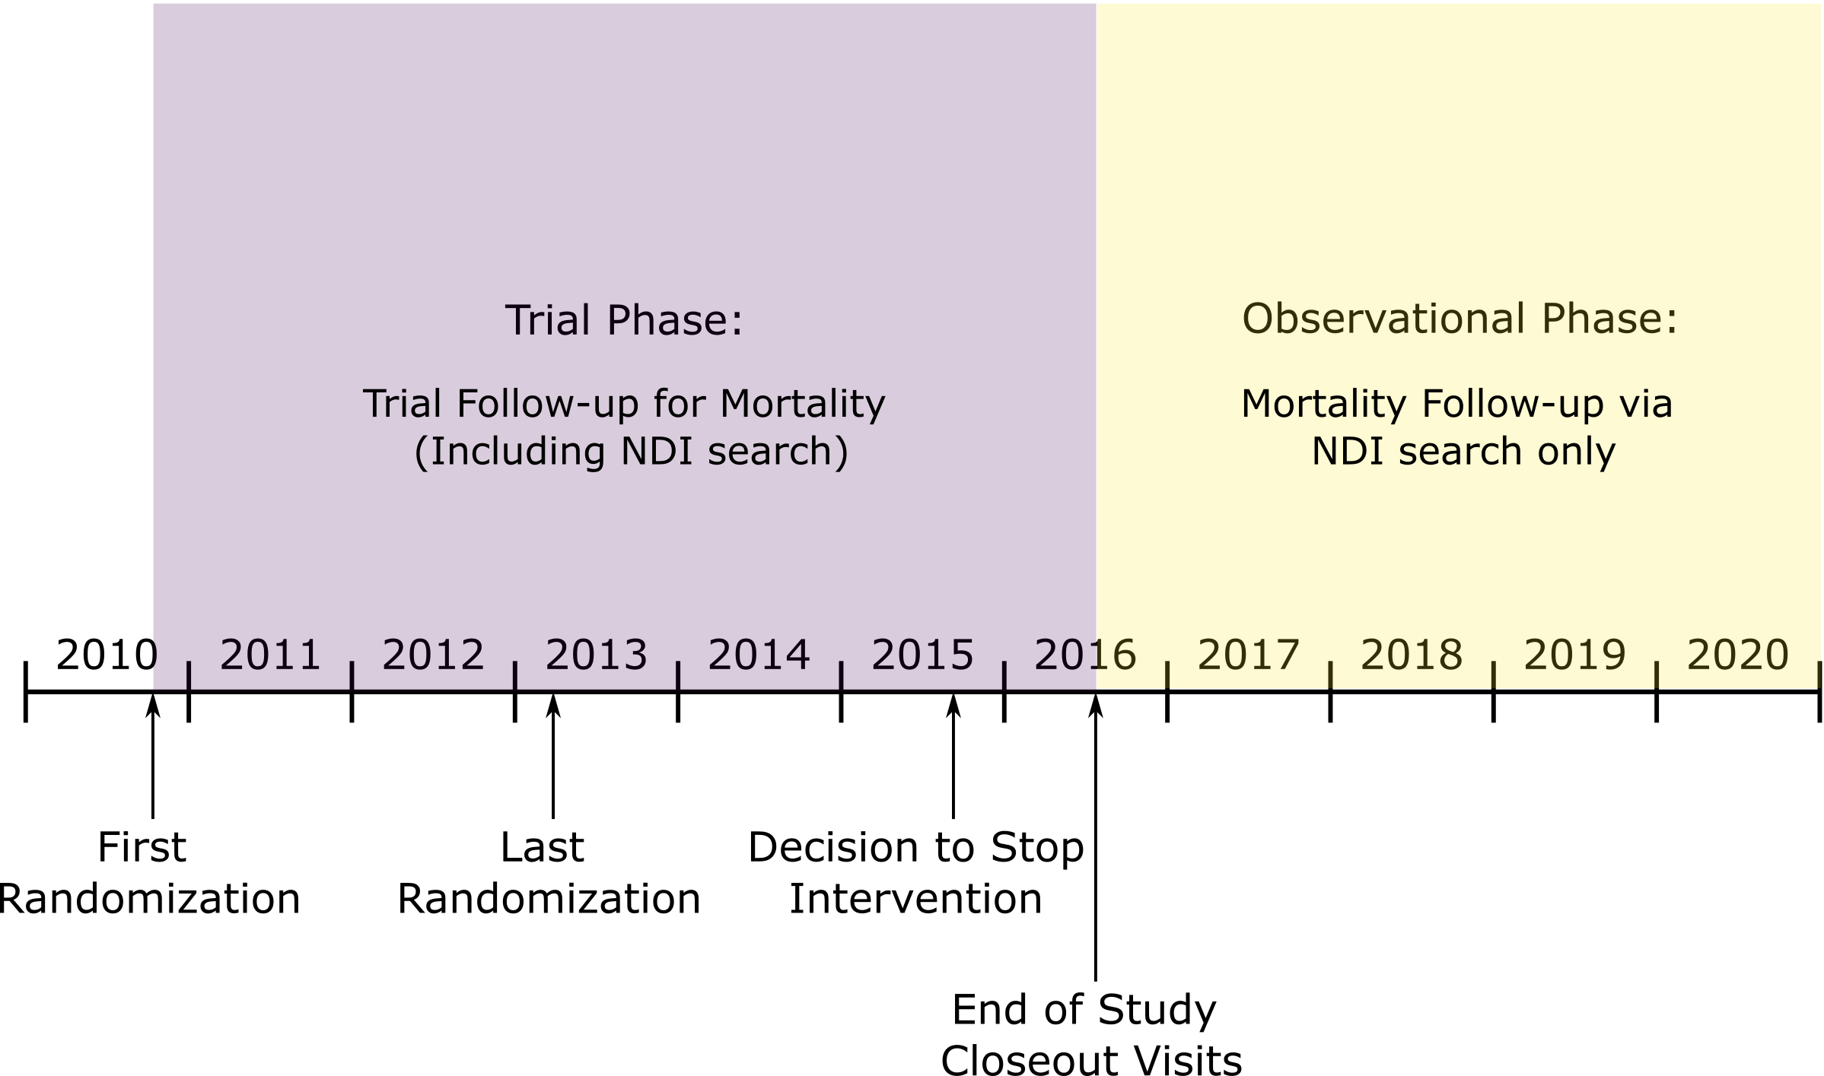

Abbreviations: NDI, National Death Index.

**eFigure 2.** All-Cause Mortality by Treatment Group

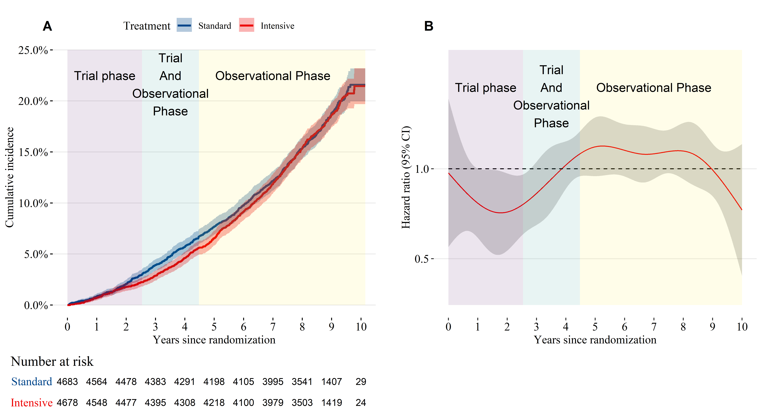

(A) Cumulative incidence of all-cause mortality by treatment group. (B) Time-dependent hazard ratio for all-cause mortality estimated from Cox proportional hazards regression model comparing intensive to standard treatment. The trial phase and observational phase do not overlap for individual participants, but due to participants being randomized over time, there is an overlap in the trial and observational phase for the trial population when time is measured relative to the date of randomization. Trial phase encompasses follow-up through the end of study closeout visits (**eFigure 1**).

**eFigure 3.** Mean Difference in Systolic Blood Pressure During Follow-up

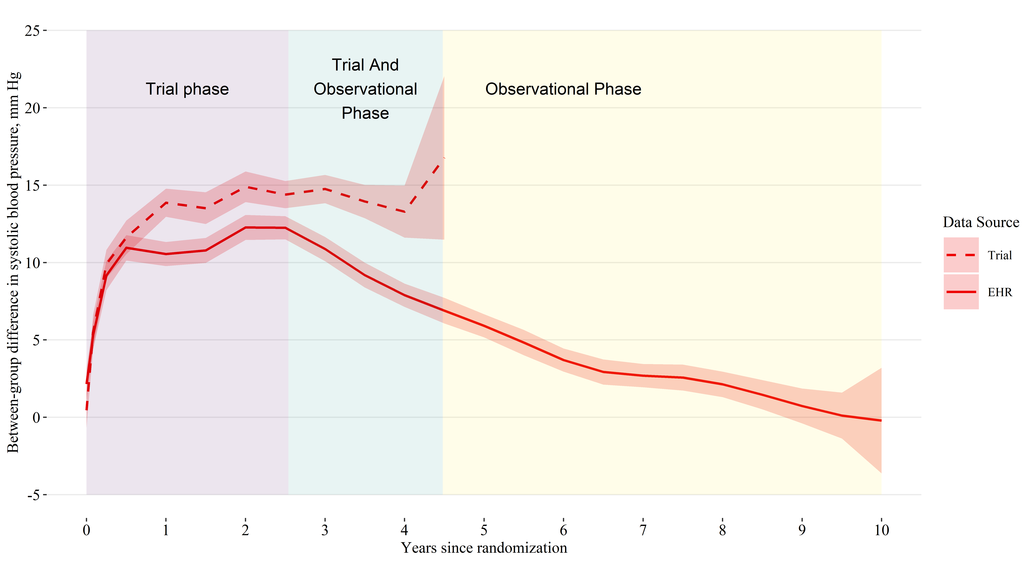

Abbreviations: EHR, electronic health record. Estimates based on a linear mixed model with random intercepts for participant and clinic site, with years since randomization modeled using B-splines. Shaded areas denote 95% pointwise confidence intervals.