Longer term All-Cause and Cardiovascular Mortality with Intensive Blood Pressure Control: A Secondary Analysis of SPRINT

Byron C. Jaeger, PhD,1 Adam P. Bress, PharmD, MS,2,3 Joshua D. Bundy, PhD,4 Alfred K. Cheung, MD,5,6 William C. Cushman, MD,7 Paul E. Drawz, MD,8 Karen C. Johnson, MD, MPH7 Cora E. Lewis, MD, MSPH9 Suzanne Oparil, MD,10 Michael V. Rocco, MD,11 Stephen R. Rapp, PhD, 12 Mark A. Supiano, MD,13 Paul K. Whelton, MD,4 Jeff D. Williamson, MD, MHS,14 Jackson T. Wright, Jr, MD, PhD,15 David M. Reboussin, PhD,1 and Nicholas M. Pajewski, PhD1

1Department of Biostatistics and Data Science, Wake Forest School of Medicine, Winston-Salem, NC. 2Informatics, Decision-Enhancement, and Analytic Sciences (IDEAS) Center, Veterans Affairs, Salt Lake City Health Care System, Salt Lake City, UT. 3Department of Population Health Sciences, University of Utah School of Medicine, Salt Lake City, UT. 4Department of Epidemiology, Tulane University School of Public Health and Tropical Medicine, New Orleans, LA. 5Renal Section, Veterans Affairs Salt Lake City Healthcare System, UT. 6Division of Nephrology and Hypertension, Department of Internal Medicine, University of Utah School of Medicine, Salt Lake City, UT. 7Department of Preventive Medicine, University of Tennessee Health Science Center, Memphis, TN. 8Division of Renal Diseases & Hypertension, University of Minnesota, MN. 9Department of Epidemiology, University of Alabama at Birmingham. 10Division of Cardiovascular Disease, Department of Medicine, University of Alabama at Birmingham. 11Section on Nephrology, Department of Internal Medicine, Wake Forest School of Medicine, Winston-Salem, NC. 11Departments of Psychiatry and Behavioral Medicine & Social Sciences and Health Policy, Wake Forest School of Medicine, Winston-Salem, NC. 13Division of Geriatrics, University of Utah School of Medicine, Salt Lake City. 14Section on Gerontology and Geriatric Medicine, Department of Internal Medicine, Wake Forest School of Medicine, Winston-Salem, NC. 15Division of Nephrology and Hypertension, University Hospitals Cleveland Medical Center, Case Western Reserve University, OH

**Correspondence to:**  
Nicholas M. Pajewski, PhD  
Department of Biostatistics and Data Science  
Division of Public Health Sciences  
Wake Forest School of Medicine  
Medical Center Boulevard  
Winston-Salem, NC 27154  
(336) 713-1396  
[npajewsk@wakehealth.edu](mailto:npajewsk@wakehealth.edu)

**Word Count:** Abstract: ; Manuscript:

# ABSTRACT

**IMPORTANCE**. The Systolic Blood Pressure Intervention Trial (SPRINT) showed that intensive treatment, defined by a systolic blood pressure (SBP) goal of <120mmHg, reduced cardiovascular and all-cause mortality risk. However, the legacy effect of intensive treatment, defined as the persistence of benefit after stopping intensive treatment, is unknown.

**OBJECTIVE**. To evaluate the effect of receiving intensive treatment during the SPRINT trial, which began in 2010 and ended in 2016, with cardiovascular and all-cause mortality through 2020.

**DESIGN, SETTING, AND PARTICIPANTS**. Randomized clinical trial of 9361 patients aged ≥50 years with hypertension and increased cardiovascular risk, but without diabetes or history of stroke. Randomization began on November 8, 2010, the trial intervention ended on August 20, 2015, and observational trial follow-up visits occurred through July 2016.

**INTERVENTIONS**. Randomization to SBP goal of <120mmHg (intensive, N=4678) versus <140mmHg (standard, N=4683).

**MAIN OUTCOMES AND MEASURES**. Extended trial follow-up assessed mortality via the US National Death Index from 2016 through 2020. In a subset of 2944 trial participants, outpatient SBP levels measured in routine clinical practice after the trial were examined.

**RESULTS**. Among 9360 randomized participants, the mean (standard deviation) age was 67.9 (9.4) years and 35.6% were women. Over the median intervention phase of 3.3 years, intensive treatment was beneficial for both cardiovascular mortality (Hazard Ratio [HR] = 0.65, 95% confidence interval [CI] 0.48 to 0.88) and all-cause mortality (HR = 0.83, 95% CI 0.68 to 1.01). However, at the median total follow-up of 11.8 years, there was no longer evidence of benefit for cardiovascular mortality (HR = 0.92, 95% CI 0.81 to 1.05) or all-cause mortality (HR = 1.00, 95% CI 0.90 to 1.10). In a subgroup of 2944 participants, the estimated mean (95% CI) outpatient SBP among participants randomized to intensive treatment increased from 132.8 (132.0, 133.7) at five years to 140.4 (137.8, 143.0) ten years following randomization.

**CONCLUSIONS AND RELEVANCE**. The beneficial effect of intensive treatment on cardiovascular and all-cause mortality did not persist after the trial. Given increasing SBP levels in participants randomized to intensive treatment following the trial, these results highlight the importance of consistent long-term management of hypertension.

# INTRODUCTION

Hypertension is the leading modifiable risk factor for cardiovascular disease (CVD)1. The Systolic Blood Pressure Intervention Trial (SPRINT) showed that intensive treatment, defined by a SBP target < 120 mm Hg, reduced the risk for cardiovascular and all-cause mortality compared with treatment to an SBP target of < 140 mm Hg2. Because a clear benefit was evident for intensive antihypertensive drug treatment after a median follow-up of 3.3 years, the trial was stopped early. However, the longer-term effect of randomization to intensive treatment on cardiovascular and all-cause mortality after the trial (i.e., the legacy effect3) has not been evaluated.

The objective of the current study was to evaluate the long-term legacy effect of intensive treatment on mortality by passive follow-up using administrative data sources. We linked participants to the National Death Index (NDI) from 2016 through 2020, adding 4 years of follow-up after the conclusion of trial visits. A secondary objective was to examine change in attained BP levels following the discontinuation of the trial intervention and study visits. To examine this issue, we extracted longitudinal outpatient measurements of SBP from 2010 to 2020 available in the electronic health record (EHR) for a subset of trial participants.

# METHODS

**Trial Design**: The design and methods of SPRINT have been published previously2,4. Briefly, it was a multicenter randomized clinical trial that compared two strategies for managing SBP in older adults with hypertension who were at increased risk for CVD. Participants were aged 50 years or older and had an SBP between 130 and 180 mm Hg at the screening visit, depending on the use and number of anti-hypertensive agents prescribed. Participants were considered to have an increased cardiovascular risk if they had clinical or subclinical cardiovascular disease, chronic kidney disease (CKD), a Framingham Risk Score of 15% or greater, or if they were aged 75 years or older. Individuals residing in a nursing home, with a diagnosis of dementia (based on medical record review), and those treated with medications prescribed for dementia were excluded, as were persons with prevalent diabetes mellitus, history of stroke, proteinuria > 1 gram per day, or polycystic kidney disease. Individuals at 102 sites in the United States and Puerto Rico were randomized (1:1) to a SBP goal of less than 120 mm Hg (intensive treatment group, n = 4678) or a goal of less than 140 mm Hg (standard treatment group, n = 4683), using random permuted blocks with the randomization stratified by clinic site. Randomization began on November 8, 2010 and ended in March 2013. On August 20, 2015, the Director of the National Heart, Lung, and Blood Institute accepted the data and safety monitoring board’s recommendation to inform the investigators and participants of the cardiovascular results, and decided to stop the trial, early, for benefit. In addition to the trial’s intervention phase, which spanned November 8, 2010 through August 20, 2015, when the administrative decision to stop the trial was made, the current study includes as part of the “trial phase” the additional period of study-provided antihypertensive medications prior to the final closeout visit on July 1, 2016 (eFigure 1). Observational follow-up continued through December 2020. The study was approved by the institutional review board at each participating site, and each participant provided written informed consent. The study is registered at ClinicalTrials.gov (NCT01206062).

**Baseline Study Measurements**: Sociodemographic data were collected at baseline, with race or ethnicity information collected via self-report. In the current study, the estimated glomerular filtration rate (eGFR) was calculated by the race-free 2021 CKD-EPI creatinine equation5. Cognitive function was assessed using the Montreal Cognitive Assessment (MoCA)6. Lower cognitive function was defined as scoring at or below the estimated age and education-specific normative 10th percentile from the Irish Longitudinal Study of Aging7, after adding three points to the scores of non-White participants8. We defined frailty status at baseline using a 36-item Frailty Index (FI) based upon the model of deficit accumulation9. The FI is calculated as the sum of the score for each deficit divided by the total number of nonmissing items. We categorized frailty status as fit (FI ≤ 0.10), less fit (0.10 < FI ≤ 0.21), or frail (FI > 0.21).

**National Death Index Linkage**: Outcomes of interest included all-cause and cardiovascular mortality. Methods of ascertainment and adjudication through the course of trial follow-up have been previously described2. In the final report of the SPRINT trial, mortality was ascertained through a US National Death Index (NDI) search completed in December 20162. For the current analysis, we completed an NDI search including deaths through December 2020. Possible matches were identified according to NDI guidelines10. Deaths were treated as confirmed if they were a Class 1 match, or a Class 2, 3, or 4 match with a probabilistic score above cutoffs recommended by the NDI10. Deaths ascertained in 2020 were based on the NDI preliminary data release. CVD mortality for NDI-based follow-up used the NDI Plus System, which automatically identifies underlying causes of death from death certificates, including conversion to ICD-10 codes. We defined CVD mortality as any death containing the ICD-10 codes of I00 to I9911.

**EHR Ancillary Study**: Methods for the linkage of participants to their medical record number and the extraction of vital sign data have been previously described12. We identified 3074 participants with 3 or more electronic health record reports of outpatient BP measurements during the trial. After excluding 130 participants without EHR data following July 2016 (i.e., conclusion of the trial phase), a total of 2944 patients were included for the ancillary BP analysis. Because encounter type information was inconsistently available (i.e. outpatient, inpatient, observation, etc.), we defined a BP measurement as outpatient if there was not a BP measurement on the preceding or following day, and if there were 2 or less BP measurements on a particular day. We averaged outpatient EHR BP readings when there were 2 on the same day.

**Statistical Analysis**: Given the *a priori* expectation that treatment group differences may not be constant as a function of follow-up time (i.e. the proportional hazards assumption was likely to be invalid), we modeled treatment group differences as a function of time using two approaches. The first approach split each participant’s follow-up time into non-overlapping trial and observational phases, and estimated regression coefficients for intensive treatment separately during each phase13. The second approach estimated a regression coefficient for intensive treatment as a continuous function of time since randomization14,15. All analyses accounted for correlation within study sites16, and analyses of cardiovascular mortality accounted for the competing risk of non-cardiovascular mortality17.

We examined the trajectory of SBP following the conclusion of the trial using outpatient SBPs extracted from the EHR. Mean between-group differences in outpatient SBP were estimated using linear mixed models. Models included random effects for participant and clinic site and an interaction between treatment group and time since randomization, which was modeled using B-splines. All analyses were performed using SAS version 9.4 (SAS Institute Inc, Cary, NC) and R version 4.4.0 (R Project for Statistical Computing [<http://www.r-project.org>]) with assistance from multiple R packages.18–23 All hypothesis tests were 2-sided, and P values less than 0.05 were considered statistically significant. No adjustments for multiple comparisons were made.

# RESULTS

***Study Participants***. A total of 9360 participants were randomized between November 2010 and March 2013. The mean (standard deviation [SD]) age was 67.9 (9.4) years, with 28.2% of participants aged 75 years or older (**eTable 1**). Participants were 35.6% female and 31.5% black. The mean (SD) SBP at baseline was 139.7 (15.6) and 27.0% of participants MoCA scores were below the 10th percentile. Compared to participants not included in the ancillary EHR study, participants included were more likely to be male, older, with lower SBP and higher scores on the MoCA, and a higher prevalence of CKD.

***All-cause Mortality***. In both treatment groups, the total median follow-up time was 11.8 years. A total of 1,270 and 1,326 deaths occurred among participants randomized to intensive and standard treatment, respectively (**eTable 2**). The hazard ratio (HR) for all-cause mortality comparing intensive to standard treatment was 0.83 (95% confidence interval [CI] 0.68, 1.01) during the trial phase, and 1.00 (95% CI 0.90, 1.10) during the observational phase. The continuous time-dependent effect of intensive versus standard treatment indicated a benefit for all-cause mortality from 0.93 to 3.1 years following randomization, and was attenuated throughout the remainder of the observational phase (**Figure 1**). In subgroups based on age, sex, race, CKD, cognitive function, and frailty status, there was no evidence that intensive treatment during the trial phase produced benefit for all-cause mortality during the observational phase of follow-up (**Figure 2**).

***Cardiovascular Mortality***. During the 11.8 years of follow-up, a total of 414 and 493 CVD deaths occurred among participants randomized to intensive and standard treatment, respectively (**eTable 3**). The HR for CVD mortality among participants randomized to intensive versus standard treatment was 0.65 (95% CI 0.48, 0.88) during the trial phase and 0.92 (95% CI 0.81, 1.05) during the observational phase. The time-dependent effect of intensive versus standard treatment indicated a benefit for CVD mortality from 2.1 to 5.6 years from randomization, and was attenuated throughout the remainder of the observational phase (**Figure 3**). Adults randomized to intensive treatment who were <75 years of age, men, non-black, without CKD, or with cognitive function >10th percentile had a lower CVD mortality risk during the trial phase compared to their counterparts randomized to standard treatment, but there was no evidence that intensive treatment during the trial phase produced benefit for CVD mortality during the observational phase (**Figure 4**).

***Blood Pressure***. Amongst a subset of 2944 trial participants, the median number of outpatient BP measurements extracted from the EHR during the observational phase of follow-up was 20 (interquartile range: 10 to 34). The estimated mean (95% CI) SBP among participants randomized to intensive treatment was 132.8 (132.0, 133.7) at 5 years following randomization and 140.4 (137.8, 143.0) at 10 years following randomization (**Figure 5**). For participants randomized to standard treatment, mean (95% CI) SBP was estimated to be 138.8 (137.9, 139.6) at 5 years following randomization and 140.2 (137.7, 142.6) at 10 years following randomization. The between-group difference in mean SBP levels (intensive minus standard) was 5.9 (5.2, 6.7) mm Hg at 5 years following randomization and was reduced to -0.21 (-3.6, 3.2) at 10 years following randomization (**eFigure 2**).

# DISCUSSION

The current study analyzed all-cause and CVD-mortality among trial participants up to 10 years following randomization, finding that the benefits associated with intensive treatment quickly attenuated after the trial intervention was discontinued. Time-varying estimates of the benefit of intensive treatment for all-cause mortality were attenuated at 3.1 years while the benefit for CVD-mortality was attenuated at 5.6 years following randomization. Findings from our ancillary study of outpatient SBP measured in routine clinical practice indicated that the difference in SBP between treatment groups diminished steadily over time, with no detectable difference in SBP approximately 9 years after randomization. These results in combination with the primary findings of the trial indicate that the beneficial effect of intensive treatment among adults with hypertension appears to diminish if BP control is not sustained.

The current study’s results in the “trial phase” are similar but not identical to results from the “intervention period” of the SPRINT final report, which considered August 20, 2015 to July 29, 2016 as an observational post-intervention period2. The current study included August 20, 2015 to July 1, 2016 in the “trial phase” because antihypertensive medications continued to be provided until the final closeout visit on July 1, 2016. Also, as the NDI is continuously updated, the current analysis includes some deaths in 2016 that were not identified at the time of the final SPRINT report.

The Strategy of Blood Pressure Intervention in the Elderly Hypertensive Patients (STEP) trial enrolled 8511 Chinese patients 60 to 80 years of age with hypertension and randomized patients to a SBP target of 110 to less than 130 mm Hg (intensive treatment) or a target of 130 to less than 150 mm Hg (standard treatment)24. STEP found a HR of 0.72 (95% CI 0.39, 1.32) with intensive versus standard treatment for CVD mortality after a median follow-up of 3.34 years, but did not find evidence of a benefit for all-cause mortality. In the current study, the protective effect of the SPRINT intensive treatment for all-cause mortality was attenuated several years before attenuation of the protective effect for CVD mortality. These results in combination with findings from the STEP trial suggest weaker evidence for reduced all-cause versus CVD mortality risk with intensive BP control.

Previous studies have found rising BP levels among US adults during the time period of the current study. General population studies of adults living in the US with hypertension found that the prevalence of uncontrolled BP (SBP ≥ 140 mm Hg or DBP ≥ 90 mm Hg) increased from 2013 to 201725. In addition, an analysis of data from 464,585 adults enrolled in a Quest Diagnostics wellness program found SBP was between 1 mm Hg and 3 mm Hg higher, depending on age group and sex, in April through December of 2020 versus their corresponding values throughout 201926. The current study shows that even for adults who have maintained intense SBP control for 3 years, increasing SBP levels may quickly diminish the protective effect. Combined with previous findings on rising BP levels among US adults, data from the current study emphasize the need for implementation of population- and community-level strategies to improve BP control in the US.

In October 2020, the US Surgeon General published a call to action to control hypertension27. Evidenced-based strategies to improve BP control addressed in the call to action include implementing treatment protocols, using integrated care teams, providing clinicians feedback on their performance, and promoting shared patient-provider management with self-measured BP monitoring. During the SPRINT trial, participants received team-based care consistent with strategies outlined in the 2020 call to action and providers received real time feedback on individual and aggregate participant blood pressure control. After the trial phase, when these protocols were no longer followed by the primary care providers, the incidence of all-cause mortality approximately doubled in both treatment groups. These data emphasize the benefit that can be realized by implementing the goals and strategies of the 2020 US Surgeon General’s call to action. Future research should continue to evaluate strategies for obtaining consistent BP control in clinical settings to reduce the burden of CVD, which remains the leading cause of death for US adults.

This study has several limitations. First, while we restricted analyses to high quality NDI matches, misclassification in linking participants to the NDI is possible. Second, while several studies have shown reasonable performance of using NDI diagnosis codes for defining CVD mortality11, it is not as robust as the adjudication process used in the primary follow-up for the trial. Third, information about SBP control after the trial was limited to routine outpatient SBP values in a subgroup of the SPRINT participants and was extracted from their EHR record, which is known to poorly reflect the standardized BP measurement process used during the trial12. While this prohibits definite conclusions about the absolute level of BP in both treatment groups, as well as pin-pointing when the between-group difference may have completely attenuated, the observation of steadily increasing SBP for participants in the intensive treatment and relatively stable SBP in the standard treatment group following the trial is likely still valid.

In conclusion, while intensive treatment produced beneficial effects on mortality during the trial, there was no evidence that this produced sustained benefits on cardiovascular and all-cause mortality subsequent to discontinuing the intervention protocol. Given steadily increasing mean SBP levels in participants randomized to intensive treatment after the trial, these results suggest that maintaining more intensive BP targets throughout adulthood will likely be essential for long-term CVD risk management.

# REFERENCES

1. Roth GA, Mensah GA, Johnson CO, et al. Global Burden of Cardiovascular Diseases and Risk Factors, 1990-2019: Update From the GBD 2019 Study. *J Am Coll Cardiol*. 2020;76(25):2982-3021.

2. SPRINT Research Group, Lewis CE, Fine LJ, et al. Final Report of a Trial of Intensive versus Standard Blood-Pressure Control. *N Engl J Med*. 2021;384(20):1921-1930.

3. Wander GS, Bansal M. Legacy effect in medicine—the expanding horizon! *Indian Heart Journal*. 2018;70(6):769-771. doi:[10.1016/j.ihj.2018.12.001](https://doi.org/10.1016/j.ihj.2018.12.001)

4. Ambrosius WT, Sink KM, Foy CG, et al. The design and rationale of a multicenter clinical trial comparing two strategies for control of systolic blood pressure: The Systolic Blood Pressure Intervention Trial (SPRINT). *Clinical Trials*. 2014;11(5):532-546. doi:[10.1177/1740774514537404](https://doi.org/10.1177/1740774514537404)

5. Inker LA, Eneanya ND, Coresh J, et al. New Creatinine- and Cystatin C–Based Equations to Estimate GFR without Race. *New England Journal of Medicine*. 2021;385(19):1737-1749. doi:[10.1056/NEJMoa2102953](https://doi.org/10.1056/NEJMoa2102953)

6. Nasreddine ZS, Phillips NA, Bédirian V, et al. The Montreal Cognitive Assessment, MoCA: A Brief Screening Tool For Mild Cognitive Impairment. *Journal of the American Geriatrics Society*. 2005;53(4):695-699. doi:[10.1111/j.1532-5415.2005.53221.x](https://doi.org/10.1111/j.1532-5415.2005.53221.x)

7. Kenny RA, Coen RF, Frewen J, Donoghue OA, Cronin H, Savva GM. Normative values of cognitive and physical function in older adults: Findings from the Irish Longitudinal Study on Ageing. *Journal of the American Geriatrics Society*. 2013;61 Suppl 2:S279-290. doi:[10.1111/jgs.12195](https://doi.org/10.1111/jgs.12195)

8. Sachs BC, Chelune GJ, Rapp SR, et al. Robust demographically-adjusted normative data for the Montreal Cognitive Assessment (MoCA): Results from the systolic blood pressure intervention trial. *Clin Neuropsychol*. Published online September 2021:1-16.

9. Pajewski NM, Williamson JD, Applegate WB, et al. Characterizing Frailty Status in the Systolic Blood Pressure Intervention Trial. *The Journals of Gerontology Series A, Biological Sciences and Medical Sciences*. 2016;71(5):649-655. doi:[10.1093/gerona/glv228](https://doi.org/10.1093/gerona/glv228)

10. National Center for Health Statistics. *National Death Index User’s Guide*.; 2013. <https://www.cdc.gov/nchs/data/ndi/ndi_users_guide.pdf>

11. Olubowale OT, Safford MM, Brown TM, et al. Comparison of Expert Adjudicated Coronary Heart Disease and Cardiovascular Disease Mortality With the National Death Index: Results From the REasons for Geographic And Racial Differences in Stroke (REGARDS) Study. *J Am Heart Assoc*. 2017;6(5).

12. Drawz PE, Agarwal A, Dwyer JP, et al. Concordance Between Blood Pressure in the Systolic Blood Pressure Intervention Trial and in Routine Clinical Practice. *JAMA internal medicine*. 2020;180(12):1655-1663. doi:[10.1001/jamainternmed.2020.5028](https://doi.org/10.1001/jamainternmed.2020.5028)

13. Zhang Z, Reinikainen J, Adeleke KA, Pieterse ME, Groothuis-Oudshoorn CGM. Time-varying covariates and coefficients in Cox regression models. *Annals of Translational Medicine*. 2018;6(7):121. doi:[10.21037/atm.2018.02.12](https://doi.org/10.21037/atm.2018.02.12)

14. Martinussen T, Scheike TH. *Dynamic Regression Models for Survival Data*. Springer Science & Business Media; 2007.

15. Therneau T, Crowson C, Atkinson E. Using time dependent covariates and time dependent coefficients in the cox model. *Survival Vignettes*. 2017;2:3.

16. Lin DY, Wei LJ. The robust inference for the Cox proportional hazards model. *Journal of the American statistical Association*. 1989;84(408):1074-1078.

17. Scheike TH, Zhang MJ. Flexible competing risks regression modeling and goodness-of-fit. *Lifetime Data Analysis*. 2008;14(4):464-483. doi:[10.1007/s10985-008-9094-0](https://doi.org/10.1007/s10985-008-9094-0)

18. R Core Team. *R: A Language and Environment for Statistical Computing*. R Foundation for Statistical Computing; 2020. <https://www.R-project.org/>

19. Jaeger B. *Table.glue: Make and Apply Customized Rounding Specifications for Tables*. <https://github.com/bcjaeger/table.glue>

20. Wickham H, Averick M, Bryan J, et al. Welcome to the tidyverse. *Journal of Open Source Software*. 2019;4(43):1686. doi:[10.21105/joss.01686](https://doi.org/10.21105/joss.01686)

21. Therneau TM. *A Package for Survival Analysis in R*.; 2021. <https://CRAN.R-project.org/package=survival>

22. Scheike TH, Zhang MJ. Analyzing competing risk data using the R timereg package. *Journal of Statistical Software*. 2011;38(2):1-15. <https://www.jstatsoft.org/v38/i02/>

23. Landau WM. The targets R package: A dynamic make-like function-oriented pipeline toolkit for reproducibility and high-performance computing. *Journal of Open Source Software*. 2021;6(57):2959. <https://doi.org/10.21105/joss.02959>

24. Zhang W, Zhang S, Deng Y, et al. Trial of Intensive Blood-Pressure Control in Older Patients with Hypertension. *N Engl J Med*. 2021;385(14):1268-1279.

25. Muntner P, Hardy ST, Fine LJ, et al. Trends in Blood Pressure Control Among US Adults With Hypertension, 1999-2000 to 2017-2018. *JAMA*. 2020;324(12):1190-1200.

26. Laffin LJ, Kaufman HW, Chen Z, et al. Rise in Blood Pressure Observed Among US Adults During the COVID-19 Pandemic. *Circulation*. 2022;145(3):235-237. doi:[10.1161/CIRCULATIONAHA.121.057075](https://doi.org/10.1161/CIRCULATIONAHA.121.057075)

27. Substance Abuse and Mental Health Services Administration (US), Office of the Surgeon General (US). *The Surgeon General’s Call to Action to Control Hypertension*. US Department of Health; Human Services; 2020. Accessed November 24, 2021. <http://www.ncbi.nlm.nih.gov/books/NBK567645/>

# ACKNOWLEDGMENTS

The views expressed in this paper are those of the authors and do not represent the official position of the National Institutes of Health (NIH), the National Heart, Lung, and Blood Institute, the Department of Veterans Affairs, or the U.S. Government, or the SPRINT Research Group. This paper was not reviewed by the SPRINT Publications and Presentations Committee. The authors also wish to acknowledge computing support provided the Veterans Affairs Informatics and Computing Infrastructure (VINCI).

# FINANCIAL DISCLOSURE

The work presented here was supported by R01HL136679, R01AG055606, and R01AG065805. The Systolic Blood Pressure Intervention Trial was funded by the National Institutes of Health (including the National Heart, Lung, and Blood Institute, the National Institute of Diabetes and Digestive and Kidney Diseases, the National Institute on Aging, and the National Institute of Neurological Disorders and Stroke) under contracts HHSN268200900040C, HHSN268200900046C, HHSN268200900047C, HHSN268200900048C, and HHSN268200900049C and interagency agreement A-HL-13-002-001. It was also supported in part with resources and use of facilities through the Department of Veterans Affairs. Azilsartan and chlorthalidone (combined with azilsartan) were provided by Takeda Pharmaceuticals International Inc.

Additional support was provided through the following National Center for Advancing Translational Sciences clinical and translational science awards: UL1TR000439 (awarded to Case Western Reserve University); UL1RR025755 (Ohio State University); UL1RR024134 and UL1TR000003 (University of Pennsylvania); UL1RR025771 (Boston University); UL1TR000093 (Stanford University); UL1RR025752, UL1TR000073, and UL1TR001064 (Tufts University); UL1TR000050 (University of Illinois); UL1TR000005 (University of Pittsburgh); U54TR000017-06 (University of Texas Southwestern Medical Center); UL1TR000105-05 (University of Utah); UL1 TR000445 (Vanderbilt University); UL1TR000075 (George Washington University); UL1 TR000002 (University of California, Davis); UL1 TR000064 (University of Florida); and UL1TR000433 (University of Michigan); and by National Institute of General Medical Sciences, Centers of Biomedical Research Excellence award NIGMS P30GM103337 (awarded to Tulane University).

**Figure 1**: Incidence of All-Cause Mortality by Treatment Group.

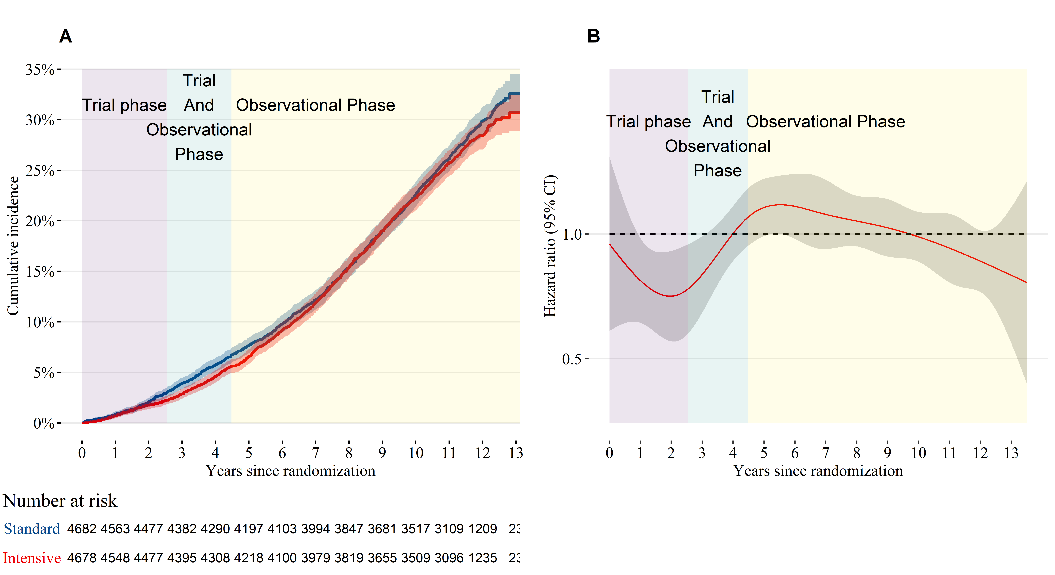

1. Cumulative incidence of all-cause mortality by treatment group. (B) Time-dependent effect of randomization to intensive treatment for all-cause mortality.

The trial phase and observational phase do not overlap for individual participants, but due to participants being randomized on different days, there is an overlap in the trial and observational phase for the population when time is measured relative to the date of randomization.

**Figure 2**: All-cause mortality hazard ratio subgroup analysis for participants randomized to intensive versus standard treatment.

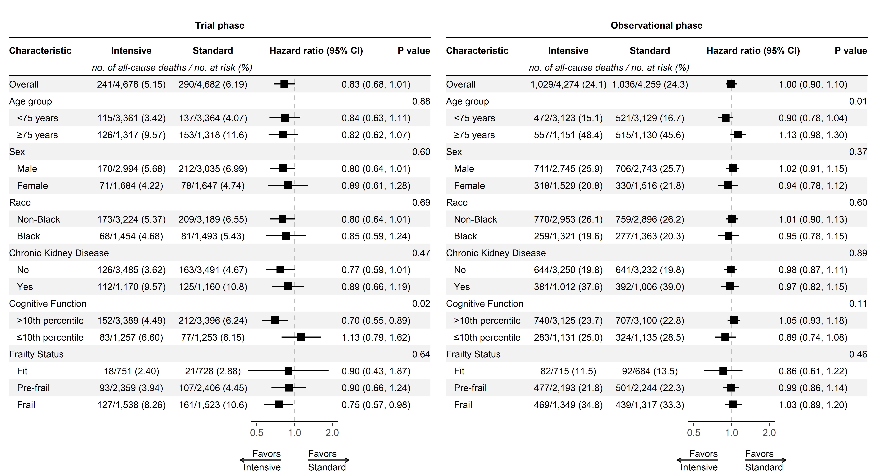

P-values test for heterogeneity in the treatment effect among subgroups and were not adjusted for multiple testing.

**Figure 3**: Incidence of cardiovascular versus non-cardiovascular mortality by treatment group.

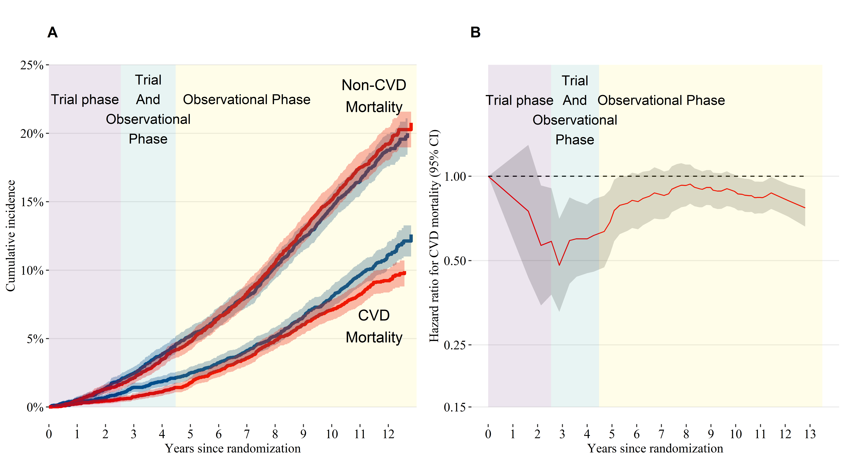

1. Cumulative incidence of cardiovascular and non-cardiovascular mortality by treatment group. (B) Time-dependent effect of randomization to intensive treatment for cardiovascular mortality.

The trial phase and observational phase do not overlap for individual participants, but due to participants being randomized on different days, there is an overlap in the trial and observational phase for the population when time is measured relative to the date of randomization.

**Figure 4**: Cardiovascular mortality hazard ratio subgroup analysis for participants randomized to intensive versus standard treatment.

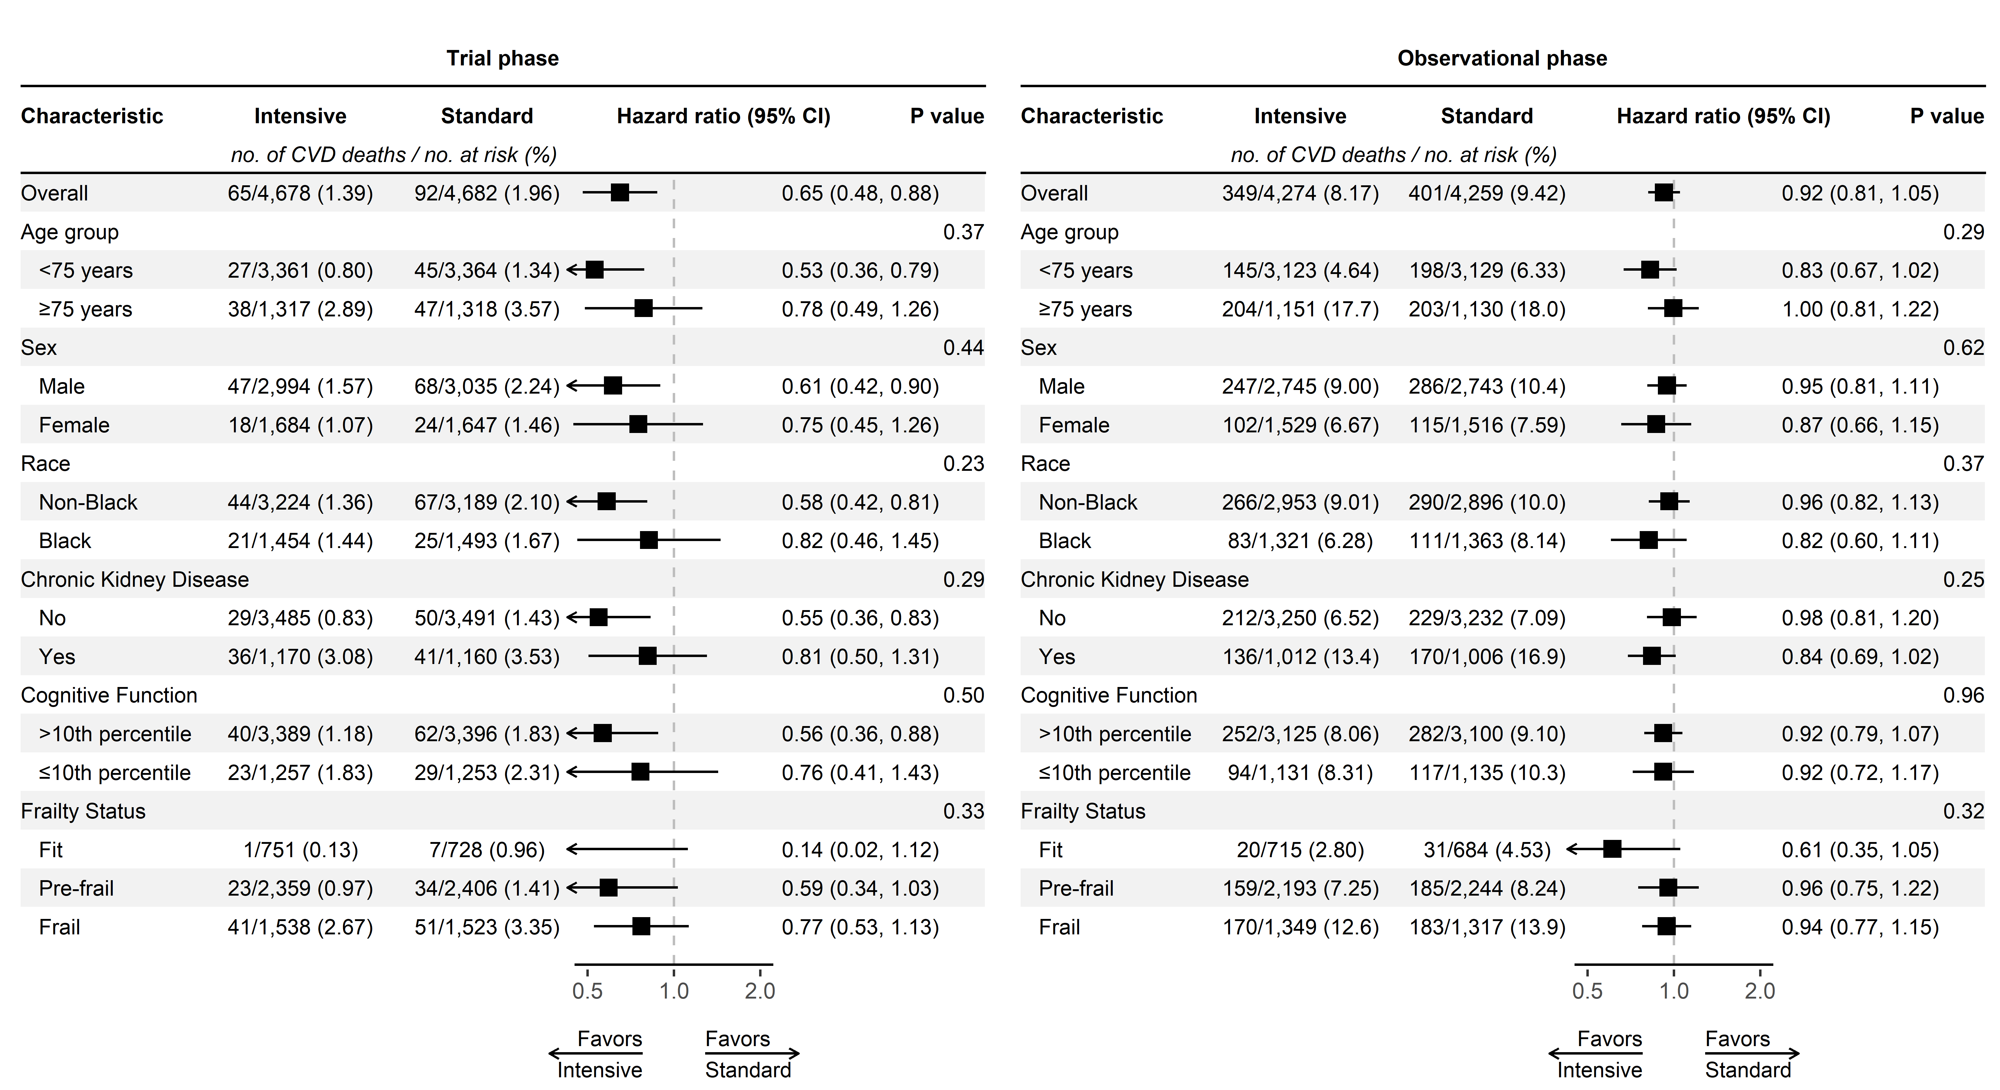

P-values test for heterogeneity in the treatment effect among subgroups and were not adjusted for multiple testing.

**Figure 5**: Mean systolic blood pressure over time by treatment group.

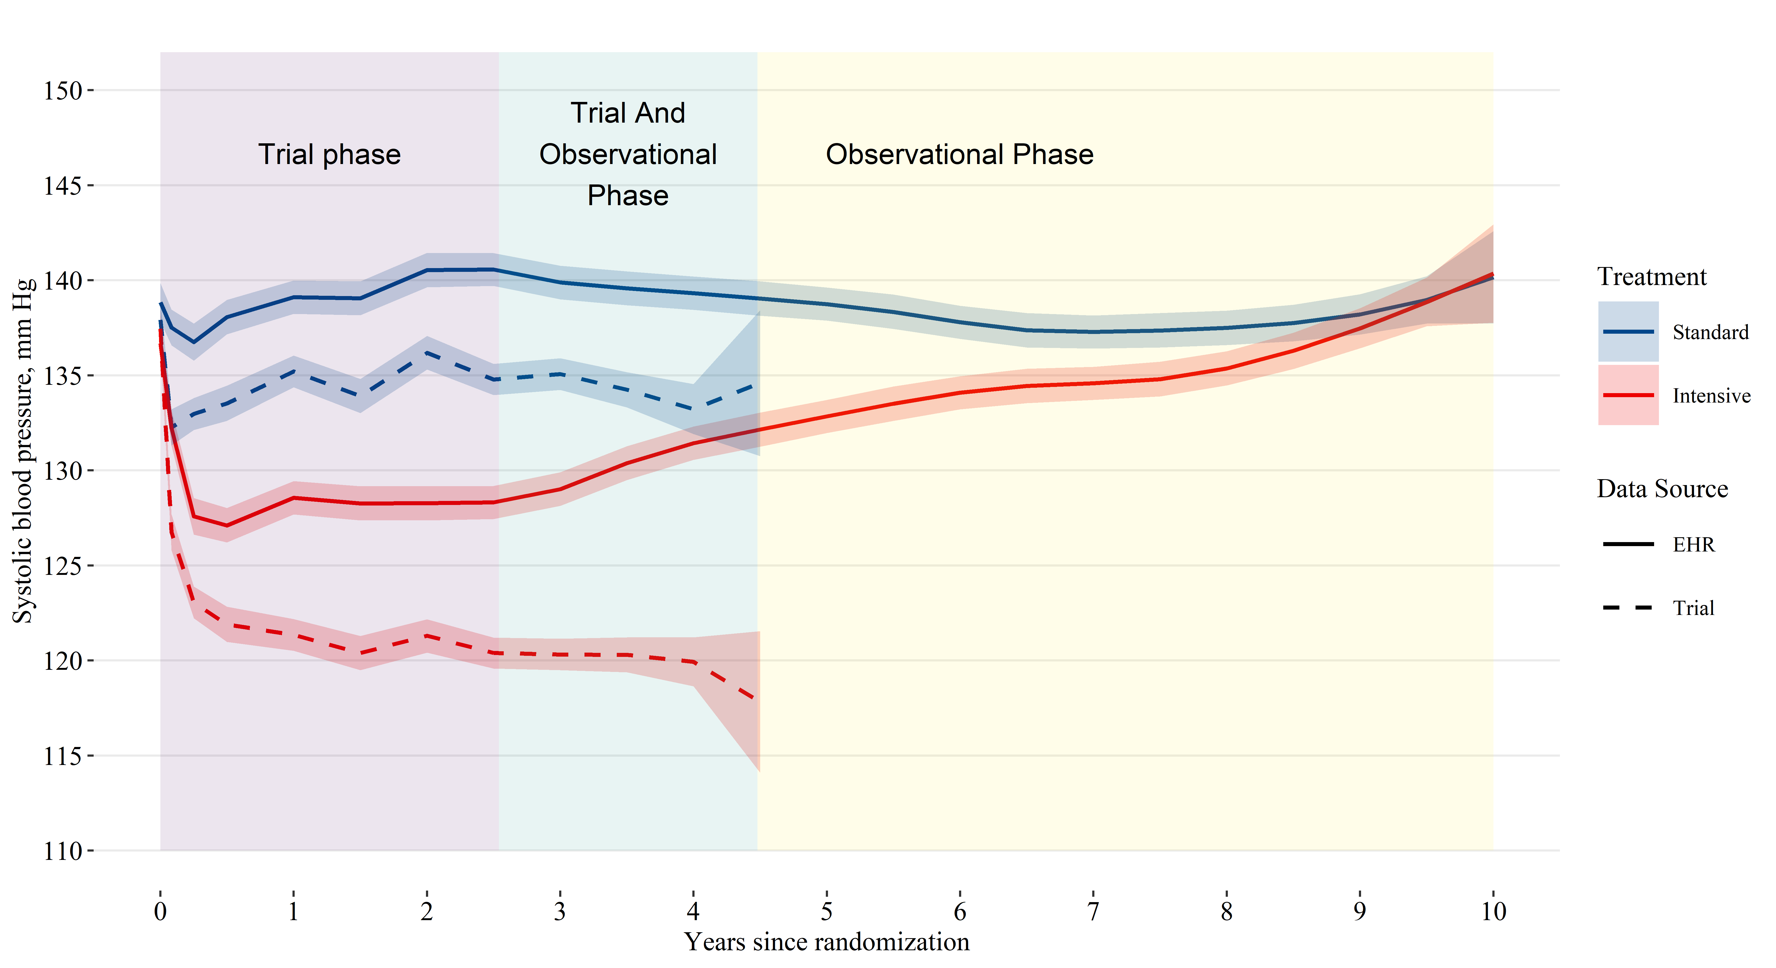

EHR denotes electronic health record. Shaded areas indicate a 95% confidence interval for the mean. The trial phase and observational phase do not overlap for individual participants, but due to participants being randomized on different days, there is an overlap in the trial and observational phase for the population when time is measured relative to the date of randomization.

**Online supplement only**

Byron C. Jaeger, PhD,1 Adam P. Bress, PharmD, MS,2,3 Joshua D. Bundy, PhD,4 Alfred K. Cheung, MD,5,6 William C. Cushman, MD,7 Paul E. Drawz, MD,8 Lawrence J. Fine, MD,9 Karen C. Johnson, MD,7 Cora E. Lewis, MD, MSPH10 Suzanne Oparil, MD,11 Michael V. Rocco, MD,12 Stephen R. Rapp, PhD, 13 Joni K. Snyder, RN,BSN,9 Mark A. Supiano, MD,14 Paul K. Whelton, MD,4 Jeff D. Williamson, MD, MHS,15 Jackson T. Wright, Jr, MD, PhD,16 David M. Reboussin, PhD,1 and Nicholas M. Pajewski, PhD1

1Department of Biostatistics and Data Science, Wake Forest School of Medicine, Winston-Salem, NC. 2Informatics, Decision-Enhancement, and Analytic Sciences (IDEAS) Center, Veterans Affairs, Salt Lake City Health Care System, Salt Lake City, UT. 3Department of Population Health Sciences, University of Utah School of Medicine, Salt Lake City, UT. 4Department of Epidemiology, Tulane University School of Public Health and Tropical Medicine, New Orleans, LA. 5Renal Section, Veterans Affairs Salt Lake City Healthcare System, UT. 6Division of Nephrology and Hypertension, Department of Internal Medicine, University of Utah School of Medicine, Salt Lake City, UT. 7Department of Preventive Medicine, University of Tennessee Health Science Center, Memphis. 8Division of Renal Diseases & Hypertension, University of Minnesota, MN. 9Clinical Applications and Prevention Branch, National Heart, Lung, and Blood Institute, National Institutes of Health, Bethesda, MD. 10Department of Epidemiology, University of Alabama at Birmingham. 11Division of Cardiovascular Disease, Department of Medicine, University of Alabama at Birmingham. 12Section on Nephrology, Department of Internal Medicine, Wake Forest School of Medicine, Winston-Salem, NC. 13Departments of Psychiatry and Behavioral Medicine & Social Sciences and Health Policy, Wakfe Forest School of Medicine, Winston-Salem, NC. 14Division of Geriatrics, University of Utah School of Medicine, Salt Lake City. 15Section on Gerontology and Geriatric Medicine, Department of Internal Medicine, Wake Forest School of Medicine, Winston-Salem, NC. 16Division of Nephrology and Hypertension, University Hospitals Cleveland Medical Center, Case Western Reserve University, OH

**eTable 1**: Characteristics of study participants.

| **Characteristic** | **Overall N = 9,361** | **Treatment** | | **Included in EHR ancillary study** | | **p-valuea b** |
| --- | --- | --- | --- | --- | --- | --- |
| **Standard N = 4,683** | **Intensive N = 4,678** | **No N = 6,417** | **Yes N = 2,944** |
| Age, years | 67.9 (9.4) | 67.9 (9.5) | 67.9 (9.4) | 67.7 (9.6) | 68.5 (9.1) | <0.001 |
| Age ≥75 years | 28.2 | 28.2 | 28.2 | 27.4 | 29.9 | 0.011 |
| Number of blood pressure medications prescribed | 1.8 (1.0) | 1.8 (1.0) | 1.8 (1.0) | 1.8 (1.1) | 1.9 (1.0) | <0.001 |
| Female | 35.6 | 35.2 | 36.0 | 43.4 | 18.5 | <0.001 |
| Black | 31.5 | 31.9 | 31.1 | 32.0 | 30.3 | 0.085 |
| Systolic blood pressure | 139.7 (15.6) | 139.7 (15.4) | 139.7 (15.8) | 140.6 (15.8) | 137.8 (14.9) | <0.001 |
| Intensive treatment | 50.0 |  |  | 49.8 | 50.3 | 0.6 |
| Included in EHR ancillary study | 31.5 | 31.2 | 31.7 |  |  |  |
| Chronic Kidney Diseasec | 25.0 | 24.9 | 25.1 | 24.2 | 26.8 | 0.007 |
| MoCA ≤10th percentile | 27.0 | 27.0 | 27.1 | 27.2 | 26.5 | 0.5 |
| Frailty Status |  |  |  |  |  | <0.001 |
| Fit (FI≤0.10) | 15.9 | 15.6 | 16.2 | 16.9 | 13.7 |  |
| Pre-frail (0.10<FI≤0.21) | 51.2 | 51.7 | 50.8 | 51.9 | 49.8 |  |
| Frail (FI>0.21) | 32.9 | 32.7 | 33.1 | 31.2 | 36.5 |  |
| Table values are mean (standard deviation) or percentage. | | | | | | |
| a P-values computed using Wilcoxon rank sum test for continuous variables and chi-square test for categorical variables. | | | | | | |
| b Hypothesis tests compare the characteristics of participants included versus excluded from the ancillary study of blood pressure levels using data from the electronic health record. | | | | | | |
| c Chronic Kidney Disease was defined by an estimated glomerular filtration rate <60 ml/min/1.73 m2 based on the 2021 CKD-EPI creatinine equation. | | | | | | |
| Abbreviations: EHR = electronic health records; FI = frailty index; and MoCA = Montreal cognitive assessment | | | | | | |

**eTable 2**: All-cause mortality by treatment group and subgroup

|  | **Trial Phase** | | | | | **Observational Phase** | | | | |
| --- | --- | --- | --- | --- | --- | --- | --- | --- | --- | --- |
| **N Events / N Total** | | **Incidence (95% CI)a** | | **Hazard Ratio (95% CI)** | **N Events / N Total** | | **Incidence (95% CI)** | | **Hazard Ratio (95% CI)** |
| **Standard** | **Intensive** | **Standard** | **Intensive** | **Standard** | **Intensive** | **Standard** | **Intensive** |
| Overall | 290 / 4,682 | 241 / 4,678 | 15.1 (13.4, 16.9) | 12.5 (11.0, 14.2) | 0.83 (0.68, 1.01) | 1,036 / 4,259 | 1,029 / 4,274 | 36.3 (34.2, 38.6) | 36.2 (34.0, 38.4) | 1.00 (0.90, 1.10) |
| *Age group* | | | | | | | | | | |
| <75 years | 137 / 3,364 | 115 / 3,361 | 9.7 (8.2, 11.5) | 8.2 (6.8, 9.8) | 0.84 (0.63, 1.11) | 521 / 3,129 | 472 / 3,123 | 23.9 (21.9, 26.0) | 21.6 (19.7, 23.6) | 0.90 (0.78, 1.04) |
| ≥75 years | 153 / 1,318 | 126 / 1,317 | 29.8 (25.3, 34.8) | 24.3 (20.3, 28.8) | 0.82 (0.62, 1.07) | 515 / 1,130 | 557 / 1,151 | 76.8 (70.3, 83.6) | 84.2 (77.4, 91.4) | 1.13 (0.98, 1.30) |
| *Sex* | | | | | | | | | | |
| Male | 212 / 3,035 | 170 / 2,994 | 17.2 (15.0, 19.6) | 13.8 (11.9, 16.0) | 0.80 (0.64, 1.01) | 706 / 2,743 | 711 / 2,745 | 38.6 (35.8, 41.5) | 39.3 (36.5, 42.3) | 1.02 (0.91, 1.15) |
| Female | 78 / 1,647 | 71 / 1,684 | 11.4 (9.0, 14.1) | 10.2 (8.0, 12.8) | 0.89 (0.61, 1.28) | 330 / 1,516 | 318 / 1,529 | 32.2 (28.9, 35.8) | 30.6 (27.4, 34.1) | 0.94 (0.78, 1.12) |
| *Race* | | | | | | | | | | |
| Non-Black | 209 / 3,189 | 173 / 3,224 | 16.0 (13.9, 18.3) | 13.0 (11.2, 15.0) | 0.80 (0.64, 1.01) | 759 / 2,896 | 770 / 2,953 | 39.4 (36.7, 42.3) | 39.6 (36.8, 42.4) | 1.01 (0.90, 1.13) |
| Black | 81 / 1,493 | 68 / 1,454 | 13.2 (10.5, 16.3) | 11.5 (8.9, 14.4) | 0.85 (0.59, 1.24) | 277 / 1,363 | 259 / 1,321 | 29.9 (26.5, 33.6) | 28.8 (25.4, 32.4) | 0.95 (0.78, 1.15) |
| *Chronic Kidney Diseaseb* | | | | | | | | | | |
| No | 163 / 3,491 | 126 / 3,485 | 11.3 (9.7, 13.1) | 8.7 (7.3, 10.4) | 0.77 (0.59, 1.01) | 641 / 3,232 | 644 / 3,250 | 28.9 (26.7, 31.2) | 29.0 (26.8, 31.3) | 0.98 (0.87, 1.11) |
| Yes | 125 / 1,160 | 112 / 1,170 | 26.5 (22.1, 31.5) | 23.6 (19.5, 28.2) | 0.89 (0.66, 1.19) | 392 / 1,006 | 381 / 1,012 | 63.6 (57.5, 70.1) | 61.7 (55.7, 68.1) | 0.97 (0.82, 1.15) |
| *Cognitive Function* | | | | | | | | | | |
| >10th percentile | 212 / 3,396 | 152 / 3,389 | 15.1 (13.1, 17.2) | 10.8 (9.1, 12.6) | 0.70 (0.55, 0.89) | 707 / 3,100 | 740 / 3,125 | 33.8 (31.4, 36.3) | 35.4 (32.9, 38.0) | 1.05 (0.93, 1.18) |
| ≤10th percentile | 77 / 1,253 | 83 / 1,257 | 15.3 (12.1, 19.0) | 16.5 (13.2, 20.3) | 1.13 (0.79, 1.62) | 324 / 1,135 | 283 / 1,131 | 43.6 (39.0, 48.5) | 37.9 (33.6, 42.5) | 0.89 (0.74, 1.08) |
| *Frailty Status* | | | | | | | | | | |
| Fit (FI ≤ 0.10) | 21 / 728 | 18 / 751 | 6.9 (4.4, 10.3) | 5.7 (3.4, 8.7) | 0.90 (0.43, 1.87) | 92 / 684 | 82 / 715 | 18.9 (15.3, 23.0) | 16.1 (12.8, 19.8) | 0.86 (0.61, 1.22) |
| Pre-frail (0.10 < FI ≤ 0.21) | 107 / 2,406 | 93 / 2,359 | 10.7 (8.8, 12.8) | 9.5 (7.7, 11.6) | 0.90 (0.66, 1.24) | 501 / 2,244 | 477 / 2,193 | 32.9 (30.1, 35.9) | 32.1 (29.3, 35.1) | 0.99 (0.86, 1.14) |
| Frail (FI > 0.21) | 161 / 1,523 | 127 / 1,538 | 26.4 (22.5, 30.7) | 20.4 (17.1, 24.2) | 0.75 (0.57, 0.98) | 439 / 1,317 | 469 / 1,349 | 52.7 (47.9, 57.8) | 55.9 (51.0, 61.1) | 1.03 (0.89, 1.20) |
| aIncidence is presented as the expected rate of events per 1,000 person-years. | | | | | | | | | | |
| bChronic Kidney Disease was defined by an estimated glomerular filtration rate <60 ml/min/1.73 m2 based on the 2021 CKD-EPI creatinine equation. | | | | | | | | | | |
| Abbreviations: CI = confidence interval; and FI = frailty index | | | | | | | | | | |

**eTable 3**: Cardiovascular and non-cardiovascular mortality by treatment group and subgroup

|  | **Trial Phase** | | | | **Observational Phase** | | | |
| --- | --- | --- | --- | --- | --- | --- | --- | --- |
| **N CVD / non-CVD / Total** | | **Hazard Ratio (95% CI)** | | **N CVD / non-CVD / Total** | | **Hazard Ratio (95% CI)** | |
| **Standard** | **Intensive** | **CVD** | **Non-CVD** | **Standard** | **Intensive** | **CVD** | **Non-CVD** |
| Overall | 92 / 198 / 4,682 | 65 / 176 / 4,678 | 0.65 (0.48, 0.88) | 0.89 (0.71, 1.10) | 401 / 635 / 4,259 | 349 / 680 / 4,274 | 0.92 (0.81, 1.05) | 1.11 (0.99, 1.23) |
| *Age group* | | | | | | | | |
| <75 years | 45 / 92 / 3,364 | 27 / 88 / 3,361 | 0.53 (0.36, 0.79) | 0.95 (0.68, 1.33) | 198 / 323 / 3,129 | 145 / 327 / 3,123 | 0.83 (0.67, 1.02) | 1.00 (0.88, 1.15) |
| ≥75 years | 47 / 106 / 1,318 | 38 / 88 / 1,317 | 0.78 (0.49, 1.26) | 0.81 (0.60, 1.09) | 203 / 312 / 1,130 | 204 / 353 / 1,151 | 1.00 (0.81, 1.22) | 1.22 (1.05, 1.41) |
| *Sex* | | | | | | | | |
| Male | 68 / 144 / 3,035 | 47 / 123 / 2,994 | 0.61 (0.42, 0.90) | 0.85 (0.67, 1.08) | 286 / 420 / 2,743 | 247 / 464 / 2,745 | 0.95 (0.81, 1.11) | 1.17 (1.02, 1.33) |
| Female | 24 / 54 / 1,647 | 18 / 53 / 1,684 | 0.75 (0.45, 1.26) | 0.98 (0.64, 1.49) | 115 / 215 / 1,516 | 102 / 216 / 1,529 | 0.87 (0.66, 1.15) | 1.00 (0.80, 1.24) |
| *Race* | | | | | | | | |
| Non-Black | 67 / 142 / 3,189 | 44 / 129 / 3,224 | 0.58 (0.42, 0.81) | 0.86 (0.67, 1.11) | 290 / 469 / 2,896 | 266 / 504 / 2,953 | 0.96 (0.82, 1.13) | 1.12 (0.98, 1.27) |
| Black | 25 / 56 / 1,493 | 21 / 47 / 1,454 | 0.82 (0.46, 1.45) | 0.94 (0.64, 1.38) | 111 / 166 / 1,363 | 83 / 176 / 1,321 | 0.82 (0.60, 1.11) | 1.06 (0.88, 1.29) |
| *Chronic Kidney Diseasea* | | | | | | | | |
| No | 50 / 113 / 3,491 | 29 / 97 / 3,485 | 0.55 (0.36, 0.83) | 0.87 (0.66, 1.15) | 229 / 412 / 3,232 | 212 / 432 / 3,250 | 0.98 (0.81, 1.20) | 1.07 (0.94, 1.22) |
| Yes | 41 / 84 / 1,160 | 36 / 76 / 1,170 | 0.81 (0.50, 1.31) | 0.87 (0.62, 1.24) | 170 / 222 / 1,006 | 136 / 245 / 1,012 | 0.84 (0.69, 1.02) | 1.15 (0.97, 1.37) |
| *Cognitive Function* | | | | | | | | |
| >10th percentile | 62 / 150 / 3,396 | 40 / 112 / 3,389 | 0.56 (0.36, 0.88) | 0.74 (0.57, 0.96) | 282 / 425 / 3,100 | 252 / 488 / 3,125 | 0.92 (0.79, 1.07) | 1.19 (1.04, 1.37) |
| ≤10th percentile | 29 / 48 / 1,253 | 23 / 60 / 1,257 | 0.76 (0.41, 1.43) | 1.22 (0.83, 1.80) | 117 / 207 / 1,135 | 94 / 189 / 1,131 | 0.92 (0.72, 1.17) | 0.92 (0.78, 1.09) |
| *Frailty Status* | | | | | | | | |
| Fit (FI ≤ 0.10) | 7 / 14 / 728 | 1 / 17 / 751 | 0.14 (0.02, 1.12) | 1.22 (0.59, 2.5) | 31 / 61 / 684 | 20 / 62 / 715 | 0.61 (0.35, 1.05) | 1.09 (0.77, 1.54) |
| Pre-frail (0.10 < FI ≤ 0.21) | 34 / 73 / 2,406 | 23 / 70 / 2,359 | 0.59 (0.34, 1.03) | 1.00 (0.73, 1.37) | 185 / 316 / 2,244 | 159 / 318 / 2,193 | 0.96 (0.75, 1.22) | 1.05 (0.90, 1.23) |
| Frail (FI > 0.21) | 51 / 110 / 1,523 | 41 / 86 / 1,538 | 0.77 (0.53, 1.13) | 0.74 (0.55, 1.00) | 183 / 256 / 1,317 | 170 / 299 / 1,349 | 0.94 (0.77, 1.15) | 1.17 (0.98, 1.40) |
| aChronic Kidney Disease was defined by an estimated glomerular filtration rate <60 ml/min/1.73 m2 based on the 2021 CKD-EPI creatinine equation. | | | | | | | | |
| Abbreviations: CI = confidence interval; CVD = cardiovascular disease; and FI = frailty index | | | | | | | | |

**eFigure 1**: Timeline of landmark events and definition of ‘trial’ and ‘observational’ periods for the current analysis

**eFigure 2**: Mean difference in systolic blood pressure measured in the trial and as part of routine clinical practice over time.

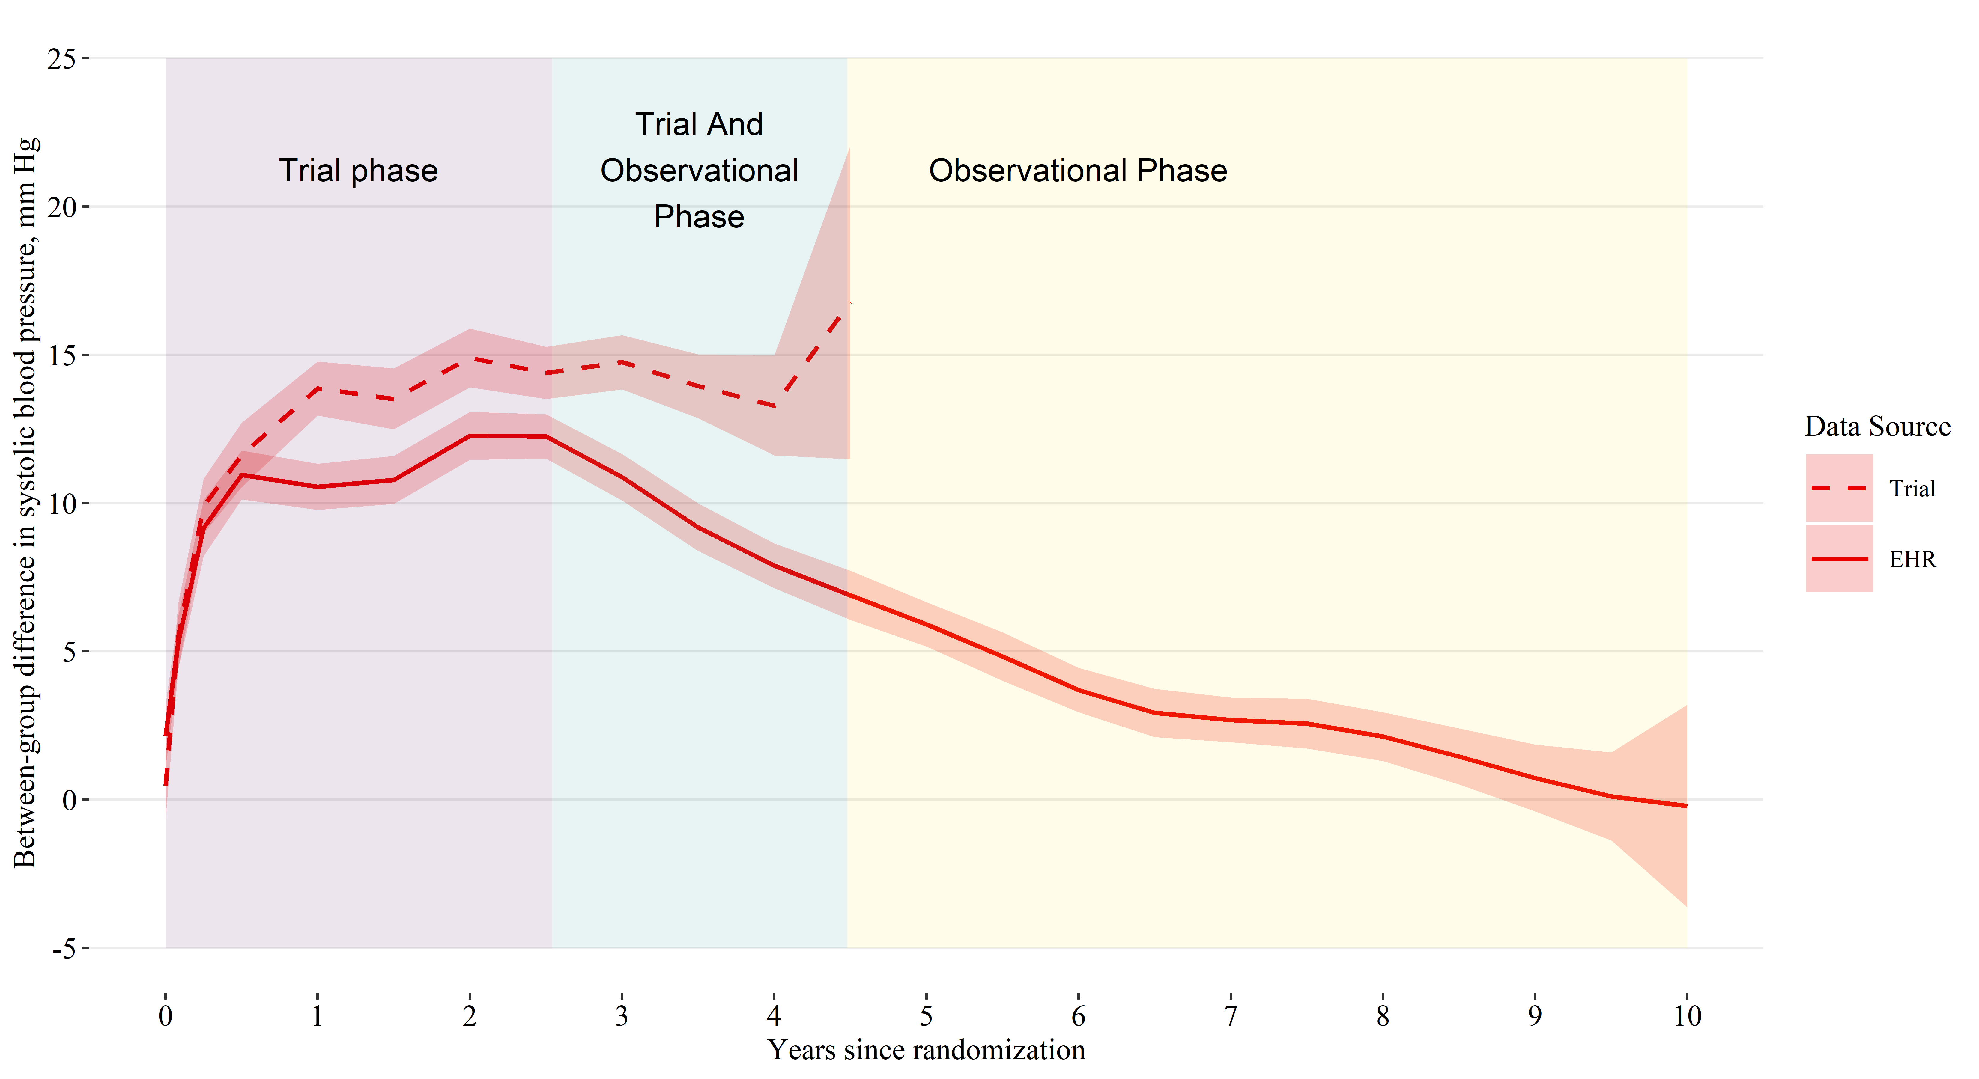

Shaded areas indicate a 95% confidence interval for the mean.

EHR denotes electronic health record.