Longer term All-Cause and Cardiovascular Mortality with Intensive Blood Pressure Control: A Secondary Analysis of SPRINT

Byron C. Jaeger, PhD1 Paul E. Drawz, MD2 Paul K. Whelton, MD3 Mark A. Supiano, MD4 Adam P. Bress, PharmD, MS5,6 Jeff D. Williamson, MD, MHS7 David M. Reboussin, PhD1, and Nicholas M. Pajewski, PhD1

1Department of Biostatistics and Data Science, Wake Forest School of Medicine, Winston-Salem, NC

2Division of Renal Diseases & Hypertension, University of Minnesota, Minneapolis.

3Department of Epidemiology, Tulane University School of Public Health and Tropical Medicine, New Orleans, LA.

4Division of Geriatrics, University of Utah School of Medicine, Salt Lake City.

5 Informatics, Decision-Enhancement, and Analytic Sciences (IDEAS) Center, Veterans Affairs, Salt Lake City Health Care System, Salt Lake City, UT

6 Department of Population Health Sciences, University of Utah School of Medicine, Salt Lake City, UT

7Section on Gerontology and Geriatric Medicine, Wake Forest School of Medicine, Winston-Salem, NC.

# ABSTRACT

**Background**. Both the Systolic Blood Pressure Intervention Trial (SPRINT) and the Strategy of Blood Pressure Intervention in the Elderly Hypertensive Patients (STEP) trial have shown benefits of intensive blood pressure control on cardiovascular morbidity and mortality. However, as both trials were ended after slightly more than 3 years of follow-up, the legacy effect of intensive treatment on longer term cardiovascular and all-cause mortality is unknown.

**Methods**. We linked participants in SPRINT to the National Death Index (NDI, 2016 to 2020), assessing cardiovascular mortality using the NDI plus system. Cox and competing risk regression models were used to model the effect of intensive treatment through the trial and during post-trial follow-up on all-cause and cardiovascular mortality respectively

**Results**. Over a median follow-up of 8.76 years, there were 248 and 818 cardiovascular and all-cause deaths with intensive treatment respectively, and 273 cardiovascular / 826 all-cause deaths for standard treatment. Intensive treatment was beneficial for both cardiovascular (Hazard Ratio [HR] = 0.66, 95% CI 0.49 to 0.89) and all-cause mortality (HR = 0.83, 95% CI 0.68 to 1.01) through close-out visits for the trial (follow-up through July 2016). However, there was no indication of benefit during post-trial follow-up for either cardiovascular (HR = 1.02, 95% CI 0.84 to 1.24) or all-cause mortality (HR = 1.08, 95% CI 0.94 to 1.23). Results were similar for subgroups based on baseline age, cognitive function, and frailty status.

**Conclusions**. Our results show a clear benefit for cardiovascular and all-cause mortality during the trial which was largely attenuated during post-trial observational follow-up. Given indications of increasing blood pressures in SPRINT participants randomized to intensive treatment following the trial, these results highlight the importance of consistent long-term management of hypertension in line with current guidelines.

# INTRODUCTION

both the The Systolic Blood Pressure Intervention Trial (SPRINT) and the Strategy of Blood Pressure Intervention in the Elderly Hypertensive Patients (STEP) trial have shown the benefits of intensive blood pressure control on cardiovascular morbidity and mortality.1,2

**Reminder: bring in the recent BPTTC meta-analyses into the introduction**3.

# METHODS

**Trial Design**: The trial design and methods have been published previously.4 Briefly, we conducted a multicenter randomized clinical trial that compared two strategies for managing systolic BP (SBP) in older adults with hypertension who were at increased risk of cardiovascular disease. Participants were aged 50 years or older and had an SBP between 130 and 180 mm Hg at the screening visit, depending on the number of anti-hypertensive agents prescribed. Participants were considered to have an increased cardiovascular risk if they had clinical or subclinical cardiovascular disease, chronic kidney disease (defined by an estimated glomerular filtration rate of <60 mL/min/1.73 m2), or a Framingham Risk Score of 15% or greater or if they were aged 75 years or older. Individuals residing in a nursing home, persons with a diagnosis of dementia (based on medical record review), and those treated with medications primarily used for dementia therapy were excluded, as were persons with prevalent diabetes mellitus, history of stroke, proteinuria > 1 gram per day, or polycystic kidney disease. Individuals at 102 sites in the United States and Puerto Rico were randomized (1:1) to a SBP goal of less than 120 mm Hg (intensive treatment group, n = 4678) or a goal of less than 140 mm Hg (standard treatment group, n = 4683), using random permuted blocks with the randomization stratified by clinic site. The algorithms and formulary for the trial are listed in the published study protocol ( **citations needed**? ). Trial enrollment began in November 2010 and ended in March 2013, with active follow-up through July 1, 2016. The study was approved by the institutional review board at each participating site, and each participant provided written informed consent. The study is registered at ClinicalTrials.gov (NCT01206062).

**National Death Index Linkage**:

**Baseline Study Measurements**: Sociodemographic data were collected at baseline, with race or ethnicity information collected via self-report. The estimated glomerular filtration rate (eGFR) was calculated by the four-variable Modification of Diet in Renal Disease study equation. Cognitive function was assessed using Montreal Cognitive Assessment (MoCA).5 Lower cognitive function was defined as scoring 18 or lower (less than high school education) or 20 or lower (high school education or higher) on the MoCA. This roughly corresponds to the estimated normative 25th percentile at 80 years of age in the Irish Longitudinal Study of Aging.6 We defined frailty status at baseline using a previously developed Frailty Index (FI) based upon the model of deficit accumulation.7 Briefly, the FI comprises a total of 36 items, and is calculated as the sum of the score for each deficit divided by the total number of nonmissing items. We categorized frailty status as fit (FI ≤ 0.10), less fit (0.10 < FI ≤ 0.21), or frail (FI > 0.21).

**EHR Ancillary Study**: We examined the trajectory of systolic blood pressure (SBP) following the conclusion of the trial using outpatient SBPs extracted from the electronic health record (EHR). Methods for the linkage of participants to their medical record number and the extraction of vital sign data have been previously described.8 Because encounter type information was inconsistently available (i.e. outpatient, inpatient, observation, etc.), we defined a BP measurement as outpatient if there were was not a BP measurement on the preceding or following day, and if there were 2 or less BP measurements on a particular day. We averaged outpatient EHR BP readings when there were 2 on the same day.

***Statistical Analysis***: The effect of randomization to intensive treatment was estimated as a function of time using two approaches. The first approach split the follow-up of study participants into non-overlapping trial and cohort phases, then estimated the effect of randomization to intensive treatment in each phase.9 The second approach estimated a continuous time-dependent effect.10,11 All analyses accounted for correlation within study sites,12 and analyses of cardiovascular mortality accounted for the competing risk of non-cardiovascular mortality.13 The mean between-group differences in SBP following the conclusion of trial follow-up (after July 2016) were estimated using linear mixed models. Models included random effects for participant and clinic site. Our primary models included an interaction between treatment group and time since randomization, which was flexibly modeled using B-splines.

All analyses were performed using SAS version 9.4 (SAS Institute Inc, Cary, NC) and R version 4.1.2 (R Project for Statistical Computing [<http://www.r-project.org>]) with multiple auxiliary R packages.14–19 All hypothesis tests were 2-sided, and P values less than 0.05 were considered statistically significant. No adjustments for multiple comparisons were made.

# RESULTS

In both treatment groups, median follow-up time was 8.76 years. A total of 818 and 826 all-cause mortality events occurred among participants randomized to intensive and standard treatment, respectively (**Table 1**). The hazard ratio (HR) for all-cause mortality among participants randomized to intensive versus standard treatment was 0.83 (95% confidence interval [CI] 0.68, 1.01) during the trial phase and 1.08 (95% CI 0.94, 1.23) during the cohort phase. The cumulative time-varying effect of intensive versus standard treatment indicated lower risk for all-cause mortality during the trial phase and was attenuated during the cohort phase (**Figure 1**).

# DISCUSSION

**Table 1**: All-cause mortality by treatment group and subgroup

|  | **Trial Follow-up Through Close-out Visits** | | | | | **Post-trial Follow-up** | | | | |
| --- | --- | --- | --- | --- | --- | --- | --- | --- | --- | --- |
| **N Events / N Total** | | **Incidence (95% CI)** | | **Hazard Ratio (95% CI)** | **N Events / N Total** | | **Incidence (95% CI)** | | **Hazard Ratio (95% CI)** |
| **Standard** | **Intensive** | **Standard** | **Intensive** | **Standard** | **Intensive** | **Standard** | **Intensive** |
| Overall | 290 / 4,683 | 241 / 4,678 | 15.1 (13.4, 16.9) | 12.5 (11.0, 14.2) | 0.83 (0.68, 1.01) | 536 / 4,260 | 577 / 4,274 | 29.6 (27.1, 32.1) | 31.9 (29.3, 34.5) | 1.08 (0.94, 1.23) |
| *Age, years* | | | | | | | | | | |
| <75 years | 137 / 3,364 | 115 / 3,361 | 9.73 (8.19, 11.5) | 8.18 (6.78, 9.77) | 0.84 (0.63, 1.11) | 257 / 3,129 | 246 / 3,123 | 18.9 (16.7, 21.3) | 18.1 (15.9, 20.5) | 0.96 (0.78, 1.17) |
| ≥75 years | 153 / 1,319 | 126 / 1,317 | 29.8 (25.3, 34.7) | 24.3 (20.3, 28.8) | 0.82 (0.62, 1.07) | 279 / 1,131 | 331 / 1,151 | 61.6 (54.7, 69.1) | 73.3 (65.7, 81.5) | 1.21 (1.00, 1.46) |
| *Sex* | | | | | | | | | | |
| Male | 212 / 3,035 | 170 / 2,994 | 17.2 (15.0, 19.6) | 13.8 (11.9, 16.0) | 0.80 (0.64, 1.01) | 353 / 2,743 | 400 / 2,745 | 30.3 (27.3, 33.6) | 34.6 (31.3, 38.1) | 1.14 (0.97, 1.34) |
| Female | 78 / 1,648 | 71 / 1,684 | 11.4 (9.02, 14.1) | 10.2 (8.01, 12.8) | 0.89 (0.61, 1.28) | 183 / 1,517 | 177 / 1,529 | 28.2 (24.3, 32.5) | 27.0 (23.2, 31.2) | 0.94 (0.74, 1.20) |
| *Race* | | | | | | | | | | |
| Non-Black | 209 / 3,190 | 173 / 3,224 | 16.0 (13.9, 18.2) | 13.0 (11.2, 15.0) | 0.80 (0.64, 1.01) | 386 / 2,897 | 426 / 2,953 | 31.4 (28.4, 34.6) | 34.2 (31.1, 37.6) | 1.10 (0.94, 1.28) |
| Black | 81 / 1,493 | 68 / 1,454 | 13.2 (10.5, 16.3) | 11.5 (8.95, 14.4) | 0.85 (0.59, 1.24) | 150 / 1,363 | 151 / 1,321 | 25.7 (21.8, 30.0) | 26.7 (22.6, 31.1) | 1.02 (0.78, 1.32) |
| *Chronic Kidney Disease* | | | | | | | | | | |
| No | 163 / 3,491 | 126 / 3,485 | 11.3 (9.67, 13.1) | 8.74 (7.30, 10.4) | 0.77 (0.59, 1.01) | 316 / 3,232 | 349 / 3,250 | 22.7 (20.3, 25.2) | 25.0 (22.5, 27.7) | 1.08 (0.91, 1.29) |
| Yes | 125 / 1,161 | 112 / 1,170 | 26.5 (22.1, 31.4) | 23.6 (19.5, 28.2) | 0.89 (0.66, 1.19) | 220 / 1,007 | 227 / 1,012 | 53.8 (47.0, 61.2) | 55.5 (48.6, 63.1) | 1.02 (0.82, 1.26) |
| *Cognitive Function* | | | | | | | | | | |
| >10th percentile | 212 / 3,397 | 152 / 3,389 | 15.1 (13.1, 17.2) | 10.8 (9.14, 12.6) | 0.70 (0.55, 0.89) | 357 / 3,101 | 408 / 3,125 | 26.9 (24.2, 29.8) | 30.7 (27.8, 33.8) | 1.13 (0.96, 1.33) |
| ≤10th percentile | 77 / 1,253 | 83 / 1,257 | 15.3 (12.1, 19.0) | 16.5 (13.2, 20.3) | 1.13 (0.79, 1.62) | 176 / 1,135 | 165 / 1,131 | 36.8 (31.7, 42.6) | 34.7 (29.6, 40.2) | 0.98 (0.76, 1.26) |
| *Frailty Status* | | | | | | | | | | |
| Fit (FI≤0.10) | 21 / 729 | 18 / 751 | 6.90 (4.35, 10.3) | 5.68 (3.45, 8.73) | 0.90 (0.43, 1.87) | 34 / 685 | 42 / 715 | 11.3 (7.88, 15.5) | 13.4 (9.71, 17.8) | 1.26 (0.72, 2.19) |
| Pre-frail (0.10<FI≤0.21) | 107 / 2,406 | 93 / 2,359 | 10.7 (8.79, 12.8) | 9.52 (7.71, 11.6) | 0.90 (0.66, 1.24) | 251 / 2,244 | 261 / 2,193 | 26.1 (23.0, 29.5) | 27.8 (24.5, 31.3) | 1.07 (0.87, 1.30) |
| Frail (FI>0.21) | 161 / 1,523 | 127 / 1,538 | 26.4 (22.5, 30.7) | 20.4 (17.1, 24.2) | 0.75 (0.57, 0.98) | 251 / 1,317 | 274 / 1,349 | 46.2 (40.7, 52.2) | 49.9 (44.2, 56.0) | 1.07 (0.87, 1.30) |

**Table 2**: Cardiovascular and non-cardiovascular mortality by treatment group and subgroup

|  | **Trial Follow-up Through Close-out Visits** | | | | **Post-trial Follow-up** | | | |
| --- | --- | --- | --- | --- | --- | --- | --- | --- |
| **N CVD / non-CVD / Total** | | **Hazard Ratio (95% CI)** | | **N CVD / non-CVD / Total** | | **Hazard Ratio (95% CI)** | |
| **Standard** | **Intensive** | **CVD** | **Non-CVD** | **Standard** | **Intensive** | **CVD** | **Non-CVD** |
| Overall | 92 / 198 / 4,683 | 65 / 176 / 4,678 | 0.66 (0.49, 0.89) | 0.89 (0.71, 1.10) | 181 / 355 / 4,260 | 183 / 394 / 4,274 | 1.02 (0.84, 1.24) | 1.13 (0.97, 1.31) |
| *Age, years* | | | | | | | | |
| <75 years | 45 / 92 / 3,364 | 27 / 88 / 3,361 | 0.53 (0.36, 0.79) | 0.95 (0.68, 1.32) | 81 / 176 / 3,129 | 73 / 173 / 3,123 | 0.92 (0.66, 1.28) | 1.01 (0.84, 1.22) |
| ≥75 years | 47 / 106 / 1,319 | 38 / 88 / 1,317 | 0.78 (0.49, 1.26) | 0.81 (0.61, 1.09) | 100 / 179 / 1,131 | 110 / 221 / 1,151 | 1.07 (0.81, 1.42) | 1.23 (0.99, 1.53) |
| *Sex* | | | | | | | | |
| Male | 68 / 144 / 3,035 | 47 / 123 / 2,994 | 0.62 (0.42, 0.90) | 0.85 (0.67, 1.08) | 119 / 234 / 2,743 | 125 / 275 / 2,745 | 1.09 (0.85, 1.38) | 1.20 (1.00, 1.44) |
| Female | 24 / 54 / 1,648 | 18 / 53 / 1,684 | 0.75 (0.45, 1.27) | 0.97 (0.64, 1.48) | 62 / 121 / 1,517 | 58 / 119 / 1,529 | 0.89 (0.63, 1.28) | 0.98 (0.71, 1.34) |
| *Race* | | | | | | | | |
| Non-Black | 67 / 142 / 3,190 | 44 / 129 / 3,224 | 0.58 (0.42, 0.81) | 0.87 (0.68, 1.12) | 126 / 260 / 2,897 | 135 / 291 / 2,953 | 1.10 (0.89, 1.37) | 1.13 (0.94, 1.36) |
| Black | 25 / 56 / 1,493 | 21 / 47 / 1,454 | 0.82 (0.46, 1.45) | 0.93 (0.64, 1.37) | 55 / 95 / 1,363 | 48 / 103 / 1,321 | 0.81 (0.54, 1.23) | 1.10 (0.84, 1.44) |
| *Chronic Kidney Disease* | | | | | | | | |
| No | 50 / 113 / 3,491 | 29 / 97 / 3,485 | 0.55 (0.36, 0.83) | 0.87 (0.65, 1.14) | 90 / 226 / 3,232 | 101 / 248 / 3,250 | 1.14 (0.84, 1.55) | 1.09 (0.90, 1.33) |
| Yes | 41 / 84 / 1,161 | 36 / 76 / 1,170 | 0.81 (0.51, 1.31) | 0.88 (0.62, 1.24) | 91 / 129 / 1,007 | 82 / 145 / 1,012 | 0.89 (0.67, 1.16) | 1.18 (0.93, 1.49) |
| *Cognitive Function* | | | | | | | | |
| >10th percentile | 62 / 150 / 3,397 | 40 / 112 / 3,389 | 0.56 (0.36, 0.88) | 0.74 (0.58, 0.96) | 128 / 229 / 3,101 | 122 / 286 / 3,125 | 0.93 (0.73, 1.19) | 1.25 (1.03, 1.53) |
| ≤10th percentile | 29 / 48 / 1,253 | 23 / 60 / 1,257 | 0.76 (0.41, 1.43) | 1.22 (0.83, 1.78) | 52 / 124 / 1,135 | 58 / 107 / 1,131 | 1.18 (0.81, 1.72) | 0.90 (0.72, 1.12) |
| *Frailty Status* | | | | | | | | |
| Fit (FI≤0.10) | 7 / 14 / 729 | 1 / 17 / 751 | 0.14 (0.02, 1.12) | 1.22 (0.59, 2.53) | 8 / 26 / 685 | 7 / 35 / 715 | 0.77 (0.31, 1.95) | 1.26 (0.78, 2.04) |
| Pre-frail (0.10<FI≤0.21) | 34 / 73 / 2,406 | 23 / 70 / 2,359 | 0.59 (0.34, 1.03) | 1.00 (0.73, 1.37) | 75 / 176 / 2,244 | 81 / 180 / 2,193 | 1.07 (0.77, 1.50) | 1.04 (0.85, 1.27) |
| Frail (FI>0.21) | 51 / 110 / 1,523 | 41 / 86 / 1,538 | 0.77 (0.53, 1.13) | 0.75 (0.56, 1.00) | 98 / 153 / 1,317 | 95 / 179 / 1,349 | 1.01 (0.77, 1.33) | 1.20 (0.96, 1.50) |

**Figure 1**: (A) Cumulative incidence of all-cause mortality by treatment group. (B) Time-dependent effect of randomization to intensive treatment for all-cause mortality.

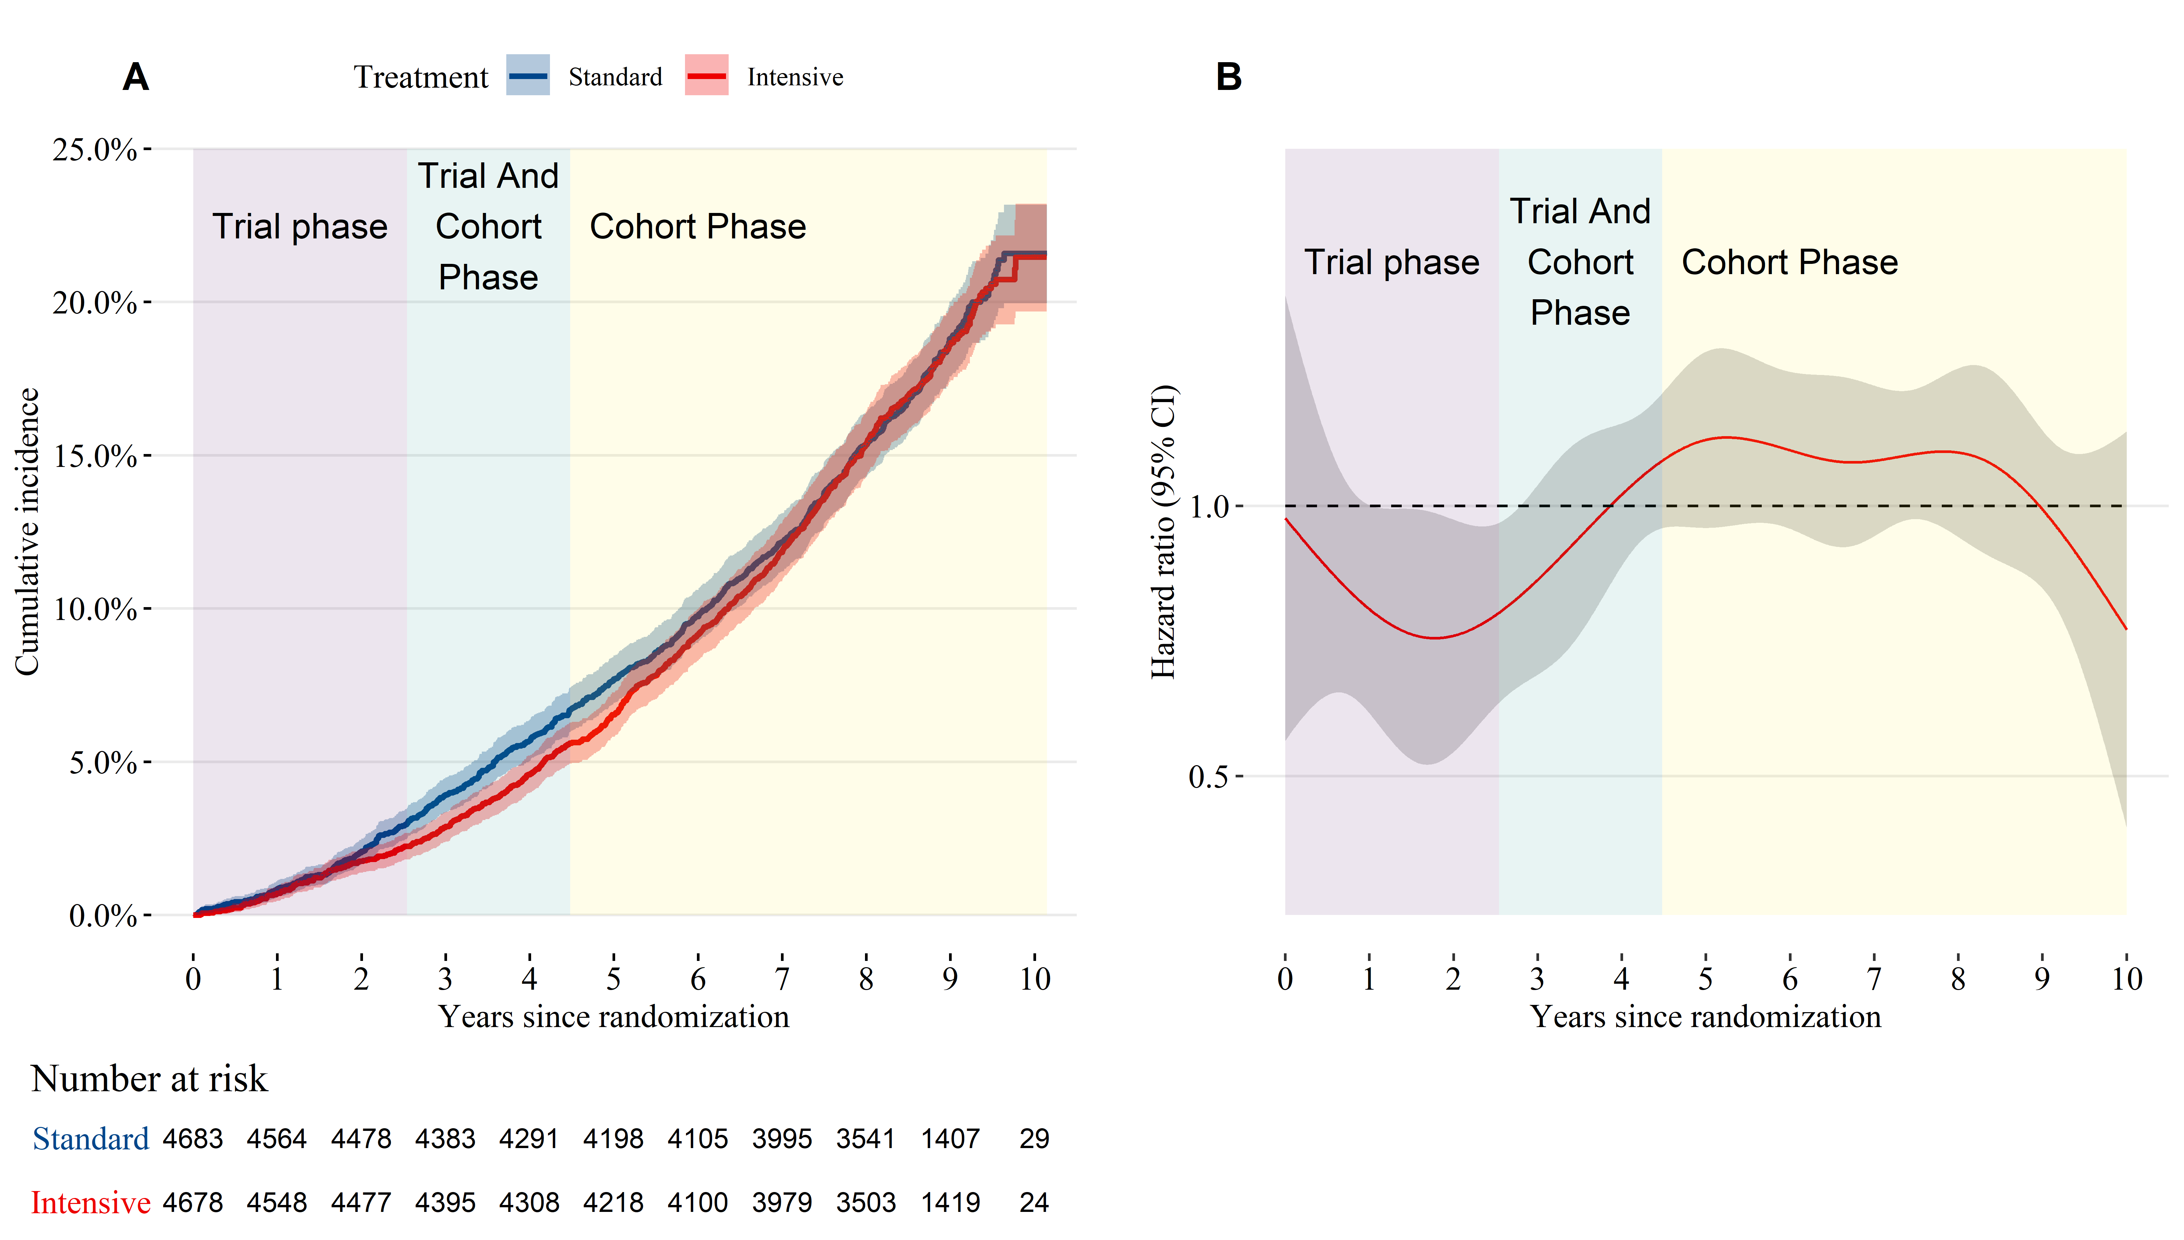

**Figure 2**: (A) Cumulative incidence of cardiovascular and non-cardiovascular mortality by treatment group. (B) Time-dependent effect of randomization to intensive treatment for cardiovascular mortality.

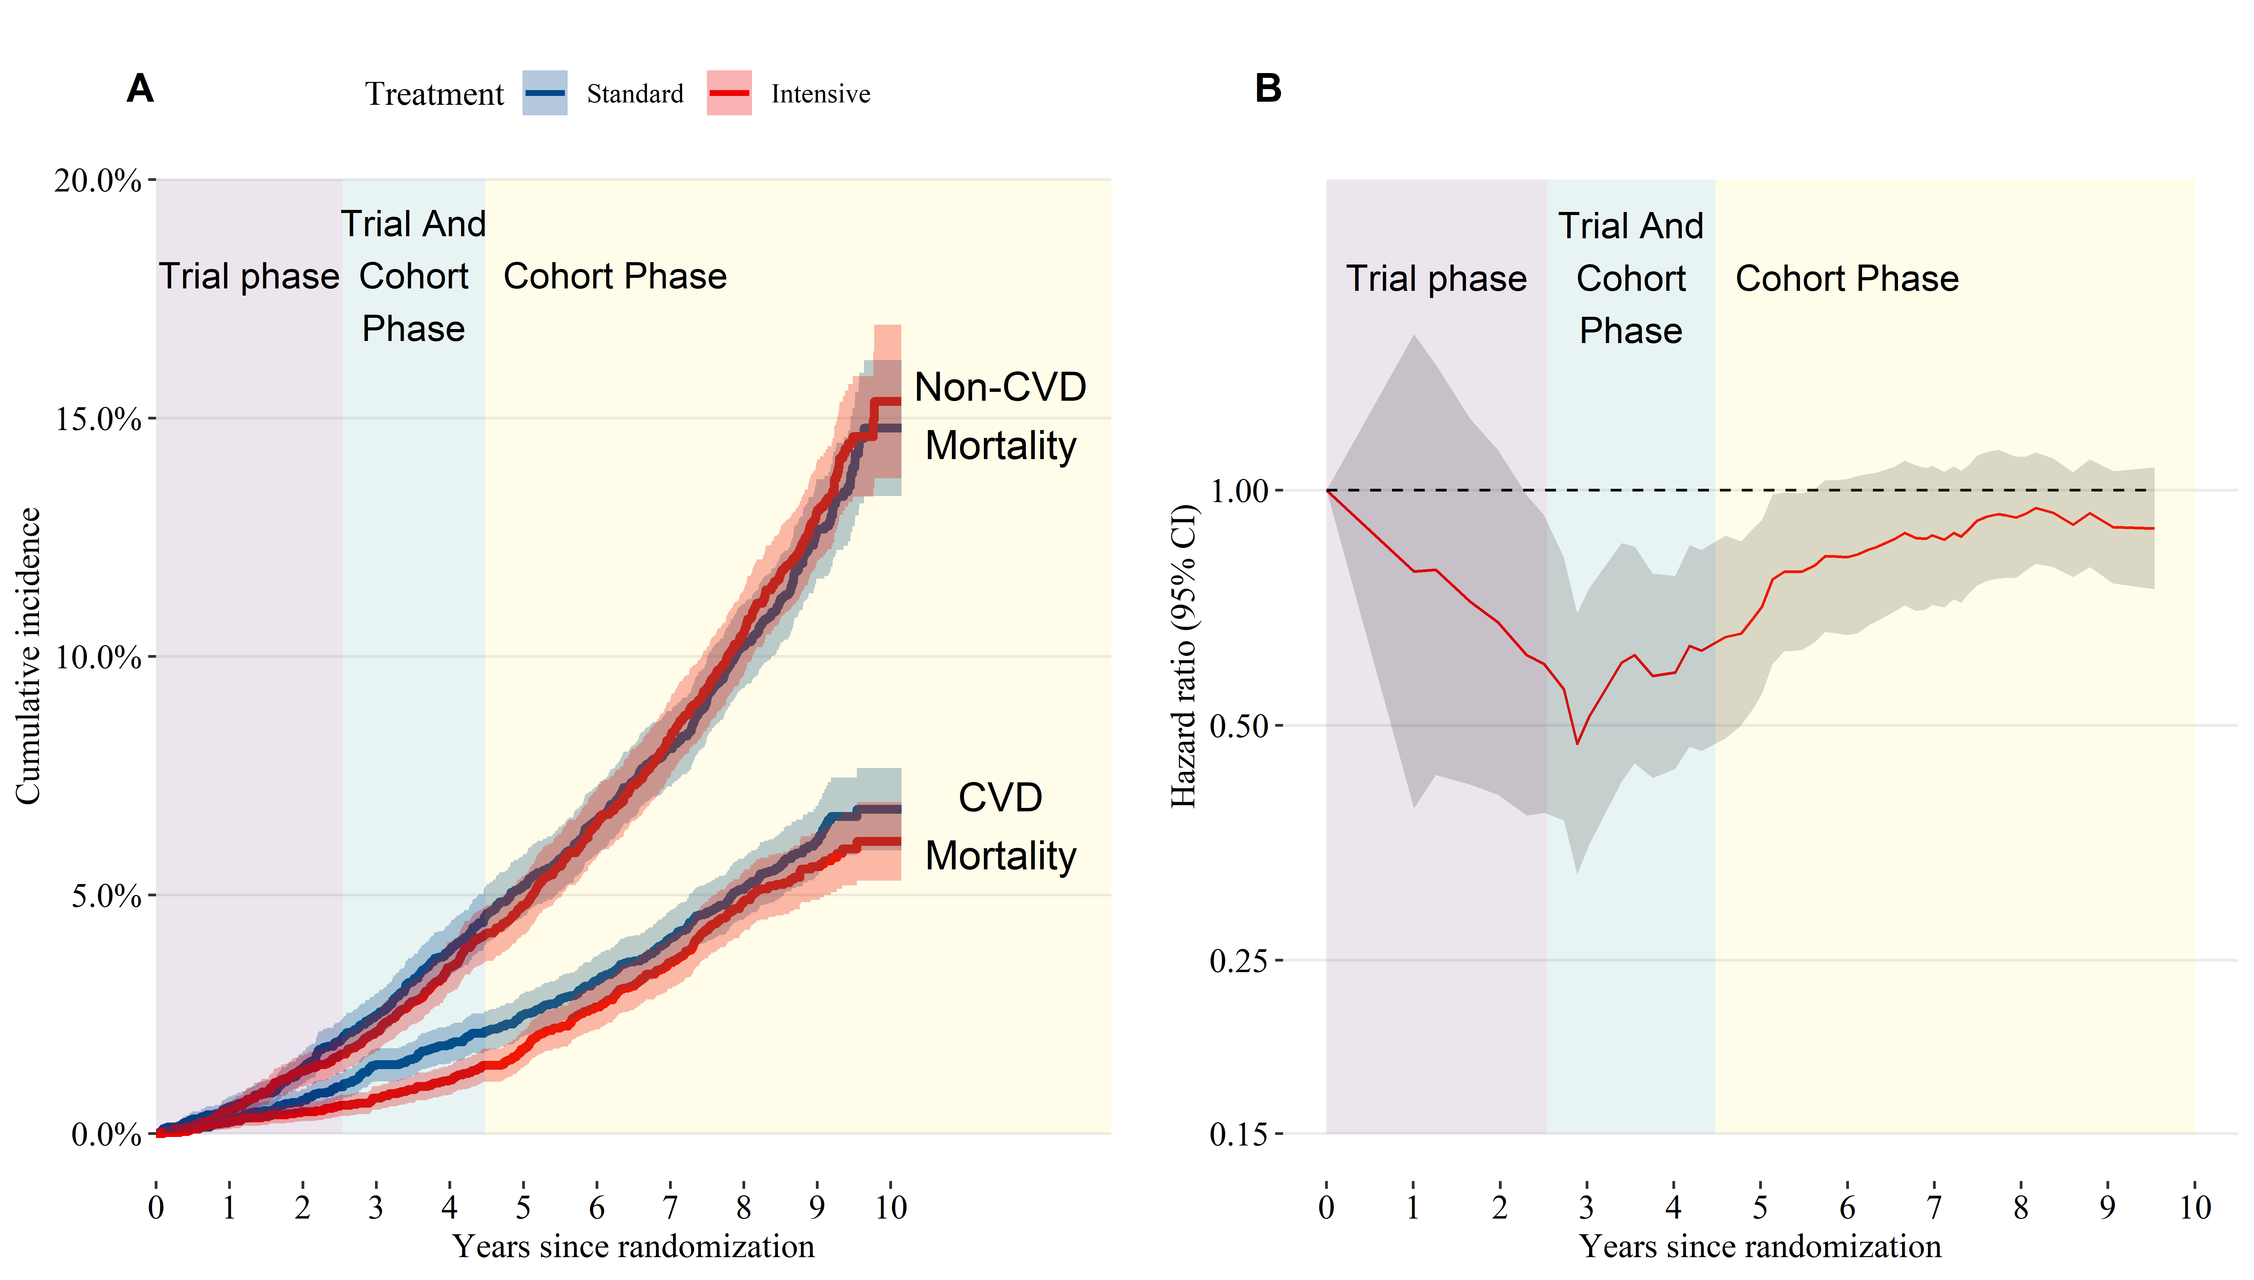

**Figure 3**: Mean systolic blood pressure over time by treatment group. Shaded areas indicate a 95% confidence interval for the mean.

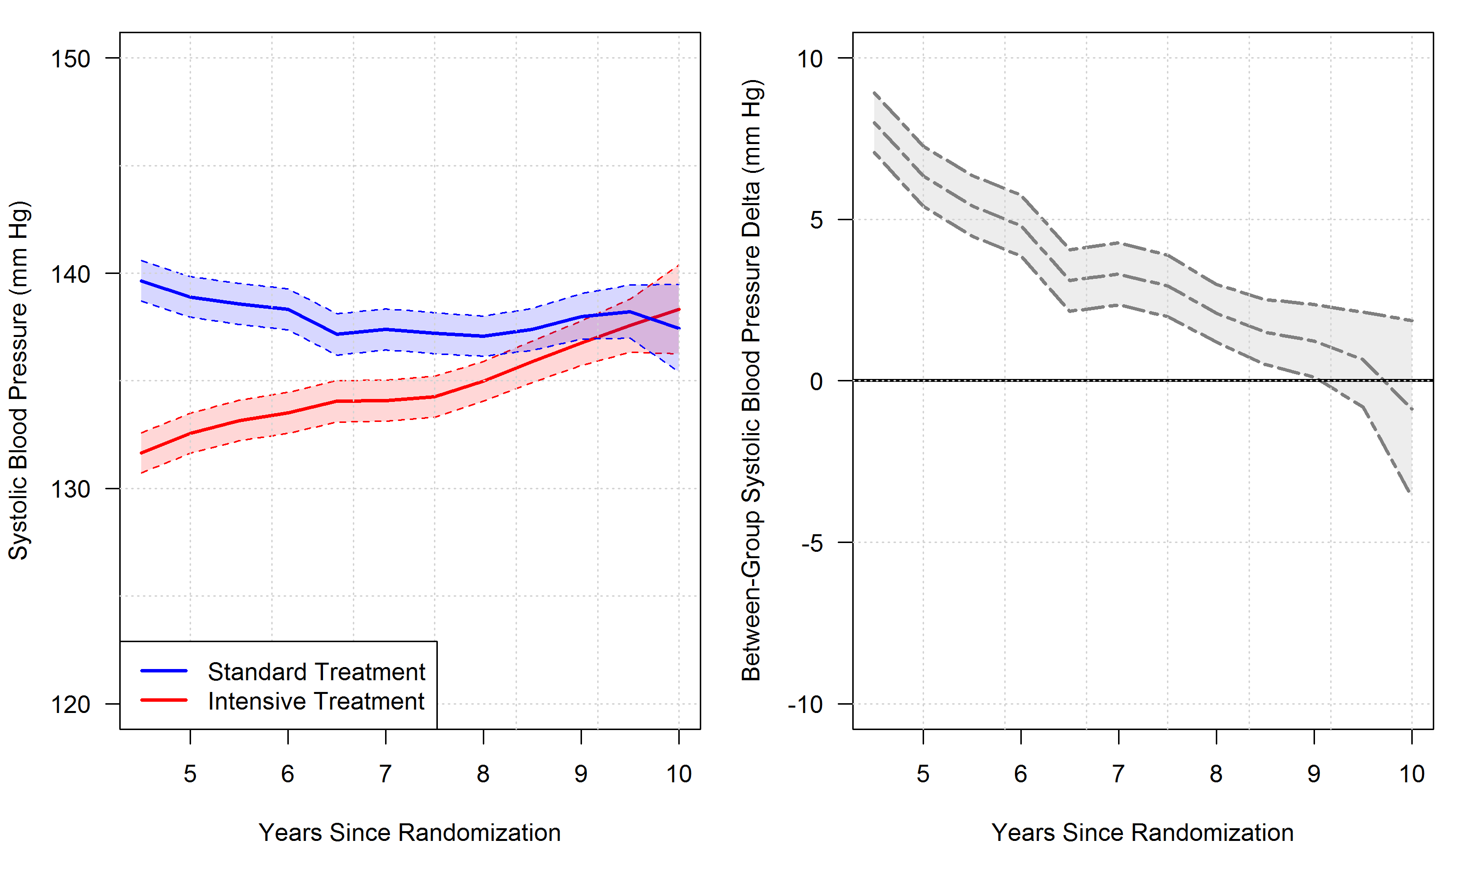

**Figure 4**: All-cause mortality hazard ratio for participants randomized to intensive versus standard treatment.

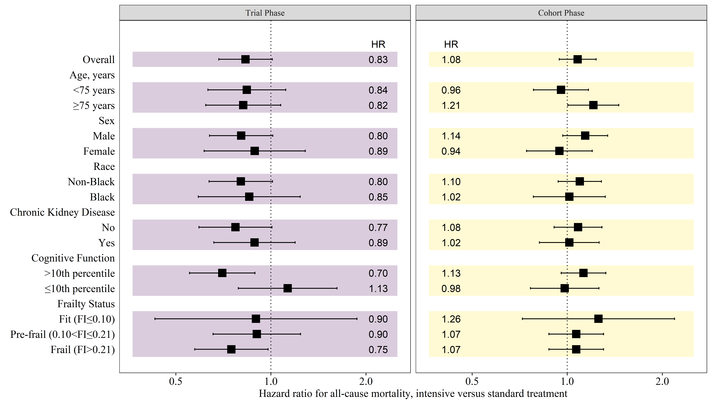

**Figure 5**: Cardiovascular mortality hazard ratio for participants randomized to intensive versus standard treatment.

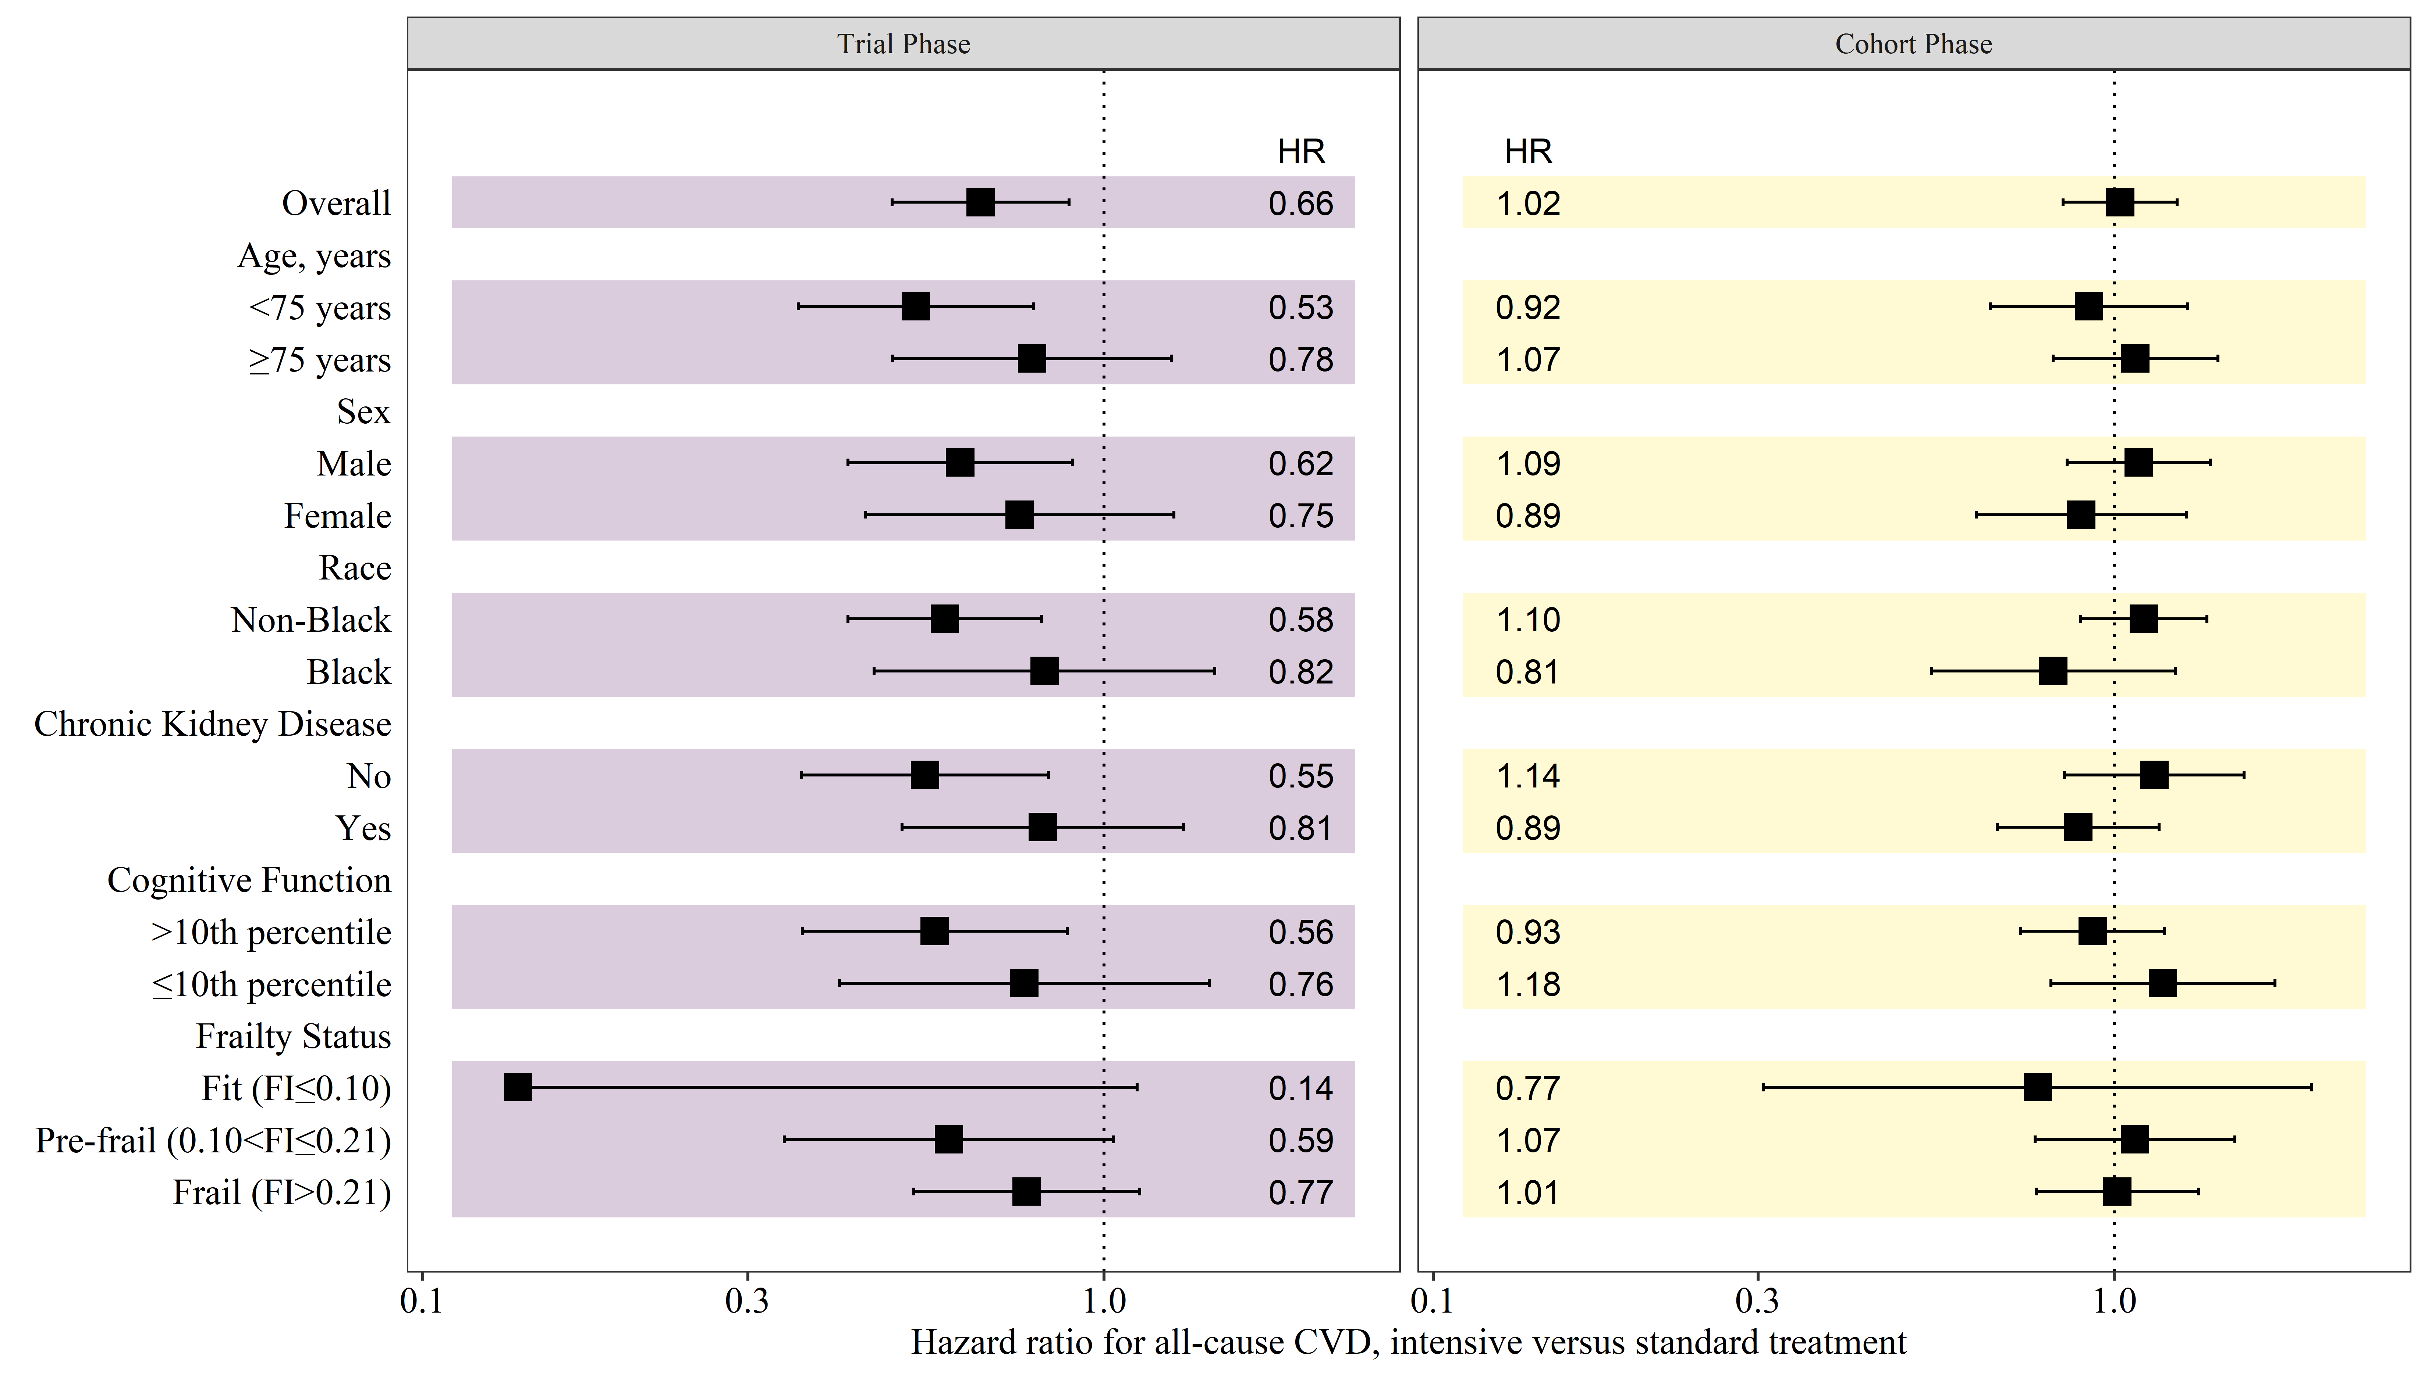

# SUPPLEMENT

To be decided.

# REFERENCES

1 Group SR. A randomized trial of intensive versus standard blood-pressure control. *New England Journal of Medicine* 2015; **373**: 2103–16.

2 Zhang W, Zhang S, Deng Y, *et al.* Trial of Intensive Blood-Pressure Control in Older Patients with Hypertension. *New England Journal of Medicine* 2021; published online Aug. DOI:[10.1056/NEJMoa2111437](https://doi.org/10.1056/NEJMoa2111437).

3 Rahimi K, Bidel Z, Nazarzadeh M, *et al.* Age-stratified and blood-pressure-stratified effects of blood-pressure-lowering pharmacotherapy for the prevention of cardiovascular disease and death: An individual participant-level data meta-analysis. *The Lancet* 2021; **398**: 1053–64.

4 Ambrosius WT, Sink KM, Foy CG, *et al.* The design and rationale of a multicenter clinical trial comparing two strategies for control of systolic blood pressure: The Systolic Blood Pressure Intervention Trial (SPRINT). *Clinical Trials* 2014; **11**: 532–46.

5 Nasreddine ZS, Phillips NA, Bédirian V, *et al.* The Montreal Cognitive Assessment, MoCA: A Brief Screening Tool For Mild Cognitive Impairment. *Journal of the American Geriatrics Society* 2005; **53**: 695–9.

6 Kenny RA, Coen RF, Frewen J, Donoghue OA, Cronin H, Savva GM. Normative values of cognitive and physical function in older adults: Findings from the Irish Longitudinal Study on Ageing. *Journal of the American Geriatrics Society* 2013; **61 Suppl 2**: S279–290.

7 Pajewski NM, Williamson JD, Applegate WB, *et al.* Characterizing Frailty Status in the Systolic Blood Pressure Intervention Trial. *The Journals of Gerontology Series A, Biological Sciences and Medical Sciences* 2016; **71**: 649–55.

8 Drawz PE, Agarwal A, Dwyer JP, *et al.* Concordance Between Blood Pressure in the Systolic Blood Pressure Intervention Trial and in Routine Clinical Practice. *JAMA internal medicine* 2020; **180**: 1655–63.

9 Zhang Z, Reinikainen J, Adeleke KA, Pieterse ME, Groothuis-Oudshoorn CGM. Time-varying covariates and coefficients in Cox regression models. *Annals of Translational Medicine* 2018; **6**: 121.

10 Martinussen T, Scheike TH. Dynamic regression models for survival data. Springer Science & Business Media, 2007.

11 Therneau T, Crowson C, Atkinson E. Using time dependent covariates and time dependent coefficients in the cox model. *Survival Vignettes* 2017; **2**: 3.

12 Lin DY, Wei L-J. The robust inference for the Cox proportional hazards model. *Journal of the American statistical Association* 1989; **84**: 1074–8.

13 Scheike TH, Zhang M-J. Flexible competing risks regression modeling and goodness-of-fit. *Lifetime Data Analysis* 2008; **14**: 464–83.

14 R Core Team. R: A language and environment for statistical computing. Vienna, Austria: R Foundation for Statistical Computing, 2020 <https://www.R-project.org/>.

15 Jaeger B. Table.glue: Make and apply customized rounding specifications for tables. <https://github.com/bcjaeger/table.glue>.

16 Wickham H, Averick M, Bryan J, *et al.* Welcome to the tidyverse. *Journal of Open Source Software* 2019; **4**: 1686.

17 Therneau TM. A package for survival analysis in R. 2021 <https://CRAN.R-project.org/package=survival>.

18 Scheike TH, Zhang M-J. Analyzing competing risk data using the R timereg package. *Journal of Statistical Software* 2011; **38**: 1–5.

19 Landau WM. The targets R package: A dynamic make-like function-oriented pipeline toolkit for reproducibility and high-performance computing. *Journal of Open Source Software* 2021; **6**: 2959.