Longer term All-Cause and Cardiovascular Mortality with Intensive Blood Pressure Control: A Secondary Analysis of SPRINT

Byron C. Jaeger, PhD,1 Adam P. Bress, PharmD, MS,2,3 Joshua D. Bundy, PhD,4 Alfred K. Cheung, MD,5,6 William C. Cushman, MD,7 Paul E. Drawz, MD,8 Lawrence J. Fine, MD,9 Karen C. Johnson, MD,7 Cora E. Lewis, MD,10 Suzanne Oparil, MD,11 Michael V. Rocco, MD,12 Stephen R. Rapp, PhD, 13 Joni K. Snyder, RN,BSN,9 Mark A. Supiano, MD,14 Paul K. Whelton, MD,4 Jeff D. Williamson, MD, MHS,15 Jackson T. Wright, Jr, MD, PhD,16 David M. Reboussin, PhD,1 and Nicholas M. Pajewski, PhD1

1Department of Biostatistics and Data Science, Wake Forest School of Medicine, Winston-Salem, NC. 2Informatics, Decision-Enhancement, and Analytic Sciences (IDEAS) Center, Veterans Affairs, Salt Lake City Health Care System, Salt Lake City, UT. 3Department of Population Health Sciences, University of Utah School of Medicine, Salt Lake City, UT. 4Department of Epidemiology, Tulane University School of Public Health and Tropical Medicine, New Orleans, LA. 5Renal Section, Veterans Affairs Salt Lake City Healthcare System, UT. 6Division of Nephrology and Hypertension, Department of Internal Medicine, University of Utah School of Medicine, Salt Lake Cite, UT. 7Department of Preventive Medicine, University of Tennessee Health Science Center, Memphis. 8Division of Renal Diseases & Hypertension, University of Minnesota, MN. 9Clinical Applications and Prevention Branch, National Heart, Lung, and Blood Institute, National Institutes of Health, Bethesda, MD. 10Department of Epidemiology, University of Alabama at Birmingham. 11Division of Cardiovascular Disease, Department of Medicine, University of Alabama at Birmingham. 12Section on Nephrology, Department of Internal Medicine, Wake Forest School of Medicine, Winston-Salem, NC. 13Departments of Psychiatry and Behavioral Medicine & Social Sciences and Health Policy, Wakfe Forest School of Medicine, Winston-Salem, NC. 14Division of Geriatrics, University of Utah School of Medicine, Salt Lake City. 15Section on Gerontology and Geriatric Medicine, Department of Internal Medicine, Wake Forest School of Medicine, Winston-Salem, NC. 16Division of Nephrology and Hypertension, University Hospitals Cleveland Medical Center, Case Western Reserve University, OH

**Correspondence to:**  
Nicholas M. Pajewski, PhD  
Department of Biostatistics and Data Science  
Division of Public Health Sciences  
Wake Forest School of Medicine  
Medical Center Boulevard  
Winston-Salem, NC 27154  
(336) 713-1396  
[npajewsk@wakehealth.edu](mailto:npajewsk@wakehealth.edu)

**Word Count:** Abstract: ; Manuscript:

# ABSTRACT

**IMPORTANCE**. Both the Systolic Blood Pressure Intervention Trial (SPRINT) and the Strategy of Blood Pressure Intervention in the Elderly Hypertensive Patients (STEP) trial have shown benefits of intensive blood pressure control on cardiovascular morbidity and mortality. However, as both trials were ended after slightly more than 3 years of follow-up, the effect of intensive treatment on longer term mortality is unknown.

**OBJECTIVE**. To evaluate the legacy effect of intensive hypertension treatment on longer term all-cause and cardiovascular mortality.

**DESIGN, SETTING, AND PARTICIPANTS**. SPRINT, a randomized clinical trial of 9361 patients aged 50 years or older with hypertension and increased cardiovascular risk, but without diabetes or history of stroke. Randomization began on November 8, 2010, the trial intervention was stopped early on August 20, 2015, and trial follow-up visits occurred through July 2016.

**INTERVENTIONS**. Randomization to a systolic blood pressure goal of either less than 120 mm Hg (intensive treatment, n=4678) versus less than 140 mm Hg (standard treatment, N=4683).

**MAIN OUTCOMES AND MEASURES**. Cardiovascular and all-cause mortality assessed via the US National Death Index, beginning in 2016 through December 31st, 2020. Outpatient blood pressures measured in routine clinical practice after the trial were examined in a subset of trial participants (N=3644).

**RESULTS**. Among 9361 randomized participants (mean age, 67.9 years; 3332 women [35.6%]), the median intervention period was 3.34 years. Over a median follow-up of 8.76 years, intensive treatment was beneficial for both cardiovascular (Hazard Ratio [HR] = 0.66, 95% CI 0.49 to 0.89) and all-cause mortality (HR = 0.83, 95% CI 0.68 to 1.01) through close-out visits for the trial. However, there was no indication of benefit during post-trial follow-up for either cardiovascular (HR = 1.02, 95% CI 0.84 to 1.24) or all-cause mortality (HR = 1.08, 95% CI 0.94 to 1.23). Results were similar for subgroups based on baseline age, cognitive function, and frailty status. Analyses of outpatient blood pressures indicated a steady decline in the mean between group difference following the trial, largely driven by increases in mean systolic blood pressure in participants randomized to intensive treatment, increasing from a mean of 131.7 mm Hg (95% CI 130.7 to 132.6 mm Hg) at 4.5 years of follow-up to 136.8 mm Hg (95% CI 135.7 to 137.8 mm Hg) at 9 years of follow-up.

**CONCLUSIONS AND RELEVANCE**. The observed benefit of intensive treatment on cardiovascular and all-cause mortality was largely attenuated during post-trial observational follow-up. Given increasing blood pressures in participants randomized to intensive treatment following the trial, these results highlight the importance of consistent long-term management of hypertension.

# INTRODUCTION

Hypertension is the leading modifiable risk factor for cardiovascular disease (CVD).1 Meta analyses of data from randomized trials has shown that pharmacological blood pressure (BP) reduction reduces the risk of major cardiovascular events across the spectrum of initial BP, with larger absolute risk reduction for older adults and lowest CVD risk when systolic BP (SBP) is 120 to 124 mm Hg.2,3 The Systolic Blood Pressure Intervention Trial (SPRINT) showed that intensive SBP control, defined by a SBP target < 120 mm Hg, reduced the risk for cardiovascular morbidity and mortality.4 As SPRINT was stopped early after a median follow-up of 3 years, the longer term, legacy effect of randomization to intensive treatment on cardiovascular and all-cause mortality risk for participants in SPRINT has not been determined.

The objective of the current study was to assess the effect of randomization to intensive treatment in SPRINT on all-cause and cardiovascular mortality up to 10 years following initiation of the trial. A secondary objective, in a subset of trial participants, was to examine SBP following the conclusion of the SPRINT trial follow-up. To accomplish these objectives, we linked SPRINT participants to the National Death Index (NDI) from 2016 to 2020, and extracted longitudinal outpatient measurements of SBP available in the electronic health record (EHR) over the same time period.

# METHODS

**Trial Design**: The design and methods of SPRINT have been published previously.4,5 Briefly, it was a multicenter randomized clinical trial that compared two strategies for managing SBP in older adults with hypertension who were at increased risk of CVD. Participants were aged 50 years or older and had an SBP between 130 and 180 mm Hg at the screening visit, depending on the number of anti-hypertensive agents prescribed. Participants were considered to have an increased cardiovascular risk if they had clinical or subclinical cardiovascular disease, chronic kidney disease (CKD; defined by an estimated glomerular filtration rate of <60 mL/min/1.73 m2), or a Framingham Risk Score of 15% or greater or if they were aged 75 years or older. Individuals residing in a nursing home, persons with a diagnosis of dementia (based on medical record review), and those treated with medications primarily used for dementia therapy were excluded, as were persons with prevalent diabetes mellitus, history of stroke, proteinuria > 1 gram per day, or polycystic kidney disease. Individuals at 102 sites in the United States and Puerto Rico were randomized (1:1) to a SBP goal of less than 120 mm Hg (intensive treatment group, n = 4678) or a goal of less than 140 mm Hg (standard treatment group, n = 4683), using random permuted blocks with the randomization stratified by clinic site. The algorithms and formulary for the trial are listed in the published study protocol ( **citations needed**? ). Trial enrollment began in November 2010 and ended in March 2013, with active follow-up through July 1, 2016.6 The study was approved by the institutional review board at each participating site, and each participant provided written informed consent. The study is registered at ClinicalTrials.gov (NCT01206062).

**Baseline Study Measurements**: Sociodemographic data were collected at baseline, with race or ethnicity information collected via self-report. The estimated glomerular filtration rate (eGFR) was calculated by the race-free 2021 CKD-EPI creatinine equation.7 Cognitive function was assessed using the Montreal Cognitive Assessment (MoCA).8 Lower cognitive function was defined as scoring at or below the estimated age and education-specific normative 10th percentile from the Irish Longitudinal Study of Aging,9 after adding 3 points to the scores of non-White participants.10 We defined frailty status at baseline using a 36-item Frailty Index (FI) based upon the model of deficit accumulation.11 The FI is calculated as the sum of the score for each deficit divided by the total number of nonmissing items. We categorized frailty status as fit (FI ≤ 0.10), less fit (0.10 < FI ≤ 0.21), or frail (FI > 0.21).

**National Death Index Linkage**: Outcomes of interest included all-cause and CVD mortality. Methods of ascertainment and adjudication through the course of trial follow-up have been previously described.4,6 Subsequently, mortality was ascertained through a US National Death Index (NDI) search. Possible matches were identified according to NDI guidelines.12 Deaths were treated as confirmed if they were a Class 1 match, or a Class 2, 3, or 4 match with a probabilistic score above cutoffs recommended by the NDI.12 NDI follow-up began in 2016 and ended on the date of death or December 31, 2020. Deaths ascertained in 2020 were based on the NDI preliminary data release. CVD mortality for NDI-based follow-up used the NDI Plus System, which automatically identifies underlying causes of death from death certificates, including conversion to ICD-10 codes. we defined CVD mortality as any death containing the ICD-10 codes of I00 to I99.13

**EHR Ancillary Study**: We examined the trajectory of SBP following the conclusion of the trial using outpatient SBPs extracted from the EHR. Methods for the linkage of participants to their medical record number and the extraction of vital sign data have been previously described.14 Because encounter type information was inconsistently available (i.e. outpatient, inpatient, observation, etc.), we defined a BP measurement as outpatient if there were was not a BP measurement on the preceding or following day, and if there were 2 or less BP measurements on a particular day. We averaged outpatient EHR BP readings when there were 2 on the same day.

**Statistical Analysis**: Given the a priori expectation that treatment group differences may not be constant as a function of follow-up time (i.e. the proportional hazards assumption was likely to be invalid), we modeled treatment group differences as a function of time using two approaches. The first approach used Cox proportional hazards regression but split follow-up time into non-overlapping trial and cohort phases, estimating separate treatment group differences for each phase.15. The second approach estimated the effect of treatment group as a continuous time-dependent effect.16,17 All analyses accounted for correlation within study sites,18 and analyses of cardiovascular mortality accounted for the competing risk of non-cardiovascular mortality.19. Mean between-group differences in outpatient SBP following the conclusion of trial follow-up were estimated using linear mixed models. Models included random effects for participant and clinic site and an interaction between treatment group and time since randomization, which was flexibly modeled using B-splines. All analyses were performed using SAS version 9.4 (SAS Institute Inc, Cary, NC) and R version 4.1.2 (R Project for Statistical Computing [<http://www.r-project.org>]) with multiple auxiliary R packages.20–25 All hypothesis tests were 2-sided, and P values less than 0.05 were considered statistically significant. No adjustments for multiple comparisons were made.

# RESULTS

***Study Participants***. A total of 9361 participants were randomized between November 2010 and March 2013. The mean (standard deviation [SD]) age was 67.9 (9.4) years, with 28.2% of participants aged 75 years or older (**eTable 1**). Participants were 35.6% female and 31.5% black. The mean (SD) SBP at baseline was 139.7 (15.6) and 27.0% of participants MoCA scores were below the 10th percentile. Participants included in the ancillary EHR study had greater age, lower SBP, less cognitive impairment, higher prevalence of CKD, and were more likely to be male or black than participants not included.

***All-cause Mortality***. In both treatment groups, median follow-up time was 8.76 years. A total of 818 and 826 deaths occurred among participants randomized to intensive and standard treatment, respectively (**eTable 2**). The hazard ratio (HR) for all-cause mortality comparing intensive to standard treatment was 0.83 (95% confidence interval [CI] 0.68, 1.01) during the trial phase, and 1.08 (95% CI 0.94, 1.23) during the cohort phase. The continuous time-dependent effect of intensive versus standard treatment indicated a benefit for all-cause mortality from 1.03 to 2.80 years from randomization, and was attenuated throughout the remainder of the cohort phase (**Figure 1**). In subgroups based on age, sex, race, CKD, cognitive function, and frailty, there was no evidence that intensive treatment during the trial phase had benefit for all-cause mortality during the cohort phase (**Figure 2**).

***Cardiovascular Mortality***. A total of 248 and 273 CVD mortality events occurred among participants randomized to intensive and standard treatment, respectively (**eTable 3**). The HR for CVD mortality among participants randomized to intensive versus standard treatment was 0.66 (95% CI 0.49, 0.89) during the trial phase and 1.02 (95% CI 0.84, 1.24) during the cohort phase. The time-dependent effect of intensive versus standard treatment indicated a benefit for CVD mortality from 2.30 to 5.62 years from randomization, and was attenuated throughout the remainder of the cohort period (**Figure 3**). Adults randomized to intensive treatment who were <75 years of age, men, non-black, without CKD, or with cognitive function >10th percentile had lower CVD mortality risk during the trial phase compared to their counterparts randomized to standard treatment, but there was no evidence that intensive treatment during the trial phase had benefit for CVD mortality during the cohort phase (**Figure 4**).

***Blood Pressure***. The estimated mean (95% CI) SBP among participants randomized to intensive treatment was 133 (132, 134) at 5 years and 140 (137, 143) at 10 years post-randomization (**Figure 5**). For participants randomized to standard treatment, mean (95% CI) SBP was estimated to be 139 (138, 140) at 5 years and 140 (137, 143) post-randomization. The difference in mean SBP levels between participants randomized to intensive versus standard treatment, in mm Hg, was 5.90 (4.87, 6.94) at 5 years post-randomization, and was attenuated at 9 years post-randomization (**eFigure 1**).

# DISCUSSION

The current study analyzed all-cause and CVD-mortality among SPRINT participants up to 10 years following randomization and found no indication of benefit for randomization to intensive treatment after the trial had ended. Time-varying estimates of the benefit of intensive treatment for all-cause mortality were attenuated at 2.80 years while the benefit for CVD-mortality was attenuated at 5.62 years post-randomization. Findings from our ancillary study of BP in the EHR indicated that the difference in SBP between treatment groups diminished over time and was attenuated approximately 9 years after randomization. These results in combination with the main findings of SPRINT indicate that the beneficial effect of BP control among adults with hypertension can be diminished if BP control is not sustained over time.

The Strategy of Blood Pressure Intervention in the Elderly Hypertensive Patients (STEP) trial enrolled 8511 Chinese patients 60 to 80 years of age with hypertension and randomized patients to a SBP target of 110 to less than 130 mm Hg (intensive treatment) or a target of 130 to less than 150 mm Hg (standard treatment).26 Similar to SPRINT, STEP found a HR of 0.72 (95% CI 0.39, 1.32) with intensive versus standard treatment for CVD mortality after a median follow-up of 3.34 years, but did not find evidence of a benefit for all-cause mortality. In the current study of SPRINT participants, the protective effect of intensive treatment for all-cause mortality was attenuated several years before the protective effect for CVD. These results in combination with findings from the STEP trial suggest weaker evidence for reduced all-cause versus CVD mortality risk with intensive BP control. Another contrasting result was that intensive treatment in SPRINT, but not STEP, increased the risk of acute kidney injury (AKI). While this may be attributable to the much lower prevalence of chronic kidney disease in STEP (2.3% vs 28.3%), the association of AKI with increased mortality risk may have been a contributing factor to the longer term effect of randomization to intensive treatment on all-cause mortality among SPRINT participants.27,28

Previous studies have found rising BP levels among US adults during the time period of the current study. General population studies of adults living in the US with hypertension found that the prevalence of uncontrolled BP (SBP ≥ 140 mm Hg or DBP ≥ 90 mm Hg) increased from 2013 to 2017.29 In addition, an analysis of data from 464,585 adults enrolled in a Quest Diagnostics wellness program found SBP was 1 mm Hg and 3 mm Hg higher, depending on age group and sex, in April through December of 2020 versus their corresponding values throughout 2019.30 The current study shows that even for adults who have maintained intense BP control for 3 years, increasing BP levels can quickly diminish the protective effect. Combined with previous findings on rising BP levels among US adults, data from the current study emphasize the need for implementation of population- and community-level strategies to improve BP control in the US.

**PARAGRAPH ON ACCAHA GUIDELINE + 2020 CALL TO ACTION?**

This study has several limitations. First, while we restricted analyses to high quality NDI matches, some small degree of misclassification in linking participants to the NDI is likely. Second, while several studies have shown reasonable performance of using NDI diagnosis codes for defining CVD mortality, it is not as robust as the adjudication process used in the primary follow-up for the trial. Third, information about BP control after the trial was limited to routine outpatient BPs extracted from the EHR, which are known to poorly reflect the standardized BP measurement process used during the SPRINT trial.14

In conclusion, the mean SBP levels of SPRINT participants randomized to intensive treatment increased after the trial and there was no indication of benefit for all-cause or CVD-mortality among SPRINT participants randomized to intensive treatment up to 10 years following randomization. Therefore, maintaining controlled SBP may be essential for long-term risk CVD risk reduction.

# ACKNOWLEDGMENTS

The views expressed in this paper are those of the authors and do not represent the official position of the National Institutes of Health (NIH), the National Heart, Lung, and Blood Institute, the Department of Veterans Affairs, or the U.S. Government, or the SPRINT Research Group. This paper was not reviewed by the SPRINT Publications and Presentations Committee. The authors also wish to acknowledge computing support provided the Veterans Affairs Informatics and Computing Infrastructure (VINCI).

# FINANCIAL DISCLOSURE

The work presented here was supported by R01HL136679, R01AG055606, and R01AG065805. The Systolic Blood Pressure Intervention Trial was funded by the National Institutes of Health (including the National Heart, Lung, and Blood Institute, the National Institute of Diabetes and Digestive and Kidney Diseases, the National Institute on Aging, and the National Institute of Neurological Disorders and Stroke) under contracts HHSN268200900040C, HHSN268200900046C, HHSN268200900047C, HHSN268200900048C, and HHSN268200900049C and interagency agreement A-HL-13-002-001. It was also supported in part with resources and use of facilities through the Department of Veterans Affairs. Azilsartan and chlorthalidone (combined with azilsartan) were provided by Takeda Pharmaceuticals International Inc.

Additional support was provided through the following National Center for Advancing Translational Sciences clinical and translational science awards: UL1TR000439 (awarded to Case Western Reserve University); UL1RR025755 (Ohio State University); UL1RR024134 and UL1TR000003 (University of Pennsylvania); UL1RR025771 (Boston University); UL1TR000093 (Stanford University); UL1RR025752, UL1TR000073, and UL1TR001064 (Tufts University); UL1TR000050 (University of Illinois); UL1TR000005 (University of Pittsburgh); U54TR000017-06 (University of Texas Southwestern Medical Center); UL1TR000105-05 (University of Utah); UL1 TR000445 (Vanderbilt University); UL1TR000075 (George Washington University); UL1 TR000002 (University of California, Davis); UL1 TR000064 (University of Florida); and UL1TR000433 (University of Michigan); and by National Institute of General Medical Sciences, Centers of Biomedical Research Excellence award NIGMS P30GM103337 (awarded to Tulane University).

**Figure 1**: (A) Cumulative incidence of all-cause mortality by treatment group. (B) Time-dependent effect of randomization to intensive treatment for all-cause mortality.

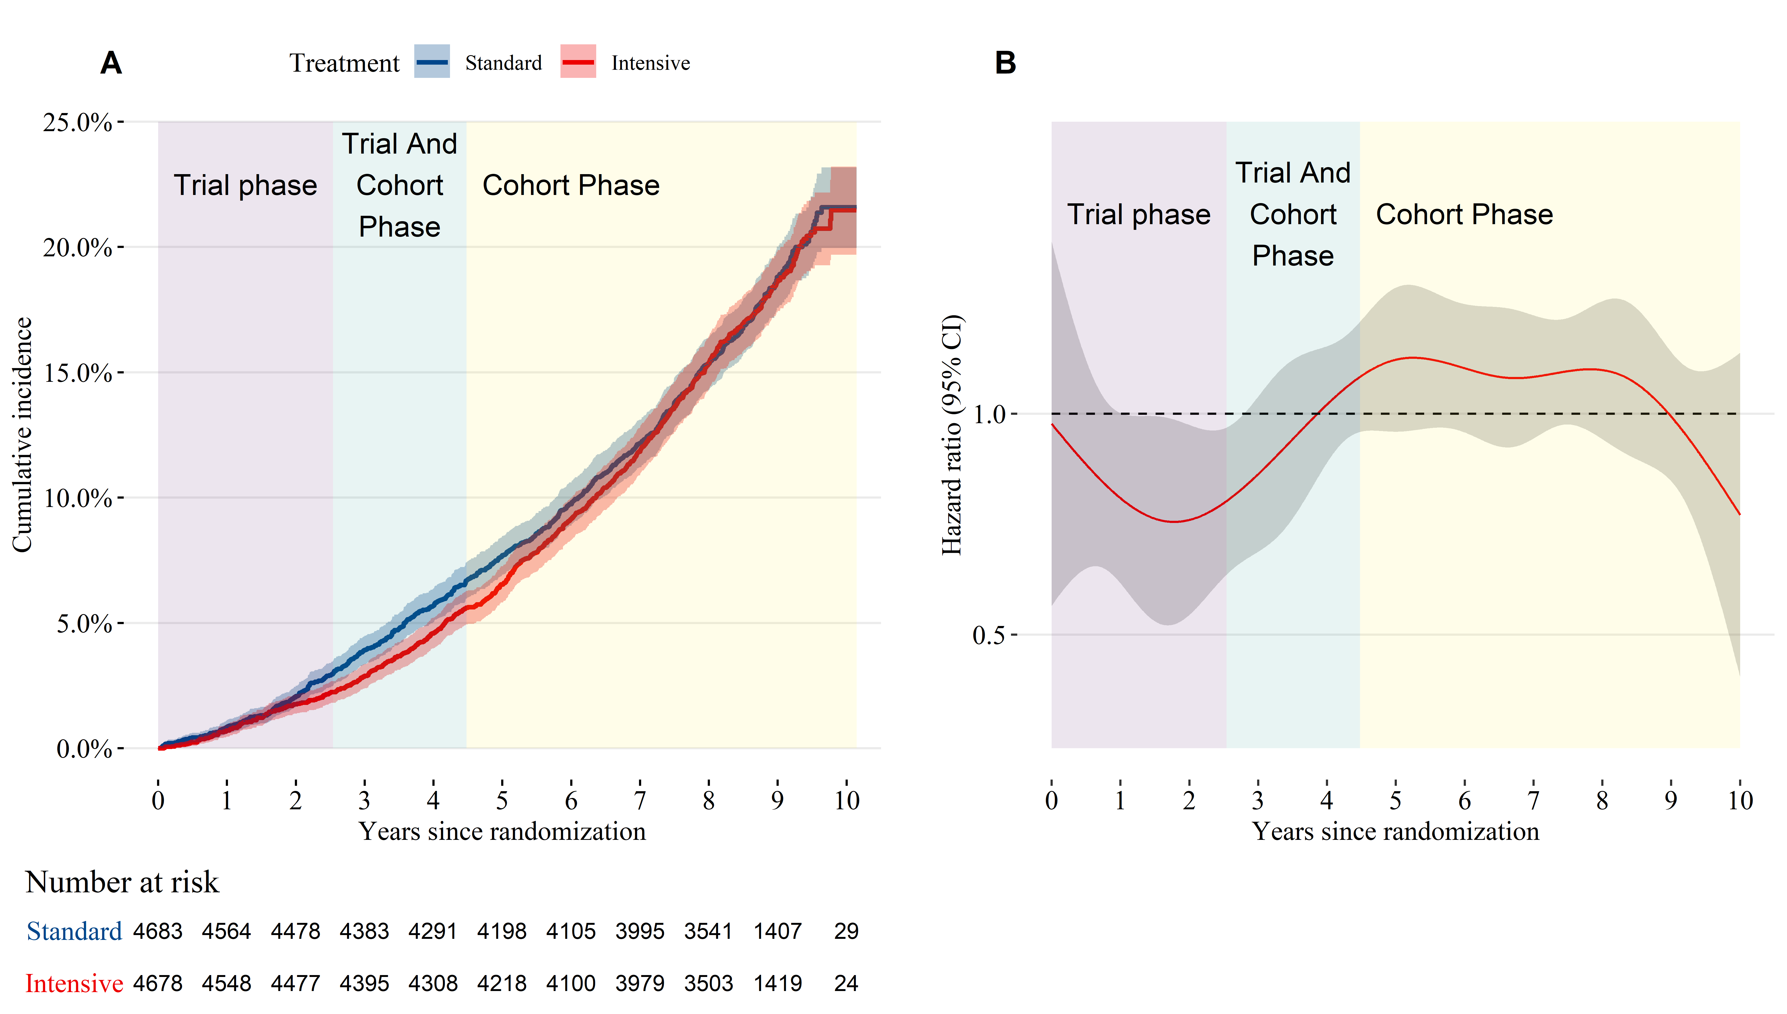

**Figure 2**: All-cause mortality hazard ratio for participants randomized to intensive versus standard treatment.

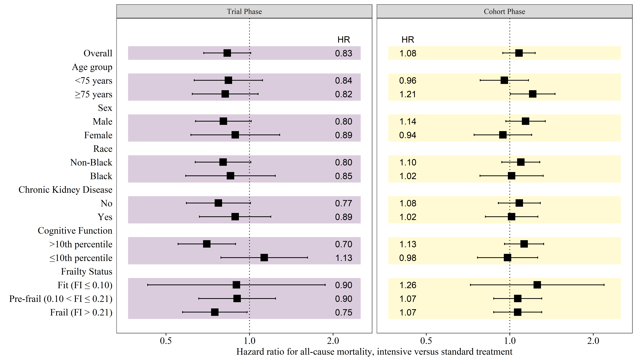

**Figure 3**: (A) Cumulative incidence of cardiovascular and non-cardiovascular mortality by treatment group. (B) Time-dependent effect of randomization to intensive treatment for cardiovascular mortality.

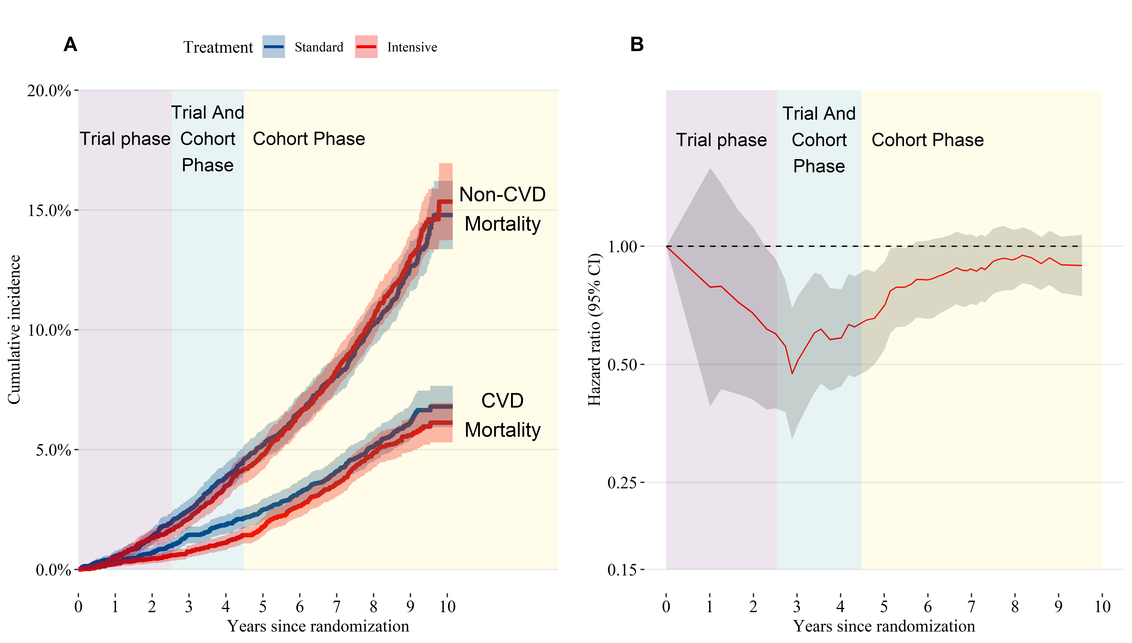

**Figure 4**: Cardiovascular mortality hazard ratio for participants randomized to intensive versus standard treatment.

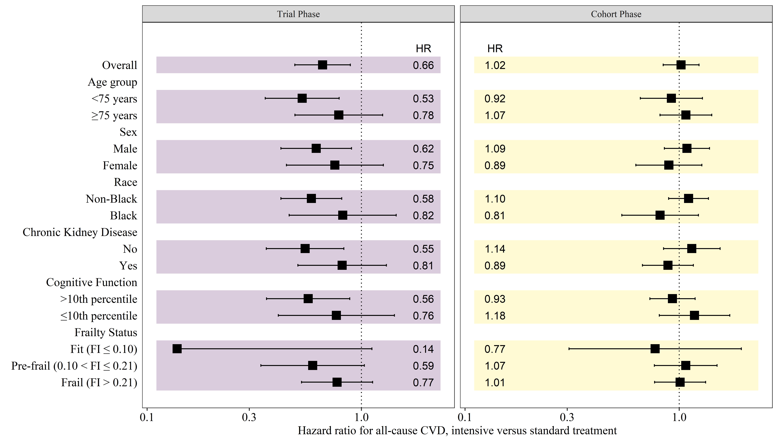

**Figure 5**: Mean systolic blood pressure over time by treatment group. Shaded areas indicate a 95% confidence interval for the mean.

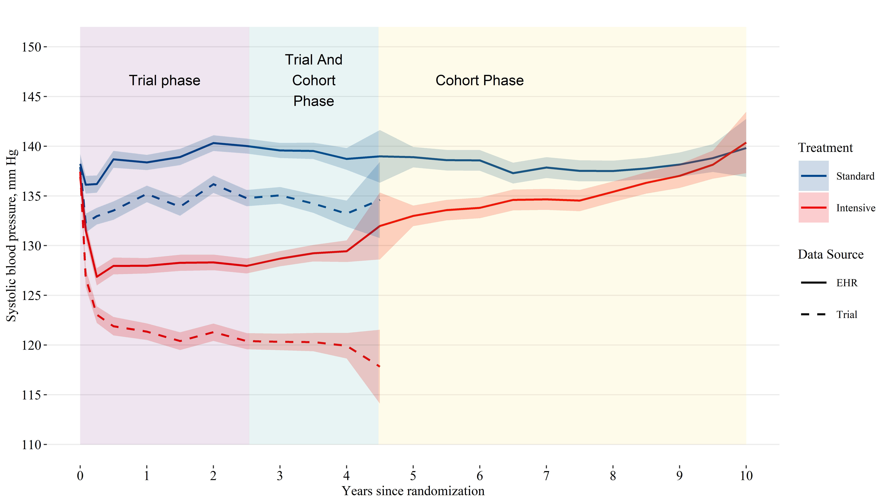

**Online supplement only**

Byron C. Jaeger, PhD,1 Adam P. Bress, PharmD, MS,2,3 Joshua D. Bundy, PhD,4 Alfred K. Cheung, MD,5,6 William C. Cushman, MD,7 Paul E. Drawz, MD,8 Lawrence J. Fine, MD,9 Karen C. Johnson, MD,7 Cora E. Lewis, MD,10 Suzanne Oparil, MD,11 Michael V. Rocco, MD,12 Stephen R. Rapp, PhD, 13 Joni K. Snyder, RN,BSN,9 Mark A. Supiano, MD,14 Paul K. Whelton, MD,4 Jeff D. Williamson, MD, MHS,15 Jackson T. Wright, Jr, MD, PhD,16 David M. Reboussin, PhD,1 and Nicholas M. Pajewski, PhD1

1Department of Biostatistics and Data Science, Wake Forest School of Medicine, Winston-Salem, NC. 2Informatics, Decision-Enhancement, and Analytic Sciences (IDEAS) Center, Veterans Affairs, Salt Lake City Health Care System, Salt Lake City, UT. 3Department of Population Health Sciences, University of Utah School of Medicine, Salt Lake City, UT. 4Department of Epidemiology, Tulane University School of Public Health and Tropical Medicine, New Orleans, LA. 5Renal Section, Veterans Affairs Salt Lake City Healthcare System, UT. 6Division of Nephrology and Hypertension, Department of Internal Medicine, University of Utah School of Medicine, Salt Lake Cite, UT. 7Department of Preventive Medicine, University of Tennessee Health Science Center, Memphis. 8Division of Renal Diseases & Hypertension, University of Minnesota, MN. 9Clinical Applications and Prevention Branch, National Heart, Lung, and Blood Institute, National Institutes of Health, Bethesda, MD. 10Department of Epidemiology, University of Alabama at Birmingham. 11Division of Cardiovascular Disease, Department of Medicine, University of Alabama at Birmingham. 12Section on Nephrology, Department of Internal Medicine, Wake Forest School of Medicine, Winston-Salem, NC. 13Departments of Psychiatry and Behavioral Medicine & Social Sciences and Health Policy, Wakfe Forest School of Medicine, Winston-Salem, NC. 14Division of Geriatrics, University of Utah School of Medicine, Salt Lake City. 15Section on Gerontology and Geriatric Medicine, Department of Internal Medicine, Wake Forest School of Medicine, Winston-Salem, NC. 16Division of Nephrology and Hypertension, University Hospitals Cleveland Medical Center, Case Western Reserve University, OH

**eTable 1**: Characteristics of study participants.

| **Characteristic** | **Overall N = 9,361** | **Treatment** | | **Included in EHR ancillary study** | | **p-valuea b** |
| --- | --- | --- | --- | --- | --- | --- |
| **Standard N = 4,683** | **Intensive N = 4,678** | **No N = 5,952** | **Yes N = 3,409** |
| Age, years | 67.9 (9.4) | 67.9 (9.5) | 67.9 (9.4) | 67.8 (9.7) | 68.2 (9.0) | 0.021 |
| Age ≥75 years | 28.2 | 28.2 | 28.2 | 27.8 | 28.8 | 0.3 |
| Female | 35.6 | 35.2 | 36.0 | 41.6 | 25.1 | <0.001 |
| Black | 31.5 | 31.9 | 31.1 | 30.7 | 32.9 | 0.030 |
| Systolic blood pressure | 139.7 (15.6) | 139.7 (15.4) | 139.7 (15.8) | 140.8 (15.7) | 137.7 (15.1) | <0.001 |
| Intensive treatment | 50.0 |  |  | 49.8 | 50.2 | 0.8 |
| Included in EHR ancillary study | 36.4 | 36.3 | 36.6 |  |  |  |
| Chronic Kidney Diseasec | 25.0 | 25.0 | 25.1 | 23.8 | 27.3 | <0.001 |
| MoCA ≤10th percentile | 27.0 | 26.9 | 27.1 | 27.9 | 25.5 | 0.014 |
| Frailty Status |  |  |  |  |  | 0.080 |
| Fit (FI≤0.10) | 15.9 | 15.7 | 16.2 | 16.5 | 14.9 |  |
| Pre-frail (0.10<FI≤0.21) | 51.2 | 51.7 | 50.8 | 51.3 | 51.1 |  |
| Frail (FI>0.21) | 32.9 | 32.7 | 33.1 | 32.3 | 34.0 |  |
| Table values are mean (standard deviation) or percentage. | | | | | | |
| a P-values computed using Wilcoxon rank sum test for continuous variables and chi-square test for categorical variables. | | | | | | |
| b Hypothesis tests compare the characteristics of participants included versus excluded from the ancillary study of blood pressure levels using data from the electronic health record. | | | | | | |
| c Chronic Kidney Disease was defined by an estimated glomerular filtration rate <60 ml/min/1.73 m2 based on the 2021 CKD-EPI creatinine equation. | | | | | | |
| Abbreviations: EHR = electronic health records; FI = frailty index; and MoCA = Montreal cognitive assessment | | | | | | |

**eTable 2**: All-cause mortality by treatment group and subgroup

|  | **Trial Follow-up Through Close-out Visits** | | | | | **Post-trial Follow-up** | | | | |
| --- | --- | --- | --- | --- | --- | --- | --- | --- | --- | --- |
| **N Events / N Total** | | **Incidence (95% CI)** | | **Hazard Ratio (95% CI)** | **N Events / N Total** | | **Incidence (95% CI)** | | **Hazard Ratio (95% CI)** |
| **Standard** | **Intensive** | **Standard** | **Intensive** | **Standard** | **Intensive** | **Standard** | **Intensive** |
| Overall | 290 / 4,683 | 241 / 4,678 | 15.1 (13.4, 16.9) | 12.5 (11.0, 14.2) | 0.83 (0.68, 1.01) | 536 / 4,260 | 577 / 4,274 | 29.6 (27.1, 32.1) | 31.9 (29.3, 34.5) | 1.08 (0.94, 1.23) |
| *Age group* | | | | | | | | | | |
| <75 years | 137 / 3,364 | 115 / 3,361 | 9.73 (8.19, 11.5) | 8.18 (6.78, 9.77) | 0.84 (0.63, 1.11) | 257 / 3,129 | 246 / 3,123 | 18.9 (16.7, 21.3) | 18.1 (15.9, 20.5) | 0.96 (0.78, 1.17) |
| ≥75 years | 153 / 1,319 | 126 / 1,317 | 29.8 (25.3, 34.7) | 24.3 (20.3, 28.8) | 0.82 (0.62, 1.07) | 279 / 1,131 | 331 / 1,151 | 61.6 (54.7, 69.1) | 73.3 (65.7, 81.5) | 1.21 (1.00, 1.46) |
| *Sex* | | | | | | | | | | |
| Male | 212 / 3,035 | 170 / 2,994 | 17.2 (15.0, 19.6) | 13.8 (11.9, 16.0) | 0.80 (0.64, 1.01) | 353 / 2,743 | 400 / 2,745 | 30.3 (27.3, 33.6) | 34.6 (31.3, 38.1) | 1.14 (0.97, 1.34) |
| Female | 78 / 1,648 | 71 / 1,684 | 11.4 (9.02, 14.1) | 10.2 (8.01, 12.8) | 0.89 (0.61, 1.28) | 183 / 1,517 | 177 / 1,529 | 28.2 (24.3, 32.5) | 27.0 (23.2, 31.2) | 0.94 (0.74, 1.20) |
| *Race* | | | | | | | | | | |
| Non-Black | 209 / 3,190 | 173 / 3,224 | 16.0 (13.9, 18.2) | 13.0 (11.2, 15.0) | 0.80 (0.64, 1.01) | 386 / 2,897 | 426 / 2,953 | 31.4 (28.4, 34.6) | 34.2 (31.1, 37.6) | 1.10 (0.94, 1.28) |
| Black | 81 / 1,493 | 68 / 1,454 | 13.2 (10.5, 16.3) | 11.5 (8.95, 14.4) | 0.85 (0.59, 1.24) | 150 / 1,363 | 151 / 1,321 | 25.7 (21.8, 30.0) | 26.7 (22.6, 31.1) | 1.02 (0.78, 1.32) |
| *Chronic Kidney Diseasea* | | | | | | | | | | |
| No | 163 / 3,491 | 126 / 3,485 | 11.3 (9.67, 13.1) | 8.74 (7.30, 10.4) | 0.77 (0.59, 1.01) | 316 / 3,232 | 349 / 3,250 | 22.7 (20.3, 25.2) | 25.0 (22.5, 27.7) | 1.08 (0.91, 1.29) |
| Yes | 125 / 1,161 | 112 / 1,170 | 26.5 (22.1, 31.4) | 23.6 (19.5, 28.2) | 0.89 (0.66, 1.19) | 220 / 1,007 | 227 / 1,012 | 53.8 (47.0, 61.2) | 55.5 (48.6, 63.1) | 1.02 (0.82, 1.26) |
| *Cognitive Function* | | | | | | | | | | |
| >10th percentile | 212 / 3,397 | 152 / 3,389 | 15.1 (13.1, 17.2) | 10.8 (9.14, 12.6) | 0.70 (0.55, 0.89) | 357 / 3,101 | 408 / 3,125 | 26.9 (24.2, 29.8) | 30.7 (27.8, 33.8) | 1.13 (0.96, 1.33) |
| ≤10th percentile | 77 / 1,253 | 83 / 1,257 | 15.3 (12.1, 19.0) | 16.5 (13.2, 20.3) | 1.13 (0.79, 1.62) | 176 / 1,135 | 165 / 1,131 | 36.8 (31.7, 42.6) | 34.7 (29.6, 40.2) | 0.98 (0.76, 1.26) |
| *Frailty Status* | | | | | | | | | | |
| Fit (FI ≤ 0.10) | 21 / 729 | 18 / 751 | 6.90 (4.35, 10.3) | 5.68 (3.45, 8.73) | 0.90 (0.43, 1.87) | 34 / 685 | 42 / 715 | 11.3 (7.88, 15.5) | 13.4 (9.71, 17.8) | 1.26 (0.72, 2.19) |
| Pre-frail (0.10 < FI ≤ 0.21) | 107 / 2,406 | 93 / 2,359 | 10.7 (8.79, 12.8) | 9.52 (7.71, 11.6) | 0.90 (0.66, 1.24) | 251 / 2,244 | 261 / 2,193 | 26.1 (23.0, 29.5) | 27.8 (24.5, 31.3) | 1.07 (0.87, 1.30) |
| Frail (FI > 0.21) | 161 / 1,523 | 127 / 1,538 | 26.4 (22.5, 30.7) | 20.4 (17.1, 24.2) | 0.75 (0.57, 0.98) | 251 / 1,317 | 274 / 1,349 | 46.2 (40.7, 52.2) | 49.9 (44.2, 56.0) | 1.07 (0.87, 1.30) |
| aChronic Kidney Disease was defined by an estimated glomerular filtration rate <60 ml/min/1.73 m2 based on the 2021 CKD-EPI creatinine equation. | | | | | | | | | | |
| Abbreviations: CI = confidence interval; and FI = frailty index | | | | | | | | | | |

**eTable 3**: Cardiovascular and non-cardiovascular mortality by treatment group and subgroup

|  | **Trial Follow-up Through Close-out Visits** | | | | **Post-trial Follow-up** | | | |
| --- | --- | --- | --- | --- | --- | --- | --- | --- |
| **N CVD / non-CVD / Total** | | **Hazard Ratio (95% CI)** | | **N CVD / non-CVD / Total** | | **Hazard Ratio (95% CI)** | |
| **Standard** | **Intensive** | **CVD** | **Non-CVD** | **Standard** | **Intensive** | **CVD** | **Non-CVD** |
| Overall | 92 / 198 / 4,683 | 65 / 176 / 4,678 | 0.66 (0.49, 0.89) | 0.89 (0.71, 1.10) | 181 / 355 / 4,260 | 183 / 394 / 4,274 | 1.02 (0.84, 1.24) | 1.13 (0.97, 1.31) |
| *Age group* | | | | | | | | |
| <75 years | 45 / 92 / 3,364 | 27 / 88 / 3,361 | 0.53 (0.36, 0.79) | 0.95 (0.68, 1.32) | 81 / 176 / 3,129 | 73 / 173 / 3,123 | 0.92 (0.66, 1.28) | 1.01 (0.84, 1.22) |
| ≥75 years | 47 / 106 / 1,319 | 38 / 88 / 1,317 | 0.78 (0.49, 1.26) | 0.81 (0.61, 1.09) | 100 / 179 / 1,131 | 110 / 221 / 1,151 | 1.07 (0.81, 1.42) | 1.23 (0.99, 1.53) |
| *Sex* | | | | | | | | |
| Male | 68 / 144 / 3,035 | 47 / 123 / 2,994 | 0.62 (0.42, 0.90) | 0.85 (0.67, 1.08) | 119 / 234 / 2,743 | 125 / 275 / 2,745 | 1.09 (0.85, 1.38) | 1.20 (1.00, 1.44) |
| Female | 24 / 54 / 1,648 | 18 / 53 / 1,684 | 0.75 (0.45, 1.27) | 0.97 (0.64, 1.48) | 62 / 121 / 1,517 | 58 / 119 / 1,529 | 0.89 (0.63, 1.28) | 0.98 (0.71, 1.34) |
| *Race* | | | | | | | | |
| Non-Black | 67 / 142 / 3,190 | 44 / 129 / 3,224 | 0.58 (0.42, 0.81) | 0.87 (0.68, 1.12) | 126 / 260 / 2,897 | 135 / 291 / 2,953 | 1.10 (0.89, 1.37) | 1.13 (0.94, 1.36) |
| Black | 25 / 56 / 1,493 | 21 / 47 / 1,454 | 0.82 (0.46, 1.45) | 0.93 (0.64, 1.37) | 55 / 95 / 1,363 | 48 / 103 / 1,321 | 0.81 (0.54, 1.23) | 1.10 (0.84, 1.44) |
| *Chronic Kidney Diseasea* | | | | | | | | |
| No | 50 / 113 / 3,491 | 29 / 97 / 3,485 | 0.55 (0.36, 0.83) | 0.87 (0.65, 1.14) | 90 / 226 / 3,232 | 101 / 248 / 3,250 | 1.14 (0.84, 1.55) | 1.09 (0.90, 1.33) |
| Yes | 41 / 84 / 1,161 | 36 / 76 / 1,170 | 0.81 (0.51, 1.31) | 0.88 (0.62, 1.24) | 91 / 129 / 1,007 | 82 / 145 / 1,012 | 0.89 (0.67, 1.16) | 1.18 (0.93, 1.49) |
| *Cognitive Function* | | | | | | | | |
| >10th percentile | 62 / 150 / 3,397 | 40 / 112 / 3,389 | 0.56 (0.36, 0.88) | 0.74 (0.58, 0.96) | 128 / 229 / 3,101 | 122 / 286 / 3,125 | 0.93 (0.73, 1.19) | 1.25 (1.03, 1.53) |
| ≤10th percentile | 29 / 48 / 1,253 | 23 / 60 / 1,257 | 0.76 (0.41, 1.43) | 1.22 (0.83, 1.78) | 52 / 124 / 1,135 | 58 / 107 / 1,131 | 1.18 (0.81, 1.72) | 0.90 (0.72, 1.12) |
| *Frailty Status* | | | | | | | | |
| Fit (FI ≤ 0.10) | 7 / 14 / 729 | 1 / 17 / 751 | 0.14 (0.02, 1.12) | 1.22 (0.59, 2.53) | 8 / 26 / 685 | 7 / 35 / 715 | 0.77 (0.31, 1.95) | 1.26 (0.78, 2.04) |
| Pre-frail (0.10 < FI ≤ 0.21) | 34 / 73 / 2,406 | 23 / 70 / 2,359 | 0.59 (0.34, 1.03) | 1.00 (0.73, 1.37) | 75 / 176 / 2,244 | 81 / 180 / 2,193 | 1.07 (0.77, 1.50) | 1.04 (0.85, 1.27) |
| Frail (FI > 0.21) | 51 / 110 / 1,523 | 41 / 86 / 1,538 | 0.77 (0.53, 1.13) | 0.75 (0.56, 1.00) | 98 / 153 / 1,317 | 95 / 179 / 1,349 | 1.01 (0.77, 1.33) | 1.20 (0.96, 1.50) |
| aChronic Kidney Disease was defined by an estimated glomerular filtration rate <60 ml/min/1.73 m2 based on the 2021 CKD-EPI creatinine equation. | | | | | | | | |
| Abbreviations: CI = confidence interval; CVD = cardiovascular disease; and FI = frailty index | | | | | | | | |

**eFigure 1**: Mean difference in systolic blood pressure over time. Shaded areas indicate a 95% confidence interval for the mean.

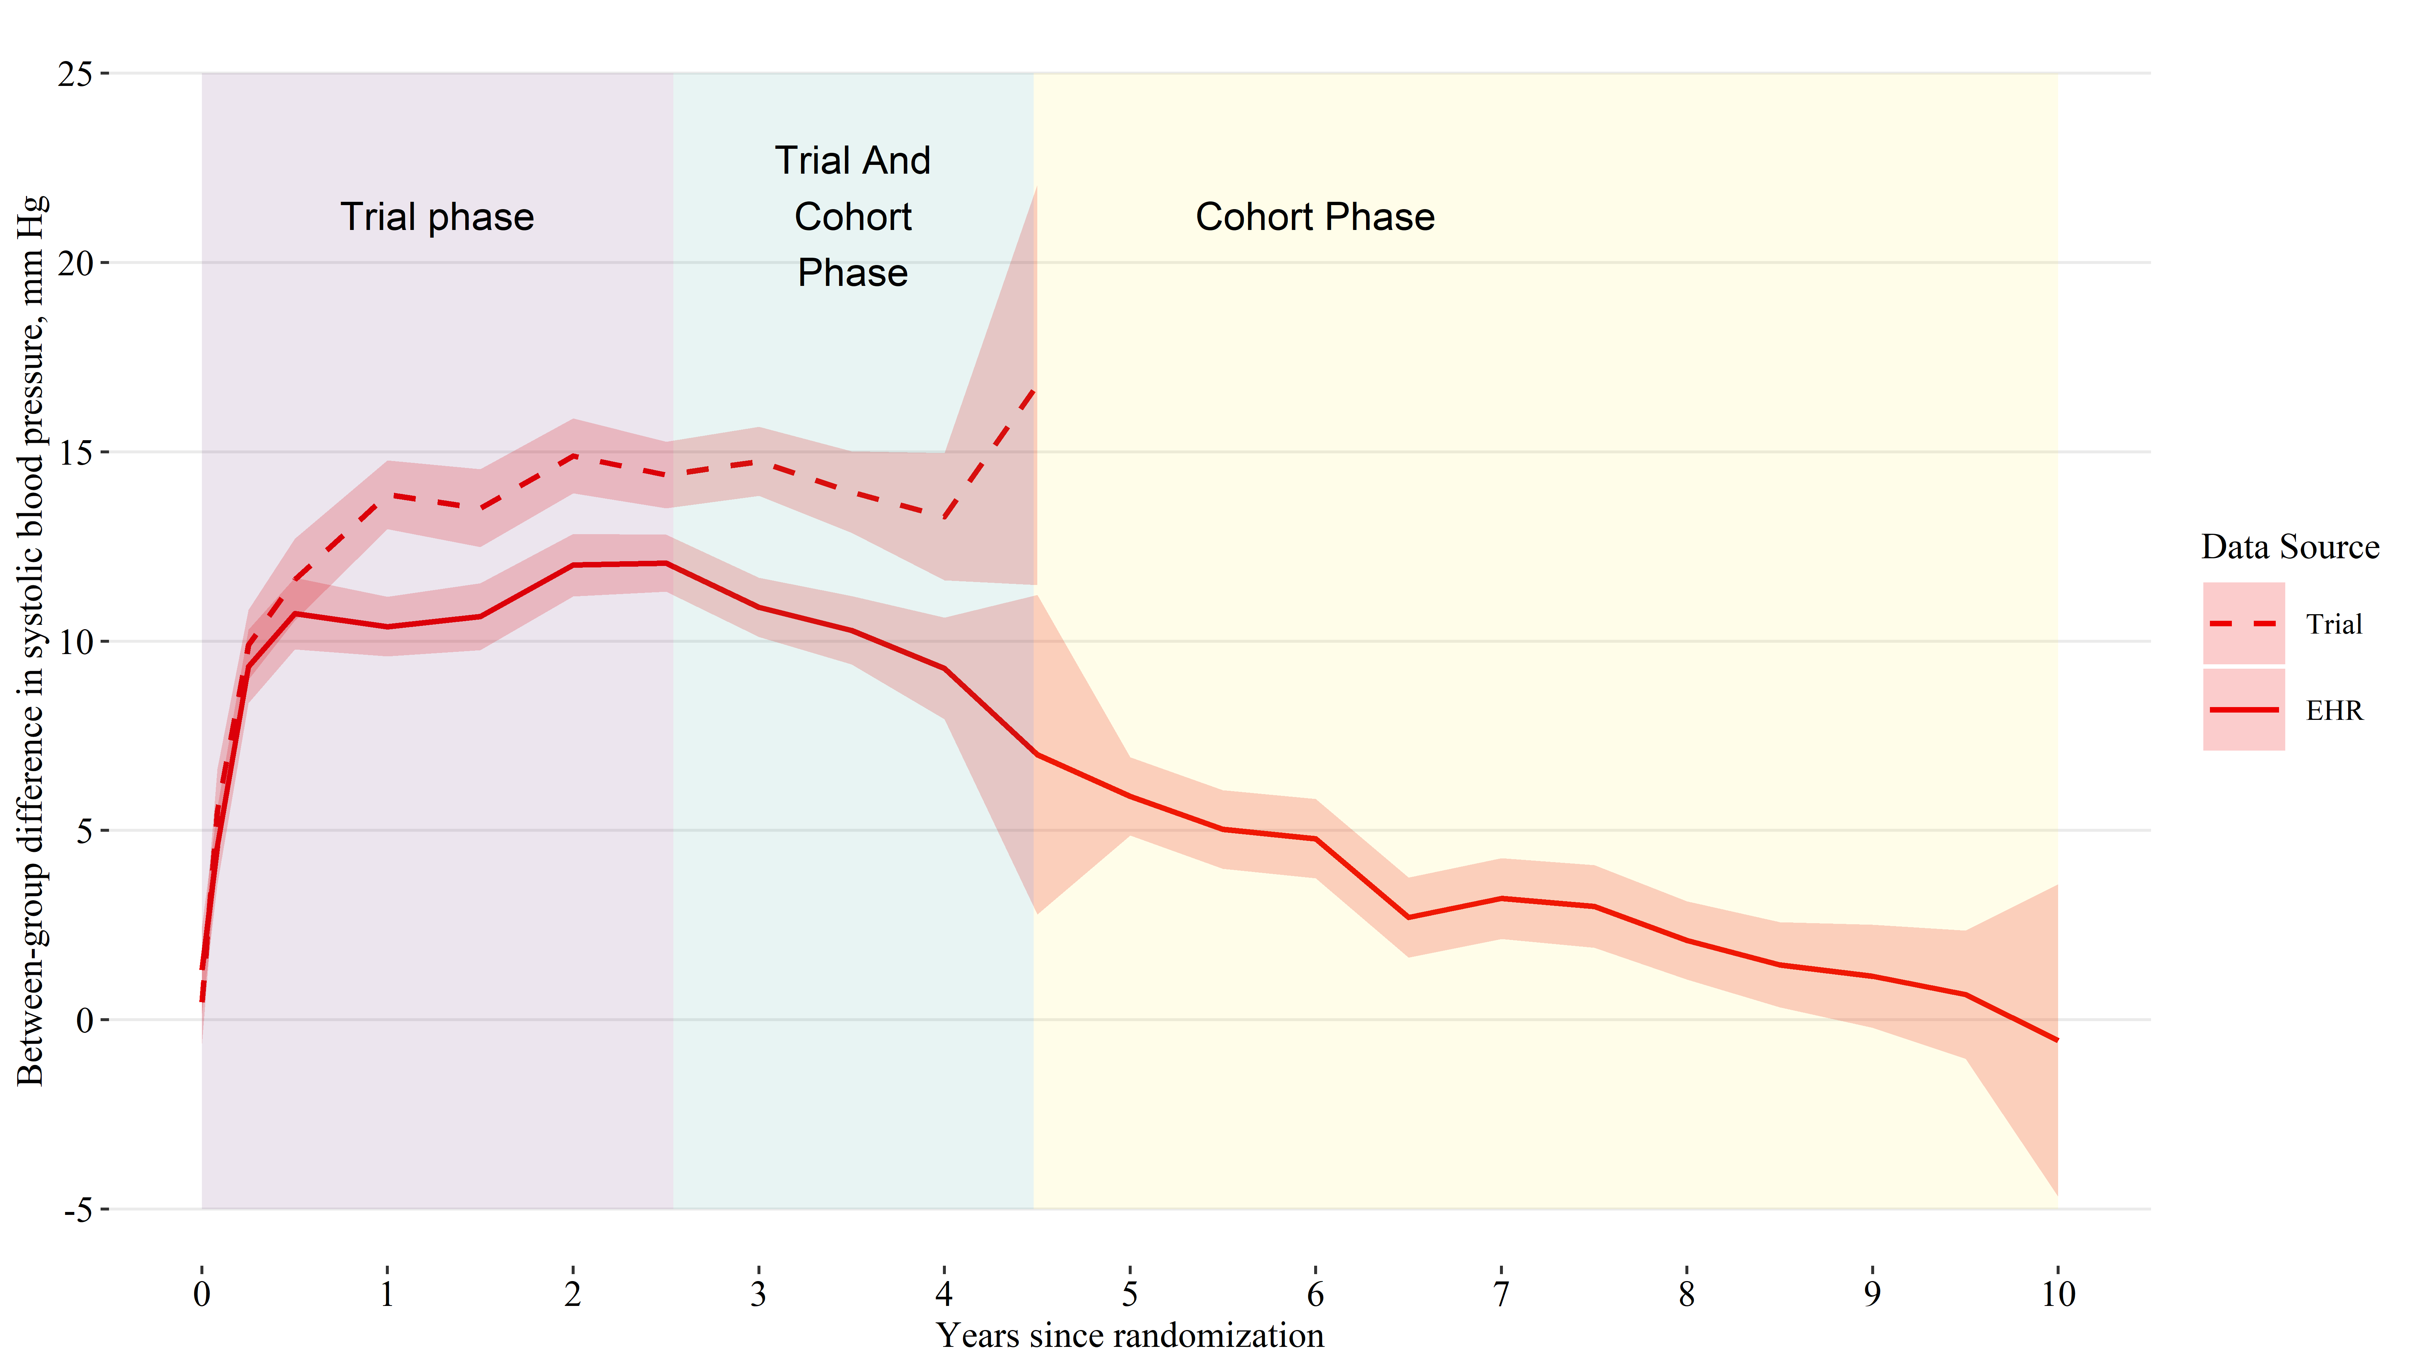

# REFERENCES

1. Roth GA, Mensah GA, Johnson CO, et al. Global Burden of Cardiovascular Diseases and Risk Factors, 1990-2019: Update From the GBD 2019 Study. *J Am Coll Cardiol*. 2020;76(25):2982-3021.

2. Rahimi K, Bidel Z, Nazarzadeh M, et al. Age-stratified and blood-pressure-stratified effects of blood-pressure-lowering pharmacotherapy for the prevention of cardiovascular disease and death: An individual participant-level data meta-analysis. *The Lancet*. 2021;398(10305):1053-1064. doi:[10.1016/S0140-6736(21)01921-8](https://doi.org/10.1016/S0140-6736(21)01921-8)

3. Bundy JD, Li C, Stuchlik P, et al. Systolic blood pressure reduction and risk of cardiovascular disease and mortality: A systematic review and network meta-analysis. *JAMA cardiology*. 2017;2(7):775-781.

4. SPRINT Research Group. A randomized trial of intensive versus standard blood-pressure control. *New England Journal of Medicine*. 2015;373(22):2103-2116.

5. Ambrosius WT, Sink KM, Foy CG, et al. The design and rationale of a multicenter clinical trial comparing two strategies for control of systolic blood pressure: The Systolic Blood Pressure Intervention Trial (SPRINT). *Clinical Trials*. 2014;11(5):532-546. doi:[10.1177/1740774514537404](https://doi.org/10.1177/1740774514537404)

6. SPRINT Research Group, Lewis CE, Fine LJ, et al. Final Report of a Trial of Intensive versus Standard Blood-Pressure Control. *N Engl J Med*. 2021;384(20):1921-1930.

7. Inker LA, Eneanya ND, Coresh J, et al. New Creatinine- and Cystatin C–Based Equations to Estimate GFR without Race. *New England Journal of Medicine*. 2021;385(19):1737-1749. doi:[10.1056/NEJMoa2102953](https://doi.org/10.1056/NEJMoa2102953)

8. Nasreddine ZS, Phillips NA, Bédirian V, et al. The Montreal Cognitive Assessment, MoCA: A Brief Screening Tool For Mild Cognitive Impairment. *Journal of the American Geriatrics Society*. 2005;53(4):695-699. doi:[10.1111/j.1532-5415.2005.53221.x](https://doi.org/10.1111/j.1532-5415.2005.53221.x)

9. Kenny RA, Coen RF, Frewen J, Donoghue OA, Cronin H, Savva GM. Normative values of cognitive and physical function in older adults: Findings from the Irish Longitudinal Study on Ageing. *Journal of the American Geriatrics Society*. 2013;61 Suppl 2:S279-290. doi:[10.1111/jgs.12195](https://doi.org/10.1111/jgs.12195)

10. Sachs BC, Chelune GJ, Rapp SR, et al. Robust demographically-adjusted normative data for the Montreal Cognitive Assessment (MoCA): Results from the systolic blood pressure intervention trial. *Clin Neuropsychol*. Published online September 2021:1-16.

11. Pajewski NM, Williamson JD, Applegate WB, et al. Characterizing Frailty Status in the Systolic Blood Pressure Intervention Trial. *The Journals of Gerontology Series A, Biological Sciences and Medical Sciences*. 2016;71(5):649-655. doi:[10.1093/gerona/glv228](https://doi.org/10.1093/gerona/glv228)

12. National Center for Health Statistics. *National Death Index User’s Guide*.; 2013. <https://www.cdc.gov/nchs/data/ndi/ndi_users_guide.pdf>

13. Olubowale OT, Safford MM, Brown TM, et al. Comparison of Expert Adjudicated Coronary Heart Disease and Cardiovascular Disease Mortality With the National Death Index: Results From the REasons for Geographic And Racial Differences in Stroke (REGARDS) Study. *J Am Heart Assoc*. 2017;6(5).

14. Drawz PE, Agarwal A, Dwyer JP, et al. Concordance Between Blood Pressure in the Systolic Blood Pressure Intervention Trial and in Routine Clinical Practice. *JAMA internal medicine*. 2020;180(12):1655-1663. doi:[10.1001/jamainternmed.2020.5028](https://doi.org/10.1001/jamainternmed.2020.5028)

15. Zhang Z, Reinikainen J, Adeleke KA, Pieterse ME, Groothuis-Oudshoorn CGM. Time-varying covariates and coefficients in Cox regression models. *Annals of Translational Medicine*. 2018;6(7):121. doi:[10.21037/atm.2018.02.12](https://doi.org/10.21037/atm.2018.02.12)

16. Martinussen T, Scheike TH. *Dynamic Regression Models for Survival Data*. Springer Science & Business Media; 2007.

17. Therneau T, Crowson C, Atkinson E. Using time dependent covariates and time dependent coefficients in the cox model. *Survival Vignettes*. 2017;2:3.

18. Lin DY, Wei LJ. The robust inference for the Cox proportional hazards model. *Journal of the American statistical Association*. 1989;84(408):1074-1078.

19. Scheike TH, Zhang MJ. Flexible competing risks regression modeling and goodness-of-fit. *Lifetime Data Analysis*. 2008;14(4):464-483. doi:[10.1007/s10985-008-9094-0](https://doi.org/10.1007/s10985-008-9094-0)

20. R Core Team. *R: A Language and Environment for Statistical Computing*. R Foundation for Statistical Computing; 2020. <https://www.R-project.org/>

21. Jaeger B. *Table.glue: Make and Apply Customized Rounding Specifications for Tables*. <https://github.com/bcjaeger/table.glue>

22. Wickham H, Averick M, Bryan J, et al. Welcome to the tidyverse. *Journal of Open Source Software*. 2019;4(43):1686. doi:[10.21105/joss.01686](https://doi.org/10.21105/joss.01686)

23. Therneau TM. *A Package for Survival Analysis in R*.; 2021. <https://CRAN.R-project.org/package=survival>

24. Scheike TH, Zhang MJ. Analyzing competing risk data using the R timereg package. *Journal of Statistical Software*. 2011;38(2):1-15. <https://www.jstatsoft.org/v38/i02/>

25. Landau WM. The targets R package: A dynamic make-like function-oriented pipeline toolkit for reproducibility and high-performance computing. *Journal of Open Source Software*. 2021;6(57):2959. <https://doi.org/10.21105/joss.02959>

26. Zhang W, Zhang S, Deng Y, et al. Trial of Intensive Blood-Pressure Control in Older Patients with Hypertension. *N Engl J Med*. 2021;385(14):1268-1279.

27. Chawla LS, Eggers PW, Star RA, Kimmel PL. Acute kidney injury and chronic kidney disease as interconnected syndromes. *N Engl J Med*. 2014;371(1):58-66.

28. Rocco MV, Sink KM, Lovato LC, et al. Effects of Intensive Blood Pressure Treatment on Acute Kidney Injury Events in the Systolic Blood Pressure Intervention Trial (SPRINT). *Am J Kidney Dis*. 2018;71(3):352-361.

29. Muntner P, Hardy ST, Fine LJ, et al. Trends in Blood Pressure Control Among US Adults With Hypertension, 1999-2000 to 2017-2018. *JAMA*. 2020;324(12):1190-1200.

30. Laffin LJ, Kaufman HW, Chen Z, et al. Rise in Blood Pressure Observed Among US Adults During the COVID-19 Pandemic. *Circulation*. 2022;145(3):235-237. doi:[10.1161/CIRCULATIONAHA.121.057075](https://doi.org/10.1161/CIRCULATIONAHA.121.057075)