Solar–wind fleets, grid harvesters and co-located fish culture
Costa Rica exploratory extension: assumptions, energy balances and annualized margins

Scope and limitations
This study extends the 10 km² native-Sargassum site screen (9 dry t/ha/year; 10% solids). It is an engineering screen without hourly weather or shipyard/farm bids; it does NOT alter the national optimiser or certify Costa Rican profits. Monetary results are illustrative 2026 US dollars using a 7% assumed discount rate.

1. Large-vessel transport; drones do NOT haul seaweed
A 1,000-wet-tonne vessel with 1,100 m² solar roof (231 kW PV), two 40-kW vertical-axis wind turbines (80 kW total), 700-kW electric propulsion and a 9-MWh battery makes 90 assumed 100-km round trips/year. The 100-km return voyage, 12-km/h speed and 12-hour port turnaround are editable assumptions. Estimated energy per full cycle is 6.69 MWh versus 7.92 MWh usable battery energy. This supports the screened round trip, not statutory reserve margins or seaworthiness.
The deck-mounted VAWTs generate electricity, not sail thrust. The model adds an explicit aerodynamic drag proxy (35% of wind generation during underway hours). It does not credit electricity produced in idle periods: potential generation is duty-cycle constrained. Shore charging remains necessary, and night autonomy is not demonstrated.
Metric | Result
Trips / hull | 90 / 1
Installed PV / VAWT | 231 / 80 kW
Annual total power demand | 602.1 MWh
Usable potential solar / wind | 55.4 / 27.5 MWh
Solar/wind load coverage | 13.8 %
Shore electricity | 519.3 MWh/año
Total hybrid annualized cost | US$1,592,976/año
Hybrid net benefit vs shore-charged electric hull | −US$74,344/año

2. Solar/wind grid harvesters
For 90,000 wet tonnes/year, five 8-t/h, 60-kW grid harvesters require 675 MWh/year for handling. Each unit is screened with 30 kW PV, 20 kW VAWT and 300 kWh buffer storage. Structural loads and cultivation-line interactions require marine engineering and environmental checks. The screen applies coincidence/curtailment losses: annual potential is not firm energy.
Metric | Result
Units | 5
PV / VAWT total | 150 / 100 kW
Electric demand | 675.0 MWh/año
Usable PV / wind | 168.0 / 148.9 MWh/año
Annual onboard coverage | 47.0 %
External electricity | 358.1 MWh/año
Annualized shore-fed cost | US$480,009/año
Annualized hybrid cost | US$607,977/año
Hybrid advantage (+) / extra cost (−) | −US$127,968/año
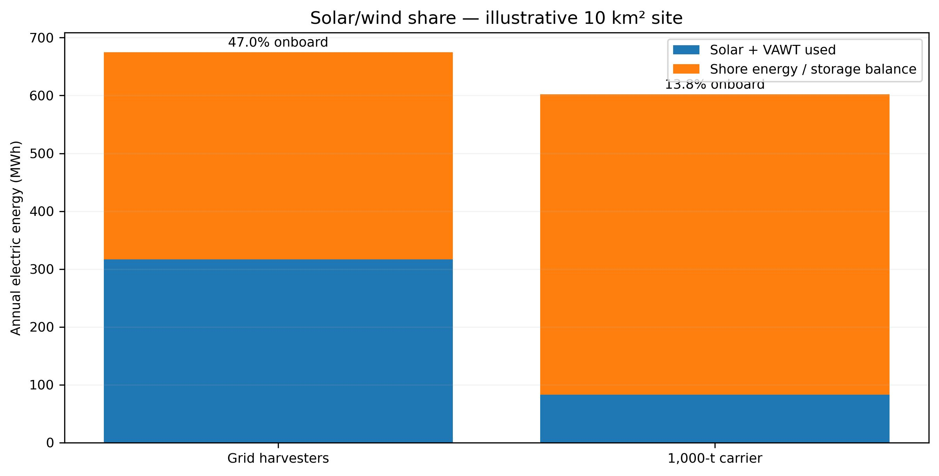
Fig. A. Annual hybrid-equipment power balance (assumptions).

3. Edible fish alongside Sargassum
Spotted rose snapper (Lutjanus guttatus) is the best-supported Pacific case: Universidad Nacional has studied its hatchery production and marine cage growing. Cobia (Rachycentron canadum) is a Caribbean-only conditional sensitivity pending permitting and local piloting; the sourced regulatory recommendation restricts culture to the Caribbean coast. Cages are separate from Sargassum long-lines: wild fish attracted to the farm are not counted as farmed. Scenario productivity and sale prices are NOT verified performance of this coupled system.
The snapper baseline assumes one hectare of cages producing 15 saleable tonnes/year, US$5/kg sales, feed-conversion ratio 1.6, feed cost US$1.40/kg, other variable costs US$2/kg, cage investment US$250,000/ha over 15 years, and US$5,000/year fixed cost. No Sargassum fish-feed replacement is assumed before feed formulation, contaminant and performance tests. Health surveillance, night dissolved oxygen, currents, N/P loading, escape prevention and protected-area siting are prerequisites.
Scenario | t/year | Revenue | Costs | Annualized profit
Pacific snapper: low price | 15 | US$52,500 | US$96,049 | −US$43,549
Pacific snapper: baseline | 15 | US$75,000 | US$96,049 | −US$21,049
Pacific snapper: high price | 15 | US$112,500 | US$96,049 | US$16,451
Pacific snapper: high efficiency | 15 | US$105,000 | US$80,224 | US$24,776
Caribbean cobia: unverified baseline | 25 | US$137,500 | US$170,428 | −US$32,928
Caribbean cobia: unverified high price | 25 | US$187,500 | US$152,428 | US$35,072
Baseline snapper breaks even at US$6,403/tonne (≈ US$6.40/kg). High-price and high-efficiency assumptions produce a potential profit, but cage stocking is not scaled linearly to the 10 km² seaweed footprint without nutrient-loading, ecological carrying capacity and market studies.
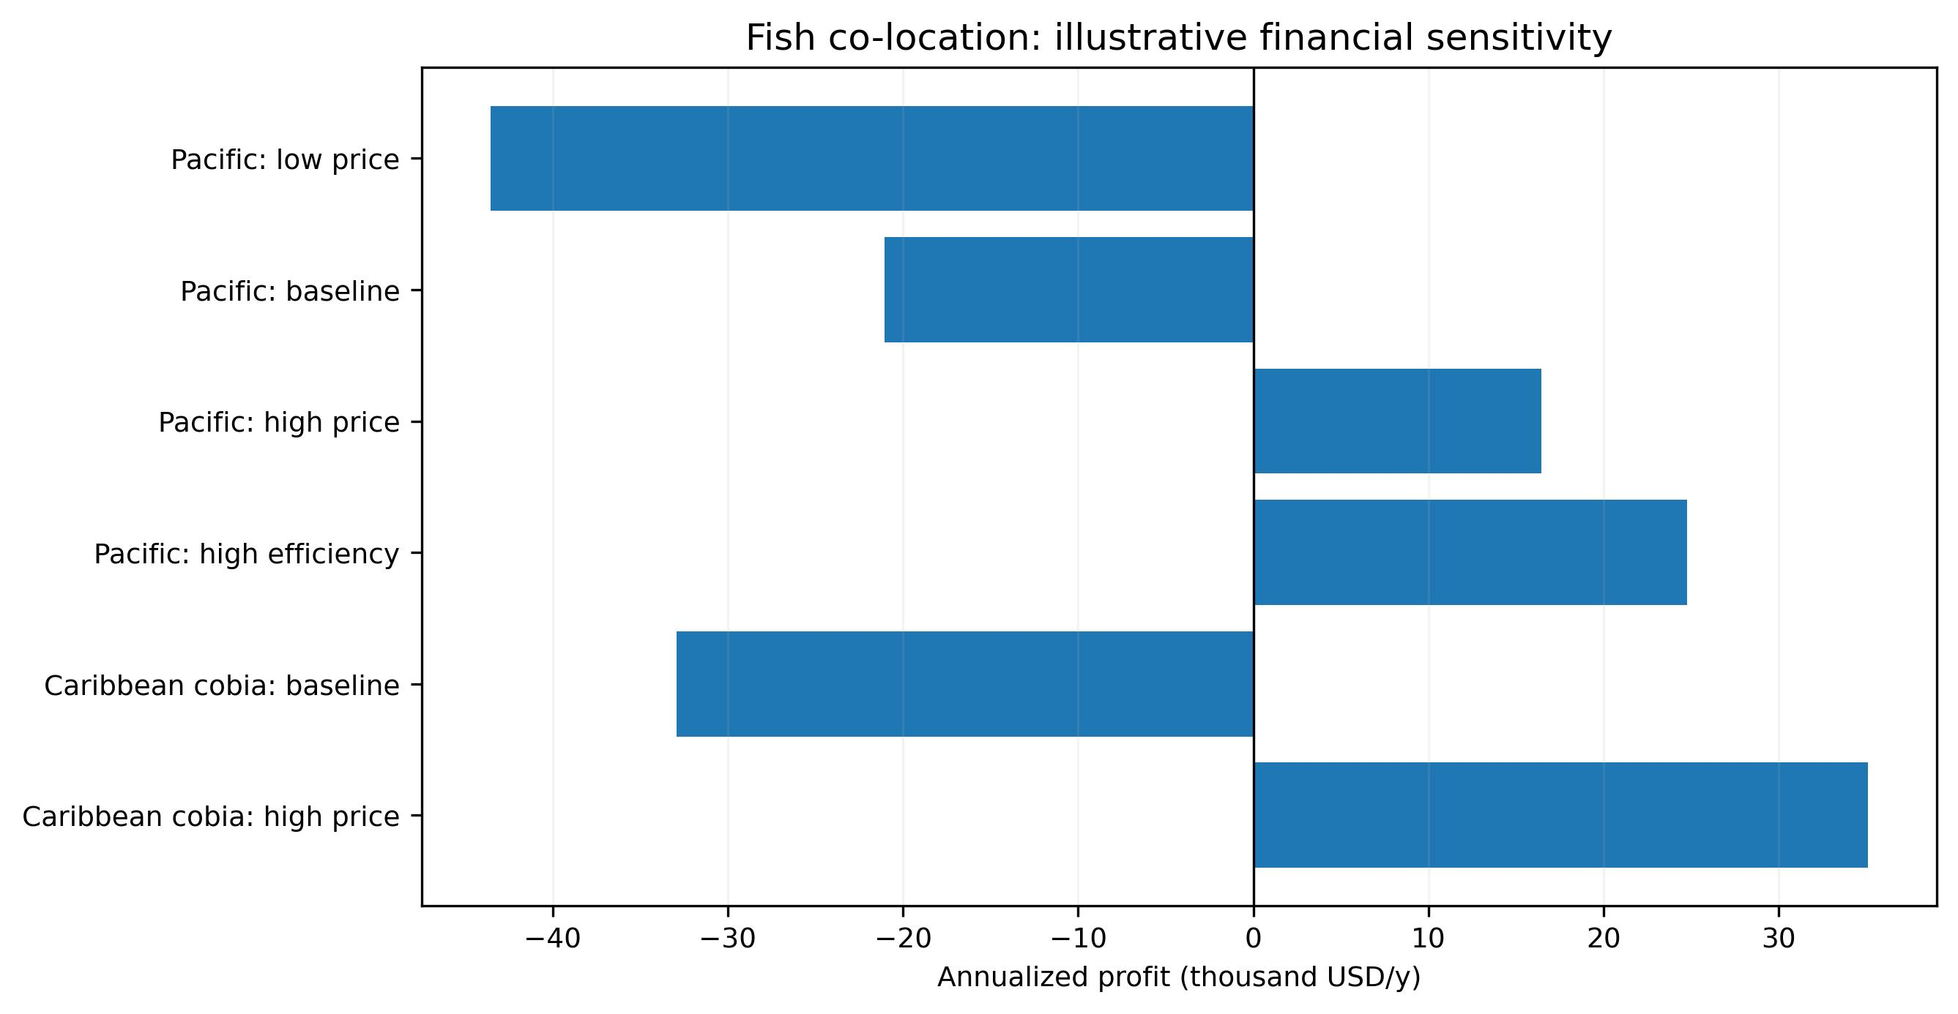
Fig. B. Cage annualized-profit sensitivity.

4. Utility drone and residual-heat dryers
The utility drone carries seed modules and supplies; it does not lift any of the 90,000 wet tonnes of seaweed. The model yields 254 flights and 1 support drone(s)/year at 30-kg payload, before flight regulation and tides are assessed. The dryer receives up to 4,600 MWh/year of temperature-qualified geothermal heat remaining AFTER preheating. The main wet HTL feed is not dried.
The screened incremental dryer benefit is US$71,211/year ONLY if that heat is already recovered, on site and available without additional infrastructure. It excludes incremental pipelines, easements, exchangers and power-generation losses not previously booked. Therefore this cannot be added to overall site benefit without reconciling the full waste-heat economics. The preserved V25 long-distance heat-recovery case could still be uneconomic.

5. Conditions for journal interpretation
This module requires measured hourly wind/irradiance, marine routes and ports, propulsion resistance curves, certified VAWT power/drag curves and stability studies, shipyard quotations, battery degradation, mooring studies, and aquaculture/feed trials. Mass and energy accounting and 25 unit tests catch computational issues but do not validate a commercial facility. The published national manuscript figures are unchanged.

Sources and scope
Universidad Nacional — Laboratorio de Acuicultura y Biotecnología Marina: Lutjanus guttatus: https://www.biologia.una.ac.cr/index.php/produccion-organismos-marinos
INCOPESCA: maricultura de pargo mancha: https://www.incopesca.go.cr/acuicultura/
Costa Rica: listado de especies de interés acuícola y restricción de cobia: https://www.pgrweb.go.cr/DOCS/NORMAS/1/VIGENTE/S/2010-2019/2015-2019/2017/14AA8/181710.HTML
Ocean Engineering: conceptual VAWT marine-power study (2016): https://www.sciencedirect.com/science/article/pii/S0029801816301718
European Commission CORDIS WHISPER: wind/solar ship development: https://cordis.europa.eu/project/id/101096577/reporting
Universidad Nacional: pargo pilot performance and historic observed sale price: https://www.revistas.una.ac.cr/index.php/revmar/article/download/250/18585?inline=1
Seaweed and seagrass aquaculture ecological interactions; USDA compilation: https://www.ars.usda.gov/ARSUserFiles/np106/Seaweeds%20and%20Seagrasses/Aquaculture%20Congressional%20Report.v5_2024%2009-10%20MC_508%20compliance.pdf
Reproduction: python fleet_fish_v26.py. Inputs, 17 scenarios and outputs are provided in fleet_fish_v26_inputs_outputs.json and fleet_fish_v26_scenarios.csv; tests_v26.txt records 25 passing tests.

