Financing simultaneous planetary restoration and human flourishing
Jonathan Karl Bily¹, Christoph Pahl²˒³
¹ Independent researcher; educational associations with Northern Alberta Institute of Technology, UC Berkeley Haas School of Business, and Kwantlen College. ² Technical University of Munich. ³ Max Planck Institute for Physics (JADE/OPAL).
Correspondence: Jonathan Karl Bily

Abstract
Planetary restoration is usually partitioned among climate, biodiversity, pollution, food, health and development programmes even though deployment, finance and physical constraints interact. We present an integrated screening framework in which an externally executed carbon-cycle core is coupled to explicitly classified ecological, engineering, finance and human-flourishing modules. The carbon core closes a referee-driven series of paired and inverse experiments using FaIR 2.2.4 (841 constrained configurations) and Hector 3.5.0. Correcting the removal-off counterfactual for programme-contingent stored-carbon reversal and dynamic permafrost reduces the median atmospheric CO2 reduction attributable to cumulative removal relative to the legacy strict pair by 7.88% in FaIR at 2300, 10.11% in FaIR at 2400 and 8.89% in Hector at 2300. Inverse FaIR calculations show that an ensemble-median 280 ppm target requires total post-2183 CDR of 32.59 GtCO2 yr−1 for 2200, 9.64 for 2300 and 7.06 for 2400; the 2200 case exceeds the modelled historical programme peak of 15.2 GtCO2 yr−1. The wider framework then preserves separate ledgers for coral reefs, fisheries, ocean acidification, plastics, seaweed food and fuels, forests, energy, materials, water, hunger, health, justice, AI/robotics and settlement finance. Coral recovery is represented by disturbance-dependent biological windows rather than a single date; AI-assisted ‘robot doctor’ and ‘robot lawyer’ modules are service-capacity sensitivities with human oversight; and a Carbonite stable-settlement scenario links transparent transaction-fee and adoption stresses to the inverse CDR requirements without using carbon credits. The result is not a forecast that all interventions occur, nor a full Earth-system model. Its contribution is an auditable architecture that distinguishes externally executed physical results from literature screens and policy hypotheses while asking whether atmospheric restoration and human flourishing can be planned in one internally consistent system.

Introduction
Stopping net greenhouse-gas emissions and restoring the atmospheric carbon stock are distinct problems. During deep negative emissions, the land and ocean do not remain passive reservoirs: carbon-cycle responses depend on state, history and forcing, so a tonne removed from the atmosphere cannot be assumed to produce a fixed long-run concentration change independent of pathway [1–3]. Reduced-complexity climate models are useful for making this state dependence falsifiable across large ensembles, but they do not by themselves answer how a removal programme is financed, whether energy and materials are available, or whether ecological and human outcomes improve.
The opposite problem also occurs. Integrated policy visions can combine forests, carbon capture, food, clean energy, ocean restoration, health care and financial reform while blurring the evidentiary boundary between a modelled physical result and a desirable social objective. The framework developed here is designed to prevent that error. Each subsystem carries an explicit status label. The current carbon-cycle attribution and inverse-target calculations are externally executed using FaIR and Hector [4,5]; coral, fisheries and other ecosystem modules are literature-anchored screens; seaweed, heat reuse and several infrastructure modules are engineering scenarios; and Carbonite, global service guarantees and AI/robotics are policy or service-capacity sensitivities. Coupling therefore means accounting interoperability, not automatic transfer of validation.
The working hypothesis is nonetheless deliberately broad: planetary restoration should be evaluated against human flourishing rather than against atmospheric CO2 alone. A pathway that lowers CO2 while worsening hunger, access to health care, clean water or justice is incomplete; a social programme that ignores carbon, reef loss, fishery depletion, persistent sea-level rise or plastic pollution is similarly incomplete. The model therefore preserves an omnivore food pathway alongside lower-land-demand diets, wild-fish recovery separate from aquaculture, coral recovery separate from ocean pH, pollution cleanup separate from CDR, and social services separate from climate tonnes.
This breadth matters for finance. The Carbonite hypothesis is a price-stable settlement cryptocurrency or stablecoin intended to redirect part of payment/intermediation revenue to a treaty-governed global restoration charity. It uses a proposed Proof of Rent (PoR) processor-rental mechanism, geotagged tree and timber-value accounting with permanence safeguards, and protected fee-free basic food and health transactions. It does not require carbon credits. Because a large nominal revenue pool cannot repeal physical deployment limits, we couple the finance screen directly to the corrected inverse FaIR targets and test adoption and unit-cost sensitivity rather than declaring the original programme automatically fundable.
Five questions organize the analysis. First, how much atmospheric benefit is causally attributable to the specified removal programme after correcting its counterfactual feedbacks? Second, how strongly does the required sustained CDR rate depend on the chosen restoration deadline? Third, how should slow and conditional systems such as sea level, coral reefs and fisheries be reported without inventing a universal restoration year? Fourth, can food, water, health, legal access and AI/robotic service capacity be represented without treating aspirational assumptions as observations? Fifth, under transparent settlement-adoption and CDR-cost sensitivities, which restoration deadlines appear financially compatible with the proposed revenue envelope and which do not?
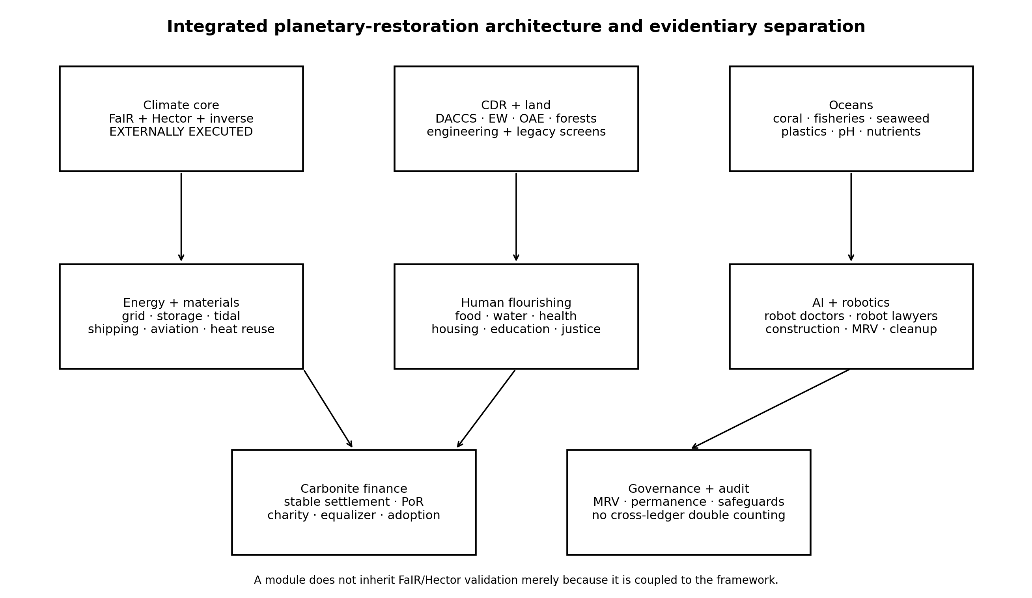
Figure 1 | Integrated architecture and evidentiary separation. The externally executed FaIR/Hector carbon core is coupled to land, ocean, energy, materials, human-flourishing, AI/robotics and finance/governance layers. Coupling does not transfer validation status across layers.

Results

Corrected paired carbon-cycle attribution
The evaluated canonical programme exports an annual 2026–2183 CO2 pathway and accumulates 2,013.8807 GtCO2 of deliberate CDR. The exported stored-carbon reversal over that interval is 83.4038 GtCO2, equal to 4.14145% of cumulative CDR. Run10 begins from an exact common FaIR state at timebound 2026, applies a configuration-specific dynamic permafrost formulation, and distinguishes stored-carbon reversal that exists because the removal programme occurred from the counterfactual world in which deliberate removal is absent. This is the causal correction needed to prevent the removal-off arm from inheriting programme-contingent burdens that should not exist in that counterfactual.
For each FaIR constrained configuration we compute ΔCO2 = CO2(removal off) − CO2(removal on) before taking ensemble quantiles. A larger Δ therefore means more atmospheric CO2 reduction attributable to deliberate removal. In the corrected combined programme-effect experiment, the median response fraction declines from 0.395 at 2156 to 0.354 at timebound 2184, 0.340 in 2200, 0.284 in 2300 and 0.255 in 2400. The result does not imply that carbon disappears. It reflects a changing counterfactual carbon system: land/ocean uptake can weaken and previously stored carbon can return relative to the no-removal world as the atmosphere is drawn down [1–3].
The correction is quantitatively material but not direction-changing. Relative to the legacy strict pair, the corrected median attributable ΔCO2 is lower by 8.196 ppm (7.88%) in FaIR at 2300 and 11.613 ppm (10.11%) at 2400. Hector independently shows a 7.323 ppm (8.89%) reduction in the 2300 attributable difference under the same conceptual programme-feedback correction. The corrected Hector response fraction at 2300 is 0.222 compared with 0.284 in FaIR. We interpret the agreement as directional and order-of-magnitude corroboration, not exact cross-model validation, because the two models do not share an identical future non-CO2 forcing architecture.
Table 1 | Run10 programme-feedback correction.
Model / year | Legacy ΔCO₂ p50 (ppm) | Corrected ΔCO₂ p50 (ppm) | Reduction (%) | Corrected response
FaIR 2.2.4 2300 | 104.032 | 95.836 | 7.878 | 0.284
FaIR 2.2.4 2400 | 114.852 | 103.239 | 10.111 | 0.255
Hector 3.5.0 2300 | 82.392 | 75.069 | 8.888 | 0.222
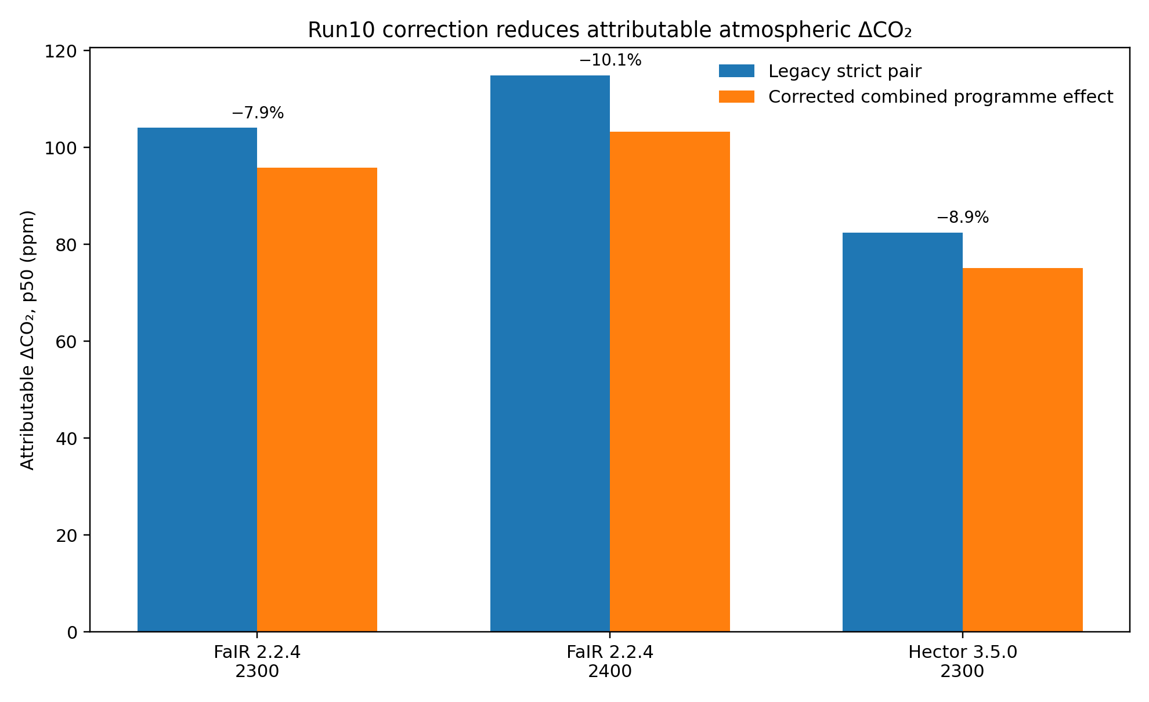
Figure 2 | Programme-feedback correction. Median attributable atmospheric CO2 differences are lower after programme-contingent stored-carbon reversal and dynamic permafrost are treated consistently in the removal-off counterfactual.

Restoration is deadline-conditioned
We next invert FaIR rather than extrapolate a single response fraction. From 2184 through the chosen endpoint, the solver adds a constant annual CDR increment and carries contemporaneous stored-carbon reversal at the canonical cumulative reversal/CDR fraction. All 12 combinations of target year (2200, 2300, 2400) and criterion (absolute 280 ppm or member-relative baseline, each at median or p90) solve numerically. The strongest simple result is the deadline effect.
For an absolute ensemble-median 280 ppm endpoint, the total post-2183 CDR rate is 32.588 GtCO2 yr−1 for 2200, 9.643 for 2300 and 7.061 for 2400. The 2200 rate is more than twice the programme's modelled historical peak of 15.2 GtCO2 yr−1. By contrast, both later deadlines remain below that peak. A p90 ≤280 criterion raises the totals to 35.025, 10.338 and 7.498 GtCO2 yr−1, respectively. The later deadline can require more cumulative extra removal than the 2200 median case even while demanding a far lower annual rate, illustrating why annual deployment rate, cumulative removal and deadline are separate planning variables.
The endpoint temperature values reported by FaIR are retained as model diagnostics, but we do not relabel them here as a new pre-industrial warming reconstruction because their anomaly convention must be interpreted in the context of the FaIR setup. More importantly, a median target is not universal restoration: the absolute-median 2400 solution places approximately half the ensemble at or below 280 ppm while p90 remains about 283.33 ppm. Decision rules therefore need an explicit percentile criterion.
Table 2 | Inverse FaIR restoration requirements. Rates are GtCO2 yr−1; cumulative extra CDR is GtCO2.
Target | Criterion | Extra CDR | Total post-2183 CDR | Cumulative extra | CO₂ p50 | CO₂ p90 | >15.2 peak
2200 | median ≤280 | 27.312 | 32.588 | 437.000 | 279.992 | 282.541 | YES
2200 | p90 ≤280 | 29.750 | 35.025 | 476.000 | 277.336 | 279.992 | YES
2300 | median ≤280 | 4.367 | 9.643 | 506.594 | 279.990 | 283.349 | NO
2300 | p90 ≤280 | 5.062 | 10.338 | 587.250 | 276.546 | 279.982 | NO
2400 | median ≤280 | 1.785 | 7.061 | 385.594 | 279.997 | 283.333 | NO
2400 | p90 ≤280 | 2.223 | 7.498 | 480.094 | 276.614 | 279.991 | NO
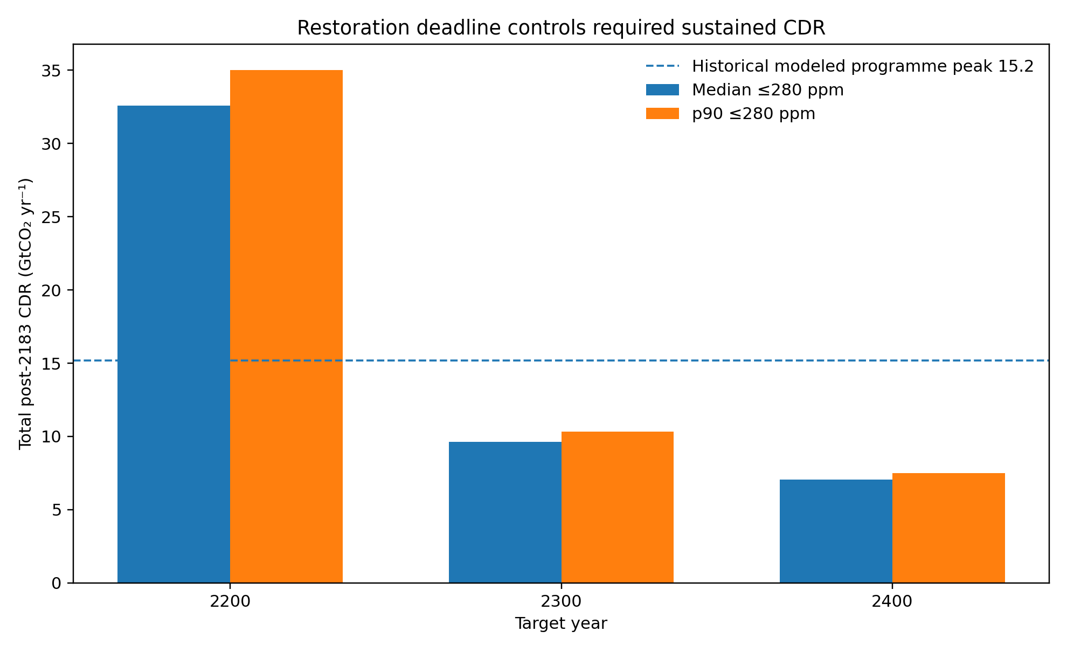
Figure 3 | Required sustained post-2183 CDR depends strongly on restoration deadline. Dashed line denotes the historical modelled programme peak of 15.2 GtCO2 yr−1.

Coral reefs require a biological recovery clock, not a CO2 date
The Great Barrier Reef illustrates why a single planetary restoration date is misleading. AIMS surveyed 121 reefs between August 2025 and June 2026 and reported region-wide average hard-coral cover of 35.1% in the Northern, 31.6% in the Central and 26.4% in the Southern GBR. Northern cover increased from 30.0% in 2025, Central from 28.6%, and Southern changed little from 26.9%. AIMS described the 2026 pattern as signalling the start of recovery from impacts of the 2024 mass-bleaching event in parts of the Reef, while emphasizing the dependence of future condition on warming and disturbance [6].
Both AIMS and the Reef Authority describe approximately 10–15 years as a typical period for reef community re-establishment when disturbance is minimal [7,8]. The model therefore uses this only as a conditional hard-coral-cover clock. If, hypothetically, 2026 began a durable low-disturbance interval, cover re-establishment would screen to approximately 2036–2041; broader ecological/community/structural recovery is represented as roughly 2041–2056. These dates reset or extend after a severe bleaching or mortality event. The historical record itself demonstrates why this condition is non-trivial: AIMS documents GBR mass-bleaching events in 1998, 2002, 2016, 2017, 2020, 2022, 2024 and 2025 [7].
Ocean acidification is a coupled but distinct constraint. Atmospheric CO2 uptake lowers ocean pH and reduces carbonate-ion availability needed by calcifying organisms, including reef-building corals [9]. The legacy fixed-temperature/salinity surface-ocean screen reaches a modelled minimum near pH 8.05 and an endpoint near 8.16 by the FaIR 2400 horizon, but those values are diagnostic and do not supply a reef-restoration date. Temperature-coupled carbonate chemistry and a regional marine-heatwave/Degree Heating Week model remain required before assigning a calendar year to durable reef recovery.
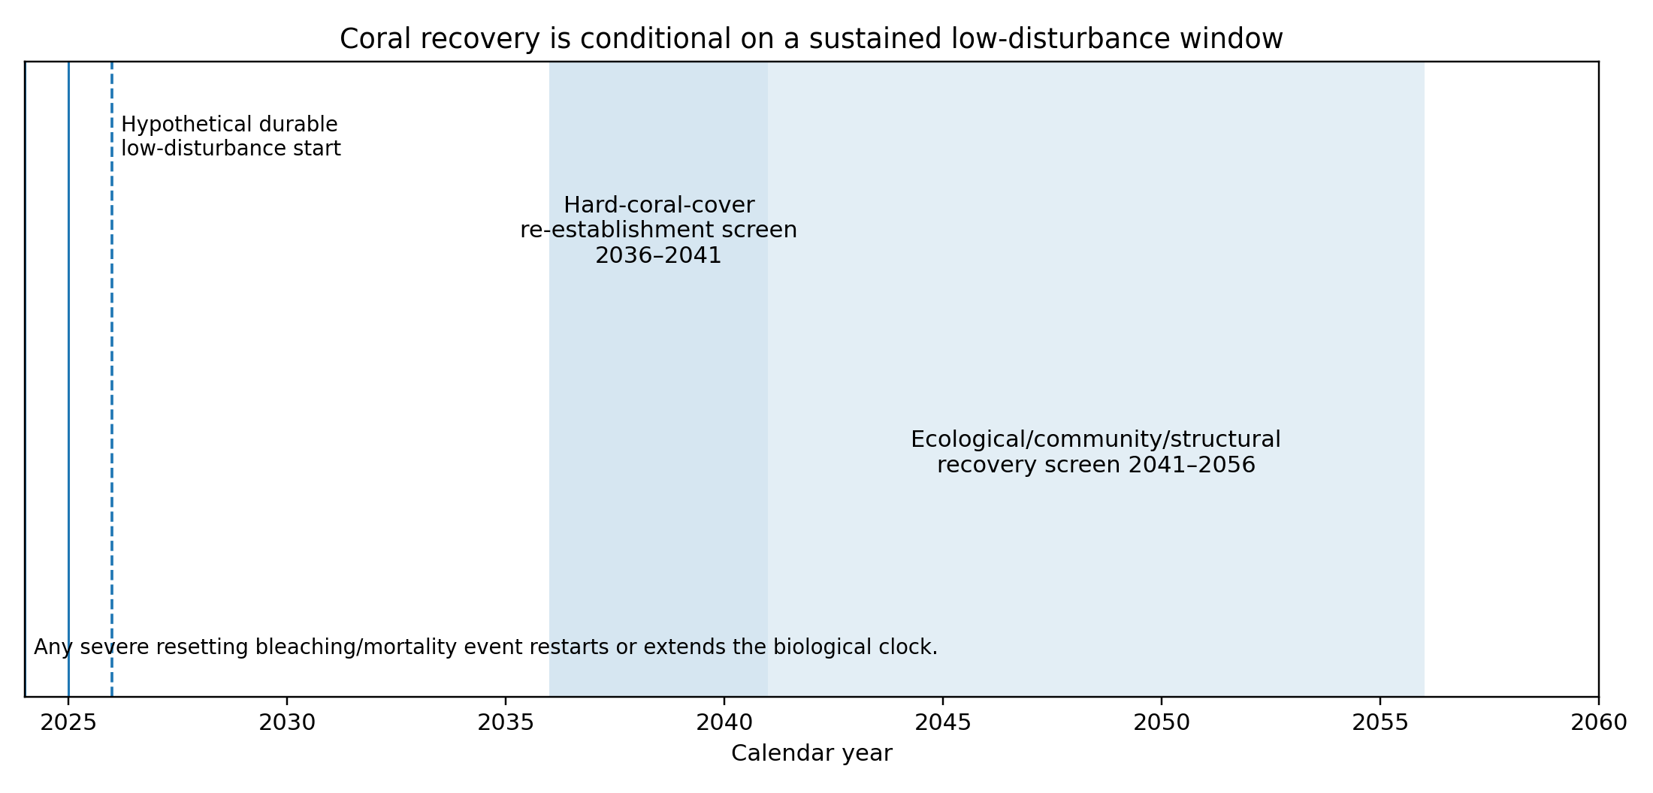
Figure 4 | Conditional coral-recovery gate. The 10–15-year cover clock begins only when severe disturbances become sufficiently infrequent; a subsequent severe event resets or extends the clock. The ecological/community/structural clock is longer.

Fisheries, seaweed, plastics and eutrophication remain separate ocean ledgers
The fishery module retains stock-specific rebuilding rather than treating aquaculture or new habitat as wild-fish recovery. Its legacy literature screen uses a median rebuilding timescale of roughly ten years after effective reform across thousands of modelled fisheries, while recognizing that individual stocks can recover more quickly, more slowly, or not at all depending on exploitation, habitat, recruitment and enforcement. FAO's 2026 global assessment provides the current evidence base for sustainable fisheries and aquatic foods [10]. Seaweed co-culture may provide managed habitat and food production, but those benefits are not credited as recovery of wild stocks.
Seaweed is represented as a multi-output bioeconomy rather than a single CDR technology. The required streams are: standing carbon in live farms; carbon in strategic liquid-fuel reserves; edible biomass and digestible protein; managed fish habitat/co-culture; liquid fuels for aviation, heavy equipment and marine use; durable biomass storage as a BiCRS substitute where validated; materials feedstock; nutrient capture; and concentrated-solar/HTL integration. The retained Grid Harvesting engineering report compares a moving harvesting head and hydraulic transport system with conventional vessel harvesting, with the design purpose of reducing the repeated movement of vessel and collected biomass [25]. Field trials, hydrodynamic validation, ecological impact assessment and lifecycle analysis remain open.
Marine plastic is tracked as pollution and material recovery, not as carbon removal. UNEP estimates that more than eleven million metric tonnes of plastic enter the oceans annually [11]. V62 therefore keeps source reduction, interception, cleanup, sorting and reuse/recycling as a separate material-flow objective. Reusing suitable recovered polymers in seaweed-farm structures may reduce virgin-material demand, but no CO2 removal is credited without a verified lifecycle carbon balance. Nutrient-loop modules likewise preserve nitrogen, phosphorus and potassium recovery and coastal eutrophication relief while flagging the earlier gross-versus-credited nutrient reconciliation as unresolved.

Food, water and health are modelled as resource floors
The human-flourishing layer is a resource and policy screen. The planning population is 10.3 billion, while population sensitivity also retains lower and higher cases from the model lineage. Food adequacy uses a central dietary-energy floor of 2,350 kcal person−1 day−1 and a protein floor of 50 g person−1 day−1. It retains an optimized omnivore pathway including meat, a mixed lower-land-demand pathway, a vegetarian dairy/egg/aquatic pathway and higher plant-forward capacity screens. The purpose is to test land, nutrient, energy and protein feasibility without making one diet compulsory. Seaweed is a supplementary food stream subject to species, iodine, contaminants, digestibility and safe-intake constraints.
Water planning retains a minimum safe municipal-service floor of 50 L person−1 day−1 and a 100 L person−1 day−1 planning service case, coupled to wastewater treatment, reuse, desalination and methane recovery. Food waste and wastewater methane are captured as an energy/nutrient stream only once, with explicit double-count protection. The resulting water service is therefore not inferred from climate recovery: it must be built and operated.
Universal health care is represented as a resource envelope rather than a claim that a particular national system can be copied globally. The retained central planning screen allocates US$2,500 person−1 yr−1 to universal basic health care at 10.3 billion people, or US$25.75 trillion yr−1, inside a broader mature-economy resource scenario. Services include primary and maternal care, emergency medicine, surgery, mental health, vaccination, antibiotics with antimicrobial stewardship, cancer prevention and treatment, remote care, public-health surveillance and medicine logistics. mRNA cancer vaccines are represented as a research-and-access pathway if indications become proven and approved, not as an assumed universal cure.

Robot doctors and robot lawyers are service-capacity sensitivities
AI and robotics are introduced where they can change the amount of service obtainable from scarce human expertise, but the model deliberately avoids equating automation with autonomous professional replacement. WHO describes AI as potentially relevant to diagnosis, clinical care, drug development, surveillance and health-system management while emphasizing evidence, ethics, equity, governance and regulatory safeguards [12,13]. The robot-doctor module therefore models triage, documentation, decision support, remote monitoring, pharmacy/logistics, translation, scheduling and robotic assistance under human clinical oversight. The conservative, central and high-automation sensitivities assume 15%, 30% and 50% of routine task volume is eligible for assistance and apply transparent systemwide capacity gains of 10%, 25% and 50%, respectively. These productivity values are author-defined sensitivities requiring external validation.
The robot-lawyer module addresses the justice gap rather than attorney headcount. World Justice Project data show large, persistent unmet civil justice needs and increasing interest in ICT-driven justice tools [14,15]. OECD similarly identifies AI as potentially supportive of justice-system access, resilience, efficiency, effectiveness and fairness while noting uneven impacts [16]. The model therefore represents triage, legal information, research, drafting, form completion, document review, translation and mediation support. The central sensitivity assumes 40% of routine legal-service volume is eligible for AI assistance and maps this to a normalized public-access capacity index of 120 versus 100 without the assistance. Regulated advice, court representation and adjudication retain human lawyer/judge oversight where required, and substantive outputs require source verification, confidentiality, jurisdiction and unauthorized-practice safeguards.
The same design principle extends to robot construction, agriculture, forest restoration, ocean cleanup, carbon-removal operation, environmental MRV, education, eldercare, manufacturing and recycling. These modules are useful because labour and inspection bottlenecks can constrain deployment, but V62 does not convert their scenario capacities into guaranteed global productivity growth.
Table 3a | Robot-doctor service-capacity sensitivities. Assumptions are not empirical forecasts.
Health scenario | Routine share eligible | Assumed capacity gain | Multiplier
conservative | 0.150 | 0.100 | 1.100
central | 0.300 | 0.250 | 1.250
high_automation | 0.500 | 0.500 | 1.500
Table 3b | Robot-lawyer legal-access sensitivities. Index is normalized to 100 without AI assistance.
Legal scenario | Routine share eligible | Legal-access index
conservative | 0.200 | 110.000
central | 0.400 | 120.000
high_digital_access | 0.600 | 130.000

Energy, materials, transport and distributed AI infrastructure
The physical programme also requires large energy and material systems. The legacy grid module retains synthetic adequacy, storage, overbuild and material constraints, together with technology-option screens rather than a predetermined generation mix. A prior claim of a special nuclear requirement is not retained. Tidal energy, wastewater bioenergy and firm-clean options remain decomposition candidates that must be reconciled against the same electricity-demand base before addition. Industrial material screens track steel, cement/binder and aluminium demand, recycling and low-carbon shares separately from CDR.
Transport is decomposed by service. Shipping includes efficiency/logistics, wind assistance, battery-electric service, hydrogen-derived fuels, synthetic fuels and biofuels; aviation and heavy equipment use direct electrification where feasible and low-carbon liquid fuels where energy density remains a constraint. Seaweed-derived liquids are one candidate pathway rather than the exclusive fuel. Carbon held in strategic fuel reserves is a stock account; combustion is an emissions flow and cannot be treated as durable storage.
Distributed AI/data-centre infrastructure is retained because digital services and automation themselves consume energy and capital. IEA projects global data-centre electricity use to approximately double to about 945–950 TWh by 2030, with AI-focused demand growing faster [17,18]. V62 includes the Los Jardines Digitales de la Fuente de Cella archetype in which distributed computing is coupled to heat recovery for hot water, district heat, greenhouses/aquaculture and other low-temperature loads. This is an implementation design, not evidence that every data centre can recover the same fraction of waste heat.

Carbonite: settlement finance, charity and Proof of Rent
Carbonite is represented as a price-stable settlement cryptocurrency/stablecoin and policy architecture, not as a climate-model input. Its proposed economic role is to redirect part of existing settlement/intermediation revenue to a treaty-governed global restoration charity while maintaining payment utility. The architecture is designed to substitute for part of existing intermediation rather than add a climate surcharge to protected basic transactions, but incidence neutrality is not established. Basic food and health payments are fee-free in the central design. Carbon credits are not required: CDR is financed as a service and verified through MRV rather than monetized through a carbon-credit market.
The proposed Proof of Rent (PoR) mechanism is based on renting processor capacity to the network rather than expending computation in proof-of-work hashing. The terminology is therefore Prospective Processor Power / Processor, not Hash Power / Hash. Tree-linked natural-capital accounting uses geotagged trees, audited timber value, measured biomass change, chain of custody and a 10–20% permanence buffer. Tree value can be tested against inflation as a sensitivity, but appreciation is not guaranteed and measured tree growth does not automatically expand money supply.
Global adoption is a critical variable. The primary architecture includes country equalization so arid or land-constrained states are not forced into forestry, parallel settlement so national currencies can coexist, and an explicit sanctions-governance module. A user-requested United States non-participation case is treated as an adoption stress rather than a geopolitical forecast: the model reduces participating settlement share and recalculates the financing envelope. This avoids assuming either inevitable global adoption or that one country's non-participation has a predetermined consequence.

Financeability stress against the corrected inverse targets
The new finance screen directly couples the Run10 absolute-280 median targets to a transparent gross settlement-revenue envelope. For comparability with the legacy resource-budget layer, mature global GDP is normalized to US$309 trillion and the gross settlement envelope to 2.14% of GDP. At 100% participating share this is US$6.613 trillion yr−1; 90%, 75% and 50% adoption scale it linearly. We then apply illustrative all-in CDR cost sensitivities of US$100, 200 and 400 tCO2−1. These are stress parameters, not a forecast of the heterogeneous CDR portfolio's cost curve.
At US$200 tCO2−1 and 100% adoption, the 2200 median target's 32.588 GtCO2 yr−1 total post-2183 CDR costs approximately US$6.518 trillion yr−1, or 98.6% of the gross envelope before other uses. At 90% adoption the same case exceeds the envelope. The 2300 and 2400 cases are much less constraining: about US$1.929 trillion and US$1.412 trillion yr−1, respectively, at the same unit cost. At US$400 tCO2−1, even full-adoption 2200 exceeds the envelope, whereas the 2300 and 2400 screens remain inside it. This does not prove fundability of the later pathways, but it falsifies the idea that deadline choice is financially irrelevant.
Table 4 | Finance stress at an illustrative US$200 tCO2−1.
Adoption | Target | Annual CDR cost (US$ tn) | Gross envelope (US$ tn) | Share of envelope (%) | Inside?
100% | 2200 | 6.518 | 6.613 | 98.563 | YES
100% | 2300 | 1.929 | 6.613 | 29.164 | YES
100% | 2400 | 1.412 | 6.613 | 21.355 | YES
90% | 2200 | 6.518 | 5.951 | 109.515 | NO
90% | 2300 | 1.929 | 5.951 | 32.405 | YES
90% | 2400 | 1.412 | 5.951 | 23.728 | YES
75% | 2200 | 6.518 | 4.959 | 131.417 | NO
75% | 2300 | 1.929 | 4.959 | 38.886 | YES
75% | 2400 | 1.412 | 4.959 | 28.473 | YES
50% | 2200 | 6.518 | 3.306 | 197.126 | NO
50% | 2300 | 1.929 | 3.306 | 58.329 | YES
50% | 2400 | 1.412 | 3.306 | 42.710 | YES
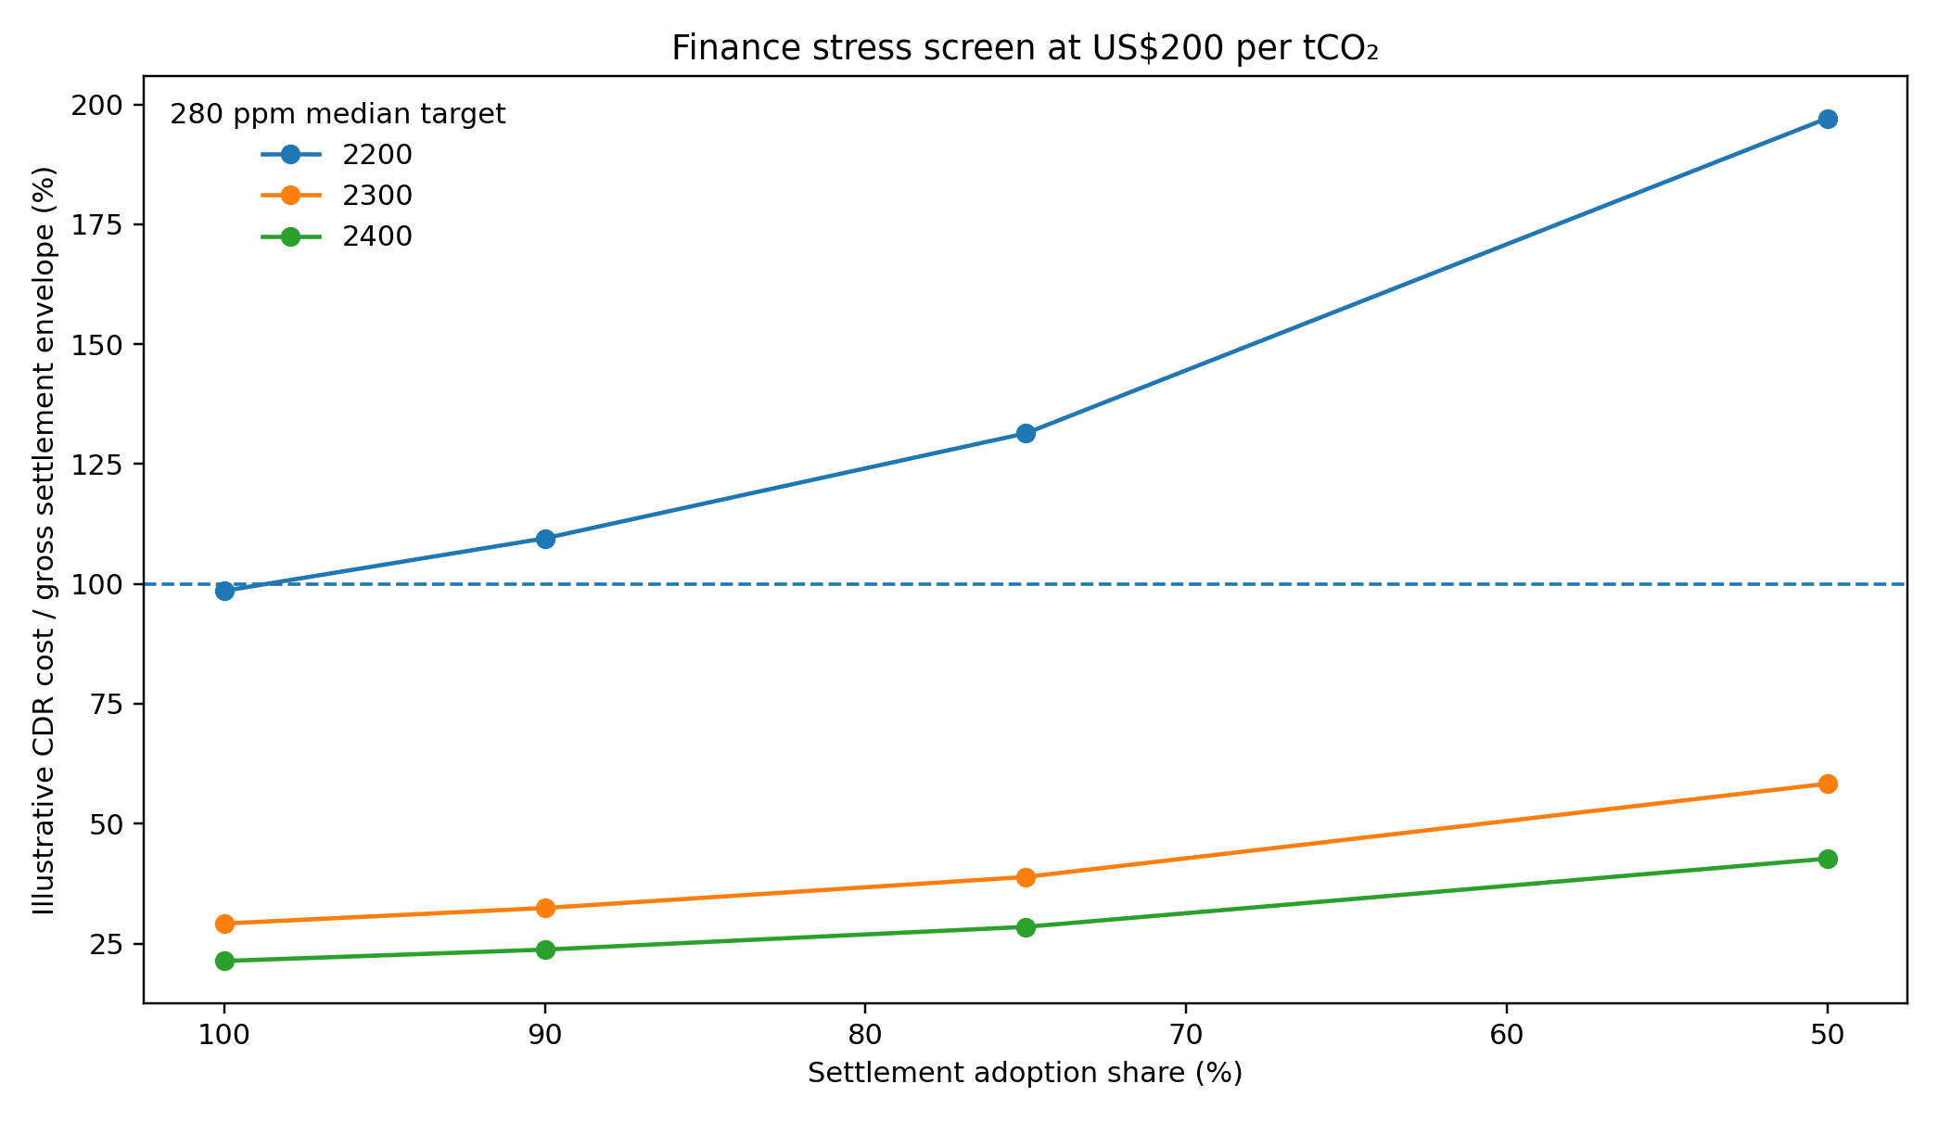
Figure 5 | Finance stress at US$200 tCO2−1. The vertical dimension is annual CDR cost as a share of the gross settlement-revenue envelope; 100% is the envelope boundary. This is not a proof of disposable net revenue.

A milestone vector replaces a single restoration year
The framework intentionally does not report a date on which ‘the planet is restored.’ Atmospheric CO2 can be inverse-solved under a specified control and endpoint criterion. Sea level can remain elevated for centuries because ocean heat content and land ice respond slowly [24]. Coral cover and ecosystem structure require disturbance-free biological windows. Fish stocks respond to stock-specific management and life histories. Plastic pollution depends on ongoing material leakage and cleanup. Food, water, health, housing, education and justice are institutional services. Collapsing these variables to one year would be less informative than a vector of conditional milestones.
Table 5 | Representative restoration milestone vector.
System | Milestone | Calendar / condition | Status
Atmospheric CO2 | FaIR ensemble-median 280 ppm target in 2200 | 2200 | Externally executed inverse
Atmospheric CO2 | FaIR ensemble-median 280 ppm target in 2300 | 2300 | Externally executed inverse
Atmospheric CO2 | FaIR ensemble-median 280 ppm target in 2400 | 2400 | Externally executed inverse
Coral reefs | Hard-coral-cover re-establishment | 2036-2041 only if 2026 starts a durable low-disturbance window | Conditional literature screen
Coral reefs | Ecological/community/structural recovery | 2041-2056 only under same hypothetical safe start | Conditional literature screen
Fisheries | Typical managed stock rebuilding | ~10 years after effective reform (median legacy literature screen) | Literature screen; not global forecast
Ocean pH | Recovery toward higher pH | coupled to CO2 decline; no publication-grade threshold year | Diagnostic only
Human flourishing | Food/health/water/legal access | policy/deployment dependent; no single physical restoration date | Policy scenario

Discussion
The strongest scientific result in this integrated framework remains the corrected paired and inverse carbon-cycle calculation. The carbon benefit of deliberate removal is state-dependent, and programme-contingent feedbacks must be treated consistently in the counterfactual. The corrected Run10 experiments reduce estimated attribution relative to the earlier strict pair by roughly 8–10% in the late-century/long-horizon comparison points examined here. More importantly for planning, inverse FaIR shows that the annual CDR burden is highly deadline-dependent. A 2200 median-280 target is physically outside the programme's historical modelled peak, whereas 2300 and 2400 targets fall below it. A p90 criterion is more demanding than a median criterion at every deadline.
The integrated scope changes the interpretation of success. Returning atmospheric CO2 toward a preindustrial reference does not reverse already committed sea level on the same schedule [24], guarantee coral recovery after recurrent heat stress, rebuild every fishery, remove plastics, eliminate hunger, or deliver universal healthcare and justice. Conversely, investments in those services can produce welfare and resilience value before full atmospheric restoration. The model therefore treats restoration as a portfolio of state variables rather than a single climate number.
This portfolio approach also clarifies potential synergies and prevents double counting. Seaweed can simultaneously produce food, fuel feedstock, managed habitat and a standing biomass stock, but one tonne of biomass cannot be counted simultaneously as food, durable CDR and fuel-reserve carbon. Wastewater methane can provide electricity and heat, but the same energy cannot be added twice to the grid balance. Tree planting can support biodiversity, timber value and carbon storage, but only additional permanence-adjusted carbon is credited as removal. Data-centre heat can support agriculture or hot water, but recovered heat is not new electricity. Robot doctors and lawyers can increase service capacity only if safe workflows, human oversight, infrastructure and institutions are present.
The finance screen is intentionally less flattering than a simple trillion-dollar revenue headline. At an illustrative US$200 tCO2−1, the aggressive 2200 target consumes almost the entire gross settlement envelope under full adoption and exceeds it at 90% adoption. This is useful: an integrated model should expose infeasible combinations rather than protect a preferred narrative. The 2300 and 2400 screens leave far more nominal room, but they still require technology-specific cost curves, capital turnover, land/mineral/storage constraints, governance and incidence modelling before a complete fundability claim is justified.
Carbonite itself remains a hypothesis. Stable settlement, Proof of Rent, geotagged natural-capital reserves and a global charity could be tested independently of the climate outcome. The architecture's proposed novelty is not that price-stable digital settlement alone removes CO2; it is the attempt to make a high-volume settlement utility finance physical restoration without relying on carbon-credit prices. That proposal must be evaluated against monetary stability, liquidity, cybersecurity, sanctions law, national regulation, distributional incidence and adoption. Partial adoption and non-participation cases are therefore first-class scenarios rather than afterthoughts.
Human flourishing should be held to the same standard. The model can estimate food energy, water, health-service and housing resource envelopes, but it cannot guarantee equitable distribution. AI can plausibly assist health and justice systems [12–16], but current evidence does not justify a universal replacement factor for doctors or lawyers. We therefore expose the productivity assumptions and require validation. The relevant research question is not ‘can a robot replace a doctor/lawyer?’ but ‘which bounded tasks can be safely automated or assisted, how does that change service capacity, and what governance preserves human responsibility and rights?’
This framework is consequently broader than a conventional carbon model but narrower than a digital twin of Earth. It is best understood as an auditable coupling and falsification layer: it makes assumptions commensurable, forces separate ledgers, and identifies which external models or observations are needed to promote a module from scenario to evidence. The next scientific gains will come not from adding more narrative breadth but from closing those gates—OSCAR or a justified replacement validation, matched non-CO2 forcing comparisons, temperature-coupled ocean carbonate chemistry, regional coral heat stress, technology-specific finance/deployment curves, and empirical trials of automation and seaweed engineering.

Methods

Evidentiary architecture and completeness gate
The executable package contains a registry of 85 named modules. Each is assigned an evidentiary classification: EXTERNALLY_EXECUTED, LEGACY_MECHANISTIC, LITERATURE_SCREEN, ENGINEERING_SCENARIO, POLICY_SCENARIO, SERVICE_CAPACITY_SCENARIO or DIAGNOSTIC_ONLY. The test suite contains 48 mandatory module identifiers and fails if any is absent. Required identifiers include coral reefs, robot doctors, robot lawyers, Carbonite, Proof of Rent, all named seaweed streams, fisheries, plastics, pH, sea level, hunger, health, water, the major CDR technologies, shipping/aviation, heat reuse, omnivore diet, population, charity/transaction finance and MRV. This converts ‘do not forget’ from an editorial instruction into a machine-checkable release constraint.

Canonical CO2 pathway and Run10 common-state design
The canonical annual trajectory spans 2026–2183 and contains gross anthropogenic CO2 emissions, exported permafrost CO2, stored-carbon reversal, deliberate CDR and net CO2. Annual mass balance is gross + permafrost + stored-carbon reversal − CDR = net. Cumulative deliberate CDR is 2,013.8807319 GtCO2 and cumulative stored-carbon reversal is 83.4038363 GtCO2. Reporting converts atmospheric concentration to burden using 2.124 GtC ppm−1 × 44.009/12.011 = 7.782459079 GtCO2 ppm−1.
FaIR 2.2.4 is run with fair-calibrate 1.4.1 and 841 constrained configurations [4]. Run10 uses an exact common 2026 state before programme emissions take effect. Dynamic permafrost uses 18 PgC °C−1 above a 1.2 °C activation, a 50-year release timescale and running-peak commitment, with fixed-point damping 0.45 and 0.0001 GtCO2 yr−1 convergence tolerance. Historical commitment is not re-injected because it is implicit in the common state.

Paired programme-feedback attribution
The legacy strict pair is retained as a regression control. Three sensitivity experiments then isolate (i) zero programme-contingent stored-carbon reversal in the removal-off world, (ii) dynamic configuration-specific permafrost, and (iii) both corrections together. For each configuration and timebound, ΔCO2 is formed before quantiles. The member response fraction is ΔCO2 × 7.782459079 / cumulative deliberate CDR. This paired quantity is an attribution metric for the specified pathway, not a universal marginal efficiency.

Hector comparator
Hector 3.5.0 [5] is initialized to an exact common end-2025 state of 418.442532 ppm CO2 and 1.526795 °C model surface temperature. The programme-feedback factorial follows the same conceptual correction, with the retained project permafrost formulation using 18 PgC °C−1, 1.2 °C activation, 50-year release time, fixed-point damping 0.5 and 10−5 GtCO2 yr−1 tolerance. At 2300 the corrected combined ΔCO2 is 75.0689 ppm and response fraction 0.2220. The comparison is within-model causal in both FaIR and Hector; exact cross-model equivalence is not claimed because background forcing implementations differ.

Inverse FaIR solver
For target years 2200, 2300 and 2400, a constant additional CDR flux is applied from 2184 through the endpoint. Additional CDR carries contemporaneous stored-carbon reversal at 0.0414144865 of the additional removal flux. Bracket-and-bisection solves four criteria: absolute 280 ppm median, member-relative baseline median, absolute 280 ppm p90, and member-relative baseline p90. The returned rate is the upper edge of the final numerical bracket. Member endpoint concentrations, temperatures and fractions at or below 280 ppm are archived.

Sea level, ocean pH and coral recovery
The sea-level screen is retained only through the archived FaIR horizon and is interpreted as a slow-response context rather than a novel sea-level model. Post-2400 peak/return dates from older releases remain excluded. Surface-ocean pH is a reduced fixed-temperature/salinity carbonate-chemistry screen; its threshold years are diagnostic pending temperature-coupled CO2SYS/PyCO2SYS implementation. Coral recovery uses three clocks—physiological survival, hard-coral-cover re-establishment and ecological/community/structural recovery—and a thermal-disturbance gate based on observed bleaching recurrence and the 10–15-year low-disturbance re-establishment context [6–9].

Seaweed, fisheries, plastic and nutrient accounting
Seaweed mass balance allocates biomass among food, fuels, durable storage, material streams and standing/reserve stocks; ash and other residuals are reconciled across allocations. Grid Harvesting is retained as an engineering design reference [25], not field-validated performance. Fishery recovery is represented independently from aquaculture and seaweed habitat. Plastic cleanup is a separate material-pollution ledger. Nutrient capture is reconciled against fertilizer replacement to avoid crediting the same nitrogen or phosphorus twice.

Human-flourishing resource screens
The planning population is 10.3 billion, with lower/higher demographic sensitivity retained. Dietary-energy and protein floors are 2,350 kcal person−1 day−1 and 50 g person−1 day−1. Water screens use 50 L person−1 day−1 as a minimum municipal-service floor and 100 L person−1 day−1 as a planning case. The health resource budget uses US$2,500 person−1 yr−1 and the healthy-food budget US$1,800 person−1 yr−1 in the legacy mature-economy normalization. These are resource envelopes, not forecasts of spending efficiency or distribution. Industry/housing screens preserve steel, cement/binder, aluminium and floor-area requirements.

AI/robotic service-capacity scenarios
For healthcare, routine-task eligibility is set to 15%, 30% and 50% in conservative, central and high-automation cases. Corresponding assumed systemwide service-capacity gains are 10%, 25% and 50%. Human clinical oversight is mandatory for regulated diagnosis, treatment and prescribing unless applicable law and validated safety cases explicitly permit otherwise. For legal access, routine-service eligibility is 20%, 40% and 60%; normalized public legal-access indices are computed as 100 × (1 + 0.5 × eligible share). Regulated legal advice, representation and adjudication remain subject to human/jurisdictional controls. Both modules include privacy/confidentiality, audit, cybersecurity, verification and liability safeguards [12–16].

Carbonite and finance stress
The Carbonite scenario uses a mature-GDP normalization of US$309 trillion and a gross settlement-revenue envelope equal to 2.14% of mature GDP at full adoption. Adoption shares of 100%, 90%, 75% and 50% scale the envelope linearly. The financeability screen multiplies each absolute-280 median total post-2183 CDR rate by illustrative unit costs of US$100, 200 and 400 tCO2−1. A case is labelled ‘within gross envelope’ only when that annual CDR cost is no greater than the gross settlement envelope; this is deliberately weaker than a claim of fundability. Capital formation, operating mix, CDR-specific cost curves, non-CDR allocations, reserves and distributional incidence remain open.
Proof of Rent is represented as a processor-rental architecture, with no hash-power terminology. Tree-value anchoring uses audited timber NPV plus verified durable carbon value subject to permanence haircut, independent audit, fire/drought buffer, geotagging and chain of custody. Measured biomass growth does not automatically mint currency. Global adoption, country equalization, parallel national settlement, sanctions modes, bank transition, worker transition and a US non-participation stress are separate policy dimensions.

Accounting and double-count controls
The model maintains separate ledgers for physical CO2 removal, avoided emissions, electricity/heat, material recycling, ecosystem recovery, pollution cleanup and human services. A benefit can be coupled across systems but cannot be numerically credited twice. Examples include: seaweed biomass cannot simultaneously be food, durable storage and combusted fuel; recovered data-centre heat is not new electricity; cultured fish are not wild fish; plastic cleanup is not CDR; and tree growth is not both unbuffered carbon removal and automatic monetary issuance. These rules are enforced structurally in the release documentation and test expectations, although several legacy submodules still require deeper numerical reconciliation.

Reproducibility
The current Run10 close-out was executed in GitHub Actions run 34289949707 on commit 3dbdcab603cf31ec16bbb2eaee4ab54b82472b17 in the public repository bcjohnjr/Planetary-Restoration-Model-V60. All five jobs completed successfully: one FaIR feedback job, three independent inverse targets, and one Hector feedback job. Artifact IDs and SHA-256 digests are recorded in the release package. V62 includes the full V60 cross-check lineage, Run10 structured summaries, model code, tests, module registry and this manuscript. Running `python planetary_restoration_model_v62.py --tests` regenerates the structured V62 result files and executes the completeness gate.

Limitations and next validation gates
Several gates remain open. OSCAR has not been executed in the current close-out. FaIR and Hector do not yet share a fully matched future non-CO2 forcing protocol. The inverse control is constant rather than optimized. The pH screen requires temperature-coupled carbonate chemistry. Coral requires regional marine heatwave/Degree Heating Week coupling. Seaweed, Grid Harvesting and several infrastructure modules require field-scale/lifecycle validation. CDR finance needs technology-specific cost curves, storage/mineral/land constraints and capital turnover. AI health/legal productivity assumptions require prospective evaluation. Carbonite requires independent monetary, legal, cybersecurity, governance and adoption analysis. These limitations are not side notes: they define which claims can be promoted in future releases.

Data and code availability
The working release package contains the executable integrated model, Run10 summary inputs, full V60/V59.1 lineage, CSV/JSON outputs, figures, source register, completeness tests, and the manuscript. The current public climate close-out repository is https://github.com/bcjohnjr/Planetary-Restoration-Model-V60 and the all-green workflow is run 34289949707. The manuscript uses the release package as the auditable systems record; external repositories and official scientific sources are listed in the source register.

Author contributions
J.K.B. conceived the integrated Planetary Restoration and Carbonite systems framework, defined the principal engineering, social and finance hypotheses, and directed the coupled modelling programme. C.P. contributed physics and quantitative-model review, including earlier seaweed-harvester analysis. Patricia Valdés contributed to earlier concept development and was a co-author of the 2021 seaweed-harvesting technical analysis; she is acknowledged here rather than listed as a manuscript author. Final CRediT roles should be confirmed by the authors before submission.

Competing interests
J.K.B. reports potential commercial or intellectual-property interests in technologies and systems evaluated in the broader Planetary Restoration programme, including Carbonite settlement architecture, Proof of Rent, seaweed-harvesting concepts, and data-centre heat-reuse concepts. C.P. should confirm any competing interests before submission. These interests do not control the external FaIR or Hector software used for the reported carbon-cycle experiments.

Acknowledgements
The authors acknowledge Patricia Valdés for earlier concept development and seaweed-engineering collaboration. The manuscript also acknowledges the developers and maintainers of FaIR and Hector and the public institutions whose monitoring data make the ecological screens falsifiable. AI tools were used during iterative drafting, code review and systems integration; all scientific claims remain subject to author verification and responsibility.

References
1. IPCC. Climate Change 2021: The Physical Science Basis. Working Group I contribution to the Sixth Assessment Report, Chapter 5: Global Carbon and other Biogeochemical Cycles and Feedbacks (Cambridge University Press, 2021).
2. Jones, C. D. et al. Simulating the Earth system response to negative emissions. Environmental Research Letters 11, 095012 (2016). doi:10.1088/1748-9326/11/9/095012.
3. Zickfeld, K. et al. Asymmetry in the climate-carbon cycle response to positive and negative CO2 emissions. Nature Climate Change (2021). doi:10.1038/s41558-021-01061-2.
4. Leach, N. J. et al. FaIRv2.0.0: a generalized impulse response model for climate uncertainty and future scenario exploration. Geoscientific Model Development 14, 3007–3036 (2021).
5. Hartin, C. A., Patel, P., Schwarber, A., Link, R. P. & Bond-Lamberty, B. P. A simple object-oriented and open-source model for scientific and policy analyses of the global climate system – Hector v1.0. Geoscientific Model Development 8, 939–955 (2015).
6. Australian Institute of Marine Science. Great Barrier Reef Annual Summary Report of Coral Reef Condition 2025–2026 (11 Aug 2026). https://www.aims.gov.au/monitoring-great-barrier-reef/gbr-condition-summary-2025-26.
7. Australian Institute of Marine Science. What is coral bleaching? https://www.aims.gov.au/research-topics/environmental-issues/coral-bleaching/what-coral-bleaching (accessed 9 Sep 2026).
8. Great Barrier Reef Marine Park Authority. Coral bleaching: reef recovery commonly requires 10–15 years with minimal disturbance. https://www2.gbrmpa.gov.au/learn/reef-health/coral-bleaching (accessed 9 Sep 2026).
9. NOAA Ocean Service. What is Ocean Acidification? https://oceanservice.noaa.gov/facts/acidification.html (updated 2024; accessed 9 Sep 2026).
10. Food and Agriculture Organization of the United Nations. The State of World Fisheries and Aquaculture 2026 (2026). doi:10.4060/cd8357en.
11. United Nations Environment Programme. Plastic pollution & marine litter. https://www.unep.org/topics/ocean-seas-and-coasts/ecosystem-degradation-pollution/plastic-pollution-marine-litter (accessed 9 Sep 2026).
12. World Health Organization. Ethics and governance of artificial intelligence for health: Guidance on large multi-modal models (2025). ISBN 978-92-4-008475-9.
13. WHO Regional Office for Europe. Artificial intelligence is reshaping health systems: state of readiness across the WHO European Region (2025). WHO/EURO:2025-12707-52481-81028.
14. World Justice Project. Access to Justice / Global Legal Needs Survey resources. https://worldjusticeproject.org/access-to-justice (accessed 9 Sep 2026).
15. World Justice Project. Access to Justice via Information and Communications Technology: A Literature Review (2025). https://worldjusticeproject.org/our-work/research-and-data/advancing-a2j-ict-driven-reforms.
16. OECD. Governing with Artificial Intelligence: AI in justice administration and access to justice (2025). doi:10.1787/795de142-en.
17. International Energy Agency. Energy and AI (IEA, Paris, 2025). https://www.iea.org/reports/energy-and-ai.
18. International Energy Agency. Key Questions on Energy and AI (online update, accessed 9 Sep 2026). https://www.iea.org/reports/key-questions-on-energy-and-ai.
19. Millward-Hopkins, J. et al. Providing decent living with minimum energy: a global scenario. Global Environmental Change 65, 102168 (2020).
20. Willett, W. et al. Food in the Anthropocene: the EAT–Lancet Commission on healthy diets from sustainable food systems. The Lancet 393, 447–492 (2019).
21. Beerling, D. J. et al. Challenges and opportunities in scaling enhanced weathering for carbon dioxide removal. Nature Reviews Earth & Environment 6, 672–686 (2025).
22. Crotty, S. M. et al. Nonenergy biomass carbon removal and storage: assessing durability across terrestrial storage fates. Chemical Reviews 126, 4375–4404 (2026).
23. Lehmann, N. & Bach, L. T. Global carbonate chemistry gradients reveal a negative feedback on ocean alkalinity enhancement. Nature Geoscience 18, 232–238 (2025).
24. IPCC. Climate Change 2021: The Physical Science Basis, Chapter 9: Ocean, Cryosphere and Sea Level Change (Cambridge University Press, 2021).
25. Bily, J. K., Pahl, C. & Valdés, P. Physical Analysis of Seaweed Harvesting – Conventional Vessel vs. Grid Technology (unpublished engineering report, 2021; archived with model package).
26. NOAA Fisheries. Understanding Ocean Acidification (2026). https://www.fisheries.noaa.gov/insight/understanding-ocean-acidification.
27. Australian Institute of Marine Science. Coral bleaching events. https://www.aims.gov.au/research-topics/environmental-issues/coral-bleaching/coral-bleaching-events (accessed 9 Sep 2026).
28. World Justice Project. Global Insights on Access to Justice 2019 (2019). https://worldjusticeproject.org/our-work/research-and-data/global-insights-access-justice-2019.
29. World Health Organization. Artificial Intelligence for Health: supporting countries to deploy responsible AI technologies to accelerate equitable health for all (2024).
30. International Energy Agency. Energy demand from AI. In: Energy and AI (2025), projections and sensitivities for data-centre electricity demand.

Supplementary Table 1 | Complete module registry and evidentiary class
This table is part of the working manuscript package so broad subsystems cannot disappear silently during revision. The executable test suite separately enforces 48 mandatory identifiers.
Module ID | Domain | Module | Class
climate_gross_emissions | Climate | Gross anthropogenic CO2 emissions pathway | LEGACY_MECHANISTIC
climate_cdr_schedule | Climate | Canonical CDR schedule and post-2183 controls | EXTERNALLY_EXECUTED
fair_paired_attribution | Climate | FaIR paired removal-on/off attribution | EXTERNALLY_EXECUTED
hector_paired_attribution | Climate | Hector paired programme-feedback comparator | EXTERNALLY_EXECUTED
inverse_fair_targets | Climate | Inverse FaIR 2200/2300/2400 target solves | EXTERNALLY_EXECUTED
stored_carbon_reversal | Climate | Programme-contingent stored-carbon reversal | EXTERNALLY_EXECUTED
dynamic_permafrost | Climate | Temperature-responsive permafrost feedback | EXTERNALLY_EXECUTED
nonco2_forcing | Climate | Non-CO2 forcing sensitivity/background | DIAGNOSTIC_ONLY
temperature_response | Climate | Temperature response / target-year diagnostics | EXTERNALLY_EXECUTED
sea_level | Cryosphere/Ocean | Sea-level persistence screen | LITERATURE_SCREEN
ice_melt | Cryosphere/Ocean | Glacier/ice-sheet lag represented through sea-level context | LITERATURE_SCREEN
ocean_ph | Ocean | Surface-ocean pH / acidification screen | DIAGNOSTIC_ONLY
coral_reefs | Ocean/Biodiversity | Coral survival, cover and ecological recovery clocks | LITERATURE_SCREEN
fisheries | Ocean/Food | Wild fish-stock rebuilding screen | LITERATURE_SCREEN
seaweed_live_carbon | Ocean/CDR | Standing live seaweed farm carbon stock | ENGINEERING_SCENARIO
seaweed_fuel_reserve_carbon | Ocean/Energy | Strategic seaweed-derived fuel reserve carbon stock | ENGINEERING_SCENARIO
seaweed_food | Ocean/Food | Edible seaweed and protein/mineral stream | ENGINEERING_SCENARIO
seaweed_fish_habitat | Ocean/Biodiversity | Managed fish habitat/co-culture services | ENGINEERING_SCENARIO
seaweed_grid_harvesting | Ocean/Engineering | Grid Harvesting energy-reduction concept | ENGINEERING_SCENARIO
seaweed_aviation_fuel | Energy/Aviation | Seaweed liquid fuels for aviation | ENGINEERING_SCENARIO
seaweed_heavy_equipment_fuel | Energy/Industry | Seaweed liquid fuels for heavy equipment | ENGINEERING_SCENARIO
seaweed_marine_fuel | Energy/Shipping | Seaweed liquid fuels for marine use | ENGINEERING_SCENARIO
seaweed_CSP_HTL | Energy/Industry | Concentrated-solar + HTL integration | ENGINEERING_SCENARIO
ocean_plastic_cleanup | Ocean/Pollution | Ocean plastic interception/removal/reuse | POLICY_SCENARIO
eutrophication | Water/Ocean | Nutrient capture and eutrophication relief | LEGACY_MECHANISTIC
blue_carbon | Ocean/Biodiversity | Mangrove/marsh/seagrass restoration | LITERATURE_SCREEN
DACCS | CDR | Direct air capture with storage | ENGINEERING_SCENARIO
enhanced_weathering | CDR/Land | Enhanced rock weathering | ENGINEERING_SCENARIO
OAE_AWL | CDR/Ocean | Ocean alkalinity enhancement / accelerated weathering of limestone | ENGINEERING_SCENARIO
mineral_carbonation | CDR/Materials | Mineral carbonation | ENGINEERING_SCENARIO
biochar | CDR/Land | Biochar carbon storage | ENGINEERING_SCENARIO
BiCRS | CDR | Biomass carbon removal and storage | ENGINEERING_SCENARIO
saline_aquifer_storage | CDR/Geology | Deep saline aquifer storage | ENGINEERING_SCENARIO
CCU | CDR/Industry | Carbon utilization accounting | ENGINEERING_SCENARIO
forest_restoration | Land/CDR | Tree planting, growth and ecological restoration | LEGACY_MECHANISTIC
tree_harvest_durable_storage | Land/CDR | Strategic harvest/use/burial/durable wood | POLICY_SCENARIO
wildfire_permanence | Land/Risk | Wildfire/drought permanence risk | POLICY_SCENARIO
soil_emissions_carbon | Land | Soil emissions/carbon response | LEGACY_MECHANISTIC
regenerative_agriculture | Land/Food | Soil/agronomic restoration pathway | POLICY_SCENARIO
food_diet_omnivore | Food | Optimized omnivore pathway including meat | LITERATURE_SCREEN
food_diet_mixed | Food | Mixed/EAT-Lancet-like pathway | LITERATURE_SCREEN
food_diet_vegetarian_aquatic | Food | Vegetarian + dairy/eggs + aquatic foods | LITERATURE_SCREEN
hunger_elimination | Food/Human | Dietary energy/protein access floor | POLICY_SCENARIO
food_waste | Food/Waste | Food-waste recovery | LEGACY_MECHANISTIC
wastewater_methane | Water/Energy | Wastewater methane capture and energy | LEGACY_MECHANISTIC
desalination | Water | Clean-water desalination | ENGINEERING_SCENARIO
water_reuse | Water | Wastewater treatment/reuse | ENGINEERING_SCENARIO
universal_healthcare | Human/Health | Universal basic health-care resource envelope | POLICY_SCENARIO
vaccines_antibiotics | Human/Health | Vaccination, antibiotics and stewardship access | POLICY_SCENARIO
mrna_cancer_vaccine_pipeline | Human/Health | mRNA cancer-vaccine R&D/access if validated/approved | POLICY_SCENARIO
robot_doctors | AI/Health | AI-assisted and robotic healthcare | SERVICE_CAPACITY_SCENARIO
robot_lawyers | AI/Justice | AI-assisted legal access | SERVICE_CAPACITY_SCENARIO
legal_access | Human/Justice | Affordable legal information/representation access | POLICY_SCENARIO
education | Human/Education | Universal education and vocational training | POLICY_SCENARIO
robot_tutors | AI/Education | AI tutoring with educator oversight | SERVICE_CAPACITY_SCENARIO
housing | Human/Housing | Housing resource/buildout screen | POLICY_SCENARIO
robot_construction | AI/Infrastructure | Construction automation | ENGINEERING_SCENARIO
robot_agriculture | AI/Food | Agricultural robotics | ENGINEERING_SCENARIO
robot_environmental_mrv | AI/MRV | Robotic/satellite/drone MRV | ENGINEERING_SCENARIO
robot_ocean_cleanup | AI/Ocean | Robotic ocean restoration/cleanup | ENGINEERING_SCENARIO
robot_eldercare | AI/Health | Robotic eldercare/disability assistance | SERVICE_CAPACITY_SCENARIO
energy_grid | Energy | Electricity, grid adequacy and storage | LEGACY_MECHANISTIC
tidal_energy | Energy | Tidal-energy screen | ENGINEERING_SCENARIO
shipping_decarbonization | Transport | Shipping efficiency/wind/battery/H2/e-fuel/biofuel portfolio | ENGINEERING_SCENARIO
aviation_decarbonization | Transport | Aviation electrification where feasible + low-carbon liquid fuel | ENGINEERING_SCENARIO
industrial_materials | Materials | Steel/cement/aluminium/circularity | LEGACY_MECHANISTIC
data_center_heat_reuse | Energy/AI | Distributed AI data-center waste-heat reuse | ENGINEERING_SCENARIO
Los_Jardines_Cella | Implementation | Eight-town distributed restoration/AI demonstration archetype | ENGINEERING_SCENARIO
Carbonite_stablecoin | Finance | Carbonite price-stable settlement cryptocurrency | POLICY_SCENARIO
Proof_of_Rent | Finance/Compute | Proof of Rent processor-rental mechanism | POLICY_SCENARIO
geotagged_tree_reserve | Finance/Forestry | Geotagged tree/timber natural-capital reserve | POLICY_SCENARIO
restoration_charity | Finance/Human | Global restoration charity funded by settlement fees | POLICY_SCENARIO
transaction_fee_finance | Finance | Settlement/cross-border fee funding | POLICY_SCENARIO
country_equalizer | Finance/Governance | Equalizer for differing domestic restoration potential | POLICY_SCENARIO
bank_transition | Finance | Bank/data-center/project-finance transition | POLICY_SCENARIO
liquidity_stress | Finance | Monetary liquidity/reserve stress | LEGACY_MECHANISTIC
sanctions_governance | Governance | Treaty sanctions/governance modes | POLICY_SCENARIO
US_nonparticipation_stress | Governance/Finance | US non-participation adoption stress case | POLICY_SCENARIO
protected_food_health_payments | Finance/Human | Basic food/health payments protected fee-free | POLICY_SCENARIO
workforce_transition | Human/Economy | Financial/industrial workforce transition | POLICY_SCENARIO
disaster_resilience | Human/Risk | Drought/shock resilience | POLICY_SCENARIO
Africa_vulnerability_priority | Regional | Africa-focused vulnerability/resource-access reporting | LITERATURE_SCREEN
population_scenarios | Human/Demography | Population planning and carrying-capacity screens | LITERATURE_SCREEN
MRV_audit_chain | Governance/MRV | Measurement, reporting, verification and chain of custody | POLICY_SCENARIO
no_carbon_credit_finance | Finance | Financing architecture independent of carbon credits | POLICY_SCENARIO

Supplementary Notes | Required subsystem boundaries
Coral reefs. No single restoration year. Separate survival/physiology, hard-coral cover, ecological structure and heat-stress recurrence. A regional thermal-stress gate precedes any calendar forecast.
Seaweed. Live-farm carbon, fuel-reserve carbon, food, fish habitat, aviation/heavy/marine fuels, durable storage, materials and nutrients are separate allocations. Grid Harvesting remains an engineering hypothesis pending field validation.
Wild fisheries. Do not count aquaculture or seaweed habitat as wild-stock recovery. Rebuilding is stock-specific and contingent on management and ecosystem conditions.
Plastics. Cleanup/reuse is pollution/material recovery and cannot be counted automatically as carbon removal.
Food. Retain meat/omnivore and lower-land-demand alternatives. Adequacy is a resource screen; micronutrients, culture, logistics and distribution remain separate.
Health. Universal access is a policy/resource objective. Vaccines and antibiotics are access/stewardship modules; mRNA cancer vaccines are R&D/access scenarios contingent on demonstrated safety, efficacy and approval.
Robot doctors. Model task assistance and service capacity, not autonomous replacement. Human oversight, privacy, validation, liability and cybersecurity are explicit constraints.
Robot lawyers. Model access to legal information, triage, research, drafting and document services. Human legal/judicial responsibility and jurisdictional rules remain binding.
Carbonite. Price-stable settlement cryptocurrency/stablecoin scenario. Proof of Rent uses processor rental, not hashing. Transaction fees fund the restoration charity; no carbon credits are required.
Trees and monetary anchor. Geotagged trees, audited timber/biomass value, permanence buffers and chain of custody. Growth may be tested against inflation but is not guaranteed and does not automatically mint money.
No-new-burden claim. The design attempts to substitute existing payment-intermediation revenues and protects basic food/health transactions, but economic incidence neutrality is not established.
US non-participation. Treated as a partial-adoption stress case, not a political prediction. Financing capacity is recalculated rather than assumed.
CDR portfolio. Includes DACCS, enhanced weathering, OAE/AWL, mineral carbonation, biochar, BiCRS, forests/durable wood, saline aquifers, seaweed durable storage and CCU accounting. Avoided emissions and CDR remain separate.
Energy. No special nuclear necessity claim. Grid/storage/firm-clean/tidal/wastewater/transport modules must be reconciled to avoid double-counted generation or demand.
Africa and regional equity. Regional vulnerability and service deficits should be reported explicitly; global averages cannot imply equal regional outcomes. Country equalization prevents land-poor states from being forced into forestry.

