**FIS Project 2**

**Multigrid Method**

Ruei-Bo Chen 416082

**1. Introduction**

This report covers the effect of the multigrid solver for a Poisson equation applied on a Cartesian grid.

First, we compare the effect of the multigrid method applied on the different kind of grid with different smoother iteration.

Next, to emphasize the performance of multigrid method, we implement Gauss-Seidel iteration only, i.e. the smoother carried out in the multigrid method, to solve the similar grid.

Finally, we compare the result of restriction and prolongation with the exact solution to see the potential error caused by these 2 ways respectively.

**2. Result**

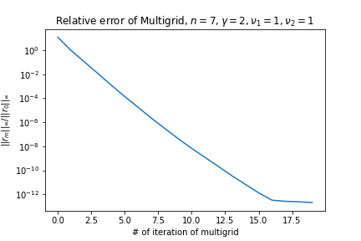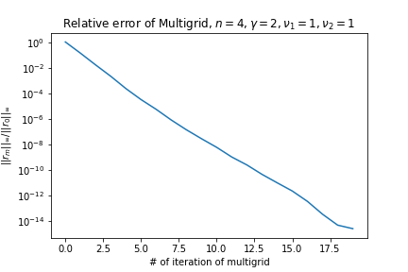**(1). Mandatory**

These 2 figures above demonstrate the effect between different grids under the same parameters. We can observe that the finer grid have the worse residue with the same iterations. Nonetheless, the performance of multigrid is still outstanding that it make the relative error less than ${10}^{-10}$ within 20 iterations. Moreover, we notice that the residue do not decrease infinitely. In the end, the curve will go flat.

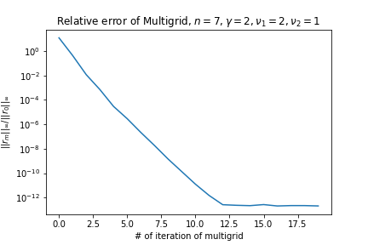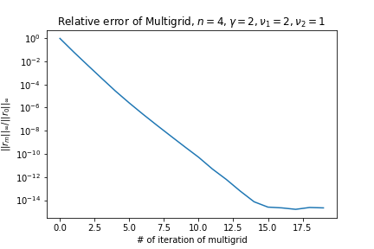

With the same parameter remaining the same, we change the iteration of the smoother, i.e. $ν_{1}$, to 2. We notice that the final relative error in the end remain the same with $ν_{1}$ being 1. However, the iteration needed for reaching the convergence sink significantly.

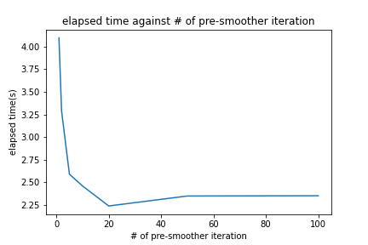

The figure above displays the relationship between elapsed time and the number of smoother iteration used. In this experiment, we set N = 128, $γ$ = 2, $ν_{2}$ = 1. And the lower threshold of the relative error for the loop to break is ${10}^{-12}$. We notice that the higher $ν_{1}$ is, the less iteration needed to meet the threshold. Consequently, the elapsed time decrease. However, the curve goes flat when $ν_{1}$ is larger than 20. This figure proves that it doesn't make sense to do too many smoothing iterations.

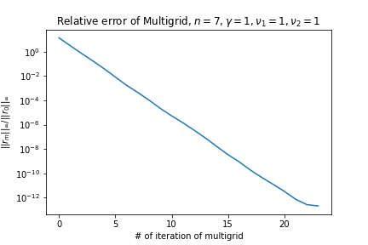

The figures above demonstrate the effect of $γ$. If we adopt V-Cycle, multigrid method will need more iterations to reach the same convergence criterion.

|  |  |
| --- | --- |
|  | Elapsed time(s) |
| Multigrid, N = 128, $γ$ = 1, $ν_{1}$ = 1, $ν_{2}$ = 1 | 4.510 |
| Multigrid, N = 128, $γ$ = 2, $ν_{1}$ = 1, $ν_{2}$ = 1 | 4.097 |

However, in terms of the elapsed time, the difference is not large.

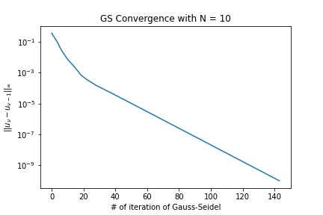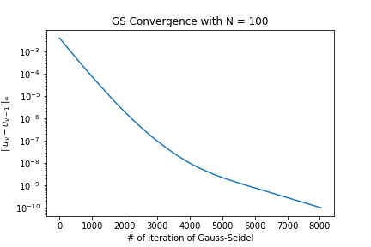**(2). WP1**

In this part, we demonstrate the result using the smoother only so that we can feel how great multigrid method is. In this experiment, the loop will break after the convergence, i.e. ${\left\|u_{ν}-u_{ν-1}\right\|}_{∞}<{10}^{-10}$.

For N = 10 it took 144 iterations, while it took 8030 iterations to complete the grid of N = 100. Compared to multigrid method, it require much more iterations. Then we choose another criterion, time.

|  |  |
| --- | --- |
| Method | Needed time(s) |
| Gauss-Seidel, N = 10 | 0.014 |
| Multigrid, N = 16, $γ$ = 2, $ν_{1}$ = 2, $ν_{2}$ = 1 | 0.034 |
| Gauss-Seidel, N = 100 | 123.0 |
| Multigrid, N = 128, $γ$ = 2, $ν_{1}$ = 2, $ν_{2}$ = 1 | 5.753 |

We observe that smoother take less time than the multigrid method in coarse, although elapsed time is quite small. However, when the grid get finer, the difference appears to be obvious. It takes more than 100 seconds using the smoother only, while multigrid method spend about 6 seconds to solve the Poisson equation on the finer mesh. Hence, as the grid to solve gets finer, the advantage of multigrid method will be much larger.

The figures above demonstrate the property of the Gauss-Seidel smoother exactly: 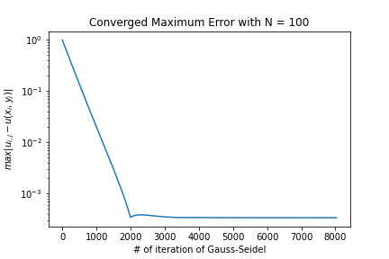the smoother can 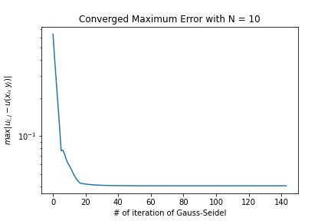reduce the high frequency component of error fast, but it can only eliminate the low frequency component of error very slowly. The flat part of the curve is exactly the remaining low frequency part of the error.

**(3). WP2**

We measure the error of the restriction and prolongation in this part. The criterion of the error in this part is defined as :

$${\left\|e_{2h}\right\|}_{∞}=\max_{i,j}\left|u_{2h}\left[i,j\right]-u(x_{i},y_{j})\right|$$

|  |  |
| --- | --- |
| Restriction |  |
| n = 4 | 0.0746719 |
| n = 7 | 0.00120418 |
| Prolongation |  |
| n = 4 | 0.707107 |
| n = 7 | 0.501203 |

About the restriction, we found that the error occurring after the restriction is not so large, especially the grid is finer. It proves that restriction works well and we can reduce the low frequency component of error with coarser grids without losing too many accuracy.

However, the error of the prolongation is not acceptable. The most part of the error of multigrid method should be from this step. It is most worthy to research this part for reducing the error of multigrid method.