Evan Dorn

Chris Cornejo

Bradley Kennedy

6.P2.user.manual

Use Instructions

Starting the app, the user begins at the login screen. On the login screen the user will initiate their session by entering their phone number for their authentication credentials. Then the app will transition to the home screen with use options. There will be a presentation of five buttons, events, my agenda, scavenger hunt, map and contact. Events will be a list of all current events from the conference, from this page the user can also go to their personal agenda. The agenda page will contain all of the events that the use is currently enrolled and will allow the user to add other events to their personal schedule. The scavenger hunt page will simple be a list of clues with check boxes to confirm that the user has found the item, and the ability to submit a foto of the item. The map page will display a map of Clemson (or wherever the conference is) with locations of key buildings and the users location relative to those buildings. The contact page will simple contain the contact information of the conference organizers.

Step by Step Instructions

1. Launch the app. You will be asked for your phone number. Once you have entered it in the text field click “Go”.

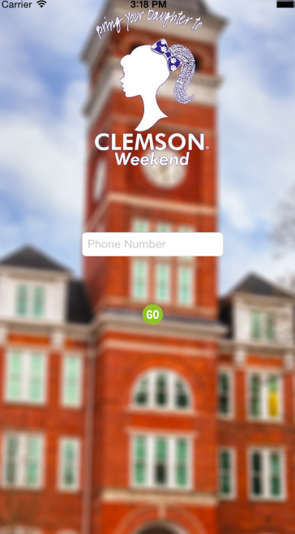

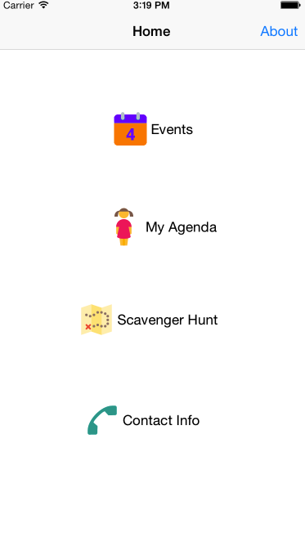

2. You will be taken to the home screen, and presented the functions of the app. The **Events** page is a master schedule and allows the user to view all the events and add them to their personal schedule. The **My Agenda** is the personal schedule. Events added to it from the Events page will show up here. The **Scavenger Hunt** icon takes you to the Scavenger Hunt page in the app. Here, the user is given certain items to find along with clues. Finally, the **Contact Info** page lists the staff for the event as well as their phone number and email.

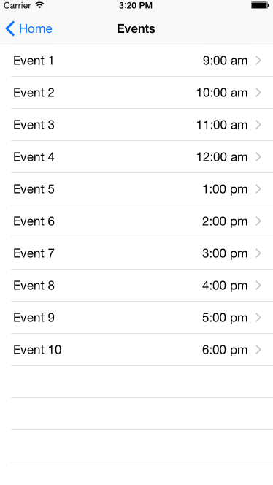

3. This is the Events page. It is the master schedule. Users will be able to click each event to find out more, as well as add it to their personal schedule.

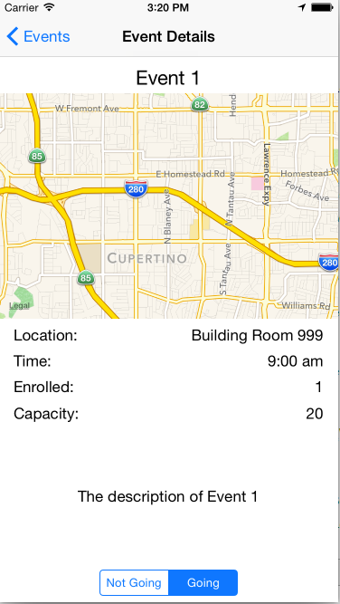

4. When you click an individual event, you will be asked to let the app use your location. This is so that the app can use the map function. Allow this. On this screen it shows more information about the event. At the bottom, users can mark if they are going to this particular event. If they set it to “Going” then the event will automatically add itself to their personal schedule.

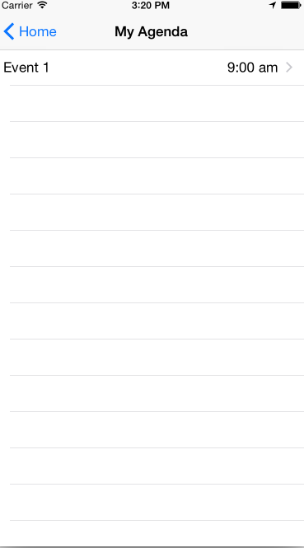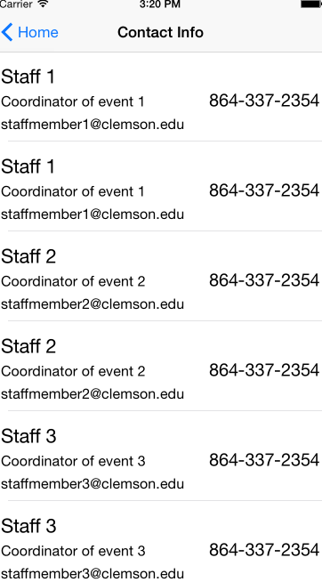

5. This is the My Agenda page. Since the user clicked “Going” for Event 1, the event is now added to this page. The user can also click the event for more information.

6. The Contact Info page lists all staff members as well as their email and phone number. Making it easy to find if someone has any problems or questions.