**UNISS_UNIGE dataset. Dataset Info**

**Participants:** 10 Elderly subjects

10 PD Patients

10 STROKE Patients

10 CHOREA Patients

**Protocol and Activities.**

Subjects were asked to walk back and forth for about one minute along a 12-meter walkway with the instrumented mat placed two meters from the starting line where they stood with their feet together for a few seconds after the beginning of the MIMU acquisition.

The subjects performed two tests:

* Walking back and forth at comfortable speed for one minutes (**Test1)**
* Walking back and forth at higher speed for one minutes (**Test2**)

Participants wore their own shoes.

Walking aids such as canes or tripods were allowed if used in daily life.

Subjects could rest in between acquisitions if requested.

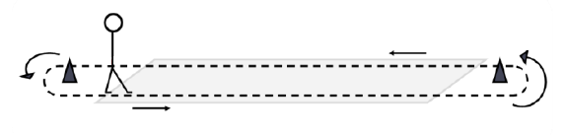

*Figure 1. Protocol*

The subjects passed several times on the 12-meter walkway during the one-minute test, while the IMUs are always on.

So, the different passages on the walkway were divided and called Trials. Inside a trial there will be only the Gaitrite's data for that passage and the correspondent IMU data. The time of first and last contact on the mat for each passage were used to divide in trials.

The two instruments were synchronized.

**Reference articles:**

1. D. Trojaniello *et al.*, «Estimation of step-by-step spatio-temporal parameters of normal and impaired gait using shank-mounted magneto-inertial sensors: application to elderly, hemiparetic, parkinsonian and choreic gait», *J NeuroEngineering Rehabil*, vol. 11, n. 1, pag. 152, 2014.
2. D. Trojaniello, A. Ravaschio, J. M. Hausdorff, e A. Cereatti, «Comparative assessment of different methods for the estimation of gait temporal parameters using a single inertial sensor: application to elderly, post-stroke, Parkinson’s disease and Huntington’s disease subjects», *Gait & Posture*, vol. 42, n. 3, pag. 310–316, set. 2015
3. M. Bertoli, A. Cereatti, D. Trojaniello, A. Ravaschio, e U. Della Croce, «The identification of multiple U-turns in gait: comparison of four trunk IMU-based methods», in *Proceedings of the 11th International Conference on Body Area Networks*, Turin, Italy, 2017.

**IMU characteristics:**

* **Model/Brand:** OPAL inertial sensors (APDM Inc.):
* **Sensors (fs;range;resolution)**:
  + 3-axes accelerometer (128 Hz; ±6g)
  + 3-axes gyroscope (128 Hz)
  + 3-axes magnetometer (128 Hz)
* **Availability of quaternions/orientation**: yes, not standardized as axes positions
* **Positions**:
  + Left and right lower shank – ***“Left/RightLowerShank”***
  + Lower back (between L4 and S2) – ***“LowerBack”***

**Standards:**

* **Type**: Instrumented walkway
* **Model/Brand**: GAITRite Electronic Walkway, CIR System Inc
* **Fs**: 120 Hz
* **Other info**: spatial resolution accuracy: ±12.7 mm temporal accuracy: ±1 sample.
* The instrumented mat returned all GEs, temporal and spatial parameters under analysis.

**Missing data:**

* **Test1** of subject S029
* **Test2** of subjects S027, S030, S037

**Notes:**

1. It is possible that some IMU data, especially on the ankles, have some offset due to bad alignment of the sensor, see the figure 2 below with an example on acceleration data, the red one has an average far from zero.

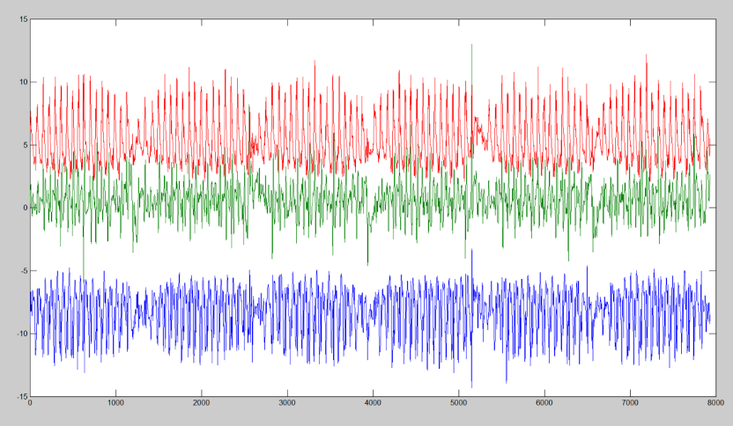

*Figure 2. Example of acceleration data.*

1. The MIMUs and the instrumented mat provided data were synchronized at ±1 sample.
2. The length of the Tests is generally about 60 seconds (as reported in the protocol). Only one subject (S021) has longer tests. We have decided not to cut his/her data.
3. SingleSupport_Duration and DoubleSupport_Duration have slightly different values than those obtained if calculated by IC and FC. It could be because GaitRite doesn’t use IC and FC in its processing (e.g. it could instead use HS and TO)
4. Five chorea subjects used walking aid (stick) during tests, but for 3 of them we don’t know on which side. So, in the field WalkingAid in infoForAlgo we wrote ‘One side only’ instead of ‘Right Only’ or ‘Left Only’.