Study Verification Test

## Teacher Report

This analysis gives an overview of the SSP.

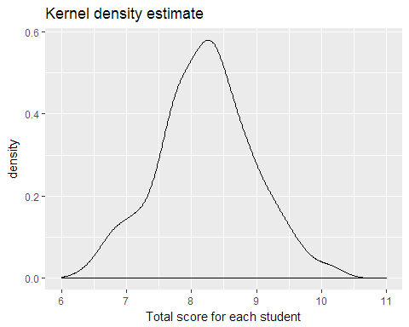

## Warning: Removed 2 rows containing non-finite values (stat_density).

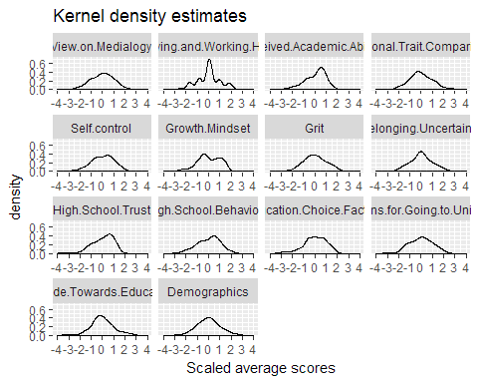

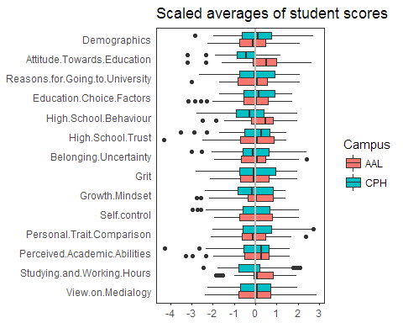

## Currently generic markdown table using pandoc is not supported.

Distribution of study hours in a week

|  |  |  |
| --- | --- | --- |
|  | AAL | CPH |
| 0-29 hours | 4 | 6 |
| 30-34 hours | 9 | 9 |
| 35-40 hours | 15 | 9 |
| More than 41 hours | 62 | 76 |
| Total | 90 | 100 |