Student dropouts 2017/2018

Analysis of first year students 2017/2018 at Medialogy. May 2018.

## 1. Dropouts/Q999

Number of student dropouts

|  |  |  |
| --- | --- | --- |
|  | Dropouts | Q999 |
| AAL | 25 | 7 |
| CPH | 14 | 7 |
| Total | 41 | 14 |

## 2. Study verification test

Average scores from student dropouts in different topics:

Table with avg. scores in SSP for dropouts:

|  |  |  |  |  |
| --- | --- | --- | --- | --- |
|  | Q999 | AAL/CPH dropouts | AAL dropouts | CPH dropouts |
| Understanding.of.Medialogy | 0.66 | 0.67 | 0.67 | 0.66 |
| Study.and.work | 0.37 | 0.35 | 0.31 | 0.42 |
| Growth.mindset | 0.66 | 0.66 | 0.67 | 0.65 |
| Grit | 0.59 | 0.59 | 0.59 | 0.59 |
| Study.habits | 0.54 | 0.54 | 0.54 | 0.53 |
| High.school.habits | 0.71 | 0.72 | 0.76 | 0.67 |
| Social.support.for.studying | 0.66 | 0.65 | 0.63 | 0.68 |

Dropout students scored low in study and work hours (time commitment), especially in AAL. Avg. scores in SSP for Q999 looks similar to dropout students.

#### Dropouts' SSP scores superimposed on boxplots of all students

Colored campus location in boxplot:

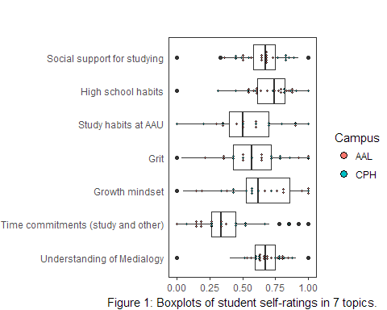

Categorized dropout reasons:

|  |  |  |
| --- | --- | --- |
| Educational reasons (A) | Personal reasons (B) | Participation reasons (C) |
| Det faglige niveau er for hoejt | Flytter til anden by | Afmeldt af studieservice |
| Det faglige niveau er for lavt | Helbredsmaessige aarsager | Ikke deltaget i foersteaarsproeven |
| Studieformen | Oekonomiske aarsager | Manglende studieaktivitet inden for 1 aar |
| Skift til anden uddannelse paa AAU | Oensker en pause | Udmeldt pga. afvist dispensation til foersteaarsproeven |
| Skift til anden uddannelsesinstitution | Oensker ikke at svare | Udmeldt pga. afvist dispensation til flere proeveforsoeg |
|  | Afbrudt af den studerende | Udmeldt pba. Sekretaeroplysning |

Colored dropout reason types in boxplot:

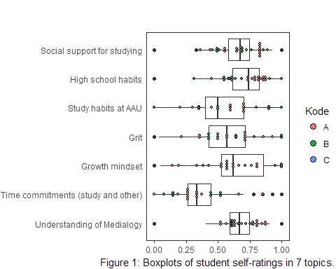

Colored dropout reasons in boxplot:

