

**4. EXPLORER**

USER   
GUIDE

*2015*

# EXPLORER

When the user complete the authentication process correctly, he will access to the files explorer screen, which the user can look in split screen mode the different files are located in the pc or in the mobile device, Figure 1: Explorer.

The user can navigate over different devices with the slide up or slide down finger action, in any of explorer half screens. The user can also access to the different subdirectories with only clicking in any of the folder icons. In addition, for each type of file the explorer has a different icon, this feature help to the user to navigate easily.

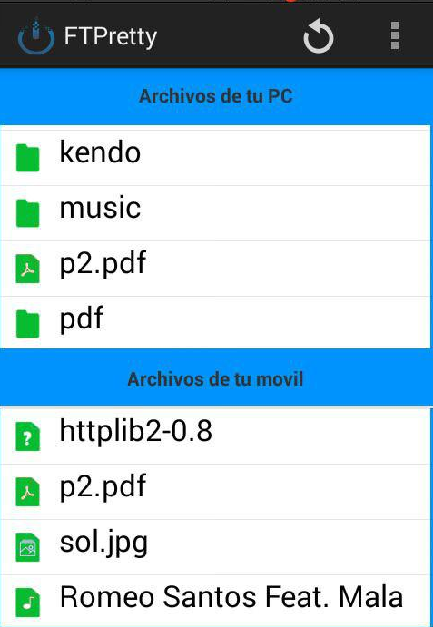

Figure 1: Explorer

The user can return to the parent directories clicking in the back button, placed in the top of the explorer, Figure 2: Explorer.

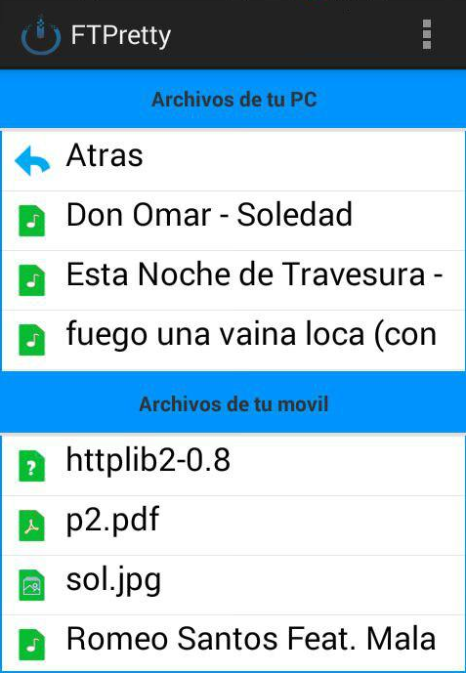

Figure 2: Explorer