

**6. UPLOAD**

USER

GUIDE

*2015*

# UPLOAD

When the user is located in the explorer screen, he can upload files from his mobile device to his computer, with the hold click in any item of the list “Archivos de tu movil”, and automatically, a secondary menu appear with the upload option, if the user click in this option, the upload starts, Figure 1: Upload.

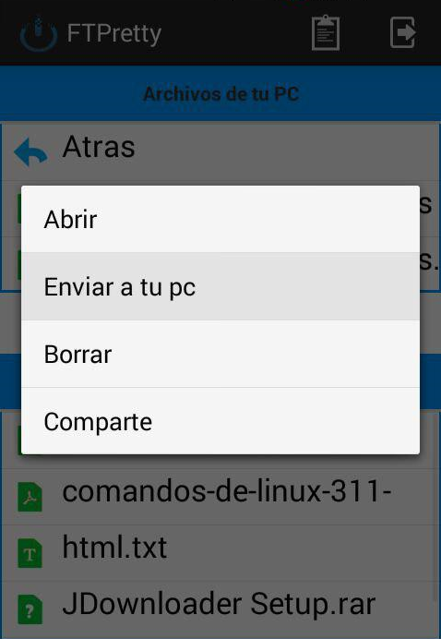

Figure 1: Upload

Once, the upload has finished, the download file, appear in the explorer “Archivos de tu PC”, Figure 2: Upload.

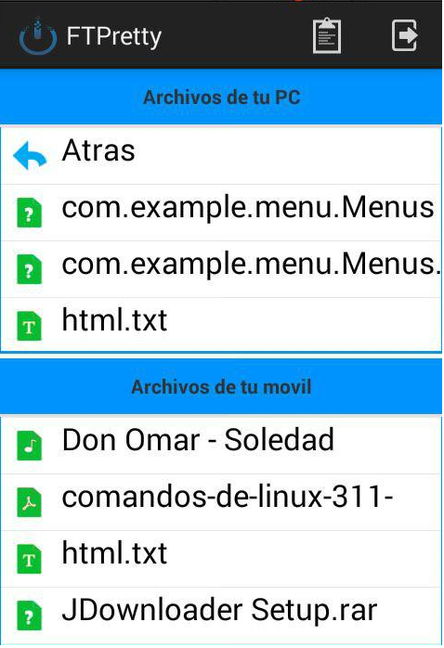

Figure 2: Upload