

**7. DELETE**

USER

GUIDE

*2015*

# DELETE

With FTPretty application, the user also can delete files, these files may be located in the device mobile and in the computer. For this purpose, the user have to hold click in any item of the two explorers, Figure 1: Delete, and click in the delete option, it can see in the, Figure 3: Delete and Figure 4: Delete.

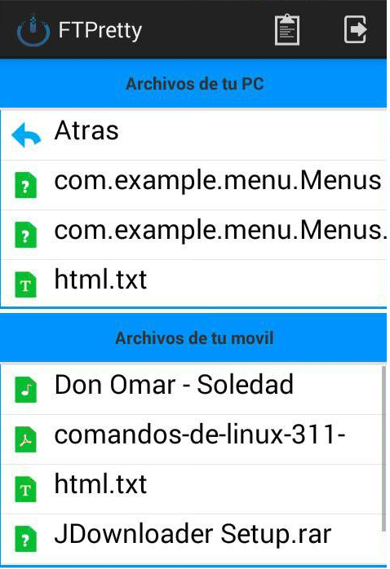

Figure 1: Delete

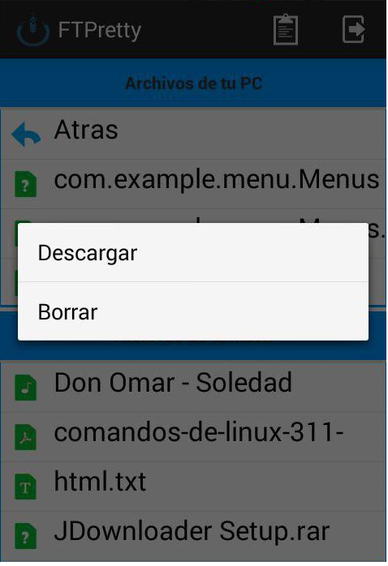

Figure 2: Delete

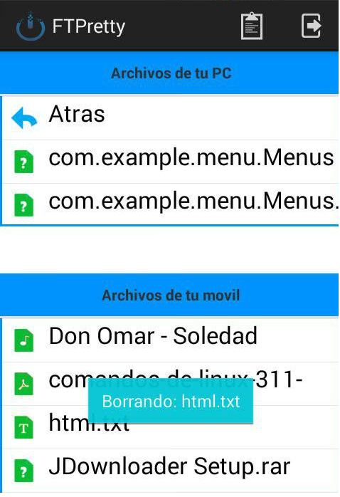

Figure 3: Delete

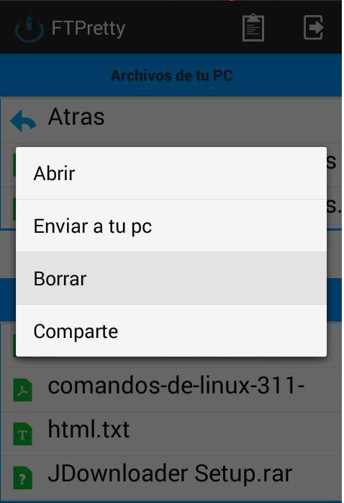

Figure 4: Delete

Finally, we can see in Figure 5: Delete, the files were deleted in the device mobile and in the computer.

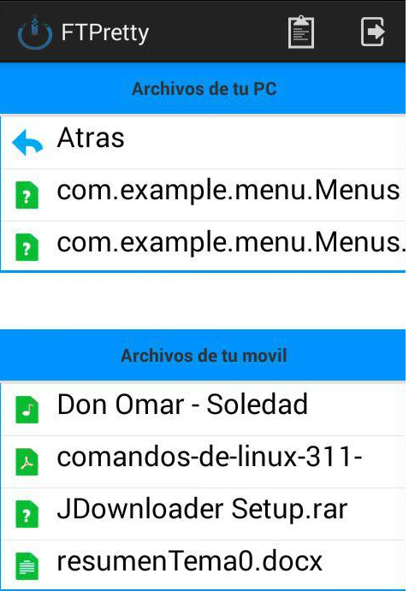

Figure 5: Delete