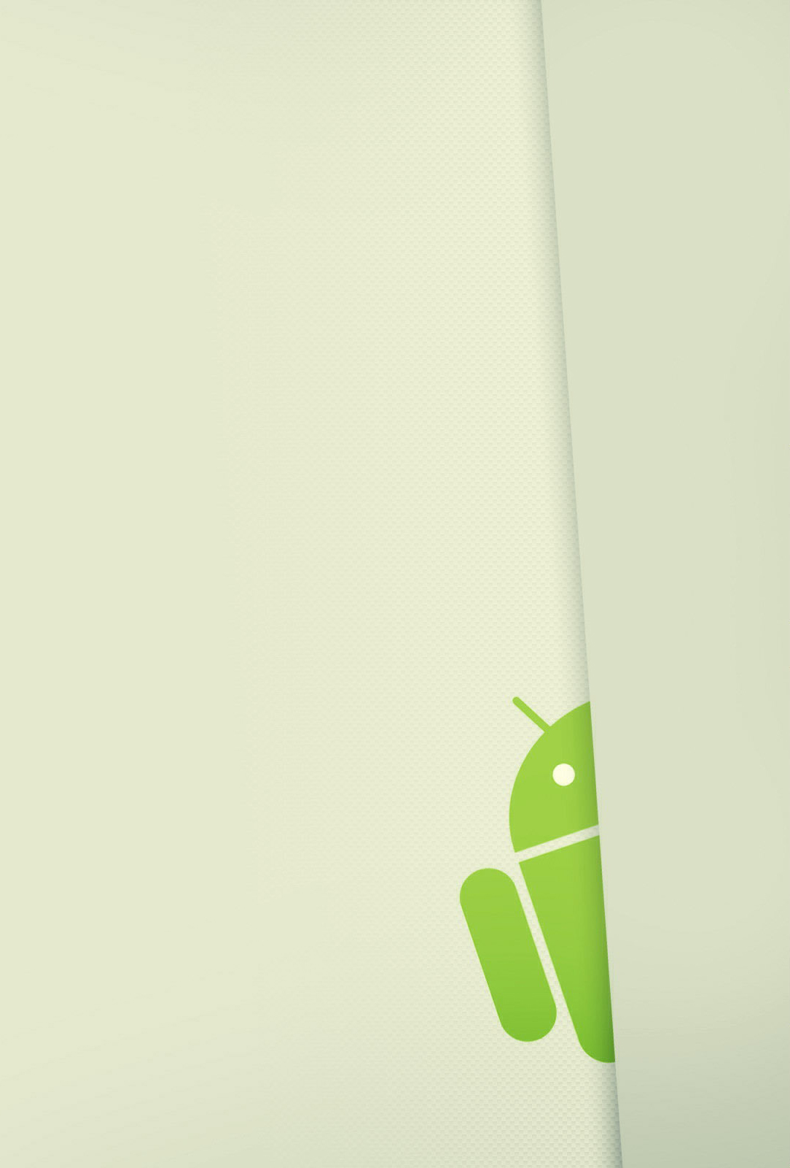

**8. LOGOUT**

USER

GUIDE

*2015*

# LOGOUT

The user can logout with the follow action bar button, see Figure 1: Logout, when the user click in this button, he return to initial screen, Figure 2: Logout.

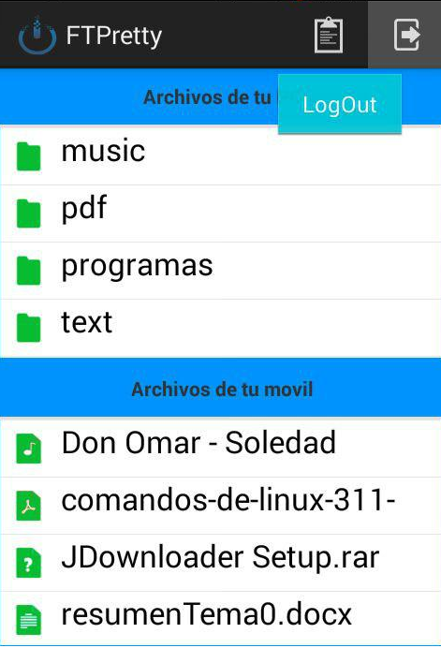

Figure 1: Logout

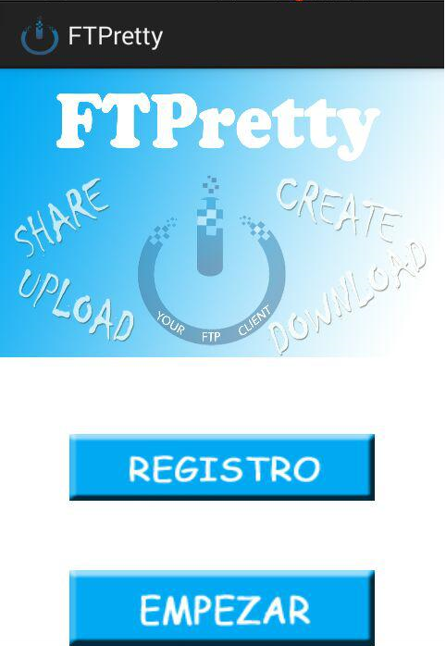

Figure 2: Logout