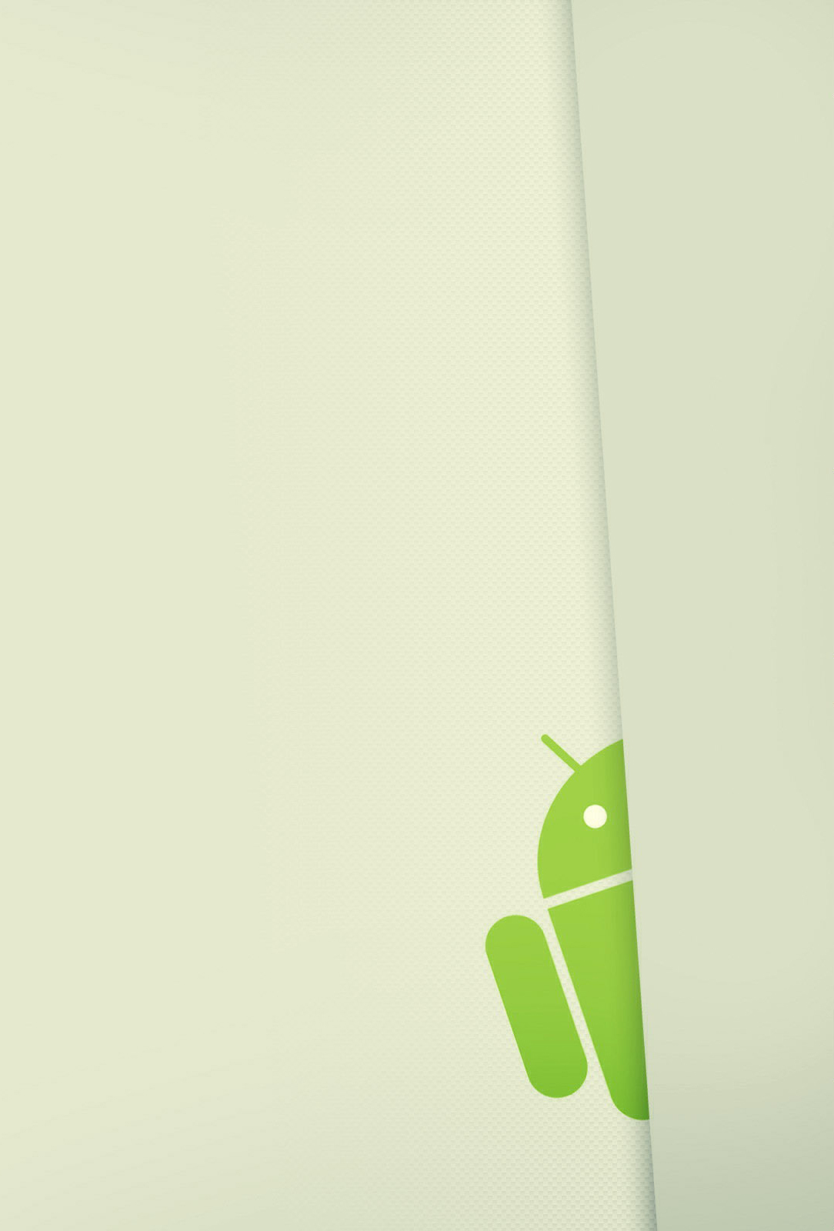

**5. DOWNLOAD**

USER

GUIDE

*2015*

# DOWNLOAD

When the user is located in the explorer screen, he can download files from his computer to his mobile devide, with the hold click in any item of the list “Archivos de tu PC”, and automatically, a secondary menu appear with the download option, if the user click in this option, the download starts, Figure 1: Download.

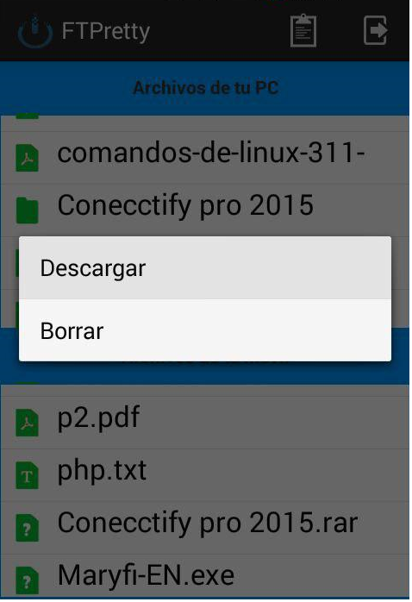

Figure 1: Download

Once, the download has finished, the download file, appear in the explorer “Archivos de tu movil”, Figure 2: Download.

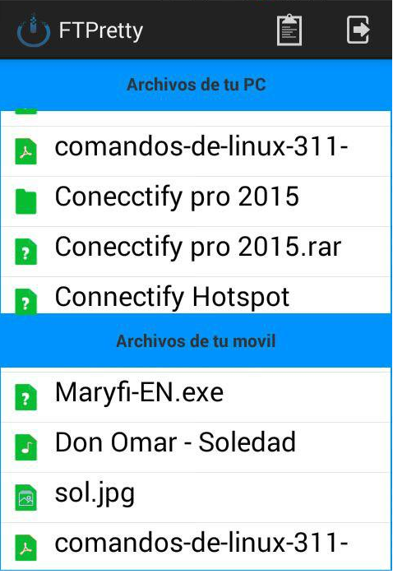

Figure 2: Download