

**9. HISTORY**

USER

GUIDE

*2015*

# HISTORY

FTPretty allows to user to visualize all the application operations (upload, download, delete, logout) from the user registration process. For this purpose, the user have to hold click the history action bar button, Figure 1: History.

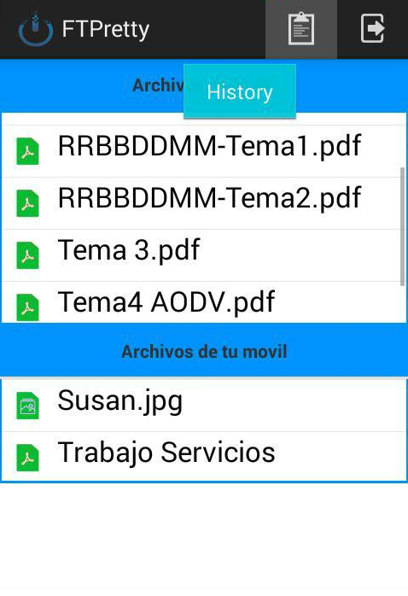

Figure 1: History

To hide the history, the user have to click the same action bar button. The user also, can open the history sliding right from de left side of the screen, and to hide history, the user will done the invert slide.

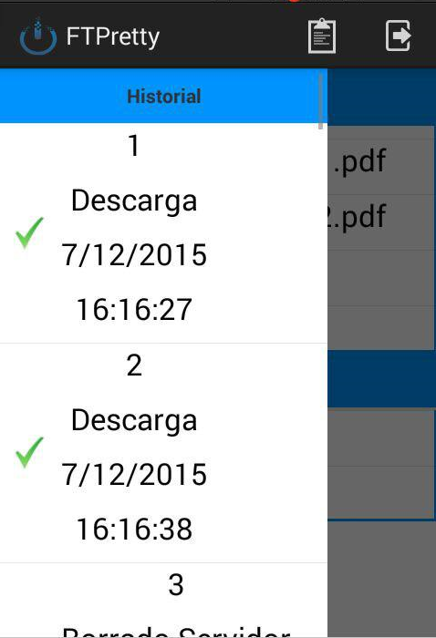

Figure 2: History