

**3. AUTHENTICATION**

USER

GUIDE

*2015*

# AUTHENTICATION

Once, the user has finished the register process, the user look the initial screen of the application, he have to click on the button “EMPEZAR”, see Figure 1: Authentication.

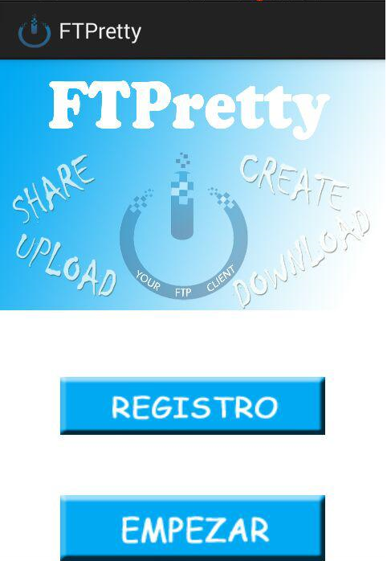

Figure 1: Authentication

After, Figure 2: Authentication, the user have to complete different fields: the username and password below register process before, ip direction or domain name of the machine where the user installed the FTPretty server, and finally, the port where the server is listening (normally TCP 21). Finally, the user have to click to the connect button.

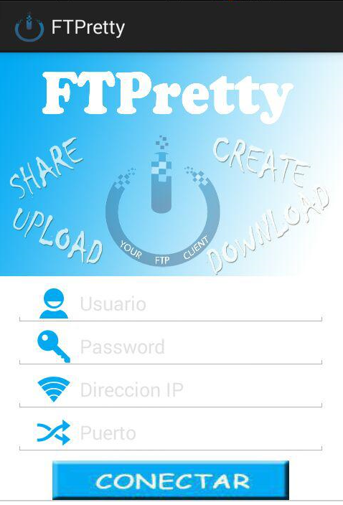

Figure 2: Authentication

Now, the user can look a new screen. It show a progress bar, which will complete while the connection to server process.

I  
Figure 3: Authentication