

**2. REGISTER**

USER

GUIDE

*2015*

# REGISTER

When the user open the application for the first time, he look the follow screen, we can see this in the Figure 1: Register. Then, the user will have to click in the button “REGISTRO”, to access to the next steep, and in this way he have to create an FTPretty account.

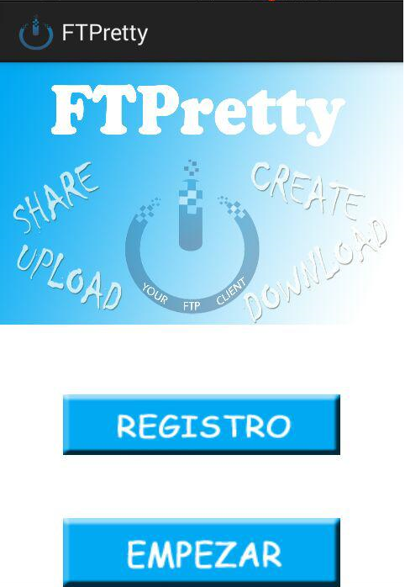

Figure 1: Register

So we can observe in the Figure 2: Register, the user have to complete the following fields which his username and his password. When the user has finished the process, he have to click again on the register button.

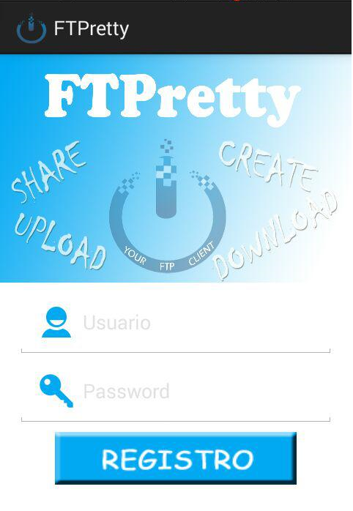

Figure 2: Register