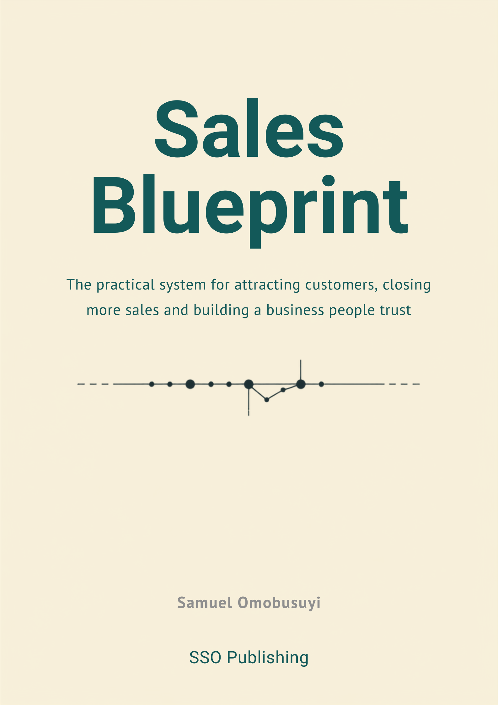

Contents
Front matter
- Copyright
- Disclaimer
- Dedication
- Preface
- How to use this book
- Introduction
- The Blueprint Framework
Part One: Foundations
- Module 1: The Truth About Sales
- Module 2: How Customers Really Buy
Part Two: The Blueprint Framework
- Module 3: Build Trust
- Module 4: Learn the Customer
- Module 5: Understand the Problem
- Module 6: Establish Value
- Module 7: Present the Offer
- Module 8: Remove Doubt
- Module 9: Inspire Action
- Module 10: Nurture Relationships
- Module 11: Turn Customers into Advocates
Part Three: Modern Selling
- Module 12: Digital Selling
- Module 13: Sales Systems
Part Four: Implementation
- Module 14: The 30-Day Sales Blueprint
Appendices
- Worksheets index
- Templates index
- Checklists index
- Glossary
- Frequently asked questions
- References
Worksheets
- Worksheet 1
- Worksheet 2
- Worksheet 3
- Worksheet 4
- Worksheet 5
- Worksheet 6
- Worksheet 7
- Worksheet 8
- Worksheet 9
- Worksheet 10
- Worksheet 11
- Worksheet 12
- Worksheet 13
- Worksheet 14
Templates
- Proposal structure
- Customer persona
- Follow-up email
Checklists
- The 30-Day Sales Blueprint Checklist

Sales Blueprint: The Practical System for Attracting Customers, Closing More Sales and Building a Business People Trust
Copyright © 2026 Samuel Omobusuyi. All rights reserved.
No part of this publication may be reproduced, stored in a retrieval system or transmitted in any form or by any means, electronic, mechanical, photocopying, recording or otherwise, without prior written permission from the copyright holder, except for brief quotations used in reviews or other uses permitted by applicable copyright law.
Published by SSO Publishing.
First Edition, 2026.
ISBN: to be assigned.
Cover design and interior layout by SSO Publishing.

Disclaimer
The information in this book is provided for educational and informational purposes only. It does not constitute legal, financial, tax, or professional advice. Every business is different, and a technique that works for one company may need adjusting, or may not apply at all, to another. Readers should use their own judgement, and consult a qualified professional, before making decisions that affect their business or finances.
The author and publisher have made every reasonable effort to ensure the accuracy of the material at the time of writing. Markets, tools, and buyer behaviour change; a specific tactic, platform, or statistic may date faster than the underlying principle it illustrates. The author and publisher make no warranties, express or implied, about completeness or accuracy, and accept no liability for any loss or damage arising from the use of this book.
Kestrel Office Interiors, Priya Shah, and every person, conversation, and event used in this book's running case study are fictional. They were created to demonstrate the Blueprint Framework in a connected, realistic setting. Any resemblance to an actual business or person, living or dead, is coincidental.

Dedication
For every business owner who is brilliant at the work and still dreads the sales call.
You didn't start your business because you love pitching. You started it because you're good at something and wanted to build a life around it. This book exists so the selling stops being the part you tolerate and starts being the part you understand.
And for the customers who said no, kindly or otherwise. You taught me more about this framework than any client who said yes ever did.

Preface
I lost a deal in my second year of running my own company that I still think about. Six weeks of calls, a proposal I was proud of, a buyer who nodded at everything I said. Then silence. When I finally got the decision-maker on the phone, she told me they'd gone with a competitor who was 30 per cent more expensive. I asked why. She said, "Because we trusted they'd actually deliver."
I had a better product. I lost anyway. That is the moment this book started, even though it took me another nine years to write it down properly.
For most of my career I believed selling was a talent. Some people had the gift: the easy charm, the quick comeback, the knack for closing. I didn't have it, so I worked around it with research, preparation, and an uncomfortable amount of honesty with prospects about what my product couldn't do. It turned out that approach won more often than the charm did. Not because charm doesn't matter. Because trust matters more, and trust is not a personality trait. It is a sequence of specific, repeatable things a seller does, in a specific order, that most sales training skips straight past.
I spent the next decade testing that sequence, first on my own deals and later while advising other founders and small business owners who, like me, were good at their craft and uneasy about selling it. The pattern held up across an accounting firm, a landscaping company, a software team, and the office fit-out business you will meet in Module 1. Different products, different price points, same nine moments determining whether the deal closed.
That sequence became the Blueprint Framework: Build Trust, Learn the Customer, Understand the Problem, Establish Value, Present the Offer, Remove Doubt, Inspire Action, Nurture Relationships, Turn Customers into Advocates. Nine words, nine chapters, one system.
This book is not a collection of tricks. I have read plenty of those, and most of them share the same flaw: they describe what a great salesperson does without explaining why it works, so the reader can't adapt it when the situation changes. Every chapter in this book answers five questions: what the idea is, why it works, how to do it, what to do with it in the next twenty-four hours, and how to know if it worked. If a chapter can't answer all five, it didn't make the final draft.
You'll notice one company running through the whole book: Kestrel Office Interiors, a fictional office fit-out business founded by a woman named Priya Shah. I built her and her business from a composite of real conversations I've had with founders over the years, changed enough that no single client would recognise themselves in it, but close enough to reality that you'll recognise the situation. Watch what she does at the start of each chapter and what changes by the end of it. That is the framework in motion, not just in theory.
I still think about that six-week deal I lost. These days, though, it is a much rarer story. I hope that by the time you finish this book, it is a rarer one for you too.
Samuel Omobusuyi

How to Use This Book

Read Part One and Part Two in order
Part One explains why most sales advice fails and how buyers actually make decisions. Part Two is the Blueprint Framework itself, nine chapters, one per stage, in the order a real deal moves through them. Each chapter builds on the last, so read Modules 3 to 11 in sequence the first time through, even if you're tempted to skip to the one that matches your current problem.
After that first read, use the book as a reference. If you're stuck on pricing objections next month, go straight to Module 8. If you've just closed a deal and need to write the follow-up email, Module 10 has the templates.

Follow Kestrel Office Interiors
Every chapter in Part Two continues the story of Kestrel Office Interiors, a fictional office fit-out company run by a founder named Priya Shah. You'll meet her in Module 1, watch her struggle with the exact problem each chapter addresses, and see what changes once she applies that chapter's stage of the framework. Her business is fictional, but her problems are not: they were built from the same patterns that show up in real founder-led sales conversations, again and again.
Watch what stays constant about Kestrel (her business, her market, her team) and what improves (her win rate, her pipeline, her referrals). The improvement is the point. It shows you the framework working over time, not just in a single conversation.

Do the exercises with your own business
Every chapter includes a worksheet or exercise, referenced by name at the point you need it and collected in full in the worksheets section at the back of this book. These are built to run on your actual business, your actual prospect, your actual price. Reading about the value stack is not the same as building one for what you sell. Twenty minutes with a worksheet, applied to a real deal you're working on right now, will teach you more than the chapter alone.

Use the templates as starting points, not scripts
The templates section at the back of this book holds reusable documents (proposal structures, follow-up emails, persona builders) that Part Two introduces and Part Three (Modules 12 and 13) helps you turn into a repeatable system. Adapt the wording to how you actually talk. A template that reads like a corporate memo will lose the trust you're trying to build.

The five questions
Every chapter in Part Two answers the same five questions, in the same order: what the concept is, why it works, how to do it, what to try in the next twenty-four hours, and how to know if it worked. If you only have ten minutes with a chapter, read the "How do I apply this today?" and "How do I measure success?" sections first. They tell you exactly what to do and how to check that it's working.

Module 14 turns the book into a plan
Once you've read Parts One through Three, Module 14 compresses the whole framework into a thirty-day rollout: what to install in your business each week, in what order, with what you should expect to see change by day thirty. That's the chapter to return to once you've finished the book and want to actually build the system, rather than just understand it.

Introduction
Two people sell the same product to two similar buyers. One gets a signed contract in three weeks. The other gets "let me think about it" and never hears back. Same product, same price, same market. What was different?
Usually, it isn't talent. It's sequence. The seller who won did five or six things in an order that built the buyer's confidence step by step. The seller who lost may have done some of the same things, but in the wrong order, or skipped one entirely, and the buyer's doubt never had anywhere to go.
Most sales advice doesn't help with this, because most sales advice is about individual moments rather than the sequence that connects them. There's a chapter on cold calling, a chapter on handling objections, a chapter on closing techniques, each treated as its own skill to master. That's a bit like teaching someone to cook by handing them twelve unrelated techniques (how to dice an onion, how to deglaze a pan, how to season to taste) and never showing them a recipe. The techniques might all be correct. Without an order to put them in, they don't add up to a meal.
This book is the recipe.

The nine moments
Every sale, whether it closes in a ten-minute phone call or a fourteen-week enterprise process, moves through the same nine stages. We call it the Blueprint Framework: Build Trust, Learn the Customer, Understand the Problem, Establish Value, Present the Offer, Remove Doubt, Inspire Action, Nurture Relationships, and Turn Customers into Advocates.
Skip a stage, or do it out of order, and the deal usually still stalls somewhere, even if the seller is charming, knowledgeable, and hard-working. A prospect who doesn't trust you yet won't absorb your value proposition, no matter how good it is. A buyer whose real problem you haven't understood will reject an offer that would have solved it perfectly, because it doesn't look like a match for the problem they described. Doubt that never gets addressed by name doesn't go away on its own; it just becomes the silence after your follow-up email.
The next chapter, The Blueprint Framework, lays out all nine stages in full, with the questions each one answers and the failure mode each one prevents. Part Two then spends one chapter per stage, showing you exactly how to run it in your own business.

What this book is not
This isn't a book about becoming a different kind of person. If you're naturally reserved, this framework will not turn you into someone who works a room. If you find small talk exhausting, nothing here asks you to fake enthusiasm you don't feel. What changes is not your personality; it's your sequence, and a sequence can be learned by anyone willing to follow it consistently.
It also isn't a book of scripts to read word for word. A handful of templates appear throughout (an email structure here, a discovery-call question list there), and you should adapt every one of them to how you actually talk. A borrowed script, delivered in someone else's voice, is one of the fastest ways to undo the trust you're trying to build.
And it doesn't promise a specific result by a specific date. Deal cycles, price points, and markets vary too much for that kind of claim to mean anything. What it promises is narrower and, I think, more useful: a system that removes the guesswork from your next conversation, and a way to measure whether it's working so you can adjust before you've lost the deal, not after.

What to expect from here
Part One looks at why sales training so often fails and how buyers actually make decisions, which turns out to matter more than most sellers assume. Part Two is the framework itself, one stage per chapter, followed through a fictional business called Kestrel Office Interiors so you can see each stage change something real, not just describe it in the abstract. Part Three covers how the framework holds up online and how to turn it from something you do into something your business does automatically. Part Four compresses everything into a thirty-day plan.
Read it in order the first time. After that, use it the way you'd use a reference manual: open to the chapter that matches whatever is stalling in your pipeline this week.
The deal you're about to lose, or the one you're about to win, is probably decided by which of the nine stages you handle next. Let's start with the one most sellers get wrong before they've said a single word to the prospect: trust.

The Blueprint Framework
A sale is a sequence of trust transfers. At the start of a conversation, the buyer trusts their own scepticism more than they trust you. By the end of a successful one, that has reversed: they trust your read of their problem, your solution, and your ability to deliver more than they trust their instinct to stay with the status quo. The Blueprint Framework is the order in which that transfer actually happens.
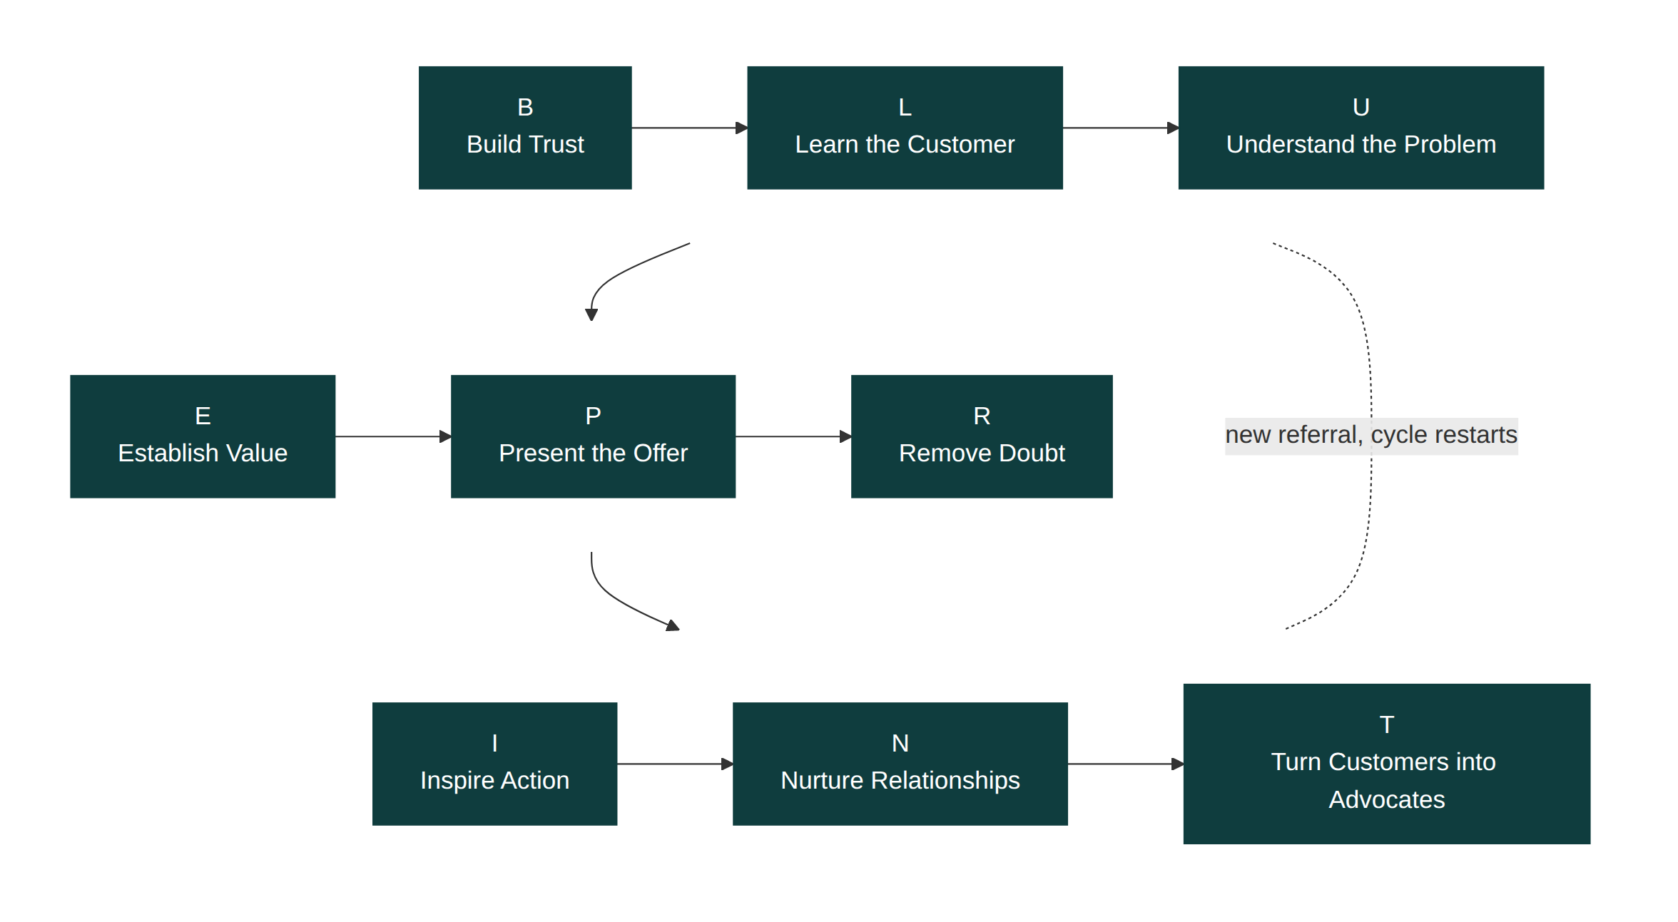
Figure 0.1: The Blueprint Framework, the nine stages a buyer moves through on the way to a decision.
B: Build Trust
L: Learn the Customer
U: Understand the Problem
E: Establish Value
P: Present the Offer
R: Remove Doubt
I: Inspire Action
N: Nurture Relationships
T: Turn Customers into Advocates

The nine stages
Build Trust. Before anything else, the buyer needs a reason to keep listening to you instead of dismissing you the way they dismiss most sales approaches. This isn't rapport-building small talk; it's specific, demonstrable behaviour that signals you're not here to extract value from them before you've added any. Skip this stage and every later one gets harder, because the buyer is evaluating your words against a baseline of suspicion.
Learn the Customer. Once you have a hearing, the next job is finding out who you're actually talking to: their role, their pressures, how they personally will be judged on this decision, and how their organisation buys. Sellers who skip this stage substitute assumption for research, and the assumption is usually wrong in a way that costs them the deal three steps later.
Understand the Problem. Most buyers describe their problem in terms of a symptom, not a cause. "Our current system is too slow" might really mean "we're losing two members of staff a year to burnout from manual data entry." Get the diagnosis wrong and you can build a technically excellent solution to the wrong problem, and watch the buyer reject it because it doesn't feel like it addresses what's actually bothering them.
Establish Value. With the real problem in hand, this stage connects your solution to a specific, believable outcome the buyer cares about, in their language and their numbers, not yours. Value that is only asserted ("we're the best in the market") is not value that has been established. Value that is demonstrated, with a concrete before-and-after the buyer can picture, is.
Present the Offer. This is where the solution gets packaged into something easy to say yes to: clear scope, clear price, clear next step. An offer that's confusing, over-optioned, or led with price before value creates hesitation that has nothing to do with whether the buyer needs what you're selling.
Remove Doubt. Every buyer who doesn't say yes immediately has a specific, nameable hesitation, even when they haven't said it out loud. This stage is about surfacing that hesitation and resolving it directly, rather than arguing with a vague, unspoken objection or hoping it disappears if you keep talking.
Inspire Action. Interest that never converts into a next step is not a stalled deal; it's a dead one. This stage gives the buyer a clear, low-friction action and a reason to take it now rather than next quarter, without resorting to artificial urgency that undermines the trust built in stage one.
Nurture Relationships. The sale closing is not the end of the relationship, it's the point where most of its long-term value begins. This stage is about staying in deliberate, useful contact after the invoice is paid, rather than only reappearing when there's something new to sell.
Turn Customers into Advocates. A satisfied customer who never refers anyone is a missed multiplier. This final stage builds a repeatable system for turning satisfaction into active referral, rather than hoping it happens on its own.

It loops
The dotted line back to Build Trust in Figure 0.1 matters. A referral from a happy customer still has to build trust with the new prospect; it just starts from a higher baseline than a cold approach did. And within a single deal, the sequence isn't always a straight line. A new stakeholder joining midway through a decision (a finance director who wasn't in the first three meetings, say) means Build Trust and Learn the Customer restart for that person specifically, even if you're deep into Present the Offer with everyone else. Module 13, Sales Systems, covers how to manage that overlap without losing track of where each stakeholder actually is.

Why nine, and why this order
Each stage removes a specific barrier that would otherwise block the next one. You cannot establish believable value with someone who is still deciding whether to trust you. You cannot present a compelling offer to a problem you haven't correctly diagnosed. The order isn't a stylistic choice; it reflects which barriers have to come down before the next one is even addressable. That's also why Part Two gives each stage its own chapter rather than folding them into a single "how to sell" chapter: each one has its own failure mode, its own diagnostic questions, and its own exercise, and conflating them is exactly how sellers end up skipping steps without realising it.
Part Two starts with the stage most sellers try to skip entirely, assuming a strong product will cover for it. It won't.

Part One: Foundations

Module 1: The Truth About Sales

Learning objectives
By the end of this module, you will be able to:
- Name the four myths that make skilled business owners avoid or dread selling
- Explain why sequence, not personality, decides whether a deal closes
- Diagnose the specific pattern behind Kestrel Office Interiors' stalled win rate
- Recognise which myth is most active in your own business, and why
- Locate the point in your own recent deals where trust, not price, actually broke down

Kestrel Office Interiors: the pitch that should have won
Priya Shah stood in the car park outside a logistics company's head office, re-reading the email on her phone for the third time. Thank you for your proposal. We've decided to go with another supplier. Six weeks of site visits, a 3D walkthrough she'd built herself over two weekends, a quote £9,000 under the next closest bid. She called the office manager, the one who'd seemed so enthusiastic in every meeting, and asked what had gone wrong. "Honestly, Priya, your design was better. We just weren't sure you'd deliver on time. The other company has done three jobs like ours before."
Priya had heard some version of that sentence four times in the last year. Her portfolio was strong. Her prices were fair, often generous. And she kept losing to competitors who, on paper, offered less.
She drove home that evening turning over a question she'd never let herself ask directly: was she actually bad at this, or was something else going on that she couldn't see from inside it? The four myths in this chapter are the answer she eventually found, and the reason it took her nine years to find it is that each one feels like common sense from the inside.

Myth one: selling is manipulation
Ask most craft-focused business owners why they dislike selling, and you'll hear some version of "I don't want to pressure people." That instinct is healthy; the myth is thinking that pressure is what selling requires. Selling, done well, is diagnosis followed by an honest match: finding out precisely what a buyer needs and telling them plainly whether you're the right fit. When that match is genuine, no pressure is needed, because the buyer is convincing themselves. When sellers reach for pressure tactics (artificial deadlines, exaggerated scarcity, guilt), it's usually a sign they've skipped the diagnosis and are trying to compensate for a weak match with force.
Priya wasn't manipulating anyone. If anything, she under-sold: she assumed a great design would speak for itself and treated the rest of the conversation as a formality. That is its own kind of mistake, just a quieter one.
If you sell a lower-cost, higher-volume product rather than Priya's considered purchases, this myth still shows up, just compressed into seconds instead of weeks. A retail assistant who over-explains and hovers is applying pressure the same way a pushy enterprise rep does; a retail assistant who answers one honest question well and then steps back is doing the diagnosis-and-match version, just at a faster tempo. The mechanism doesn't change with deal size. Only the clock does.

Myth two: you need a certain personality
The confident, quick-talking salesperson is a stock character, and plenty of business owners conclude early on that they don't have "the gift" and never will. But watch what actually happens in a winning deal and a losing one side by side, and personality explains surprisingly little of the difference. What explains it is sequence: whether trust was established before value was pitched, whether the real problem was understood before a solution was proposed, whether doubts were named and addressed rather than argued with or ignored.
Sequence can be learned by someone who finds small talk exhausting just as easily as by someone who thrives on it. It cannot be improvised by relying on charm alone, which is why naturally charismatic sellers still lose deals they should have won: charm gets you a hearing, not a signature.
This is worth sitting with, because it's the myth that does the most damage. A business owner who decides early that they're "not a people person" often stops trying to improve the specific, learnable behaviours in this book, and instead either avoids selling altogether (handing it to someone else, or simply doing less of it than the business needs) or over-corrects into a performance of confidence that feels false and reads as false to buyers. Neither response fixes anything, because neither one addresses sequence. The fix isn't becoming a different kind of person. It's running the same nine steps, in order, regardless of what kind of person you already are.

Myth three: the best product or the lowest price wins
This is the myth Priya's story punctures directly. Her design was better. Her price was lower. She still lost, because the buyer's actual bottleneck wasn't quality or cost; it was confidence that the job would be delivered on time by a team they'd never worked with before. Price and quality only decide between options the buyer already trusts roughly equally. Below that trust threshold, a cheaper, better solution loses to a more expensive, adequate one every time, because the buyer is pricing in risk, not just cost.
This is why Part Two of this book spends its first three chapters on trust, the customer, and the problem, and only reaches value and price in Modules 6 and 7. By the time price enters the conversation, the outcome is usually already decided.
There's a genuine exception worth naming honestly: in markets where the product is a true commodity (identical, interchangeable, bought entirely on spec sheets, such as raw materials sold to industrial buyers who audit suppliers on price alone), price and quality do carry more of the decision than trust does. If that's your market, this myth is less of a myth for you, and you should weight Modules 6 and 7 more heavily than 3 and 4. Most considered purchases, though, including anything with a person on the other end making a judgement call rather than running a spec comparison, work the way Priya's story shows.

Myth four: an objection is the buyer's final word
"We've decided to go with another supplier" sounds final. It rarely is, in the sense that matters: there was almost always a specific, resolvable concern sitting underneath it, one that never got surfaced and addressed while there was still time to do something about it. Treating an objection as a closed door means you stop learning from it. Treating it as a symptom (in Priya's case, "will you actually deliver on time?") means you can build a system that surfaces and answers that question before the buyer has to raise it as a decline.
Module 8 is dedicated entirely to this: not to overcoming objections through argument, but to removing the doubt that produces them in the first place.

The four myths, side by side
Myth | What it leads a seller to do | What actually works instead
Selling is manipulation | Avoid directness, under-sell, hope the product speaks for itself | Diagnose the buyer's need plainly and say honestly whether you're a fit
You need a certain personality | Avoid selling, or perform a confidence that isn't genuine | Run the same sequence regardless of temperament
The best product or price wins | Compete on quality or discount instead of building trust first | Establish trust and diagnosis before value and price ever enter the conversation
An objection is final | Accept a decline at face value and stop learning from it | Treat it as an unresolved, nameable doubt and ask what's behind it

Why capable people fall for these myths anyway
None of the four myths above are stupid. Each one is a reasonable-sounding rule of thumb that happens to be wrong in a specific, costly way, which is exactly what makes them durable. A rule that was obviously false would get discarded the first time it failed; a rule that's usually close enough to true survives dozens of failures before anyone questions it directly.
There's also a status question hiding underneath all four. Admitting "I don't know how to sell" feels, to a lot of skilled business owners, like admitting a weakness in a skill that has nothing to do with the craft they're actually proud of. It's easier to conclude that selling is beneath the work, or that the market decides on price alone, or that you simply weren't built for this, than to sit with the more uncomfortable possibility: that selling is a learnable craft you haven't yet learned, the same way plumbing or copywriting or accounting are learnable crafts. Priya's nine years between that car park and writing any of this down were mostly spent avoiding that particular discomfort.
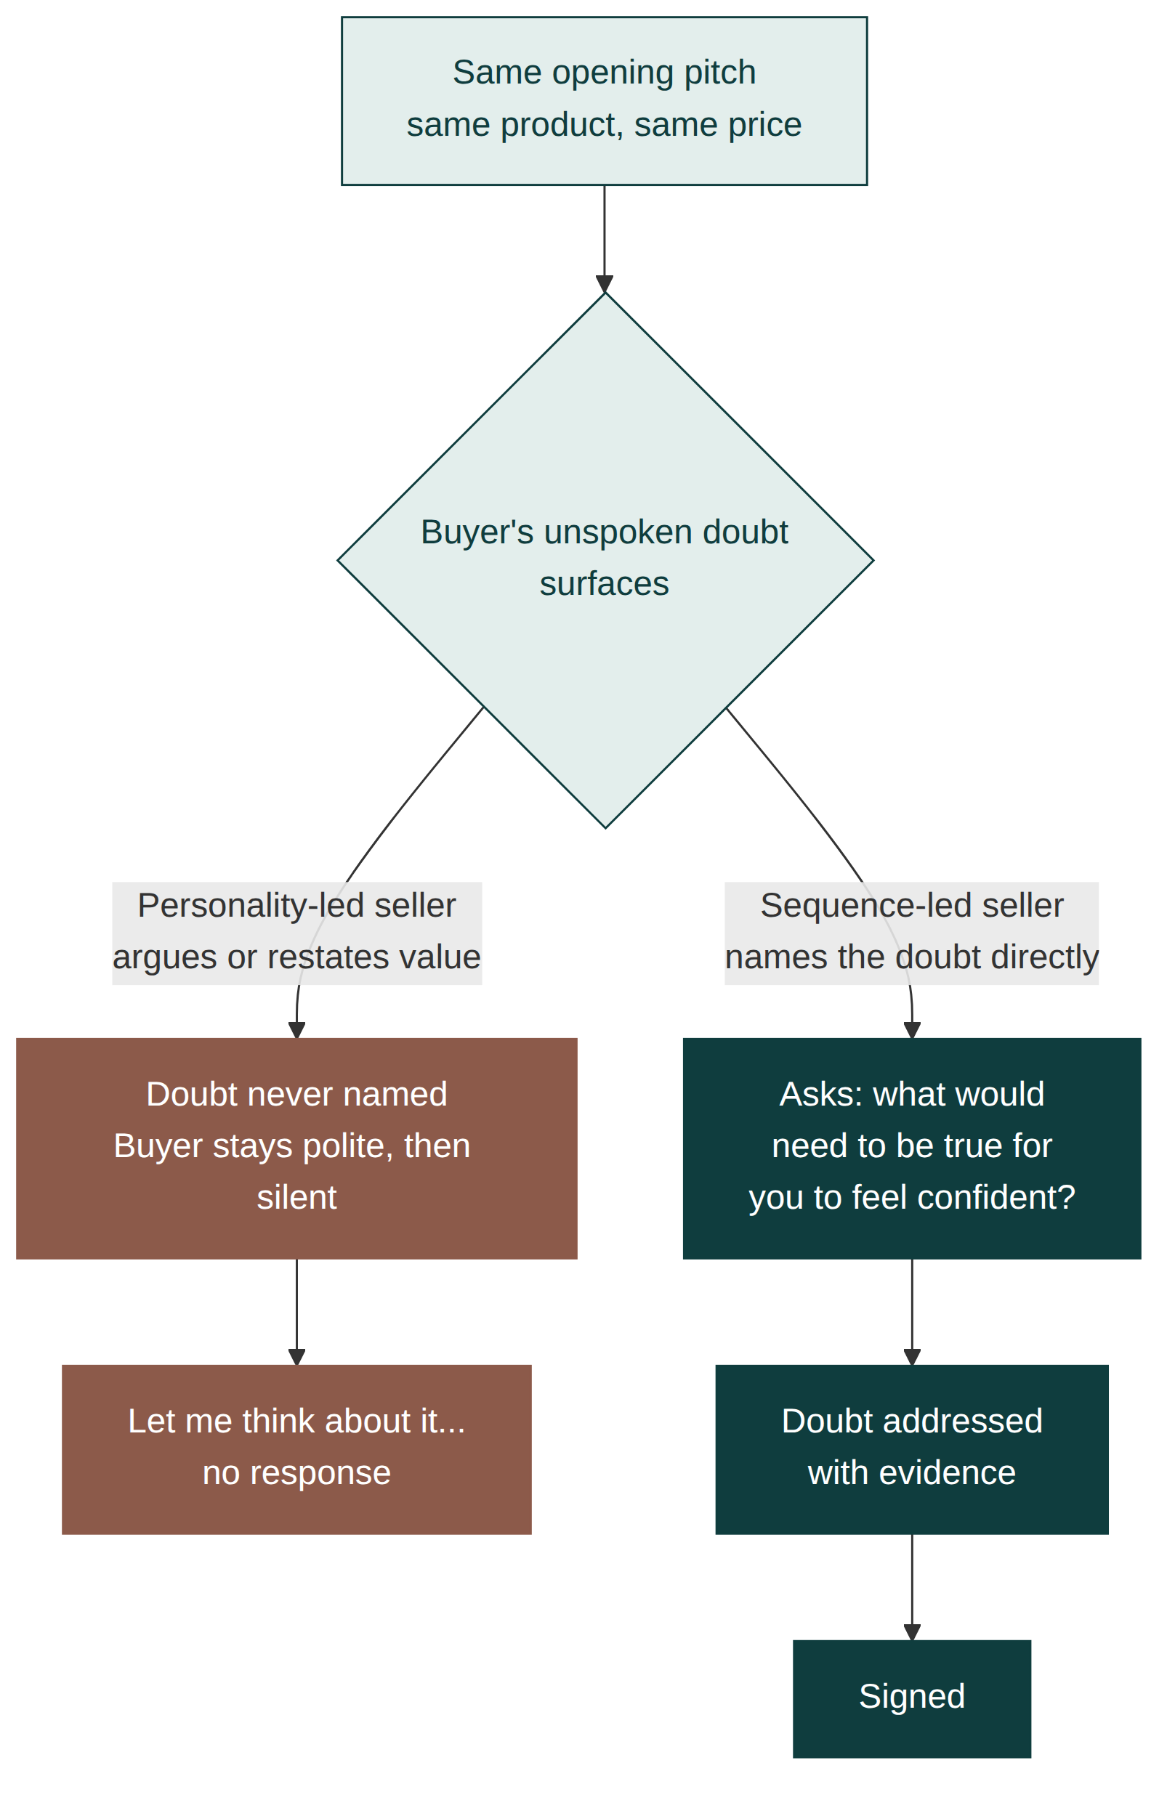
Figure 1.1: Two sellers, same deal. The personality-led approach and the sequence-led approach both start from an identical opening pitch; they diverge at the first unaddressed doubt, and only one path reaches a close.

Apply this today
Pull up the last deal you lost where you genuinely believed you had the stronger offer. Write down, in the buyer's likely words, the one sentence they would give if asked honestly why they chose someone else. Not the polite reason they gave you; the real one. If you can't answer that question about a deal from last month, that's the gap this book closes.
Then go a step further: name which of the four myths was quietly shaping how you ran that deal. Were you avoiding directness because you didn't want to seem pushy (myth one)? Did you assume your personality, or a colleague's, decided the outcome (myth two)? Did you lean on product quality or price and skip the trust-building that would have mattered more (myth three)? Did an early hesitation get treated as a fixed no rather than something to probe (myth four)? Most lost deals have one myth doing most of the damage. Finding it is more useful than a general resolution to "sell better."

A weekly drill, not a one-off exercise
Make this a standing five-minute habit rather than something you do once and set aside. At the end of every week, look back at every conversation where a buyer said no, went quiet, or delayed, and ask the same question each time: which myth, if any, was quietly running the conversation? Some weeks the answer will be none; the deal genuinely wasn't a fit. Most weeks, across enough deals, a pattern will surface faster than it did the first time you looked for it, because you'll already recognise the shape of your own default myth from having named it before.

Measure success
You'll know this module has landed when you can look at your current pipeline and sort each open deal into one of two piles: "I know exactly what's slowing this down" and "I'm not sure." The second pile is where Modules 3 to 5 will do the most work. A shrinking second pile, month over month, is the actual metric; it means you're diagnosing deals instead of guessing at them.
A second, slower signal: within a few months of working this way, you should notice yourself narrating fewer excuses about lost deals ("they went with the cheaper option," "we just didn't click") and more specific diagnoses ("they weren't confident we'd hit the deadline, and I never gave them a reason to believe we would"). The shift from excuse to diagnosis is the actual skill this chapter is teaching.

Common mistakes
- Assuming a lost deal was about price when the buyer never actually said so
- Treating a competitor's win as proof they were better, rather than checking whether they were simply more trusted
- Reading this module as confirmation that you're "just not a salesperson," rather than as a description of a fixable sequence
- Skipping straight to Part Two's later chapters (Value, Offer, Price) because they feel more comfortable than Trust and Diagnosis
- Deciding your market is the commodity exception described above without actually checking whether your buyers make judgement calls or run spec comparisons

In a different kind of business
The same four myths show up well outside considered, high-value sales like Kestrel's. Elena, a freelance copywriter, spent years assuming that clients who went quiet after a strong pitch call had simply found someone cheaper. When she finally started asking directly what made a prospect choose someone else, the actual answer was rarely price. It was usually a specific, nameable doubt about whether she could turn work around fast enough during a tight launch window, something no amount of portfolio polish would have fixed, and something she could have surfaced and answered in the very first call if she had thought to ask rather than assume.
Elena's deals close in days, not weeks, which made the pattern easier to see once she started looking for it: a client who said "we've decided to go a different way" almost never meant her writing was weak. It meant an unresolved worry, about speed, about reliability, about whether she'd disappear mid-project, had never been named out loud and so never got the chance to be answered. The myths that cost Priya six weeks of work can cost a freelancer a single afternoon of second-guessing; the mechanism behind them doesn't change with the size or the length of the deal, only the clock it runs on.

Chapter summary
- Most sales advice that doesn't work fails because it targets the wrong myth: it teaches technique where the real problem is sequence.
- Selling well is diagnosis and honest matching, not pressure, whether the deal takes six weeks or six seconds.
- Sequence, not personality, decides outcomes; it can be learned regardless of temperament.
- Below a certain trust threshold, price and quality stop being the deciding factor, except in genuine spec-driven commodity markets.
- An objection is a symptom of unresolved doubt, not a final verdict, and it can be worked with directly.
- These myths persist because each one protects against an uncomfortable admission: that selling is a learnable craft, not a fixed trait or a lost cause.

Key takeaway
The deal you lost was decided long before the price was ever discussed.

Module 2: How Customers Really Buy

Learning objectives
By the end of this module, you will be able to:
- Explain why most considered purchases are decided by a committee, not a single buyer
- Identify the distinct concern each stakeholder in a deal is privately weighing
- Recognise why a technically superior option still loses to the status quo
- Judge how large a buying committee is likely to be before you've met everyone in it
- Map the hidden decision-makers in your own current pipeline

Kestrel Office Interiors: the meeting Priya almost didn't get invited to
Three months after the logistics job, Priya was back in a similar room: a growing accountancy firm, moving from a shared building into their own floor. She'd built a strong relationship with Neil, the office manager, over four meetings. Neil loved the plan. Then, in the fifth meeting, a woman named Farah joined by video, introduced only as "our finance director." She asked two questions: what happens if the project overruns, and what was included versus what would be billed as a variation. Priya hadn't prepared answers to either, because until that morning she hadn't known Farah existed.
Neil wanted the office to feel impressive. Farah wanted no surprises on the invoice. Priya had spent five meetings winning over exactly one of the two people who needed to say yes.

The buyer is rarely one person
When a purchase is small or personal, "the buyer" is a useful shorthand: one person, one decision. Once a purchase involves the buyer's employer's money, that shorthand breaks down. A considered purchase, one significant enough that saying yes carries real consequences for the person saying it, usually runs through a small, informal committee, even when no one calls it that. At Kestrel's typical client, that committee looks like an office manager who feels the day-to-day pain first, a finance director who controls the budget and answers for it later, and a managing director who cares how the decision reflects on their judgement and how disruptive it will be.
Selling to only the most enthusiastic person in that group, and assuming their enthusiasm will carry the others, is one of the most common ways a strong pitch quietly loses. Module 4 teaches how to identify and work with every stakeholder in a deal deliberately, rather than discovering them, as Priya did, in the fifth meeting.

Committee size scales with deal size, not with company size
It's tempting to assume a small business means a small committee, but the honest driver is the size and reversibility of the decision, not the size of the company. A fifteen-person business spending a meaningful share of its annual budget on a single purchase will often involve as many stakeholders as a two-hundred-person business making a routine, easily reversed one. Kestrel's smallest clients, run by a single founder who controls the money and the decision alone, sometimes have a committee of one; a mid-sized client spending heavily and disrupting daily operations for weeks can have a committee of four or five, including people Priya never speaks to directly.
The practical implication: don't estimate committee size from company size. Estimate it from how much this specific decision costs the business and how hard it would be to reverse if it went wrong. The accountancy firm was small, but the decision (a full office move) was expensive and highly visible, which is exactly why Farah existed and Priya hadn't accounted for her.

Each stakeholder is solving a different problem
Neil's problem was practical: he has to work in this space every day, and he wants it to function and to look right. Farah's problem was financial exposure: she is the one who explains any overspend to the board, so an unclear scope is a personal risk to her, regardless of how the finished office looks. A managing director's problem is usually reputational: they are betting their own judgement on the outcome, and a visibly disruptive or delayed project reflects on them specifically, not just on the business.
A pitch built around only one of these concerns will satisfy the person who shares it and leave the others unaddressed, and unaddressed concerns don't disappear quietly; they surface later, often as a stalled decision that never gets explained to the seller directly.

When stakeholders disagree with each other
Sometimes the harder problem isn't an unaddressed stakeholder; it's two stakeholders who want different things from the same decision. Neil wanted an office that felt impressive to visiting clients. Farah wanted the lowest defensible spend. Those aren't automatically compatible, and a seller who only hears from Neil can walk straight into a proposal that Farah will resist on principle, not because anything in it is wrong. The fix isn't to pick a side. It's to surface the tension directly, early, by asking each stakeholder what the others in the room care about, rather than assuming their own priority is shared. Priya's mistake wasn't building the wrong design for Neil. It was never finding out, until Farah spoke up, that a second, different priority existed at all.

The status quo has its own gravity
Doing nothing always feels lower-risk to a buyer than switching, even when the numbers say otherwise, because the cost of a bad decision to switch is personal and visible, while the cost of staying put is diffuse and easy to attribute to circumstances. This is why an objectively better, cheaper option can still lose to "let's stay with what we know": the buyer isn't comparing your offer to the alternative on a spreadsheet. They're comparing the risk of being blamed for a decision that goes wrong against the safety of a decision no one will ever ask them to justify, because nothing changed.
This asymmetry is worth naming plainly: a wrong decision to act gets attributed to the person who acted. A wrong decision to do nothing usually gets attributed to circumstances, bad luck, or someone else. No one gets fired for the office staying slightly cramped for another year. Someone can get blamed for championing an expensive move that didn't work out. Every seller is quietly competing against that asymmetry, whether or not they can see it happening.
Overcoming this isn't about pushing harder. It's about reducing the buyer's personal exposure to being wrong, which is a large part of what the coming chapters on trust and value are actually doing underneath the surface.

Buyers need to justify the decision, not just make it
Even a stakeholder who is completely convinced still has to explain the choice to someone else: a board, a business partner, their own manager. A pitch that only convinces the person in the room and gives them nothing to repeat convincingly to the person who wasn't in the room puts the entire decision at risk one conversation later. Part of preparing an offer well, covered in Module 7, is giving your champion inside the buying organisation the specific language and evidence they need to defend the decision on your behalf, when you are not there to defend it yourself.
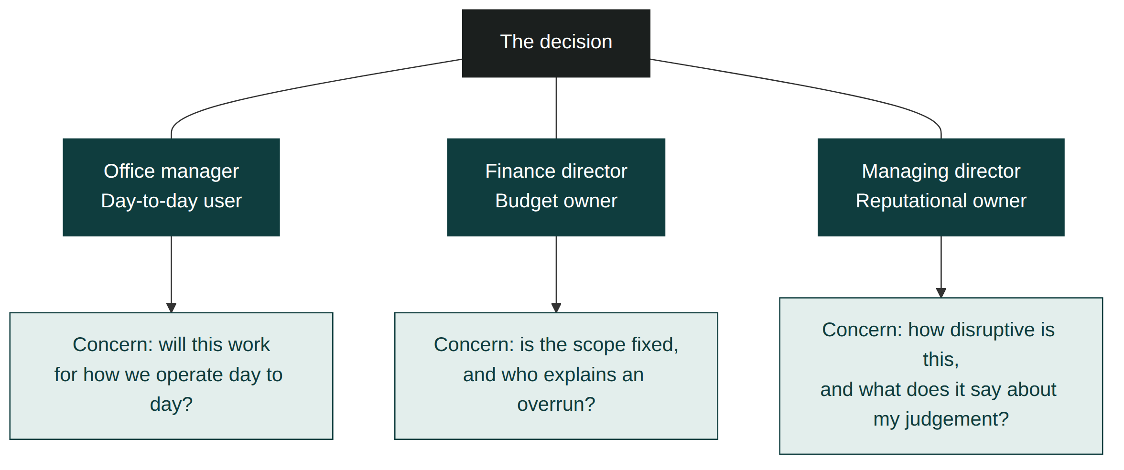
Figure 2.1: The hidden committee. Three roles, three separate concerns, one decision. A pitch aimed at only one role leaves the others unaddressed.

Three roles, three checks
Role | Typical concern | Question that surfaces it
Day-to-day user | Will this work for how we actually operate? | "Who has to live with this decision every day?"
Budget holder | Will this cost more than agreed, or be hard to justify? | "Who explains this spend if it goes over?"
Reputational owner | How disruptive is this, and what does it say about my judgement? | "Whose judgement is on the line if this goes badly?"
These three roles won't always map to three separate people; in a small business, one person can hold all three concerns at once. The questions are still worth asking, because the answers tell you which concern to address first even when you're only ever speaking to one person.

Apply this today
Take your largest open deal right now. Write down the name of every person who could delay or block it, not just the person you've been talking to. For each name, write one sentence describing what they personally stand to lose if this decision goes wrong. If you can only name one person, that is very likely why the deal has been quiet for longer than you'd expect.
Then ask your main contact one direct question: "Is there anyone else on this who might want something different from what you and I have been discussing?" That single question, asked early, would have surfaced Farah three meetings before she surfaced herself.

Make committee mapping a standing habit
Don't treat this as a one-time exercise for a single deal. At the start of every new opportunity, before the first proposal is even drafted, run the same two questions: who else could delay or block this, and what does each of them personally stand to lose. Over time, this becomes a reflex rather than a worksheet, and the moment it does, you'll notice yourself asking about the wider committee automatically, in the first conversation, rather than remembering to check for it afterward.

Measure success
You'll know this module has landed when, before your next proposal, you can name every stakeholder in the deal and the specific concern each one is weighing, without having to guess. A good sign this is working: fewer deals that stall unexpectedly after seeming close to done, because the previously invisible stakeholder was accounted for from the start rather than discovered in the final meeting.

Common mistakes
- Treating your main point of contact's enthusiasm as if it were the whole organisation's decision
- Building a single pitch that only answers the concern of whoever is in the room
- Assuming a delayed decision means disinterest, rather than an unaddressed stakeholder still weighing in
- Never asking directly who else needs to be comfortable with this before it can move forward
- Estimating committee size from company size instead of from the size and reversibility of the decision itself
- Assuming every stakeholder wants the same outcome and being surprised when two of them disagree

In a different kind of business
A wedding photographer's committee looks nothing like an accountancy firm's, and it is still a committee. Marcus, who shoots weddings for a living, used to pitch to whichever partner reached out first, assuming that person's enthusiasm was the whole decision. It rarely was. One partner cared about the emotional coverage of the day itself; the other cared about how the album would read years later, alongside a budget set, more often than either partner would admit outright, by a parent quietly paying for part of the day. Marcus lost more than one booking to a competitor whose sample album simply photographed better in a screenshot forwarded to a mother who was never in the room for his actual pitch.
Once he started asking, early and directly, who else besides the couple in front of him would see the proposal before a deposit was paid, his booking rate improved without him changing a single photograph in his portfolio. The lesson travels cleanly from a forty-person office move to a single day's photography: the person enjoying the pitch and the person who can quietly veto it are not reliably the same person, whatever the size of the purchase.

Chapter summary
- Considered purchases are almost always decided by a small, often informal committee, not by one person.
- Each stakeholder in that committee is weighing a distinct concern: practical, financial, or reputational.
- Committee size tracks the size and reversibility of the decision, not the size of the company making it.
- Stakeholders sometimes want different things from each other, and surfacing that tension early beats discovering it in a late meeting.
- The status quo has built-in gravity because staying put carries less personal risk to the buyer than switching does, regardless of the numbers.
- A convinced stakeholder still needs the tools to justify the decision to people who weren't in the room.

Key takeaway
You are never selling to one person; you are selling to everyone who can say no.

Part Two: The Blueprint Framework

Module 3: Build Trust

Learning objectives
By the end of this module, you will be able to:
- Explain why Build Trust is the first stage of the Blueprint Framework and what breaks when it's skipped
- Distinguish genuine trust-building behaviour from charm, rapport, and small talk
- Diagnose the size of the trust deficit in a specific deal before you try to close it
- Explain why admitting a limitation builds trust rather than losing it
- Apply three concrete, repeatable behaviours that build trust in the first conversation, including with a first-time buyer who has no past experience to reference

Why B comes first
Every stage after this one assumes the buyer is willing to take what you say at face value. Learn the Customer only works if they answer honestly. Establish Value only lands if they believe your numbers. Present the Offer only gets a fair hearing if they're not already looking for the catch. Build Trust exists to earn that willingness before you ask for it, which is why it is the first letter in the framework rather than an optional warm-up before the "real" pitch.
Skip it, and every later stage still happens, just filtered through suspicion. A prospect who doesn't trust you yet doesn't ignore your value proposition; they discount it, quietly, and you rarely find out by how much until the deal has already stalled.

Kestrel Office Interiors: the deal Priya ran differently
A 45-person analytics company called Bramble Analytics was outgrowing its second office in two years, and their operations lead, a man named Dominic, had been burned before: the last fit-out ran three weeks over schedule with no warning. Priya's first meeting with him could easily have opened the way her pitches always had, with the portfolio and the walkthrough software. Instead, prompted by what she'd started noticing about her last few losses, she opened differently.
"Before I show you anything, can I ask what went wrong with the last company you used?" Dominic talked for ten minutes. Priya took notes and didn't interrupt once. At the end, she said, "I can't promise a project never runs late. What I can tell you is exactly how we'd flag it to you in week one if it started to, and here's the schedule format we'd use so you'd see it before we did." She hadn't shown him a single render yet.

Trust is a signal, not a feeling
Buyers don't grant trust because they like you. They grant it because you've given them specific, checkable evidence that you understand their situation and won't hide bad news from them. That evidence comes in three forms, and a seller who leans on only one of them is building on a single leg.
Competence signals show you can actually do the work: relevant specifics about past jobs like this one, not a generic portfolio. Reliability signals show you'll do what you say, when you say it: Priya's schedule-flagging format was one, because it demonstrated a system, not a promise. Candour signals show you'll tell the buyer the truth even when it's not flattering to you: admitting a project could run late is a candour signal precisely because most sellers won't say it.
Charm and rapport can make a conversation pleasant without producing any of these three signals, which is why a likeable seller can still lose to a blunter one who actually answered the buyer's real question.

The trust deficit is measurable, not vague
Every buyer starts a conversation with a certain amount of confidence they need before they'll commit, and a certain amount they actually have in you at that moment. The gap between those two is the trust deficit, and it is rarely the same size twice. Dominic's deficit was large and specific: he needed proof around schedule reliability more than proof of design skill, because that was where his last supplier had failed him. A seller who didn't ask his opening question would have spent the whole first meeting closing the wrong gap.
Before your next first meeting, you can estimate this deficit directly by asking what happened the last time this buyer tried to solve this problem, and listening for where it went wrong. That answer tells you which of the three signals to lead with.

What to do when there's no past experience to ask about
Dominic's question was easy to answer because he had a specific, recent bad experience to draw on. Plenty of buyers don't. A founder buying a service for the first time, or a company solving a genuinely new problem, has no supplier history to complain about, which means Priya's opening question needs an alternative. In that situation, ask what they're most worried could go wrong, hypothetically, rather than what went wrong last time. The answer usually reveals the same three categories (will you actually be able to do this, will you do it on time, will you tell me the truth along the way) even without a specific past failure attached to them. A first-time buyer's imagined worst case carries the same diagnostic information as a repeat buyer's real one.

Why admitting a limitation works, not just feels risky
Naming a real weakness before the buyer finds it sounds, to most sellers, like handing them a reason to walk away. It does the opposite, for a specific reason: a buyer's default assumption about any seller is that they're hearing the flattering, curated version of the truth. The moment a seller says something unflattering and true, that default assumption breaks, and everything said afterward gets evaluated differently, because the buyer now has evidence you're capable of telling them things that don't serve you. This is why candour has to come after competence and reliability in the pyramid rather than first: a stranger who opens with a confession sounds like they're apologising for something, not building anything. The same confession, offered by someone who has already demonstrated they know what they're doing, reads as honesty instead of weakness.

Old habit versus new behaviour
Situation | Priya's old habit | What she does now
Opening a first meeting | Leads with portfolio and past projects | Asks what went wrong with the last supplier first
A limitation in the product or process | Hopes the buyer won't ask | States it plainly before the buyer discovers it
A mid-deal delay | Stays quiet and hopes it isn't noticed | Names it, explains the fix, and reconfirms the plan
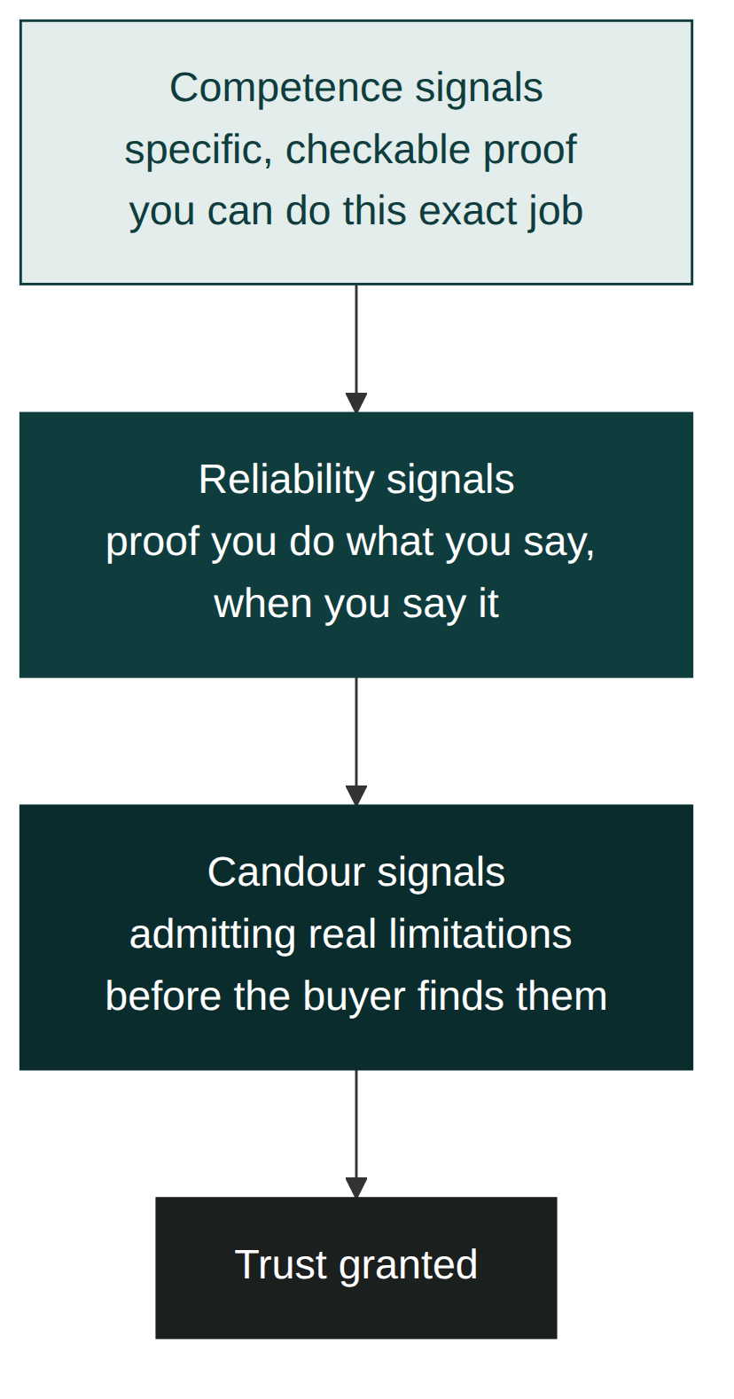
Figure 3.1: The Trust Pyramid. Competence and reliability signals form the base; candour sits above them, because admitting a limitation only builds trust once the buyer already believes you're capable and dependable. Trust granted sits at the apex, not the start.

Trust can be spent and re-earned within a single deal
Trust built in the first meeting isn't a permanent balance; it can be drawn down by a missed call, a late reply, or a promise that slips, and it has to be actively maintained through every later stage, not just established once and assumed to hold. If something does go wrong mid-deal (a delayed response, a schedule slip), the same three signals apply in reverse: acknowledge it plainly (candour), explain specifically what you're doing about it (reliability), and let the buyer see the underlying competence that makes the fix credible. Treating a small breach as unworthy of comment is usually what turns it into a large one; the buyer notices either way, and silence reads as either not noticing or not caring.

Apply this today
Before your next first meeting, write down one question you can ask that surfaces what went wrong the last time this buyer tried to solve this problem, or what they're most worried could go wrong if they have no past experience to reference. Ask it before you present anything. Then choose one candour signal, a real limitation of your product or service, and say it out loud in that same meeting, before the buyer has to discover it themselves.

Build this into every first meeting, not just this one
Treat the opening question and the candour signal as a standing routine, not a one-time technique for this deal. Before every first meeting from now on, spend thirty seconds preparing both: the question that surfaces the deficit, and the one true limitation you'll name unprompted. Over several meetings, this becomes a fixed opening move rather than something you have to remember to do, which is exactly when it starts working best, because it stops sounding rehearsed and starts sounding like how you naturally open every conversation.

Measure success
You'll know this is working when a prospect starts volunteering information they wouldn't tell a stranger: a budget ceiling, an internal disagreement, a past bad experience. That kind of disclosure doesn't happen with someone the buyer is still filtering. Track it deal by deal; an increase in unprompted disclosure in first meetings is an early, leading signal that later-stage conversion will follow.

Common mistakes
- Opening with your portfolio or credentials before asking anything about what the buyer has already tried
- Treating rapport (being liked) as a substitute for evidence (being trusted)
- Only offering competence signals when the buyer's actual deficit is about reliability or candour
- Hiding a real limitation instead of naming it, and having the buyer discover it later at a worse moment
- Assuming a first-time buyer has nothing to diagnose because they have no past supplier to complain about
- Staying silent about a small mid-deal slip on the assumption the buyer won't notice

In a different kind of business
An independent accountant named Farooq built his entire client base on referrals, which meant he rarely got a real first meeting; a new client usually arrived already half-trusting him because a friend had vouched for him. That worked until a referral came from a client he barely knew, a fast-growing online retailer whose previous accountant had missed a filing deadline and left them exposed to a penalty. The retailer's founder didn't want warmth. She wanted to know, specifically, what system would catch a deadline before it became a crisis, because that was precisely where her trust had been broken before.
Farooq's instinct, the one he'd relied on for years, was to talk about his qualifications and his years in practice. It didn't land, because her deficit wasn't about competence at all; it was entirely about reliability. Once he described the exact reminder system he used, and the specific point at which he'd flag a looming deadline to a client rather than wait for it to become urgent, she signed within the week. The three trust signals don't arrive in equal proportion with every buyer; the skill is diagnosing which one this particular buyer is actually short of, rather than defaulting to whichever one you're proudest of.

Chapter summary
- Build Trust comes first because every later stage assumes the buyer is willing to take what you say at face value.
- Trust is built from three specific signals: competence, reliability, and candour, not from charm or rapport.
- Every buyer has a trust deficit of a particular size and shape, and you can estimate it by asking what went wrong last time, or what they're most worried could go wrong if there's no past experience to ask about.
- Candour works because it breaks the buyer's default assumption that they're hearing a curated version of the truth, which is why it only lands once competence and reliability are already established.
- Trust is a balance that can be drawn down mid-deal; a small slip handled openly rebuilds it faster than silence does.

Key takeaway
Trust is not something you ask for; it's something you demonstrate before you ask for anything else.

Module 4: Learn the Customer

Learning objectives
By the end of this module, you will be able to:
- Explain why Learn the Customer only works once trust has been established, and not before
- Ask the three questions that reveal a stakeholder's role, pressure, and personal stake in the decision
- Map the full buying committee for a deal at the first opportunity, rather than discovering it late
- Apply a discovery structure that feels like genuine curiosity rather than an interrogation
- Handle a stakeholder who stays guarded even after trust is established
- Restart discovery cleanly when a new stakeholder joins a deal already in progress

Why L follows B
Dominic answered Priya's question about the last supplier honestly, in detail, within minutes of meeting her. That doesn't happen by accident. A buyer who is still filtering you through suspicion gives you the polished, careful version of their situation, the one that reveals nothing you could use against them. Trust is what earns you the unpolished version, which is the only version worth learning from.
This is why Learn the Customer sits second, not first. Ask discovery questions before trust exists and you'll get answers, but not honest ones, and every stage built on top of them (the diagnosis in Module 5, the value case in Module 6) inherits that dishonesty without you realising it. Skip trust and go straight to discovery, and you end up doing exactly what cost Priya the accountancy job in Module 2: building a confident, detailed picture of the wrong thing.

Kestrel Office Interiors: what Priya learned about Dominic
With the trust from their first meeting in place, Priya's second conversation with Dominic went somewhere her pitches rarely went before. She asked him directly: "Who else, beyond you, needs to be comfortable with this decision before it happens?" Dominic named two people without hesitating: Marguerite, the co-founder who controlled the budget, and a wider team who'd complain loudly if the new office disrupted a busy quarter. Priya asked what Dominic personally was measured on this year. "Keeping the team happy without blowing the budget my co-founder set," he said. "If this goes well, nobody notices. If it goes badly, everyone does, including her."
That single answer told Priya more than four meetings with Neil had told her at the accountancy firm. Dominic wasn't just the office manager; he was personally exposed if the project disrupted the team or ran over cost, and his co-founder was the one he had to answer to.

Three questions that reveal what you actually need to know
Generic discovery ("tell me about your business," "what are your goals?") produces generic answers, because the question doesn't signal that you're going to use the answer for anything specific. Three sharper questions do more work in less time.
"Who else needs to be comfortable with this before it happens?" surfaces the buying committee immediately, rather than leaving you to discover it in a later meeting the way Priya did with Neil and Farah. "What are you personally measured on this year?" surfaces the stakeholder's actual stake in the outcome, which is usually more specific and more personal than "we want a nicer office." "What would make this decision hard to defend to your board or your team?" surfaces the objection you'll need to resolve later, long before Module 8 asks you to name it.
None of these questions work as a checklist read aloud in order. They work because trust, built in the previous stage, makes the buyer willing to answer them honestly, in a normal conversation rather than a form.
Each question is aimed at a different failure that shows up later if it's skipped. Skip the committee question, and you get Module 2's problem: a confident pitch to the wrong audience. Skip the personal-stake question, and your value case in Module 6 ends up generic, because you never learned what "success" actually means to this specific person. Skip the hard-to-defend question, and you spend Module 8 discovering an objection live that you could have prepared for weeks earlier. The three questions aren't arbitrary; each closes a specific gap that a later stage would otherwise have to work around blind.

When a stakeholder stays guarded anyway
Trust makes honest answers more likely, not certain. Some stakeholders are guarded by habit or by role (a finance director who has been trained never to reveal budget ceilings, for instance) regardless of how much trust exists. When a direct question gets a deflected answer, don't repeat it more insistently; change its shape instead. Ask about a comparable past decision rather than this one directly ("how did a purchase like this usually get decided here before?"), or ask what a good outcome would look like rather than what they're afraid of. Both versions get at the same information from an angle that feels less exposing to answer. If a stakeholder still won't open up after two attempts at rephrasing, treat that reticence itself as data: it usually means either the relationship needs more time, or that person genuinely isn't the one worth learning more from right now.

The three questions and what they prevent
Question | Gap it closes | What happens if skipped
Who else needs to be comfortable with this? | Reveals the buying committee | A confident pitch to the wrong audience (Module 2)
What are you personally measured on this year? | Reveals the personal stake | A generic value case with no real stakes attached (Module 6)
What would be hard to defend to your board or team? | Reveals the likely objection early | Discovering the objection live, unprepared (Module 8)

Learning the organisation, not just the person
Individual discovery tells you about Dominic. Organisational discovery tells you how Bramble Analytics actually makes this kind of decision: whether it needs board sign-off, whether there's a formal procurement process, how fast decisions have moved on similar purchases before. Priya asked Dominic how the company had chosen its accounting software the previous year, a purchase of comparable weight but nothing to do with office design, specifically to learn the shape of their decision process rather than the details of this particular deal. He told her it took six weeks and needed both his and Marguerite's sign-off, which set her expectations for this sale's timeline before she'd built a single proposal.
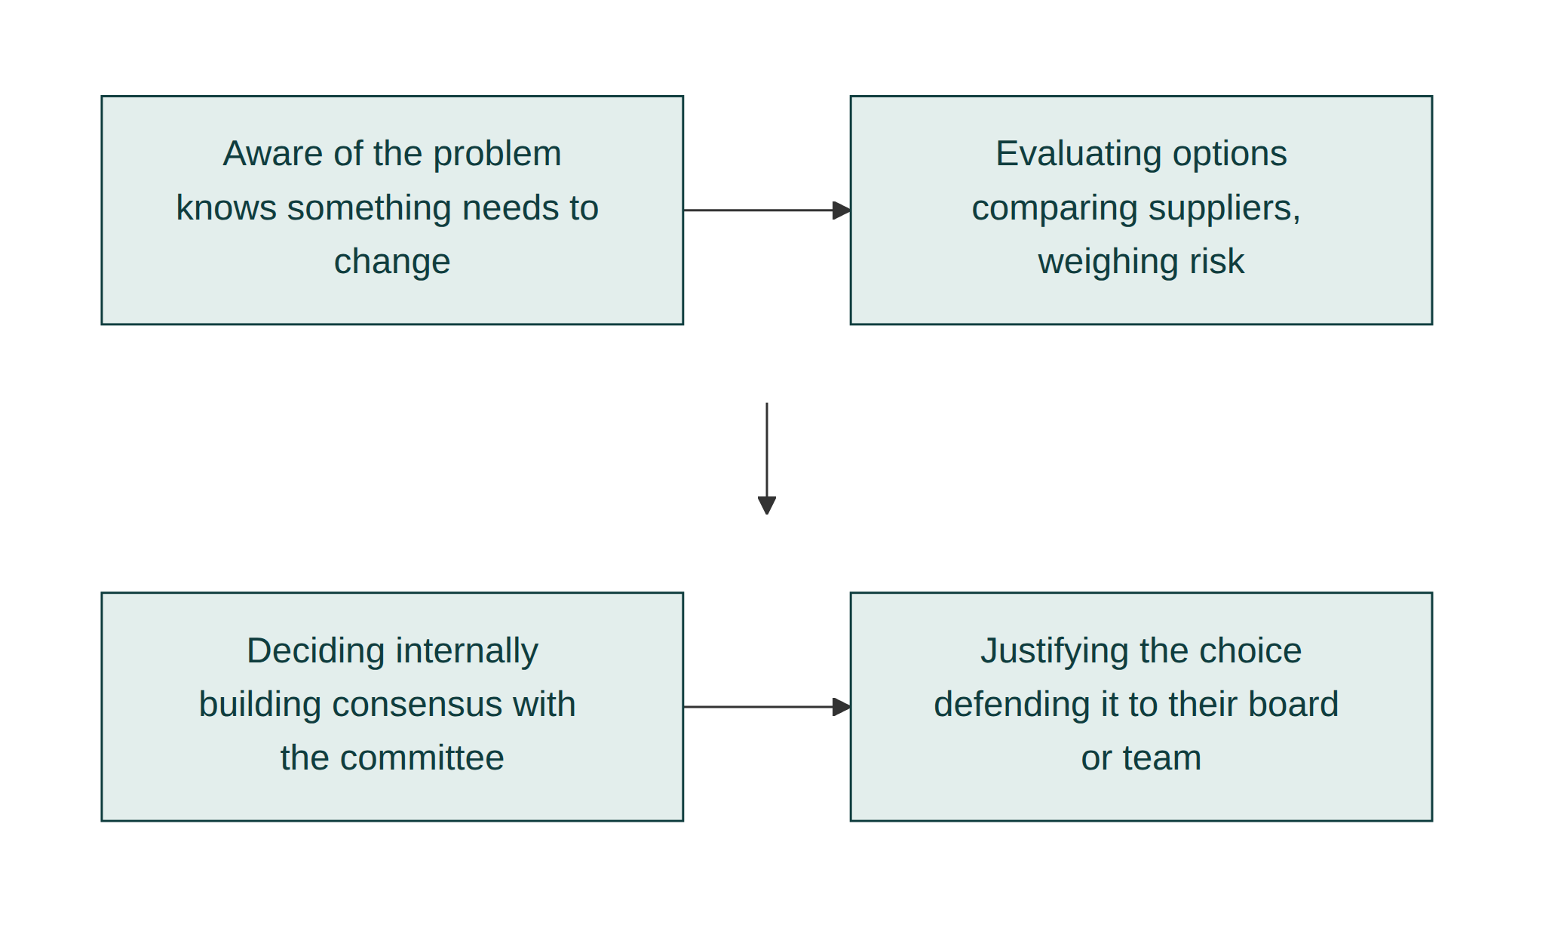
Figure 4.1: The Customer Journey. What Priya learned about Dominic maps onto four stages of his own journey toward a decision: aware of the problem, evaluating options, deciding internally, and justifying the choice afterward. Each stage needs different information from him, which is why one long discovery conversation rarely captures it all.

Restarting discovery when someone new joins
Marguerite hadn't been in the room for any of Priya's early conversations with Dominic, which meant that when she eventually did get involved, Build Trust and Learn the Customer both had to restart for her specifically, even though the deal itself was well past that point with Dominic. This is the framework's loop-back in practice: a new stakeholder doesn't inherit the trust or the discovery already done with someone else in the same deal. Treating Marguerite as already-sold because Dominic was would have skipped stages she'd never actually been through, and it's exactly the kind of gap that shows up later as an unexpected objection. Module 13 covers how to track this without losing your place across a whole pipeline; the discipline itself starts here, the first time a deal grows a second name.

Apply this today
In your next conversation with an existing prospect, ask one question you haven't asked yet: what they're personally measured on this year, or who else needs to be comfortable with the decision. Write down the answer immediately, in their words, not your summary of it.

Rotate the three questions across every deal
Rather than trying to fit all three questions into a single conversation, spread them across your natural check-ins with a prospect: one per call, in whatever order the conversation makes room for. Over a handful of deals, cycling through all three consistently will tell you more about your typical buyer than trying to interrogate any single one of them in full on day one.

Measure success
You'll know this is working when your proposals start referencing details a generic pitch never would: a specific internal pressure, a named co-decision-maker, a comparable past purchase and how long it took. A rising number of deals where you can name the full buying committee before the second meeting, rather than discovering a new name in the fifth one, is the concrete sign this stage is doing its job.

Common mistakes
- Running discovery before trust is established, and getting the polished answer instead of the real one
- Asking broad, generic questions that produce broad, generic answers
- Learning about the individual in the room without learning how their organisation actually decides
- Treating discovery as a one-time form to fill in rather than an ongoing habit throughout the deal
- Repeating a deflected question more insistently instead of rephrasing it from a less exposing angle
- Assuming a new stakeholder is already sold because someone else on the deal is

In a different kind of business
A commercial cleaning company owner named Grace used to open every new-client conversation with a walkthrough of her checklist and her staff's training, which felt thorough and rarely won the deal. The client who finally taught her otherwise ran a small medical clinic, and the walkthrough of her cleaning checklist meant nothing to him until she asked her own version of Priya's three questions. What she learned changed everything: the practice manager was personally measured on passing an unannounced hygiene inspection, not on how the waiting room looked, and the thing he could least defend to his partners was a missed corner during exactly that kind of inspection.
Grace's original pitch had been built entirely around visible cleanliness, a generic answer to a question nobody at the clinic was actually asking. Once she rebuilt the proposal around inspection readiness specifically, using the practice manager's own language, the same service she'd been offering all along suddenly sounded like the right fit. The three questions work whether the deal is a six-figure office fit-out or a modest recurring cleaning contract, because what they surface, the actual stake behind the stated request, doesn't scale with the size of the invoice.

Chapter summary
- Learn the Customer only works once Build Trust has earned the buyer's honest answers, which is why it comes second.
- Three specific questions (who else must be comfortable, what they're personally measured on, what would be hard to defend) each close a specific gap that a later stage would otherwise have to work around blind.
- A guarded stakeholder needs a differently shaped question, not a more insistent version of the same one.
- Learning the organisation's decision process, not just the individual's preferences, sets realistic expectations for the whole deal.
- Discovery is not a one-time form; it restarts for every new stakeholder who joins a deal already in progress.

Key takeaway
You cannot diagnose a problem you never asked the right questions about.

Module 5: Understand the Problem

Learning objectives
By the end of this module, you will be able to:
- Distinguish the symptom a buyer describes from the cause actually driving it
- Quantify the cost of a problem in the buyer's own numbers, not yours
- Confirm a diagnosis with the buyer before proposing anything, so you never solve the wrong problem well
- Recognise when the buyer's first description was actually correct, rather than manufacturing a deeper cause that isn't there
- Apply this to separate what a buyer asks for from what they actually need

Why U follows L
Dominic told Priya, in their very first conversation, what the problem was: Bramble Analytics had outgrown its office. That statement is true, and it is also a symptom, not a diagnosis. A seller who accepts the buyer's own framing of the problem at face value will build a solution to that framing, competently, and still watch it fail to land, because the framing was never quite right to begin with. Learn the Customer gave Priya the access and the specifics to look past that first statement. Understand the Problem is where she actually does it.
Skip this stage, or rush through it, and you risk the failure mode that defines it: solving the wrong problem well. A beautifully designed larger office, delivered on time and on budget, can still be a loss if it wasn't what the business actually needed.

Kestrel Office Interiors: what "we've outgrown this office" actually meant
Priya's next question to Dominic wasn't about square footage. "On a typical Tuesday, is the office full?" Dominic paused. "Actually, no. Tuesdays and Thursdays are packed, everyone else works from home the other three days." Priya asked what happened on the packed days. "It's chaos. No one can find a quiet room, people are on calls at their desks, and half the team ends up in a coffee shop down the street."
The problem wasn't that Bramble Analytics had too little space in total. It was that the space they had didn't flex to match wildly uneven daily attendance, so on the two busiest days it felt desperately cramped while sitting half-empty the rest of the week. A bigger office at the same fixed size would have solved the wrong problem, at a much higher cost than the one that actually needed solving.

Separating the symptom from the cause
A symptom is what the buyer notices and says out loud, because it's the visible discomfort. A cause is the underlying condition producing that discomfort, and it's rarely stated in the first sentence because the buyer often hasn't traced it that far themselves; they've just been living with the symptom long enough to want it gone. "We've outgrown this office" was Dominic's honest description of what he felt. "Our space doesn't flex to match attendance that varies by 40 per cent between our busiest and quietest days" is the cause, and it points toward a completely different, and considerably cheaper, solution.
Getting from one to the other usually takes two or three specific follow-up questions, not a single clever one. Priya's question about a typical Tuesday worked because it was concrete and answerable in seconds, not because it was a trick.
Buyers describe symptoms first because a symptom is what they've actually experienced; a cause is an inference they usually haven't had a reason to work out. Dominic felt cramped on Tuesdays. He hadn't sat down and calculated that the real driver was an attendance pattern varying by 40 per cent, because doing that calculation wasn't his job. It was Priya's, once she had the access Module 4 gave her.

When the first answer actually is the cause
Not every stated problem hides something deeper, and treating every buyer statement as automatically incomplete can create a diagnosis that isn't there. If Bramble Analytics genuinely needed more total desks because they'd hired fifteen people in three months with no corresponding attendance pattern to blame, "we've outgrown this office" would have been the complete, correct diagnosis, and further digging would only have wasted the buyer's patience. The test isn't whether you can find something underneath the first answer; it's whether the follow-up questions actually surface something that changes the shape of the solution. If Priya had asked about Tuesday attendance and Dominic had said "it's full every single day, evenly," that would have confirmed the original statement rather than complicated it, and the honest move would have been to accept it and move to Module 6.

When there's more than one cause
Some problems don't resolve into a single clean cause. By the time Priya finished asking, Dominic's situation had at least two compounding factors: uneven attendance, and a noise problem that was itself discouraging attendance on the days it mattered most. These interacted rather than sitting side by side; solving only the space problem wouldn't have fixed the behavioural pattern it was partly causing. When a diagnosis surfaces more than one factor like this, resist the urge to pick the tidiest one and ignore the rest. Name all of them to the buyer, and let Module 6's value stack address each one separately rather than collapsing them into a single, oversimplified story.

Symptom versus cause, side by side
What the buyer says (symptom) | What follow-up questions reveal (cause) | What it changes
"We've outgrown this office" | Space doesn't flex to a 40 per cent attendance swing | Points to a flexible-room redesign, not a bigger footprint
"Sales calls keep getting missed" | No one owns follow-up once a lead goes quiet | Points to a process fix, not more headcount
"Our website looks dated" | Visitors can't find the one page that actually converts | Points to a navigation fix, not a full redesign

Quantify the cost, in their numbers
A vague problem produces a vague sense of urgency, and vague urgency is easy for a buyer to defer indefinitely. Priya asked Dominic to estimate how many people worked from a coffee shop on a typical packed day. "Maybe six or seven," he said. At a rough hourly cost of their time and the awkwardness of client calls taken in public, that put a real, specific number on a problem that had previously just been "annoying." Numbers the buyer generates themselves carry more weight internally than any figure you could offer them, because they can repeat those numbers to their own co-founder without having to defend where they came from.

Confirm the diagnosis before proposing anything
Priya didn't move straight from that conversation into a proposal. She summarised it back to Dominic in one sentence: "So the real issue isn't total space, it's that your two busiest days need roughly twice the flexible capacity your quietest days do, and right now nobody has anywhere quiet to work when it's busy." Dominic agreed immediately, and added a detail Priya hadn't asked about: the noise wasn't just uncomfortable, it was making people less likely to come in on the days the business actually needed them there. Confirming the diagnosis out loud did two things: it caught an error before it became an expensive one, and it surfaced one more piece of the real cost.
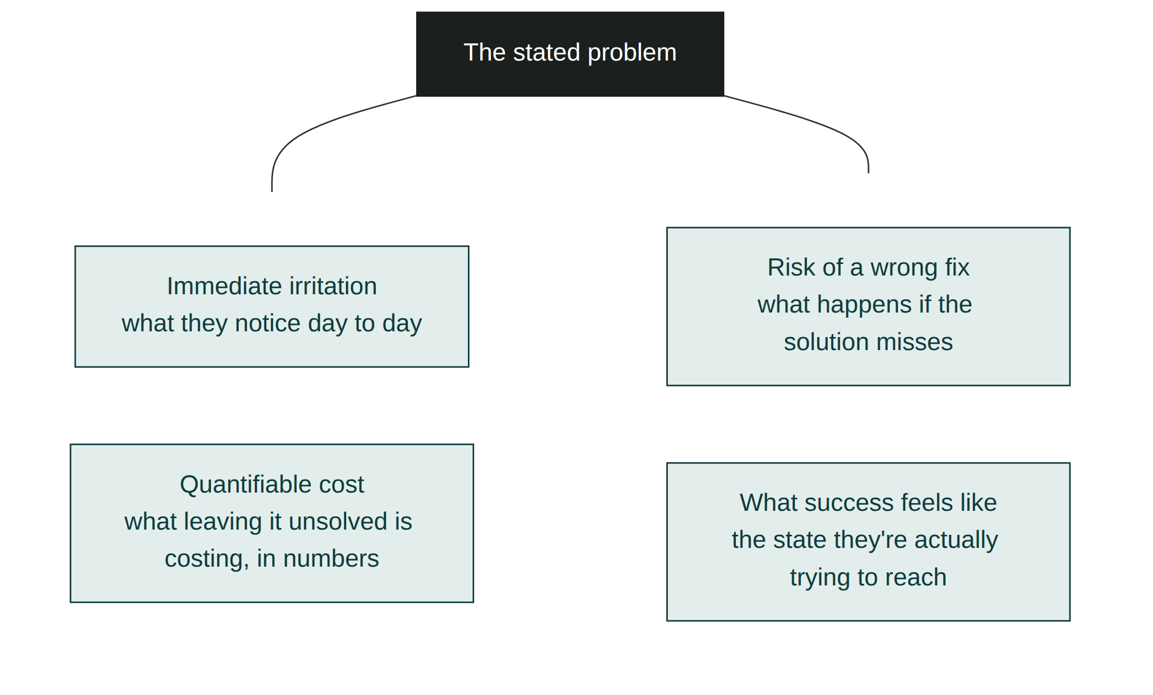
Figure 5.1: The Buying Psychology Wheel. A buyer's stated problem is usually a mix of four forces: the immediate irritation, the quantifiable cost of leaving it unsolved, the risk of getting a fix wrong, and what success would actually feel like. Missing any one of the four means an incomplete diagnosis.

Apply this today
Take the problem your current prospect described to you in their own words. Ask one follow-up question specific enough to have a concrete, short answer (a day, a number, a moment it happens), the way Priya asked about a typical Tuesday. Write down how the answer changes, or doesn't change, what you thought the problem was.

Practise the habit on old deals, not just new ones
If your pipeline is quiet this week, don't wait for a new prospect to practise this on. Pull up a deal you closed months ago and ask, in hindsight, whether you actually solved the cause or just the symptom the buyer originally described. Many sellers find, looking back, that a project succeeded despite an incomplete diagnosis rather than because of a correct one. Recognising that gap after the fact sharpens the same instinct for the next live conversation.

Measure success
You'll know this is working when you can summarise a buyer's problem back to them in a sentence they immediately agree with and then add detail to, rather than a sentence they have to correct. Corrections mean you're still solving the symptom; unprompted additions mean you've reached the actual cause.

Common mistakes
- Accepting the buyer's first description of the problem as the finished diagnosis
- Proposing a solution before confirming the diagnosis out loud and getting agreement
- Leaving the cost of the problem vague instead of turning it into a number the buyer generated themselves
- Solving a bigger, more expensive version of the symptom instead of the smaller, cheaper cause
- Manufacturing a deeper cause that isn't actually there, when the buyer's first answer was already correct
- Picking the tidiest of several compounding causes and quietly ignoring the rest

In a different kind of business
A small marketing agency run by a woman named Iris kept losing pitches to a specific kind of client complaint: "our previous agency didn't really understand our audience." Every prospective client said some version of it, and Iris's instinct for years was to respond with a bigger portfolio and more case studies, proof that she did, in fact, understand audiences in general. It never quite worked, because the stated symptom, "you don't understand our audience," was standing in for something more specific that clients rarely spelled out unprompted.
The pattern only became visible once she started asking one direct follow-up: "can you show me an example of content that missed, and tell me exactly what felt wrong about it?" The answers converged on something she hadn't expected: it wasn't audience understanding at all. It was tone, specifically a previous agency's tendency to sound more corporate than the client's own brand voice, dressed up in the language of "audience fit" because that was the easiest way for a frustrated client to describe a feeling they hadn't fully named. Once Iris started diagnosing tone mismatch instead of audience misunderstanding, her pitches started addressing the actual cause, and her win rate on exactly this kind of complaint improved within a single quarter.

Chapter summary
- What a buyer says the problem is (the symptom) and what's actually causing it (the cause) are often different, and only the second one is worth solving.
- Buyers describe symptoms first because a symptom is what they've experienced; the cause is an inference that was never their job to work out.
- Sometimes the first answer is genuinely correct, and further digging only wastes the buyer's patience; the test is whether follow-up questions actually change the shape of the solution.
- Some problems have more than one compounding cause, and each one deserves its own place in the value case rather than being collapsed into a single story.
- Quantifying the cost in the buyer's own numbers creates urgency they can defend internally without your help.
- Confirming the diagnosis out loud before proposing anything catches mistakes early and often surfaces more of the real problem.

Key takeaway
The problem the buyer describes first is rarely the one worth solving.

Module 6: Establish Value

Learning objectives
By the end of this module, you will be able to:
- Distinguish value that is asserted from value that is demonstrated
- Translate a solution into the buyer's own language and numbers, not yours
- Demonstrate value even when the outcome is genuinely hard to quantify in numbers
- Build a value stack that itemises distinct outcomes so a price feels small against the pile, without padding it with weak filler items
- Apply this to your own offer using a real diagnosed problem, not a generic pitch

Why E follows U
Priya now knew, precisely, what was actually costing Bramble Analytics money and morale: six or seven people working from a coffee shop on peak days, and a growing reluctance among staff to come in when the business most needed them there. That diagnosis is what makes this stage possible. Establish Value means connecting a solution to that specific, already-confirmed problem, in terms Dominic himself supplied. Without Module 5's diagnosis, this stage collapses into generic claims about good design, the kind of value that gets asserted rather than demonstrated, and asserted value is exactly what buyers have learned to discount.
Skip straight to value without a confirmed diagnosis, and you end up presenting benefits that are true in general but not obviously connected to what this particular buyer told you was actually wrong.

Kestrel Office Interiors: from design pitch to specific outcome
Priya's old approach would have shown Dominic a beautifully rendered floor plan and talked about flexible working culture. Instead, she opened with his own numbers. "You told me roughly six or seven people end up working from the coffee shop on your two busiest days. At even a conservative estimate of lost focus time and the client calls that shouldn't be taken in public, that's a real, recurring cost, and it's the thing this design solves directly." She then walked him through a layout with convertible focus rooms that expand on high-attendance days and contract into shared space the rest of the week, exactly matched to the attendance pattern he'd described, not a generic "flexible office" concept borrowed from a magazine.
Dominic's response was different from anything Priya had heard from him before. He didn't ask what it looked like. He asked how quickly it could be built.

Assert less, demonstrate more
Asserted value is a claim: "our designs improve team productivity." It might be true, but it gives the buyer nothing to check it against, so it lands as marketing rather than evidence. Demonstrated value connects a specific feature of your solution to a specific outcome the buyer already told you they wanted, ideally using their own numbers. "This design gives you the equivalent of twelve additional focus-capable desks on your two busiest days, which is roughly the number of people you said end up working elsewhere" is a claim Dominic can verify against what he already knows to be true, because he's the one who supplied the six or seven in the first place.
This is also why value has to come after diagnosis and not before it. You cannot demonstrate a connection to a problem you haven't yet confirmed with the buyer.
Asserted value gets discounted for a specific reason: a claim costs the person making it nothing, so a sceptical listener correctly treats it as weak evidence. Anyone can say their product improves productivity; saying it costs nothing and proves nothing. A number the buyer already gave you, reflected back with a concrete connection to what you're offering, costs you nothing extra to say but is far harder to dismiss, because dismissing it means dismissing something they told you themselves.

Asserted versus demonstrated, three examples
What you might say (asserted) | What you say instead (demonstrated) | Why it lands harder
"Our designs improve team productivity" | "This gives you the equivalent of twelve additional focus-capable desks on your two busiest days, roughly matching the six or seven people you said work from the coffee shop" | The buyer can check it against a number they supplied themselves
"We're known for a calm, professional atmosphere" | "On a Tuesday afternoon, nobody will be standing in the kitchen taking a call, because there's nowhere quieter to go" | Specific and checkable against their own week, not a general reputation claim
"We offer strong value for the price" | Three separate, itemised outcomes, each priced against a single total | A pile of distinct, real value is harder to dismiss than one vague phrase

When the outcome genuinely can't be quantified
Not every value is countable. Some of what Priya sold Dominic (a calmer, less chaotic office atmosphere on the busiest days) is real but resists being turned into a number the way lost focus-hours can be. When that happens, demonstrate instead of quantify: describe the specific, concrete scene rather than reaching for a fabricated statistic to make it look measurable. "On a Tuesday afternoon, nobody will be standing in the kitchen taking a call because there's nowhere quieter to go" is demonstrated value without a single number in it, because it's specific and checkable against what the buyer already knows their Tuesdays look like. A vague claim dressed up with an invented percentage is worse than an honest, specific, unquantified one.

Speak the buyer's language, not your industry's
Priya doesn't talk to Dominic about "activity-based working" or "agile space utilisation," terms that mean something specific inside the office design industry and very little to an analytics company's operations lead. She talks about the coffee shop, the client calls, and the Tuesday and Thursday crunch, because those are the words Dominic used first. Jargon forces the buyer to translate your claim back into their own situation before they can evaluate it, and that translation step is exactly where interest quietly drops off.

Build the value stack
A single benefit, however well demonstrated, is easy for a buyer to weigh against a single price and find wanting. A value stack lists every distinct outcome separately, so the buyer sees the full pile rather than one item. For Dominic, Priya's stack included the recovered focus time from staff no longer working off-site, the avoided cost of a full office expansion (a much larger and slower project than the one she was proposing), and a specific, if harder to quantify, improvement in in-office attendance on the days that mattered most to the business. Priced against any single one of those items, the project might look expensive. Priced against all three together, it looked like the obviously smaller cost.
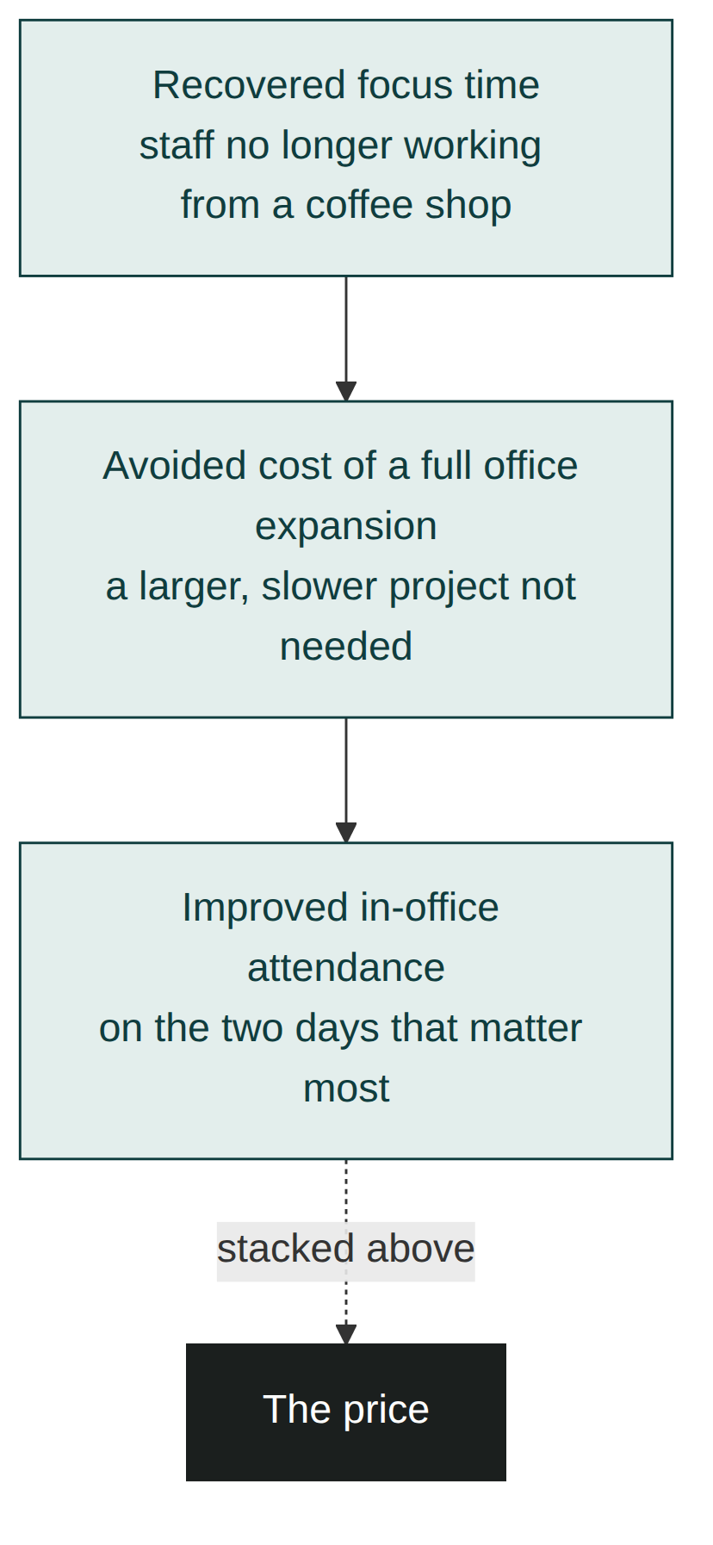
Figure 6.1: The Value Stack. Each layer is a distinct, buyer-confirmed outcome. The price sits at the bottom, visually smaller than the pile of value stacked above it.

Don't pad the stack
A value stack works because every item in it is real and distinct, and that stops being true the moment you add a fourth or fifth item that's really just a rephrasing of the first one to make the pile look bigger. Buyers notice padding, even when they can't name what's wrong with it; a stack of three sharp, specific, different outcomes is more convincing than five where two are filler, because filler quietly signals that you ran out of real value and started manufacturing more. If your honest count is two solid outcomes, present two. A shorter, entirely real stack beats a longer, partly hollow one every time.

Apply this today
Take the diagnosed problem from Module 5's worksheet and write down every distinct outcome your solution produces for it, not just the headline one. Aim for at least three, and phrase each one using a number or a detail the buyer gave you, not a generic industry term.

Rehearse the translation before every proposal
Before you send any proposal from now on, run one quick check on every claim it contains: could the buyer verify this against something they already told you, or are you simply asserting it and hoping it lands? Circle anything you can't answer with a specific number or detail from their own words, and rewrite it before the proposal goes out. Done often enough, this stops being a proofreading step and becomes how you draft the first version, because you'll start reaching for the buyer's own language automatically rather than falling back to your industry's.

Measure success
You'll know this is working when a buyer's next question is about implementation or timing, not about what something means or how it's different from a competitor's offer. Questions about meaning signal the value hasn't landed yet; questions about logistics signal it has.

Common mistakes
- Presenting value in industry language the buyer has to translate before they can evaluate it
- Asserting a benefit without connecting it to the specific problem the buyer already confirmed
- Offering one large, vague benefit instead of several distinct, itemised ones
- Building the value case before the diagnosis in Module 5 is actually confirmed
- Inventing a statistic to make an inherently unquantifiable benefit look measurable
- Padding the value stack with a weak, repetitive item just to make the pile look bigger

In a different kind of business
A bespoke furniture maker named Owen used to describe his work the way most craftspeople do: solid oak, hand-finished joints, built to last generations. It was all true, and none of it moved a client who'd already been told the same three phrases by two competitors quoting a similar price. The client who changed how Owen pitched was a couple furnishing a narrow, oddly-shaped dining room that had defeated every off-the-shelf table they'd tried, the reason they'd come to a bespoke maker in the first place.
Instead of repeating his usual language about craftsmanship, Owen measured the room himself and said plainly: "Every table you've looked at online forces you to choose between fitting through the doorway in one piece or seating the eight people you actually want at it. This one does both, because I'm building it in two sections that join invisibly once they're in the room." That sentence, tied to the specific problem the couple had spent months failing to solve, did more work than any description of the wood grain. The same underlying quality claim, generically asserted, would have sounded like every other quote in their inbox.

Chapter summary
- Value that is asserted is a claim; value that is demonstrated is a connection the buyer can check against what they already told you.
- Asserted value gets discounted because a claim costs nothing to make; a number the buyer already gave you back is far harder to dismiss.
- When a benefit genuinely can't be quantified, describe the specific scene rather than inventing a statistic to fake measurability.
- Speaking the buyer's own language, not your industry's, keeps them evaluating your claim instead of translating it.
- A value stack of several distinct, itemised outcomes makes a price look small by comparison, but only if every item is real; padding is noticed even when it isn't named.
- Establish Value only works once Understand the Problem has produced a diagnosis the buyer has already confirmed.

Key takeaway
Value isn't what you claim; it's what the buyer can check against what they already told you.

Module 7: Present the Offer

Learning objectives
By the end of this module, you will be able to:
- Explain why Present the Offer only works once value has already been established
- Build one clear, recommended package instead of a menu of confusing options
- Handle a formal procurement process that requires multiple priced options
- Fix the scope explicitly, so "what counts as extra" is answered before the buyer has to ask
- Give the buyer a single, specific next step instead of leaving the decision open-ended

Why P follows E
Dominic already understood, in his own numbers, what this project was worth to Bramble Analytics before Priya showed him a single price. That ordering matters. An offer presented before value is established gets evaluated on price alone, because price is the only concrete thing the buyer has to react to. An offer presented after value is established gets evaluated against everything that value stack represents, which is a much easier comparison to win.
Skip straight to the offer, lead with price, or present too many options at once, and you create the failure mode that defines this stage: an offer that's confusing, over-optioned, or price-led, one the buyer has to work to understand before they can even decide whether they want it.

Kestrel Office Interiors: one proposal, not three
Priya's old proposals for a job like this offered three sizes: a modest refresh, a mid-range redesign, and a full renovation, priced separately with no clear steer on which one fit. Dominic, or any buyer, faced with three unconnected options and no recommendation, would typically default to the cheapest one or stall entirely while trying to compare them. This time, Priya sent one proposal: a single recommended package built to solve the exact problem she and Dominic had already confirmed together, with two small, named add-ons underneath it rather than three competing packages above it.
She also included a page Dominic hadn't seen in a Kestrel proposal before: an explicit list of what was included in the fixed price, and a separate, equally explicit list of the specific things that would count as a chargeable variation. Given what she now knew about Marguerite's exposure to budget overruns, that page did more work than any part of the design.

One recommended option, not a menu
Multiple options presented with equal weight force the buyer to do comparative analysis before they can even decide whether to buy, and comparative analysis is where deals stall. A single, clearly recommended package, built directly from the value stack the buyer already agreed with, turns the decision into a yes or no rather than a multiple-choice question. Where variation genuinely helps (a buyer who wants to see a smaller or larger version), it should sit underneath the recommendation as a scaled add-on, not beside it as an equal alternative.
The mechanism is straightforward: every additional option a buyer has to weigh adds a comparison they have to resolve before they can act, and each comparison is a fresh opportunity to feel unsure and defer the whole decision. A single recommendation removes that comparison entirely, replacing "which of these three is right for us?" with the much smaller question "is this right for us?" The second question gets answered faster, because there's nothing to weigh it against except the buyer's own confirmed problem.

When procurement requires multiple options
Some buyers, particularly larger organisations with a formal purchasing process, will ask directly for two or three priced options as a condition of even considering the deal, and refusing outright isn't realistic. In that situation, the recommendation still exists; it just has to survive being placed next to alternatives rather than being the only thing on the page. State plainly, in the document itself, which option you recommend and why, tied to the specific diagnosed problem, rather than presenting all options neutrally and letting the buyer guess your view. A seller who stays silent about their own recommendation inside a mandated menu is still creating the over-optioned, directionless choice this stage exists to avoid, even though the format wasn't their idea.

Menu, ladder, and single recommendation, compared
Format | What the buyer experiences | When to use it
Equal-weight menu (three unconnected options) | Comparative analysis before they can even decide whether to buy at all | Avoid it by default
Anchored ladder (one recommendation, two bounded alternatives) | A bounded choice around a clear default | When the buyer genuinely wants options, or procurement requires them
Single recommendation | A yes or no decision, not a multiple-choice one | Whenever you have the freedom to present it this way

Fix the scope before the buyer has to ask
Priya's fixed-scope page directly answered the concern Farah raised cold in Module 2 and Marguerite would almost certainly raise here: what's included, and who explains it if something changes. Naming the boundary of the offer in writing, before the buyer asks, is a reliability signal in the same family as the ones covered in Module 3, applied now to the specific document the buyer will actually sign.
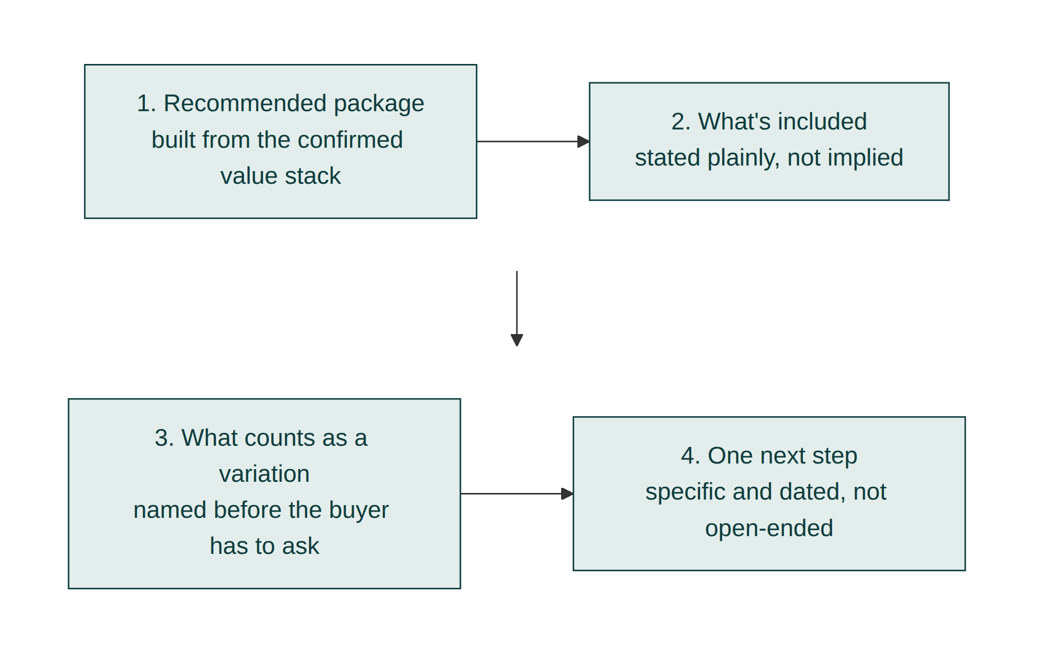
Figure 7.1: The Offer Builder. A well-built offer has four parts in a fixed order: the recommended package, what's included, what counts as a variation, and one clear next step.

Price as a ladder, not a single figure
Where Priya did want to give Dominic and Marguerite a real, bounded choice, she used a short ladder rather than a wide menu: the recommended package in the middle, a slightly reduced version below it, and a defined enhancement above it, with the recommended tier visually and verbally the default. A ladder with a clear anchor lets a budget-conscious co-founder feel she has a genuine choice without reopening the entire proposal from scratch.
The middle position does specific work here. A buyer scanning three tiers reads the lowest as a compromise and the highest as excessive, almost automatically, which leaves the middle feeling like the reasonable choice before they've evaluated a single feature. That's why the recommended package belongs in the middle rather than at either end, and why it should be visually distinguished (larger, more prominent, explicitly labelled) rather than left to win the comparison on position alone. Position helps; it isn't a substitute for the tier actually being the right one for the buyer's confirmed problem.
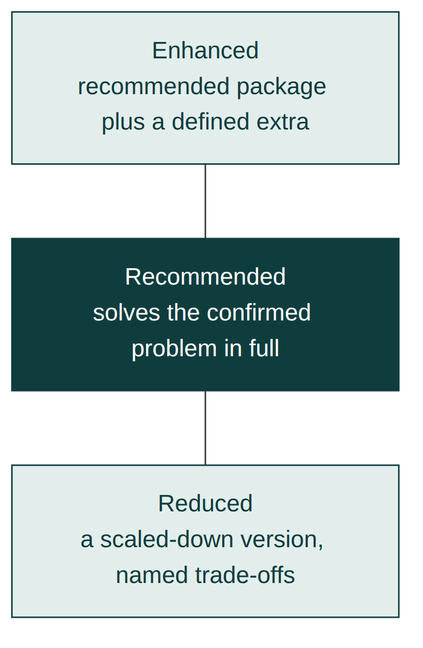
Figure 7.2: The Pricing Ladder. Three tiers, one clearly anchored as the recommendation. A ladder, not a menu of equals.

End with one specific next step
Priya's proposal closed with a single sentence: "To hold the installation slot in your target window, we'd need a signed agreement by the 14th." Not "let me know what you think," which leaves the next move entirely to the buyer and gives momentum nowhere to go. A specific, dated, low-friction next step keeps the deal moving toward Module 9's territory instead of drifting.

Apply this today
Look at your current proposal template. If it presents more than one package with equal weight, pick the one you'd actually recommend and rebuild the document around it, with any alternatives clearly subordinate. Add one sentence naming exactly what counts as a scope change, and replace any vague closing line with a specific, dated next step.

Check every proposal against the same four parts
Once your template is rebuilt, don't let it drift back toward a menu the next time a buyer asks for options. Before any proposal goes out, run through the same four checks: is there one clear recommendation, is the included scope stated plainly, is the variation boundary named, and does it close with a specific, dated step rather than an open invitation. The check takes under a minute once it's a habit, and it's the difference between a template that was fixed once and a standard that holds across every deal.

Measure success
You'll know this is working when buyers respond to a proposal with a question about the recommended option specifically, rather than asking you to explain the difference between options. Fewer proposals met with "which one do you think we should go with?" is the clearest sign the offer itself is doing that job already.

Common mistakes
- Presenting several options with equal weight and no clear recommendation
- Staying neutral inside a procurement-mandated menu instead of stating a clear recommendation anyway
- Leading with price before the value stack has been shown
- Leaving scope boundaries unstated until a dispute forces the conversation
- Closing with an open-ended invitation to respond instead of a specific, dated action
- Relying on the middle tier's position to do all the persuasive work instead of making sure it's genuinely the right fit

In a different kind of business
An IT support provider named Deshawn used to send prospective clients a rate card with three support tiers, bronze, silver, and gold, each described in terms of response times and included hours. Clients routinely asked him to walk them through the differences on a call, which he took as a sign of interest but was actually a sign the document wasn't doing its job. Every additional question was a comparison he hadn't resolved for them in writing.
The proposal that changed his close rate dropped the three-tier rate card entirely for new clients and replaced it with one recommended plan, sized specifically to the server count and support history the client had already described to him, with a single clearly labelled downgrade option underneath for anyone who genuinely wanted less. He also added, on the same page, one sentence he'd never written before: exactly what counted as an emergency call-out versus routine support, and what each one cost. Clients stopped asking him to explain the document and started asking when he could start, the same shift Priya saw once her own proposals stopped reading like a menu.

Chapter summary
- Present the Offer only works once Establish Value has given the buyer something to weigh the price against.
- One clearly recommended package, with any alternatives subordinate to it, is easier to say yes to than a menu of equals, because every extra option adds a comparison the buyer has to resolve before they can act.
- Even inside a procurement process that mandates multiple options, state a clear recommendation rather than presenting them neutrally.
- Naming the scope boundary in writing, before the buyer asks, answers the reliability concern before it becomes an objection.
- A middle-tier ladder position helps a recommendation read as reasonable, but it only works when that tier is actually the right fit.
- A specific, dated next step keeps momentum; an open invitation to respond lets it stall.

Key takeaway
An offer should be easy to say yes to, not merely accurate.

Module 8: Remove Doubt

Learning objectives
By the end of this module, you will be able to:
- Explain why an objection is a symptom of a specific, nameable doubt rather than a final answer
- Ask the direct question that surfaces what's actually worrying a hesitant buyer
- Distinguish a real objection from ordinary politeness or a stalling tactic
- Resolve a doubt with a specific plan or evidence, rather than general reassurance
- Respond well when resolving one doubt reveals another one underneath it
- Handle an objection that turns out to be valid and genuinely unresolvable

Why R follows P
An offer built well, as Module 7 covered, removes most of the confusion a buyer might otherwise raise as an objection. It does not remove every doubt, particularly the ones that only surface once a buyer is seriously close to signing and the decision starts to feel real. Remove Doubt exists for exactly that moment: the specific, late hesitation that a good offer alone doesn't answer.
Skip this stage, or treat a hesitation as a wall to argue against rather than a question to answer, and you get the failure mode that defines it: objections argued with instead of resolved, which usually just makes the buyer more certain about saying no, more politely, later.

Kestrel Office Interiors: Marguerite's question
Dominic brought the proposal to Marguerite, and she called Priya directly with one question: "If you're doing construction work in our office, what happens to Tuesdays and Thursdays while it's underway? Those are the two days we can least afford to lose." It was a fair question, and a specific one, not a vague "let me think about it." Priya's old instinct would have been to reassure her broadly: "don't worry, we're very experienced, this won't be a problem." Instead, she asked one question back: "Would it help if I showed you the exact week-by-week schedule, including which days we'd do the noisiest work on, so you can see we've planned around your Tuesdays and Thursdays specifically?"
Marguerite said yes. Priya sent a schedule that deliberately routed the loudest phase of the work to the two quietest days of the Bramble Analytics week, something she could only have planned because Module 4's discovery had already told her which days those were. Marguerite replied the same afternoon: "This is exactly what I needed to see. I don't think there's anything stopping this now." The proposal still sat unsigned on her desk a week later.

An objection is a question wearing a statement's clothes
"What happens to Tuesdays and Thursdays" is, on its surface, a concern. Underneath it, it's a question: will you actually plan around what matters most to us, or are we the ones who'll absorb the disruption? Treating it as a concern to soothe produces reassurance. Treating it as a question to answer produces a schedule, and only one of those two responses actually resolves anything. The first step in removing a doubt is almost always to ask what, specifically, is behind it, rather than guessing and reassuring against the wrong thing.

Real objections are specific; stalling is vague
Marguerite's question named a day, a risk, and a reason. That specificity is what marks it as a real, resolvable objection rather than a polite way of declining. A vague "we're still thinking it over" or "it's not quite the right time," with nothing concrete attached, is more often stalling than genuine doubt, and it usually means an earlier stage (often Build Trust or Understand the Problem) was never fully completed, rather than something this stage alone can fix. Module 1's story, the buyer who said "we've decided to go with another supplier" without any specifics, is the version of an objection that never got the chance to become concrete, because the question that would have surfaced it was never asked.
Buyers tend to voice concerns as flat statements rather than open questions for a straightforward reason: stating "we're not sure this will work" sounds more assured than admitting "I don't know whether to trust this, and I'm uncomfortable saying so directly." The statement form protects the buyer from sounding uncertain in front of colleagues or in front of you. Recognising that the statement is doing that protective work is what makes it possible to ask the underlying question directly without the buyer feeling exposed for having had it in the first place.
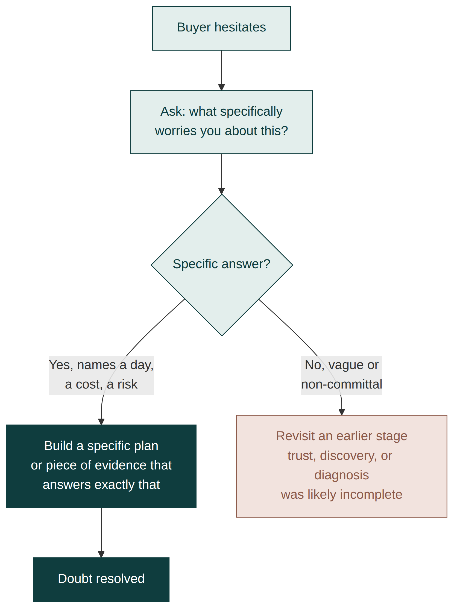
Figure 8.1: The Objection Flowchart. When a buyer hesitates, ask what specifically is behind it before responding. A specific answer gets a specific resolution; a vague answer signals an earlier stage needs revisiting.

Resolve with a plan, not persuasion
Priya didn't try to talk Marguerite out of her concern. She built a schedule that answered it directly, using specifics Marguerite could check against her own calendar. That's the pattern worth repeating: once a doubt is named, the fastest way to resolve it is usually a specific plan, document, or piece of evidence the buyer can verify themselves, not a more confident version of the same reassurance that didn't work the first time.
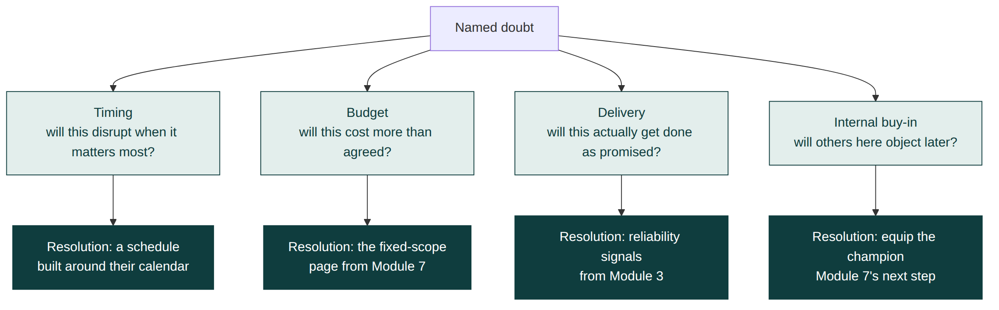
Figure 8.2: The Decision Tree. Once the specific doubt is named, it usually sorts into one of a small number of categories (timing, budget, trust in delivery, internal buy-in), each with its own kind of resolution.

Reassurance versus resolution, three doubt types
Doubt type | Reassurance (what doesn't work) | Resolution (what does)
Timing or disruption | "Don't worry, we're very experienced" | A week-by-week schedule matched to their own quietest days
Budget or scope | "We'll keep costs under control" | The fixed-scope and variation page built in Module 7
Trust in delivery | "We've done this many times before" | A specific reference, or the exact escalation plan if something slips

When resolving one doubt reveals another
Removing a doubt sometimes uncovers a second one that was hiding behind the first, and this is not a sign that the process has failed. Marguerite's scheduling question, once answered, could easily have been followed by a question about which specific contractor would be doing the noisy work, or what happens if the schedule itself slips. Treat a second doubt the same way as the first: ask what's specifically behind it, and resolve it with evidence rather than reassurance. A deal with two or three sequential, specific doubts that each get properly resolved is healthier than one where a single vague doubt never gets named at all.

When the doubt is valid and you can't resolve it
Occasionally an objection turns out to be entirely reasonable and genuinely beyond what you can fix. If Kestrel's schedule genuinely couldn't avoid disrupting Bramble's busiest days, no amount of reframing would make that concern go away, because it wouldn't be wrong. The honest move in that situation is to say so plainly, name the trade-off, and let the buyer decide with accurate information, rather than manufacturing a reassurance that won't survive contact with reality. A seller who admits a real limitation here is spending exactly the candour signal built in Module 3, at the moment it matters most. Losing a deal this way costs less, over time, than winning one on a reassurance that later turns out to be false.

Apply this today
Think of the last hesitation a live prospect raised with you. Write down the specific question you believe was actually behind it, and one piece of evidence or a specific plan, not a general reassurance, that would answer that exact question. If you haven't asked them directly what's behind the hesitation, do that first.

Review the whole pipeline for silence, not just one deal
Once a week, go past the deal that's currently on your mind and look at every proposal that has gone quiet without a stated reason. For each one, write down your best guess at the specific question sitting underneath that silence, then decide whether it's worth reopening with a direct question of your own. Most sellers only apply this thinking to the deal that's loudest right now; the quiet ones, reviewed on the same schedule, are often where a genuinely resolvable doubt has been sitting unanswered the longest.

Measure success
You'll know this is working when hesitations in your pipeline start arriving as specific questions rather than vague delays, and when you can resolve most of them with something the buyer can check for themselves rather than a more persuasive version of your original pitch. Fewer deals that go quiet without a stated reason is the clearest long-term sign.

Common mistakes
- Responding to a hesitation with general reassurance instead of asking what's specifically behind it
- Treating a vague stall as a resolvable objection instead of revisiting an earlier stage that was never fully completed
- Arguing with an objection instead of building a specific plan that answers it directly
- Assuming silence after a proposal means disinterest rather than an unaddressed, unspoken doubt
- Treating a second doubt, surfaced after resolving the first, as a sign the deal is falling apart
- Manufacturing a reassurance for a doubt that's actually valid and can't honestly be resolved

In a different kind of business
A landscaping company owner named Petra used to hear the same soft objection from homeowners at the end of a strong quote conversation: "we just want to think about it." For years she took that at face value and followed up a week later, usually to silence. The client who broke the pattern for her finally said what was actually underneath it, but only because Petra asked directly what specifically she wanted to think over: whether the newly planted beds would survive the first winter, because a previous landscaper's work had died within months and never been replaced.
"We want to think about it" had been standing in for a specific, resolvable fear the whole time. Once Petra started asking that direct question of every hesitant client, she stopped hearing the vague version nearly as often, because she was resolving the real concern (in this case, a written one-year establishment guarantee on all planting) before it had the chance to calcify into a polite decline. The lesson holds regardless of whether the objection concerns a six-figure office fit-out or a modest garden border: a specific fear named early is answerable; a vague feeling left unnamed usually isn't.

Chapter summary
- An objection is a question wearing a statement's clothes, often because stating a concern feels less exposing than admitting uncertainty directly.
- Specific objections are usually real and resolvable; vague stalling usually signals an earlier stage was never finished.
- A specific plan or piece of verifiable evidence resolves doubt; a more confident version of the same reassurance does not.
- A second doubt surfacing after the first is resolved is normal, not a bad sign; resolve it the same way.
- A genuinely valid, unresolvable doubt deserves an honest admission, not a reassurance that won't survive contact with reality.
- Removing doubt well depends on having done the discovery in Module 4 well enough to build a plan that answers the buyer's actual concern.

Key takeaway
Every objection is a question in disguise; answer the question, not the disguise.

Module 9: Inspire Action

Learning objectives
By the end of this module, you will be able to:
- Explain why agreement and action are two different things, separated by ordinary friction rather than doubt
- Identify the real reason a convinced buyer hasn't yet acted
- Reduce the next step to the smallest possible action a buyer can take immediately
- Use genuine deadlines instead of manufactured urgency to prompt a decision
- Prompt action honestly when no natural deadline exists
- Judge how much follow-up is persistence and how much has become pressure

Why I follows R
Marguerite told Priya, in as many words, that nothing was stopping the project. A week later, the proposal was still unsigned. That gap is not a doubt Module 8 missed; it's a different problem entirely. A convinced buyer and a committed buyer are not the same person, and the distance between them is usually filled with ordinary friction (a busy week, a task that hasn't reached the top of a list, a form that takes longer to review than expected) rather than anything Remove Doubt could have addressed.
Skip this stage, or simply wait for the buyer to act on their own momentum, and you get the failure mode that defines it: the seller waits for the buyer to chase them, and a genuinely won deal quietly stalls on an admin desk instead of closing.

Kestrel Office Interiors: the unsigned proposal
Priya's old habit here would have been to wait, or to send a version of "just checking in, let me know if you have any questions," which asks the buyer to do more work rather than less. Instead, she called Dominic directly and asked plainly what was holding things up. "Honestly," he said, "Marguerite's completely convinced, but signing a formal proposal has become one more thing on a very long list. It's not a priority conversation for her; it's an admin task she hasn't gotten to."
That told Priya exactly what to do. She didn't need to resell the value or resolve another doubt. She needed to shrink the remaining task and give it a real, not invented, reason to move to the top of the list. She offered Marguerite a fifteen-minute call, not to discuss anything new, but specifically to walk through and sign, and she reminded Dominic, honestly, that the installation slot they'd built the whole schedule around would need to be released to another client if the agreement wasn't signed by the following Friday. Marguerite took the call. The agreement was signed before it ended.

Agreement and action are separated by friction, not doubt
Once you've correctly diagnosed a doubt as resolved, as Marguerite's clearly was, don't keep treating the deal as if a doubt is still the obstacle. Ask instead what's physically or organisationally in the way of the buyer taking the next action: competing priorities, an unclear process for who actually signs, a document that's longer or more effortful to deal with than the decision itself deserves. Priya's fifteen-minute call worked because it replaced an open-ended task ("review and sign this document at some point") with a bounded, scheduled one, which is a much easier thing for a busy person to say yes to.
"Let me know when you're ready" fails for the same reason Module 2's status quo has gravity: it puts the entire burden of disrupting the buyer's routine on the buyer, with no scheduled moment forcing the question, and an easy, low-effort default (do nothing today, deal with it later) will win against a vague, unscheduled ask almost every time. A specific, scheduled action removes that default by giving the task an actual place on the calendar rather than a permanent spot on an ever-growing list.
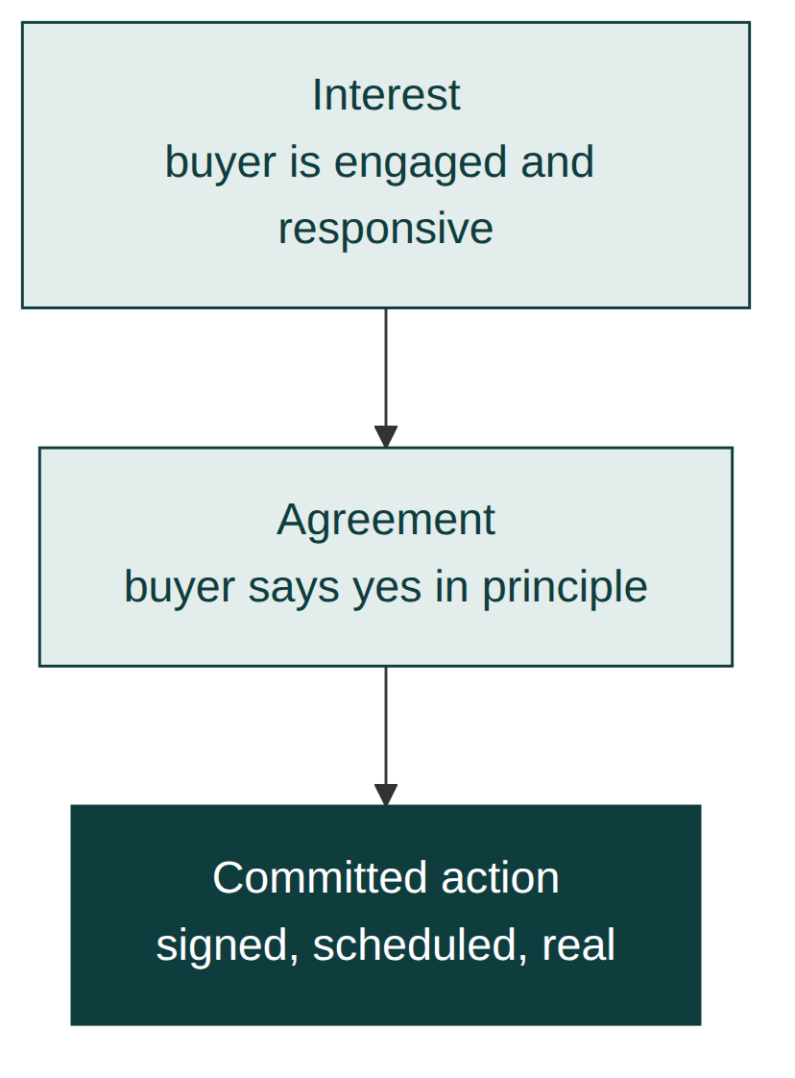
Figure 9.1: The Sales Funnel. Interest and agreement are wide; committed action is the narrowest point. Most deals that stall do so at exactly that narrowing, not earlier.

Shrink the next step
Every stage before this one has been building toward a decision. This stage is about making that decision as small and specific an action as possible at the moment it's needed. "Sign this document" is a bigger, vaguer ask than "give me fifteen minutes to walk through it together and sign." The content of the decision doesn't change; the size of the immediate action does, and smaller, more specific actions get taken faster than large, open-ended ones.

Diagnosing the friction, not the doubt
What's actually in the way | Wrong response | Right response
Competing priorities | Reopening the value conversation from scratch | A scheduled, bounded action, such as a fifteen-minute call
Unclear who signs internally | Waiting for the buyer to work it out | Asking directly who needs to be on the call to close it
A long, effortful document | Sending another reminder to review it | Walking through it live together and signing on the call

Genuine urgency, not manufactured urgency
The installation slot Priya mentioned to Dominic was real: Kestrel's schedule genuinely depended on it, and missing it genuinely would have pushed the project back. That's the difference between a real deadline and the manufactured kind ("only two spots left this month!") that buyers have learned to discount, and which actively damages the trust built all the way back in Module 3 if it's ever caught being untrue. Use a real constraint when one exists. Don't invent one when it doesn't.

When there's genuinely no deadline
Some deals have no natural constraint to point to: no limited slot, no seasonal factor, nothing that actually changes if the buyer signs this week rather than next month. In that situation, resist the temptation to invent one, and instead shrink the action itself even further rather than manufacturing urgency around it. A fifteen-minute scheduled call still works without a deadline attached, because it's replacing an open-ended task with a bounded one, which was always the more important half of what made Priya's approach effective. The deadline sharpened the timing; the shrunk action was what actually got the signature.

How much follow-up is too much
There's a point where reasonable persistence starts to read as pressure, and it usually arrives sooner than sellers expect. One follow-up call asking plainly what's in the way is diagnostic and welcome. A second or third message that repeats the same ask without new information starts to feel like exactly the kind of pushing Module 1 warned against, and it can quietly undo trust built over several earlier stages. If a shrunk, scheduled action and one honest follow-up haven't produced movement, the more useful move is usually to ask directly whether something has changed, rather than to simply ask again in a different tone.

Apply this today
Look at any deal in your pipeline where the buyer has said something close to "yes, we want to do this" but hasn't yet acted. Call them and ask plainly what's in the way. Then reduce whatever they tell you into the smallest possible next action, scheduled specifically, rather than left open-ended.

Audit every yes in your pipeline, not just the loudest one
Once a month, list every deal where the buyer has verbally agreed but hasn't yet signed, and check each one against a single question: is there a specific, scheduled action already on the calendar, or is it sitting on an open-ended "let me know"? Any deal without a scheduled action gets one before the review ends. This catches the quietly stalled agreements that never announce themselves the way an unresolved objection does, because nothing about them looks urgent until weeks have already passed.

Measure success
You'll know this is working when the average time between a buyer's verbal agreement and a signed commitment shrinks, and when you're the one initiating that final push rather than waiting for the buyer to find time for it on their own. A deal that stalls for weeks after "we want to do this" is a sign this stage was skipped, not that the buyer changed their mind.

Common mistakes
- Treating friction after agreement as if it were an unresolved doubt and reopening a conversation that's already settled
- Leaving the next action open-ended ("let me know when you're ready") instead of scheduled and specific
- Waiting passively for the buyer to act on their own momentum
- Inventing artificial urgency instead of using a genuine constraint, and risking the trust built in earlier stages
- Manufacturing a deadline when none exists instead of simply shrinking the action further
- Repeating the same follow-up until reasonable persistence starts to read as pressure

In a different kind of business
A corporate training consultant named Winifred used to lose a strange share of deals after what felt, by every normal signal, like a successful final call: the client agreed enthusiastically, thanked her for her time, and then simply never returned the signed agreement she emailed afterward. For a long time she assumed those clients had quietly decided against her and were too polite to say so. The truth, once she started calling instead of waiting, was almost always smaller and less dramatic: the agreement had landed in an inbox during a busy week and needed a second internal sign-off nobody had mentioned to her.
Winifred's fix wasn't a stronger follow-up email. It was a direct question, asked once, plainly: "is there anyone else who needs to see this before it's signed, and can we get fifteen minutes with both of you this week?" That question alone recovered several deals a quarter that would otherwise have quietly gone cold, not because the training itself needed reselling, but because the actual obstacle was never the training at all. It was an ordinary scheduling gap nobody had named out loud.

Chapter summary
- A convinced buyer and a committed buyer are different people, usually separated by ordinary friction, not lingering doubt.
- Diagnosing that friction correctly (a priority problem, not a trust problem) tells you what kind of push is actually needed.
- Shrinking the next action to something small, specific, and scheduled gets it done faster than an open-ended request, because it removes the easy, low-effort default of doing nothing today.
- Genuine deadlines prompt action without damaging trust; manufactured urgency risks the trust built in every earlier stage.
- Without a natural deadline, shrink the action itself rather than inventing urgency around it.
- Persistence has a limit; one honest follow-up beats several repeated ones.

Key takeaway
A convinced buyer who hasn't acted doesn't need more persuading; they need a smaller next step.

Module 10: Nurture Relationships

Learning objectives
By the end of this module, you will be able to:
- Explain why the sale closing is the start of the relationship's value, not the end of it
- Build a scheduled, deliberate contact cadence rather than an occasional reactive one
- Distinguish genuine nurture from a disguised sales pitch
- Respond well when a nurture check-in surfaces a problem rather than good news
- Scale a nurture cadence across many customers without it turning mechanical
- Apply this to a customer you closed weeks or months ago and haven't spoken to since

Why N follows I
The signed agreement in Module 9 was Kestrel's biggest achievement in the deal so far, and it's also the point where most sellers, without quite meaning to, stop treating the relationship as something to actively manage. Priya's old pattern matched that exactly: deliver the project, invoice it, and only reappear if something went wrong or if there was something new to sell. Nurture Relationships exists because the value of a customer doesn't end at delivery; in many businesses, it barely begins there.
Skip this stage, and you get the failure mode that defines it: contact stops the day the invoice is paid, and a relationship that could have compounded into repeat business and referrals quietly goes cold instead.

Kestrel Office Interiors: the call that wasn't a pitch
The Bramble Analytics installation went in over a long weekend, exactly as scheduled around Tuesdays and Thursdays. Six weeks later, Priya called Dominic, not with an invoice query or an upsell, but with one question: "Are people still ending up at the coffee shop on your busy days?" Dominic laughed. "Barely. Actually, a couple of other teams have asked if they can book the flexible rooms for their own busy days now too."
That call produced no revenue and pitched nothing. It also told Priya something she wouldn't have learned otherwise: the flexible space was being used more widely across Bramble Analytics than the original brief covered, which meant the relationship had room to grow on its own, without Priya having to manufacture a reason to reach out.

When the check-in surfaces a problem instead
Dominic's answer happened to be good news, but the same question could easily have surfaced a problem instead, and that outcome is still worth having asked for. If the flexible rooms had turned out not to be used the way Priya designed them, hearing that at six weeks, directly and early, is far better than discovering it a year later from a client who's quietly decided not to work with Kestrel again. A nurture check-in that surfaces a real problem is an opportunity to apply the same candour signal from Module 3: acknowledge it, propose a specific fix, and treat the honesty of the conversation as part of what the relationship is actually worth. Sellers who only check in when they expect good news are, without realising it, avoiding exactly the conversations most likely to save a relationship that's quietly going wrong.

Nurture is scheduled, not reactive
A relationship that only gets attention when something breaks or when there's a new proposal to send teaches the customer, correctly, that contact from you means either a problem or a pitch. Priya built a simple cadence instead: a check-in at six weeks, purely about how the space was performing against the original problem; a check-in at six months, about anything that had changed in the business since; and an open, no-agenda note around the anniversary of the project, sharing something genuinely useful (an article, an observation from another client's similar situation) rather than a reason to buy again.
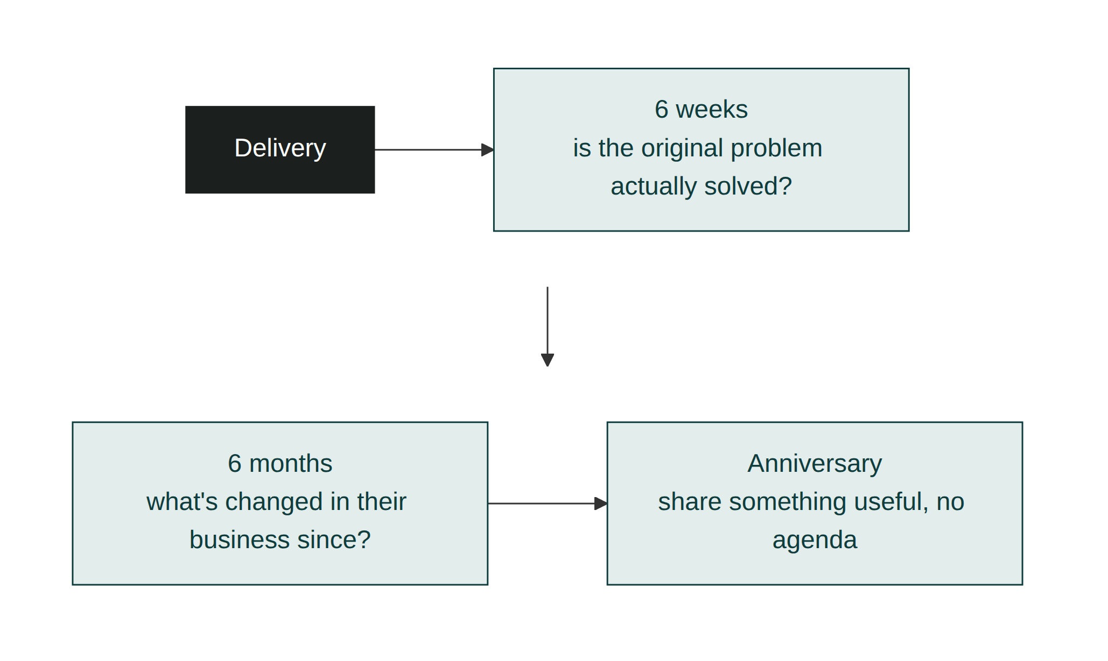
Figure 10.1: The Follow-up Timeline. A handful of deliberate touchpoints, each with its own honest purpose, spaced out from delivery onward. None of them exists to sell something.

The nurture cadence, at a glance
Touchpoint | Timing | Purpose | What it isn't
First check-in | Six weeks after delivery | Confirm the original diagnosis actually held up in practice | An upsell attempt
Business check-in | Six months after delivery | Learn what's changed in the business since | A renewal pitch
Anniversary note | Around twelve months | Share something genuinely useful | A reason to buy again

Genuine nurture has no pitch hiding in it
The test for whether a follow-up is nurture or a disguised pitch is simple: if you removed any possibility of future revenue from the conversation, would you still make the call? Priya's six-week question about the coffee shop passed that test easily; she wanted to know whether the diagnosis in Module 5 had actually held up in practice, independent of whether Bramble Analytics ever bought from her again. A customer can tell the difference between a call like that and a call that's really a warmed-up sales pitch wearing a check-in's clothes, and the difference is exactly what determines whether they pick up the phone next time.
This is also why genuine nurture builds more goodwill than more frequent transactional contact: a gesture with no attached ask is legible as generosity, while the same gesture immediately followed by a pitch reads, correctly, as a means to an end. Buyers remember which sellers gave them something for nothing far more clearly than they remember any single feature of what was sold to them.

Scaling nurture without making it mechanical
A handful of customers is easy to nurture individually; a growing client base is not, and the temptation is to templatise every message until it reads like the automated marketing emails this whole approach is meant to avoid. The way to keep it genuine at scale is to keep the schedule systematic (the timing of six weeks, six months, an anniversary can absolutely be a calendar reminder) while keeping the content specific to that customer every time. A reminder that says "call Bramble Analytics about the flexible rooms" is a system. A message that opens with "are people still ending up at the coffee shop" is what makes the system feel, correctly, like it isn't one. Module 13 covers building this into a repeatable process across an entire pipeline; the discipline that keeps it from feeling automated starts here, in what you actually say once the reminder fires.

Apply this today
Pick one customer you closed more than a month ago and haven't spoken to since. Call or message them with a single, genuine question about how what you delivered is actually working, with nothing to sell attached. Note what they tell you; it's often information you can't get any other way.

Put the cadence on a calendar, not in your memory
Rather than relying on remembering to check in, set the six-week, six-month, and anniversary touchpoints as calendar reminders the moment a deal closes, for every customer, not just the ones you happen to think of. When a reminder fires, spend a minute recalling something specific to that customer before you reach out, so the message still reads as genuine rather than templated. The schedule can run on autopilot; the content never should.

Measure success
You'll know this is working when past customers respond quickly and openly to your check-ins, rather than warily, and when some of those conversations surface expansion opportunities or referrals without you having asked for either. A growing list of customers you're in genuine, non-transactional contact with, months after the invoice was paid, is the concrete sign this stage is working.

Common mistakes
- Going silent after delivery until a problem or a new pitch gives you a reason to call
- Disguising a sales pitch as a check-in, which customers usually recognise immediately
- Treating nurture as occasional and reactive instead of scheduled and deliberate
- Assuming a satisfied customer will stay engaged without any active effort from you
- Only checking in when you expect good news, and avoiding the calls most likely to catch a problem early
- Templatising the content of a check-in so heavily that it stops feeling specific to that customer

In a different kind of business
A boutique PR agency founder named Callum used to treat a signed retainer as the finish line, the moment a new client stopped being a prospect to chase and became a name on an invoice schedule. His agency's actual growth only started once he built a habit borrowed, without quite realising it, from the same instinct Priya later formalised: calling a client six weeks into a retainer with one plain question, "has the coverage we've landed so far actually changed anything for you internally, or does it just feel like activity?"
More than one client answered that question with something Callum would never have learned from a status report: a placement he'd been quietly proud of had never reached the internal audience the client actually cared about, because it ran in the wrong section of the wrong outlet. That kind of correction, caught at six weeks rather than at the end of a disappointing quarter, saved several retainers that would otherwise have quietly not renewed. The habit worked precisely because it wasn't attached to a renewal conversation; it was a genuine question asked before there was anything to sell.

Chapter summary
- The value of a customer relationship often only begins at the point most sellers stop paying attention to it.
- A scheduled cadence of genuine check-ins beats reactive contact that only happens around problems or pitches.
- A follow-up that would still be worth making even with no possible future sale attached is genuine nurture; one that wouldn't is a disguised pitch.
- A check-in that surfaces a problem is still a success; it catches issues early instead of losing the customer quietly later.
- Nurture surfaces information and opportunities (expansion, referral) that you can't get any other way, precisely because it isn't asking for anything.
- The schedule can scale systematically across a whole client base; the content of each message has to stay specific to that customer or the system starts to show.

Key takeaway
The invoice being paid is the start of the relationship's value, not the end of the transaction that produced it.

Module 11: Turn Customers into Advocates

Learning objectives
By the end of this module, you will be able to:
- Explain why hoping for referrals produces far fewer of them than asking for referrals deliberately
- Identify the moment a satisfied customer is most ready to advocate for you
- Make a specific, low-effort referral ask instead of a vague, easy-to-forget one
- Ask for something valuable even when the customer has no specific introduction in mind
- Close the loop with an advocate so the relationship compounds instead of quietly ending
- Recognise when a well-meaning advocate has been asked too often

Why T follows N
Dominic's comment in Module 10, that other teams at Bramble Analytics had started asking about the flexible rooms, was exactly the kind of moment Priya's old habits would have let pass by. She'd have been pleased to hear it, said something polite, and moved on, quietly hoping it might turn into something later. Turn Customers into Advocates is what happens instead: treating that comment as a specific, actionable opening rather than a nice thing someone said.
Skip this stage, or treat referrals as something that happens to lucky businesses rather than something you build, and you get the failure mode that defines it: hoping for referrals instead of building a system that reliably produces them.

Kestrel Office Interiors: the ask Priya used to avoid
In the same call where Dominic mentioned the interest from other teams, Priya asked a specific question instead of a vague one. Not "let us know if you hear of anyone who needs this," which is easy to agree to and easy to forget, but: "Would you be comfortable introducing me directly to whoever runs operations for those other teams? I'd rather hear it from you than send a cold email." Dominic said yes immediately and made the introduction that afternoon. Two weeks later, Priya sent him a short note: the introduction had led to a first meeting, and win or lose, she wanted him to know his name had opened the door.
Neither the ask nor the thank-you cost Priya anything beyond a moment's attention. Both of them were structured, not left to chance, and both would have been easy to skip.
Asking directly like this feels uncomfortable to a lot of sellers for the same reason Module 1's myths persist: it feels like imposing, the same way a direct opening question can feel like pressure to someone who's never separated genuine curiosity from pushiness. The discomfort is misleading in the same way. A satisfied customer who is asked plainly for a specific, easy favour is rarely bothered by it; the discomfort belongs almost entirely to the person asking, not the person being asked.

The right moment is right after proof, not right after the sale
A customer's willingness to advocate for you peaks at the point they've seen tangible proof that what you promised actually happened, which is often weeks or months after the invoice was paid, not on the day it was signed. Dominic was more ready to make an introduction six weeks after installation, once he'd watched the space genuinely solve the problem it was built for, than he would have been on closing day, when the outcome was still a promise rather than a fact. This is why Turn Customers into Advocates sits after Nurture Relationships in the sequence: nurture is what puts you in the room at the moment proof actually lands.

Ask specifically, not generically
"Let me know if you hear of anyone" asks the customer to do ongoing, unprompted work on your behalf, which is exactly the kind of open-ended task that quietly never happens, for the same reasons an unsigned proposal sits on a desk in Module 9. A specific ask, aimed at a specific person or a specific kind of introduction, asks for one bounded action instead. Priya's question named the exact people Dominic already had in mind and asked for one specific thing: an introduction, not a general endorsement.
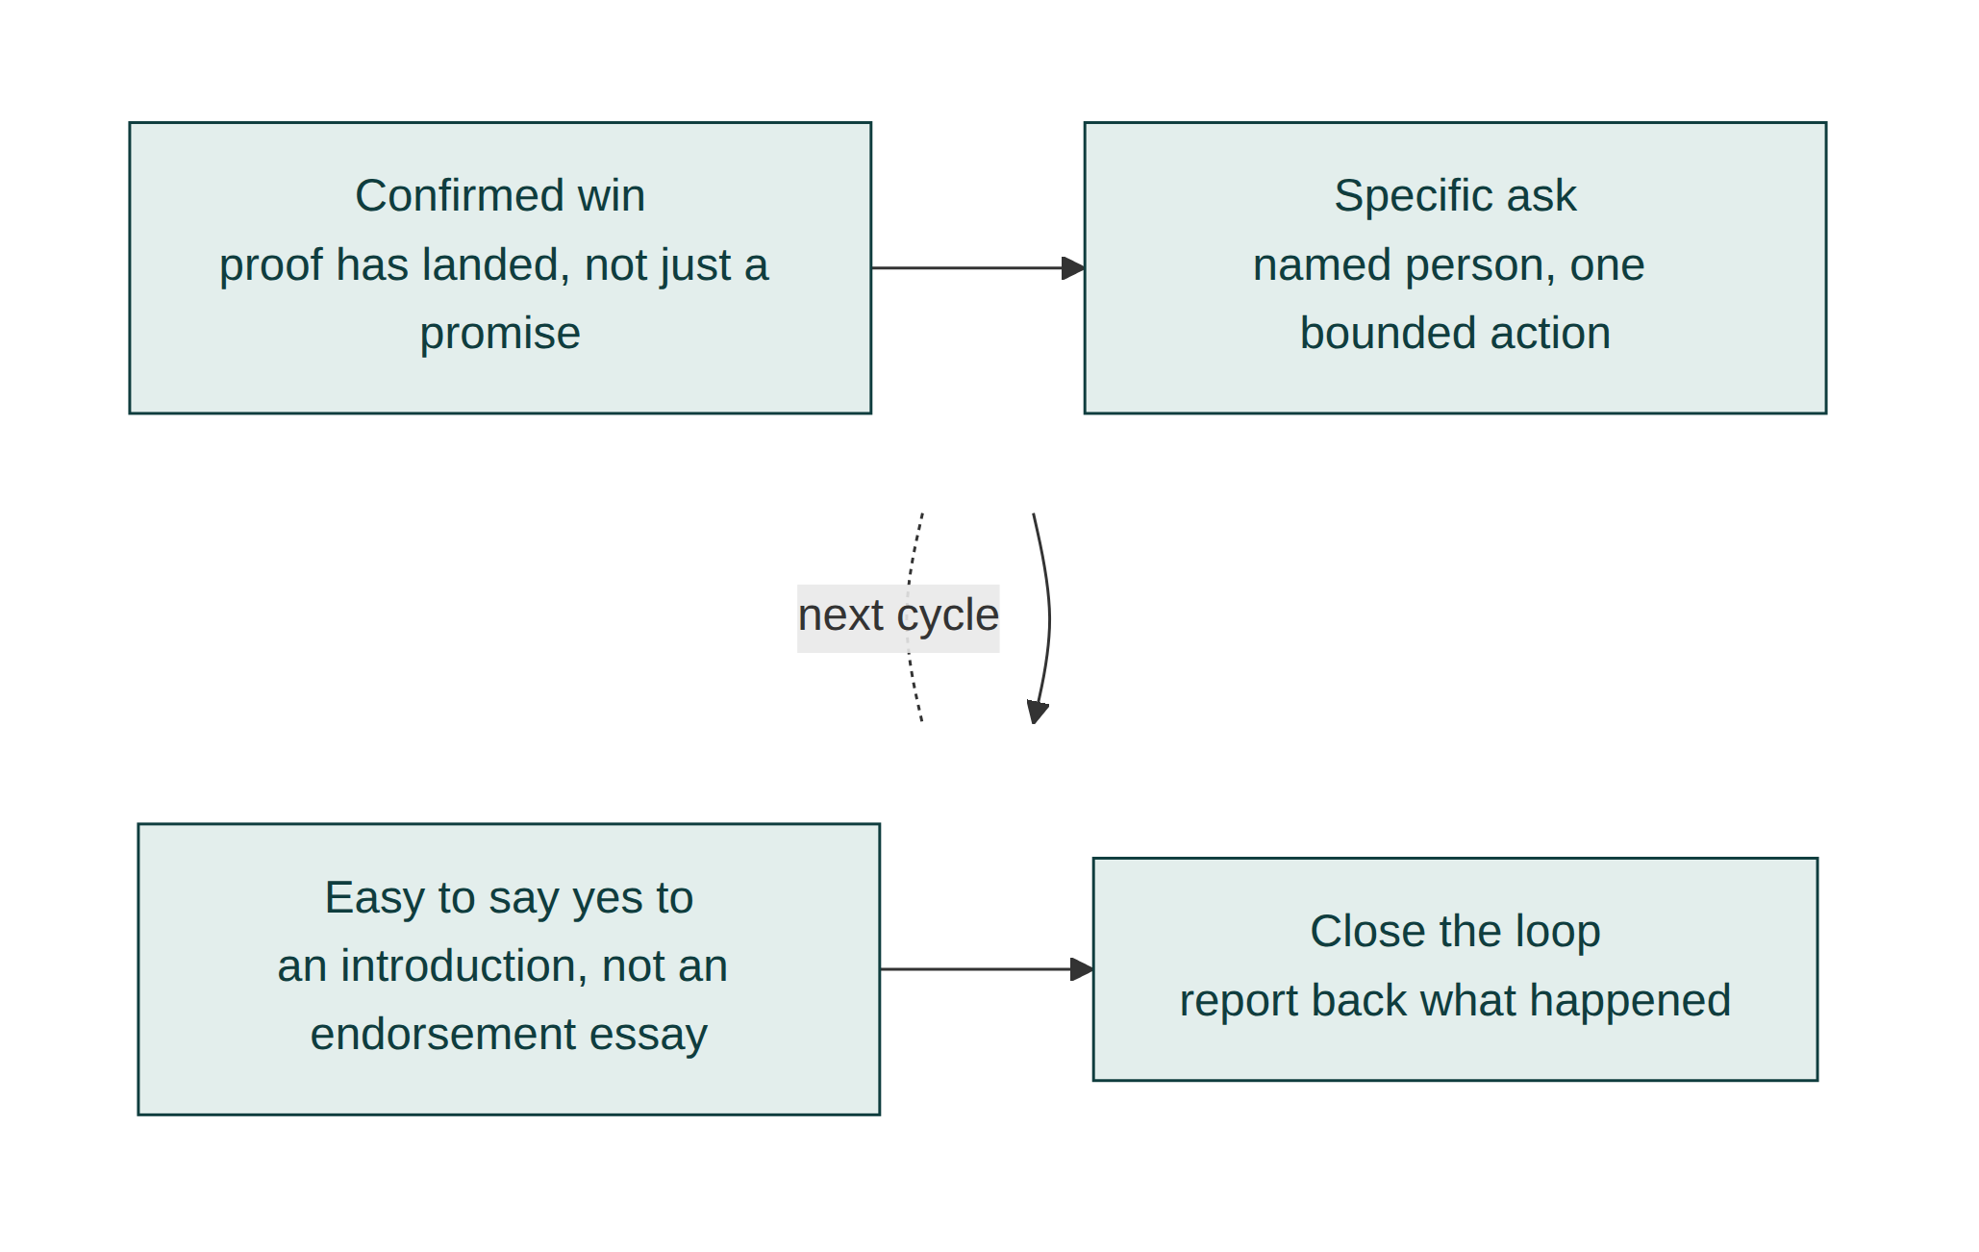
Figure 11.1: The Referral Flywheel. Deliver a confirmed win, ask specifically at the moment proof lands, make the ask easy to say yes to, then close the loop, which is what makes the next revolution of the flywheel easier than the last.

When there's no specific person to name
Not every satisfied customer has a specific introduction in mind, and asking "do you know anyone?" with nothing more specific than that reverts to the same vague, easy-to-forget ask this stage exists to avoid. In that situation, ask for something else concrete instead: permission to use their result as a named case study, a short written testimonial about the specific problem that got solved, or a public review describing the outcome in their own words. Each of these is a bounded, specific action just like an introduction is, and each one does real work even without a named lead attached to it: a detailed case study becomes evidence the next prospect can check, in exactly the way Module 3 describes.

Close the loop, every time
Priya's short note back to Dominic (the introduction led to a meeting, and she wanted him to know) did more for the relationship than the referral itself. A customer who makes an introduction and never hears anything about it again learns, correctly, that the effort disappeared into a void, and is less likely to offer another one. Closing the loop, telling the advocate what happened, win or lose, is what turns a single referral into a habit rather than a one-off favour.

Vague ask versus specific ask
Situation | Vague ask (easy to forget) | Specific ask (bounded and actionable)
A named person comes to mind | "Let me know if you hear of anyone" | "Would you introduce me directly to this person?"
No specific person comes to mind | "Keep me in mind for anyone who needs this" | A named case study, testimonial, or review
After the introduction happens | Nothing further said | A short note closing the loop on what happened

The compounding value of an advocate
A customer who refers even one similar business roughly doubles the value Kestrel gets from the original relationship, without any proportional increase in Priya's own prospecting effort. Over several years and several introductions, that compounding effect is usually larger than the value of the original project itself.
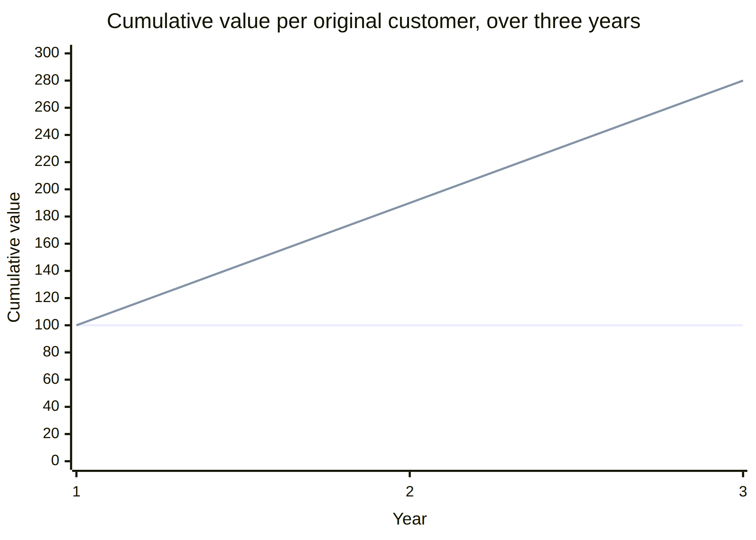
Figure 11.2: Customer Lifetime Value. A single transaction produces one flat line of value. A nurtured, systematically-asked relationship compounds, because referrals bring new customers who can themselves become advocates.

Recognising when you've asked too often
An advocate who has made two or three introductions for you has done something genuinely generous, and treating them as an inexhaustible source by asking again every time you need a new lead will eventually turn goodwill into fatigue. There's no fixed number that marks the line, but a useful check is whether your next ask is driven by this customer's own enthusiasm (they've mentioned something unprompted, the way Dominic did) or by your own need for pipeline. The first is a genuine opening. The second is the same pressure Module 9 warned against, aimed at a relationship instead of a single deal.

Apply this today
Think of a customer who has recently told you something positive about the result you delivered, even in passing. Ask them one specific question: whether they'd be willing to introduce you to a particular person or a particular kind of contact, rather than a general request to keep you in mind.

Attach the ask to your existing nurture cadence
Rather than waiting for a customer to volunteer something you can act on, build the referral ask into the six-week and six-month check-ins from Module 10. When proof has clearly landed and the conversation is already positive, ask the specific question then, instead of treating it as a separate task you have to remember to do at some other time. The nurture cadence already puts you in the room at the right moment; this just makes sure you use it.

Measure success
You'll know this is working when a growing share of your new business arrives through named introductions rather than cold outreach, and when past customers respond to a specific referral ask more often than they ever responded to a general one. Consistently closing the loop with advocates, and seeing some of them refer more than once, is the sign the system is compounding rather than relying on luck.

Common mistakes
- Asking generally ("let me know if you hear of anyone") instead of specifically
- Waiting for a referral to happen unprompted instead of asking at the moment proof has just landed
- Falling back on a vague ask when there's no specific introduction available, instead of requesting a case study, testimonial, or review
- Never closing the loop, so an advocate has no idea whether their introduction led to anything
- Treating a single referral as a nice surprise rather than the first cycle of a repeatable system
- Returning to the same advocate again and again out of your own need for pipeline rather than their genuine enthusiasm

In a different kind of business
A specialty coffee roaster supplying independent cafes, run by a man named Idris, spent years assuming that word of mouth among cafe owners would eventually bring him new accounts on its own. It brought him a trickle, not a system, because the cafe owners who loved his coffee had no reason to think introducing him to a competitor down the street was something he actually wanted, let alone something he'd ask for directly. The shift came when he started asking one specific question at exactly the point a cafe owner mentioned, unprompted, that customers kept commenting on the coffee: "would you be comfortable introducing me to one other cafe owner you respect, the way I'd want you to if the situation were reversed?"
That single, specific, well-timed question produced more new accounts in a year than the previous three years of hoping had. It worked for the same reason it worked for Priya: the ask arrived right after proof had landed, named exactly what Idris wanted, and cost the cafe owner almost nothing beyond a short message they were often glad to send. A referral system doesn't require a large customer base to function; it requires asking specifically, at the right moment, rather than waiting for gratitude to translate itself into action on its own.

Chapter summary
- Referrals that are asked for deliberately happen far more often than referrals that are only hoped for; the discomfort of asking belongs to the seller, not the customer being asked.
- The best moment to ask is right after the customer has seen tangible proof of the result, not at the point of sale itself.
- A specific ask, aimed at a named person or a named kind of introduction, gets far more action than a vague, open-ended one.
- When there's no specific introduction available, a case study, testimonial, or review is still a specific, valuable ask.
- Closing the loop with an advocate, reporting back on what happened, is what turns one referral into a repeatable habit.
- Even a generous advocate can be over-asked; a genuine opening looks different from your own need for a new lead.

Key takeaway
A referral you asked for specifically is a system; a referral you merely hoped for is luck.

Part Three: Modern Selling

Module 12: Digital Selling

Learning objectives
By the end of this module, you will be able to:
- Adapt each stage of the Blueprint Framework to a deal that starts and often finishes without an in-person meeting
- Identify the digital equivalents of the trust signals covered in Module 3
- Run discovery and diagnosis well over video and asynchronous messages
- Compensate for the tone and nuance lost when a conversation happens in writing
- Run nurture and advocacy for a customer you may never meet face to face
- Recognise where digital selling changes the pace of the framework, without changing its order

Kestrel Office Interiors: a lead that never set foot in the office
A year after the Bramble Analytics project, Priya published a short write-up of it on Kestrel's website: nothing salesy, just a description of the uneven-attendance problem and how the flexible-room design had solved it. Three weeks later, an email arrived from Tom, who ran operations for a fully distributed twelve-person startup renting a single shared floor two days a week. "We're basically the opposite of Bramble," he wrote. "Nobody's ever in the office at the same time, and we're paying for space nobody uses most days. Your write-up is the first thing I've read that describes our actual problem." Priya had never met Tom, and wouldn't meet him in person until the installation was nearly finished.

The framework doesn't change; the signals do
Every stage from Module 3 through Module 11 still applies to a deal like Tom's. What changes is how each stage gets executed when a handshake, a walk around an existing office, or a face-to-face read of hesitation isn't available. Trust, discovery, diagnosis, value, offer, doubt, action, nurture, and advocacy are still the sequence. Digital selling is the same framework, run through a narrower set of channels, usually faster and with less room for the ordinary social cues that used to do some of the work automatically.

Trust signals without a handshake
In Module 3, Priya's first competence signal with Dominic was largely conversational: what she said, how she listened. With Tom, the first trust signal happened before they'd spoken at all: the published write-up itself, which demonstrated specific, checkable competence (a real diagnosed problem, a real result) without requiring a meeting to prove it. Response speed matters more here too. A buyer who found you through a search or a recommendation and gets a same-day, specific reply forms a different impression than one who waits a week for a generic acknowledgement; the wait itself functions as a reliability signal, just a negative one. Priya replied to Tom within two hours, referencing the exact line in his email about paying for unused space.

Discovery over video and asynchronous messages
Module 4's three questions (who else needs to be comfortable, what they're personally measured on, what would be hard to defend) work identically over video; what changes is how much you have to ask outright rather than read from the room. In person, a buyer's hesitation often shows in their posture or their pause before answering. Over video and especially over email, it often doesn't show at all unless you ask for it directly. Priya's discovery call with Tom included a question she rarely needed to ask Dominic in person: "Is there anything about this that you're not sure your co-founders will agree with?" Tom told her, unprompted, that one co-founder wanted to give up the office entirely, which reframed the whole diagnosis that followed.
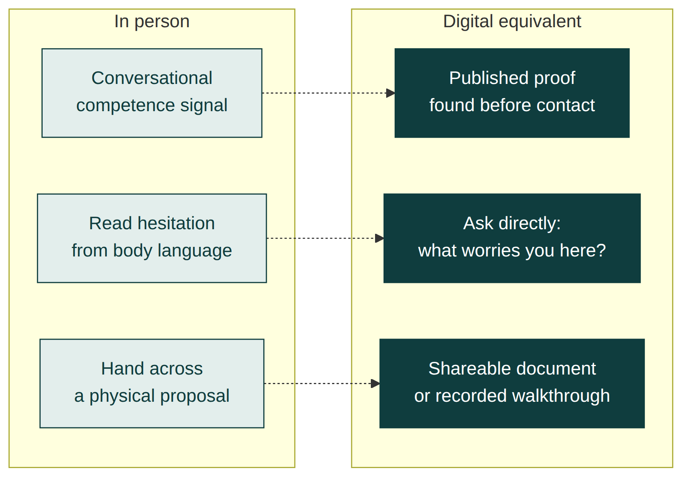
Figure 12.1: Digital Trust and Discovery Signals. Each in-person signal from Modules 3 and 4 has a digital equivalent; asking directly replaces reading the room.

Writing carries less tone than speech, so be more specific
A written message strips out tone of voice, pacing, and facial expression, all of which normally carry some of the emotional weight of a conversation. The natural instinct is to compensate with warmer-sounding language (more exclamation marks, more hedging, more "just checking in"), but that usually reads as vague rather than warm. The better compensation is more specificity, not more softness: naming the exact detail from the buyer's message you're responding to, as Priya did with Tom's line about paying for unused space, communicates attention in a way that tone of voice would have carried automatically in person. A specific reference to something the buyer actually said does the emotional work that a warmer adjective can't.

Adapting to the channel itself
Email, video, and chat-based messaging aren't interchangeable, and the framework's stages land differently in each. A first message on a fast, informal channel (a chat platform, a social media message) should be shorter and more direct than an equivalent email, because the channel itself signals a faster expected reply; a long, formal opening on an informal channel reads as mismatched before the buyer even gets to the content. Video suits Learn the Customer and Remove Doubt well, because both benefit from a real-time back-and-forth. Written documents suit Present the Offer well, for the reasons already covered. Matching the stage to the channel it needs, rather than running every stage through whichever channel happens to be open, keeps the framework's pace close to what an in-person deal would achieve.

Presenting and deciding without being in the room
Module 7's fixed-scope offer and Module 8's specific-doubt resolution both translate directly to a digital process, usually as a shared document or a short recorded walkthrough rather than a page handed across a table. What doesn't translate well is a long, unstructured video call standing in for what should be a written, referenceable offer; a buyer reviewing a decision with people who weren't on the call needs something they can forward, not just a memory of what was said. Priya sent Tom a recorded video walkthrough of the proposed layout alongside the same fixed-scope document she'd have used in person, specifically so he could share it with his co-founders without needing her present to explain it.

In-person signal versus digital equivalent
In-person version | Digital equivalent | Why it matters
A face-to-face first impression | A published result plus a fast, specific reply | Competence and reliability get signalled before a conversation even starts
Reading hesitation from posture or a pause | Asking directly what a colleague or co-founder might not agree with | Nothing surfaces on its own without a direct question
A conversation summarised afterward from memory | A shareable document or a recorded walkthrough | Absent stakeholders need something to review, not a secondhand account

Nurture and advocacy without ever meeting in person
Modules 10 and 11 don't require physical proximity to work, but they do require the same discipline, arguably more of it, because there's no chance encounter or office visit to substitute for a deliberate check-in. Priya's six-week nurture question worked as well over a video call with Tom as it had over the phone with Dominic, precisely because its power came from being genuine and specific, not from being delivered face to face. The same holds for a referral ask: a remote customer can make an introduction just as easily as a local one, sometimes more easily, because a digital introduction (forwarding an email, adding someone to a group chat) costs the advocate even less effort than arranging an in-person meeting would.

Apply this today
Look at your current inbound or remote-sourced leads. Pick one stage from Modules 3 to 8 and write down its specific digital equivalent for this deal: what proof, question, or document replaces the in-person version. Send or ask it within the next working day.

Check the channel before every message, not just the first one
Before sending anything at any stage of a remote deal, ask one quick question: does this need real-time back-and-forth, or does it need to be something the buyer can forward to someone who wasn't there? Match the channel to the answer rather than defaulting to whichever one happens to be open. Over enough deals, this becomes an automatic filter rather than a conscious decision, and it's usually the difference between a remote deal that moves at a normal pace and one that stalls on a channel mismatch nobody noticed.

Measure success
You'll know this is working when remote-sourced deals move through the framework at a comparable rate to in-person ones, rather than stalling for lack of the informal cues those meetings used to provide. A shrinking gap between your response time and the buyer's first message is an early, leading sign.

Common mistakes
- Assuming digital deals need a different framework rather than digital equivalents of the same one
- Letting response time slip, which reads as a negative reliability signal before the conversation has even started
- Replacing a structured discovery question with silence, on the assumption a video call will surface hesitation on its own
- Using an unstructured call where a shareable, referenceable document is what the buyer's other stakeholders actually need
- Compensating for lost tone with softer language instead of more specific, attentive detail
- Running every stage through whichever channel happens to be open instead of matching the stage to the channel it needs

In a different kind of business
Tom's deal still involved video calls and a recorded walkthrough; some digital deals never get even that much. An independent bookkeeper named Priyanka won a full year-long client entirely through asynchronous text, a handful of emails and a messaging app thread, without a single live call at any point in the sale. The client, a small online retailer that had grown out of a single founder's own spreadsheet, replied to Priyanka's messages only late at night after the shop had closed, which meant every stage of the framework had to survive being conducted a message at a time, sometimes with a full day between question and answer.
What made it work wasn't a script; it was discipline about specificity in every single message, because there was no tone of voice or follow-up call to repair a vague one. Priyanka's discovery question, sent as a single clear line rather than folded into a longer paragraph, got a direct answer within a day: the founder's actual fear wasn't cost, it was handing financial control to someone who might not flag a problem until the year-end accounts, the same reliability concern Farooq's client had, just surfaced over a messaging app instead of a phone call. The framework held; only the medium changed, and it changed how patient each stage needed to be, not what each stage needed to accomplish.

Chapter summary
- The Blueprint Framework's stages and order don't change online; the channels and cues used to execute each stage do.
- Published proof of competence can build trust before a conversation even starts, and response speed itself acts as a reliability signal.
- Discovery questions that get read from body language in person need to be asked directly over video or async messages.
- Specificity, not softer language, compensates for the tone that writing strips out of a conversation.
- Different channels suit different stages; video for discovery and doubt resolution, written documents for offers.
- Offers and doubt resolution should produce something shareable, not just something said, so absent stakeholders can review it themselves.
- Nurture and advocacy work the same at a distance, and a digital introduction often costs an advocate even less effort than an in-person one.

Key takeaway
Digital selling doesn't change the sequence; it removes the cues that used to carry some of the weight, so you have to carry it in words instead.

Module 13: Sales Systems

Learning objectives
By the end of this module, you will be able to:
- Turn an individually-run framework into a system that tracks every deal without relying on memory
- Track each deal, and each stakeholder within it, by its actual Blueprint stage rather than a generic pipeline label
- Notice a deal that has gone quiet at a stage, not just the ones asking loudest for attention
- Build a small set of dashboard metrics that tell you whether the system is actually working
- Manage the framework's loop-back, when a new stakeholder or a referral restarts an earlier stage, without losing track of where everyone else stands
- Hand the system to someone else on your team without it losing its accuracy

Why this module exists
Tom's remote deal from Module 12 didn't arrive alone. The published write-up that found him also produced two more inbound enquiries within a fortnight, on top of the ongoing nurture cadence with Bramble Analytics and a handful of older clients. Priya's old system for tracking all of this was a notebook and her memory, which had worked when she had one or two live conversations at a time. It stopped working the week she nearly missed following up with one of the new leads because she'd been focused entirely on Tom.
A framework that only works when one person holds every deal in their head isn't a system; it's a habit that breaks under load. This module is about the difference.

Track deals by Blueprint stage, not generic labels
Most off-the-shelf pipeline tools use generic stages: lead, qualified, proposal, closed. Those labels don't tell you what to do next, because they don't map to a specific action. Priya rebuilt her pipeline board around the nine Blueprint letters instead: every open deal sits under Build Trust, Learn the Customer, Understand the Problem, and so on, through to Turn Customers into Advocates. A deal sitting under R (Remove Doubt) tells her exactly what needs to happen next: find and resolve the specific doubt, using Module 8's approach, not a vague instruction to "follow up."
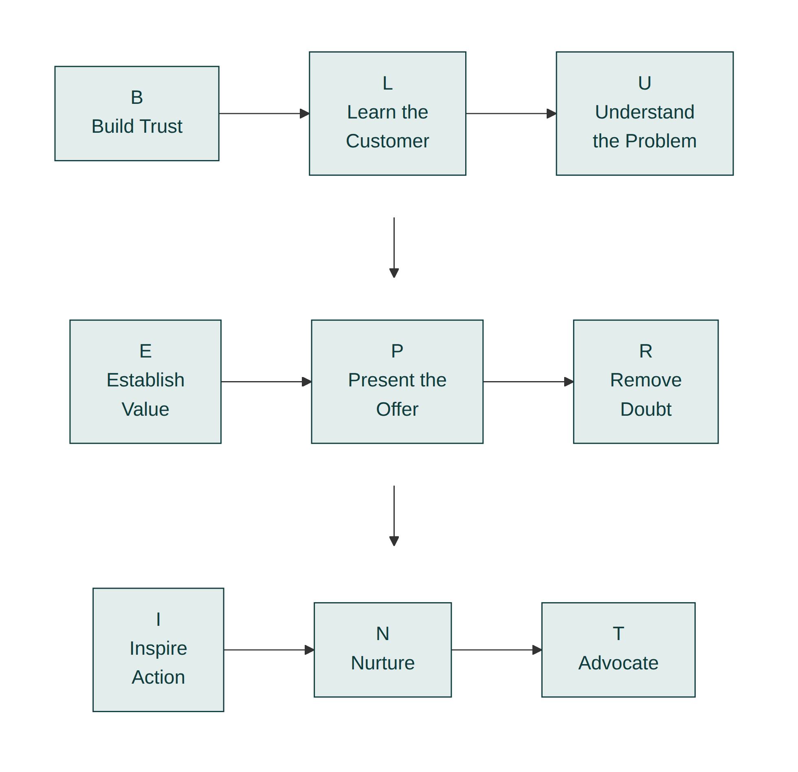
Figure 13.1: The Lead Pipeline. Every open deal sits under its actual Blueprint stage, which tells you the next specific action, not just how far along it is.

Generic pipeline versus Blueprint-staged pipeline
Generic label | What it tells you | Blueprint stage equivalent | What it tells you instead
"Lead" | Someone showed interest | Build Trust or Learn the Customer | Which specific signal or question is still missing
"Proposal" | A document was sent | Present the Offer or Remove Doubt | Whether it needs a clearer recommendation or a named doubt resolved
"Closed" | Money changed hands | Nurture Relationships or Turn Customers into Advocates | The relationship's value is only just starting

The quiet deal is the dangerous one
Attention naturally goes to whichever deal is asking loudest for it: the buyer who just emailed, the one closest to signing, the one with a looming deadline. A deal that has gone quiet at a particular stage doesn't announce itself the same way, which is exactly why it's the one most likely to be silently lost. A pipeline organised by Blueprint stage makes this visible in a way a mental list never does: a glance at the board shows which deals have sat at the same letter for weeks without moving, and that staleness is itself information, usually meaning either the next action was never taken or an unspoken doubt (see Module 8) is quietly blocking progress. Reviewing the pipeline isn't just about updating what's changed; it's about noticing what hasn't.

Track people, not just deals
The framework's loop-back, covered briefly in the overview chapter, means a single deal can have different stakeholders at different stages simultaneously: Priya might be well into Present the Offer with Dominic while a newly-involved finance contact on a different deal is still at Build Trust. A system built only around deals loses this distinction. Priya's board tracks each stakeholder within a deal separately when more than one is involved, so a new name joining midway through a decision doesn't get silently assumed to be at the same stage as everyone else.

The dashboard: a small number of honest metrics
A system is only useful if it tells you whether it's working. Priya tracks four numbers, reviewed monthly: win rate (deals closed against deals quoted), average time from first contact to signature, referral rate (the share of new deals arriving through an introduction rather than cold outreach), and the split between in-person and remote-sourced deals. None of these numbers exist to look impressive; each one answers a specific question about whether the framework is being applied consistently.
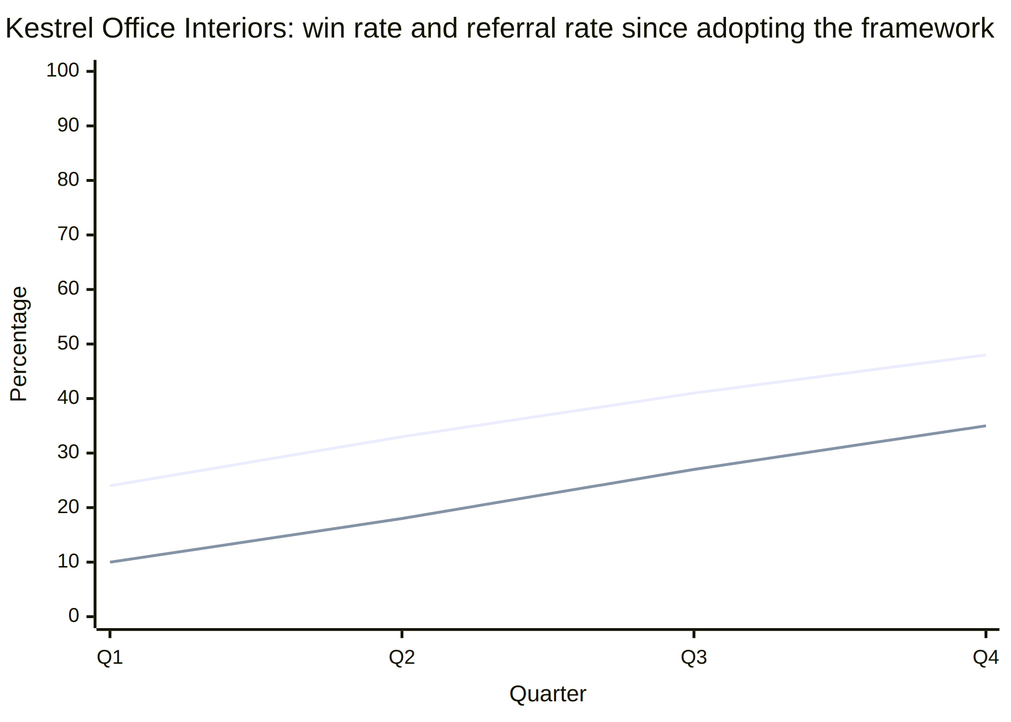
Figure 13.2: The Sales Dashboard. Win rate and referral rate, tracked monthly, are the two numbers that most directly reflect whether the framework's earlier stages are being run well.
Since adopting the framework, Priya's own numbers have moved in one direction: win rate up from under one in four quotes to something closer to one in two, and a growing share of new deals arriving through referral rather than cold outreach, exactly the pattern the framework predicts when trust, diagnosis, and nurture are all being run deliberately rather than left to chance.

Prune the pipeline honestly
Not every deal that goes quiet is stalled and recoverable; some are simply lost, and leaving them sitting in an active stage inflates the pipeline with deals that will never close, making every metric built from it less honest. Once a deal has been genuinely unresponsive after a fair, direct attempt to re-engage, mark it closed-lost rather than leaving it to linger indefinitely under Remove Doubt or Inspire Action. A pipeline that only ever grows, and never gets pruned, stops being a useful picture of what's actually live.

Handing the system to someone else
As a business grows past one person doing all the selling, the system has to survive being run by someone other than the person who built it. This depends less on the tool used to track it and more on the discipline behind it: does everyone tag deals to the stage they're honestly at, not the stage they wish they were at, and does everyone use the same four metrics rather than each person tracking whatever feels most flattering. A system that only makes sense to its original builder isn't a system yet; it becomes one when a new hire can look at the board and know exactly what to do next, the same way Priya can.

Apply this today
Rebuild your own pipeline, however simple, around the nine Blueprint letters instead of generic stage labels. For each open deal, write down which letter it's actually at and the one specific action that letter calls for, using the relevant module's guidance.

Run the same four-number review every month, regardless
Put the monthly dashboard review on the calendar as a fixed date, not something you get to when a quiet stretch gives you time. Review win rate, time to signature, referral rate, and the in-person-to-remote split whether the month felt busy or slow, and whether the numbers moved or stayed flat. A metric only tells you something useful when you have several months of it in a row; skipping the review in a hectic month is exactly when the pipeline is most likely to have quietly gone stale.

Measure success
You'll know this is working when you can look at your pipeline and immediately know the next action for every open deal, without having to reconstruct the history from memory. Rising win rate and referral rate, tracked over several months rather than a single deal, are the concrete signs the system is compounding rather than just organising.

Common mistakes
- Using generic pipeline labels that describe progress without specifying the next action
- Tracking deals but not the individual stakeholders within them, and losing track when a new person joins midway
- Measuring vanity numbers instead of the few metrics that actually reflect whether earlier stages are being run well
- Letting the system exist only in one person's head, which breaks the moment volume increases
- Only paying attention to whichever deal is asking loudest, while a quiet one dies unnoticed at the same stage for weeks
- Leaving genuinely lost deals sitting in the active pipeline, which inflates every metric built from it

In a different kind of business
A small events staffing agency run by three partners hit the same wall Priya did, only faster, because three people were each keeping their own version of the pipeline in their own head, with no shared picture of who was talking to which client about what. One partner assumed a promising venue-services client was still at the discovery stage; another partner had actually sent that same client a full proposal two weeks earlier and forgotten to mention it. The client received two contradictory follow-ups in the same week and quietly went with a competitor rather than untangle the confusion.
Rebuilding their shared pipeline around the same nine Blueprint stages, rather than each partner's private mental notes, fixed the specific failure that had cost them that client: a glance at the board now shows, for any deal, exactly which stage it's at and who last touched it, which matters more with three sellers sharing a client list than it ever did for Priya working alone. A system's real test isn't whether one disciplined person can hold it together. It's whether it still works when nobody in particular is the one holding it.

Chapter summary
- A framework that depends entirely on one person's memory is a habit, not a system, and it breaks under load.
- Tracking deals by their actual Blueprint stage tells you the next specific action; generic pipeline labels don't.
- A deal that has gone quiet at a stage for weeks is itself a signal worth noticing, not just the deals demanding attention.
- Stakeholders, not just deals, need to be tracked individually, because the framework loops back for each new person separately.
- A small number of honest metrics, reviewed regularly, tell you whether the system is actually working, but only if the pipeline is pruned of deals that are actually dead.
- A system survives being handed to someone else only if the discipline behind it (honest staging, shared metrics) travels with it, not just the tool.

Key takeaway
A system is a framework that survives having more than one deal on your desk at once.

Part Four: Implementation

Module 14: The 30-Day Sales Blueprint

Learning objectives
By the end of this module, you will be able to:
- Install the nine-stage Blueprint Framework into your business over four structured weeks, rather than all at once
- Sequence the rollout so each week's habit has something solid to build on
- Know specifically what should be different in your pipeline by day thirty
- Adjust the thirty-day plan for a sales cycle that genuinely runs longer than a month
- Recover a week that didn't go as planned without abandoning the sequence
- Use the framework's worksheets, in order, as the actual mechanism of installation, not just as reading material

Everything so far, condensed
Every module in this book has followed Kestrel Office Interiors and Priya Shah through one framework, one stage at a time. What the book hasn't shown you directly is how Priya actually installed all of it in her own business in the first place, before Bramble Analytics ever called. She didn't read the framework and become fluent in all nine stages overnight. She rolled it out over a month, one or two stages at a time, testing each one on live conversations before adding the next. This module is that rollout, written so you can run the same one.
Trying to adopt all nine stages simultaneously, on every deal, in the first week, is the most common way this framework fails in practice. Sequencing it, the way the four weeks below do, is what actually makes it stick.

Week 1: Build Trust and Learn the Customer
Spend this week on the two stages every later one depends on. Complete Worksheet 3 (trust audit) before your next first meeting with a new prospect, and identify, in advance, which of the three trust signals (competence, reliability, candour) that specific buyer is most likely to need. In every existing conversation, ask at least one of Module 4's three discovery questions you haven't been asking: who else needs to be comfortable with this, what the buyer is personally measured on, or what would be hard to defend internally. By the end of the week, you should be able to name the full buying committee, not just your main contact, on every live deal.

Week 2: Understand the Problem and Establish Value
Take the two or three deals furthest along in your pipeline and run Worksheet 5 (problem diagnosis) on each: separate the stated symptom from the actual cause, and quantify the cost in the buyer's own numbers rather than yours. Once the diagnosis is confirmed with the buyer, build a value stack for each deal using Worksheet 6, with at least three distinct, itemised outcomes rather than one broad benefit. By the end of the week, every live deal should have a confirmed diagnosis and a value stack the buyer has already agreed with, not just a product description.

Week 3: Present the Offer, Remove Doubt, and Inspire Action
Rebuild your proposal template around Worksheet 7: one recommended package, an explicit scope boundary, and a specific, dated next step, rather than a menu of equal options. As doubts surface on live deals, use Worksheet 8 to ask what's specifically behind each hesitation rather than reassuring generally. And for any deal where the buyer has agreed in principle but hasn't acted, apply Worksheet 9: diagnose the friction, shrink the next step, and attach a genuine deadline if one exists. By the end of the week, you should have at least one deal move from agreement to a signed commitment using this exact sequence.

Week 4: Nurture Relationships, Turn Customers into Advocates, and Systems
In the final week, look back at every customer you've closed in the last year and pick three you haven't spoken to since delivery. Use Worksheet 10 to plan a genuine, no-pitch check-in for each. For the one you're most confident is satisfied, use Worksheet 11 to make a specific referral ask rather than a vague one. Finally, rebuild your pipeline using Worksheet 13, tagging every open deal to its actual Blueprint stage, and choose the small number of metrics (win rate, referral rate, time to signature) you'll track from this point on.
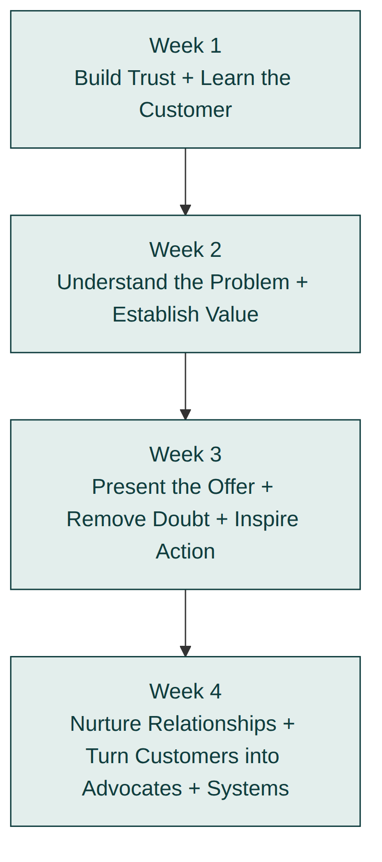
Figure 14.1: The 30-Day Rollout. Four weeks, two or three stages installed at a time, each building on the trust and diagnosis established in the week before.

The four-week rollout at a glance
Week | Stages installed | Worksheet | Sign it's working
1 | Build Trust, Learn the Customer | 3, 4 | You can name the full buying committee on every live deal
2 | Understand the Problem, Establish Value | 5, 6 | Every live deal has a confirmed diagnosis and an agreed value stack
3 | Present the Offer, Remove Doubt, Inspire Action | 7, 8, 9 | At least one deal moves from agreement to a signed commitment
4 | Nurture Relationships, Turn Customers into Advocates, Systems | 10, 11, 13 | Three genuine check-ins completed and one specific referral ask made

If your sales cycle runs longer than a month
Kestrel's projects typically close in three to fourteen weeks, which means a single deal can span the entire rollout without reaching a signature. If your business runs a longer cycle than that, don't expect day thirty to show a finished deal; expect it to show the framework correctly applied at whatever stage your live deals have actually reached. A twelve-month enterprise sales cycle installs the same way, just measured in earlier signals: has Build Trust and Learn the Customer been run properly on every live deal, rather than has anything closed. The habits are what thirty days installs. The deals close on their own timeline, not the rollout's.

When a week doesn't go as planned
Some weeks won't go the way the plan describes; a slow week for new enquiries, an unexpected crisis in an existing project, a Week 2 with no deal advanced enough to run a real diagnosis on. When that happens, don't skip ahead to keep pace with the calendar. Repeat the week, using whatever live deal is available, even an old or unpromising one, rather than moving to Week 3's material without having actually practised Week 2's. The four-week structure is a sequence, not a deadline; a five- or six-week rollout that's genuinely installed each stage beats a four-week one that rushed past a stage nobody actually practised.

What should be different by day thirty
You won't have closed every deal in your pipeline using the full framework in one month; most sales cycles run longer than that. What you should have, by day thirty, is a pipeline where every open deal is correctly tagged to a real stage, a proposal template that leads with a recommended package instead of a menu, at least one resolved doubt and one shrunk next step you can point to directly, three genuine nurture conversations completed with past customers, and one specific referral ask made rather than hoped for. Those are the concrete, checkable signs that the system, not just the reading, is now running.

Treat the thirty days as a reset, not a one-time onboarding
Habits installed once still slip, especially after a hectic quarter or a run of deals that pulled focus back onto whichever one was loudest. When you notice a stage from this book has quietly stopped happening on live deals, don't treat that as a failure of the framework; rerun the relevant week's worksheet against your current pipeline the same way you did the first time. A business that revisits the rollout whenever a habit has clearly slipped keeps the system running for years, not just for the thirty days it took to install it the first time.

Where Kestrel ended up
The Priya Shah at the start of this book stood in a car park re-reading a rejection email, certain her product was good enough and quietly unsure whether she was. The Priya Shah at the end of it runs a pipeline tagged by Blueprint stage, has a documented value stack template built from real client language, has turned a single satisfied customer's offhand comment into a repeatable referral system, and watches her win rate climb quarter over quarter on a dashboard she actually trusts. Nothing about her personality changed between those two points. What changed was the sequence she ran, in order, on every deal, until it stopped being something she had to think about and became simply how Kestrel sold.
That is the actual promise of this book, restated plainly at the end of it: not a transplant into someone more naturally suited to selling, but a system precise enough to run on purpose, in an order that removes the guesswork one stage at a time.

In a different kind of business
The thirty-day structure stretches differently for a business whose deals close in days rather than weeks. Elena, the freelance copywriter from Module 1, didn't have a single slow-moving deal to carry through all four weeks the way Priya did with Bramble Analytics. She had a dozen short client conversations most weeks, which meant Week 1's trust-deficit question got tested a dozen times before the week was even over, not once. By the end of thirty days, Elena hadn't installed the framework stage by stage on one long deal; she had run the entire nine-stage sequence, start to finish, against ten or twelve separate short deals, some of which she'd won and some of which she'd lost cleanly enough to know exactly why.
The lesson for a fast-cycle business is that the four weeks aren't really about the calendar; they're about getting enough live repetitions of each stage to make it a reflex. A business that closes one deal a quarter needs a full month to test a single habit properly. A business that closes several deals a week can test the same habit that many times before lunch on a Tuesday, and the thirty-day structure compresses accordingly, doing in days what it took Kestrel a full rollout to achieve.

Common mistakes
- Trying to apply all nine stages to every deal simultaneously in week one, rather than installing them in sequence
- Treating the four weeks as a reading schedule instead of a doing schedule tied to worksheets and live deals
- Skipping Week 4's systems work because it feels less urgent than the deals in front of you right now
- Measuring success by how much of the book you've read rather than what's changed in your actual pipeline
- Expecting a long sales cycle to produce a closed deal by day thirty instead of correctly applied early stages
- Skipping ahead to the next week's material when the current week wasn't actually practised on a live deal

Chapter summary
- The nine-stage framework installs best in sequence, two or three stages at a time over four weeks, not all at once.
- Each week's habit is tied to a specific worksheet and applied to live deals, not read about in the abstract.
- A longer sales cycle installs the same habits on the same schedule; only the closed deal itself arrives later.
- A week that didn't go as planned should be repeated, not skipped, even if that stretches the rollout past thirty days.
- By day thirty, the concrete signs of progress are a correctly tagged pipeline, a rebuilt proposal template, at least one resolved doubt, completed nurture conversations, and a specific referral ask, not a finished deal count.
- The system Priya built this way is the same one that later won Bramble Analytics, Tom's remote deal, and everything that followed it; nothing about her personality changed, only the sequence she ran.

Key takeaway
You don't need to master nine stages at once; you need thirty days to install them one week at a time.

Appendices

Appendix: Worksheets
Every worksheet is collected in full, in this order, in the worksheets section at the back of this book, so you can fill one in without flipping back to the chapter that introduced it. This index lists them in the order they appear.
# | Worksheet | Introduced in | Use it to
1 | Myth Audit | Module 1: The Truth About Sales | Diagnose which of the four myths shaped a deal you lost
2 | Buying Committee Map | Module 2: How Customers Really Buy | Map every stakeholder who could delay or block a decision
3 | Trust Audit | Module 3: Build Trust | Prepare competence, reliability, and candour signals before a first meeting
4 | Discovery Questions | Module 4: Learn the Customer | Run the three discovery questions and map the buying committee
5 | Problem Diagnosis | Module 5: Understand the Problem | Separate a stated symptom from its real cause and quantify the cost
6 | Value Stack Builder | Module 6: Establish Value | Build a value stack of distinct, buyer-confirmed outcomes
7 | Offer Builder | Module 7: Present the Offer | Rebuild a proposal around one recommendation, a scope boundary, and a next step
8 | Objection Resolution | Module 8: Remove Doubt | Sort a hesitation and build a specific resolution for it
9 | Action Friction Audit | Module 9: Inspire Action | Diagnose friction on a stalled, agreed deal and shrink the next step
10 | Nurture Cadence Planner | Module 10: Nurture Relationships | Plan genuine, no-pitch touchpoints for a past customer
11 | Referral Ask Builder | Module 11: Turn Customers into Advocates | Prepare a specific referral ask and a loop-closing message
12 | Digital Signal Audit | Module 12: Digital Selling | Map digital equivalents of in-person trust and discovery signals
13 | Pipeline Rebuild | Module 13: Sales Systems | Rebuild a pipeline around the nine Blueprint letters
14 | Thirty-Day Rollout Planner | Module 14: The 30-Day Sales Blueprint | Plan a four-week rollout of the full framework
Use them in order the first time through the book; after that, open whichever one matches the stage your current deal is actually at.

Appendix: Templates
Templates are collected in full in the templates section at the back of this book: reusable documents you adapt to your own business, distinct from worksheets, which are one-time reflective exercises.
Template | Introduced in | Purpose
Proposal Structure | Module 7: Present the Offer | The seven-part structure behind every proposal in this book: confirmed problem, value stack, recommended package, inclusions, scope boundary, price, next step
Customer Persona | Module 4: Learn the Customer | One completed persona per stakeholder in a buying committee, not one per deal
Follow-up Email | Module 10: Nurture Relationships | Six-week and six-month check-ins, an anniversary note, a referral ask, and a loop-closing message
Adapt the wording in every template to how you actually talk. A template that reads like a corporate memo undoes the trust Module 3 spent effort building.

Appendix: Checklists
Checklists are collected in full in the checklists section at the back of this book: quick-reference, tick-box versions of a module's rollout, distinct from the deeper planning worksheets.
Checklist | Introduced in | Purpose
The 30-Day Sales Blueprint Checklist | Module 14: The 30-Day Sales Blueprint | A week-by-week tick-list version of the full framework rollout, for tracking completion once Worksheet 14 has done the planning
Use the checklist to track progress once you've planned your rollout with the corresponding worksheet; use the worksheet when you need to think something through, not just tick it off.

Glossary
Terms as used throughout this book, in alphabetical order.
Advocate. A past customer who proactively refers, reviews, or defends the business without being asked each time. See Module 11.
Budget holder. The person who controls or releases the money for a purchase. Not always the same person as the decision-maker; see Module 2.
Buying committee. The small, often informal group of people who together decide on a considered purchase, even when no one in the organisation calls it a committee. See Module 2.
Candour signal. A trust signal built from admitting a real limitation before the buyer discovers it themselves. See Module 3.
Champion. A person inside the buying organisation who wants you to win and will advocate internally, even when not in the room. See Module 7.
Competence signal. A trust signal built from specific, checkable proof that you can do the exact job in front of you. See Module 3.
Considered purchase. A purchase the buyer will not make on impulse: it involves risk, cost, or more than one decision-maker.
Decline. A genuine no, distinct from an objection, which is a signal of unresolved doubt rather than a final answer. See Module 8.
Economic buyer. The person whose approval is ultimately required because they own the budget outcome.
Objection. A signal of unresolved doubt, not a rejection. See Module 8.
Reliability signal. A trust signal built from proof you do what you say, when you say it. See Module 3.
The Blueprint Framework. The book's central nine-stage system for winning and keeping a customer: Build Trust, Learn the Customer, Understand the Problem, Establish Value, Present the Offer, Remove Doubt, Inspire Action, Nurture Relationships, Turn Customers into Advocates. See the Blueprint Framework chapter in the front matter.
The 30-Day Sales Blueprint. The book's closing implementation plan: a four-week rollout of the full framework for a real business. See Module 14.
Trust deficit. The gap between how much confidence a buyer needs to say yes and how much they currently have. See Module 3.
Value stack. The visible, itemised list of outcomes a customer gets, arranged so the price feels small next to the pile. See Module 6.
Asserted value. A benefit stated as a claim, with nothing the buyer can check it against. Gets discounted because it costs the seller nothing to say. See Module 6.
Demonstrated value. A benefit connected to a specific outcome the buyer already confirmed, ideally using the buyer's own numbers or words. Harder to dismiss than an asserted claim. See Module 6.
Discovery. The structured process of learning a stakeholder's role, personal stake, and pressures, run only once trust has been established. See Module 4.
Friction. Ordinary organisational or personal obstacles (a busy week, an unclear sign-off process) that delay a convinced buyer from acting, distinct from an unresolved doubt. See Module 9.
Loop-back. The framework's rule that a new stakeholder joining a deal already in progress restarts Build Trust and Learn the Customer for that person specifically, regardless of how far along the deal is with someone else. See Module 4 and Module 13.
Nurture cadence. A scheduled, deliberate sequence of genuine, no-pitch check-ins with a past customer, distinct from reactive contact that only happens around problems or new pitches. See Module 10.
Pipeline. The full set of open deals a seller or business is tracking, ideally organised by actual Blueprint stage rather than a generic label. See Module 13.
Status quo gravity. The tendency of a buyer to prefer doing nothing over switching, because a bad decision to act is personally attributed to the person who acted, while a bad decision to stay put is usually attributed to circumstance. See Module 2.
Symptom. The problem a buyer states out loud, based on what they've actually experienced, as distinct from the underlying cause producing it. See Module 5.
Trust signal. Specific, checkable evidence, of competence, reliability, or candour, that earns a buyer's willingness to take what a seller says at face value. See Module 3.

Frequently asked questions
Direct answers to the questions readers ask most often once they start applying the Blueprint Framework to their own business, rather than reading about Priya's.
What if my industry genuinely is price-driven and trust doesn't matter much?
Module 1 names this exception honestly: true commodity markets, where buyers compare identical, interchangeable products entirely on a spec sheet, really do decide more on price and quality than on trust. Before concluding you're in that category, check the test properly: does a person make a judgement call about whether to work with you specifically, or does a procurement system simply compare numbers with no room for that judgement at all? Most businesses that assume they're the exception discover, once they look closely, that a person is still deciding, which means trust is still doing more work than the price sheet suggests.
How do I apply this if I don't control the whole sales process, for example if I'm a rep inside a larger company?
Every stage of the framework can be run inside a single conversation or a single call, even if the company around you hasn't formally adopted any of it. You don't need permission to ask a trust-deficit question in your first meeting, or to confirm a diagnosis out loud before proposing anything. Start with the stages you have the most personal control over, usually Build Trust and Understand the Problem, and let your own results make the case for the rest internally, the same way Module 13 describes a system earning its keep before it gets handed to a whole team.
I'm nervous about asking the direct trust-deficit question from Module 3. What if it feels too forward?
The discomfort nearly always belongs to the person asking, not the person being asked, which Module 11 makes the same point about referral asks. Try it once, on a low-stakes deal, phrased plainly: "what went wrong the last time you tried to solve this?" Buyers who have genuinely been burned before are usually relieved to be asked directly, because it signals you're taking their history seriously rather than assuming a clean slate. If it still feels forward after a few tries, soften the framing, not the substance: ask what they'd want to see to feel confident, rather than what went wrong.
How long should I expect it to take before I see results?
It depends entirely on your sales cycle length, which Module 14 addresses directly. A business with a multi-week cycle, like Kestrel's, needs a full thirty-day rollout to test each stage properly, because a single deal can span several weeks. A business that closes several deals a week, like Elena's copywriting practice in Module 1, can test the whole framework end to end within the same thirty days, simply because there are more repetitions available. The habits, not the calendar, are what actually take time to install.
Does this work for very short, low-value transactions, like retail or e-commerce?
Yes, though every stage compresses into seconds rather than weeks. Module 1 covers this directly: a retail assistant who answers one honest question well and steps back is running the same diagnosis-and-match sequence as a considered, high-value sale, just at a much faster tempo. For e-commerce specifically, several stages move into the product page and the checkout flow itself: specific, checkable proof functions as a trust signal even with no human conversation involved, the same principle Module 12 describes for a published case study that builds trust before a buyer ever makes contact.
What if my prospects never tell me who else is involved in the decision?
This is exactly the gap Module 2 and Module 4 exist to close, and the fix is rarely more persistence on the same question. Ask it earlier, before the relationship has settled into a routine that makes the question feel like second-guessing a decision already in motion. If a stakeholder still won't name others involved, treat the reluctance itself as information: it may mean trust isn't yet strong enough for a fully honest answer, which points you back to Module 3 rather than forward to a harder version of the discovery question.
Can I use this framework to sell an idea internally, for example pitching a project to my own manager or board?
Internal pitches follow the same sequence with the buying committee simply relabelled: your manager is often the budget holder, a department head is often the day-to-day user, and a board is often the reputational owner described in Module 2's three roles. Build Trust and Understand the Problem matter just as much internally as externally, arguably more, because an internal audience has years of history with you that either supports or undermines the trust signals you're sending in that specific pitch.
What if I genuinely don't have a differentiated product?
Module 6 addresses this directly: value that is demonstrated, connected specifically to a diagnosed problem in the buyer's own words, works even when two competitors' underlying products are functionally similar. Differentiation at the product level matters less than most sellers assume, because buyers rarely evaluate two products in a vacuum; they evaluate two sellers' understanding of their specific situation. A generic product, sold with a specific, demonstrated value stack, regularly beats a superior product sold with a generic pitch.
How do I avoid sounding scripted when I use these questions?
Scripted delivery is usually a sign the question is being asked from memory rather than from actual curiosity about the answer. The fix isn't memorising better wording; it's genuinely wanting to know what the buyer will say, which changes your tone whether or not you notice it happening. Module 3's practice-drill guidance, preparing the question thirty seconds before a meeting rather than reciting it from a card, is designed specifically to keep the delivery natural rather than rehearsed.
What if a competitor is doing something similar and using the same tactics?
A competitor asking similar discovery questions doesn't cancel out the value of asking them well. Two sellers can both ask what went wrong with a previous supplier; only one of them may actually listen without interrupting, summarise the answer back accurately, and build a proposal that visibly reflects it. The framework describes a sequence, not a set of lines to say, and execution quality inside that sequence is still the differentiator even when the structure itself becomes widely known.
Should I use this with existing customers too, not just new prospects?
Modules 10 and 11 are built entirely around existing customers, and an upsell or renewal conversation benefits from the same discipline as a first sale: confirm the current problem before proposing an expansion, demonstrate value in the customer's own updated numbers, and resolve any new doubt specifically rather than reassuring generally. Many businesses apply the framework diligently to new prospects and skip it entirely with existing customers, which is precisely the gap Module 10 exists to close.
What if my business sells through partners or resellers rather than directly to the end customer?
Run the framework with the partner as the buyer, since they are the one you need to build trust with, diagnose, and offer value to directly. Separately, equip your partner with the language and evidence Module 2 describes for a champion defending a decision internally, because your partner will often need to run a compressed version of the same sequence with their own end customer, without you in the room to help.
How do I know if I've actually built trust versus just been pleasant to talk to?
Module 3 gives a concrete test: trust shows up as unprompted disclosure, a buyer volunteering a budget ceiling, an internal disagreement, or a past bad experience without being pushed for it. Pleasantness produces a comfortable conversation with no new information in it. If you leave a meeting having enjoyed it but learned nothing you didn't already know, that is a sign of rapport rather than trust, and it's worth revisiting which of the three signals in Module 3 you actually demonstrated.
What if the buyer lies to me during discovery?
Most inaccurate answers during discovery aren't deliberate lies; they're the buyer's own incomplete understanding of their situation, which is exactly what Module 5's symptom-versus-cause distinction is built to catch. Confirming the diagnosis out loud before proposing anything, as Module 5 recommends, catches this regardless of whether the original inaccuracy was innocent or not, because it gives the buyer a chance to correct the picture before you've built anything on top of it.
Can a team of multiple salespeople all run this framework consistently?
Yes, and Module 13 is specifically about making that survive past one person. The discipline that travels between team members is honest staging (tagging a deal to the stage it's actually at, not the stage it's hoped to be at) and a shared, small set of metrics, rather than any particular script or tool. A team where everyone tags deals honestly against the same nine stages can coordinate on a single deal, as the three-partner events agency in Module 13 eventually did, without the confusion that comes from each person tracking a different private version of the same pipeline.
What if my sales cycle is genuinely one interaction with no possibility of a follow-up, like a single cold retail transaction?
Compress the sequence rather than abandoning it. A single interaction can still open with a quick, specific trust signal, surface the one thing that matters most to this particular buyer with a single sharp question, and close with a specific, low-friction next step, all inside a conversation that might last under a minute. Module 1's point about retail selling applies here directly: the mechanism doesn't change with deal size, only the clock it runs on, and a single-interaction sale simply runs that clock faster than any other stage in this book describes.
Is it manipulative to deliberately build trust as a technique, rather than it happening naturally?
No, provided the trust signals themselves are genuine: a real limitation actually admitted, a real system actually followed, a real diagnosis actually confirmed. Module 1 draws this line clearly between diagnosis-and-honest-match, which is simply selling done well, and manipulation, which relies on pressure or invented urgency to compensate for a weak match. Being deliberate about when and how you demonstrate real competence, reliability, and candour is no more manipulative than being deliberate about listening carefully; both are just doing the work on purpose instead of by accident.
What's the single most common reason people give up on this framework too early?
Trying to run all nine stages perfectly on every deal in the first week, exactly the failure mode Module 14 names directly, and concluding the framework doesn't work when the first attempt feels clumsy. The framework is a sequence to install gradually, not a performance to get right immediately. Most people who stick with the thirty-day rollout, repeating a week rather than rushing past it when it doesn't go to plan, report that the sequence stopped feeling like effort within a few weeks and started feeling like how they naturally sell, exactly the shift Priya describes at the end of Module 14.
What if I run a business with no repeat customers at all, so Modules 10 and 11 seem irrelevant?
Very few businesses genuinely have zero repeat contact of any kind; even a one-off purchase, like Owen's bespoke dining table in Module 6, sits inside a couple's wider network of friends and family who might furnish a room of their own one day. Nurture and advocacy don't require an ongoing contract to matter. A single, genuine check-in weeks after delivery, and a single, specific referral ask once proof has landed, both still apply to a business built entirely on one-off transactions; they just happen once per customer instead of on a recurring cadence.
How do I handle a buyer who wants everything done through a formal RFP, with no room for a real conversation at any stage?
Treat the written document itself as the channel and apply the same sequence inside it. A well-answered RFP response can still demonstrate competence and reliability signals in its language, can still reference the buyer's own stated requirements rather than generic capability claims, and can still close with a specific next step rather than a vague invitation to be in touch. Module 7's guidance on procurement-mandated menus applies directly here: state your clearest recommendation plainly within the document, even when the format itself wasn't your choice.
Should smaller, less experienced sellers on my team run the exact same scripts as the most senior people?
The specific words matter far less than the sequence and the underlying discipline, which is precisely why Module 13 emphasises honest staging and shared metrics over any particular script. A newer seller who genuinely wants to know what went wrong with a buyer's last supplier will ask a version of that question in their own words and get a useful answer. A senior seller reciting the exact same line from memory, without genuine curiosity behind it, will often get a worse one. Train the sequence and the intent; let the exact phrasing vary by person.
What if my product or service changes frequently, making it hard to keep proposals and value stacks up to date?
Build the value stack around the buyer's confirmed problem rather than around your current feature list, and it will need far less maintenance than a stack built the other way round. Dominic's flexible-room design in Module 6 was itemised around outcomes (recovered focus time, avoided expansion cost, better attendance on key days), not around specific product features that might change with the next season's materials or software release. A value stack tied to outcomes survives a product update; one tied to feature names has to be rewritten every time the product changes.

Quick reference: the nine stages and their key question
A one-line reminder of what each stage of the Blueprint Framework is actually asking, useful to keep near your desk or your call notes.
Stage | Key question to answer
Build Trust | What specific, checkable evidence have I given this buyer that I understand their situation and won't hide bad news?
Learn the Customer | Who else needs to be comfortable with this, and what is each person personally measured on?
Understand the Problem | Is what the buyer just told me the actual cause, or only the symptom sitting on top of it?
Establish Value | Can the buyer check this claim against something they already told me themselves?
Present the Offer | Is there one clear recommendation here, or am I asking the buyer to compare and decide unaided?
Remove Doubt | What specific question is this hesitation actually standing in for?
Inspire Action | Is the next step small, specific, and scheduled, or open-ended and easy to defer?
Nurture Relationships | Would I still make this call if there were no possible future sale attached to it?
Turn Customers into Advocates | Have I asked for something specific, at the moment proof has just landed, rather than hoping quietly?
When a deal stalls anywhere in the sequence, this table is usually the fastest way to spot which question was never actually answered.

References
The Blueprint Framework is an original synthesis, not a repackaging of another author's model, and no other book's framework, wording, or structure is reproduced here. Where a specific fact, quote, or figure would ordinarily need a citation, this book uses none because none of Kestrel Office Interiors' story is real: Priya Shah, Dominic, Marguerite, Tom, and every deal in this book are fictional, built to demonstrate the framework rather than to report on actual events.

Further reading
If you want to go deeper into the ideas that sit alongside this book's approach, without treating any of them as this book's source material, the following are worth your time:
- To Sell Is Human by Daniel H. Pink
- The Challenger Sale by Matthew Dixon and Brent Adamson
- Never Split the Difference by Chris Voss and Tahl Raz
- Influence by Robert Cialdini
Each takes a different angle on persuasion and selling than this book does; reading them alongside the Blueprint Framework will show you where the ideas agree, and where they don't.

Worksheets

All fourteen, in full

Worksheet 1: Myth Audit
Use this with a real deal you lost in the last twelve months, one where you believed you had the stronger offer.

Step 1: Write the polite reason
What did the buyer actually tell you, in their words or in the rejection email? Write it exactly as they said it.

Step 2: Write the real reason
Guess honestly. If you asked them over a drink, off the record, what would they actually say? Common real reasons include: unsure you'd deliver on time, unsure you understood their specific situation, uneasy about a stakeholder who never got won over, or genuinely happy with an incumbent and never seriously shopping.

Step 3: Match it to a myth
Which myth from this module was quietly shaping how you ran the deal?
- ☐ Myth one: I avoided being direct because I didn't want to seem pushy
- ☐ Myth two: I assumed my personality (or lack of a certain one) decided the outcome
- ☐ Myth three: I assumed the stronger product or lower price would win on its own
- ☐ Myth four: I treated an early hesitation as a fixed no and stopped probing

Step 4: Name the actual gap
In one sentence, what would you need to have done differently, in what order, for the real reason in Step 2 to never have become a factor?

Step 5: Apply it forward
Pick one open deal in your current pipeline. Using Step 4's answer, write down the single next action you'll take in the next 24 hours to close that same gap before it costs you this deal too.

Step 6: Check for the pattern
Repeat Steps 1 to 3 for two more lost deals from the last year. Do the same myth keep showing up? If so, that is your primary myth, the one worth watching for on every deal from now on, not just the one you happened to audit today.

Step 7: Name the discomfort
In one honest sentence, what did believing this myth protect you from admitting? (For example: "believing my product should speak for itself let me avoid the discomfort of asking directly for the sale.") You don't need to share this with anyone. Naming it is what makes it easier to catch next time.

Worksheet 2: Buying Committee Map
Use this on your largest open deal right now.

Step 1: List everyone who could delay or block this decision
Don't stop at your main contact. Include anyone who could say "wait" or "no," even if you've never spoken to them directly.
Name | Role | Have you spoken to them directly?

Step 2: Name each person's private concern
For each name above, write one sentence describing what they personally stand to lose if this decision goes wrong. Practical, financial, and reputational are common categories, but use whatever fits.

Step 3: Check your pitch against every row
Does your current proposal, as written, speak to every concern you listed in Step 2? Circle the ones it doesn't address at all.

Step 4: Equip your champion
Pick the stakeholder most likely to advocate for you when you're not in the room. Write down the exact sentence or evidence you'll give them to defend this decision to someone else on the list.

Step 5: Apply it forward
Before your next meeting on this deal, contact one person from your list you have not yet spoken to directly, even briefly, and ask them what would need to be true for them to feel comfortable with this decision.

Step 6: Check for disagreement between stakeholders
Look at the concerns you listed in Step 2. Do any two of them pull in different directions (for example, one wants the most impressive option, another wants the lowest cost)? If so, name the tension directly rather than assuming it will resolve itself.

Step 7: Judge committee size honestly
Estimate how large this committee is likely to grow, based on how much this decision costs the business and how hard it would be to reverse, not based on how big the company is. If the answer is "probably bigger than the two or three people I've already met," plan your next meeting around finding out who's missing.

Worksheet 3: Trust Audit
Use this before your next first meeting with a new prospect.

Step 1: Ask about the last attempt
What is the one question you'll ask to find out what happened the last time this buyer tried to solve this problem? Write it out in full, in the words you'll actually say. If this is a first-time buyer with no past supplier to reference, write the hypothetical version instead: what are they most worried could go wrong?

Step 2: Predict the deficit
Based on what you already know about this buyer, guess which trust signal is likely to matter most to them:
- ☐ Competence: they need proof you can actually do this
- ☐ Reliability: they need proof you'll do what you say, on time
- ☐ Candour: they need proof you'll tell them the truth, including bad news

Step 3: Prepare one signal of each kind
Write one specific, checkable example you can offer for each signal, ready to use if the conversation calls for it:
Signal | Your example
Competence
Reliability
Candour (a real limitation)

Step 4: Choose your candour signal in advance
Naming a limitation on the spot is harder than it sounds. Decide now, before the meeting, which true limitation of your product or service you will say out loud, unprompted, in the first conversation.

Step 5: Apply it forward
After the meeting, note whether the buyer volunteered any information they wouldn't tell a stranger (a budget figure, an internal disagreement, a past bad experience). If they did, your trust-building worked. If they didn't, revisit Step 2: you likely led with the wrong signal.

Step 6: Plan for a slip
Trust built in this meeting isn't permanent. Decide now how you'll handle it if something on your side slips later in this deal (a late reply, a missed date): what you'll say, how quickly, and what specific fix you'll offer. Deciding this in advance means you won't improvise it badly under pressure later.

Worksheet 4: Discovery Questions
Use this on an active deal where you've already built some initial trust.

Step 1: Ask the three questions
Record the buyer's answers in their own words, not your summary.
Question | Their answer
Who else needs to be comfortable with this before it happens?
What are you personally measured on this year?
What would make this decision hard to defend to your board or team?

Step 2: Map the committee
List everyone named in your answer to the first question above, plus anyone you already knew about.
Name | Role | Contacted directly?

Step 3: Learn the organisation's decision process
Ask how they made a comparable decision before (even in a different category) and note:
- How long did it take?
- Who had to sign off?
- What almost made them choose differently?

Step 4: Apply it forward
Compare your current proposal or pitch against what you learned in Steps 1 to 3. Does it speak to the personal stake you uncovered, or only to the generic business need? Revise one sentence of your pitch to reference something specific you learned in this conversation.

Step 5: Rephrase for a guarded stakeholder
If any answer in Step 1 came back vague or deflected, write a rephrased version of that same question, aimed at a comparable past decision or a good outcome, instead of the direct version. Use it next time you speak with that stakeholder.

Step 6: Flag new stakeholders for a restart
If a new person joins this deal after today, note their name here and mark that Steps 1 to 3 need to be repeated for them specifically. Do not assume their answers will match the stakeholder you already spoke to.

Worksheet 5: Problem Diagnosis
Use this on a deal where you already have the buyer's initial description of their problem.

Step 1: Write the stated symptom
What did the buyer say, in their own words, when you first asked what was wrong?

Step 2: Ask one concrete follow-up
Write a question specific enough to have a short, concrete answer: a day, a number, a moment it happens. Record the answer.

Step 3: Separate symptom from cause
- Symptom (what they notice):
- Cause (what's actually producing it):

Step 4: Quantify the cost
In the buyer's own numbers, what is this problem costing them? Time, money, missed opportunity, staff attrition, whatever applies. Let the buyer generate the number if at all possible.

Step 5: Confirm the diagnosis
Write the one sentence you'll say back to the buyer to confirm your understanding of the real problem. Use it in your next conversation and note whether they agreed immediately, added detail, or corrected you.

Step 6: Apply it forward
If they corrected you, repeat Steps 2 to 5 before proposing anything. If they agreed and added detail, you're ready for Module 6.

Step 7: Check for more than one cause
Did your follow-up questions surface a second, separate factor alongside the main one? If so, list it here rather than folding it into the main cause. Each one may need its own place in your value case.

Step 8: Sanity-check against over-diagnosis
Honestly: did your follow-up question actually change the shape of the solution, or did it just confirm what the buyer told you the first time? If nothing changed, the first answer was likely already correct. Don't manufacture complexity that isn't there.

Worksheet 6: Value Stack Builder
Use this with the diagnosed problem from Worksheet 5.

Step 1: List every distinct outcome
Don't stop at the headline benefit. List at least three separate outcomes your solution produces for this specific, diagnosed problem.
Outcome | Buyer's own number or detail it connects to

Step 2: Check for jargon
Read each outcome back. Cross out any term the buyer hasn't used themselves and replace it with their own words.

Step 3: Connect each outcome to something the buyer already told you
For each row above, write the specific thing the buyer said (in an earlier conversation) that this outcome directly answers. If you can't find one, the outcome is asserted, not demonstrated; revise it or cut it.

Step 4: Stack it
Write the full value stack as you'll present it, outcome by outcome, with the price named only at the end, after the full stack is visible.

Step 5: Apply it forward
After presenting this, note the buyer's first question. If it's about meaning or difference from competitors, the stack needs another pass. If it's about timing or implementation, move to Module 7.

Step 6: Handle the unquantifiable
If any outcome resists a hard number, don't invent one. Write instead a specific, concrete scene the buyer will recognise (a moment, a place, a small detail) that demonstrates the outcome without a fabricated statistic attached.

Step 7: Cut the padding
Re-read your full stack. Is every item genuinely distinct, or does one just restate another to make the pile look bigger? Remove any item that doesn't survive this check, even if it leaves you with only two.

Worksheet 7: Offer Builder
Use this to rebuild a proposal for an active deal that already has a confirmed value stack (Worksheet 6).

Step 1: Pick the one recommended package
If your current template offers multiple equal options, choose the one you'd actually recommend to this buyer and describe it in one paragraph.

Step 2: State what's included
List everything covered in the fixed price, in plain language.

Step 3: Name what counts as a variation
List the specific things that would trigger extra cost or time, stated before the buyer has to ask.

Step 4: Build the ladder, if you need one
If a genuine choice helps this buyer, define a reduced tier and an enhanced tier beneath and above your recommendation. Keep the recommendation visually and verbally the default.
Tier | What changes | Price
Enhanced
Recommended
Reduced

Step 5: Write one specific next step
Replace any open-ended closing line with a specific, dated action needed from the buyer.

Step 6: Apply it forward
Send the rebuilt proposal and note the buyer's first question. A question about the recommended option itself means the offer is doing its job; a question asking you to explain the difference between options means Step 1 needs another pass.

Step 7: If procurement requires multiple options
If this buyer's process mandates more than one priced option, write the exact sentence you'll include stating which one you recommend and why, tied to their confirmed problem. Do not leave the document neutral.

Worksheet 8: Objection Resolution
Use this the next time a live prospect hesitates or raises a concern.

Step 1: Write down what they said
Use their exact words, not your interpretation.

Step 2: Ask what's specifically behind it
If you haven't already, ask directly: "What specifically worries you about this?" Record the answer.

Step 3: Sort the doubt
- ☐ Timing: will this disrupt something that matters to them
- ☐ Budget: will this cost more than agreed
- ☐ Delivery: will this actually get done as promised
- ☐ Internal buy-in: will someone else here object later

Step 4: Check for specificity
Does the answer name a day, a number, a person, or a risk? If yes, it's a real, resolvable objection. If it's vague, an earlier stage (trust, discovery, or diagnosis) likely needs revisiting before this one can be resolved.

Step 5: Build the resolution
Write the specific plan, document, or piece of evidence, not a general reassurance, that answers exactly what they named in Step 2.

Step 6: Apply it forward
Deliver the resolution and note what happened next. If the deal moves forward, the doubt was real and now resolved. If a new hesitation appears, repeat this worksheet; it may be a different doubt underneath the first one.

Step 7: If the doubt turns out to be valid
If, in building the resolution in Step 5, you realise the concern is actually true and you cannot honestly fix it, write down the plain, honest sentence you'll use to name the trade-off to the buyer instead of forcing a resolution that won't hold up.

Worksheet 9: Action Friction Audit
Use this on a deal where the buyer has agreed in principle but hasn't yet acted.

Step 1: Confirm it's friction, not doubt
Has the buyer stated a specific concern (a doubt, see Worksheet 8), or have they said something close to "yes, we want to do this" with no action following? If it's an unstated concern, go back to Worksheet 8 first.

Step 2: Ask plainly what's in the way
Call or message the buyer directly: "What's stopping this from moving forward?" Record their answer.

Step 3: Diagnose the friction
- ☐ Competing priorities: this task hasn't reached the top of their list
- ☐ Unclear process: they're not sure who needs to sign or approve
- ☐ Effort mismatch: the remaining step feels bigger than the decision itself

Step 4: Shrink the next action
Rewrite the outstanding task as the smallest, most specific, scheduled action you can offer. Not "review and sign," but a bounded call, a single page, a specific time.

Step 5: Name a genuine deadline, if one exists
Is there a real constraint (a schedule slot, a resource availability, a seasonal factor) that gives this a true deadline? Write it down. Do not invent one if none exists.

Step 6: Apply it forward
Deliver the shrunk next step and the genuine deadline together. Note how long it takes from this point to a committed action, and compare it to how long the deal had already been stalled.

Step 7: Track your follow-up count
Log how many times you've followed up on this specific ask. If you're past one honest follow-up with no new information to add, stop repeating it and instead ask directly whether anything has changed.

Worksheet 10: Nurture Cadence Planner
Use this for a customer you closed at least a month ago.

Step 1: Pick the customer
Name one customer you haven't spoken to since delivery or since your last transaction with them.

Step 2: Design three touchpoints
For each, write the genuine, no-pitch question or note you'd offer, and when you'd send it.
Touchpoint | Timing | What you'll say (no pitch)
First check-in
Second check-in
Open, no-agenda note

Step 3: Apply the no-pitch test
For each row above, ask: if there were no possibility of future revenue from this customer, would you still make this contact? If the answer is no, rewrite it until it is yes.

Step 4: Apply it forward
Send the first touchpoint this week. Record what the customer tells you, especially anything about how what you delivered is actually being used. That information often points to an expansion opportunity or a referral without you having to ask for either.

Step 5: Prepare for either answer
Before you send it, write down what you'll do if the answer is good news, and separately what you'll do if it surfaces a real problem. Having a plan for the second case makes it easier to actually ask the question instead of unconsciously avoiding it.

Step 6: Build the schedule, not the script
If you have more than a handful of customers, set calendar reminders for the timing in Step 2 across all of them. Keep the reminder generic ("check in with [name] about [what they bought]"); write the actual message specific to that customer each time you send it.

Worksheet 11: Referral Ask Builder
Use this with a customer who has recently confirmed a good result, even in passing conversation.

Step 1: Confirm the moment
Has this customer seen tangible proof of the result, not just a promise? If not, wait until they have; that's the moment this stage works best.

Step 2: Name a specific person or type of contact
Who, specifically, would you like an introduction to? A named person is stronger than a general category, but a specific category ("another operations lead at a company your size") still beats a vague request.

Step 3: Write the specific ask
Draft the exact question you'll ask, aimed at one bounded action (an introduction, a specific conversation), not a general request to keep you in mind.

Step 4: Plan the loop-closing message
Write, in advance, the short note you'll send this customer after the introduction happens, regardless of whether it leads anywhere. Reporting back, win or lose, is what makes the next ask easier.

Step 5: Apply it forward
Make the ask. Log the outcome and the date you closed the loop. Over time, track how many introductions convert to new customers, and how many of those new customers eventually become advocates themselves.

Step 6: If no specific person comes to mind
If Step 2 comes up empty, write an alternative, equally specific ask instead: permission for a named case study, a short testimonial about the specific problem solved, or a public review. Use this version rather than defaulting to a vague, general request.

Step 7: Check your own asking frequency
Before you ask this customer again in future, check: is this ask driven by something they mentioned unprompted, or by your own need for a new lead? If it's the latter, wait for a genuine opening instead.

Worksheet 12: Digital Signal Audit
Use this on a lead or deal that started, or is running, primarily online or remotely.

Step 1: Map your stages to digital equivalents
For each stage below, write the specific digital equivalent you're using right now, or the gap if you're not using one yet.
Stage | In-person version | Your current digital equivalent
Build Trust | Conversational competence signal
Learn the Customer | Reading hesitation from body language
Present the Offer | Handing across a physical proposal

Step 2: Check your response time
How long did it take you to respond to this lead's first message? Would a same-day, specific reply have been possible? If not this time, what would make it possible next time?

Step 3: Find the unasked question
Which discovery question from Module 4 have you been relying on reading from the room, that you should ask directly instead over video or in writing?

Step 4: Make the offer shareable
Does your current proposal or offer exist as something the buyer can forward to a stakeholder who wasn't on the call? If not, build that version before your next digital deal reaches Module 7.

Step 5: Apply it forward
Send the direct question from Step 3 in your next conversation with this lead, and note whether it surfaces something you wouldn't otherwise have learned.

Step 6: Match stages to channels
List which channel (email, video, chat) you're currently using for each stage of this deal. Flag any mismatch, such as running discovery entirely over email when a video call would surface more, or presenting an offer only verbally on a call when a shareable document is needed.

Step 7: Plan nurture at a distance
If this deal closes, write down the specific, genuine check-in you'll send at six weeks, exactly as you would for an in-person customer. Note which channel suits it best.

Worksheet 13: Pipeline Rebuild
Use this to rebuild your own pipeline around the Blueprint Framework.

Step 1: List every open deal
Include everything currently live, however early or late.

Step 2: Tag each deal to its actual stage
For each deal, write the single Blueprint letter (B, L, U, E, P, R, I, N, or T) that honestly describes where it is right now, not where you wish it were.
Deal | Stage | Next specific action (from that module)

Step 3: Track stakeholders separately where needed
For any deal with more than one stakeholder, note whether each person is genuinely at the same stage. If a new person has joined recently, they likely need to restart at Build Trust or Learn the Customer even if the rest of the deal is further along.

Step 4: Choose your four numbers
Decide what you'll track monthly: win rate, average time to signature, referral rate, and any other metric specific to your business. Write down this month's baseline for each.

Step 5: Apply it forward
Review this pipeline weekly. After three months, compare your four numbers to the baseline in Step 4 and note what changed.

Step 6: Flag the quiet deals
Mark any deal that has sat at the same stage for more than three weeks without a specific action taken. For each one, decide honestly: is it stalled and recoverable, or genuinely dead? Move dead deals to closed-lost so they stop inflating your pipeline.

Step 7: Check the system travels
If anyone else is or will be involved in selling, confirm they can look at this board and know the next action for any deal on it, without asking you to explain it first.

Worksheet 14: 30-Day Rollout Planner
Use this to plan your own rollout of the framework, week by week.

Week 1: Build Trust and Learn the Customer
- Complete Worksheet 3 (trust audit) before your next new-prospect meeting.
- Ask at least one of Module 4's three discovery questions in every live conversation this week.
- By Friday, name the full buying committee on every open deal.

Week 2: Understand the Problem and Establish Value
- Run Worksheet 5 (problem diagnosis) on your two or three most advanced open deals.
- Build a value stack (Worksheet 6) for each, with at least three itemised outcomes.
- By Friday, every deal you worked on has a buyer-confirmed diagnosis and value stack.

Week 3: Present the Offer, Remove Doubt, Inspire Action
- Rebuild your proposal template using Worksheet 7: one recommendation, a scope boundary, a dated next step.
- Apply Worksheet 8 to any hesitation that surfaces this week.
- Apply Worksheet 9 to any deal where agreement hasn't yet turned into action.
- By Friday, at least one deal has moved from agreement to signed commitment using this sequence.

Week 4: Nurture, Advocates, and Systems
- Pick three past customers you haven't spoken to since delivery and plan a genuine check-in (Worksheet 10) for each.
- Make one specific referral ask (Worksheet 11) with your most satisfied recent customer.
- Rebuild your pipeline around the nine Blueprint letters (Worksheet 13) and set your baseline metrics.

Day 30 review
Answer honestly:
- Is every open deal correctly tagged to a real Blueprint stage?
- Does your proposal template lead with one recommendation, not a menu?
- Can you point to one resolved doubt and one shrunk next step from this month?
- Did you complete three genuine nurture conversations?
- Did you make at least one specific referral ask?
Whatever isn't yet true, repeat that week before moving on. The sequence matters more than the calendar.

If your sales cycle is longer than a month
Replace "at least one deal has moved from agreement to signed commitment" in Week 3 with "at least one deal has been correctly diagnosed, valued, and offered using this sequence." Judge Week 3 by whether the stages were run properly, not by whether a signature exists yet.

If a week didn't go as planned
Note here which week, and why (no advanced deal to work with, an unexpected crisis, something else). Repeat that week using whatever live deal is available before moving on to the next one, even if it means your rollout takes five or six weeks instead of four.

Templates

Template: Proposal Structure
Introduced in Module 7 (Present the Offer). Use this structure after Worksheet 6 (value stack builder) is complete; do not start a proposal before the value stack exists.

1. The confirmed problem
One paragraph, in the buyer's own words and numbers, restating the diagnosis they already agreed to (see Worksheet 5). This is not new information to the buyer; it is proof you understood them correctly.

2. The value stack
List each distinct, itemised outcome from Worksheet 6, in the buyer's language, with the number or detail it connects to. Present this before any price appears.

3. The recommended package
Describe one clear, recommended solution. If a ladder is useful, show a reduced and an enhanced tier beneath and above it, with the recommendation visually and verbally the default (see Module 7's Pricing Ladder).

4. What's included
A plain list of everything covered by the fixed price.

5. What counts as a variation
A plain list of the specific things that would trigger extra cost or time. State this before the buyer has to ask.

6. Price
Only appears here, after the value stack and scope are already visible.

7. One next step
A single, specific, dated action needed from the buyer. Not "let me know what you think."

Template: Customer Persona
Introduced in Module 4 (Learn the Customer). Complete one of these per stakeholder in a buying committee, not one per deal; Module 2 covers why a single persona per deal usually misses the people who can actually block it.

Role and title

What they're personally measured on this year
From Module 4's second discovery question. Not the business goal; their individual stake in the outcome.

What they'd find hard to defend internally
From Module 4's third discovery question. The concern most likely to surface later as an objection (see Module 8) if it isn't addressed early.

How they prefer to communicate
In person, video, async message. Relevant for adapting your approach per Module 12.

Their relationship to the budget
Do they control it, influence it, or answer for it afterward. Distinct roles that need different handling (see Module 2's buying committee).

Trust signal most likely to matter to them
Competence, reliability, or candour (see Module 3's Trust Pyramid). Base this on what you learn about their past experience with similar purchases.

Template: Nurture Follow-up Email
Introduced in Module 10 (Nurture Relationships). Use for a scheduled check-in, not a sales pitch. Before sending, apply the no-pitch test from Worksheet 10: if there were no possibility of future revenue, would you still send this?

Six-week check-in
Subject: How's [the specific thing you delivered] working out?
Body: Reference the original diagnosed problem by name (not the product). Ask one specific question about whether it's actually solved. Nothing else. No mention of future work.

Six-month check-in
Subject: Checking in
Body: Ask what's changed in their business since delivery. Genuine curiosity, not a lead-in to a pitch.

Anniversary note
Subject: Thought of you
Body: Share something genuinely useful (an article, an observation from a comparable situation) with no ask attached.

Referral ask (see Module 11)
Subject: A specific ask
Body: Name the specific person or type of contact you'd like an introduction to. State plainly why you're asking them specifically. One bounded action, not a general request to keep you in mind.

Loop-closing note (after a referral)
Subject: Update on that introduction
Body: Report what happened, win or lose. This message matters more than the ask itself for whether the next referral happens.

Checklists

Checklist: The 30-Day Sales Blueprint
A quick-reference version of Module 14's rollout. Use Worksheet 14 for the detailed planning; use this to track completion week by week.

Week 1: Build Trust and Learn the Customer
- ☐ Completed a trust audit (Worksheet 3) before a new-prospect meeting
- ☐ Asked at least one of the three discovery questions in every live conversation
- ☐ Named the full buying committee on every open deal

Week 2: Understand the Problem and Establish Value
- ☐ Ran a problem diagnosis (Worksheet 5) on two or three advanced deals
- ☐ Built a value stack (Worksheet 6) with at least three itemised outcomes for each
- ☐ Confirmed each diagnosis with the buyer before proposing anything

Week 3: Present the Offer, Remove Doubt, Inspire Action
- ☐ Rebuilt the proposal template around one recommendation, not a menu
- ☐ Named the scope boundary (what's included vs. a variation) in writing
- ☐ Resolved at least one specific, named doubt
- ☐ Shrunk at least one stalled next step and attached a genuine deadline
- ☐ Moved at least one deal from agreement to signed commitment

Week 4: Nurture, Advocates, and Systems
- ☐ Completed three genuine, no-pitch check-ins with past customers
- ☐ Made one specific, named referral ask
- ☐ Closed the loop with that advocate, regardless of outcome
- ☐ Rebuilt the pipeline around the nine Blueprint letters
- ☐ Set a baseline for win rate, referral rate, and time to signature

Day 30 review
- ☐ Every open deal is tagged to a real, honest Blueprint stage
- ☐ The proposal template leads with one recommendation
- ☐ There is at least one resolved doubt and one shrunk next step to point to
- ☐ Three nurture conversations and one referral ask are complete
If any box above is unchecked, repeat that week before starting the next cycle. The sequence matters more than the calendar.
Long sales cycle? Swap "moved at least one deal to signed commitment" for "correctly diagnosed, valued, and offered at least one deal using this sequence." The habit is what thirty days installs; the signature arrives on its own timeline.

