Open Source Analytics

NBA Real Time Prediction using Spark v2

Dustin VanStee

@dustinvanstee



This document is written so that the user can reproduce the NBA real time machine learning demo. The demo consists of 2 parts:

1. Data Analysis & Modelling: We provide two approaches here:
   * IBM Data Science Experience(DSX): RStudio
   * IBM Data Scientist Workbench(DSWB): Zeppelin Notebook for the data scientist
2. Web application desired for user interaction on Bluemix

After the environment is setup, there will be a brief description of the Logistic Regression model that was built, and how it was ‘wired’ into the Bluemix environment. Upon completion, you will have a full demo environment setup, with a live website.

# Setup the DSX Environment

The following steps will guide you through the process of setting up Data Science Experience. At the end of this section, you will be able to conduct data analysis and data modelling in RStudio integrated within DSX.

1. Download the [project](https://github.com/dustinvanstee/nba-rt-prediction) from GitHub.
2. Log in to [DSX](http://datascience.ibm.com/). (Sign up if you have not done so!)

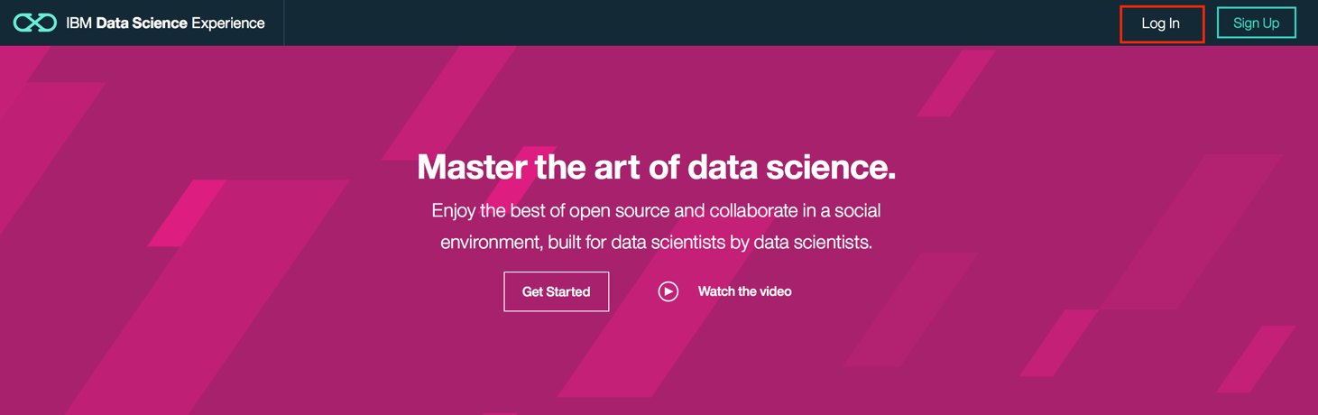

1. Click to show the hidden side panel on the left and open RStudio.

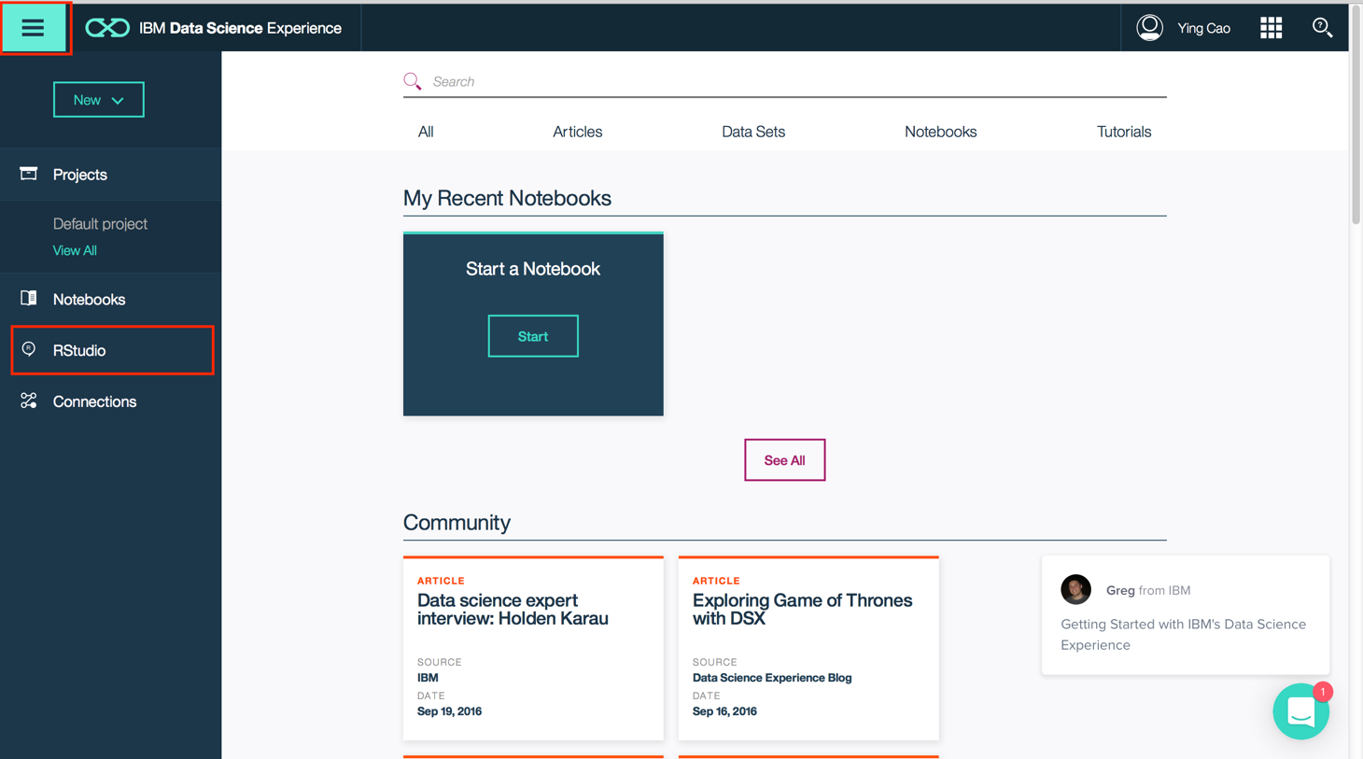

1. It only takes a few seconds for the RStudio to set up. Click upload and use browse to find the .zip file you have just download and then click OK.

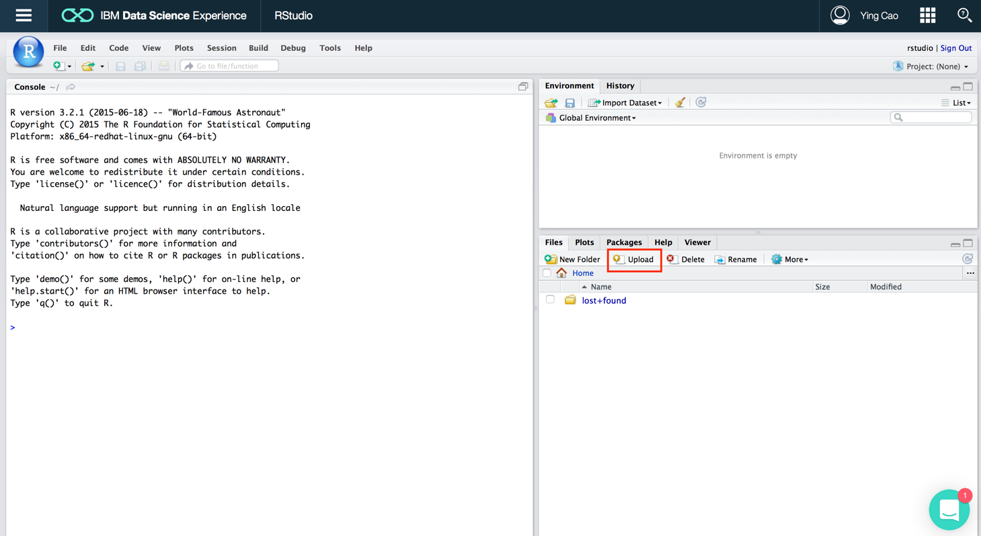

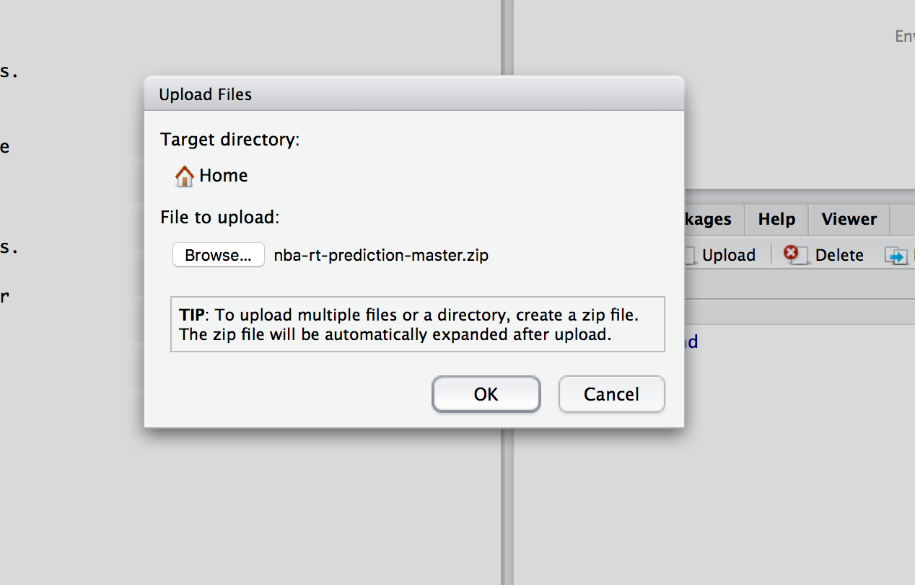

The uploaded file will be shown as following.

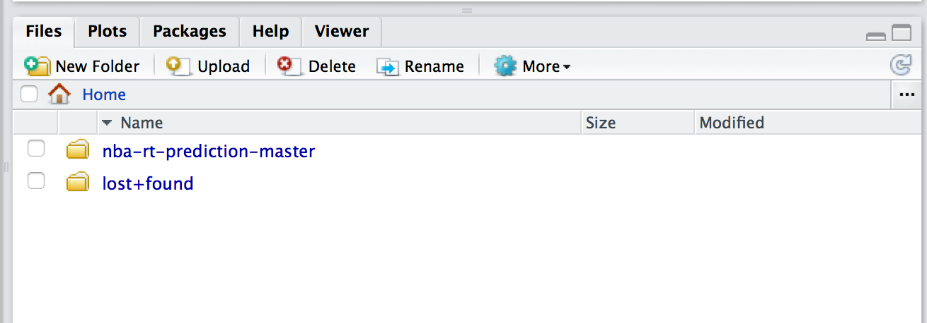

1. Open **NBA_Data_Wrangling_v2.Rmd** in the folder */nba-rt-prediction/DSX_NBA_Demo_in_R*. And click **Knit HTML** you will get the webpage as we have presented. If there pops up any windows asking for package updates, just click yes.  
   Open **NBA_Logistic_Regression_v2.Rmd** if you want to run data modelling session.

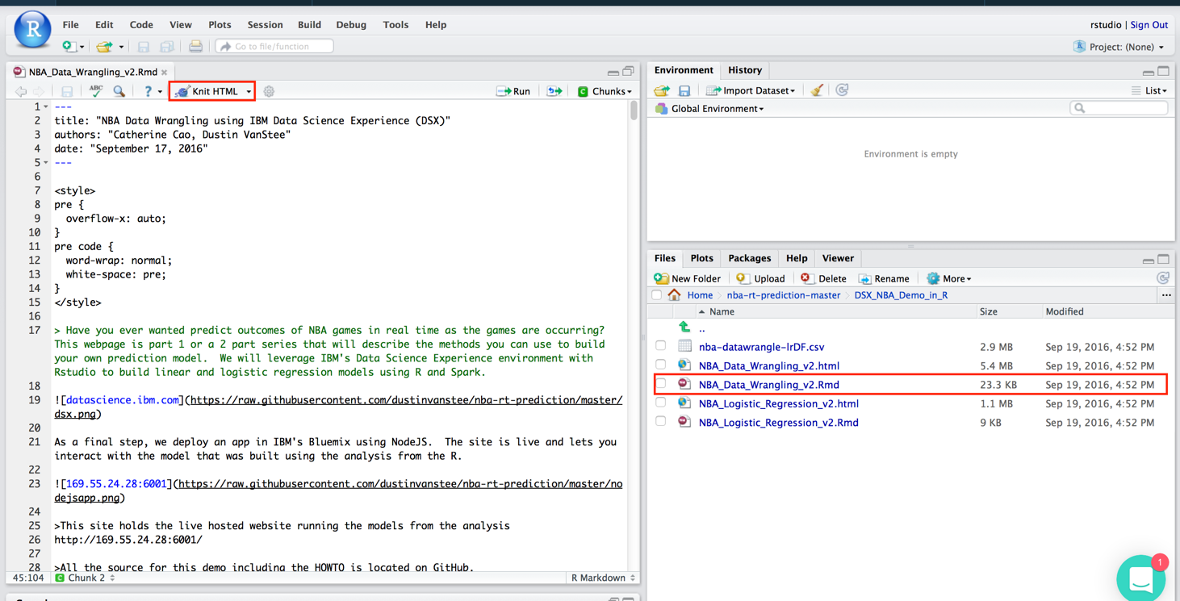

We use Rmarkdown for reporting purpose. You can directly run R codes in the chunks to conduct data analysis. There is more documentation within the Rmarkdown file(.Rmd) to guide you through that portion of the demo.

# Setup the DSWB Environment

The following steps will guide you through the process of setting up datascientist workbench. At the end of this section, you will be able to run your zeppelin notebook and create a logistic regression model in Spark.

1. download <https://github.com/dustinvanstee/nba-rt-prediction> project
2. Setup DSWB environment
   1. create userid if you have not already done so
   2. For the zeppelin notebook in datascientistworkbench, you will need to upload 3 notebooks and 2 data files into the environment.
      1. Copy nbaodds.xml into /data/resources
      2. Copy scores_nba.test.dat into /data/resources

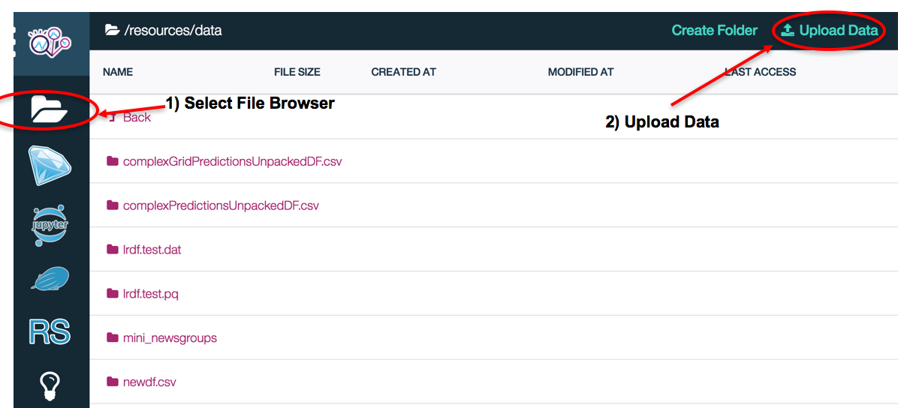

* + 1. 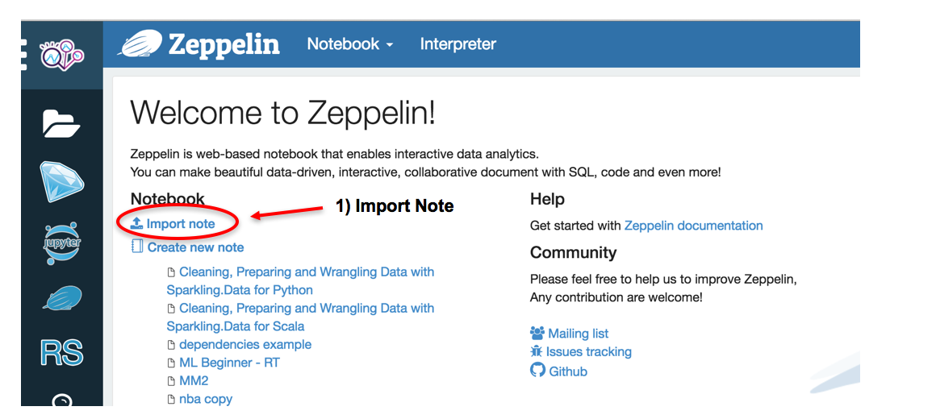Import the 3 json notebooks into your zeppelin Environment

Congratulations, you can now run the rest of the demo from within the notebook!

The notebooks are organized into 3 files :

NBA-Predictions-1-DataWrangling-V2.json : data preparation notebook

NBA-Predictions-2-LinearRegression.json : Linear regression model

NBA-Predictions-3-LogisticRegression.json : Logistic regression model

Note, you need to run the entire data wrangling notebook prior to running the modelling notebooks

Click on the notebook you just added and run each of the cells. There is more documentation within the notebook to guide you through that portion of the demo.

INFO: This completes the Analytics Setup portion of the document

# Reproduce the Bluemix Web Application Environment

## Software pre-requisites

* Install Node Package Manager (npm) - <https://docs.npmjs.com/getting-started/installing-node>
* Setup a Bluemix account - https://console.ng.bluemix.net/registration

## Bluemix Configuration and Setup

To setup the web application portion of your demo, we will use the node.js framework in Bluemix. This framework provides convenient method to develop and test our application on your local machine, and then deploy the finished product to Bluemix. The first step will be to deploy the Node.js framework from within Bluemix as shown below

### Install Node.js Framework

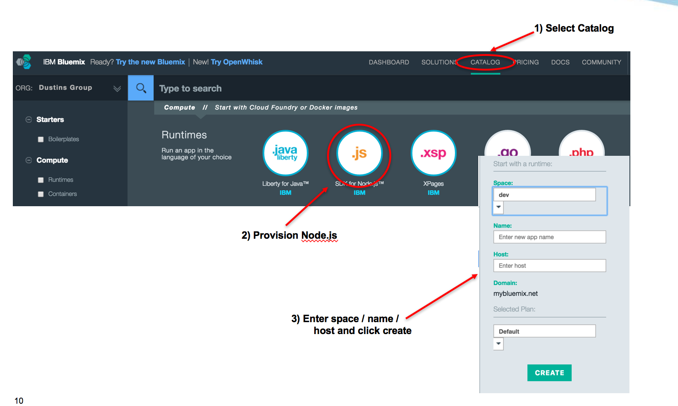

### Customize our Node.js app

While the service is being deployed, your screen will display the instructions for the next steps. You will need to install the following tools so that you can push your web application to Bluemix. Follow the instructions to install those 2 applications to your computer.



From here, we will deviate slightly from the directions in Step 1 of the getting started. Instead of downloading the starter app, you will use the app downloaded earlier from github.

Unzip the Node.js web application and move the directory to the desired location on your computer

tar –zxvf nodejs.tar.gz

mv nodejs/ <directoryOfYourChoice>

Next, we will follow the directions as laid out in the getting started guide for node.js in Bluemix. Here are the commands I typed to get my temporary node.js environment working….

bluemix api https://api.ng.bluemix.net

Invoke 'cf api https://api.ng.bluemix.net'...

Setting api endpoint to https://api.ng.bluemix.net...

OK

API endpoint: https://api.ng.bluemix.net (API version: 2.44.0)

User: vanstee@us.ibm.com

Org: vanstee@us.ibm.com

Space: dev

cd /tmp/nodejs/

# use cloud foundary to push my application to my Node.js

# instance name in bluemix (named temp-temp-temp)

cf push temp-temp-temp

Updating app temp-temp-temp in org Dustins Group / space dev as vanstee@us.ibm.com... cf push temp-temp-temp

OK

Uploading temp-temp-temp...

Uploading app files from: /private/tmp/nodejs

Uploading 4.8M, 1271 files

Done uploading

OK

Stopping app temp-temp-temp in org Dustins Group / space dev as vanstee@us.ibm.com...

OK

Starting app temp-temp-temp in org Dustins Group / space dev as vanstee@us.ibm.com...

-----> Downloaded app package (7.2M)

-----> Downloaded app buildpack cache (456K)

-----> IBM SDK for Node.js Buildpack v3.3-20160428-1409

Based on Cloud Foundry Node.js Bui

ldpack v1.5.4

-----> Creating runtime environment

### Test our Node.js app

Once the code push iscomplete, you have now deployed your web application ! You can test this by pointing your browser to your apps URL and you should see the screen below.

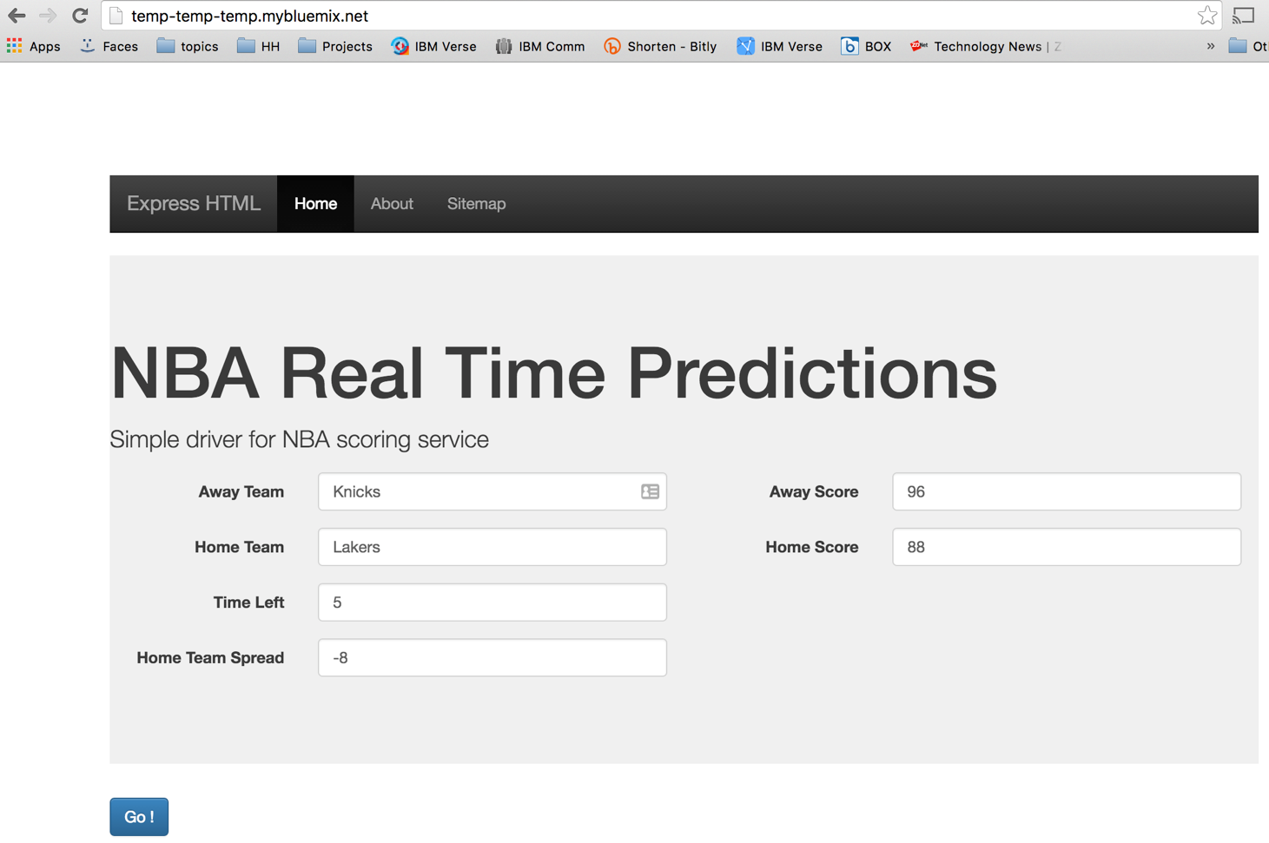

### Node.js app implementation details

When you point your browser to this URL, the node.js server that is listening at that URL responds with this webpage (coded with Bootstrap). You can enter some data into the cells and click ‘go’.

Once you click to, some javascript is run on the browser client to send a request to the node.js service to score this outcome based on the point spread, time left, and home/away score. Some JSON is returned from the node.js service and formatted in a simple tabular view. Here is a diagram the represents what is going on ‘under the hood’

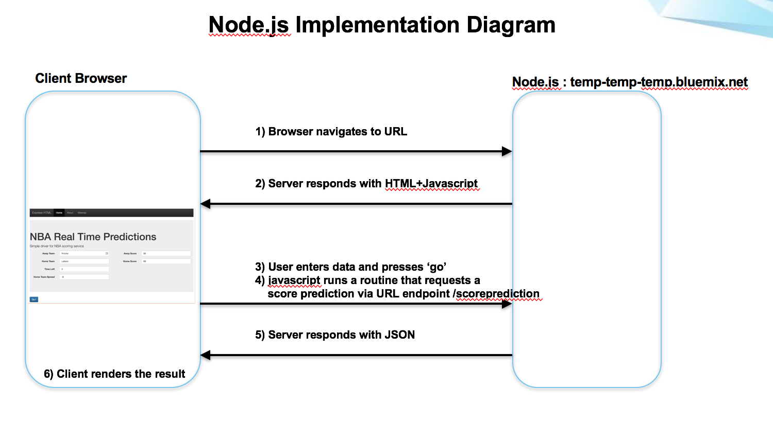

### Code layout

There are 3 main files that contain most of the custom code for this project

app.js : node.js file that uses express library to create a rest API

public/index.html : NBA real time prediction web page

public/rtp.js : javascript function that is invoked by clicking ‘go’

I will briefly cover the the app.js file. This file make use of a few libraries, with the main library being express. ExpressJs provides all the web server functions you need to make a web server without have to know all the details of the underlying framework. The custom part of the code is this code below. Here you can see that I have 2 endpoints under my base URL defined. When a browser navigates to the base URL + / , the main index.html page is return. If a user were to browse to the base URL + /scoreprediction/ , the scoreprediction service is run with 3 inputs that are passed as part of the URL. This code executes the logistic regression scoring model (more details on that in the next section), and returns an answer back to the client in JSON format.

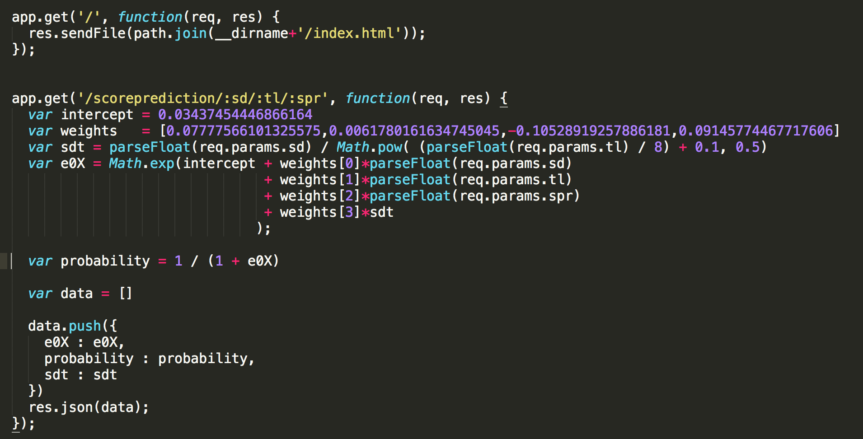

The webpage was built using a nice web framework called bootstrap. I like it because the formatting and look of the pages is very moderation and fairly easy to manipulate. I won’t go into the gory detail for the webpage and javascript, but will just highlight the one line of code that is activated when the ‘go’ button is pushed

<form class="form-horizontal container" role="form" onSubmit="return handleClick(this.homescorertp.value,this.awayscorertp.value,this.timeleftrtp.value,this.spreadrtp.value,this.homertp.value,this.awayrtp.value)">

What happens is that a handleClick function gets called with the values that are in the form of the webpage. This function is coded in the rtp.js. The rtp.js:handleClick function calls the /scoreprediction service on the server side and then waits (asynchronously) for the JSON data to be return. The result values are shown in the results table.

### Code Modification

There is one dependency that needs to get updated in the public/rtp.js file so that you can use your own score prediction service instead of the one I setup (I have a hardcoded URL in the code). To fix this modify this line of code to point to your web URL (this is the value you typed in for the name of your Node.js project when you created it in Bluemix).



Once you have done this, you can push this change to Bluemix by running this command in your node.js project directory.

cf push nba-rt-prediction

This will copy the entire project back up to Bluemix and redeploy your app. You can also run the app locally for debugging purposes if you type this

node app.js

This will setup the webserver locally on your laptop and you can point your browser to localhost:6001 for local debugging.

INFO: This completes the Bluemix Setup portion of the document

# How to ‘Operationalize’ Machine Learning Insights

So far, we have been able to reproduce the environment, but let’s have a deeper look at what is happening in this demo environment. In the Zeppelin workbook, we went through a number of data refinement steps to produce an input data set. We then took that input data set and split it into a training and test partition that we fed into the logistic regression modelling functions within Spark MLLIB. Simply stated, the logistic regression model returns a set of weights that transform the inputs into the predicted output. In our test we had just 4 ‘features’. Here is what the logistic regression output summary looks like in the zeppelin notebook.

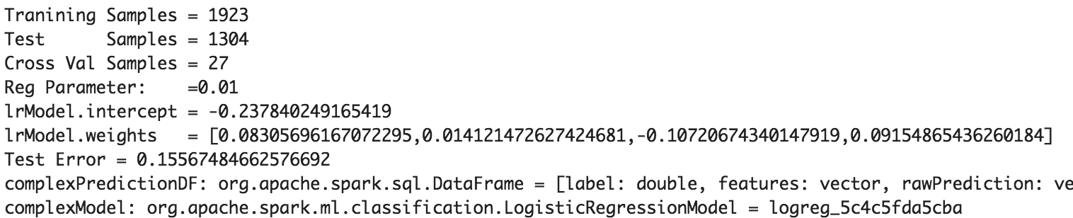

For the model, the important values to focus on are the intercept and the weights. For this specific example the weights will scale to the following input variables [score_difference, time_left, spread, custom_score_diff].

To implement simple logistic regression in our Node.js web application, we just need to know how to apply these weights to the logistic regression formula. We implement the formula using this equation

where

Explicitly in this example the inputs from the web form (X) are multiplied by the weights (theta) as follows

We then take the number apply the sigmoid function, and out comes a probability. The higher the number the more likely the home team will win. A value near 0.50 means that our model has no more predictive value than flipping a coin. The zeppelin notebook has some commentary about the weights, so I will omit the discussion here.

In practice, a pattern like this works well enough to get the job done when the number of inputs to the model are small, but for models that are more complex(neural nets, svm) or updated frequently this manual coding approach doesn’t work so well. We benefitted from the fact that the logistic equation can be coded in a few lines of code, but we should not always expect that to be the case. There are some other alternatives I will discuss in the next section ….

## Extensions to this demo …

Extensions to what has been shown here include methods to connect our Node.js framework directly to spark for execution of the scoring. Frameworks like EclairJS look very interesting from this perspective. For the next revision of this demo I plan try to implement something like that. Here is a brief list of some other improvements ….

Implement machine learning pipeline to select best hyper parameters for model

Experiment with linear regression to predict final score

Assess prediction sensitivity and margin of error (variance)