How to Build Skeleton Solutions:

Download Zip file and unpack (7z may need to be installed)

Then double click-on solution file.

And then build the solution.

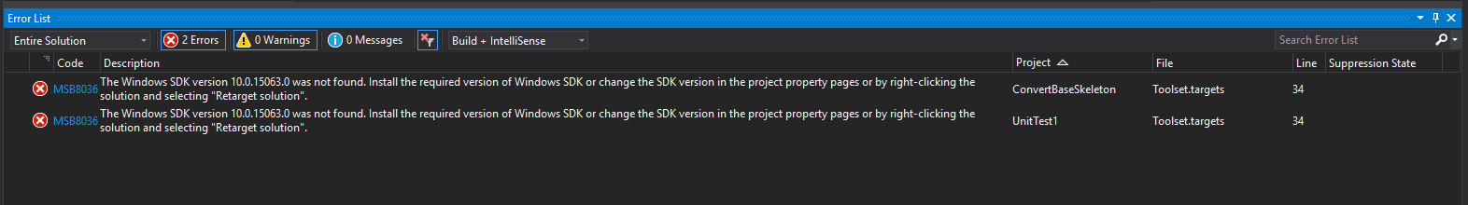

If you see the above error, you need to modify the SDK target. This is easy to do.

RMB on Project and pick Properties. This should bring you to this tab, if not go this tab.

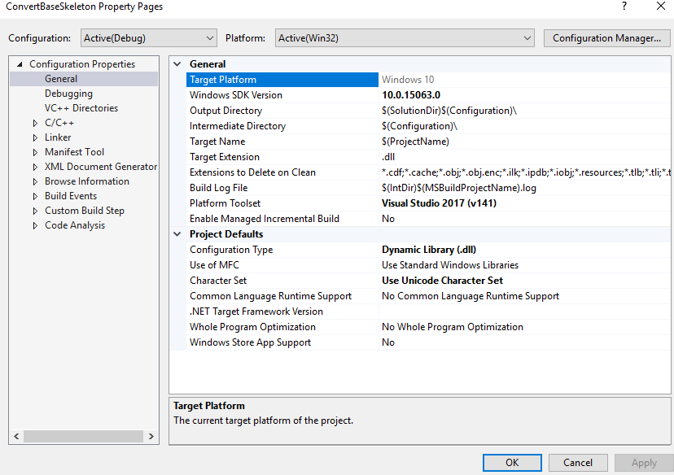

The field that needs to be modified is the Windows SDK Version, Click on SDK box.

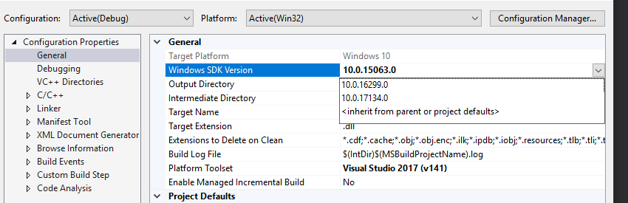

And select a value that is in the list (typically the largest one 😊).

You will need to do this to each project in the solution (typically the application dll, unit test dll, and exe (if present)).

Then build again. This time you should see at least (but maybe two) errors about opening up header files. We need to modify the project to reference a directory for header files. For the Unit Test and\or Exe project, RMB properties.

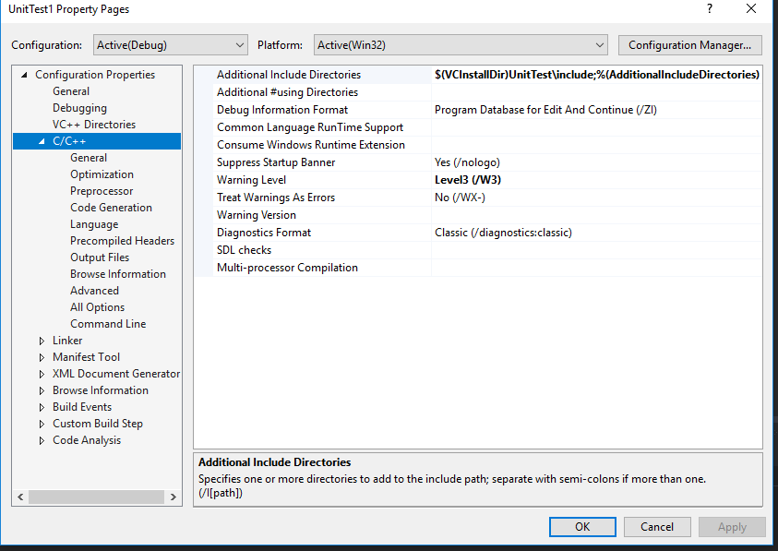

Click in the box, and click on the downward carrot, and the pick the edit from that pulldown.

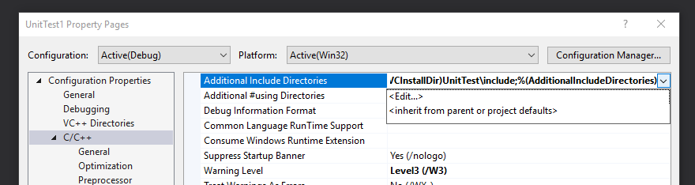

This will bring up this dialog. Click on the new button.

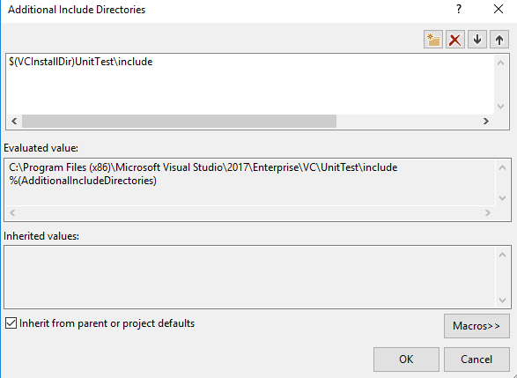

Click on the “…” which will bring up a browser. Go up one directory. Then click on the directory where the application directory (i.e. ConvertBaseSkeleton). Then select the Select Directory button. Then hit OK, and OK one more time. Then Build. Then you should be able to run the tests from the test explorer. Or using the Test pulldown.