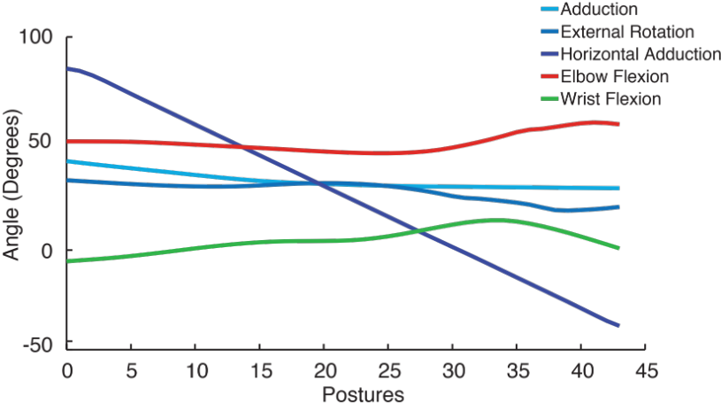
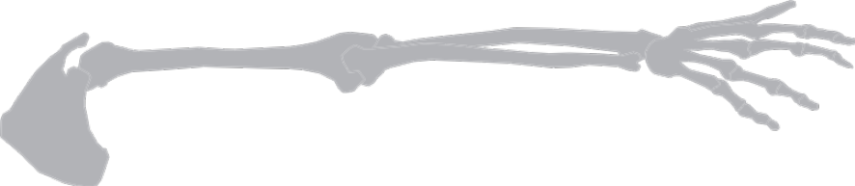
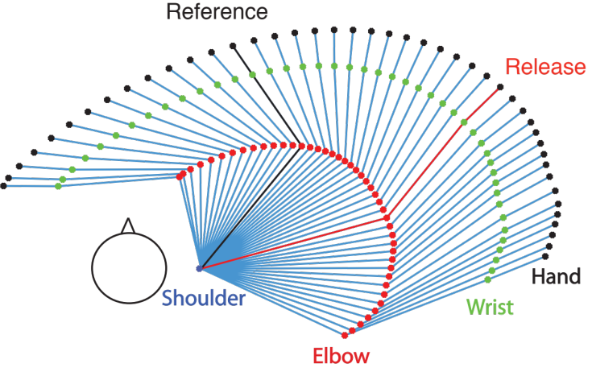
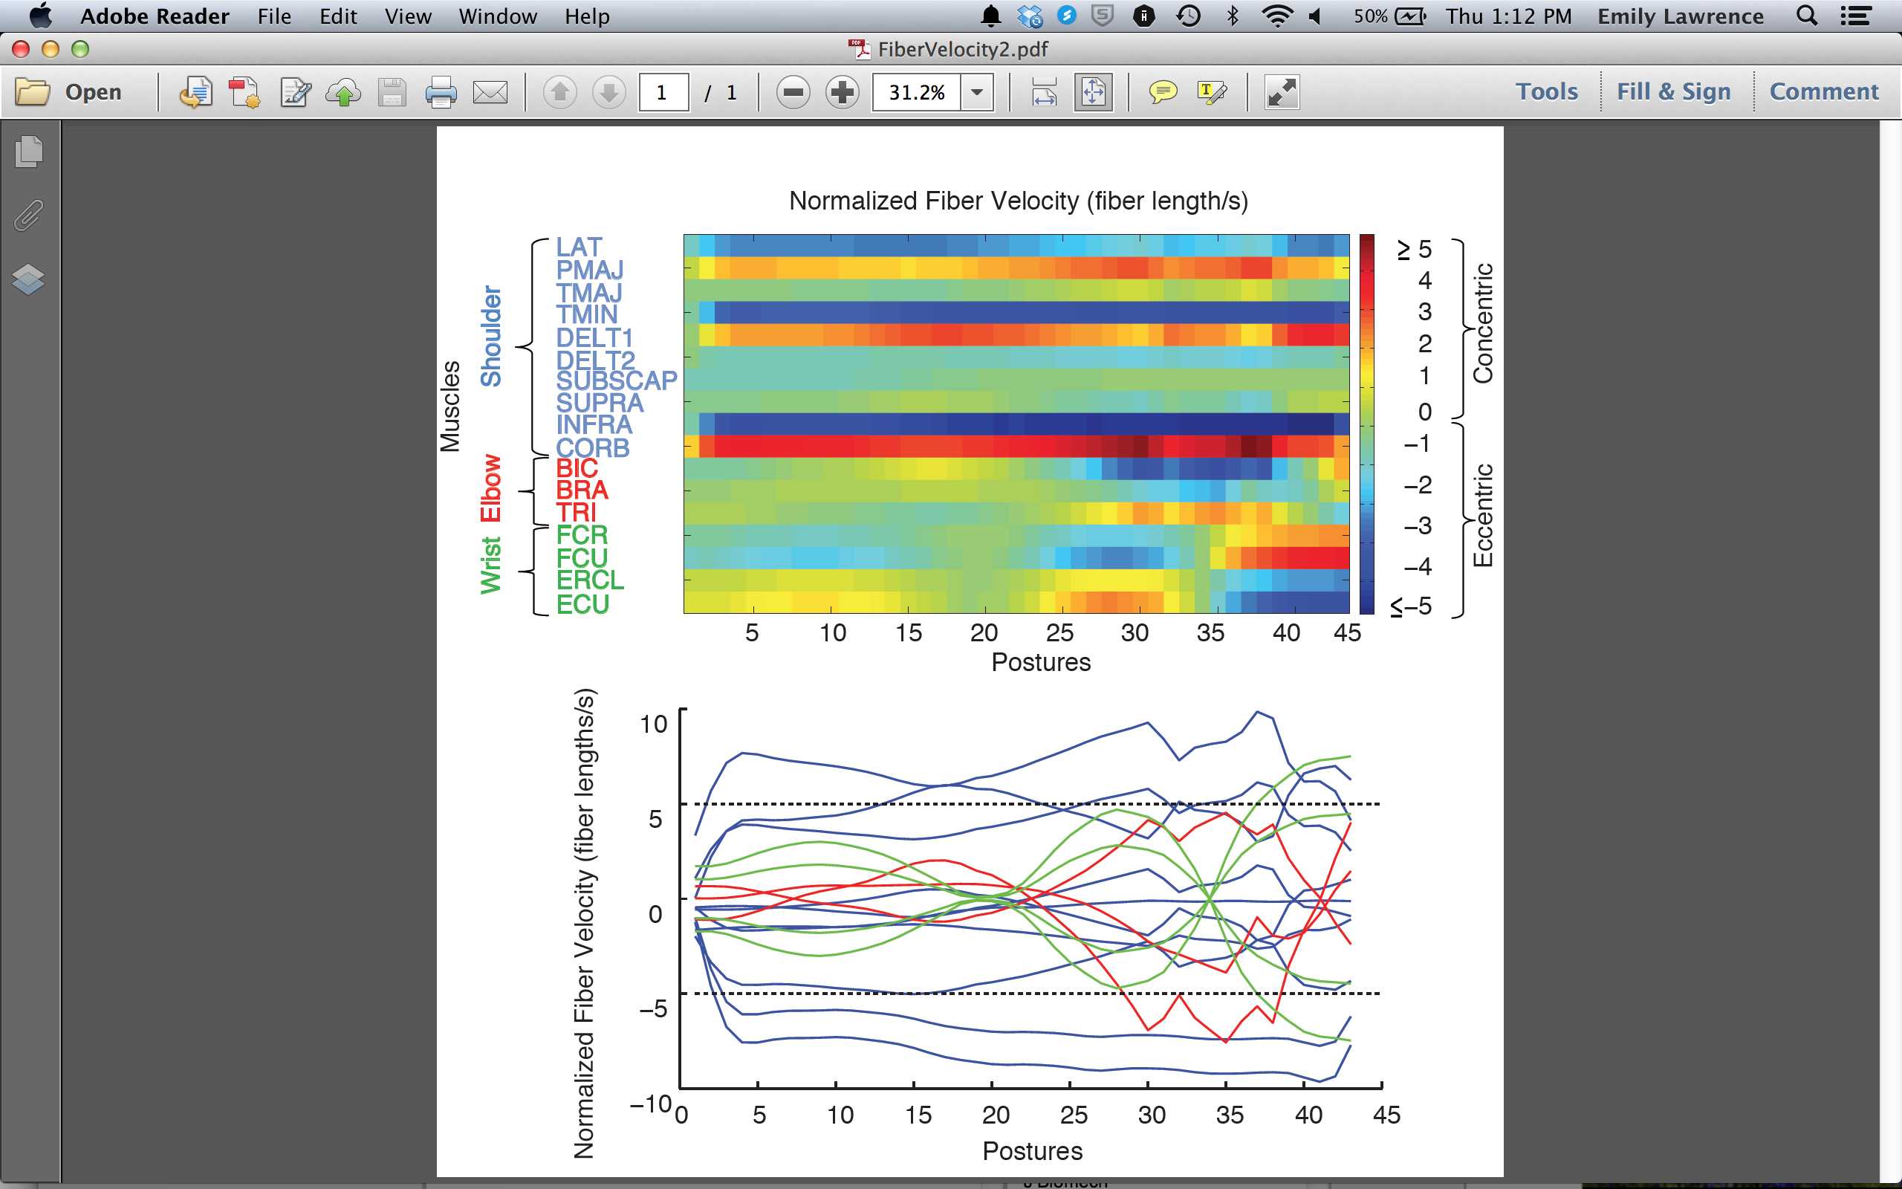
TITLE
*F. J. Valero-Cuevas ^{1, 2}, B.A. Cohn³, H. F. Ingvason⁴, E. L. Lawrence¹
¹Department of Biomedical Engineering, University of Southern California,, Los Angeles, CA, USA.
²Division of Biokinesiology and Physical Therapy, University of Southern California, Los Angeles, CA, USA.
³XXXX, CA, USA
⁴Eidgenössische Technische Hochschule Zürich, Zürich, Switzerland

* Correspondence:
Francisco J. Valero-Cuevas
Brain-Body Dynamics Laboratory
Department of Biomedical Engineering
Division of Biokinesiology and Physical Therapy
University of Southern California
3710 McClintock Ave., Ste. 404
Los Angeles, CA, 90089, USA
valero@usc.edu

To be submitted as an Original Article to Journal of Biomechanics (3500 words max)

Abstract (250 words max):
[[needs work….add something about human and cat models…different approaches??]] Models predicting force capabilities of a tendon driven system can either be generalized to a species, or modeled on an individual basis; however, without quantitative comparison techniques of the feasible force space (and the muscles generating them), we can’t designate specific directions where population models are more appropriate. These spaces are typically visualized with a convex shape representing the feasible force volume, but aren’t easy to compare. We innovated a spherical ‘vector map’ visualization of feasible force space, as well as a map for the muscle activation solution space. The ‘vector map’ is generated by calculating the maximum feasible force for predetermined directions (using linear programming), and highlighting force magnitude as a heatmap on a spherical surface. For each direction, we recorded the maximum feasible force magnitude (in Newtons) and the activations (from 0 to 1, for each muscle) that would generate the vector’s maximal length. We validated our approach by comparing and contrasting feasible forces and activations in models of 3 cat hindlimbs, each comprised of 31 muscles and 6 degrees of freedom. Vectormaps of muscle activation across the feasible force space show that areas just outside of the maximal activation regions have more interspecimen variation. To date, we have generated the first force-space species average, and developed a novel way to highlight differences in the muscle activation solution space across specimens- highlighting areas of the solution space which are more prone to being individualized.
Experimental EMG and 3D force sensor data may be visualized and compared with vectormaps, which could generate spatially accurate datasets for model fitting.

Keywords:

Introduction:

---------------
Note to Francisco:
Here's the organization of the cat section:

Visualizations of muscle role and force capability across three feline hindlimbs
After discussing both traditional feasible force spaces and explaining our novel vectormap transformation, we organize our results as follows:
First, we explore comparisons of feasible force spaces with a vectormap transformation, and use a standard deviation plot to assess areas (in output space) where there may be higher variation.
Second, we investigate the regions of output space where each muscle is highly activated, and highlight regions where this activation varies across specimens.
Third, we present muscle antagonists side by side to show the roles of each muscle.

---------------

Methods:
Animal Model:

In order to pinpoint regions of output space which are affected by individual variation, we present a new way to visualize how limbs produce static forces. To our knowledge, feasible output forces have never been combined into an average across multiple individuals, because there exist few mathematical operations to combine or compare feasible force spaces. Instead, feasible wrench sets have been compared in terms of their relative volume, sphereness, and diameter. There is a need to analyze output force, while preserving the dimensionality of both the muscle activations required to generate torques, and the forces themselves. We look to illustrate different regions of force output space which may have higher and lower variation across specimens, by preserving the high-dimensionality . We used the model originally presented by McKay and Ting, 2008, and modified by Sohn et al. 2013. The data are comprised of three feline hindlimbs, each with 31 muscles articulating 7 degrees of freedom (DOF) from the hip to the ankle. To bring context to feasible force and muscle activation plots, we illustrate the moment arm lengths (averaged across three cats) for each muscle across each joint (Figure [R matrix]). This figure also illustrates the axes with respect to the endpoint.

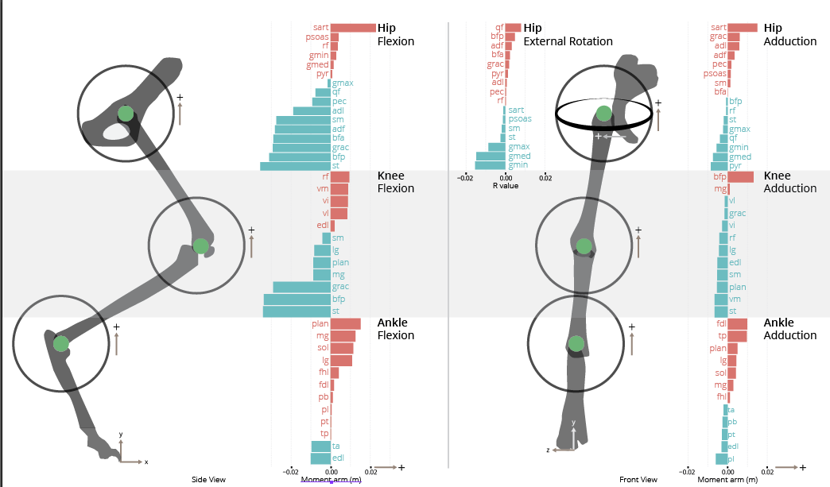
Figure [momentarm]. Visualization of the moment arm matrix (species average), illustrating the effect of each muscle across 7 degrees of freedom (in cm). FIGURE PLACEHOLDER.

Defining the feasible wrench space
A ‘feasible wrench set’ describes all of the combinations of force and torques a limb’s endpoint could attain in a static position, and is typically visualized with a 2D or 3D object surrounding the end effector- this shape is called a zonotope (Figure [zonotope imaging]). Each muscle in output space has a different wrench vector at the endpoint. Keeping the limb posture static, we develop a Minkowski sum of all vectors, thereby creating a ‘zonotope’, which represents the feasible force space. The zonotope is a set of vertices in [x y z t_x, t_y, t_z] space, and has been referred to in the literature as a ‘convex polytope’ or a ‘convex hull’. While a zonotope viewed in 2D or 3D offers a general view of the regions of high force output , it is difficult for a reader to use it quantitatively for comparisons outside the plane of the page.
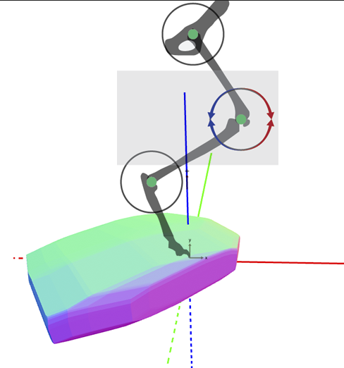
Figure [zonotope imaging]. A 3-dimensional feasible force set zonotope (topleft) and the feasible torque magnitude zonotope (topright) for one of the three cats. The feasible force set aligned with the axes of the leg (bottom). Shading and coloring does not represent any value.

Vector mapping the feasible force-space
Our new method to analyze (and visualize) force zonotopes, by using a radial projection transformation, is called ‘vector mapping’. A vectormap is used for combining zonotope wrenches and muscle activation patterns into one standardized spherical data format, is generated by computing the magnitude of force vectors in preset directions. We chose 200,000 random directions (unit n-sphere of radius 1), and refer to these direction vectors as ‘task vectors’ or ‘tasks’.
[x y z]
<placeholder for Hordur’s more complicated math symbols, and description of the linear programming opimization in reference to Sohn et. al.>
After recording the maximum feasible force magnitudes for each task, we compute the unique activation vector required to reach the maximum force. We arrive at a vectormap matrix VM: for each task (row), the columns describe task coordinates (x,y,z), a force vector magnitude (in Newtons), and activations a (from 0 to 1) for 31 muscles.
Intraspecies comparisons of force and activation
To identify regions of higher output force variability among specimens, and visualize muscle activation across the realm of feasible maximum forces, we combined vectormap matrices generated from three feline hindlimbs (VM_mean), and generated a separate standard deviation matrix (VM_std). We visualized feasible force and activation vectormaps with a spherical scatter plot, where point color set according to force magnitude. We also made plots of force and activation standard deviation.

Human Model:
Understanding performance of high-speed athletic movement is one goal of musculoskeletal modeling. Therefore, we created a model to predict instantaneous muscle fiber velocity during one specific athletic activity—a disc golf backhand throw. A simplified 5-degree of freedom (DOF) 17-muscle arm model of the right arm was created in MATLAB (The Mathworks, Natick MA) consisting of 3 links (upper arm, lower arm, and hand/disc) with lengths of 0.35m, 0.27m, and 0.11m, respectively, and three joints (shoulder, elbow, and wrist) [1]. The three DOF’s at the shoulder included internal/external rotation, abduction/adduction, and horizontal abduction/adduction and the DOF’s at both the elbow and wrist were flexion/extension. The joint angles from each DOF during the entire throw were obtained from the literature and are illustrated in Figure 1 [1].
Figure 1. Angles for all 5 DOF’s used in the model [1].
The parameters of the 17 muscles included in this model, optimal fiber lengths, moment arms, and pennation angles, were obtained from [2-5] and the moment arm matrix for this model is illustrated in Figure 2.

Figure 2. Moment Arms Figure [[needs work…add script from Brian]]
Next, the wind-up, release, and follow-through motions of the throw were broken down into 45 unique postures, which are illustrated in Figure 3. Finally, after completion of the nominal model, separate Monte Carlo analyses to consider a range of optimal length and moment arm values ±50% of the estimates.
Monte Carlo analyses use repeated random sampling to obtain numerical results; typically one runs simulations many times over in order to obtain the distribution of an unknown probabilistic entity

Monte Carlo analyses were applied to evaluate a range of moment arm and optimal length values to determine the importance of parameter values in the model. Despite considering a range of parameters, there were still some muscles that produced no force at times during the throw. This raises the important issue that if muscles are modeled as producing no force even when considering a large range of input parameter values perhaps there is something inherently wrong with the structure, for example, the F-L and F-V adjustments of the model.
Figure 3. Three-dimensional plot of geometric model. This figure illustrates the initiation of forward motion through follow-through of the throw. The reference posture is shown in black and the release point in the throw is shown in red.

Results:

Animal Model:

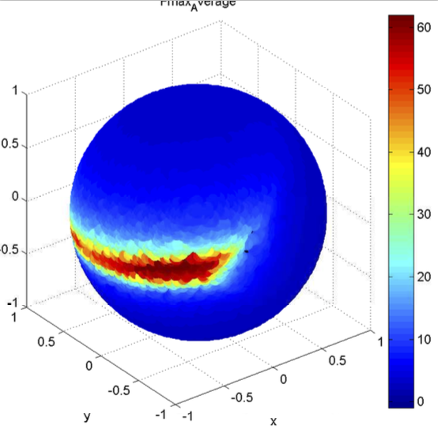
Figure [vectormap fmax_av]. A vectormap of the maximal feasible force across all sampled output vectors in three feline hindlimbs. (Force in Netwons represented by color gradient)

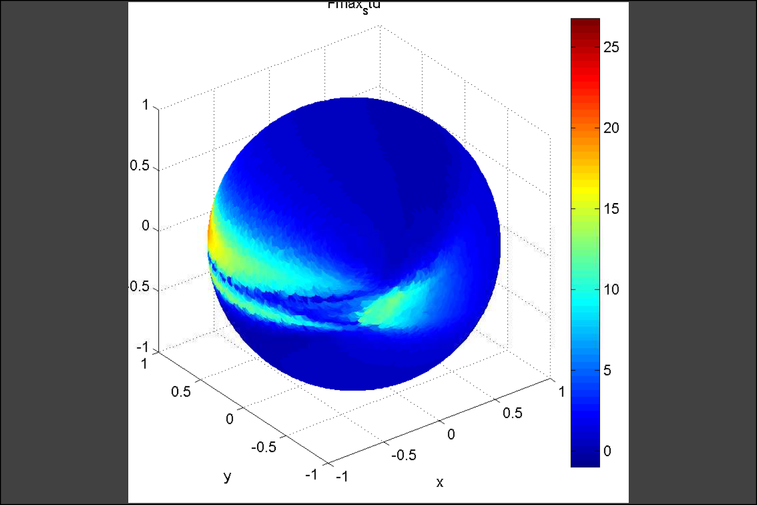Figure [vectormap fval std]. A vectormap displaying regions of the feasible force space which have higher standard deviation across three cat hindlimbs. Force in Newtons represented by color scale).

Human Model:
Starting from objective measurements of limb kinematics [1] and using reasonable estimates of muscle length and moment arms obtained from the literature, we predicted the instantaneous normalized fiber velocity throughout the throw (Fig. 1). Negative and positive values correspond to eccentric and concentric contractions, respectively. Velocities greater than ±5 fiber lengths/sec are considered to either exceed the limits for force production for concentric contractions, or be prone to injury due to eccentric contractions. Even after an extensive exploration of parameter values with Monte Carlo analyses, we find that measured kinematics invariably correspond to excessive muscle velocities (deep red or deep blue colors).
Given that these robust results come from objective kinematic measurements and skeletal geometry, they challenge the applicability of the Force-Velocity (F-V) as we know it to high-speed athletic movements. There are reports that strength and speed training can result in shifts or alterations in the F-V curve, implying it is likely that the F-V curve varies among muscles (and individuals), and that a generic F-V curve should not be used to simulate these tasks. Furthermore, we underscore (i) the need for time-critical neural inhibitory mechanisms to allow rapid lengthening and prevent injury during high-speed eccentric contractions, and (ii) the likelihood that muscles are used passively as visco-elastic elements when active sarcomere function is not possible or sufficient. Future work is needed to adapt or revise our understanding of muscle mechanics for high-speed athletic movements.
This raised concerns about the force adjustment calculations. Monte Carlo analyses were used to consider ±20% of the optimal muscle lengths, moment arms, and pennation angles obtained from literature [2-5]. While more muscles were predicted to produce force during the throw, the results were similar to the nominal model. Once the analyses were expanded to consider ±50%, all muscles were shown to produce force during the majority of the throw; however, many of these values were biologically unfeasible.
despite considering a range of muscle parameters. If the model parameters do not significantly affect the force adjustment as indicated by the Monte Carlo analyses, then the F-L and F-V curves should be investigated. It has been reported that strength and speed training can result in shifts or alterations in the F-V curve [7]. This implies that it is possible, and likely, that the F-V and F-L curves vary between muscles (and individuals) and absolute curves, such as the ones used in this model, lack the ability to provide accurate estimates of force production capabilities in all muscles. This complements the results from [8], where it is reported that the F-V curve may not be the limiting factor to force production. These studies indicate a need for further investigation into the influence of length and velocity on the force production capabilities of muscles. While these properties undoubtedly influence force production, the amount to which they do seems to be unclear.
Figure X. Normalized instantaneous fiber velocities for all modeled muscles during the backhand throw. Top: The muscles are listed on the y-axis and the 45 postures making up the throw are shown on the x-axis. Excessive muscle velocities are shown in red (shortening) and blue (lengthening). Bottom: The same data are illustrated with individual traces for each muscle that show the fiber velocity. Muscles controlling the shoulder, elbow, and wrist are illustrated in blue, red, and green, respectively. Instantaneous fiber velocity is given on the y-axis and the postures during the throw are on the x-axis. Regions of the traces outside of the dashed lines indicate excessive muscle velocities.

Discussion:

References:

1. Hummel, S.A., Frisbee flight simulation and throw biomechanics, in Mechanical Engineering. 2003, UNIVERSITY OF CALIFORNIA-DAVIS.
2. Garner, B.A. and M.G. Pandy, Estimation of musculotendon properties in the human upper limb. Ann Biomed Eng, 2003. 31(2): p. 207-20.
3. Gonzalez, R.V., T.S. Buchanan, and S.L. Delp, How muscle architecture and moment arms affect wrist flexion-extension moments. J Biomech, 1997. 30(7): p. 705-12.
4. Holzbaur, K.R., W.M. Murray, and S.L. Delp, A model of the upper extremity for simulating musculoskeletal surgery and analyzing neuromuscular control. Ann Biomed Eng, 2005. 33(6): p. 829-40.
5. Murray, W.M., T.S. Buchanan, and S.L. Delp, Scaling of peak moment arms of elbow muscles with upper extremity bone dimensions. J Biomech, 2002. 35(1): p. 19-26.

