FALLARM Project Report v0.1

Capstone Project’s Report
In partial fulfillment for the degree of
Master of Science in Computer Science

By
Burhan COKCA (10809)
Sheela JEEVAN (10450)
Abuzer DOGAN (11880)
Venkat Raghavvarma (11514)
Ashish Raymonds (11196)

Prepared under the guidance of Dr. Henry Chang

School of Engineering
Northwestern Polytechnic University
47671 Westinghouse Dr., Fremont, CA 94539

February 2015

Revision History
Date | Version | Description | Author
2-14-2015 | 0.1 | Document created, added abstract, introduction and prepared the structure. Use case class and sequence diagram added. | Burhan COKCA

Acknowledgments
TBC(To be completed)
Abstract
The United Nations predicts that by the year 2050, 22% of the global population will be aged 60 years or over, from current 11.2% (2011). This ageing population has brought about multiple challenges and opportunities to the healthcare industry. One of these challenges is fall and injury prevention of the aged in hospitals, care facilities, as well as home settings. The Fallarm project is to develop a technology which can prevent and detect accidental falls, keep the person informed about the risks while they are moving around, and also inform the hospital care team, or the family members in case of an event. A wristband to be worn in the wrist will provide the inputs to the system. The sensors in this band will monitor and record the movement and activities of the person, while keeping the person informed of his risk status at all times. The sensors will also detect a fall and report it to the care team so that appropriate action can be taken to minimize the impacts of the fall. The system will continuously update itself based on the data from the sensor and will maintain a risk profile, mobility patterns, adverse events record of its users. This historical data in turn will be provided to the sensors to more accurately identify and prevent a fall. The idea is to enable elderly people to lead an independent life, with the risk of fall being tracked round the clock.

CONTENTS
Section Page
Acknowledgments ii
Abstract iii
1.0 INTRODUCTION 1
1.1 The Concept 1
1.2 Background 1
1.3 Objectives 2
1.4 Environment 2
2.0 Design 2
2.1 Introduction 3
2.2 Use Case Diagram 3
2.3 Activity Diagram 3
2.3 Class Diagram 3
2.4 Sequence Diagram 4
3.0 Implementation Details 3
3.1 Introduction 3
3.2 Internet programming – NodeJS 3
3.3 Database – MySQL 3
3.4 Network Programming – Java 3
4.0 Test Result 3
4.1 Introduction 3
4.2 Test Result Summary 3
7.0 Future Enhancements 3
8.0 Conclusion 4
Bibliography 5
Appendix A 6
Appendix B 6

ILLUSTRATIONS
Figure Page
Figure 2 Whole system hierarchy view Error! Bookmark not defined.

1.0 INTRODUCTION

1.1 The Concept
Fallarm project involves capturing mobility patterns of a person so as to help prevent and detect falls. For this project, we assume that the device will be used within the hospital environment and the hospital staff will use the software to monitor the patients. The hardware development part involves preparing the wristband which will have the sensors, and will not be in the scope of this project. This project focuses on the software part, which in turn can be broadly categorized into three areas:
- Internet programming – to develop a client-server model where the sensor will directly communicate with the server to provide the device data and the client interface will be used by the hospital staff to view, track patient’s information, and process the data.
- Network programming – socket programming to enable communication between the client and the server.
- Database – to hold the data related to the system at the server. This will include information about the user profile of the clients, the information received from the device.

1.2 Background
Fallarm project was initiated by QIRIS (Quality Innovation Research Instruction Safety), a non-profit organization specializing in developing innovative technology committed to social interests. They developed Fallarm, a wearable fall prevention device especially suitable for the elderly and for hospitalized patients. Fallarm has been endorsed by several hospitals and risk management organizations.
This project has been adapted as a Capstone Project for the course. This project will be researched, designed and developed, to be submitted towards fulfillment of the degree requirements.

1.3 Objectives
To develop the software part of the Fallarm project, which could be then integrated with the device being developed by the electrical engineering team.

1.4 Environment
1. Physical hardware specific specification:
CPU: AMD E-350 Processor 1.6 GHz
Memory: 4 GB
Video Card: ATI X2300
2. Host operating system platform:
Windows 7 Professional, 64-bit
3. Virtual Machine:
VMware ServerVersion 2.0.2Build 203138
This software was acquired from http://www.vmware.com.
4. Workshop platform operating system:
CentOS 6.0
CentOS-6.0-x86_64-LiveCD.iso
This iso file was acquired from http://mirrors.usc.edu/pub/linux/distributions/centos/6.0/

2.0 Design

2.1 Introduction

2.2 Use Case Diagram

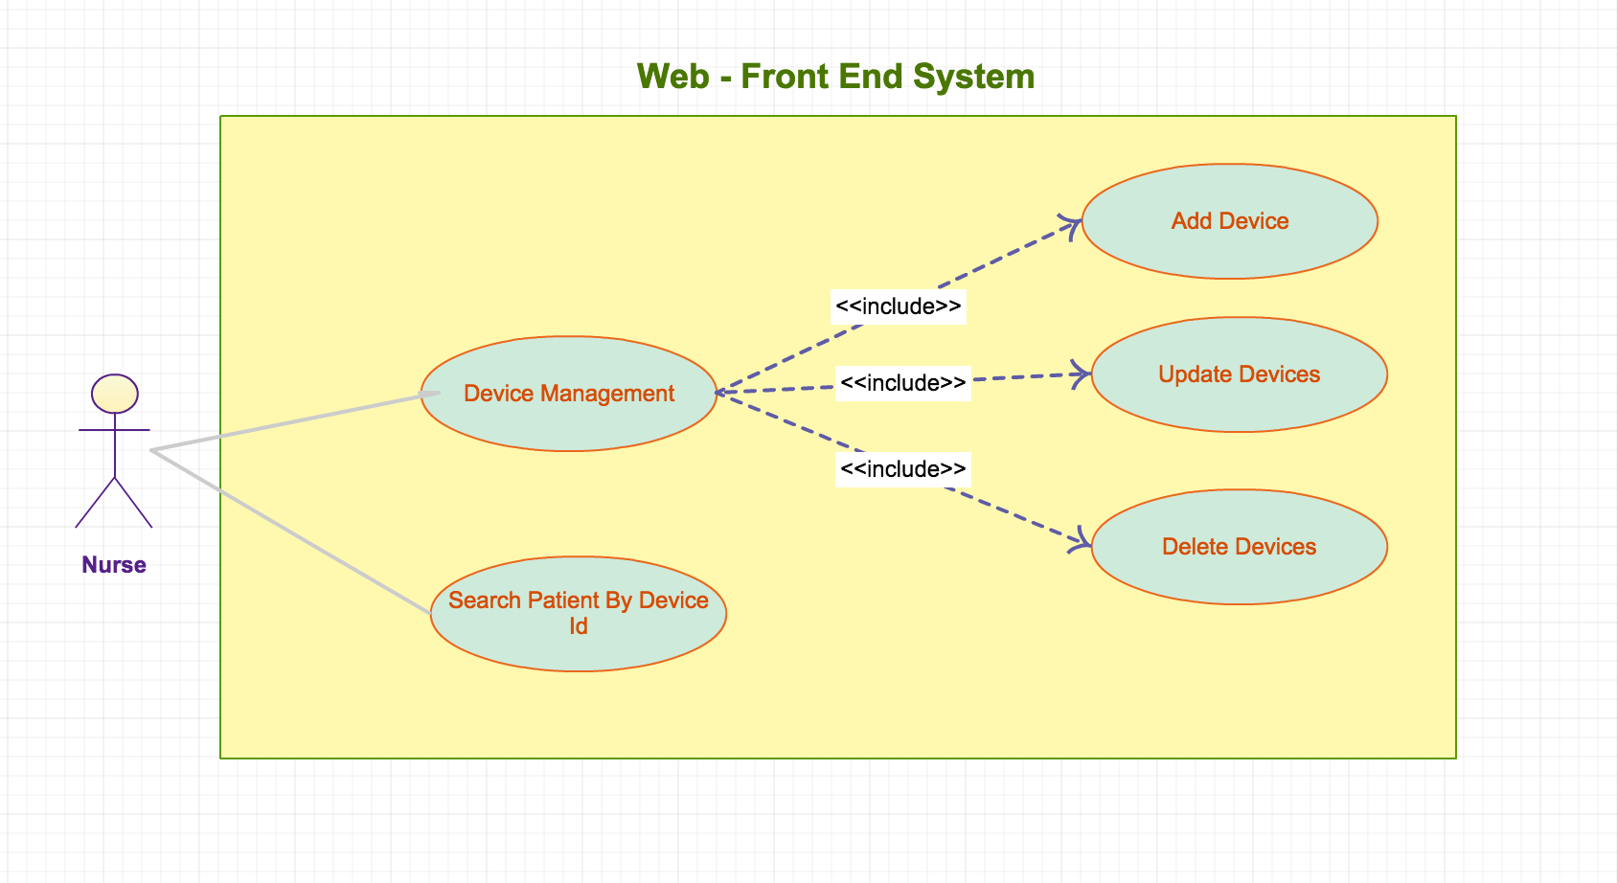
Figure 2.2.1 Web-Front End System
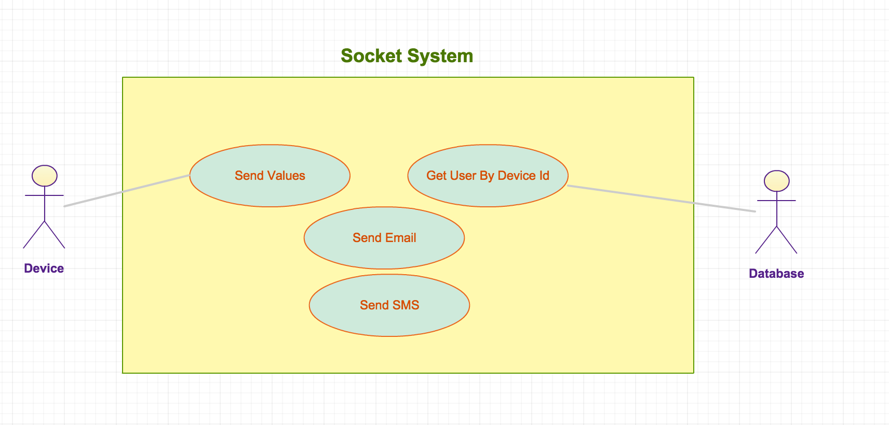
Figure 2.2.2 Socket System Use Case Diagram

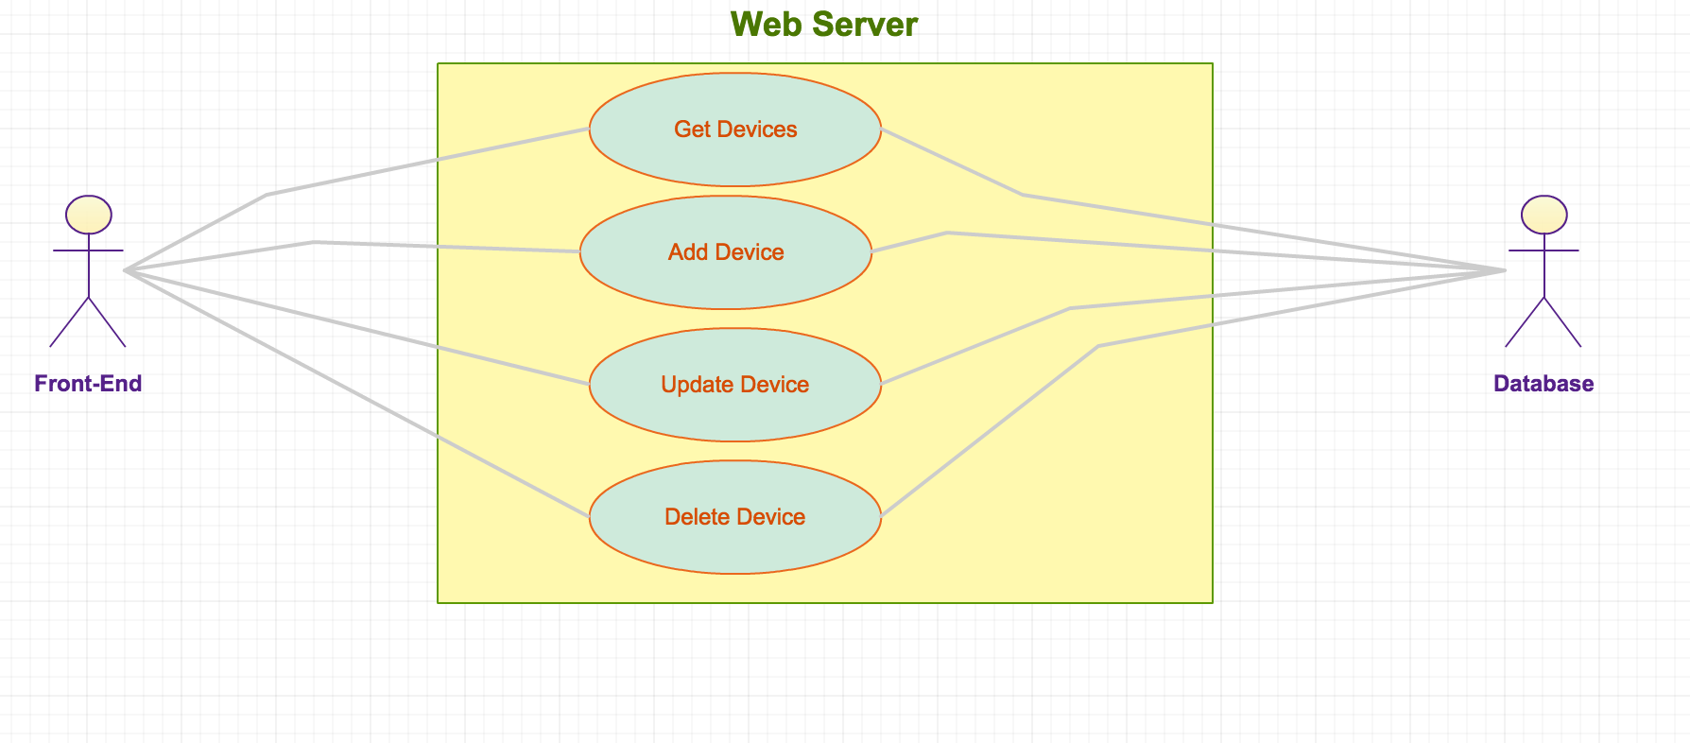
Figure 2.2.3 Web Server Use Case Diagram

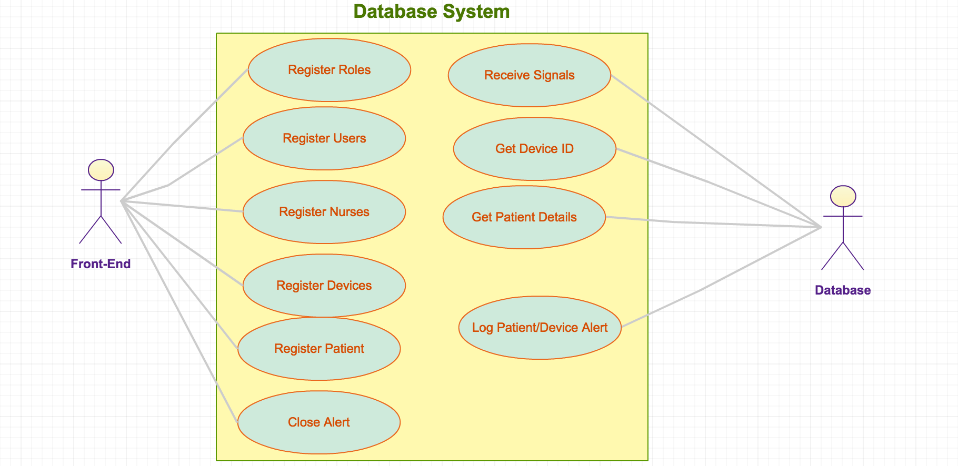
Figure 2.2.4 Database System Use Case Diagram

2.3 Class Diagram

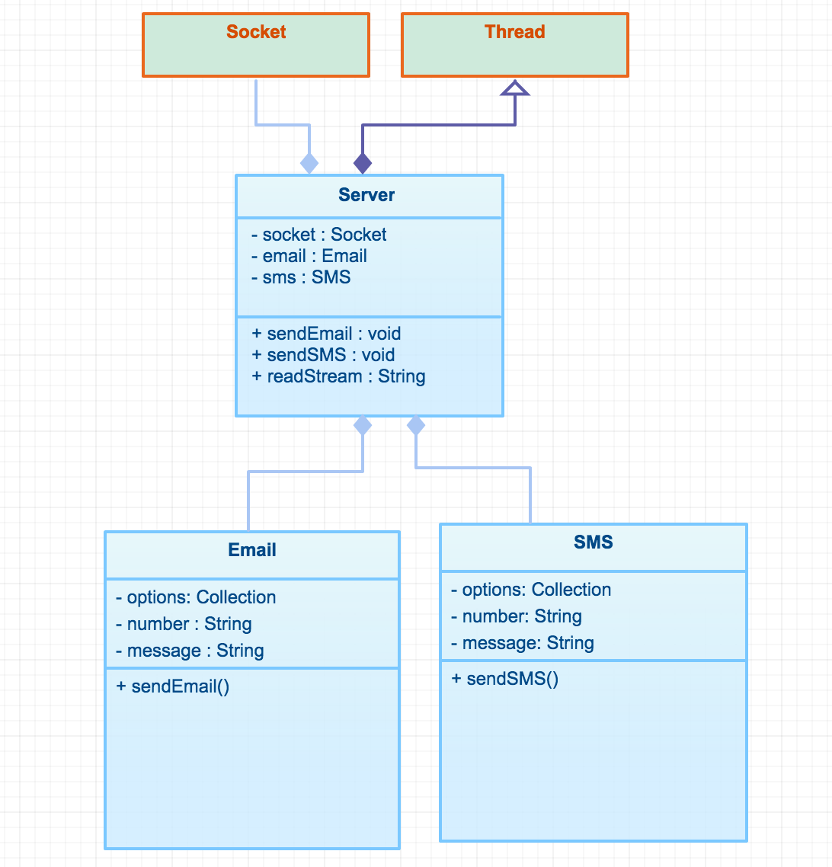
Figure 2.3.1 Socket Server Class Diagram

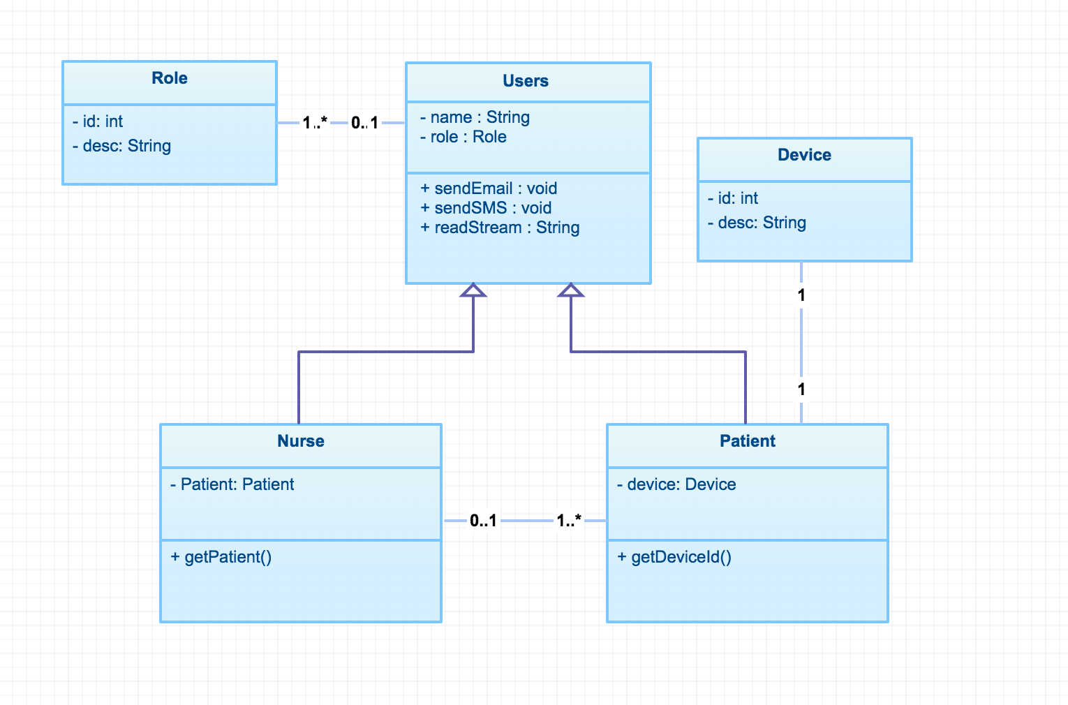
Figure 2.3.2 Web Server Class Diagram
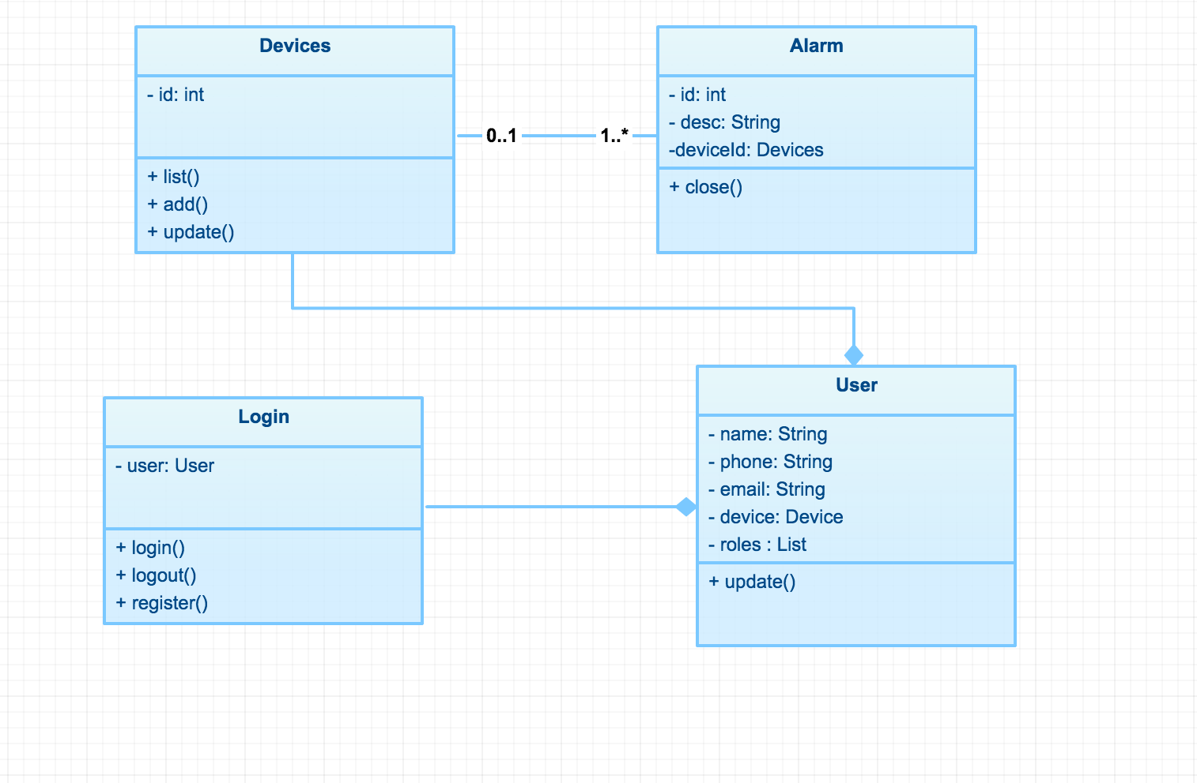
Figure 2.3.3 Web Client Class Diagram

2.4 Sequence Diagram
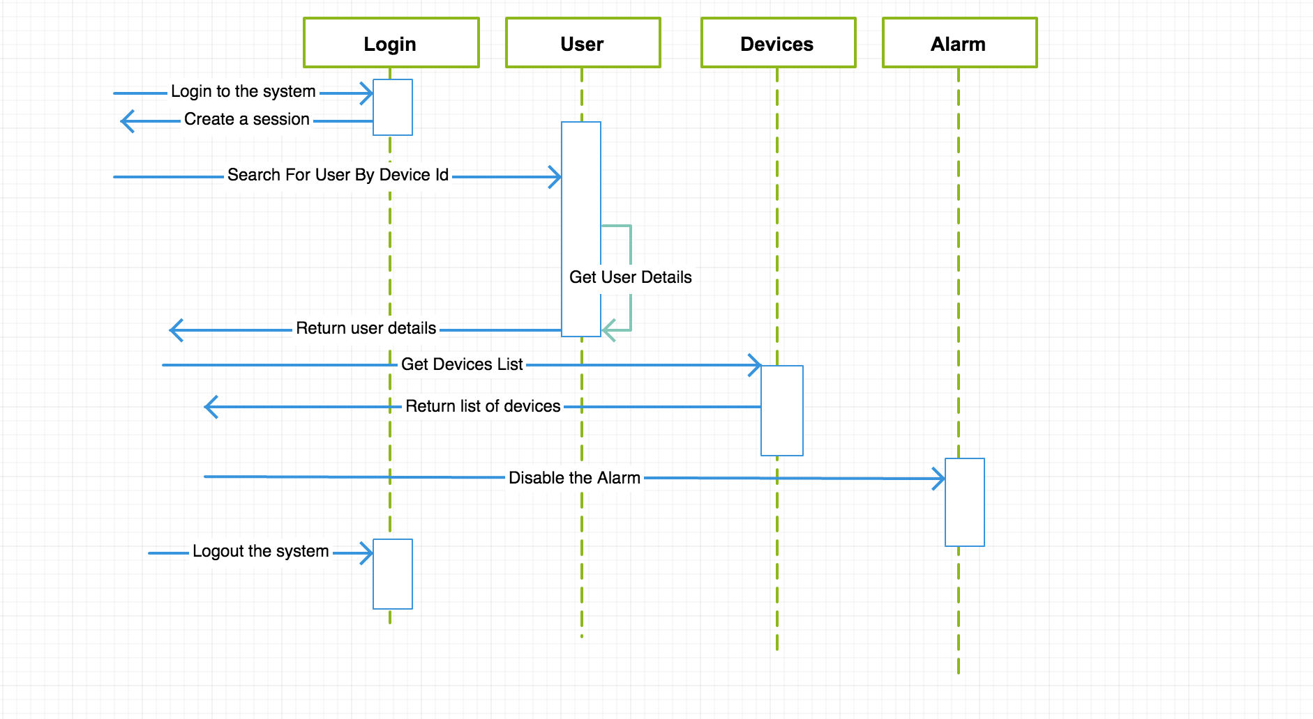
Figure 2.4.1 Web Client Sequence Diagram

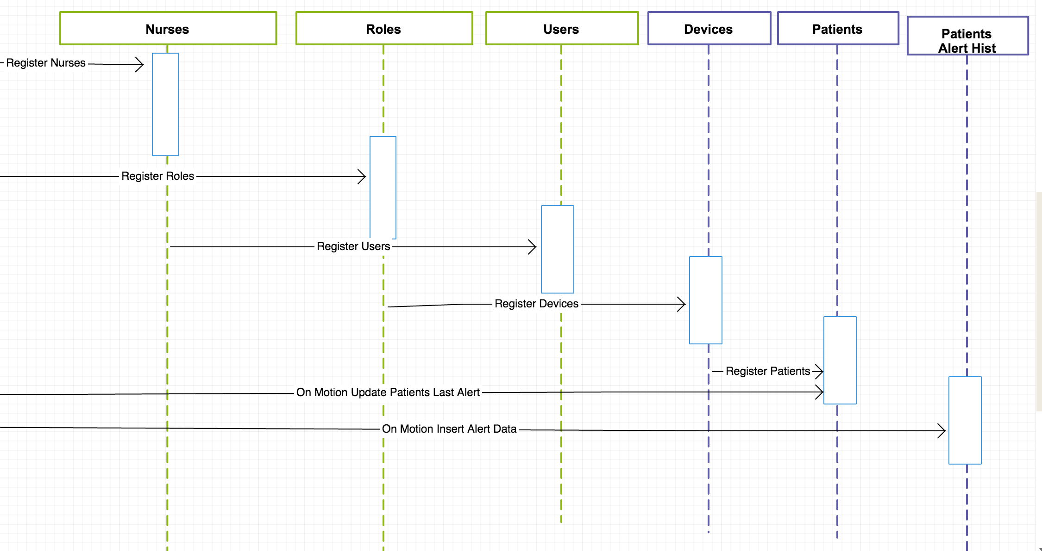
Figure 2.4.2 Database Sequence Diagram
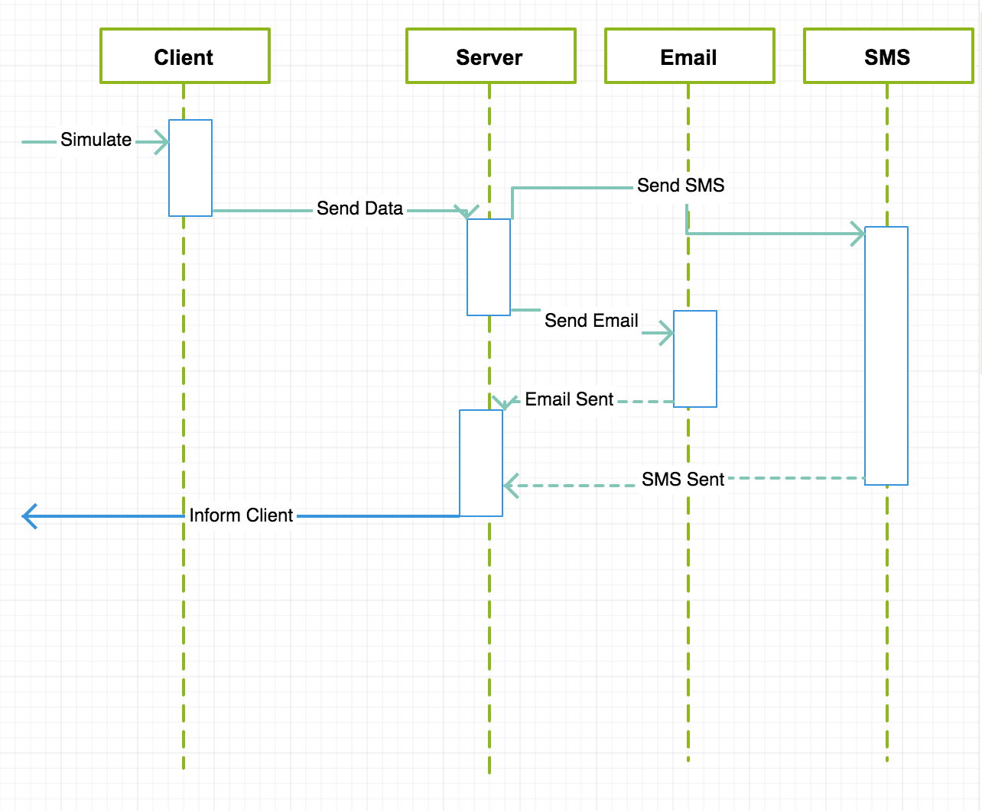
Figure 2.4.3 Socket Server Sequence Diagram

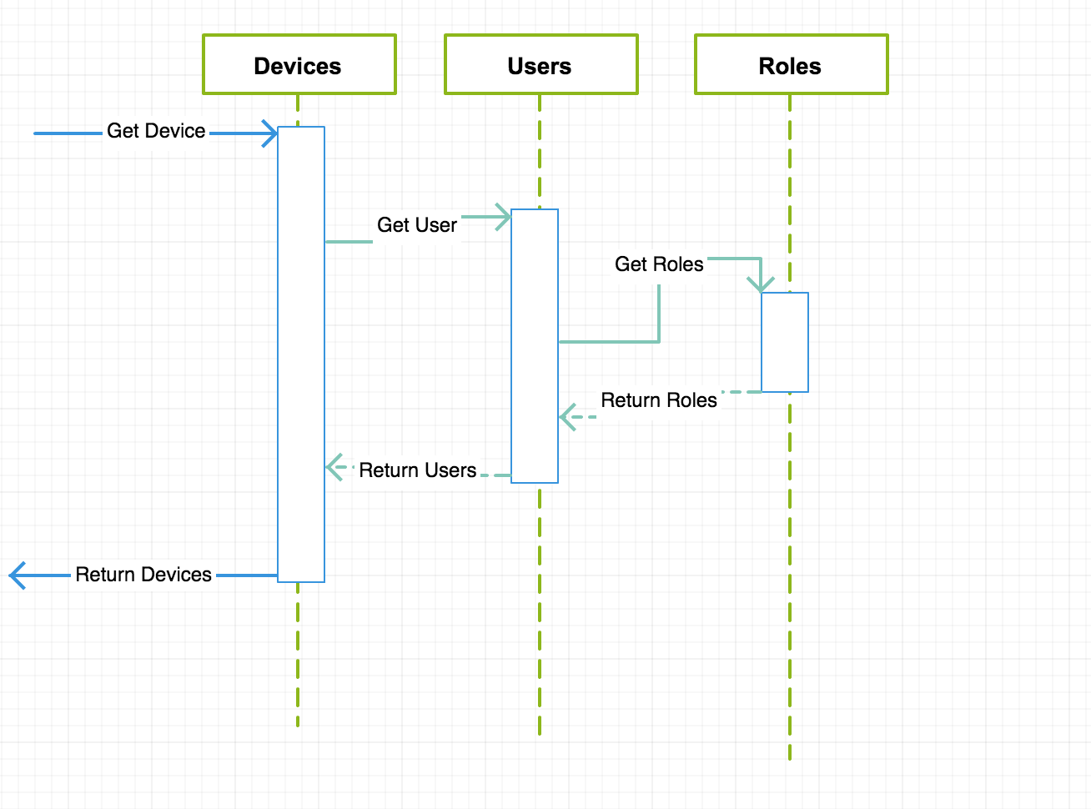
Figure 2.4.3 Web Server Sequence Diagram

2.5 Activity Diagram

2.6 Component Diagram

3.0 Implementation Details

3.1 Introduction

3.2 Environment Setup

3.3 Internet programming – NodeJS

3.4 Database – MySQL

3.5 Network Programming – Java

4.0 Test Result

4.1 Introduction

4.1 Test Environment

4.3 Test Result Summary

7.0 Future Enhancements
To be completed

8.0 Conclusion
To be completed

Bibliography
United Nations, Department of Economic and Social Affairs, Population Division. World Population Prospects: The 2010 Revision, Volume II: Demographic Profiles.2011.
Nicholas Caporusso, Irene Lasorsa , Oliviero Rinaldi, and Leonardo la Pietra. A Pervasive Solution for Risk Awareness in the context of Fall Prevention. 2009.

Appendix A

Appendix B

