Northwestern Polytechnic University
School of Engineering

Spring Semester 2014-2015

FALLARM PROJECT REPORT

Capstone Project’s Report
In partial fulfillment for the degree of
Master of Science in Computer Science

By
Burhan COKCA (10809)
Sheela JEEVAN (10450)
Abuzer DOGAN (11880)
Venkat Raghavvarma (11514)
Ashish Raymonds (11196)

Prepared under the guidance of Dr. Henry Chang

Revision History
Date | Version | Description | Author
2-14-2015 | 0.1 | Document created, added abstract, introduction and prepared the structure. Use case class and sequence diagram added. | Burhan COKCA
4-11-2015 | 1.1 | Created DB tables,Created  Client and Server | Burhan Cokca

Acknowledgments
We would like to express our gratitude and appreciation to all those who gave us the

possibility to complete this report. A special thanks to go to the Professor Henry Chang

whose have given his full effort in guiding the team in achieving the goal as well as his

encouragement to main to maintain our progress in track.

ABOUT THE TEAM

TEAM LEADER
Burhan COKCA is responsible for Web App

MEMBERS

Sheela Jeevan is responsible for working on Database
Ashish Raymonds is responsible for Testing
Abuzer DOGAN is responsible for Socket Programming
Venkat Raghavvarma is responsible for Web Server

Abstract

This study analyzes data on accidental falls for those aged 65 and older. The data are based on mortality statistics from 1980 to 1989 and morbidity statistics from 1985 to 1989. These statistics are provided to the Canadian Centre for Health Information by the provincial governments. Mortality rates and hospital separation rates for accidental falls are highest for those aged 65 and older. Accidents are one of the leading causes of death and hospitalization among seniors. In 1989, for those aged 65 and older, accidental falls accounted for 56% of accidental deaths and 65% of accident-related hospital separations. Mortality and hospital separation rates for accidental falls increased with age. For those aged 65 and older, the mortality rates for accidental falls were higher for men than women. However, the accident-related hospital separation rate was higher for women than men. The reason for this difference is not fully understood, but it has been suggested that while more women fall than men, more men seriously injure themselves. For men requiring hospitalization due to accidental falls, the most common injuries, in descending order, were fractures of the hip, ribs, vertebral column, humerus, and pelvis. For women, the most common injuries were fractures of the hip, humerus, radius and ulna, pelvis, and ankle. Of fall-related injuries resulting in hospitalization, hip fractures were the leading cause of death and proportionately more men than women died of hip fractures.

CONTENTS
1.0 Introduction 6
1.1 Project Description
1.2 Background
2.0 Design 9
2.1 Introduction 9
2.2 Use Case Diagram 9
2.3 Class Diagram 12
2.4 Sequence Diagram 4
3.0 Implementation Details 18
3.1 Introduction 19
3.2 Internet programming – NodeJS 19
3.3 Database – MySQL 19
3.4 Network Programming – Java 19
4.0 Test Result 19
4.1 Test stratgy 20
4.2 Test Plan 20
5.0 Future Enhancements 20
6.0 Conclusion 20
7.0 Bibliography 21
8.0 Appendix A 21
9.0 Appendix B 21

Introduction

In the present work, we introduce Fallarm, a pervasive fall prevention solution suitable for hospitals and care facilities, as well as for home settings. We applied a multifaceted intervention strategy based on closed-loop information exchange between proactive and reactive methods: comprehensive assessment protocols determine the individuals' risk of falling; an innovative device continuously monitors subjects' activities, and it provides patients with constant feedback about their actual risk. Thus, it increases their awareness; simultaneously, it realizes measures to prevent adverse events, and it reports any incident and aims to reduce the level of injury. As a result, our solution offers a comprehensive strategy for the remote management of a person's risk of falling 24 hours a day, enabling many vulnerable people to remain living independently. In this paper, we detail the architecture of our system, and we discuss the results of an experimental study we conducted to demonstrate the applicability of Fallarm in both clinical and home settings.

Discription of Project
Fallarm project involves receiving the signal from the mobile device worn by a patient. This helps detect the fall immediately and fecilitates required action towards the same. In this project, we assume that the device will be used within the hospital premasis. On motion of the device, a signal is sent to the application. The application receives the signal which contains the vectors for the magnitude of the motion and the device identifier. If the motion is identified to be a fall, an alert is raised in the application and an email alert is sent to the nurse. Then nurse, on receiving the alert can then take the relevant action. On completion of the action, the nurse can then close the alert. At a high level, this project can be categorized into the following three areas:
- Internet programming – to develop a client-server model where the sensor will directly communicate with the server to provide the device data and the client interface will be used by the hospital staff to view, track patient’s information, and process the data.
- Network programming – socket programming to enable communication between the client and the server.
- Database – This is where the data is stored. The data stored involves Nurse, Roles, Users, Devices and Patient information. Apart from that it also maintains the Alert information and its history.

2.0 Design

2.1 Introduction

The Unified Modeling Language- UML - is OMG's most-used specification, and the way the world models not only application structure, behavior, and architecture, but also business process and data structure. UML, along with the Meta Object Facility (MOF™), also provides a key foundation for OMG's Model-Driven Architecture®, which unifies every step of development and integration from business modeling, through architectural and application modeling, to development, deployment, maintenance, and evolution.

2.2 Use Case Diagram

A use case diagram at its simplest is a representation of a user's interaction with the system that shows the relationship between the user and the different use cases in which the user is involved. A use case diagram can identify the different types of users of a system and the different use cases and will often be accompanied by other types of diagrams as well.
Use Case Diagram for Database
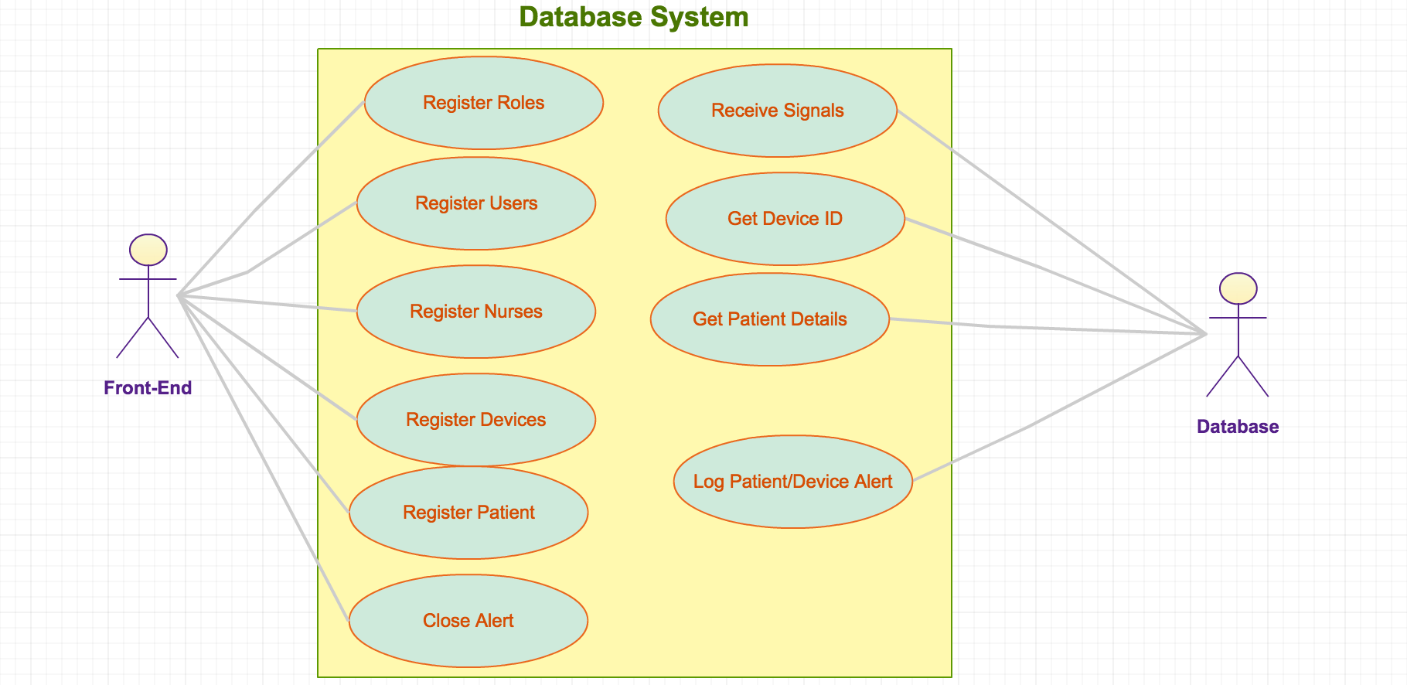

Use Case Diagram for Web-Front End

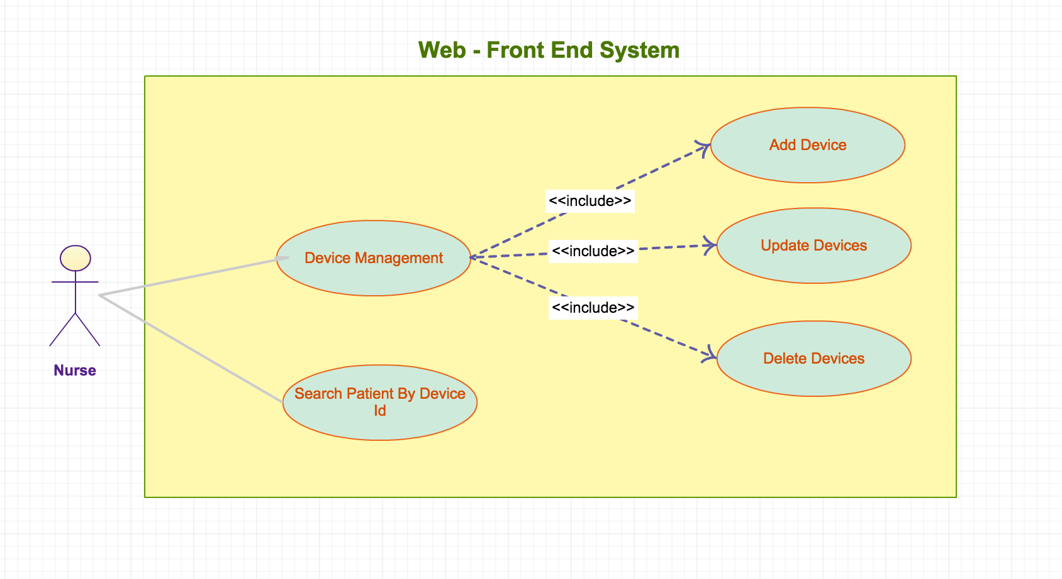

Use Case Diagram for Socket System
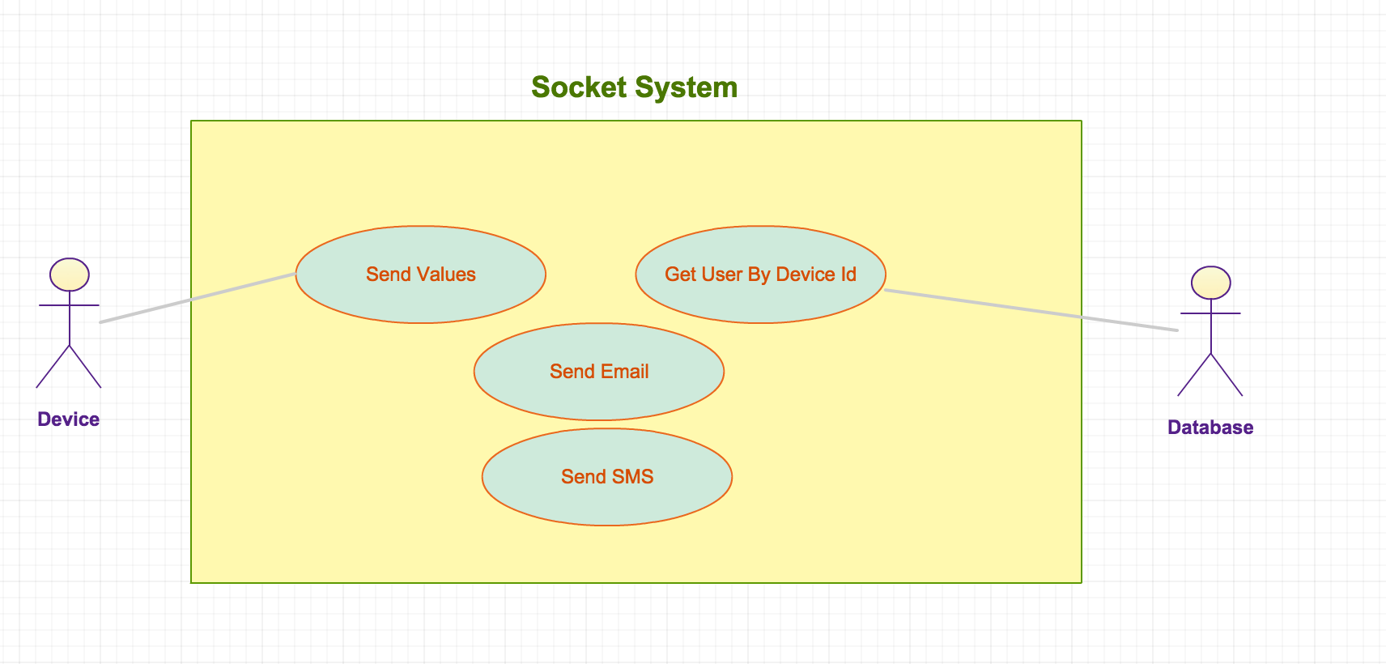

Use Case Diagram for Web Server
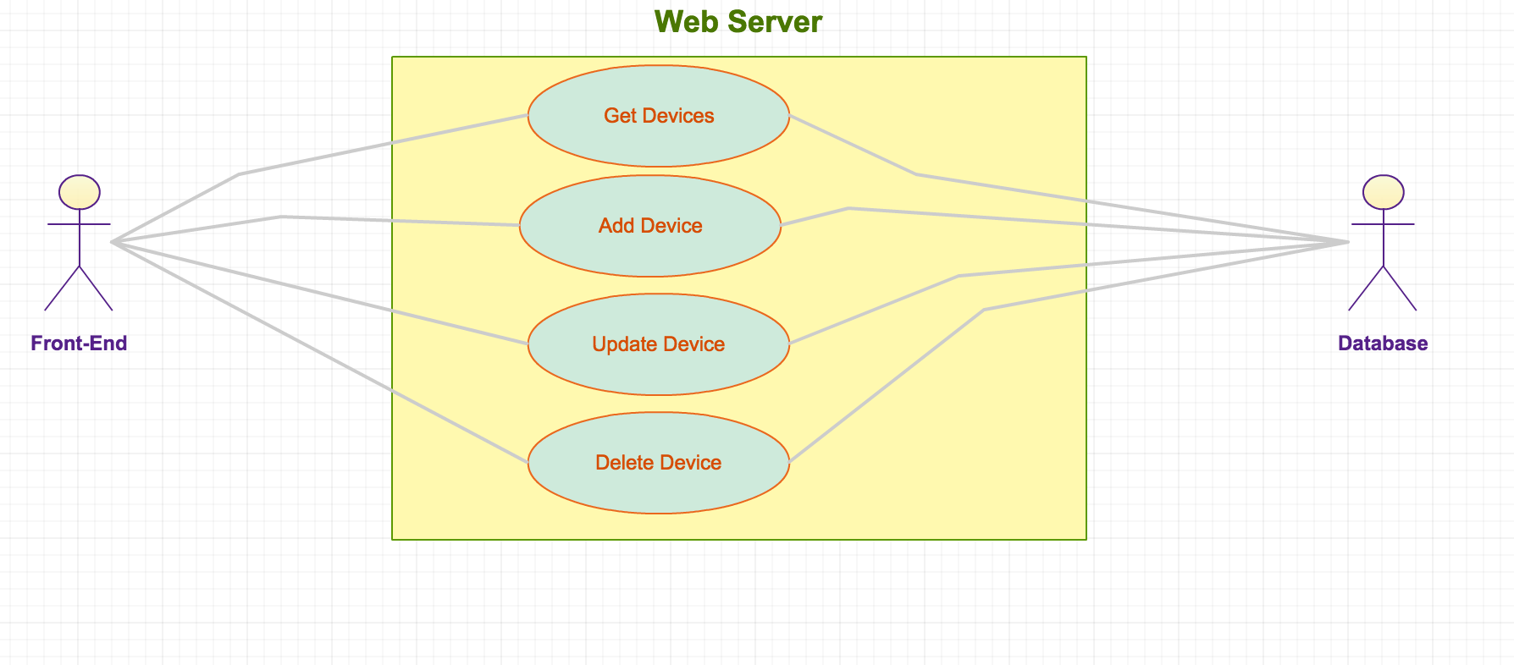

2.3 Class Diagram

A class diagram in the Unified Modeling Language (UML) is a type of static structure diagram that describes the structure of a system by showing the system's classes, their attributes, operations (or methods), and the relationships among objects.
Class Diagram for Web-Front End

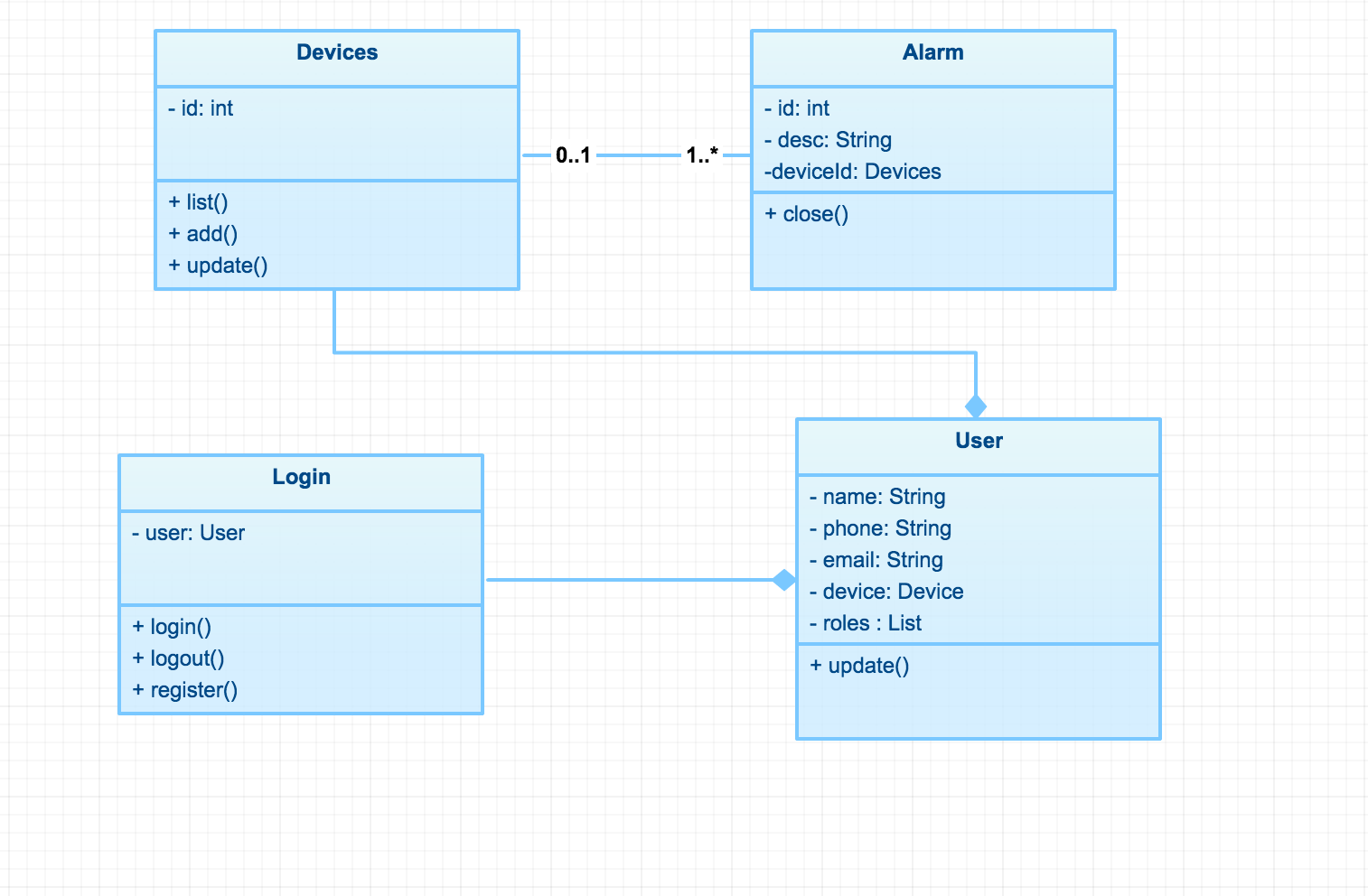

Class Diagram for Socket Server

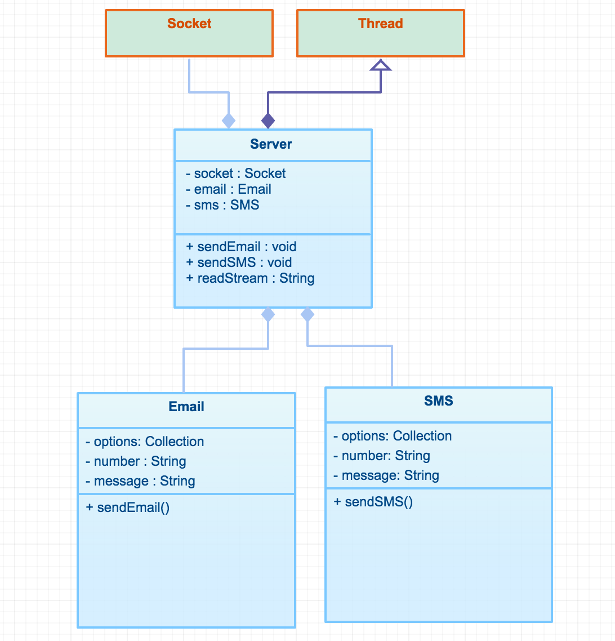

Class Diagram for Web-Server End

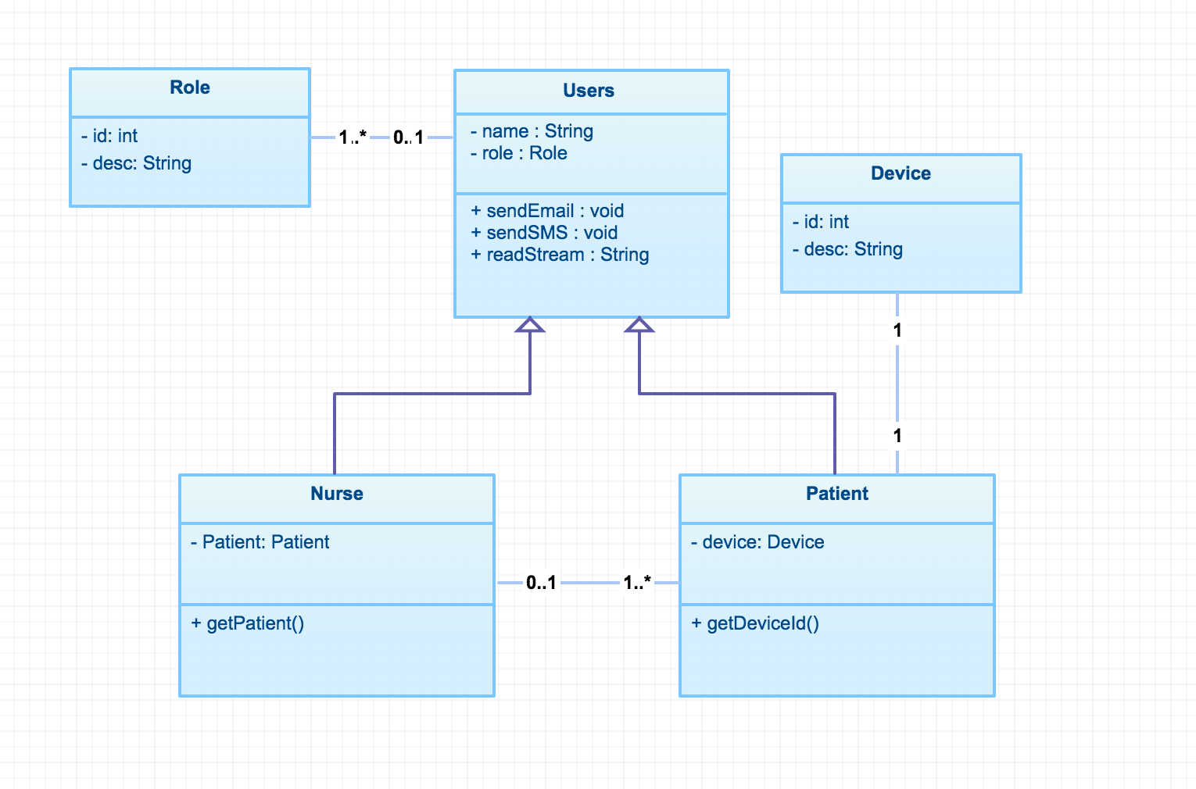

Class Diagram for Web-Client End

2.4 Sequence Diagram

A Sequence diagram is an interaction diagram that shows how processes operate with one another and what is their order. It is a construct of a Message Sequence Chart. A sequence diagram shows object interactions arranged in time sequence.

Sequence Diagram for Web-Client End

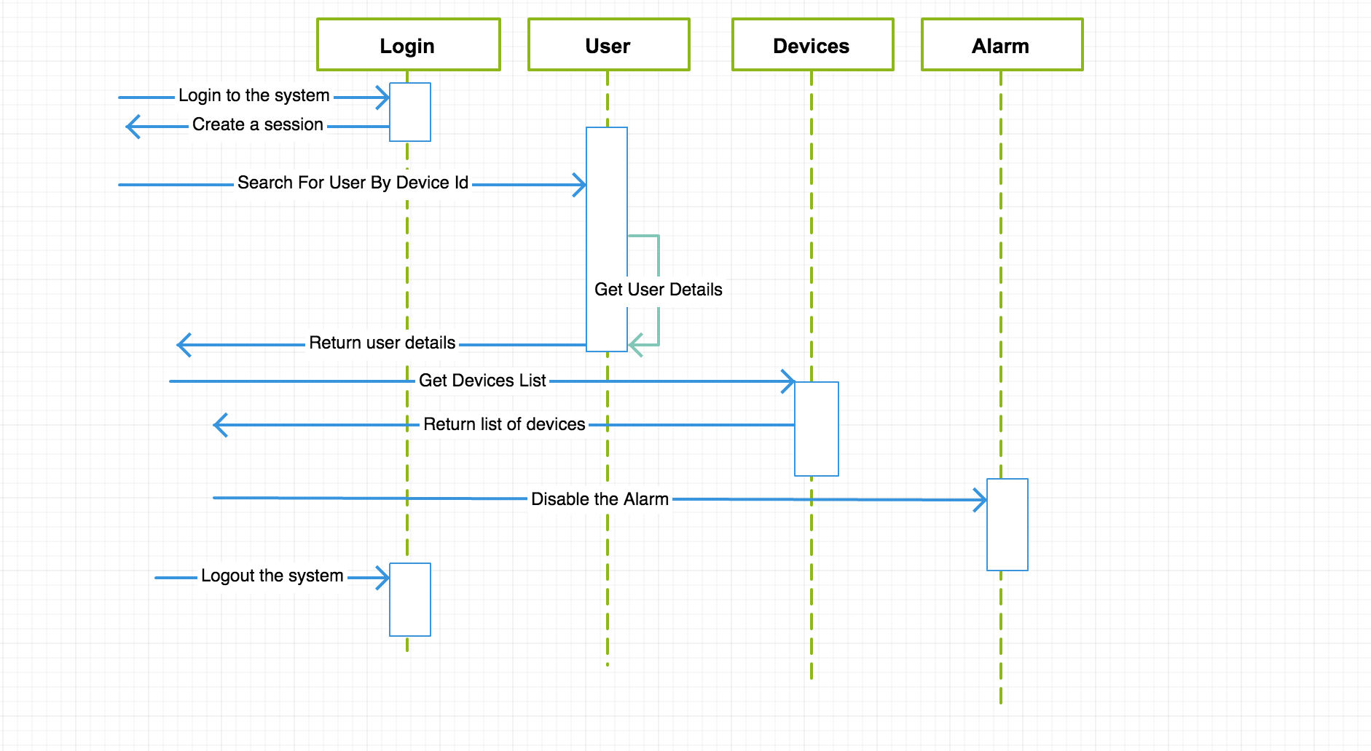
Sequence Diagram for Database
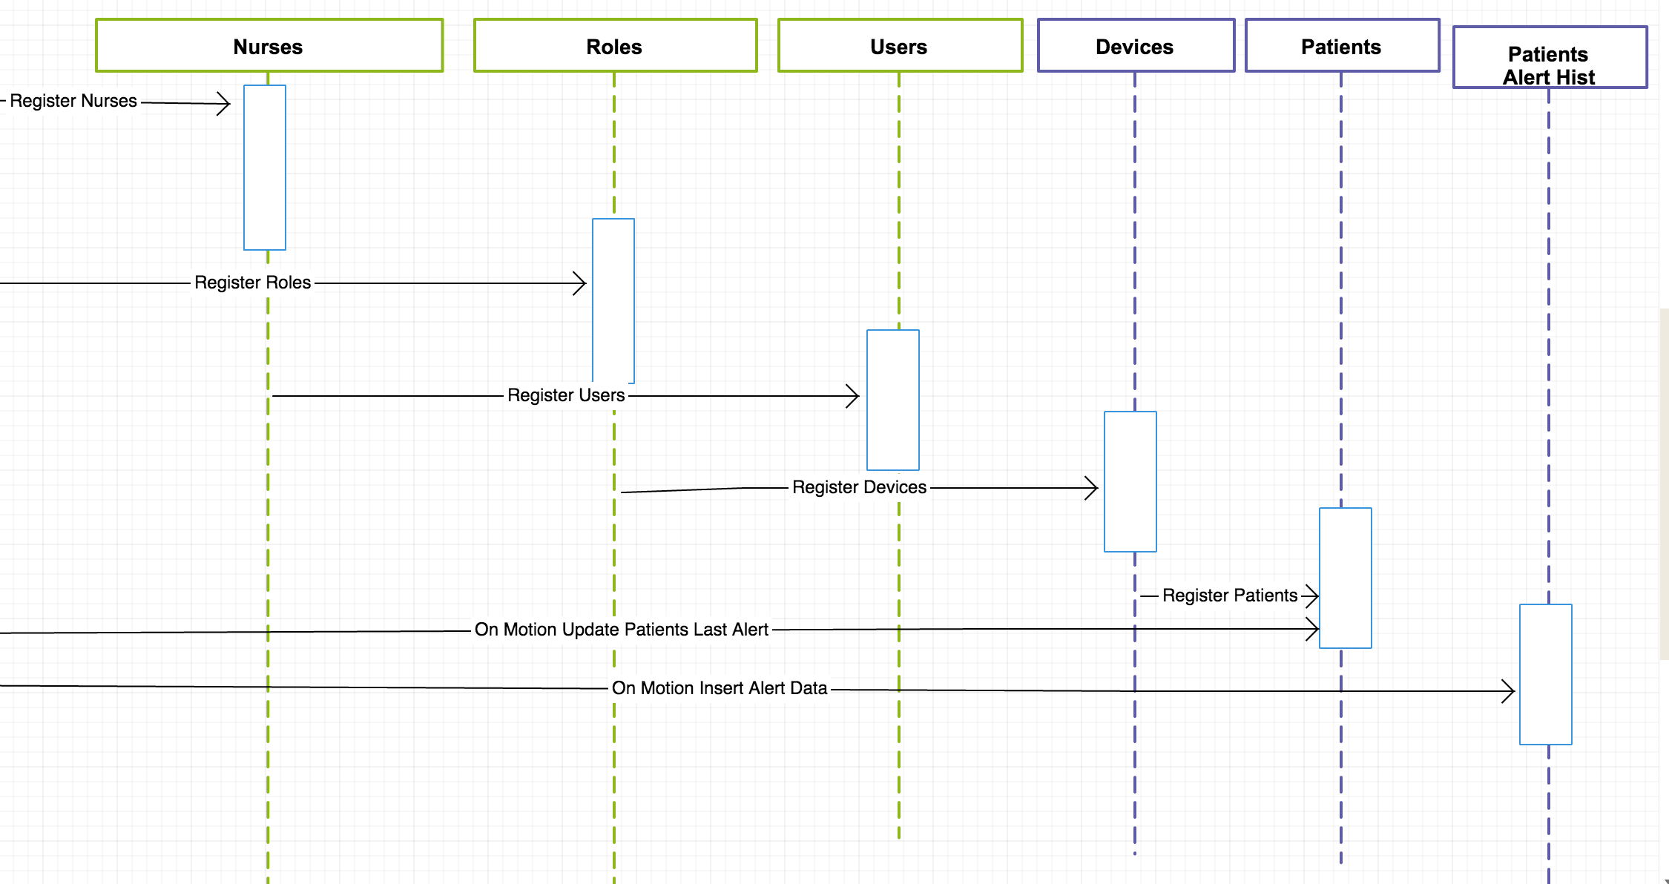

Sequence Diagram for Socket-Server

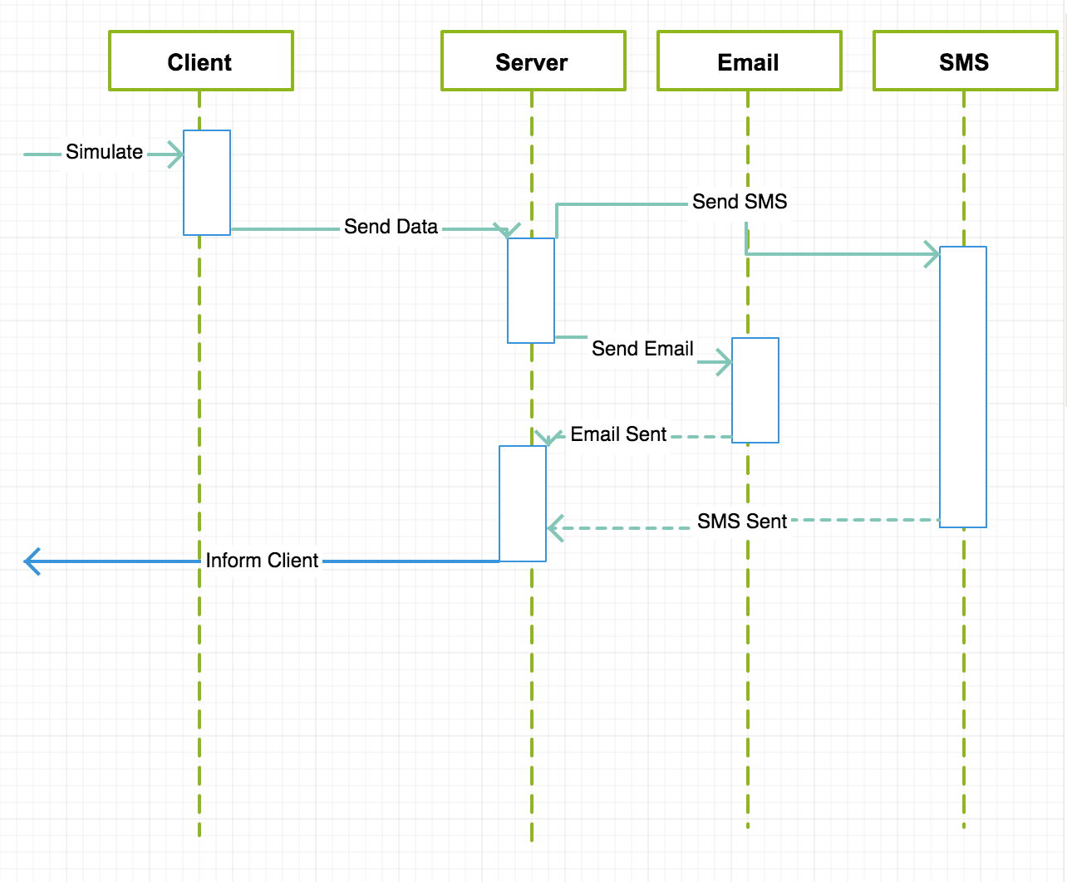

Sequence Diagram for Web-Server

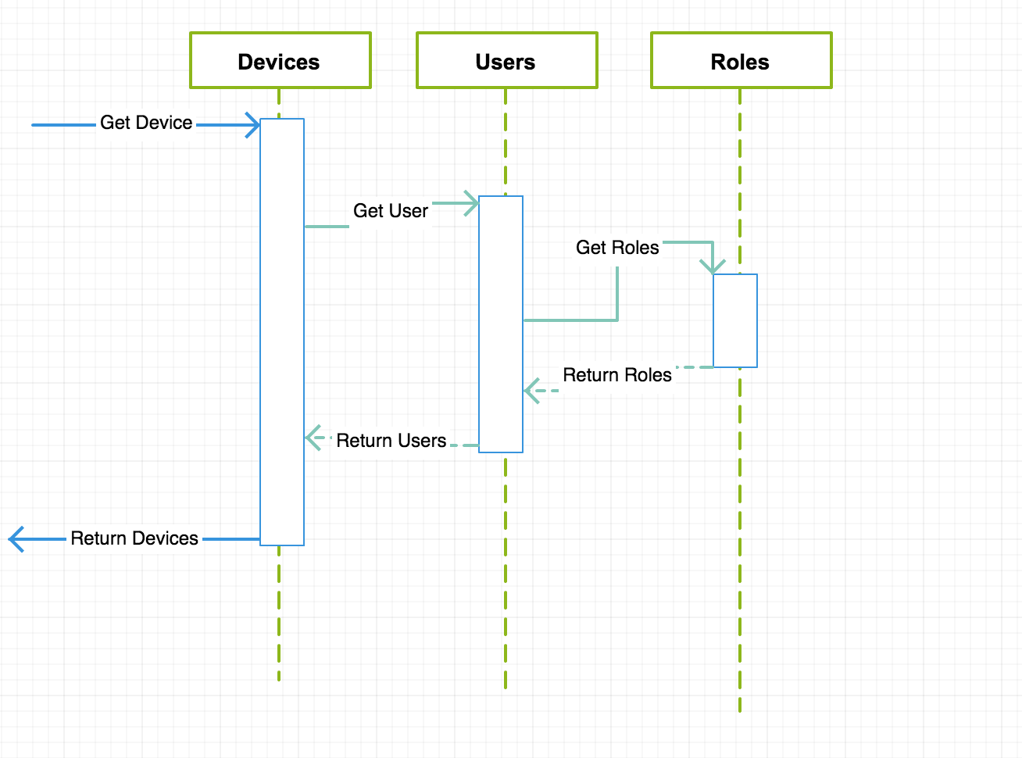

3.0 Implementation Details

3.1 Introduction

The project is divided into 4 major parts, in the network part we have program in java swing based simulator to send some mock datas to server side, we used socket programming to enable communication between client and server, JavaMail API is used to send alert messages to staff and it is sent via Gmail SMTP server using ssl connection. In internet part we used Nodejs as server, for fronted we used Angularjs to build up pages. For Database part we used MySql database, about connection we used node mysql library to connect our java program to the database.

3.2 Internet programming – NodeJS

JavaScript is a powerful option for programming the Internet of Things (IoT). It can be used for programming both endpoint devices and web services, using Node.js. Javascript can also be used to develop portable user interface apps that can run on literally any device, using HTML5. Finally, Javascript is standardized (as ECMAScript) and supported by high-performance implementations (eg Google’s Chrome V8, the Javascript engine used in Node.js).
Node.js: Node.js shines in real-time, and can be run within web applications employing push technology over websockets. Node.js is an open source, cross-platform runtime environment for server-side and networking applications. Node.js applications are written in JavaScriptthe Node.js
Goal
- Single Threaded
- Event Loop
- Non blocking I/O
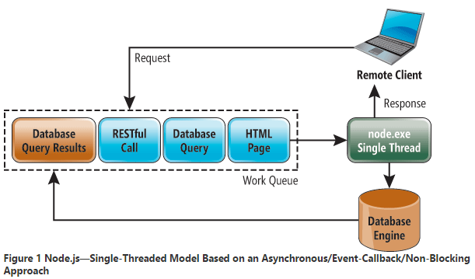

3.3 Database – MySQL

Create a database fallarm in MySql, Create a JdbcManager class in which use JDBC connect to MySql, in this class we also have some method to retrive data from database. When the android device sends the reading (6 parameters) to the network server, it will insert the readings into the table ‘reading’. The web fallarm system when registering nurse will insert a record into nurse table.

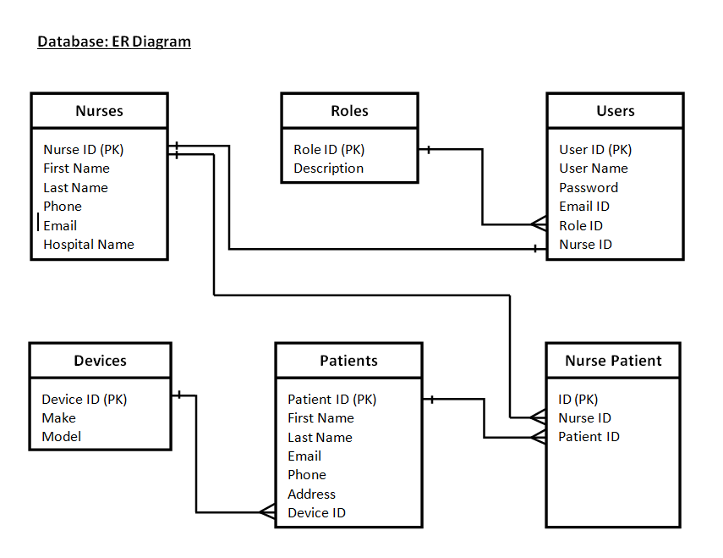

3.4 Web Service – Java Script, AngularJS, CSS
AngularJS: We use Angular as a Front-End Javascript MVC framework and we also use twitter bootstrap as a CSS framework. Angular is a single page MVC framework.

How MVC Works
Model View Controller or MVC as it is popularly called, is a software design pattern for developing web applications. A Model View Controller pattern is made up of the following three parts:
- Model - It is the lowest level of the pattern responsible for maintaining data.
- View - It is responsible for displaying all or a portion of the data to the user.
- Controller - It is a software Code that controls the interactions between the Model and View.
MVC is popular because it isolates the application logic from the user interface layer and supports separation of concerns. The controller receives all requests for the application and then works with the model to prepare any data needed by the view. The view then uses the data prepared by the controller to generate a final presentable response. The MVC abstraction can be graphically represented as follows.
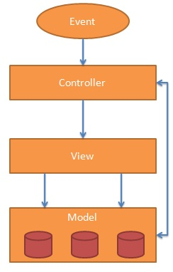

Angular JS: A Secure Single Page Application
Sites that mimic the single page app behavior are able to provide the feel of a phone/tablet application. Angular helps to create applications like this easily.

Goals
- Single page application
- No page refresh on page change
- Different data on each page
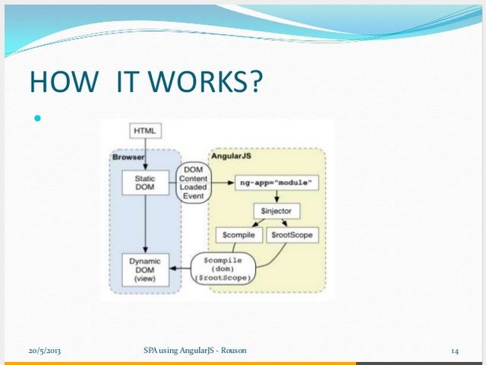
We have used this idea to serving our html files and all other resource files from the client side. Only get the index html file once from server when you loading the web app. All communications between api and client needs to be handled by AJAX. That way, its way faster than server side web frameworks (an example to server side web framework can be Spring MVC).

3.5 Socket Programming and Simulator
We used java.swing library to create a simulator GUI. We have a TCP server to listen the simulator and do the notification. Our simulator has three inputs: gyroscope, acceloremeter and device id. Based on device id, socket serve do the queries to the database via JDBC and get nursers information related to the patient. After the data fetch, socket server sends email and sms to nurse with the patient id.

3.5.1 Maven
Apache Maven is a software project management and comprehension tool. Based on the concept of a project object model (POM), Maven can manage a project's build, reporting and documentation from a central piece of information.

We use maven to manage the dependencies. Instead of carrying and importing jars, maven do that for you, all you need to do is define those dependencies in the POM.xml file. The dependencies that we uses are:
- Junit
- Mail
- Mysql

4.0 Test Plan

4.1 Test Streategy

4.2 Test Result

5.0 Future Enhancment
- RBAC : Role based access control mechanism needs to be added.
- Ability to crud operation in the web app.

6.0 Conclusion

The complete software package is successfully implemented and available for service. From a java gui simulator sensor data sent successfully to the socket server side, on the socket server side the risk of the motion is calculated, when a fall is detected, email and sms will sent to nurse in the hospital, then nerse could log into the system to check patient information. The Fallarm software could help patient in getting emergency help in the event of fall.

7.0 Bibliography
United Nations, Department of Economic and Social Affairs, Population Division. World Population Prospects: The 2010 Revision, Volume II: Demographic Profiles.2011.
Nicholas Caporusso, Irene Lasorsa, Oliviero Rinaldi, and Leonardo la Pietra. A Pervasive Solution for Risk Awareness in the context of Fall Prevention. 2009.

Appendix A

Appendix B

