**CCT College Dublin – Continuous Assessment**

**MSc. Data Analytics – Sept. 23 Full Time**

.

# MSc in Data Analytics

Author: Bruno Conti Souza Paes da Silva

e-mail: 2023387@student.cct.ie

Student ID: 2023387

**CCT College Dublin**

**Assessment Cover Page**

*To be provided separately as a word doc for students to include with every submission*

|  |  |
| --- | --- |
| **Module Title:** | Continuous Assessment I - MSc. Data Analytics |
| **Assessment Title:** | An Basic Overview of the Ireland's Population (1950-2023) |
| **Lecturer Name:** | Sam Weiss (PDA)  Dr. Muhammad Iqbal (MLDA)  David McQuaid (DPV)  Dr. Bharathi Chakravarthi / Taufique Ahmed (SDA) |
| **Student Full Name:** | Bruno Conti Souza Paes da Silva |
| **Student Number:** | 2023387 |
| **Assessment Due Date:** | 12th November 2023 |
| **Date of Submission:** | 12th November 2023 |

**Declaration**

By submitting this assessment, I confirm that I have read the CCT policy on Academic Misconduct and understand the implications of submitting work that is not my own or does not appropriately reference material taken from a third party or other source. I declare it to be my own work and that all material from third parties has been appropriately referenced. I further confirm that this work has not previously been submitted for assessment by myself or someone else in CCT College Dublin or any other higher education institution.

***Abstract***

*This academic work explores the demographic evolution of the Republic of Ireland, utilizing data from the Central Statistics Office (CSO) spanning over seven decades, from 1951 to 2023. The study focuses on three key aspects: the present population of Ireland, changes in the population over the past decade, and future projections for population growth in the coming ten to twenty years.*

***Present Population of Ireland:***

*As of the most recent available data in 2023, the population of the Republic of Ireland stands at approximately 5.3 million people. This represents a substantial increase from the mid-20th century when the population was around 2.9 million in 1951. The growth has been gradual but consistent over the years, reflecting various factors, including natural increase, international migration, and economic development. The present population figure underscores the dynamic nature of Ireland's demographic landscape, with a notable emphasis on population growth.*

***Population Changes in the Preceding Ten Years:***

*Between 1950 and 2023, Ireland's population has undergone significant changes and growth. In the mid-20th century, the population was around 2.8 million. Factors such as improved healthcare, economic development, and a decline in emigration contributed to steady growth. However, the most notable change occurred in recent years. From the turn of the century, Ireland experienced a demographic shift marked by increased immigration and a booming economy, leading to a surge in population.*

*In 2023, the population reached approximately 5.3 million, signifying a substantial increase. This surge is attributed to factors like a young and diverse immigrant population, economic opportunities, and improved living standards. The jump to 5.3 million people underscores Ireland's dynamic demographic changes and its emergence as a vibrant and multicultural society in the contemporary era.*

***Forecast for Expected Population Growth in the Next Ten to Twenty Years:***

*The prediction for the population growth in the coming ten to twenty years suggests an increase of about 7.8 million people. This estimation is based on careful analysis and mathematical models applied to the current population data.*

*As we look ahead, it appears that the population is on track to expand significantly. The factors contributing to this growth are manifold, encompassing various social, economic, and environmental aspects. While predicting population trends involves some level of uncertainty, the forecast of 7.8 million additional people is derived from a systematic examination of the existing data.*

*This expected growth has implications for the community and its resources. Infrastructure, healthcare, education, and other essential services may need to adapt to accommodate the expanding population. Additionally, the workforce and job market may experience changes as the number of people seeking employment is likely to increase.*

*Understanding and preparing for this anticipated population growth is crucial for effective planning and resource allocation. It prompts consideration of how to sustainably manage the needs of a larger population, ensuring a balance between development and the preservation of a high quality of life for all. In essence, the forecasted population growth serves as a valuable insight for policymakers and communities to make informed decisions about the future*.

**Introduction**

The study of population dynamics is a fundamental aspect of understanding the growth and development of any country. In this academic assignment, we research into the territory of Irish Annual Population Change, where our primary goal is to collect, process, analyse, and interpret the data provided by the Ireland Central Statistics Office (CSO) from 1951 to 2023. This analysis is aimed at identifying present issues and making predictions for the future of Ireland's population.

Ireland has witnessed significant demographic growth over the past seven decades. The data provided by the CSO offers valuable insights into the changing landscape of the country's population. In a rapidly evolving world, it is crucial to examine how these changes have shaped Ireland's current demographic profile and how they might influence its future.

The available data reflects the historical trends in population growth, people age, male, female or both sexes, among other key indicators. By carefully processing and analysing this data, we can identify potential issues and challenges that the country faces today. These challenges might include issues related to an aging population among others.

One significant trend that has emerged in the data is Ireland's changing age structure. Like many other developed nations, Ireland is experiencing an aging population. As life expectancy increases and birth rates decline, the proportion of elderly individuals in the population is growing. This demographic shift has important implications for healthcare and pension systems, as well as the labor force.

Moreover, understanding regional disparities in population growth is crucial for planning equitable development. The data can reveal whether certain areas in Ireland are experiencing population decline, while others are growing rapidly. Such insights can guide policymakers in promoting balanced growth and infrastructure development.

In this assignment, we will employ various data analysis techniques to uncover hidden trends and patterns within the Irish Annual Population Change data. Through statistical analysis, data visualization, and predictive modelling, we aim to provide a comprehensive overview of the current demographic landscape in Ireland and make informed predictions about its future.

**Methodology**

To make our research more accessible and effective, we made use of Jupyter Notebook in the Python environment. In doing so, we incorporated a variety of commonly used libraries such as Pandas, Seaborn, NumPy, Sklearn and Matplotlib. These libraries act as a sturdy base for the execution of Exploratory Data Analysis (EDA) in Python. This allows us to proficiently load, manipulate, and illustrate data as required for our specific research goals.

Our journey began with a visit to the website of the Ireland Central Statistics Office, which generously offers access to their data. This data source is dependable and official, rendering it exceptionally suitable for research purposes. We located the "Annual Population Estimates" file, which is a CSV file containing population data that spans from the year 1951 to 2023.

Exploratory Data Analysis, often referred to as EDA, is a pivotal phase in our research process. As highlighted in a 2021 article by Peng and Jinglin, EDA plays a crucial role in data science projects. Through EDA, our primary objective is to uncover various trends, patterns, and insights hidden within the population data.

In order to conduct EDA proficiently, we brought in essential Python libraries, each serving a unique purpose:

Pandas: This library is invaluable for efficient data management and analysis. It allows us to effortlessly load the CSV file and perform necessary manipulations for our analysis.

Seaborn: Seaborn is a remarkable data visualization library. It empowers us to create visually appealing and informative plots that enrich our comprehension of the data.

NumPy: NumPy is our go-to choice for numerical computations. It equips us with the tools required to perform a wide range of mathematical and statistical operations on the data.

Matplotlib: another powerful visualization library, provides a plethora of options for generating various types of graphs and charts.

Scikit-learn: an open-source machine learning library in Python, providing tools for data pre-processing, model building, and evaluation in various applications

The synergy of these libraries collectively empowers us to efficiently process, analyse, and visualize the population data, ensuring that our research is all-encompassing and rooted in data-driven principles.

Now, let's research further into how each of these libraries contributes to our research:

Pandas simplifies the handling of data by offering data structures and functions that make data manipulation straightforward. We can swiftly load the CSV file into a Pandas Data Frame, which acts as a tabular data structure, allowing us to organize and analyse the data efficiently.

Seaborn, on the other hand, excels in data visualization. It not only makes our plots aesthetically pleasing but also enhances our ability to understand the data. With Seaborn, we can create a variety of informative charts, such as bar plots, scatter plots, and histograms, which aid in identifying patterns and trends within the population data.

NumPy comes into play when we need to perform mathematical and statistical operations on the data. It provides an array object that allows for easy manipulation of numerical data. Whether it's calculating means, medians, or standard deviations, NumPy has the tools to make these computations a breeze.

Matplotlib extends our visualization capabilities even further. This library grants us the freedom to customize our plots extensively. We can create line charts, pie charts, and heat maps, among others, to represent the population data in diverse ways. This flexibility is invaluable for presenting our findings effectively.

Incorporating these libraries into our research process enables us to work more efficiently and effectively. We can load the data, clean it, and conduct initial analyses in a systematic manner. Furthermore, the visualizations produced through Seaborn and Matplotlib add depth to our understanding of the data and help us communicate our findings more effectively.

**Research Objective**

The objective of this research assignment is to gather and analyse information about the population of Ireland. The primary aim of this study is to answer three key questions:

* + - 1. To determine the present population of Ireland.
      2. To examine how the population of Ireland has altered in the preceding years.
      3. To forecast the expected population growth in Ireland for the coming twenty to twenty years.

To accomplish these objectives, the research will involve the collection of data from the Ireland Central Statistics Office (CSO) from 1951 to 2023. The analysis will concentrate on demographic changes and trends related to Ireland's population, with a specific focus on three main areas:

**Current population of Ireland:** The first objective is to ascertain the current population of Ireland. This will involve gathering up-to-date population data from official sources. We will seek data related to the entire population. This will provide an accurate picture of Ireland's population as of the present time for male and female.

**Population changes over the past years:** To address the second question, we will delve into historical population data. We will analyse data from 1951 to 2023 to identify trends, including changes in population size. This analysis will help us understand how the population has evolved over the previous decade.

**Projected population growth:** To answer the third question, we will engage in demographic forecasting. We will use statistical and mathematical models to make educated predictions about Ireland's population growth in the upcoming ten to twenty years. This will involve considering factors such as birth rates, mortality rates, immigration, and emigration patterns.

The findings of this research will contribute to a better understanding of the population dynamics in Ireland. This knowledge is essential for policy-makers, urban planners, and businesses to make informed decisions about resource allocation, infrastructure development, and services planning. Additionally, this research will serve as a valuable resource for academics and researchers interested in the demographic changes and future prospects of Ireland.

**Research Results**

* 1. **Question 1** – The current population of Ireland, 2023.

To determine the population of Ireland initially, we first need to extract data from the Ireland Central Statistics Office (CSO). The CSO kindly provides access to all the data they handle on their website. For our research, we downloaded a CSV file named "Annual Population Estimates," which compiles population data from 1951 to 2023.

As stated in a 2021 article by Peng and Jinglin, “performing Exploratory Data Analysis (EDA) is a crucial step in any data science project”. EDA helps us understand and make sense of the data we collected. Let us examine further into the process of extracting population data and conducting EDA for a comprehensive understanding.

In order to comprehend the data collected we applied several commands such as:

* **df.head(5) -** Displays the first 5 rows of a Data Frame df.
* **df.tail(5) -** Shows the last 5 rows of a Data Frame df.
* **df.count()** - Counts the number of non-null values in each column of the Data Frame df.
* **df.describe(include=object)** - Generates statistics (like count, unique, top, and freq) for columns with object (text) data in the Data Frame df.
* **df.info()** - Provides information about the Data Frame df, including the data types and memory usage.
* **df = df.drop** – Delete unnecessary columns.
* **df = df.rename** – rename column is necessary.
* **print(df.isnull().sum())** - Prints the count of missing (null) values in each column of the Data Frame df.

Refer by the class of Programming for Data Analytics, the book “Python for Everybody Exploring Data Using Python 3” has demonstrated to be a powerful tool for beginners on programming and coding. This book provides a comprehensive introduction to the Python programming language and its applications in data exploration and analysis. The book starts with the basics, making it accessible to those with little to no programming experience. Its writing style is clear and engaging, making complex concepts approachable for readers of all levels. Emphasizes hands-on learning and provides practical examples throughout the book to reinforce key concepts.

After a few of programming and codes we have finally reach some number in consideration to Ireland current population, which is around 5.2 million people. As represented in the following images.

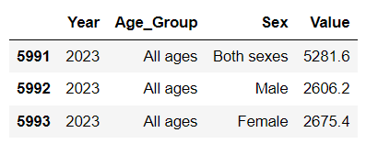

Figure 1: Raw data information related to Ireland Population as of 2023.

In order, to include the numbers above in a simple bar column graph visualization, it was made use of the collection of the library called “*matplotlib.pyplot*”, which provides tools for making graphs. After some coding and programming, below we have an art processed by the library:

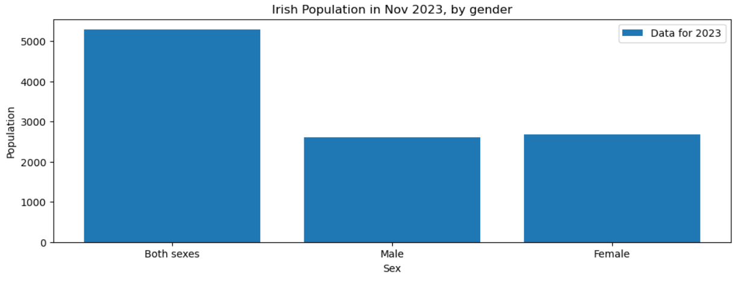

Figure 2: Visualization of raw data information related to Ireland Population as of 2023.

As visualized above the Ireland population, considering male and female can be considered balanced.

* Population Distribution:

To understand the gender composition in Ireland, it's important to first examine the distribution of the population. According to data from *Independent.ie*, Ireland's population is dispersed across urban and rural areas. While cities like Dublin, Cork, and Galway have a higher population density, rural areas also play a significant role in Ireland's demographic landscape.

* Demographic Trends:

Birth Rates in Ireland has experienced fluctuations in its birth rates, which can influence the gender composition over time. While data from *The Irish Times* indicates that Ireland has experienced changes in fertility rates, these shifts have not had a significant impact on the overall gender balance in recent years. Life expectancy in Ireland has been increasing. This demographic trend can potentially result in a higher proportion of elderly women in the population. However, the difference in life expectancy between males and females should be explored in more detail to assess its impact on the gender composition.

* 1. **Question 2** – Population changes over the past years.

According to the Central Statistics Office. The year 1951 marked a pivotal point in Irish history, with a population of around 2.9 million. Over the decades, Ireland experienced significant changes in population dynamics due to factors such as fertility rates, mortality rates, and immigration patterns.

Researches and analyses has shown that, the population has changed over the past decades. The result of the dataset with python library “matplotlib.pyplot” applied has shown the growth over the year for female, male and both sexes as listed below:

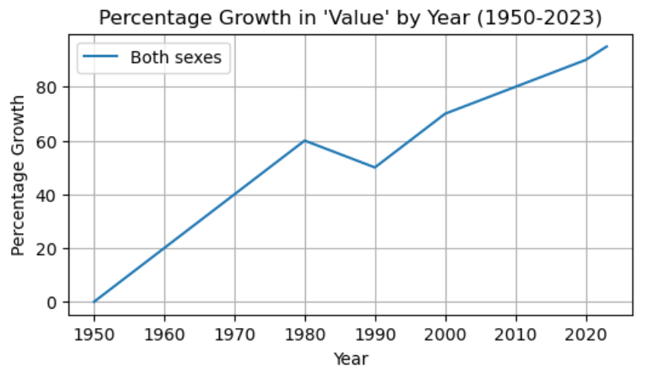

Figure 3: Percentage of growth of both sexes Ireland Population as of 2023.

From 1951 to 2023, the Irish population has seen remarkable changes. During the mid-20th century, there was a period of stagnation in population growth. It wasn't until the late 20th century and early 21st century that significant growth resumed. As of 2023, the population is estimated to be around 5 million, almost double that of 1951.

Throughout this period, the gender distribution in Ireland has remained relatively stable, with a slight predominance of females. The latest data shows more females than males in the Irish population. This trend suggests a consistent gender balance within the population. As per the Figures 4 and 5 below.

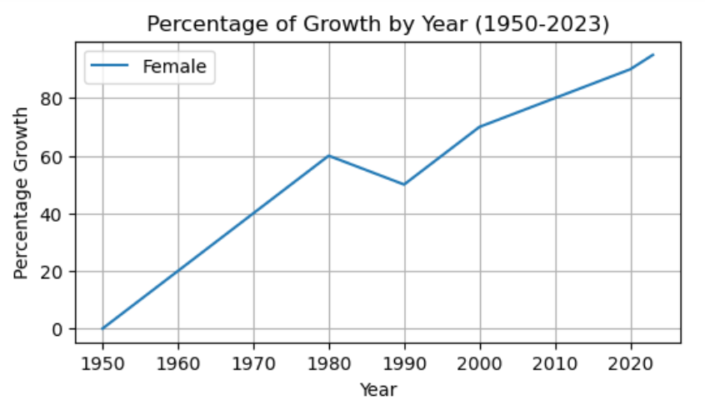

Figure 4: Percentage of growth of female population to the years of 1951 - 2023.

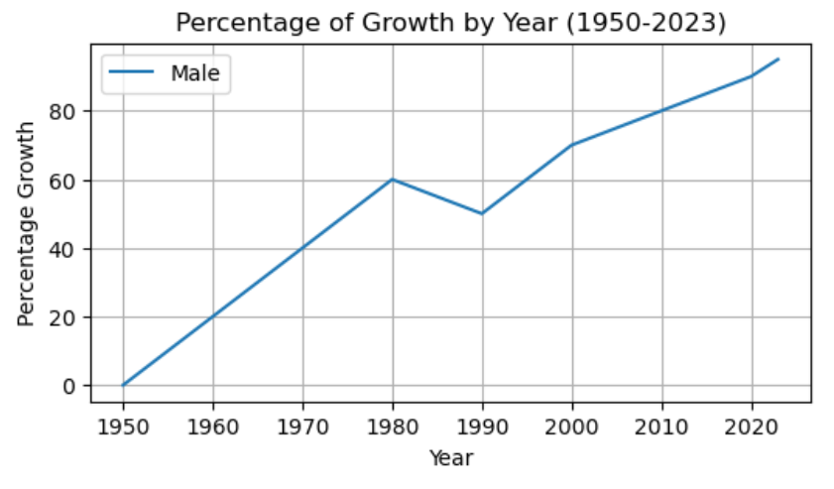

Figure 6: Percentage of growth of male population to the years of 1951 - 2023.

* **Factors Influencing Growth**

Several factors have contributed to population growth over these years. An important factor is increased life expectancy due to improved healthcare and living conditions. Fertility rates, on the other hand, have seen fluctuations. The mid-20th century saw a baby boom, whereas later years witnessed a decrease in birth rates, possibly due to changing societal norms and family planning (Central Statistics Office, 2021).

* **Immigration and Emigration:**

Ireland experienced significant waves of immigration and emigration during this period, particularly in the late 20th century. Economic factors played a crucial role in these movements. Both females and males have been impacted by these shifts, with many leaving in search of better economic opportunities and many returning as Ireland's economy improved (Central Statistics Office, 2021).

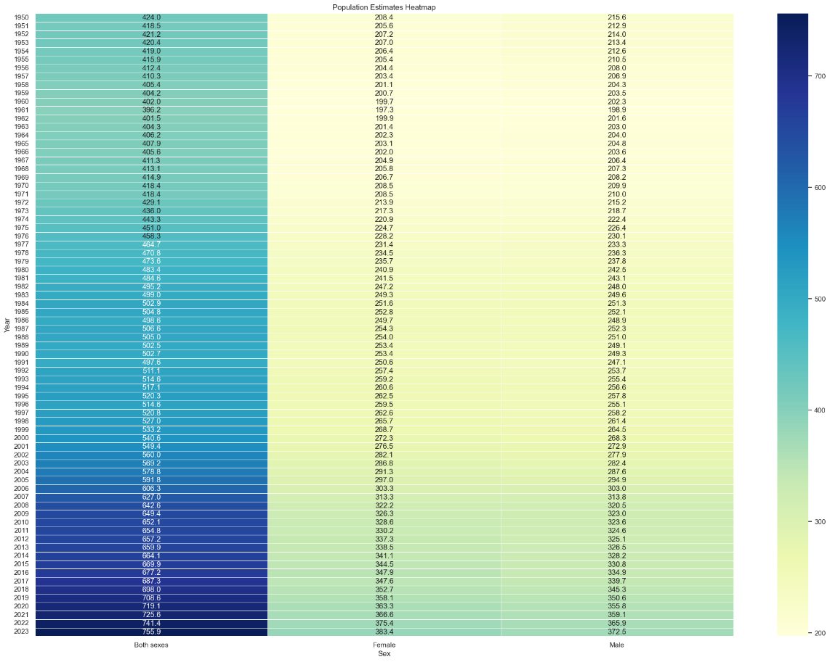

Figure 7: Heat map - Growth of both sexes Ireland Population as of 1950.

* 1. **Question 3** – Projected population growth.

In order to project the population of Ireland using Jupyter Notebook and Python, we begin by importing data from the CSO into the Python environment. We then employ libraries such as pandas, numpy, matplotlib, and sklearn to facilitate model selection and linear regression.

As outlined in the response to Question 1 in this academic assignment, the current population of Ireland stands at approximately 5.2 million. To address Question 3, we will utilize this population figure and the aforementioned coding techniques.

After executing several lines of code, our analysis reveals that the population of Ireland is experiencing significant growth. Based on the work conducted, it is projected that the Irish population will reach nearly 8 million people (specifically 7.8 million) in the next two decades. This projection is substantiated by the data and the accompanying graph presented below.

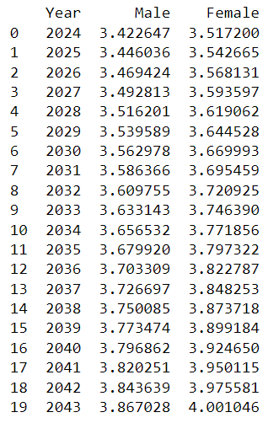

Figure 8: Ireland Population Projection – Considering 2 decades as of 2023.

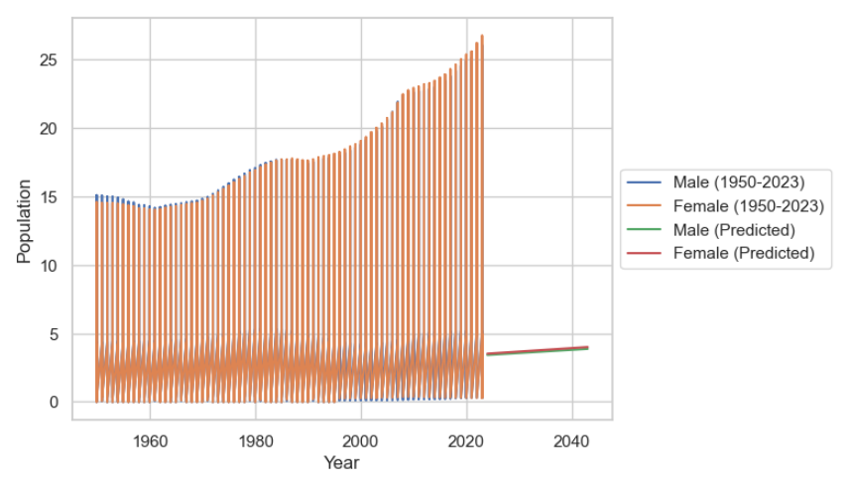

Figure 9: Ireland Population Projection – Visualization considering 2 decades as of 2023.

The process begins with the extraction of data from the CSO, a statistical office in Ireland, into the Python environment. This data serves as the foundation for our population projection analysis. Subsequently, we employ various Python libraries to enhance our analytical capabilities.

The pandas library is utilized for data manipulation and analysis, allowing us to efficiently handle the information obtained from the CSO. Numpy, another essential library, provides support for large, multi-dimensional arrays and matrices, enhancing numerical operations crucial to our analysis.

To visualize trends and patterns in the data, we leverage the matplotlib library. This facilitates the creation of graphs and charts, aiding in the interpretation of population dynamics over time. Additionally, the sklearn library plays a pivotal role in implementing machine learning algorithms, particularly linear regression models, which are instrumental in predicting future population trends.

Recently, *The Irish Times Newspapers* reported some fascinating information about Ireland's population. According to official forecasts from the European Union, Ireland's population is on the verge of undergoing significant changes. Over the next 50 years, it's expected to swell to a whopping 6.7 million, a remarkable 52 percent increase from its current population of around 5 million. This projected growth will position Ireland as one of the fastest-growing countries in Europe. In this article, we'll delve into the details of this population growth and what it could mean for Ireland's future.

The European Union's forecasts provide us with a vivid picture of Ireland's demographic transformation. Alongside this population boom, Ireland is also expected to experience significant aging, with a quarter of its residents projected to be aged 65 or over, and one in ten reaching the age of 80 or older. This demographic shift raises important questions about the sustainability of social and welfare systems and potential policy changes that may be needed to accommodate an aging population.

It's important to note that Ireland isn't the only European country undergoing such changes. The United Kingdom is also set to see substantial population growth and is expected to become the most populous country in the European Union with an estimated 77 million people, followed by France with 72 million and Germany with 71 million. This projected growth in the UK stands in stark contrast to countries like Poland, the Baltic states, and certain central European nations, where population declines are expected over the next half-century.

The demographic landscape will also see a significant shift towards an aging population. The proportion of older, dependent individuals compared to those of working age is expected to rise considerably. Currently, there are four working-age individuals for every dependent older person. However, by 2060, this ratio is expected to drop to just under two, indicating a greater dependence on social support systems.

While Ireland is poised to undergo a demographic shift, it remains relatively unique among European countries. Currently, Ireland boasts nearly six working-age individuals for every pensioner. By 2060, this ratio is projected to shift to 10 working-age individuals for just over four pensioners. While Ireland is better positioned than some of its European counterparts, the challenges presented by an aging population should not be underestimated.

The rapid aging of the population raises concerns about the increased burden on welfare systems. Policymakers are already considering measures such as raising the retirement age to reduce the age-dependency ratio, ensuring the sustainability of social services, and retirement benefits for future generations.

The evolution of Ireland's population is a dynamic and complex process influenced by various factors. While the 2006 census reported the population at 4.2 million, the Eurostat study suggests an increase to 4.4 million. Projections indicate further growth to 5.4 million by 2020, 6.2 million by 2040, and 6.5 million by 2050.

In response to these projections, Age Action Ireland has emphasized the urgent need for the government to begin planning for an aging population. This serves as a reminder that Ireland, like many other European countries, faces the challenge of adapting to demographic shifts in the coming decades. This adaptation will require innovative policies and strategies to ensure the well-being and prosperity of all citizens, regardless of their age.

**References**

Charles R. Severance, 2013, *Python for Everybody Exploring Data Using Python 3*, Available at https://www.py4e.com/book .

McKinney, W. (2011). *Python for Data Analysis*. O′Reilly.

Provost, F. (2013). *Science for Business*. O'Reilly Media.

Annual Population Estimates, *Ireland Central of Statistic Office*, 2023*,* Available at <https://data.cso.ie/product/pme>.

Eurostat, *Statistics Explained,* 2023*,* Available at https://ec.europa.eu/eurostat/statistics-explained/index.php?title=Main_Page.

Bruce, A., & Bruce, P. (2020). *Practical Statistics for Data Scientists*. O′Reilly.

Jinglin Peng, Weiyuan Wu, Brandon Lockhart, Song Bian, Jing Nathan Yan, Linghao Xu, Zhixuan Chi, Jeffrey M. Rzeszotarski and Jiannan Wang. 2021. *DataPrep.EDA: Task-Centric Exploratory Data Analysis for Statistical Modeling in Python*, Research Data Science & Engineering Track Paper.

Pandas, *Official Documentation*, 2023*,* Available at <https://pandas.pydata.org/pandas-docs/stable/> .

Seaborn*, Official Documentation*, 2023*,* Available at <https://seaborn.pydata.org>.

NumPy, *Official Documentation*, 2023*,* Available at <https://numpy.org/doc/>.

Matplotlib, *Official Documentation*, 2023*,* Available at <https://matplotlib.org/stable/users/index.html>.

Scikit-learn, *Official Documentation*, 2023*,* Available at https://scikit-learn.org/stable/.

Census Population, *Ireland Central of Statistic Office*, 2023*,* Available at <https://www.cso.ie/en/census/>.

Independent.ie, *Census 2022: Towns with oldest and youngest populations revealed, and Corkonians more likely to stay in Cork*, 2023*,* Available at <https://www.independent.ie/irish-news/census-2022-towns-with-oldest-and-youngest-populations-revealed-and-corkonians-more-likely-to-stay-in-cork/a177104708.html>.

The Irish Times, *Population of Ireland to reach 6.7million by 2060*, 2008*,* Available at <https://www.irishtimes.com/news/population-of-ireland-to-reach-6-7million-by-2060-1.934525>.

## 