Chicken door application

1. general
2. operation

The chicken door is controlled by a Raspberry PI 4B. The chicken door control program is named ‘coop.’ This document will refer to coop by name when describing some action or feature that it controls directly.

This diagram shows the physical elements of the system.

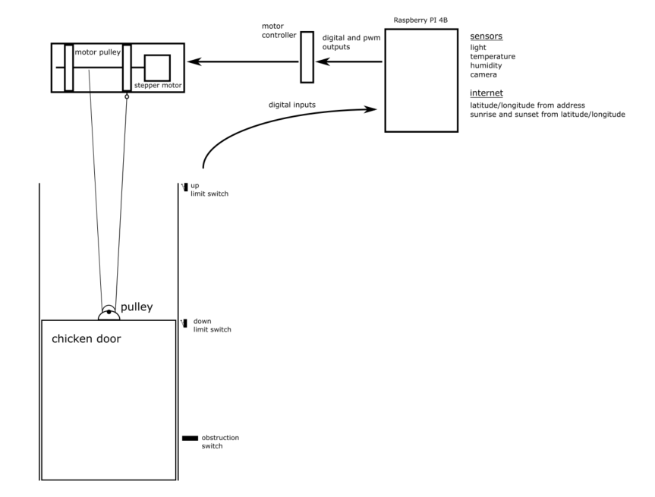

* 1. software block diagram

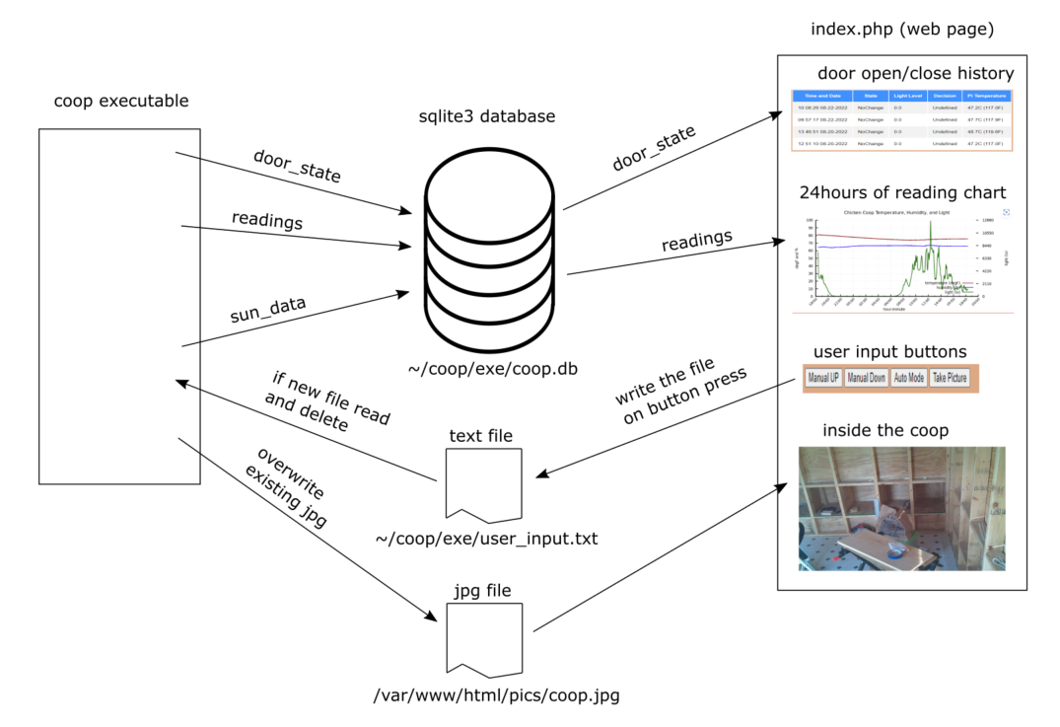

* 1. I/O circuits and wiring

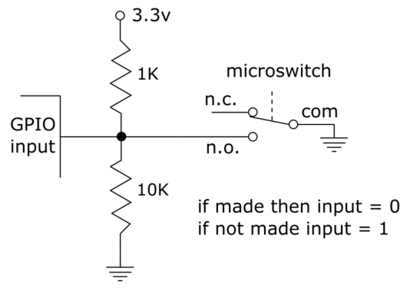

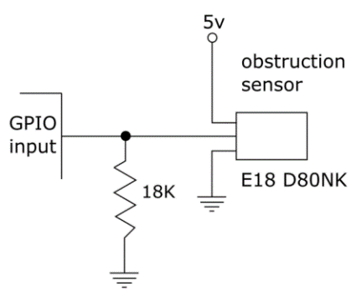

* 1. web services
     1. for address to lat long coordinates use https://geocoding.geo.census.gov/
     2. for lat/long use https://aa.usno.navy.mil
  2. web page
  3. github
     1. https://github.com/bcookOh1/ChickenDoor.git

1. build
   1. make
   2. folders and files
      1. permissions
2. code description
   1. configuration
   2. command line
      1. user inputs for debugging
   3. control loop

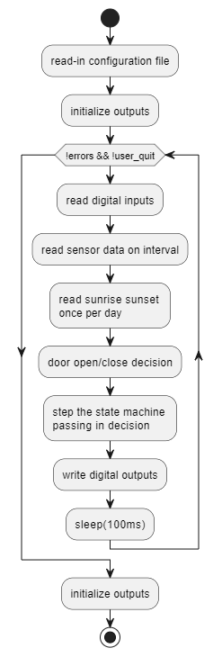

* 1. state machine
  2. readers
     1. The coop program uses several reader classes to

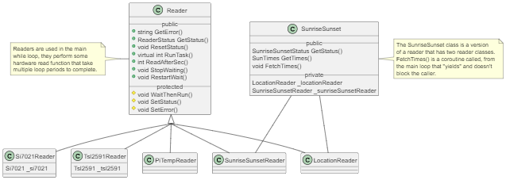

Tsl2591r is typical of reader usage found in the main:

if(tsl2591r.GetStatus() == ReaderStatus::NotStarted){

tsl2591r.ReadAfterSec(some_read_period_sconds);

}

else if(tsl2591r.GetStatus() == ReaderStatus::Complete){

Tsl2591Data data = tsl2591r.GetData();

tsl2591r.ResetStatus();

// do something with the data

}

else if(tsl2591r.GetStatus() == ReaderStatus::Error) {

cout << tsl2591r.GetError() << endl;

tsl2591r.ResetStatus();

} // end if

This if structure will periodically start a tsl2591 read and check status done or error and start again on he

next "some_read_period_sconds"

* 1. open/close decision

The open/close decision follows a priority of three inputs: user input (for manual mode), sunrise and sunset, and light level. The highest priority is the user input, then the sunrise and sunset times followed by the light level.

User input has two sources 1) the console and 2) the webpage buttons. There are three user input options: manual up, manual down, and auto mode. Both manual up and manual down move the door to those positions immediately. The auto mode selection gives the open/close decision to either the sunrise and sunset times or the light level. If the sunrise and sunset times are available, coop uses those values, else it uses the light levels to open and close the door.

Coop gets the sunrise and sunset times from two steps using web services. The first step requests the latitude and longitude using the address from the json configuration file. Coop then uses the latitude and longitude to get the sunrise and sunset times.

Coop uses, <https://geocoding.geo.census.gov>, for the address to latitude and longitude coordinates.

And, <https://aa.usno.navy.mil>, for the latitude and longitude to sunrise sunset times. Both of these web services are free and use https for private access.

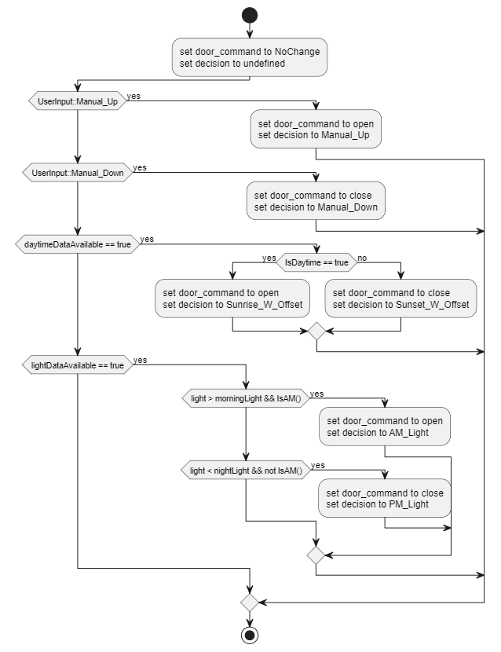

1. special code
   1. WatchConsole
   2. SmallIpc
   3. Rp4bPwm
   4. StateMachine
   5. UserInputIPC