**Jason Milgram**

Cooper City, FL 33330 | (954) 665-6778 | [Jason@milgram.me](mailto:Jason@milgram.me) | [www.linked.com/in/jasonmilgram](http://www.linked.com/in/jasonmilgram)

***Senior Executive: Information Technology and Architecture****Strategic Enterprise Solutions, Emerging Technologies, Software Architecture, MSFT Azure MVP*

* **High-performance, bottom-line focused IT executive** with 20+ years of experience in bringing-to-market SaaS and PaaS solutions and profitably managing professional service practices.
* **Deep expertise in Microsoft Azure Cloud**: security, compliance, modern datacenter, app modernization, DevOps, advanced analytics + AI, cost management, and automation.
* **Forward-thinking leader adept at transforming IT operations**, fueling company growth, and driving revenue performance through comprehensive, innovative technology solutions.
* **Primary architect and pioneer of first-generation technology initiatives** that reposition companies for long-term growth and continued financial success.
* **Articulate, compassionate communicator** with the natural talent for building and leading teams while motivating individual contributors to perform at elevated levels of excellence.

**Leadership Assets**

C-Suite and Board Member Communications ⚫ Development of Key Alliances ⚫ Technology Innovator ⚫ Strategist ⚫ Change Agent ⚫ Team Builder ⚫ Cultural Agility

**Leadership Competencies**

|  |  |  |
| --- | --- | --- |
| Global Implementation Projects | Software Architecture Frameworks | IT Planning and Direction |
| Enterprise Data Management | Security and Compliance | P&L Management, Forecasting |
| SaaS, PaaS Solutions | Software Engineering | Change Management |

**professional Experience**

[**Champion solutions Group**](https://championsg.com/) **2015-Present**

**Vice President, Platform Architecture and Engineering, 2018 – Present**Sought out to build professional services practice and modernize security and compliance.

* Ensure preventative capabilities are in place and compliance requirements are met.
* Manage the **App Modernization, Advanced Analytics, and Big Data** professional service practices.
* Implement software solutions and development efforts related enterprise SaaS solution CSPBoss.
* Direct a team of 16 associates representing business unit revenues of $15.9M.

**Key Contributions:**

* Gained CEO buy-in and devised comprehensive IT strategy to redesign CSPBoss software solution.
* Consolidated nine applications into a single portal and redesigned CSPBoss software architecture resulting in streamlined communications between departments and acceleration of productivity.
* Created foundation for the launch of additional practices related to IoT, Mixed Reality, and Artificial Intelligence.

**Azure Practice Director**, 2017 – 2018  
Directed IT strategy to promote strategic growth and operations of the Microsoft Azure Cloud practice.

* Managed security and compliance, automation and control, protection and recovery, and insight and analytics.
* Primary sales and implementation champion of the CSPBoss solution in the United States and Europe representing 50+ MSPs and 2,200 businesses.
* Directed a team of 13 associates representing business unit revenues of $7.4M.

**Key Contributions:**

* Managed the re-architecture of CSPBoss from a Platform-as-a-Service (PaaS) solution to Azure Service Fabric, a distributed microservices and containers platform.

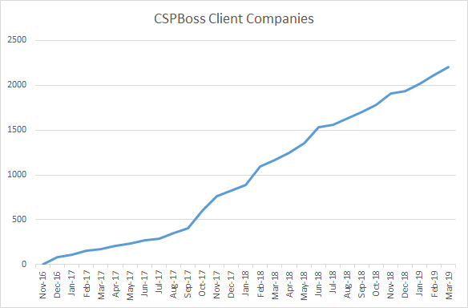

* As practice Director, increased revenues by 57% within 12 months.
* Served as C-Suite strategic advisor in DevOps, Engineering, Business Analysis, Accounting, Operations, and Security.

**Director of Software Development**, 2015 – 2017

Managed the creation of in-house software solutions and trans-continental teams on/offshore.

* Managed the Azure practice including pre-sales and project implementation. Focused on cloud migration, security, and compliance.
* Direct a team of 9 associates representing business unit revenues of $3.7M.

**Key Contributions:**

* Product launched: CSPBoss - used by 2,200 businesses around the globe.
* Product launched: Office 365 Adoption, enabled MSFT MSPs to become a CSP Tier1.
* Product launched: Discovery Scout - an audit, legal search, and compliance tool.

**Additional relevant experience**

**President**, [**allAware, Inc.**](https://www.bloomberg.com/research/stocks/private/people.asp?privcapId=305657369) **2014 – 2015**Led the strategic direction and management of IT operations and development of software solutions.

**Founder/CEO,** [**Linxter, Inc.**](https://www.bloomberg.com/research/stocks/private/snapshot.asp?privcapId=99623203)**, 2007 – 2014**Aligned business strategy with IT infrastructure; implemented MOM solution on all platforms.

**Founder/CEO, Useful Technology Corporation, 1995 – 2007**Established IT consulting company focused on IBM Lotus Notes/Domino application development.

**Military Experience**

**United States Army Reserve, Fort Thomas, KY (Honorable Discharge), 1990 -1998**

* NBC NCO (E5), 1993 – 1998
* Army Chemical School 54B - Fort McClellan, AL, 1994
* Primary Leadership Development Course (PLDC) - Milan Training Center, Lavinia, TN, 1993
* Combat Engineer Training 12B - Fort Leonard Wood, MO, 1990

**Medals**: Army Good Conduct Medal (1992, 1994), US National Defense Medal (Desert Storm), US Army Achievement Medal

**technology PORTFOLIO**

**SOFTWARE**: Azure Active Directory, Intune, Azure Information Protection, Azure Service Fabric, Azure Sentinel, Security Center, Azure Dev Ops, Kubernetes, Microservices, SQL Data warehouse, EventHub, Data Factory, Microsoft SQL Server Analysis Services (SSAS), Power BI Embedded, Analytics Services, HDInsight, Data Bricks, TIBCO Rendezvous, VMWare, Microsoft Office 365, Rational

**LANGUAGES**: Basic, Pascal, C, C++, C#, Visual Basic, Lotus Script

**SERVERS**: Windows, Linux, Azure Virtualization, AS/400, IBM AIX

**KNOWLEDGE AREAS**: SD-WAN, API Developer, API Management, Multi-Factor Authentication, Advanced Threat Analytics, Advanced Threat Protection, Cloud App Security, Privileged Identity Management, Identity Protection, SIEM, Machine Learning, Cognitive Services, TensorFlow, Bot Services, Mixed Reality, Disaster Recovery, Data Lake, Mobile Apps, UI/UX, Usability Testing, Quality Assurance, CI/CD, ITIL, ITSM, Zachman, Agile, Scrum, TOGAF, Domain Driven Design, Merger & Acquisitions

**Education**

* **Executive Certificate -** Management and Leadership, [MIT Sloan School of Management](https://executive.mit.edu/), 2008
* **Bachelor of Arts** - Political Science, [University of Cincinnati](https://www.uc.edu/), 1993