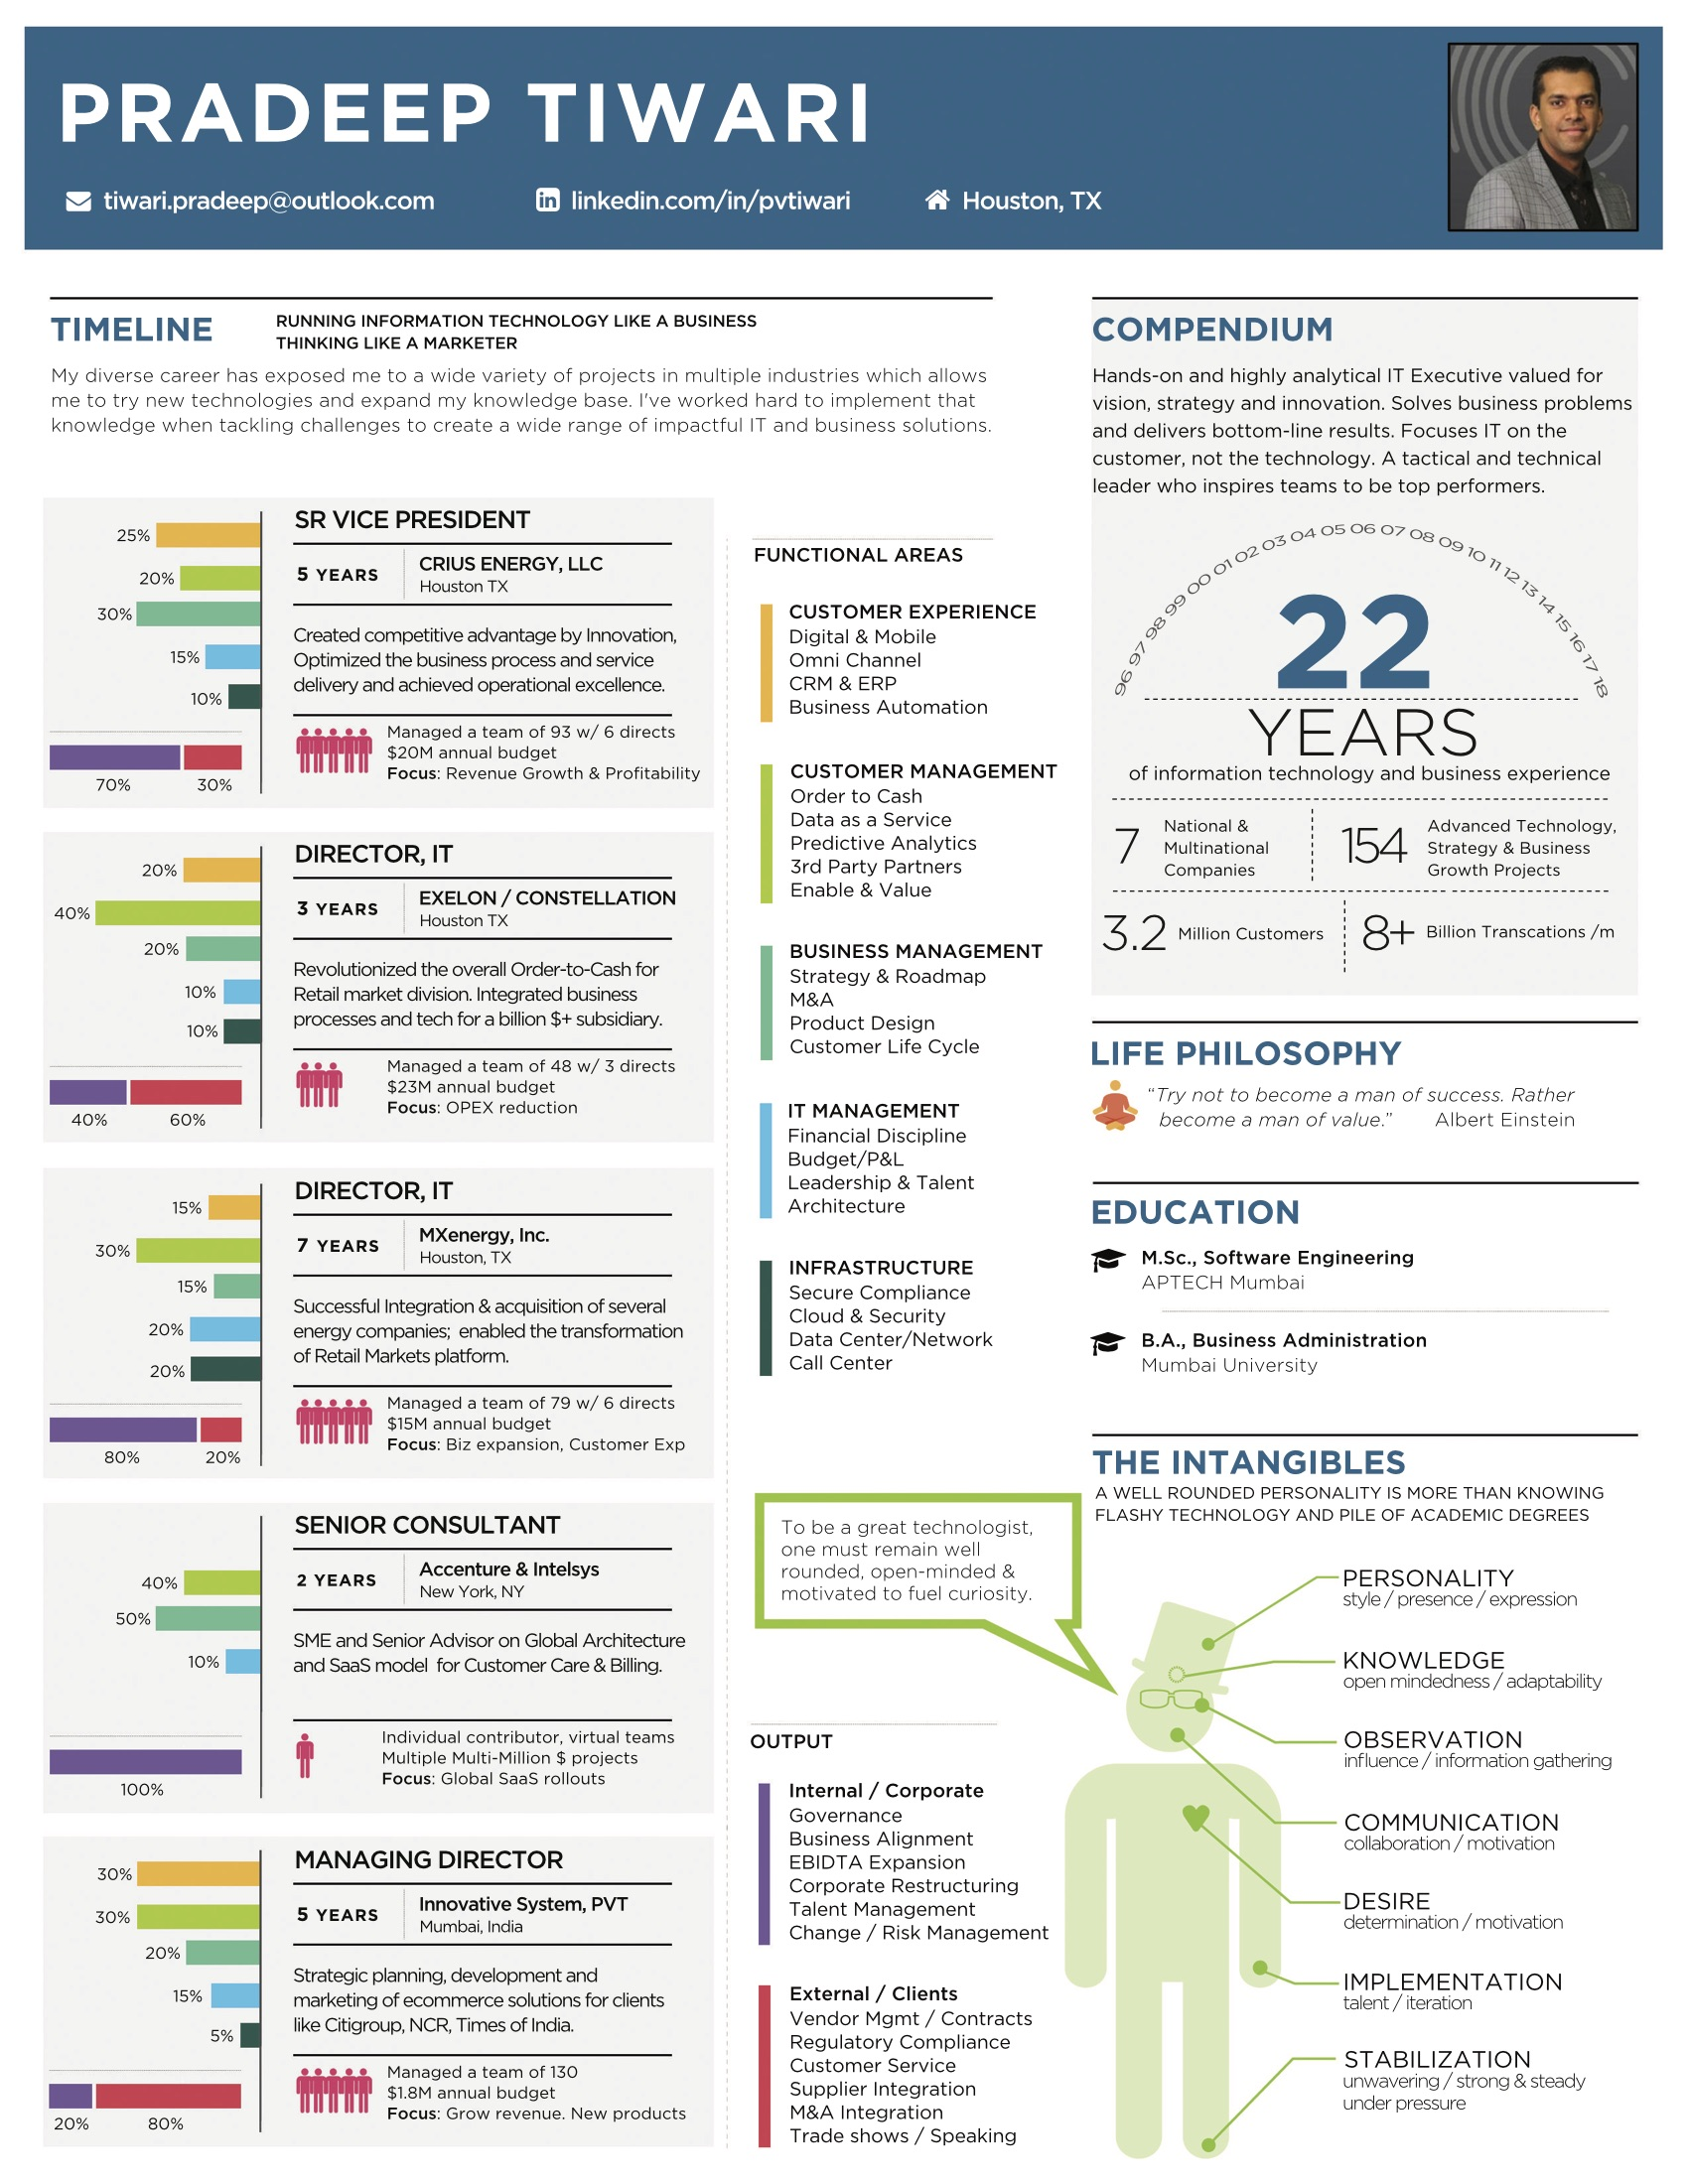

### **Pradeep Tiwari**

201.913.3750 / 2712 Ravens Creek Drive, Pearland, TX 77584

[tiwari.pradeep@outlook.com](mailto:tiwari.pradeep@outlook.com) / <https://www.linkedin.com/in/pvtiwari>

Well-rounded Senior Executive with experience in Strategy, Technology, Operations, M&A, Quality and Business Improvement experience. Created a competitive advantage by business innovation, optimizing process and service delivery and achieving operational excellence by providing effective and reliable service. Designed and led business transformations, achieving first-mover advantage for organizations in highly competitive markets. Solves business problems, customer demands and facilitates new product development and operational improvements by aligning IT capabilities with business strategy. Experience in Energy, Financial Services and Consulting.

### **Core Competencies**

|  |  |  |  |  |
| --- | --- | --- | --- | --- |
| Customer  Experience | Customer Management | Business  Management | IT  Management | Infrastructure |
| Digital & Mobile  Omni Channel  CRM & ERP  Business Automation | *Order to Cash*  *Data as a Service*  *Predictive Analytics*  *3rd Party Partners* | *Vision & Strategy*  *M&A*  *Product Design*  *Customer Life Cycle* | *Financial Discipline*  *Budget/P&L*  *Leadership*  *Architecture* | *Secure Compliance*  *Cloud & Security*  *Data Center/Network*  *Call Center* |

### **Professional Experience**

|  |  |
| --- | --- |
| **Crius Energy, LLC** | **2013 - 2018** |

Crius Energy LLC is one of the largest independent energy retailers in the United States and Australia, providing electricity, natural gas and solar products to more than 1.4million residential and commercial customers.

**SVP/CIO, IT**

Responsible for managing IT, M&A, Strategy, and enabling business for customer growth and increasing customer life time value by providing state of the art technology ecosystem in terms of Customer experience, Customer management, Competitive differentiator and 3rd party platforms.

* Revolutionized the Technology eco system from practically nothing to state of the art Retail energy platform managing the customer portfolio across 77 markets and 13 different brands close to 300+ Markets and Brand combination. Enabled digital transformation across all the brands that provide simplified customer experience on any device. Over the period of 3 years technology footprint was reduced by 300%, reduce the technology head count by 60%, increased the number of acquisitions and speed to markets was dramatically improved from months to days, increased the confidence and credibility for the partners and brokers by providing transparency in Daily Sales, Customer life cycle and the Commission Payout. Customer Count in 3 years grew from 300K RCE to 1.4million RCE.
* Instrumental in enabling channel partner relationship like Comcast, Rise, Credo and Brokers. Key stakeholder in driving the decision on acquisition.
* Dramatically improved Customer Experience by providing digital experience for Customers, Brokers, Partners, Business Users and created frictionless customer experiences that enabled company to become closer to the Customer.
* Standardized and consolidated the overall portfolio in simple Order to Cash model that allows single view and management of the Customer. Overall Customer portfolio is tracked like FedEx model. Dramatically reduced Customer Churn and enabled stickiness by reducing errors and serving customer right.
* Created competitive advantage by building the in house solutions on Pricing, Commission, and Product management worked in conjunction with business partners. Improvised the overall Billing and Accounting process by implementing controls and enabled Data as a Service model.
* Played critical role in the launching Solar platform by launching Salesforce technology and partnering with Solarcity, Sungevity for the installation of Solar Panels.
* Built the strong diverse team located across multiple states with laser focus on results.
* Executed strategy allowing Crius IT to become SaaS model and provide solutions to Retail Energy Companies who are Crius Competitor. Supplementing IT from growth driver and driving towards Revenue generation.
* Managed the overall Budget of the Company and enabled financial discipline by instituting Strong PMO and FP&A group. At peak managed team of 93 w/6 directs $20M annual budget (Opex + Capex) and Integration budget.

|  |  |
| --- | --- |
| **Constellation Energy an Exelon Company** | **2011 – 2013** |

Constellation Energy has a long and pioneering history in the energy industry. From their roots as the nation’s first gas light utility, it has evolved into one of the largest and most innovative energy companies in America. Constellation Energy completed the purchase of MXenergy (a large retailer of natural gas and electricity in over 45 markets) on June 30, 2011.

**Director, IT**

Member of Senior Leadership team. Successfully led and managed IT team managing retail mass market division of Billing, Collections, Data Warehouse, Business Intelligence, Risk, Forecasting, Pricing, Supply, Accounting and Finance.

* Played a significant role in making platform decision for operating and managing Mass Market residential and small commercial customers with the growth and scalability projection of 5+ million customers. Rebranded with Constellation brand across all the markets.
* Billing and Accounting creating one sub ledger across all the billing type and calculating unbilled revenue at account level using our back cast data for 50+ markets.
* Commission Payment system for all the brokers and vendors. Decommissioning multiple commission systems that were inherited due to acquisitions.
* Building Inventory to sell model all the way from creating campaign, pricing, enrollment, forecasting, back casting, pre hedge and post hedge. System is designed to manage Day 1 and Day 2 risk, booking short-term position and PnL calculation.
* Successfully led the management of new market entries for government aggregation. Consolidated multiple books of business in the Mass Market platform and ending the vendor relationship.

|  |  |
| --- | --- |
| **MXenergy Inc.** | **2004 – 2011** |

MXenergy was a large retailer of natural gas and electricity in over 45 markets.

**Director, IT**

Responsible for IT, Project Planning and Management, Business Continuity and rapid growth, Order to Cash and Supply Management.

* Increased business unit control over IT investments and project portfolios by revamping project planning process and realigning IT resources along the business lines.
* Expertise in acquisition, integration, consolidation of CRM’s and Data Management. Led the acquisition and integration of Shell gas, Total gas and electric, Castle power, etc.
* Improved performance of critical business by leading and managing redesign of cross functional project between Finance, Internal Audit, Operations, and IT teams to implement an automated process for Account Receivables reporting for 45 Markets. Single and auditable source of generating Revenue Report, Aging, Invoice and Payment reconciliation, Exception Control and Roll forward.
* Dramatically improved information quality and management decision-making ability using Data Warehouse and Business Intelligence to build custom dashboards. Improved data quality and availability by introducing Validation/Estimation/Editing of scalar and IDR meter. Data from 6 CRMs for 42 markets got consolidated into a Single Unit Data Warehouse.
* Led team that selected and implemented Risk Management System. Gas and Electric wholesale supply trade capture (in communication with internal trade capture systems), including volume, M2M, PL and cost calculation, as well as meeting all the necessary financial reporting requirements.
* Re-engineered meter to bill processing processes to dramatically improve Billing function.
* Decreased time to enter new markets by automation, process standardization, market knowledge repository and IT/Business Alignment.
* Dramatically improved data quality and availability by introducing Validation/Estimation/Editing of scalar and IDR meter data; new data ware-house/BI platform; custom Dashboards and Transaction Management framework.
* Managed CRM’s, which came in through acquisition. Successfully managed and lead the system by incorporating new utilities. Optimized and normalized the flow on Data operation, Collection, Billing and Enrollment.
* Managed Retail forecasting team generating Daily, Short and Long term forecast for all the electric markets. Leading the team for implementing the lodestar forecasting system for all the Gas and Electric Markets.

|  |  |
| --- | --- |
| **Accenture** | **2004** |

Accenture is a global management consulting, technology services and outsourcing company.

* Application Security Engineering, Component Architecture, Web Service and Integration Architecture, Network and Security Technology

|  |  |
| --- | --- |
| **Intelsys Inc** | **2003** |

Intelsys is an Edi service provider for Gas and Electric industries.

* Increase of productivity due to growing number of trading partners for EDI development. The establishing of new trading partners, which increases EDI activity for both customers and suppliers.
* Designed and co-developed a unique enterprise-level, n-tier Internet based customer care and billing system targeted to the deregulated energy utility.

|  |  |
| --- | --- |
| **Innovative System, India** | **1998 – 2003** |

Innovative System is a leading consultant for CITIBANK India/US/London/Dubai, NCR Corporation Ltd., Reliance Info-com Ltd., Satyam Infoway Ltd., Times Online Money Ltd.

Managing Director

* Directed all project lifecycle logistics including research and analysis, cost justification, project planning, systems design/architecture, user-interface designs, coding, documentation and follow-up user support. Managed teams and contract developers.
* Boosted revenues up to 200% by developing cutting edge IT and business solutions.
* Citibank, London, developed and implemented tele banking software syntellect. Reducing the call center volume by 23% and improved customer experience.
* Citibank, India, Successfully managed and lead the significant Y2K project for Asia Pacific division. Implemented asset management and tracking system. Managing and overseeing the IT operations of Paylink check management system running across 25 countries, Exceller customer relationship management system, Entrust security management system used across multiple countries.

### **Educational and Professional Certifications**

* Bachelor degree in Business - 1998, Mumbai University, India

## Software Engineering - 1997, Aptech, India

* Member of CIO Council Since 2013
* Leadership Training Pathway CIO Program – 2012
* Leadership Training Center for Creative Leadership - 2011
* Trading and Hedging EMI - 2011