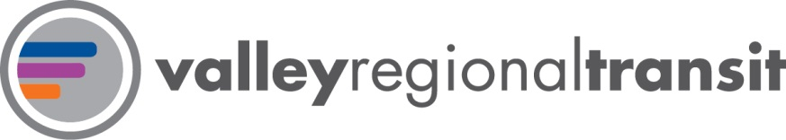

# TOPIC: Changes to Quarterly Performance Reporting

# DATE: July 25, 2018

# Introduction

Valley Regional Transit (VRT) is reviewing how it measures and reports on its performance moving forward. We are looking to provide our Board and stakeholders with understandable, brief snapshots that indicate the performance of all public transportation providers in the Treasure Valley.

# Background

**ValleyConnect 2.0** calls for several metrics to be tracked regularly as a method of monitoring progress toward three broad goals of the plan:

1. Provide safe and reliable multi-modal transportation choices considering the entire trip from origination to destination.
2. Prioritize investments inefficient fixed-route service that expands public mobility while leveraging, maximizing, and enhancing the utilization of the existing transportation assets and resources.
3. Ensure comprehensive transportation choices and access that support economic growth and enhance quality of life for the region.

Additionally, many decision makers have been asking for better data from VRT so that they can feel confident that they are wisely investing taxpayer dollars.

Our reporting in the past has typically been siloed based on service types. Fixed-route, demand response, vanpool, specialized transportation, and bikeshare have each been shown in their own graphs, making at-a-glance comparisons challenging.

# Changes

In an effort to improve the readability of our performance reporting, we are making changes to the quarterly report:

1. Layout

We are proposing to move to a dashboard-style layout. Rather than having several pages of detailed, time-series data, we are going to produce several high-level graphs that will allow our stakeholders to understand the productivity and health of the public transportation system without having to dig through tables. More robust data will be available, but not automatically included in the Board packet.

1. Readability

As these changes are designed to make information clear and understandable, we feel that year-to-date data should be provided by calendar year rather than fiscal year. It is much more intuitive to spot seasonality trends using calendar years.

1. Modules

There are a variety of metrics included in **ValleyConnect 2.0** that will provide a more holistic view of our system health than a singular ridership report. The ridership report provided in the July Board packet was the first module developed. Additional modules will be provided as they are developed. On-time performance is likely to be the next module developed.

# Next Steps

VRT staff is working on a Data and Performance Measurement Policy and Plan. Improved data reporting will be a result of this process.

# Staff Recommendation/Request:

This is an informational item.

# Implication (policy and/or financial):

Complete reporting could lead to additional federal funding resources for the region.

# More Information:

Brian Parker, Associate Planner, 208.258.2717, bparker@valleyregionaltransit.org