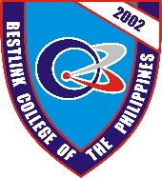BESTLINK COLLEGE OF THE PHILIPPINES

1071 BrgyKaligayahan, Quirino Highway,

Novaliches, Quezon City

Hotel and Restaurant Management System

CORE 2

Prepared by:

Project Manager: Dela Torre, Nelson M.

30 January 2018