1. **Project Charter**
   1. **Project Background**

Hotel and Restaurant Management System is an enterprise information system designed and can be modified for the needs of Hotel and Restaurant establishment or any similar business nature. This software helps the front desk officer up to managerial position to operate and manage day-to-day business transaction including reservation, guest check-in and check-out, billing and payment, purchasing, room facilities, housekeeping, payroll and accounting.

Core Transaction Two of current Hotel and Restaurant Management System contains sub modules for business operation including Front office, Billing, Housekeeping and Laundry management, Room Facilities and Supplier Management. Though the HRM solution works on its business scope, it should collaborate other business modules.

The Billing module of Hotel and Restaurant Management System processes the billing procedure of the hotel for the guest’s portfolio. It handle time and billing tracking as well as invoicing customers for services and products. It can support bills regarding even to an aggregated guest consumed products and services within the whole vicinity of the company. It support common terms of payment like cash, card and sent payment via cheque. This billing system is composed of conjunctive manual and electronic hotel billing procedure to reduce the work load of designated officers.

* 1. **Problem description**
* **Outdated pricing and promotions**

Outdated promotions and price adjustment due to unintegrated Accounting and Billing modules.

* **Outdated sales report**

Outdated sales report due to manual input of room reservation from online transaction to a separate offline system. Time consuming for front desk personnel.

* **Outdated SOA**

Billing in guest portfolios are sometimes not updated due to manual recording of requested paid amenities.

* **Unintegrated multiple system**

Restaurant and Hotel works on a separate offline billing systems.

* **Non-cumulated billing**

The current system does not support an automated and cumulated guests’ statement of account.

* 1. **Goals**

The executive sponsor take advantage the use of a company- wide billing system that is flexible for promotions and future price adjustment, securely receives an email update for room reservation via online and provide an updated portfolio upon guests check-out with accurate statement of account in respect to clients’ precious time.

* 1. **Objective**
* To create a billing system that is flexible for future discount, promotions and any price adjustment.
* To make a secured billing system that receives an email update direct from online reservation.
* To reduced manual recording of requested paid amenities.
* To create a billing system that works on Hotel and Restaurant as a whole wide company billing system.
* To make a billing system that support a cumulated and automated statement of account.
  1. **Deliverables**

|  |  |
| --- | --- |
| Deliverable | Description |
| Updated promotions and pricing. | The accounting and billing system is integrated so the front desk officer can now view current promotions and pricing. |
| Updated sales reports with data from online reservation. | This can be achieve by adding email receiving features to the system. This reduce the manual input of reservation. |
| Updated guest portfolio with data from consumed products and services of guests. | The billing system include the products and services price offered by the hotel so the front desk can add the requested amenities by the guest directly to SOA of the guests. |
| One company wide billing system for hotel and restaurant. | Billing system that support both hotel and restaurant business needs like sales report, forecasting, payment and discounts. |
| Accumulated guest SOA | The system can generate and updated and accumulated guests’ statement of account. |

* 1. **Benefits**
* The system help the front desk personnel to update the guest portfolio in effective and accurate manner.
* The system help the front desk personnel to generate sales report with updated reservation data from online.
* Hotel and restaurant point of sales directly pass their sales to accounting system in real-time.
* This may lead to high customer satisfaction rate because of fast and accurate transaction upon check-in and check-out.
  1. **Stakeholders and Clients**

|  |  |
| --- | --- |
| Stakeholders | Description |
| Executive Sponsors | This refers to the Hotel and Restaurant company the requested the system for their business needs. These are the ultimate decision maker. |
| Major Sponsors | These are to the company’s department which are the major source of business process ideas and responsible for holding, storing, transferring and processing of data. |
| Project Manager | The person who manage and monitor the progress of the whole software project. Works as a spokesperson of the developers’ team and update the Executive Sponsors for the status of the project. |
| Members | Understand the user needs and business process of their area.  Identify risks and issues and help in making resolutions in accordance of project completion. |
| Adviser | Lend expertise and guidance as needed. |

* 1. **Out of scope**
* The billing system does not support cheque payment for personal stay in the hotel, only those sent payment or payment charged to company.
* The billing system does not support payments via any forms of crypto money.
* The billing system cannot adjust and only retrieve products and services price from Accounting and Marketing.
* The company uses one billing system but generate separate report for hotel and restaurant respectively.
  1. **Approach and Methodology**

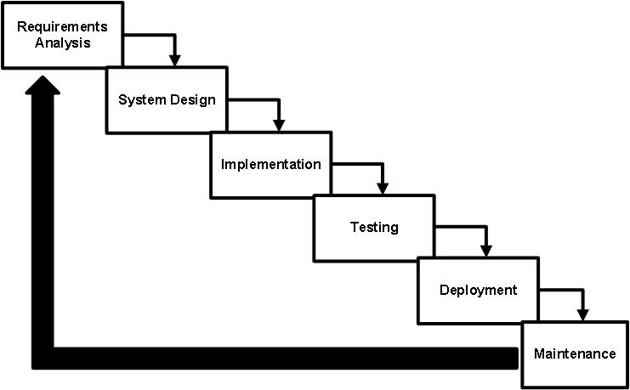

The proponents uses the Waterfall method of structured analysis SDLC as shown in the diagram above.

* **Requirements Analysis**

The proponents gather and analyse the business needs of Executive sponsors by conducting interviews, observation, comparative analysis and online research.

* **System Design**

Adfadffaf adfad asdkadfadf adfadf. adfadfadff addfadff adfafa adfadfad, adsfad. Adfasdfadf, asdfadf. Asdfoadsfadffadf.asdffoasdf. asdfasdfadsfad, asdfadf.asdfadsff asdfasdfasdfad, adsffadf.

* **Implementation**

Adfadffaf adfad asdkadfadf adfadf. adfadfadff addfadff adfafa adfadfad, adsfad. Adfasdfadf, asdfadf. Asdfoadsfadffadf.asdffoasdf. asdfasdfadsfad, asdfadf.asdfadsff asdfasdfasdfad, adsffadf.

* **Testing**

Adfadffaf adfad asdkadfadf adfadf. adfadfadff addfadff adfafa adfadfad, adsfad. Adfasdfadf, asdfadf. Asdfoadsfadffadf.asdffoasdf. asdfasdfadsfad, asdfadf.asdfadsff asdfasdfasdfad, adsffadf.

* **Deployment**

Adfadffaf adfad asdkadfadf adfadf. adfadfadff addfadff adfafa adfadfad, adsfad. Adfasdfadf, asdfadf. Asdfoadsfadffadf.asdffoasdf. asdfasdfadsfad, asdfadf.asdfadsff asdfasdfasdfad, adsffadf.

* **Maintenance**

Adfadffaf adfad asdkadfadf adfadf. adfadfadff addfadff adfafa adfadfad, adsfad. Adfasdfadf, asdfadf. Asdfoadsfadffadf.asdffoasdf. asdfasdfadsfad, asdfadf.asdfadsff asdfasdfasdfad, adsffadf.

* 1. **Project Timeline**

|  |  |  |  |
| --- | --- | --- | --- |
| Activity | Start | Finish | Duration |
| Initiation   * Requirements Specification * Interviews and observation * Research and comparative analysis | 02/1/2018 | 02/10/2018 | 10days |
| Planning   * Brainstorming * Designing * Software Architecture | 02/11/2018 | 02/17/2018 | 7days |
| Execution   * Coding * Construction phase * Logic and design implementation | 02/18/2018 | 02/28/2018 | 10days |
| Monitoring   * Testing * Debugging | 03/1/2018 | 02/5/2018 | 5days |
| Close-out   * Installation and Maintenance | To be announce | To be announce | To be announce |

* 1. **Success Criteria**
* The front desk personnel should be able to see promotions and pricing on the front desk User Interface alone.
* The system should be able to generate updated reports with data from online room reservation.
* The front desk personnel should be able add requested amenities and service to guest account effectively and accurate.
* The Executive sponsors should be able to use one billing system that is integrated to accounting.
* The system should generated and support a cumulated guests account and their bills.
  1. **Risk Management Plan**

|  |  |  |  |
| --- | --- | --- | --- |
| Risk Factor | Probability | Impact | Risk Management Plan |
| User Risk | High | High | * Provide input mask in every field and use a high level validation for users input. * Provide an easy to understand tooltip and user manual. * Record scenarios and users input to consider for the next debugging schedule. |
| Technical Risk | High | High | * Conduct training for all the persons directly involve in the project development. |
| Financial Risk | High | High | * Plan ahead the anticipated costs. * Allot at least 10% of total budget for the unexpected cost that may arise. * We can use the contingency fund. |
| Natural Calamity Risk | Low | Low | * This is unexpected but we can reduced its impact if we use online version control system. |

|  |  |  |  |
| --- | --- | --- | --- |
| Business Risk | Low | Medium | * Review the project plan, analyse the scenarios then apply adjustment as it may needed. * Involve the Executive sponsors in day-to-day progress of the project. |
| Operational Risk | Medium | Medium | * The main reason of this problem is that not all the persons involve are aware of the current strategic plan; so follow the plan that was created. Apply any adjustment when needed. |

* 1. **Technical Features**
* **Recommended**

|  |  |
| --- | --- |
| **Hardware Requirements** | **Specification** |
| RAM | 4GB |
| Hard Disk | 32 GB HDD Free Space |
| Processor | Intel® Atom ™ x5-z8300 CPU@ 1.44GHz 1.44GHz |
| **Software Requirements** | **Specification** |
| Operating System | Windows 10 Home |
| Screen Resolution | 1366x768 |
| Front End | Java Netbeans |
| Back End | MySQL |

* **Minimum**

|  |  |
| --- | --- |
| **Hardware** | **Specification** |
| RAM | 2 GB |
| Hard Disk | 32 GB HDD Free Space |
| Processor | Intel® Atom ™ x5-z8300 CPU@ 1.44GHz 1.44GHz |
| **Software** |  |
| Operating System | Windows 10 Home |
| Application | Java Netbeans |
| JRE | At least JRE 8 for run time environment |

* 1. **Project Organization and Staffing**

|  |  |  |
| --- | --- | --- |
| Role | Name | Responsibilities |
| Project Manager | Dela torre, Nelson | * The person who manage and observed the development of the whole project. * Report to and receive direction from sponsors * Manage, review, and prioritize project work plans * Provide status reports * Manage project team * Recommend changes, escalate issues, and mitigate risks |
| Business Analyst | Raagas, Chelsy  Taña, Marvin | * Assigned to create and check documents which must suit to client and business needs. * The person who know all the business process related to the project. |
| Lead Programmer | Apelido, Joshua Ryan | * Responsible for technical issues; including coding, security of the data and whole logic implementation. |
| Document Specialist | Sacnahon, Arkee | * Responsible for technical documentation of the project. In correct format, grammar, term in related to the business. |
| System Analyst | Nimo, Maica | * Responsible for analysing and making decision related to execution of project ideas and logic. |

* 1. **Project budget**

**\***For 1 month expense of development including deployment.

|  |  |  |
| --- | --- | --- |
| One time cost | Software | ₱13,167.00 |
| Hardware | ₱382,454.00 |
| Contingency fund | ₱85,000.00 |
|  |  |
|  |  |
|  |  |
| On-going cost | Miscellaneous | ₱50,400.00 |
| Salary Expense | ₱291,077.00 |
| Facilities | ₱5,000.00 |
| Services | ₱6,600.00 |
|  |  |
|  |  |
|  |  |
| Total (Approx.) | | ₱833,698.00 |

1. **Foreign and local studies**
   1. **Foreign Studies**

* **E-soft Hotel Management System**

Is and enterprise information system for hotel. It I made up of visual basic, it manage and operate small to medium sized hotels. It is user friendly and compact application that support multi-user

Features:

1. Billing and invoice method
2. Checkout billing and periodic billing
3. Quick check out billing method for cash transaction.

Retrieve from: https://www.slideshare.net/colimmy/hotel-management-system?qid=cd680cb7-4e01-4c63-90e8-7c7529cc0d66&v=&b=&from_search=9

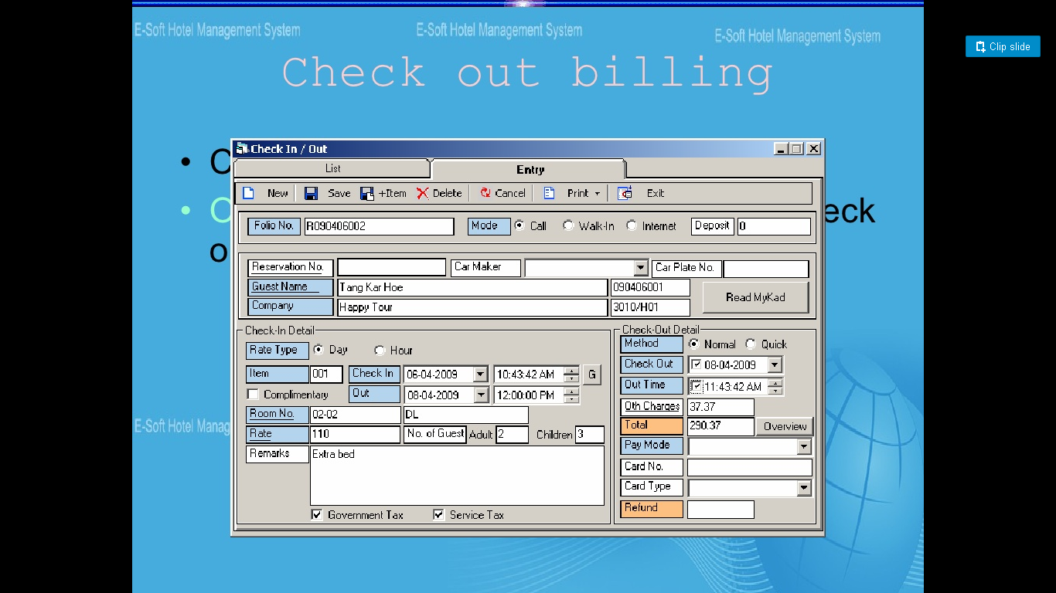

* **Tejasya Hotel**

A complete Hotel Billing, ordering and reservation system. It enhances the productivity of all the stakeholders involved in the Hotel ecosystem. Provides easy communication, reduced efforts in maintaining the records and eliminating the paper usage.

Features:

1. Billing information
2. Fully responsive design
3. Kitchen ordering

Retrieve from: <https://www.slideshare.net/kiranc0/tetejasya-hotel-datasheet?qid=7f25b2ea-a3c1-4581-9d6e-8f72c948f44c&v=&b=&from_search=1>

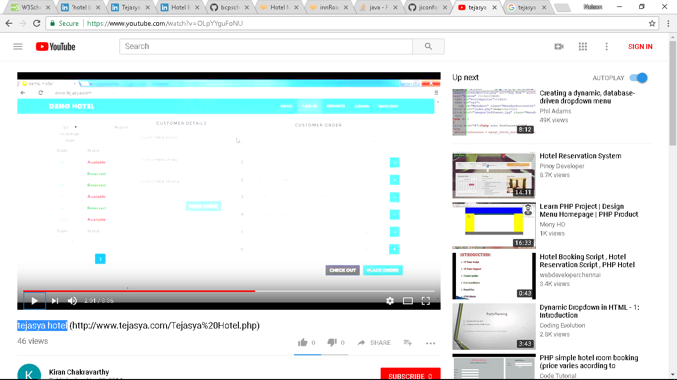

* **Premium Hotel Management**

Premium HMS gives total software solution to Hotel and Resort management with both side internal and external like Front Office and Back Office Operations. The System provides modular approach to Implement Problem Solving Process in fast, efficient and through manner. Review for performance efficiency and convenience of usage. Since this is a continual process, changes are bound to occur from time to time.

Features:

1. Generate sales report
2. Room occupancy statistics
3. Employees master form for transactions.

Retrieve from: https://www.slideshare.net/visionraval/hotel-management-software-presentation?qid=64c95a26-3c00-4414-9697-e4043f5af006&v=&b=&from_search=12

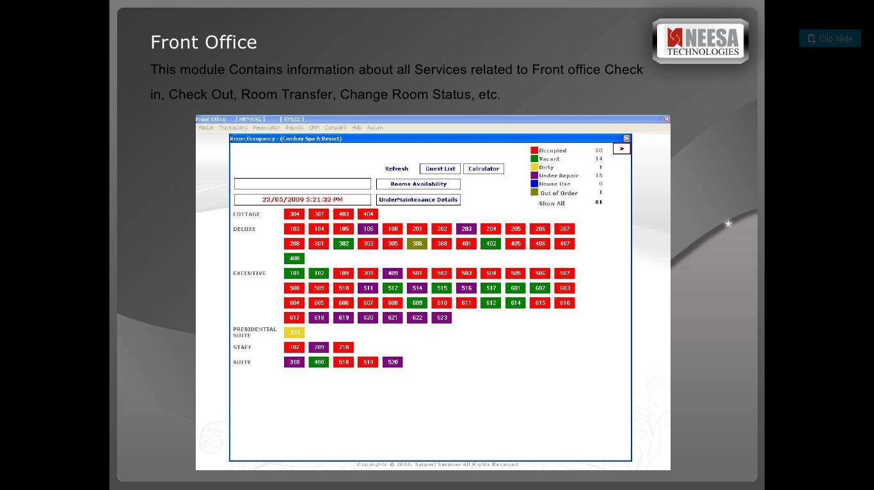

* **Hotel ITM Villa**

Hotel ITM Villa is a 30 year old small family run chain of Hotel located in 5 Metro Cities in India. We believe inthe age old Indian tradition of “AtithiDevoBhav” which means “Guest is God” a way of life & where everyone is committed to taking guests to reverential heights.

Features:

1. Reports
2. Occupancy Chart
3. Employees master form for transactions.
4. Monthly Revenue statistics

Retrieve from: https://www.slideshare.net/raj_qn3/hotel-reservation-system-project?qid=1f46b541-0919-431e-a940-93bc515a6a1f&v=&b=&from_search=20

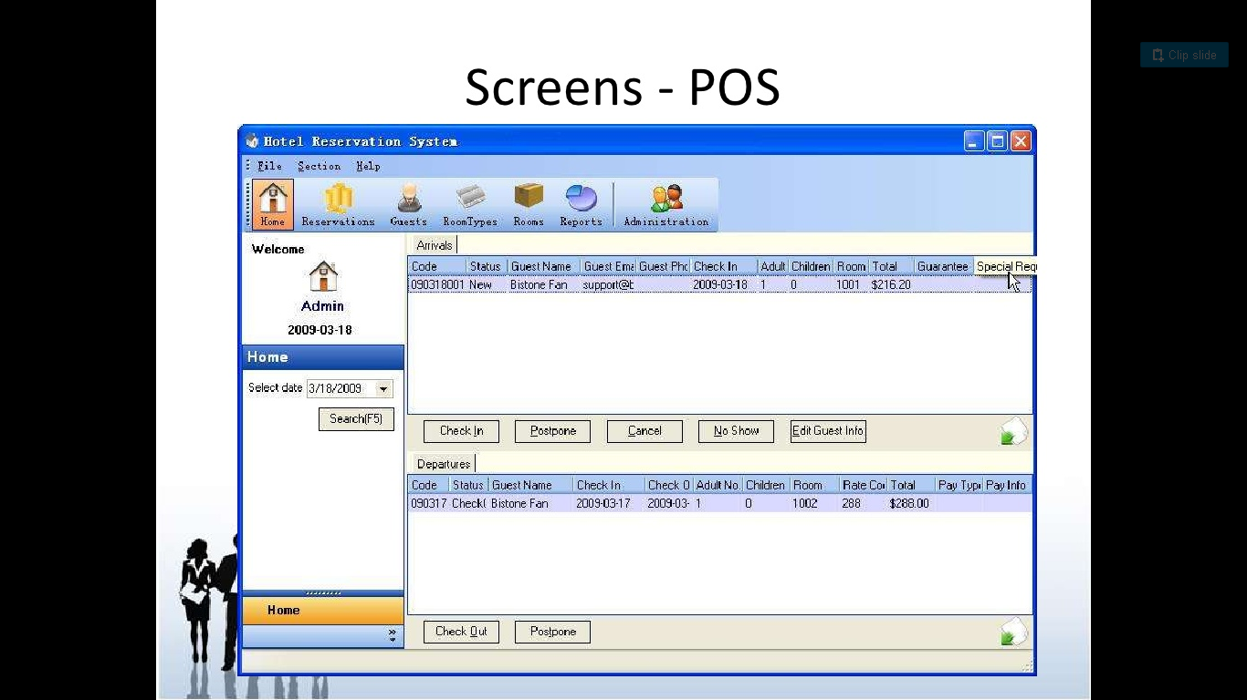

* **Luxury Hotel Management System**

A typical luxury Hotel requires a management system to control its various operations such as maintaining account of all the people in its domain of services, attending to various needs of customers and also achieving increased efficiency in the overall working of the Hotel itself.

Features:

1. Getting the information
2. Getting customer information who are lodged in
3. Allocating a room to the customer
4. Checking the availability
5. Displaying the features of the rooms.
6. Preparing a billing function for the customer according to his room no.

Retrieve from: https://www.slideshare.net/princejustleavehimalone/hotel-management-system-in-c?qid=e64bb09b-3457-457e-b349-acd61094d53e&v=&b=&from_search=32

­­­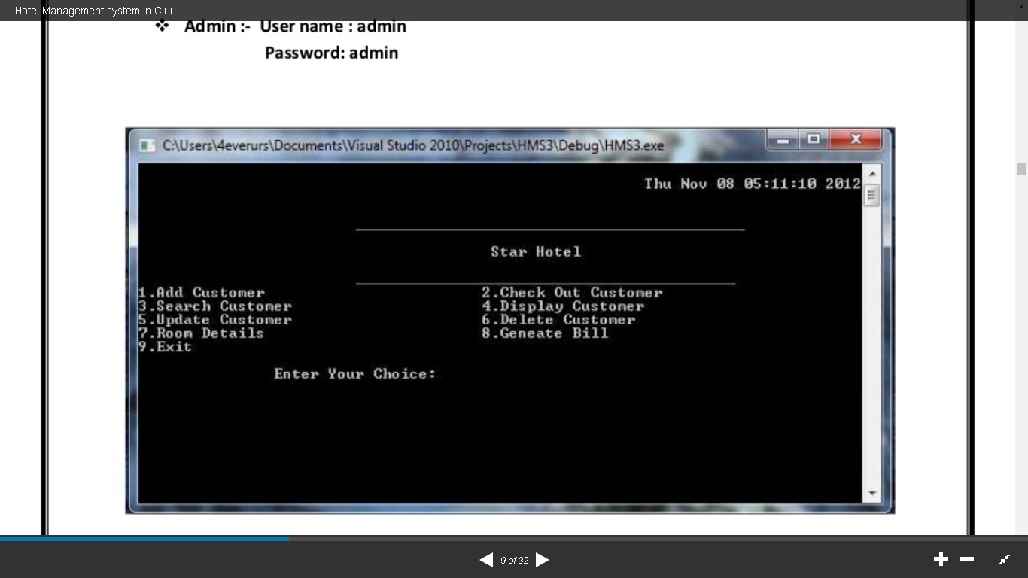

* 1. **Local Studies**
* **Gatessoft**

Gatessoft’s hotel software suite is the only resorts oftware in the world where all departments—including front office, reservations, housekeeping, accounting, inventory and food &beverage—boast fully compatible and fully integrate-able systems created by thesame software. It has over 1500 rooms under management just in the Philippines, the Genesis Hotel Management System currently serves every type of hotel.

Features:

1. Easy to learn
2. Fully integrated to other hotel department
3. Post charge to customer

Retrieve from: https://www.slideshare.net/GeorgeLlorente/genesis-hotel-pms-brochure?qid=58ff99a4-23bb-4648-beb3-381acfc73a97&v=&b=&from_search=9

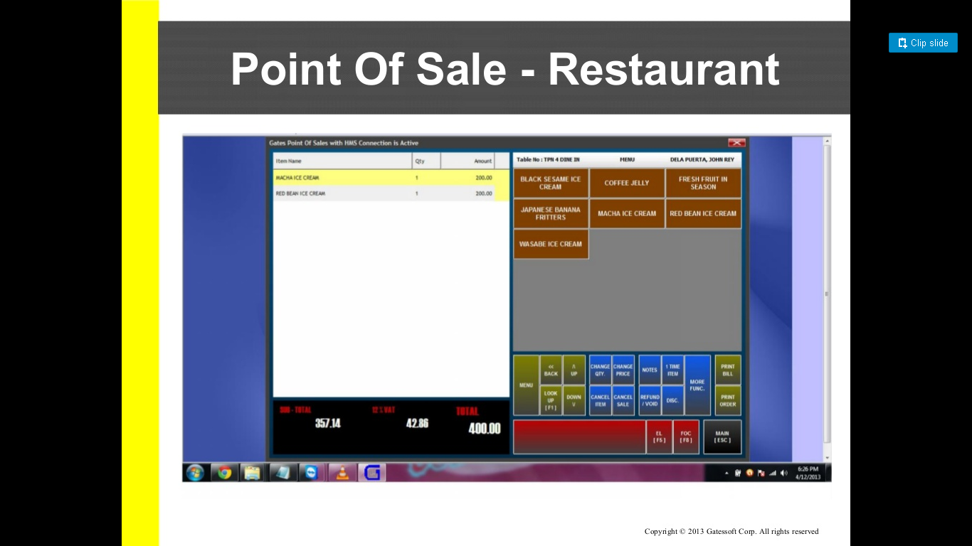

* **Genesis Hotel Management System**

World’s all-in-one fully integrated software for Hotel Management that works in any department without third party. It is use by many luxury hotel in Davao and Cebu.

Features:

1. Room Plan
2. In house graph
3. In house guest management
4. Housekeeping status

Retrieve from: https://www.slideshare.net/joseph_gayod/gatessoft-corp-genesis-hotel-property-management-system-26723594?qid=7301e373-6bb3-4719-8791-e7b4d3470df5&v=&b=&from_search=13

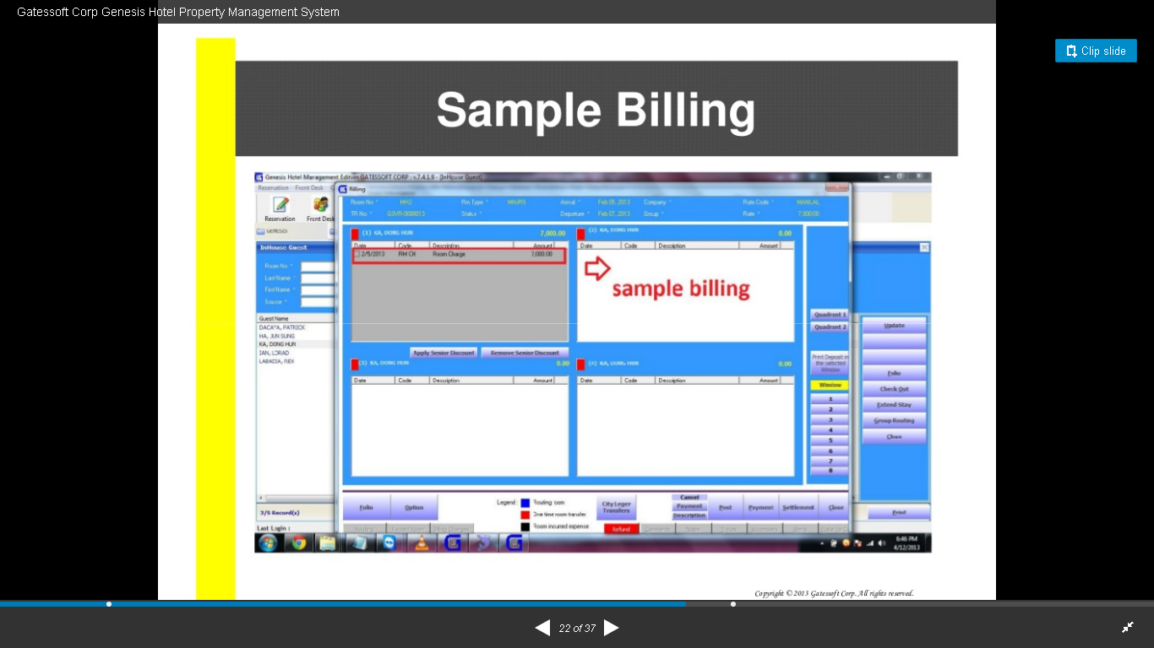

* **eZee FrontDesk**

eZee FrontDesk packed with powerful features, makes it easy for you to manage your daily operations while improving your overall guest services. Designed and developed under the guidance of hospitality experts, the hotel management system can accommodate the most stringent operational requirement regardless what type of property you manage. Time is of the essence in the industry, and a good property management system not only saves you time but helps you complete the operations efficiently and increase productivity.

Features:

1. User Friendly
2. Room Layout plan
3. Summary View
4. Inventory View
5. Guest Laundry

Retrieve from: http://www.ezeefrontdesk.com/hotel-pms.php

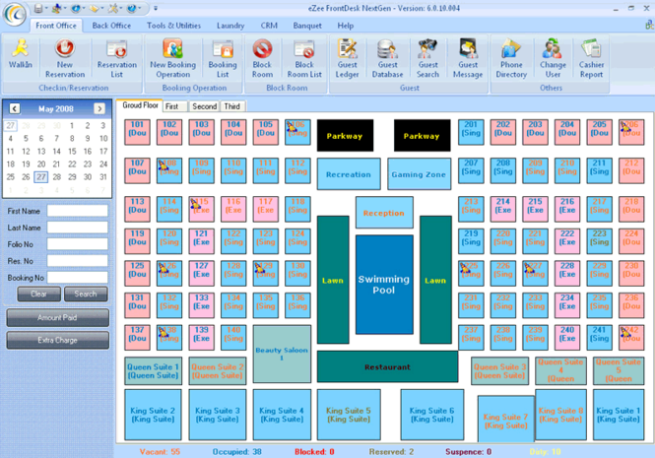

* **Zennate Hotel Management System**

A web based software which manages all the departments of the hotel, motels, inns, resorts, lodges, hostel, military guest houses, ranch, suites, apartments, medical centres and bed, breakfast operations. The software main features include booking and room stay management, yield management, day rate management, booking calendar, guest relationship management, folio management and accounting documents such as invoices and receipts.

Features:

1. Guest Data Management
2. Hotel Rooms Rates Management
3. Reservation management
4. Front Office Management
5. Housekeeping
6. Employee Management
7. Supplementary Hotel Services
8. Conference Booking & Management

Retrieve from: https://www.slideshare.net/lalbahadur2/hotel-management-software-41658708?qid=8aa3bd67-8ca3-4799-a7c2-44276d849845&v=&b=&from_search=9

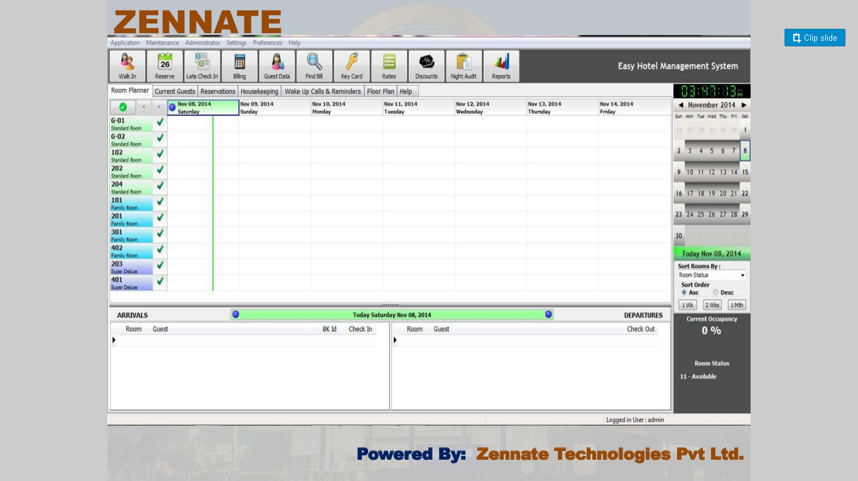

* **Folio+ Hotel Management System**

Folio+ Hotel Management System is created to address the complex and diverse needs on hotel operations such booking/reservation management, room/housekeeping management, event management, guest service administration, facilities and amenities handling, sales and marketing operation, financial management, food and beverage operations and many more. Folio plus features are designed to help hotel users easily do their respective hotel tasks.

Features

1. Sales and Marketing Division
2. Rooms Division
3. Food and Beverages Services
4. Finance Division
5. General Services Division

Retrieve from: http://jinisyssoftware.com/hotel-management-system/folio-plus/

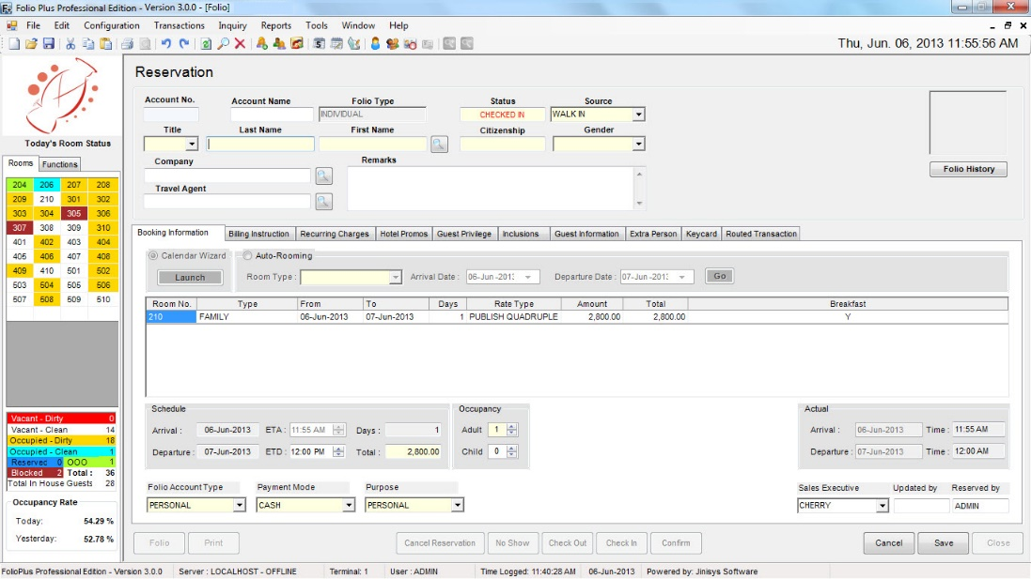

* 1. **Comparative Analysis**

**Foreign Studies**

|  |  |  |  |  |  |  |
| --- | --- | --- | --- | --- | --- | --- |
| Feature | S1 | S2 | S3 | S4 | S5 | Proposed |
| Billing information |  |  |  |  |  |  |
| Fully responsive design |  |  |  |  |  |  |
| Kitchen ordering |  |  |  |  |  |  |
| Quick check out billing method for cash transaction. |  |  |  |  |  |  |
| Billing and invoice method |  |  |  |  |  |  |
| Checkout billing and periodic billing |  |  |  |  |  |  |
| Employees master form for transactions. |  |  |  |  |  |  |
| Room occupancy statistics |  |  |  |  |  |  |
| Generate sales report |  |  |  |  |  |  |
| Room features display |  |  |  |  |  |  |
| Preparing a billing function for the customer according to his room no. |  |  |  |  |  |  |
| User Friendly |  |  |  |  |  |  |

**Local Studies**

|  |  |  |  |  |  |  |
| --- | --- | --- | --- | --- | --- | --- |
| Feature | S1 | S2 | S3 | S4 | S5 | Proposed |
| Easy to learn |  |  |  |  |  |  |
| Fully integrated to other hotel department |  |  |  |  |  |  |
| Post charge to customer |  |  |  |  |  |  |
| In house graph |  |  |  |  |  |  |
| In house guest management |  |  |  |  |  |  |
| Housekeeping status |  |  |  |  |  |  |
| User Friendly |  |  |  |  |  |  |
| Guest Laundry |  |  |  |  |  |  |
| Inventory View |  |  |  |  |  |  |
| Summary View |  |  |  |  |  |  |
| Room Layout plan |  |  |  |  |  |  |
| Room Charge |  |  |  |  |  |  |
| Sales and Marketing reference |  |  |  |  |  |  |
| General Services |  |  |  |  |  |  |
| Food and Beverages Services |  |  |  |  |  |  |
| Guest Data Management |  |  |  |  |  |  |
| Conference Booking & Management |  |  |  |  |  |  |
| Supplementary Hotel Services |  |  |  |  |  |  |
| Housekeeping |  |  |  |  |  |  |
| Front Office Management |  |  |  |  |  |  |
| Reservation management |  |  |  |  |  |  |
| Hotel Rooms Rates Management |  |  |  |  |  |  |

* 1. **Synthesis**

All of the foreign and local studies share most of the basic function of hotel management system, like processing of check-in and check-out, billing, food and beverages services, room availability management and other general services. Some studies have online version and integration to other department like GateSoft and Genesis HMS because they are under one software company. Most of foreign and local studies are user friendly except to Luxury Hotel and Management System because it made of pure C++ command line however it gives complex function to this study like customer account management and billing. Tejasya HMS is web-based app so it’s fully responsiveness feature is not applicable to other desktop application and in our proposed system but our proposed system give more useful function for all stakeholder involve.

1. **Project Management**
   1. **Dataflow Diagram**
      1. **As is**
      2. **To be**
   2. **Business Process Diagram**
      1. **As is**
      2. **To be**
   3. **Work Break down Status**
   4. **Use Case Diagram**
   5. **Test Scenario (table)**
      1. **Black box test**
      2. **White box test**
   6. **Screen shots**
2. **Test Results (table)**
3. **Conclusion and Recommendations**